Supplementary materials
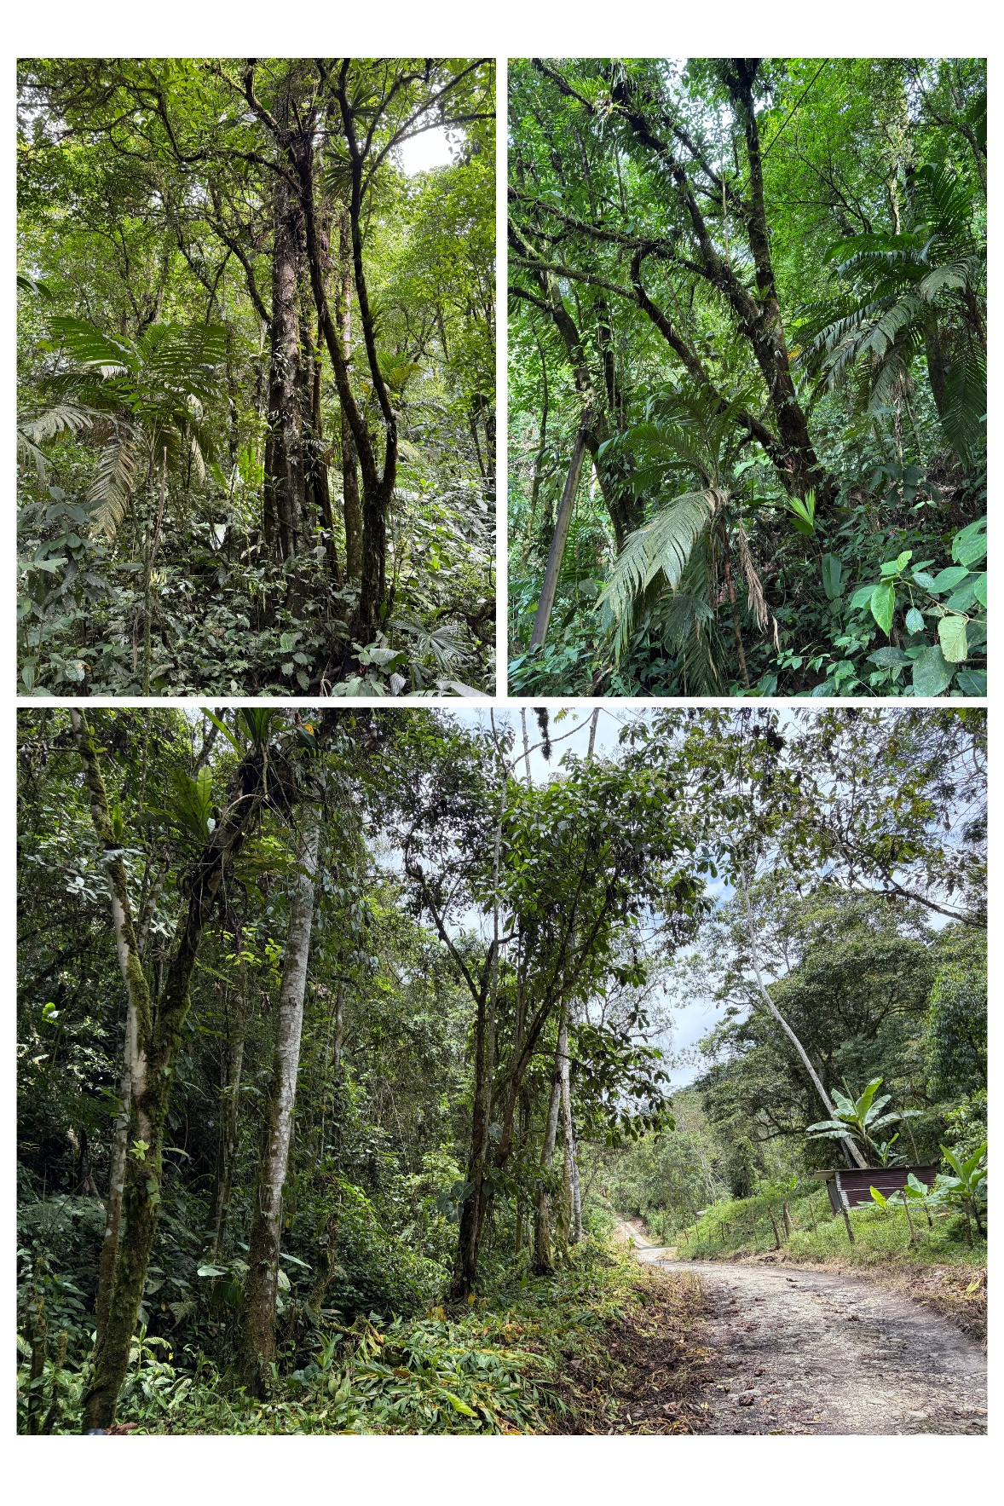
Figure S1. Photo series of the nesting trees and habitats for the three documented nests of the Tawny-chested Flycatcher (Aphanotriccus capitalis) in Costa Rica. Photos by TW and DRL.

