Supplementary Information

Season and soil depth reshape inference from paired grazing contrasts in alpine soils
Xuegang Zhu, Yi He and Ling Liu
Corresponding author: Xuegang Zhu (zhuxg18@lzu.edu.cn)

Supplementary Methods

Independent units and compositing
Each habitat contained four independent pairs of a seasonally excluded fence and neighbouring grazed land. Every management unit was approximately 3 ha. The fences had excluded livestock from March to October each year since 2011. On each PLFA date and at each depth, three newly selected spatial cores were combined before one laboratory measurement. The field composite_n = 3 is retained in the clean tables to document field support; it is not a sample-size multiplier. Pair IDs 1–4 align neighbouring grazed and excluded units within habitat.

Model and multiplicity details
The paired response for all eight PLFA outcomes was lnRR = ln(grazed) − ln(excluded). Each primary model used restricted maximum likelihood with fixed habitat × date × depth and a pair-within-habitat random intercept. Type-III tests used Kenward–Roger denominator degrees of freedom. Benjamini–Hochberg correction was applied separately across the eight outcomes for date, date × depth, habitat × date and habitat × date × depth.
Greenhouse–Geisser repeated-measures tests used pair as subject, habitat as the between-subject factor, and date and depth as within-subject factors. The 199-simulation parameter bootstrap compared nested maximum-likelihood models built from the sum-coded fixed-effect design matrix. Each primary model was also refitted eight times after omitting one independent pair. The main paper's “supported” classification required q < 0.05, Greenhouse–Geisser P < 0.05 and bootstrap P < 0.05.

Day-0 soil and root analyses
Root biomass and soil physicochemical properties were observed only on 15 July 2018 (Day 0). Pair IDs in the source soil workbook follow the author-confirmed within-cell row order 1–4. Positive-valued outcomes were represented as paired lnRR; pH used grazed minus excluded. These analyses describe vertical context and were not included as seasonal mediators.

Supplementary Results
Every PLFA date term remained nominally significant in all eight leave-one-pair-out refits. Six date × depth terms and five habitat × date terms met the combined robustness rule. The AM-fungi-associated and Gram-positive date × depth terms were Benjamini–Hochberg-significant but did not pass the Greenhouse–Geisser check. No habitat × date × depth q value was below 0.05.
Three primary models estimated zero pair-level random-intercept variance. Several residual distributions contained heavy tails. The parameter bootstrap, Greenhouse–Geisser and leave-one-pair-out analyses were therefore integral to interpretation rather than optional post hoc checks.
Day-0 paired root biomass, C:N and water contrasts varied with depth after correction across the ten root/soil outcomes. Soil organic carbon and total nitrogen paired contrasts showed habitat × depth terms. Because these variables were measured once, they provide no evidence about the cause of the later PLFA trajectories.

Supplementary Tables
Supplementary Table S1. Sampling structure and inferential units.
Component | Levels or count | Inferential interpretation
Habitat | Swamp meadow; meadow | Pair-level between-subject factor
Independent pair | 4 per habitat; 8 total | Statistical subject and independent unit
Management unit | Excluded fence; neighbouring grazed land | Paired comparison; allocation not confirmed random
PLFA dates | Day 0, 13 and 40 | Repeated within pair
Soil depths | 0–5, 5–15 and 15–30 cm | Repeated within pair
Component cores | 3 per management unit × date × depth | Composited before measurement; not independent replicates
PLFA laboratory observations | 144 | Complete balanced source table
Paired PLFA lnRR rows | 576 | 8 outcomes × 2 habitats × 4 pairs × 3 dates × 3 depths
Soil and root timing | Day 0 only | Supplementary vertical context

Supplementary Tables S2–S5 are generated directly from the frozen CSV outputs by the document build script.

Supplementary Table S2. Complete primary and sensitivity tests for PLFA outcomes
Outcome | Term | F | Num df | Den df | P | q | GG P | Bootstrap P | LOO P<0.05 | Class
General Bacteria | day | 39.13 | 2 | 48.0 | 8.30e-11 | 6.64e-10 | 1.05e-05 | 0.005 | 1.000 | headline-supported
Gram Negative | day | 32.46 | 2 | 48.0 | 1.21e-09 | 4.85e-09 | 1.89e-05 | 0.005 | 1.000 | headline-supported
G+:G- | day | 23.90 | 2 | 48.0 | 6.27e-08 | 1.67e-07 | 0.003 | 0.005 | 1.000 | headline-supported
Fungi | day | 20.96 | 2 | 48.0 | 2.87e-07 | 5.74e-07 | 2.23e-04 | 0.005 | 1.000 | headline-supported
F:B | day | 13.43 | 2 | 48.0 | 2.33e-05 | 3.74e-05 | 3.26e-05 | 0.005 | 1.000 | headline-supported
AM Fungi | day | 8.61 | 2 | 48.0 | 6.38e-04 | 8.51e-04 | 2.55e-04 | 0.005 | 1.000 | headline-supported
Actinomycetes | day | 7.55 | 2 | 48.0 | 0.001 | 0.002 | 0.008 | 0.005 | 1.000 | headline-supported
Gram Positive | day | 6.94 | 2 | 48.0 | 0.002 | 0.002 | 0.019 | 0.015 | 1.000 | headline-supported
Fungi | day:depth | 13.21 | 4 | 48.0 | 2.49e-07 | 1.99e-06 | 0.003 | 0.005 | 1.000 | headline-supported
General Bacteria | day:depth | 10.22 | 4 | 48.0 | 4.55e-06 | 1.82e-05 | 0.005 | 0.005 | 1.000 | headline-supported
F:B | day:depth | 7.59 | 4 | 48.0 | 8.04e-05 | 2.15e-04 | 0.024 | 0.005 | 1.000 | headline-supported
Actinomycetes | day:depth | 7.24 | 4 | 48.0 | 1.21e-04 | 2.42e-04 | 0.027 | 0.005 | 1.000 | headline-supported
Gram Negative | day:depth | 6.55 | 4 | 48.0 | 2.73e-04 | 4.36e-04 | 0.025 | 0.005 | 1.000 | headline-supported
G+:G- | day:depth | 4.11 | 4 | 48.0 | 0.006 | 0.008 | 0.032 | 0.015 | 1.000 | headline-supported
AM Fungi | day:depth | 3.65 | 4 | 48.0 | 0.011 | 0.013 | 0.105 | 0.015 | 0.750 | BH-significant but sensitivity-dependent
Gram Positive | day:depth | 2.64 | 4 | 48.0 | 0.045 | 0.045 | 0.139 | 0.025 | 0.375 | BH-significant but sensitivity-dependent
AM Fungi | habitat:day | 13.11 | 2 | 48.0 | 2.86e-05 | 1.14e-04 | 4.42e-05 | 0.005 | 1.000 | headline-supported
Gram Positive | habitat:day | 13.54 | 2 | 48.0 | 2.17e-05 | 1.14e-04 | 0.002 | 0.005 | 1.000 | headline-supported
Actinomycetes | habitat:day | 11.54 | 2 | 48.0 | 8.06e-05 | 2.15e-04 | 0.002 | 0.005 | 1.000 | headline-supported
General Bacteria | habitat:day | 6.88 | 2 | 48.0 | 0.002 | 0.004 | 0.004 | 0.015 | 1.000 | headline-supported
F:B | habitat:day | 6.84 | 2 | 48.0 | 0.002 | 0.004 | 6.69e-04 | 0.005 | 1.000 | headline-supported
Gram Negative | habitat:day | 3.51 | 2 | 48.0 | 0.038 | 0.051 | 0.052 | 0.040 | 0.500 | uncertain/exploratory
G+:G- | habitat:day | 2.92 | 2 | 48.0 | 0.064 | 0.073 | 0.177 | 0.075 | 0.250 | uncertain/exploratory
Fungi | habitat:day | 0.79 | 2 | 48.0 | 0.460 | 0.460 | 0.372 | 0.475 | 0 | uncertain/exploratory
General Bacteria | habitat:day:depth | 2.94 | 4 | 48.0 | 0.030 | 0.170 | 0.102 | 0.025 | 0.625 | uncertain/exploratory
Gram Positive | habitat:day:depth | 2.68 | 4 | 48.0 | 0.042 | 0.170 | 0.135 | 0.065 | 0.375 | uncertain/exploratory
Gram Negative | habitat:day:depth | 1.82 | 4 | 48.0 | 0.140 | 0.375 | 0.246 | 0.145 | 0.125 | uncertain/exploratory
AM Fungi | habitat:day:depth | 1.30 | 4 | 48.0 | 0.285 | 0.456 | 0.414 | 0.245 | 0.125 | uncertain/exploratory
F:B | habitat:day:depth | 1.32 | 4 | 48.0 | 0.275 | 0.456 | 0.389 | 0.325 | 0 | uncertain/exploratory
G+:G- | habitat:day:depth | 1.00 | 4 | 48.0 | 0.417 | 0.556 | 0.412 | 0.475 | 0 | uncertain/exploratory
Actinomycetes | habitat:day:depth | 0.86 | 4 | 48.0 | 0.494 | 0.565 | 0.507 | 0.495 | 0 | uncertain/exploratory
Fungi | habitat:day:depth | 0.57 | 4 | 48.0 | 0.684 | 0.684 | 0.614 | 0.685 | 0 | uncertain/exploratory

Supplementary Table S3. Model-estimated changes from Day 0 by habitat and depth
Outcome | Habitat | Depth (cm) | Contrast | Estimate | SE | df | 95% CI | P
Actinomycetes | Swamp meadow | 0-5 | Day 13 - Day 0 | 0.019 | 0.446 | 48.0 | -0.877 to 0.915 | 0.966
Actinomycetes | Swamp meadow | 0-5 | Day 40 - Day 0 | -0.042 | 0.446 | 48.0 | -0.938 to 0.854 | 0.926
Actinomycetes | Meadow | 0-5 | Day 13 - Day 0 | 1.398 | 0.446 | 48.0 | 0.502 to 2.294 | 0.003
Actinomycetes | Meadow | 0-5 | Day 40 - Day 0 | 0.937 | 0.446 | 48.0 | 0.041 to 1.833 | 0.041
Actinomycetes | Swamp meadow | 5-15 | Day 13 - Day 0 | -1.246 | 0.446 | 48.0 | -2.142 to -0.350 | 0.007
Actinomycetes | Swamp meadow | 5-15 | Day 40 - Day 0 | -0.445 | 0.446 | 48.0 | -1.341 to 0.451 | 0.323
Actinomycetes | Meadow | 5-15 | Day 13 - Day 0 | 0.278 | 0.446 | 48.0 | -0.618 to 1.174 | 0.536
Actinomycetes | Meadow | 5-15 | Day 40 - Day 0 | -0.592 | 0.446 | 48.0 | -1.488 to 0.304 | 0.191
Actinomycetes | Swamp meadow | 15-30 | Day 13 - Day 0 | -0.913 | 0.446 | 48.0 | -1.809 to -0.017 | 0.046
Actinomycetes | Swamp meadow | 15-30 | Day 40 - Day 0 | -1.908 | 0.446 | 48.0 | -2.804 to -1.012 | 8.87e-05
Actinomycetes | Meadow | 15-30 | Day 13 - Day 0 | 1.314 | 0.446 | 48.0 | 0.418 to 2.211 | 0.005
Actinomycetes | Meadow | 15-30 | Day 40 - Day 0 | -1.124 | 0.446 | 48.0 | -2.020 to -0.228 | 0.015
AM Fungi | Swamp meadow | 0-5 | Day 13 - Day 0 | -1.376 | 0.510 | 48.0 | -2.402 to -0.350 | 0.010
AM Fungi | Swamp meadow | 0-5 | Day 40 - Day 0 | -0.897 | 0.510 | 48.0 | -1.923 to 0.129 | 0.085
AM Fungi | Meadow | 0-5 | Day 13 - Day 0 | 0.440 | 0.510 | 48.0 | -0.586 to 1.466 | 0.393
AM Fungi | Meadow | 0-5 | Day 40 - Day 0 | 0.767 | 0.510 | 48.0 | -0.259 to 1.793 | 0.139
AM Fungi | Swamp meadow | 5-15 | Day 13 - Day 0 | -0.464 | 0.510 | 48.0 | -1.490 to 0.562 | 0.368
AM Fungi | Swamp meadow | 5-15 | Day 40 - Day 0 | -2.741 | 0.510 | 48.0 | -3.767 to -1.715 | 2.25e-06
AM Fungi | Meadow | 5-15 | Day 13 - Day 0 | 0.667 | 0.510 | 48.0 | -0.359 to 1.693 | 0.197
AM Fungi | Meadow | 5-15 | Day 40 - Day 0 | 0.147 | 0.510 | 48.0 | -0.879 to 1.173 | 0.775
AM Fungi | Swamp meadow | 15-30 | Day 13 - Day 0 | -0.785 | 0.510 | 48.0 | -1.811 to 0.241 | 0.131
AM Fungi | Swamp meadow | 15-30 | Day 40 - Day 0 | -2.129 | 0.510 | 48.0 | -3.155 to -1.103 | 1.26e-04
AM Fungi | Meadow | 15-30 | Day 13 - Day 0 | -0.418 | 0.510 | 48.0 | -1.444 to 0.608 | 0.417
AM Fungi | Meadow | 15-30 | Day 40 - Day 0 | -0.281 | 0.510 | 48.0 | -1.307 to 0.745 | 0.584
Fungi | Swamp meadow | 0-5 | Day 13 - Day 0 | 0.594 | 0.365 | 48.0 | -0.139 to 1.328 | 0.110
Fungi | Swamp meadow | 0-5 | Day 40 - Day 0 | 0.589 | 0.365 | 48.0 | -0.145 to 1.322 | 0.113
Fungi | Meadow | 0-5 | Day 13 - Day 0 | 0.919 | 0.365 | 48.0 | 0.186 to 1.652 | 0.015
Fungi | Meadow | 0-5 | Day 40 - Day 0 | 0.648 | 0.365 | 48.0 | -0.086 to 1.381 | 0.082
Fungi | Swamp meadow | 5-15 | Day 13 - Day 0 | 0.152 | 0.365 | 48.0 | -0.581 to 0.886 | 0.678
Fungi | Swamp meadow | 5-15 | Day 40 - Day 0 | -0.416 | 0.365 | 48.0 | -1.149 to 0.317 | 0.260
Fungi | Meadow | 5-15 | Day 13 - Day 0 | -0.014 | 0.365 | 48.0 | -0.747 to 0.719 | 0.970
Fungi | Meadow | 5-15 | Day 40 - Day 0 | -0.499 | 0.365 | 48.0 | -1.233 to 0.234 | 0.177
Fungi | Swamp meadow | 15-30 | Day 13 - Day 0 | 0.129 | 0.365 | 48.0 | -0.604 to 0.862 | 0.725
Fungi | Swamp meadow | 15-30 | Day 40 - Day 0 | -1.781 | 0.365 | 48.0 | -2.514 to -1.048 | 1.20e-05
Fungi | Meadow | 15-30 | Day 13 - Day 0 | 1.046 | 0.365 | 48.0 | 0.313 to 1.780 | 0.006
Fungi | Meadow | 15-30 | Day 40 - Day 0 | -1.497 | 0.365 | 48.0 | -2.230 to -0.763 | 1.57e-04
General Bacteria | Swamp meadow | 0-5 | Day 13 - Day 0 | -0.585 | 0.313 | 48.0 | -1.214 to 0.045 | 0.068
General Bacteria | Swamp meadow | 0-5 | Day 40 - Day 0 | -1.347 | 0.313 | 48.0 | -1.977 to -0.718 | 8.25e-05
General Bacteria | Meadow | 0-5 | Day 13 - Day 0 | -0.254 | 0.313 | 48.0 | -0.883 to 0.376 | 0.421
General Bacteria | Meadow | 0-5 | Day 40 - Day 0 | -0.076 | 0.313 | 48.0 | -0.705 to 0.554 | 0.810
General Bacteria | Swamp meadow | 5-15 | Day 13 - Day 0 | -1.124 | 0.313 | 48.0 | -1.754 to -0.495 | 7.74e-04
General Bacteria | Swamp meadow | 5-15 | Day 40 - Day 0 | -0.929 | 0.313 | 48.0 | -1.559 to -0.300 | 0.005
General Bacteria | Meadow | 5-15 | Day 13 - Day 0 | -0.155 | 0.313 | 48.0 | -0.785 to 0.474 | 0.622
General Bacteria | Meadow | 5-15 | Day 40 - Day 0 | -0.986 | 0.313 | 48.0 | -1.616 to -0.357 | 0.003
General Bacteria | Swamp meadow | 15-30 | Day 13 - Day 0 | -0.105 | 0.313 | 48.0 | -0.734 to 0.525 | 0.740
General Bacteria | Swamp meadow | 15-30 | Day 40 - Day 0 | -2.104 | 0.313 | 48.0 | -2.734 to -1.475 | 1.98e-08
General Bacteria | Meadow | 15-30 | Day 13 - Day 0 | 1.111 | 0.313 | 48.0 | 0.482 to 1.741 | 8.77e-04
General Bacteria | Meadow | 15-30 | Day 40 - Day 0 | -0.910 | 0.313 | 48.0 | -1.539 to -0.280 | 0.006
Gram Negative | Swamp meadow | 0-5 | Day 13 - Day 0 | -0.317 | 0.366 | 48.0 | -1.052 to 0.419 | 0.391
Gram Negative | Swamp meadow | 0-5 | Day 40 - Day 0 | -0.354 | 0.366 | 48.0 | -1.090 to 0.382 | 0.338
Gram Negative | Meadow | 0-5 | Day 13 - Day 0 | 0.451 | 0.366 | 48.0 | -0.285 to 1.186 | 0.224
Gram Negative | Meadow | 0-5 | Day 40 - Day 0 | -0.070 | 0.366 | 48.0 | -0.806 to 0.666 | 0.850
Gram Negative | Swamp meadow | 5-15 | Day 13 - Day 0 | -0.330 | 0.366 | 48.0 | -1.065 to 0.406 | 0.372
Gram Negative | Swamp meadow | 5-15 | Day 40 - Day 0 | -0.959 | 0.366 | 48.0 | -1.695 to -0.224 | 0.012
Gram Negative | Meadow | 5-15 | Day 13 - Day 0 | -0.371 | 0.366 | 48.0 | -1.107 to 0.365 | 0.316
Gram Negative | Meadow | 5-15 | Day 40 - Day 0 | -1.561 | 0.366 | 48.0 | -2.296 to -0.825 | 9.34e-05
Gram Negative | Swamp meadow | 15-30 | Day 13 - Day 0 | -0.642 | 0.366 | 48.0 | -1.378 to 0.093 | 0.086
Gram Negative | Swamp meadow | 15-30 | Day 40 - Day 0 | -2.290 | 0.366 | 48.0 | -3.026 to -1.554 | 1.01e-07
Gram Negative | Meadow | 15-30 | Day 13 - Day 0 | 0.974 | 0.366 | 48.0 | 0.238 to 1.710 | 0.011
Gram Negative | Meadow | 15-30 | Day 40 - Day 0 | -1.134 | 0.366 | 48.0 | -1.870 to -0.398 | 0.003
Gram Positive | Swamp meadow | 0-5 | Day 13 - Day 0 | -0.537 | 0.300 | 48.0 | -1.140 to 0.065 | 0.079
Gram Positive | Swamp meadow | 0-5 | Day 40 - Day 0 | -0.418 | 0.300 | 48.0 | -1.021 to 0.184 | 0.169
Gram Positive | Meadow | 0-5 | Day 13 - Day 0 | 0.278 | 0.300 | 48.0 | -0.324 to 0.881 | 0.358
Gram Positive | Meadow | 0-5 | Day 40 - Day 0 | 0.435 | 0.300 | 48.0 | -0.168 to 1.038 | 0.153
Gram Positive | Swamp meadow | 5-15 | Day 13 - Day 0 | -0.426 | 0.300 | 48.0 | -1.028 to 0.177 | 0.162
Gram Positive | Swamp meadow | 5-15 | Day 40 - Day 0 | -0.479 | 0.300 | 48.0 | -1.082 to 0.124 | 0.117
Gram Positive | Meadow | 5-15 | Day 13 - Day 0 | 0.316 | 0.300 | 48.0 | -0.287 to 0.918 | 0.298
Gram Positive | Meadow | 5-15 | Day 40 - Day 0 | -0.487 | 0.300 | 48.0 | -1.090 to 0.115 | 0.110
Gram Positive | Swamp meadow | 15-30 | Day 13 - Day 0 | -1.367 | 0.300 | 48.0 | -1.969 to -0.764 | 3.55e-05
Gram Positive | Swamp meadow | 15-30 | Day 40 - Day 0 | -1.535 | 0.300 | 48.0 | -2.137 to -0.932 | 5.34e-06
Gram Positive | Meadow | 15-30 | Day 13 - Day 0 | 0.883 | 0.300 | 48.0 | 0.280 to 1.485 | 0.005
Gram Positive | Meadow | 15-30 | Day 40 - Day 0 | -0.193 | 0.300 | 48.0 | -0.796 to 0.409 | 0.522
F:B | Swamp meadow | 0-5 | Day 13 - Day 0 | 0.998 | 0.276 | 48.0 | 0.443 to 1.554 | 7.25e-04
F:B | Swamp meadow | 0-5 | Day 40 - Day 0 | 0.947 | 0.276 | 48.0 | 0.391 to 1.502 | 0.001
F:B | Meadow | 0-5 | Day 13 - Day 0 | 0.476 | 0.276 | 48.0 | -0.079 to 1.032 | 0.091
F:B | Meadow | 0-5 | Day 40 - Day 0 | 0.275 | 0.276 | 48.0 | -0.281 to 0.830 | 0.325
F:B | Swamp meadow | 5-15 | Day 13 - Day 0 | 0.642 | 0.276 | 48.0 | 0.086 to 1.197 | 0.025
F:B | Swamp meadow | 5-15 | Day 40 - Day 0 | 0.134 | 0.276 | 48.0 | -0.421 to 0.690 | 0.629
F:B | Meadow | 5-15 | Day 13 - Day 0 | -0.217 | 0.276 | 48.0 | -0.772 to 0.339 | 0.437
F:B | Meadow | 5-15 | Day 40 - Day 0 | 0.196 | 0.276 | 48.0 | -0.360 to 0.751 | 0.482
F:B | Swamp meadow | 15-30 | Day 13 - Day 0 | 1.220 | 0.276 | 48.0 | 0.665 to 1.776 | 5.70e-05
F:B | Swamp meadow | 15-30 | Day 40 - Day 0 | -0.147 | 0.276 | 48.0 | -0.703 to 0.408 | 0.597
F:B | Meadow | 15-30 | Day 13 - Day 0 | 0.107 | 0.276 | 48.0 | -0.449 to 0.662 | 0.701
F:B | Meadow | 15-30 | Day 40 - Day 0 | -0.983 | 0.276 | 48.0 | -1.538 to -0.427 | 8.56e-04
G+:G- | Swamp meadow | 0-5 | Day 13 - Day 0 | -0.221 | 0.275 | 48.0 | -0.774 to 0.332 | 0.426
G+:G- | Swamp meadow | 0-5 | Day 40 - Day 0 | -0.064 | 0.275 | 48.0 | -0.617 to 0.489 | 0.817
G+:G- | Meadow | 0-5 | Day 13 - Day 0 | -0.172 | 0.275 | 48.0 | -0.726 to 0.381 | 0.534
G+:G- | Meadow | 0-5 | Day 40 - Day 0 | 0.505 | 0.275 | 48.0 | -0.048 to 1.058 | 0.073
G+:G- | Swamp meadow | 5-15 | Day 13 - Day 0 | -0.096 | 0.275 | 48.0 | -0.649 to 0.457 | 0.728
G+:G- | Swamp meadow | 5-15 | Day 40 - Day 0 | 0.481 | 0.275 | 48.0 | -0.073 to 1.034 | 0.087
G+:G- | Meadow | 5-15 | Day 13 - Day 0 | 0.687 | 0.275 | 48.0 | 0.134 to 1.240 | 0.016
G+:G- | Meadow | 5-15 | Day 40 - Day 0 | 1.073 | 0.275 | 48.0 | 0.520 to 1.626 | 2.99e-04
G+:G- | Swamp meadow | 15-30 | Day 13 - Day 0 | -0.724 | 0.275 | 48.0 | -1.278 to -0.171 | 0.011
G+:G- | Swamp meadow | 15-30 | Day 40 - Day 0 | 0.755 | 0.275 | 48.0 | 0.202 to 1.309 | 0.008
G+:G- | Meadow | 15-30 | Day 13 - Day 0 | -0.092 | 0.275 | 48.0 | -0.645 to 0.462 | 0.741
G+:G- | Meadow | 15-30 | Day 40 - Day 0 | 0.941 | 0.275 | 48.0 | 0.388 to 1.494 | 0.001

Supplementary Table S4. Primary-model diagnostics
Outcome | n | Pairs | Singular | Shapiro W | Shapiro P | Max |std. residual| | Residual–fitted r | Convergence message
Actinomycetes | 72 | 8 | TRUE | 0.868 | 2.07e-06 | 4.355 | 1.87e-16 | boundary (singular) fit: see help('isSingular')
AM Fungi | 72 | 8 | FALSE | 0.889 | 1.10e-05 | 4.634 | 0.041 | None
Fungi | 72 | 8 | FALSE | 0.964 | 0.038 | 3.112 | 2.65e-04 | None
General Bacteria | 72 | 8 | FALSE | 0.940 | 0.002 | 3.274 | 0.033 | None
Gram Negative | 72 | 8 | FALSE | 0.953 | 0.009 | 2.940 | 0.020 | None
Gram Positive | 72 | 8 | TRUE | 0.959 | 0.020 | 3.814 | 1.19e-16 | boundary (singular) fit: see help('isSingular')
F:B | 72 | 8 | TRUE | 0.979 | 0.288 | 3.272 | -4.95e-17 | boundary (singular) fit: see help('isSingular')
G+:G- | 72 | 8 | FALSE | 0.948 | 0.005 | 3.729 | 0.032 | None

Supplementary Table S5. Day-0 soil-property and root-biomass paired-profile tests
Outcome | Term | F | Num df | Den df | P | q
Available P | habitat | 0.22 | 1 | 6.0 | 0.658 | 0.731
Available P | depth | 1.05 | 2 | 12.0 | 0.380 | 0.475
Available P | habitat:depth | 0.21 | 2 | 12.0 | 0.810 | 0.810
C:N | habitat | 5.23 | 1 | 6.0 | 0.062 | 0.207
C:N | depth | 23.58 | 2 | 12.0 | 6.97e-05 | 6.97e-04
C:N | habitat:depth | 4.71 | 2 | 12.0 | 0.031 | 0.077
NH4-N | habitat | 0.76 | 1 | 6.0 | 0.417 | 0.595
NH4-N | depth | 0.36 | 2 | 12.0 | 0.702 | 0.702
NH4-N | habitat:depth | 3.62 | 2 | 12.0 | 0.059 | 0.103
NO3-N | habitat | 2.21 | 1 | 6.0 | 0.188 | 0.376
NO3-N | depth | 2.46 | 2 | 12.0 | 0.127 | 0.255
NO3-N | habitat:depth | 3.37 | 2 | 12.0 | 0.069 | 0.103
Root biomass | habitat | 6.58 | 1 | 6.0 | 0.043 | 0.207
Root biomass | depth | 16.46 | 2 | 12.0 | 3.63e-04 | 0.002
Root biomass | habitat:depth | 3.10 | 2 | 12.0 | 0.082 | 0.103
Soil organic C | habitat | 0.27 | 1 | 6.0 | 0.622 | 0.731
Soil organic C | depth | 4.64 | 2 | 12.0 | 0.032 | 0.081
Soil organic C | habitat:depth | 10.94 | 2 | 12.0 | 0.002 | 0.019
Soil water content | habitat | 7.65 | 1 | 6.0 | 0.033 | 0.207
Soil water content | depth | 14.04 | 2 | 12.0 | 7.21e-04 | 0.002
Soil water content | habitat:depth | 6.05 | 2 | 12.0 | 0.015 | 0.051
Total N | habitat | 1.18 | 1 | 6.0 | 0.319 | 0.531
Total N | depth | 0.86 | 2 | 12.0 | 0.448 | 0.497
Total N | habitat:depth | 9.19 | 2 | 12.0 | 0.004 | 0.019
Total P | habitat | 4.13 | 1 | 6.0 | 0.088 | 0.221
Total P | depth | 1.28 | 2 | 12.0 | 0.313 | 0.448
Total P | habitat:depth | 3.14 | 2 | 12.0 | 0.080 | 0.103
pH | habitat | 0.02 | 1 | 6.0 | 0.900 | 0.900
pH | depth | 1.37 | 2 | 12.0 | 0.291 | 0.448
pH | habitat:depth | 0.47 | 2 | 12.0 | 0.638 | 0.708

Supplementary Figures
Supplementary Figure S1. Observed PLFA concentrations and ratios. Points and lines are means across the four independent management units; error bars are standard errors. Blue denotes swamp meadow, orange denotes meadow, solid lines denote excluded units and dashed lines denote grazed units. These raw-scale panels complement the pair-level lnRR analysis.
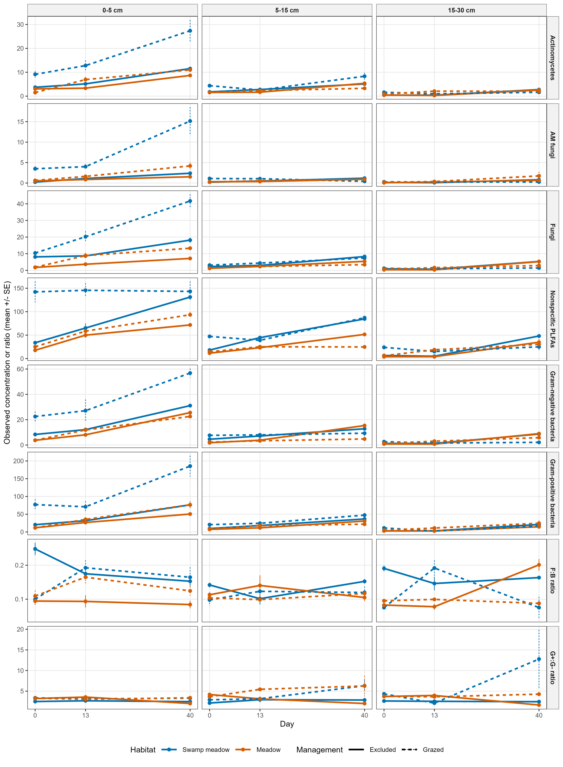
Supplementary Figure S2. Day-0 paired soil and root profiles. Points are mean paired contrasts and horizontal bars are 95% confidence intervals from four pairs per habitat. Positive-valued outcomes use lnRR; pH uses grazed minus excluded. Shapes identify depth. These one-date profiles are environmental context, not temporal mediators.
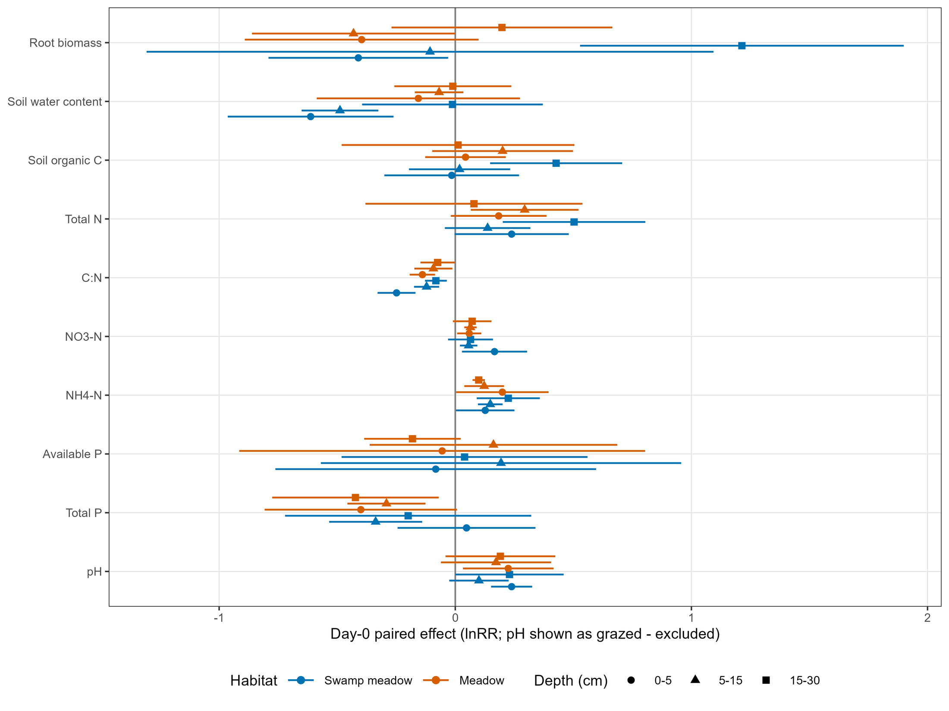
Supplementary Figure S3. Primary-model diagnostics. (a) Standardised residuals versus fitted values. (b) Normal quantile plots. Panels show all eight PLFA outcomes; no observation was excluded.
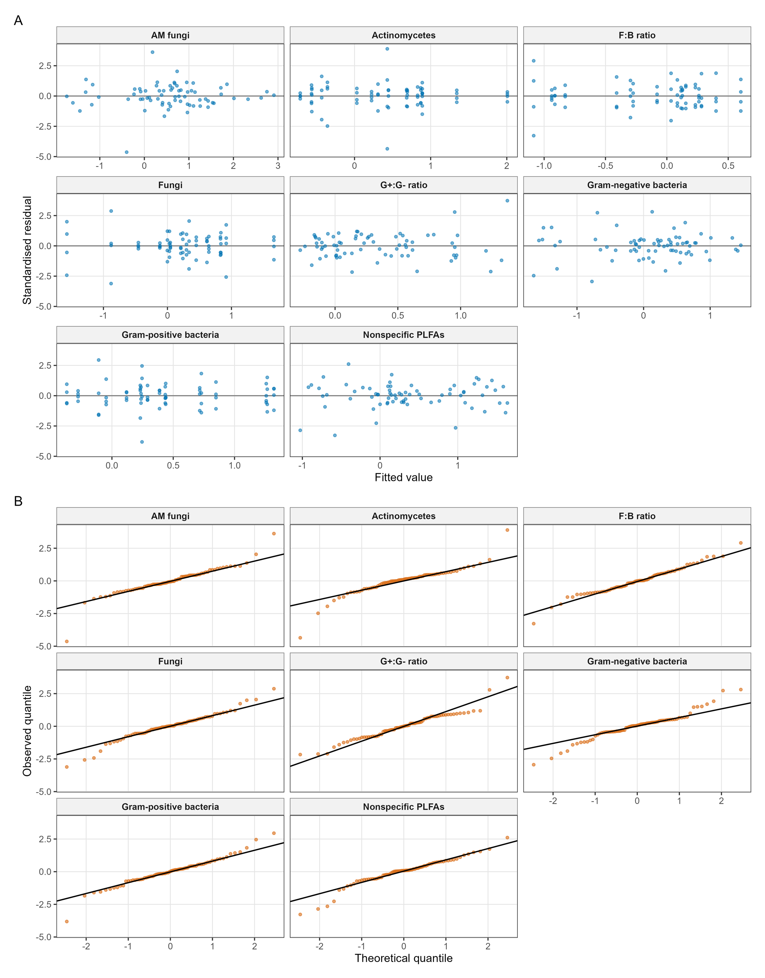
Supplementary Figure S4. Leave-one-independent-pair-out P values. Each column omits one of the eight pair subjects. Values are capped at 0.10 for display; red cells denote smaller P values. The complete numerical table is supplied in the source-data workbook.
