Supporting Information
Magnetically Recoverable Fe₂O₃/ZSM-5 Composite for Fenton-Like Oxidation of Organic Dyes in Water

Yang Song¹, Zhaochen Dong¹, Shuying Li^{1,*}, Wenmei Zhao¹, Yanzhen Wang¹, Xianglong Zhao¹, Yang Zhao², Xiuqin Sun^{2,*}, Mulan Zhu³, Wei Fan⁴, Feiyong Chen¹
1 Resources and Environment Innovation Institute, Shandong Jianzhu University, Jinan 250101, Shandong Province, China.
2 Shandong Coal Field Geological Survey and Research Institute, Jinan 250100, Shandong Province, China.
3 School of Environmental Science and Engineering, Xiamen University of Technology, Xiamen 361024, China
4 School of Environment, Northeast Normal University, 2555 Jingyue Street, Changchun 130117, China
*Corresponding Authors: Email: shuyingli@mail.sdu.edu.cn (Shuying Li); 18653177227@126.com (Xiuqin Sun)
† These authors contributed equally to this work.

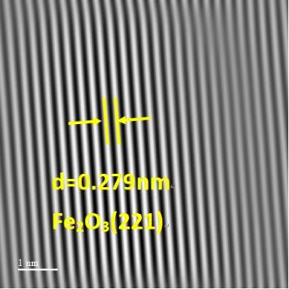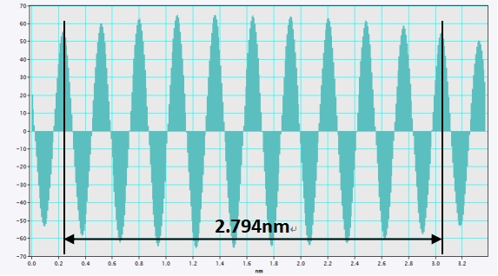
Figure S1 Lattice spacing of Fe2O3 (2 2 1) crystal plane.

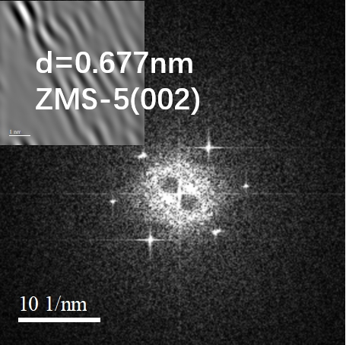
Figure S2. The SAED pattern of the ZMS-5.

Table S1 The element content of Fe, O, Si, and Al in the Fe₂O₃/ZSM-5.
Elemental | Line | Concentration (wt%)
Al | Ka | 2.83
Si | Ka | 2.17
Fe | Ka | 64.96
O | Ka | 30.05
 |  | 100.000 | Total

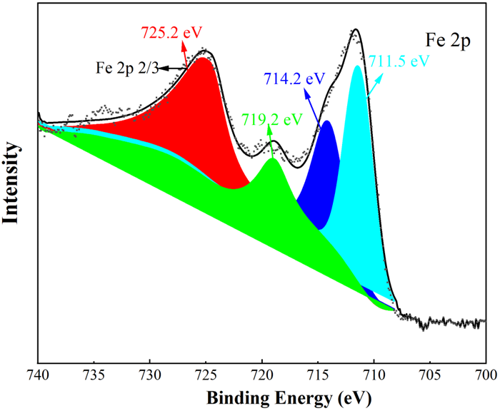
Figure S3 The X-ray photoelectron spectroscopy of Fe element in the Fe₂O₃/ZSM-5.

Figure S4 Standard curve of RhB concentration corresponded the absorbance.

Figure S5 Comparison of the RhB removal rate between the degradation of only Fe₂O₃/ZSM-5 catalyt without H₂O₂ and the only oxidation with H₂O₂.

