Supporting Information
Targeting Proteasome Complex in the CNS: Subunit-Specific Inhibition as a Promising Strategy for Novel Neuropathic Pain Therapies
Natalia Stelmach¹, Katarzyna Popiolek-Barczyk², Wioletta Rut-Schedlok¹, Alicja Kisielewicz¹, Marta Kaminska³, Natalia Malek¹*
¹Department of Chemical Biology and Bioimaging, Faculty of Chemistry, Wroclaw University of Science and Technology, Na Grobli 15, Wroclaw, 50-421, Poland.
² Department of Neurochemistry, Maj Institute of Pharmacology, Polish Academy of Science, Smetna 12, Krakow, 31-343, Poland.
³Department of Clinical Sciences Broegelmann Research Laboratory, University of Bergen, Jonas Lies vei 87, Bergen, 5021, Norway
*Corresponding author - e-mail: natalia.malek@pwr.edu.pl

Supplemental Table 1. Primer sequences used in qPCR analysis.
Gene name | Direction of cDNA synthesis | Sequence | Concentration, mM | Melting point, ˚C
HPRT1  (hypoxanthine phosphoribosyltransferase 1) | Forward | CATTATGCTGAGGATTTGGAAAGG | 10 | 56.7
HPRT1  (hypoxanthine phosphoribosyltransferase 1) | Reverse | CTTGAGCACACAGAGGGCTACA | 10 | 56.7
GADPH (glyceraldehyde-3-phosphate dehydrogenase) | Forward | GTCTCCTCTGACTTCAACAGCG | 10 | 56.7
GADPH (glyceraldehyde-3-phosphate dehydrogenase) | Reverse | ACCACCCTGTTGCTGTAGCCAA | 10 | 56.7
GADPH (glyceraldehyde-3-phosphate dehydrogenase) | Forward | CATCACTGCCACCCAGAAGACTG | 10 | 56.7
GADPH (glyceraldehyde-3-phosphate dehydrogenase) | Reverse | ATGCCAGTGAGCTTCCCGTTCAG | 10 | 56.7
PSMB1 (proteasome 20S subunit beta 1) | Forward | CGTTCACTCCAGACTGGGAAAG | 10 | 56.7
PSMB1 (proteasome 20S subunit beta 1) | Reverse | CGGTCGTGAATAGGTGTCAGCT | 10 | 56.7
PSMB1 (proteasome 20S subunit beta 1) | Forward | CATCGTCGCTTCAGACACTCGA | 10 | 56.7
PSMB1 (proteasome 20S subunit beta 1) | Reverse | CCATGGAAACCACTGCAGCCAA | 10 | 56.7
PSMB9 (proteasome 20S subunit beta 9 | Forward | CGAGAGGACTTGTCTGCACATC | 10 | 56.7
PSMB9 (proteasome 20S subunit beta 9 | Reverse | CACCAATGGCAAAAGGCTGTCG | 10 | 56.7
PSMB9 (proteasome 20S subunit beta 9) | Forward | TACCGTGAGGACTTGTTAGCGC | 10 | 56.7
PSMB9 (proteasome 20S subunit beta 9) | Reverse | GGCTGTCGAATTAGCATCCCTC | 10 | 56.7
PSMB2 (proteasome 20S subunit beta 2) | Forward | TTCTGGCTCCTTGGCAGCAATG | 10 | 56.7
PSMB2 (proteasome 20S subunit beta 2) | Reverse | CAGGTCGTTGAAGATGCCAGCT | 10 | 56.7
PSMB2 (proteasome 20S subunit beta 2) | Forward | AACCTGGCTGACTGTCTTCGGA | 10 | 56.7
PSMB2 (proteasome 20S subunit beta 2) | Reverse | TTAGCCAAGGCTTGCCAGGGTAGT | 10 | 56.7
PSMB10 (proteasome 20S subunit beta 10) | Forward | GGACAAGAGCTGCGAGAAGATC | 10 | 56.7
PSMB10 (proteasome 20S subunit beta 10) | Reverse | ATCTTGGACGCCACCATCCGTG | 10 | 56.7
PSMB10 (proteasome 20S subunit beta 10) | Forward | TTCGGGTTCCTCATGCACGCAA | 10 | 56.7
PSMB10 (proteasome 20S subunit beta 10) | Reverse | TTTGTCCGCCACAACCGAATCG | 10 | 56.7
PSMB5 (proteasome 20S  subunit beta 5) | Forward | GTGTCCCAGAAGAGCCAGGAAT | 10 | 56.7
PSMB5 (proteasome 20S  subunit beta 5) | Reverse | TCTTCACCGTCTGGGAGGCAAT | 10 | 56.7
PSMB5 (proteasome 20S  subunit beta 5) | Forward | CTGTGGCTGGATAAGAGAGAGGC | 10 | 56.7
PSMB5 (proteasome 20S  subunit beta 5) | Reverse | CAGGTCATAGGAGTAGCCTCGA | 10 | 56.7
PSMB8 (proteasome 20S  subunit beta 8) | Forward | CCTTACCTGCTTGGCACCATGT | 10 | 56.7
PSMB8 (proteasome 20S  subunit beta 8) | Reverse | TTGGAGGCTGCCGACACTGAAA | 10 | 56.7
PSMB8 (proteasome 20S  subunit beta 8) | Forward | CCTTACCTGCTTGGCACCATGT | 10 | 56.7
PSMB8 (proteasome 20S  subunit beta 8) | Reverse | TTGGATGCTGCAGACACGGAGA | 10 | 56.7
ARG1  (arginase 1) | Forward | GAACAAGAGTGTGATGTGAA | 10 | 56.7
ARG1  (arginase 1) | Reverse | TCACAATTTGAAAGGGACTG | 10 | 56.7
TGFB  (tumor growth  factor beta) | Forward | GCCAGAGTGGTTATCTTTTG | 10 | 56.7
TGFB  (tumor growth  factor beta) | Reverse | CCACTTGCAGTGTGTTATC | 10 | 56.7
COX2  (cyclooxygenase 2) | Forward | TGGAATTACCCAGTTTGTTG | 10 | 56.7
COX2  (cyclooxygenase 2) | Reverse | GAAGCCTGTGATACTTTCTG | 10 | 56.7
NOS2  (inducible nitric  oxide synthase 2) | Forward | AGGATGACCTTCAGTATCAC | 10 | 56.7
NOS2  (inducible nitric  oxide synthase 2) | Reverse | CCAGTTTTTGATCCTCACAT | 10 | 56.7
NFKB1  (nuclear factor  kappa-light  -chain-enhancer  of activated B cells) | Forward | GCAGCACTACTTCTTGACCACC | 10 | 56.7
 | Reverse | TCTGCTCCTGAGCATTGACGTC | 10 | 56.7
CTSB  (cathepsin B) | Forward | GGCTGCAGGGCTCCGGCA | 10 | 56.7
CTSB  (cathepsin B) | Reverse | CGAAGTCCAGGAGCCATT | 10 | 56.7
CASP1  (caspase 1) | Forward | GCTGAGGTTGACATCACAGGCA | 10 | 56.7
CASP1  (caspase 1) | Reverse | TGCTGTCAGAGGTCTTGTGCTC | 10 | 56.7
NLRP3  (NOD-, LRR-  and  pyrin  domain-  containing protein 3) | Forward | GGACTGAAGCACCTGTTGTGCA | 10 | 56.7
 | Reverse | TCCTGAGTCTCCCAAGGCATTC | 10 | 56.7
GSDMD  (gasdermin D) | Forward | ATGAGGTGCCTCCACAACTTCC | 10 | 56.7
GSDMD  (gasdermin D) | Reverse | CCAGTTCCTTGGAGATGGTCTC | 10 | 56.7
IL1B  (interleukin 1 beta) | Forward | CCACAGACCTTCCAGGAGAATG | 10 | 56.7
IL1B  (interleukin 1 beta) | Reverse | GTGCAGTTCAGTGATCGTACAGG | 10 | 56.7
IL6  (interleukin 6) | Forward | TGCCTTCTCCCTGGGGCTGC | 10 | 56.7
IL6  (interleukin 6) | Reverse | AATTTTTAAAATGCCATTTA | 10 | 56.7
CNR2  (cannabinoid receptor 2) | Forward | CATGGGATGGACTTGCTGTC | 10 | 56.7
CNR2  (cannabinoid receptor 2) | Reverse | CACACTTCTTCCAGTGAGCC | 10 | 56.7

Supplemental Table 2. Composition of assay buffers.
Buffer name | Composition
Lysing buffer | 20 mM HEPES  0.5 mM EDTA  0.5% Triton X-100  Up to 50 ml H₂O  pH 7.5
4x Upper Gel Buffer | 3.51g 2-Amino-2-methyl-1,3-propanediol (Ammediol)  Up to 100 ml H₂O  2.06 ml conc. Hydrochloric acid
3x Loading Buffer | 50 ml 4x Upper Gel Buffer  7 g Sodium dodecyl sulfate  20 ml Glycerol  Bromophenol blue
Loading Buffer | 475 µl 3x Loading Buffer  25 µl dithiothreitol
Running buffer | 30 g Tris  144 g Glycine  10 g Sodium dodecyl sulfate  Up to 1000 ml H₂O  pH 8.3
Transfer Buffer | 24.2 g Tris  150.1 g Glycine  Up to 1000 ml H₂O  pH 8.8
TBS-T | 2.4 g Tris  8.8 g Sodium chloride  Up to 1000 ml H₂O  0.1% Tween 20

Supplemental Table 3. Antibodies used in Western Blot analysis.
Target protein | Host organism |  | Clonality | Sensitivity | Brand | Catalogue number | Observed Mass | Dilution
β-actin | Mouse | Monoclonal IgG |  | Mouse, Rat, Human | Santa Cruz Biotechnology | sc-517582 | 43 kDa | 1:200
PSMB1 | Mouse | Monoclonal IgG |  | Human | Proteintech | 67847-1-Ig | 25 kDa | 1:5000-1:50 000
PSMB5 | Rabbit | Polyclonal IgG |  | Human, mouse | Proteintech | 19178-1-AP | 22 kDa | 1:500-1:2000
PSMB1 | Rabbit | Polyclonal |  | Human, mouse | Invitrogen | PA5-49648 | 28 kDa | 1:1000
PSMB2 | Mouse | Monoclonal IgG |  | Human, Mouse, Rat | Proteintech | 68180-1-Ig | 23 kDa | 1:5000-1:50000
PSMB5 | Mouse | Monoclonal IgG |  | Human | Proteintech | 2E9H1 | 22 kDa | 1:5000-1:50000
PSMB8 | Rabbit | Polyclonal |  | Human, mouse | Proteintech | 14859-1-AP | 23 kDa | 1:500-1:2000
PSMB9 | Rabbit | Polyclonal |  | Human, mouse, rat | Proteintech | 14544-1-AP | 20-23 kDa | 1:1000-1:6000
MECL-1 | Rabbit | Monoclonal IgG |  | Human, Mouse | Cell Signalling Technology | 17579 | 25/29 kDa | 1:1000
LMP 2 | Rabbit | Polyclonal |  | Human,Mouse,Rat | Affbiotech | DF6606 | 23 kDa | 1:500-1:2000
LMP 7 | Rabbit | Polyclonal |  | Human,Mouse,Rat | Affbiotech | DF13259 | 30 kDa | 1:500-1:2000
Secondary Antibodies
IgG (H+L) | Donkey | 488 nm |  | Mouse | Invitrogen | A32766 | N/A | 0.1-0.4 µg/mL
IgG (H+L) | Goat | 532 nm (Alexa Fluor) |  | Rabbit | Life Technologies | A11009 | N/A | 1:10000

Supplemental Table 4. Chemical structure of activity-based probes used in the protein-level assays. The structures are based on previously cited Rut et al., 2018 paper. Unnatural amino acids and its derivatives were incorporated into the structures including aminocaproic acid (Ahx), homo-arginine(hArg),D-arginine (DArg), homo-serine (hSer), O-benzyl threonine (Thr (Bzl)) and 3-(benzyloxymethyl)-histidine (His (3-Bom)) to allow better specificity of substrates to respective proteases.
Name | Sequence | Structure
β1-Cy5 | Cy5-Ahx-hArg-Pro-Phe(2F)-Asp-VS | 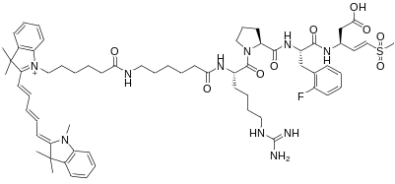
β2-BODIPY | BOPIPY-Ahx-DArg-hSer-Thr-Arg-VS | 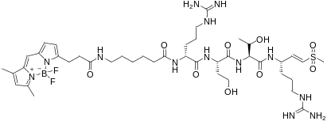
β5-Cy7 | Cy7-Ahx-Phe-Thr (Bzl)-His(3-Bom)-Leu-VS | 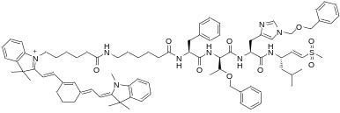

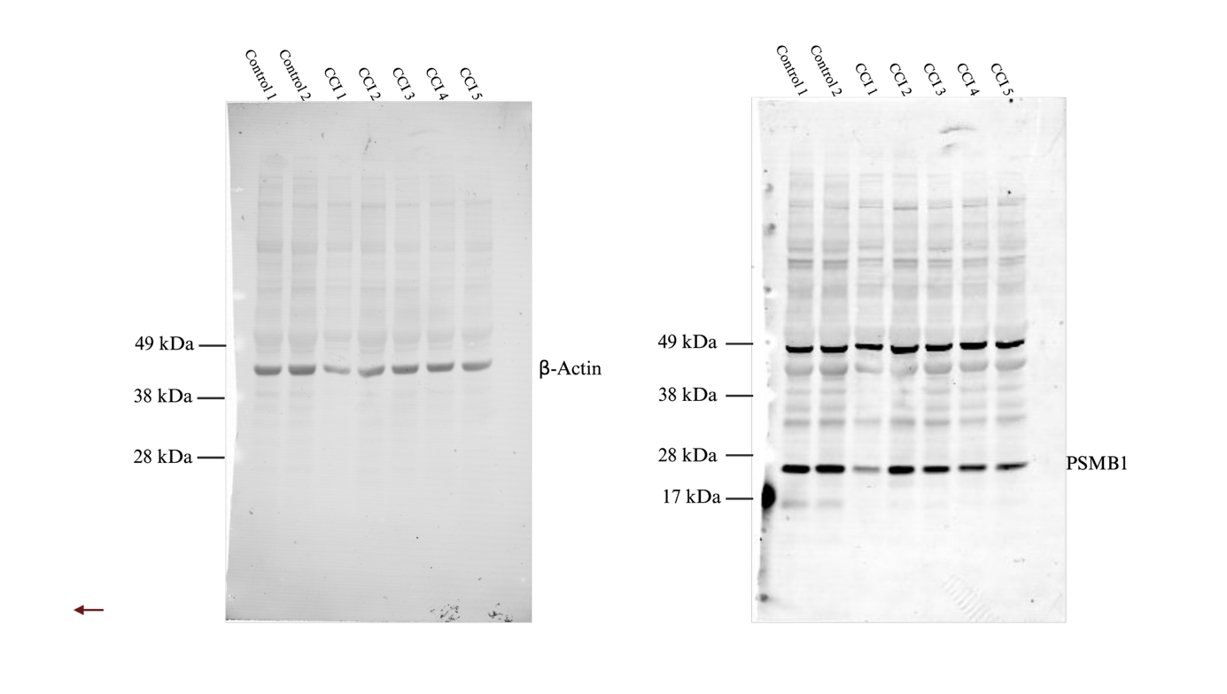
Supplemental Figure 1. Membrane after Western Blot Analysis of Cerebral Cortex treated with β-actin and β1 antibody.
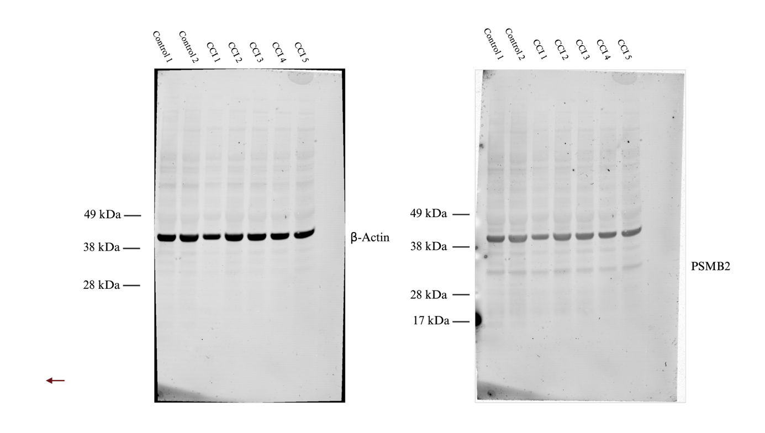

Supplemental Figure 2. Membrane after Western Blot Analysis of Cerebral Cortex treated with β-actin and β2 antibody.

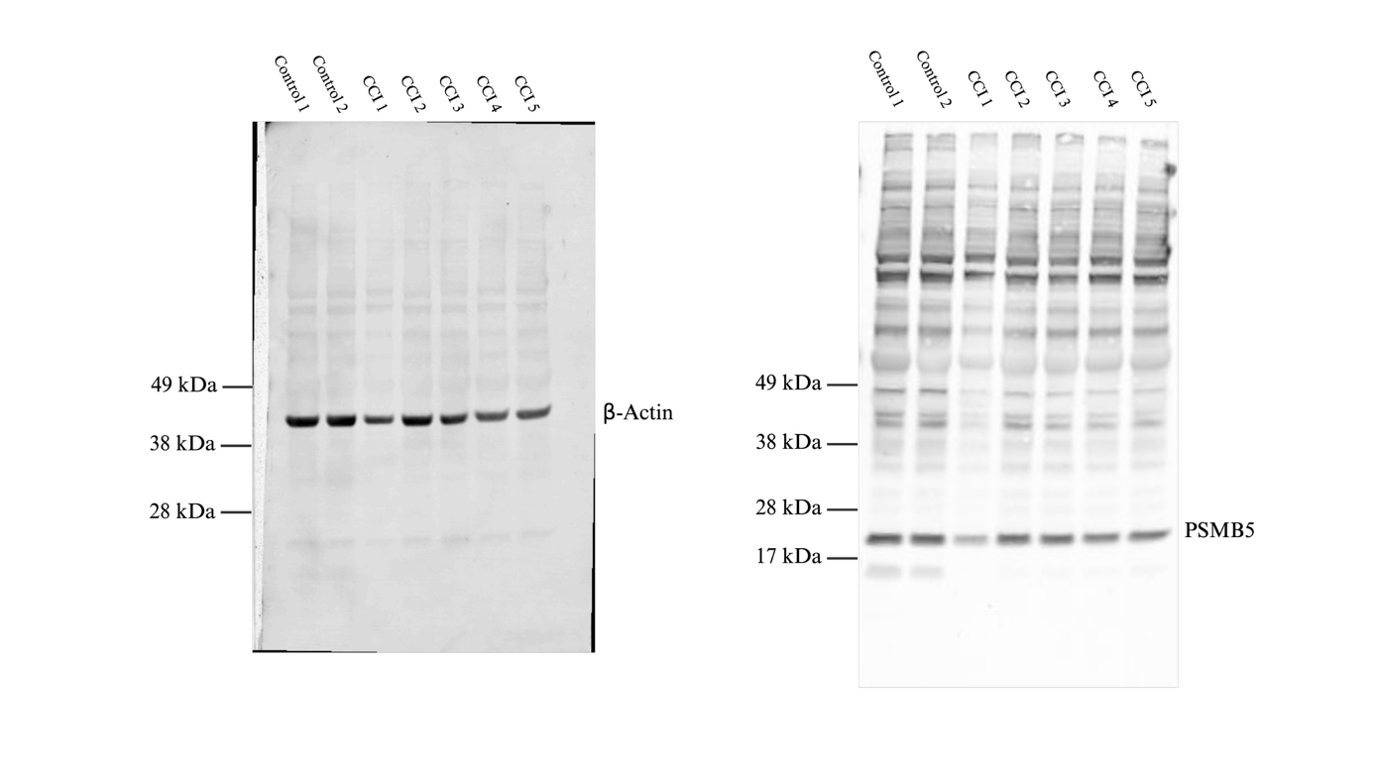
Supplemental Figure 3. Membrane after Western Blot Analysis of Cerebral Cortex treated with β-actin and β5 antibody.
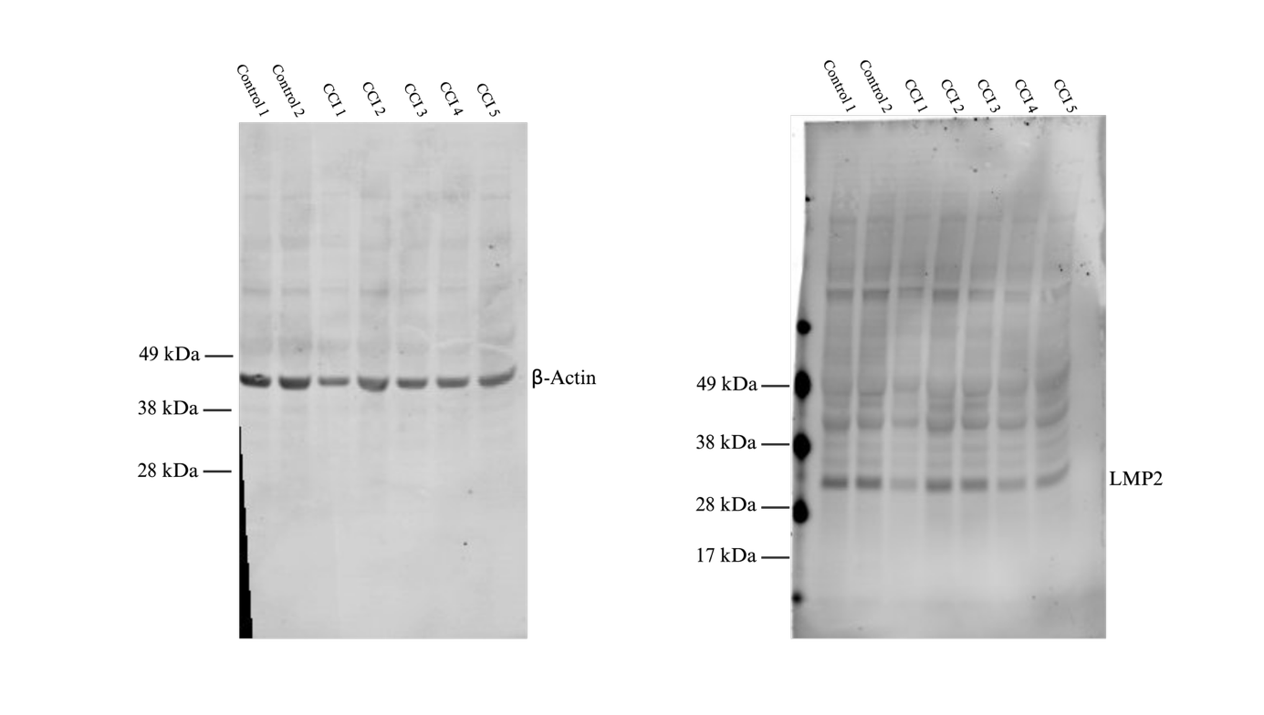
Supplemental Figure 4. Membrane after Western Blot Analysis of Cerebral Cortex treated with β-actin and LMP2 antibody.

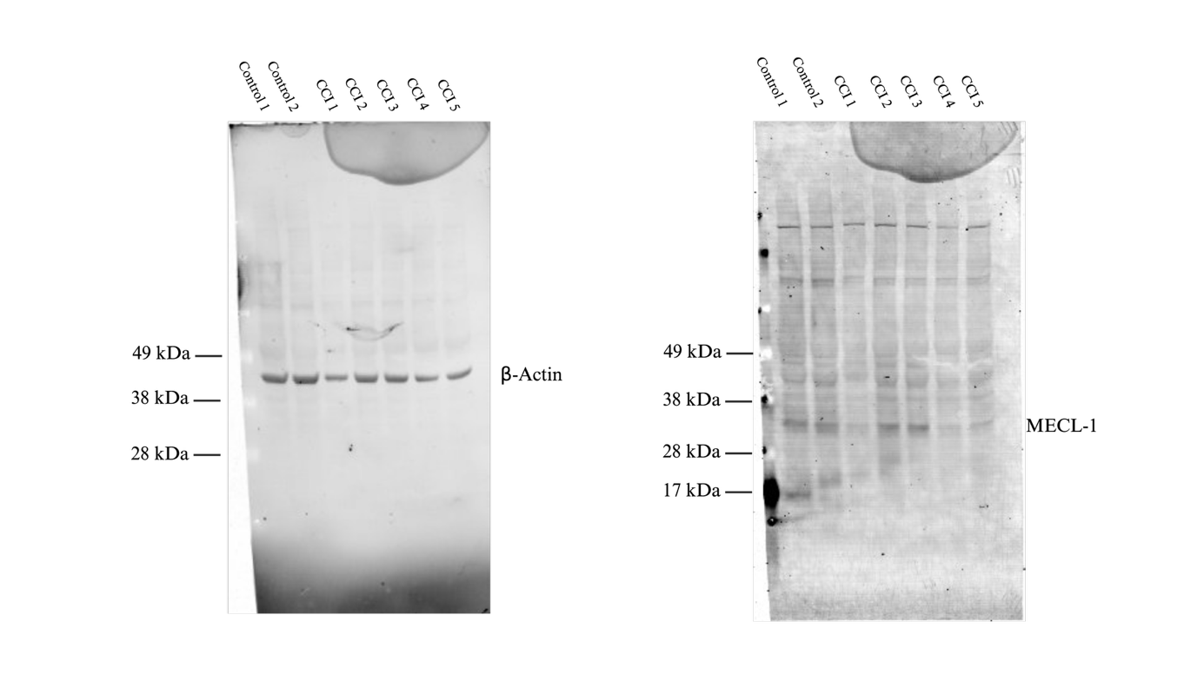
Supplemental Figure 5. Membrane after Western Blot Analysis of Cerebral Cortex treated with β-actin and MECL-1 antibody.
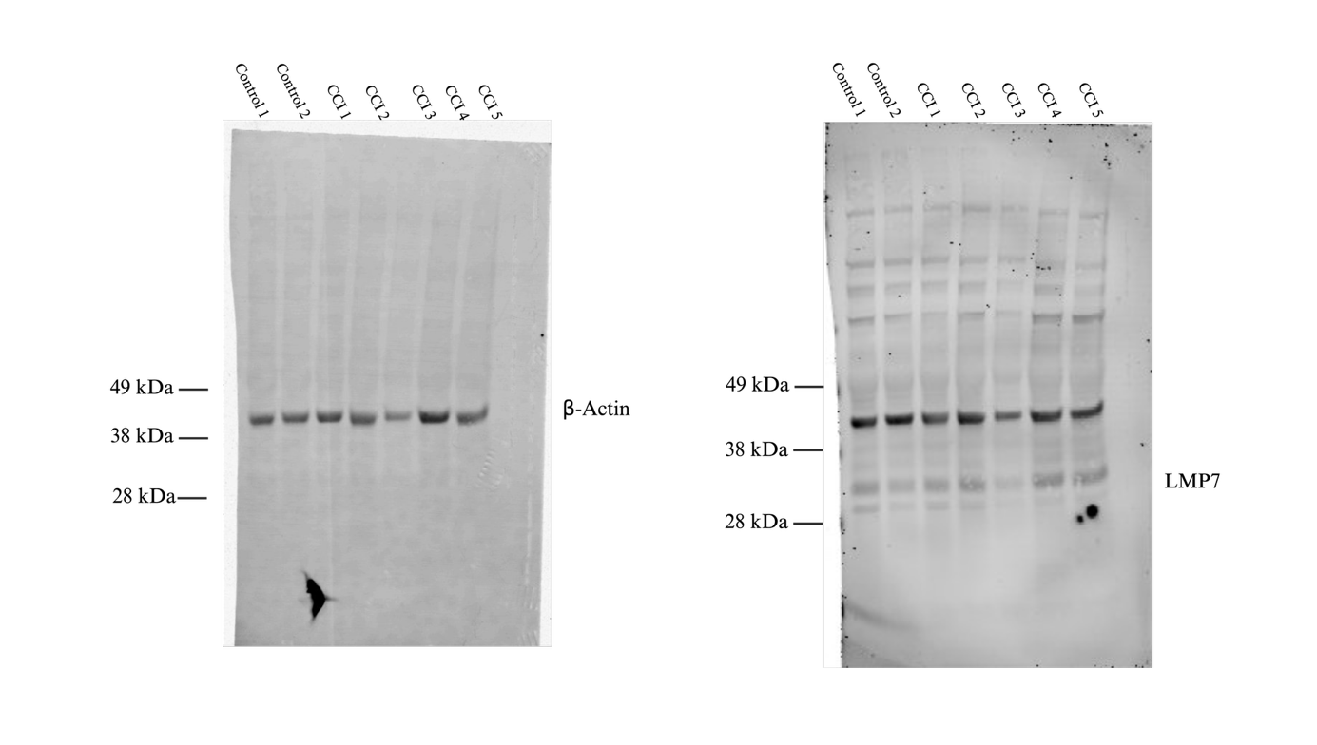
Supplemental Figure 6. Membrane after Western Blot Analysis of Cerebral Cortex treated with β-actin and LMP7 antibody.

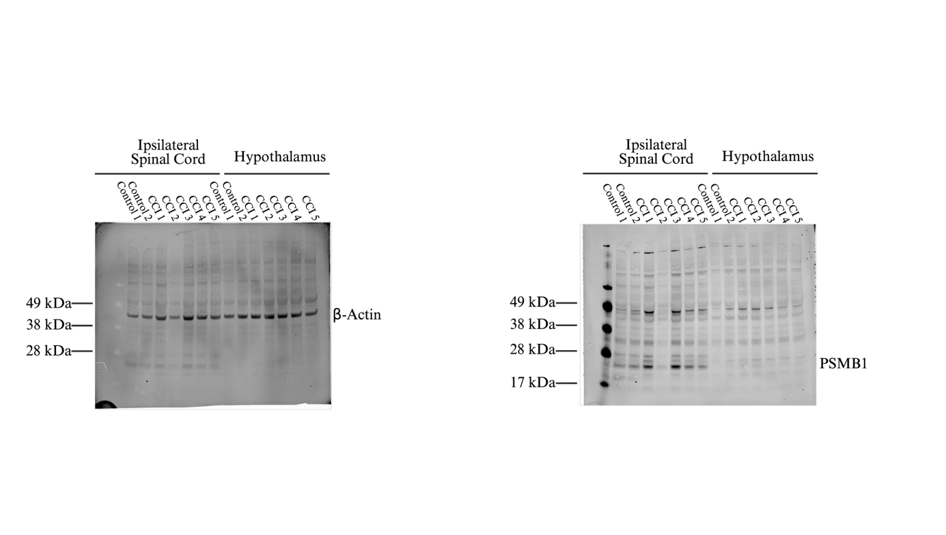
Supplemental Figure 7. Membrane after Western Blot Analysis of ipsilateral spinal cord and hypothalamus treated with β-actin and β1 antibody.
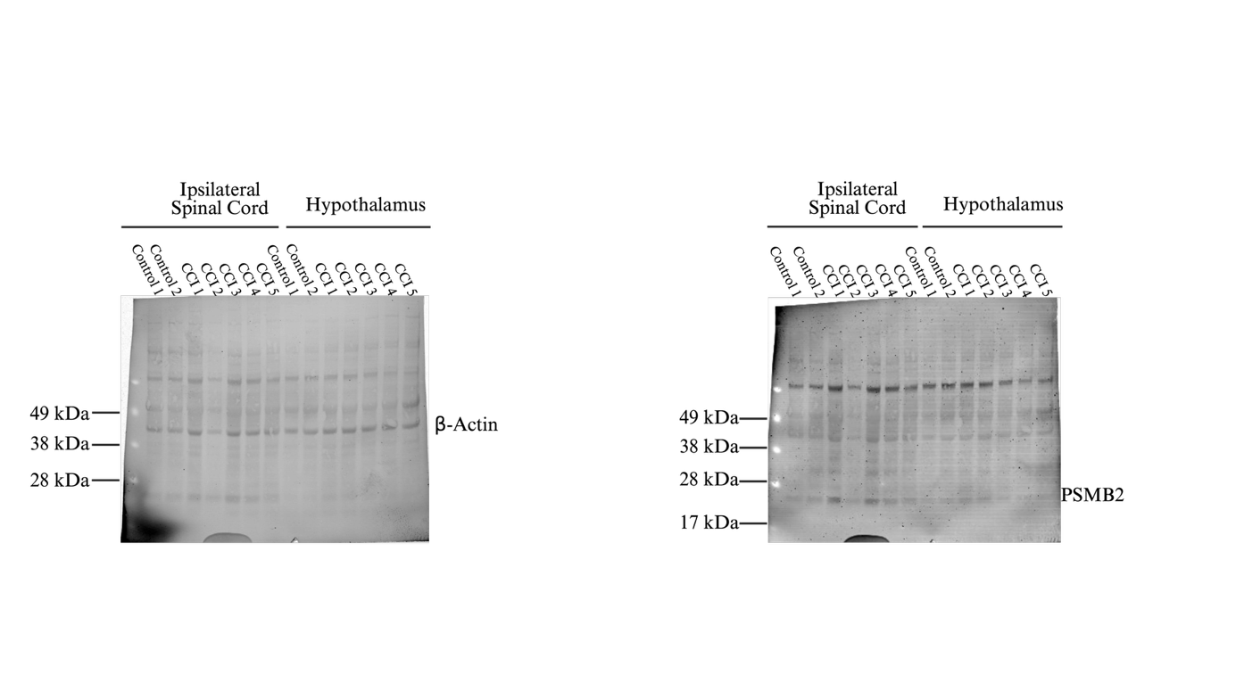
Supplemental Figure 8. Membrane after Western Blot Analysis of ipsilateral spinal cord and hypothalamus treated with β-actin and β2 antibody.
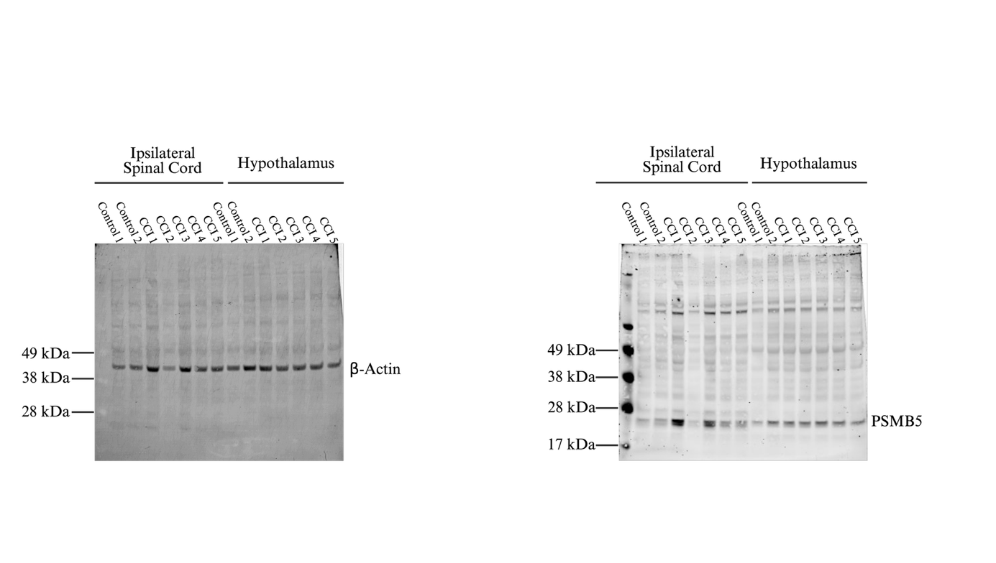
Supplemental Figure 9. Membrane after Western Blot Analysis of ipsilateral spinal cord and hypothalamus treated with β-actin and β5 antibody.
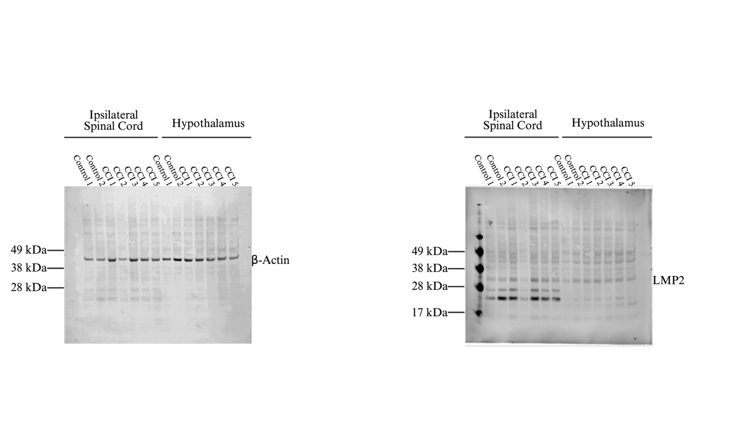
Supplemental Figure 10. Membrane after Western Blot Analysis of ipsilateral spinal cord and hypothalamus treated with β-actin and LMP2 antibody.
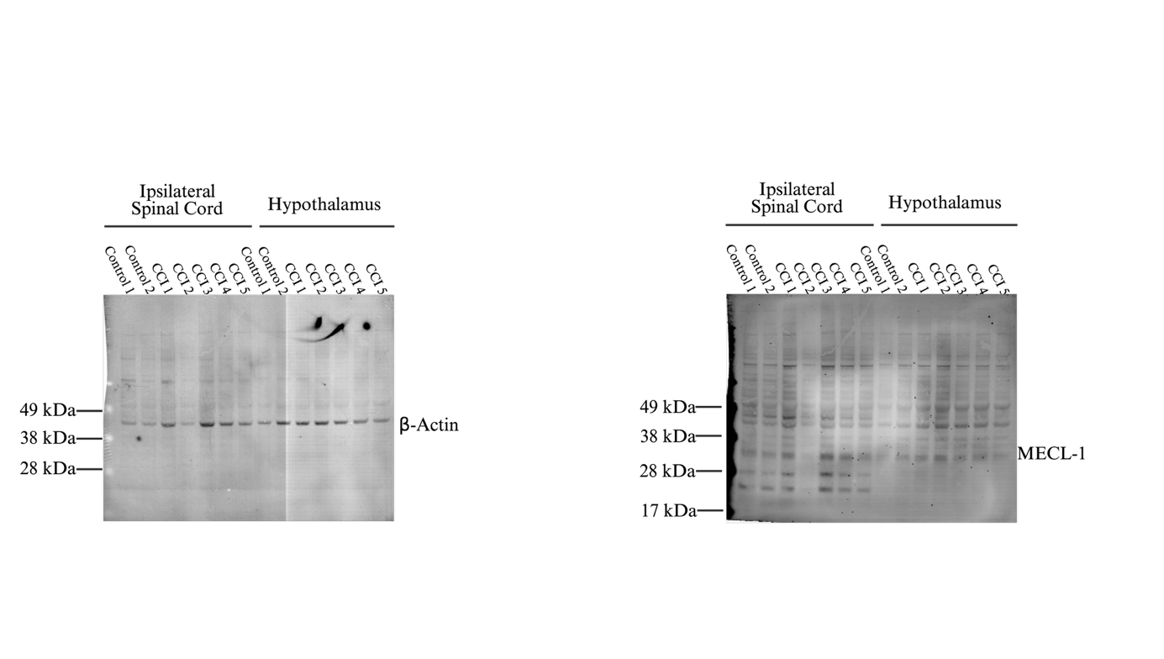
Supplemental Figure 11. Membrane after Western Blot Analysis of ipsilateral spinal cord and hypothalamus treated with β-actin and MECL-1 antibody.
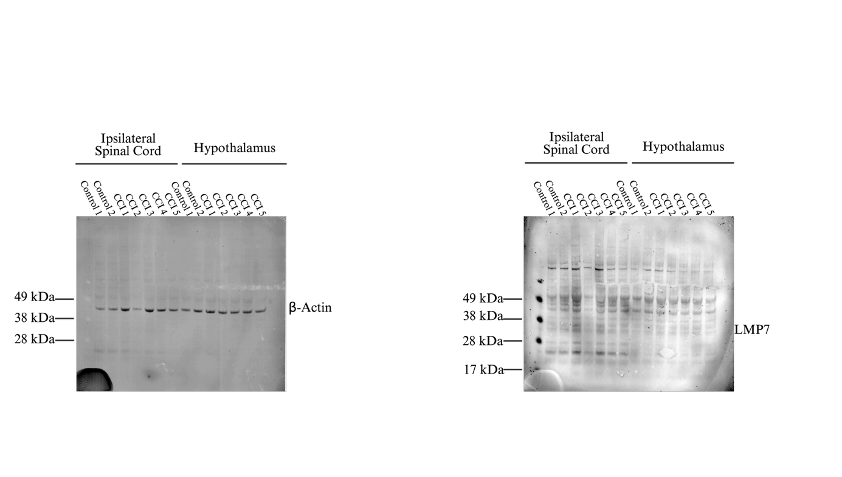
Supplemental Figure 12. Membrane after Western Blot Analysis of ipsilateral spinal cord and hypothalamus treated with β-actin and LMP7 antibody.

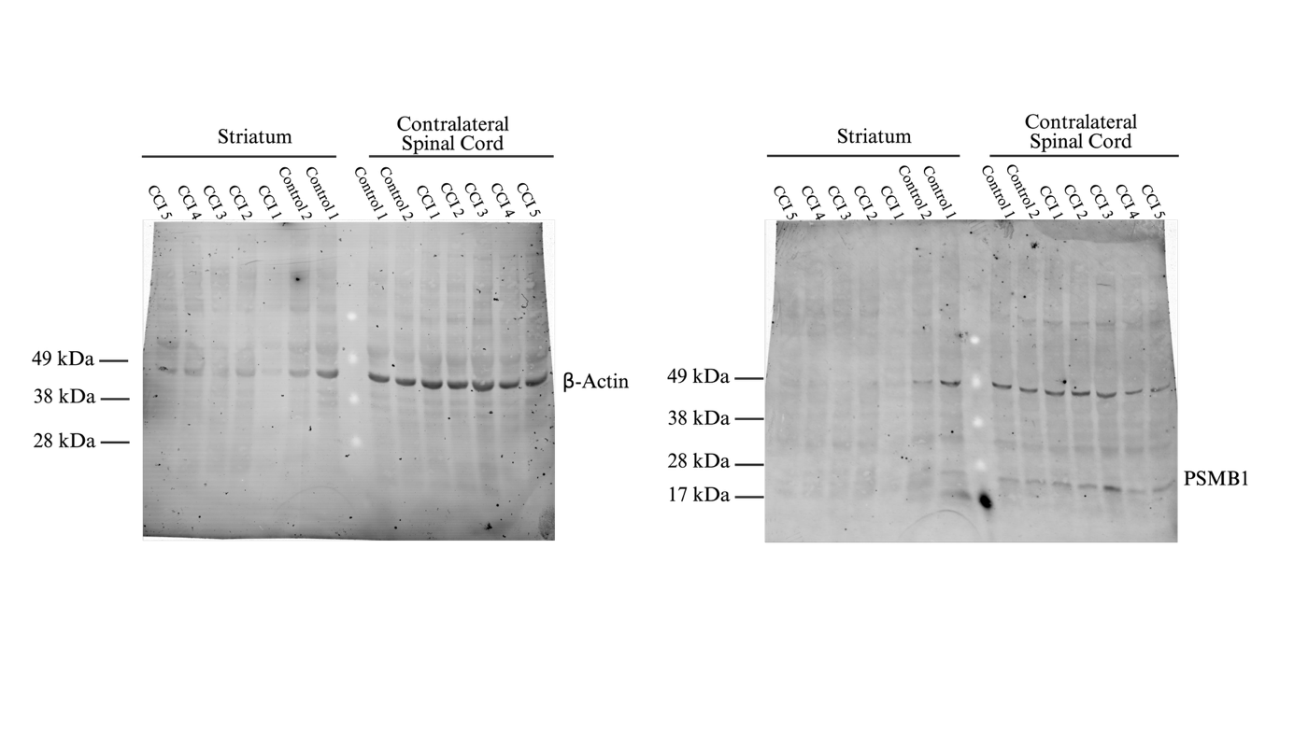
Supplemental Figure 13. Membrane after Western Blot Analysis of striatum and contralateral spinal cord treated with β-actin and β1 antibody.
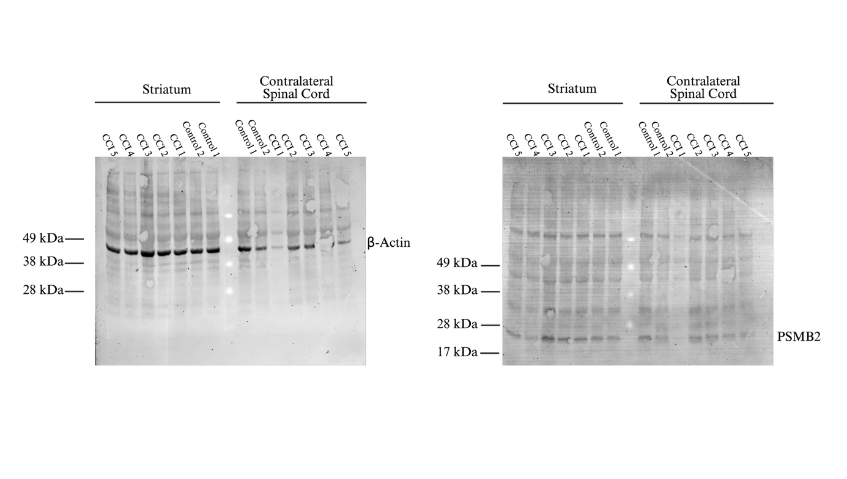
Supplemental Figure 14. Membrane after Western Blot Analysis of striatum and contralateral spinal cord treated with β-actin and β2 antibody.
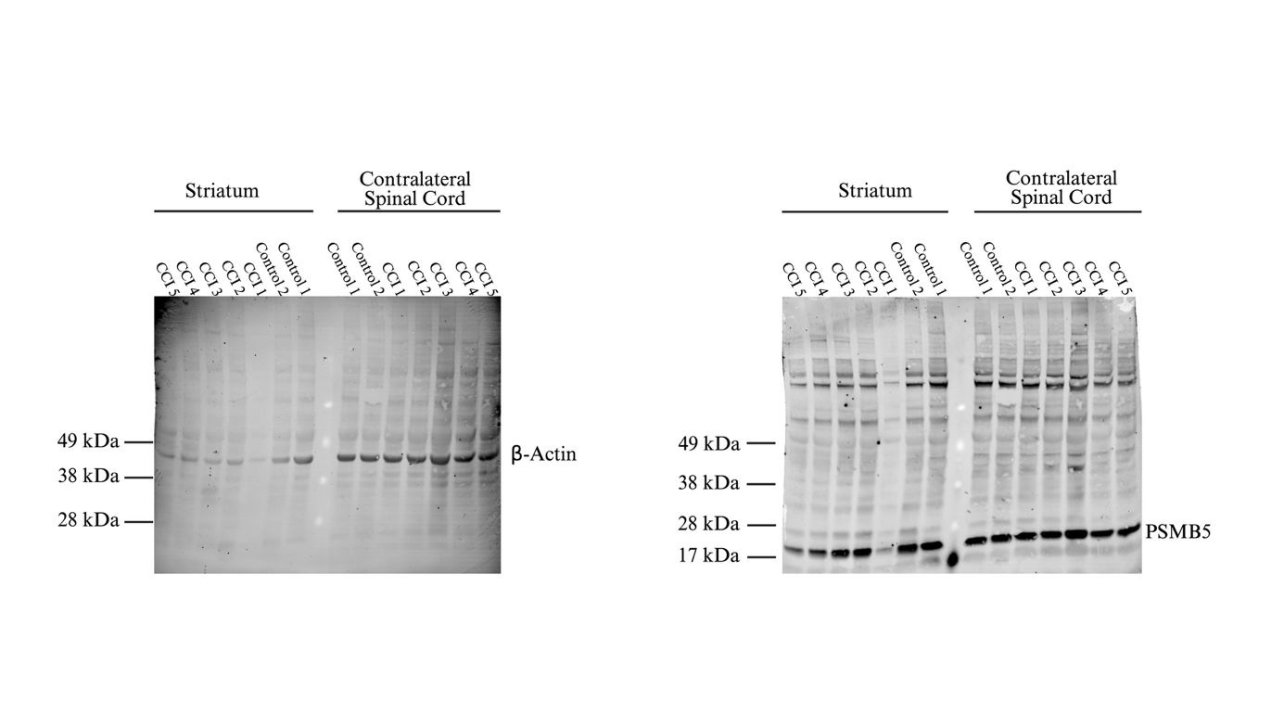
Supplemental Figure 15. Membrane after Western Blot Analysis of striatum and contralateral spinal cord treated with β-actin and β5 antibody.
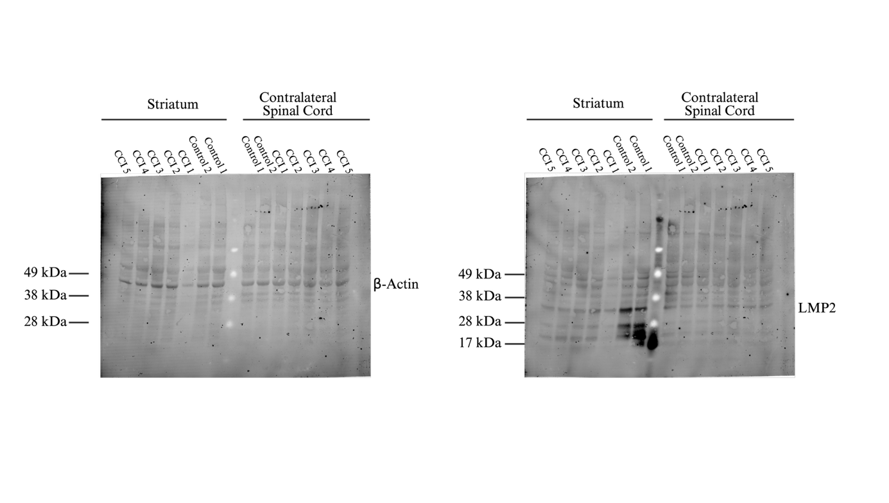
Supplemental Figure 16. Membrane after Western Blot Analysis of striatum and contralateral spinal cord treated with β-actin and LMP2 antibody.

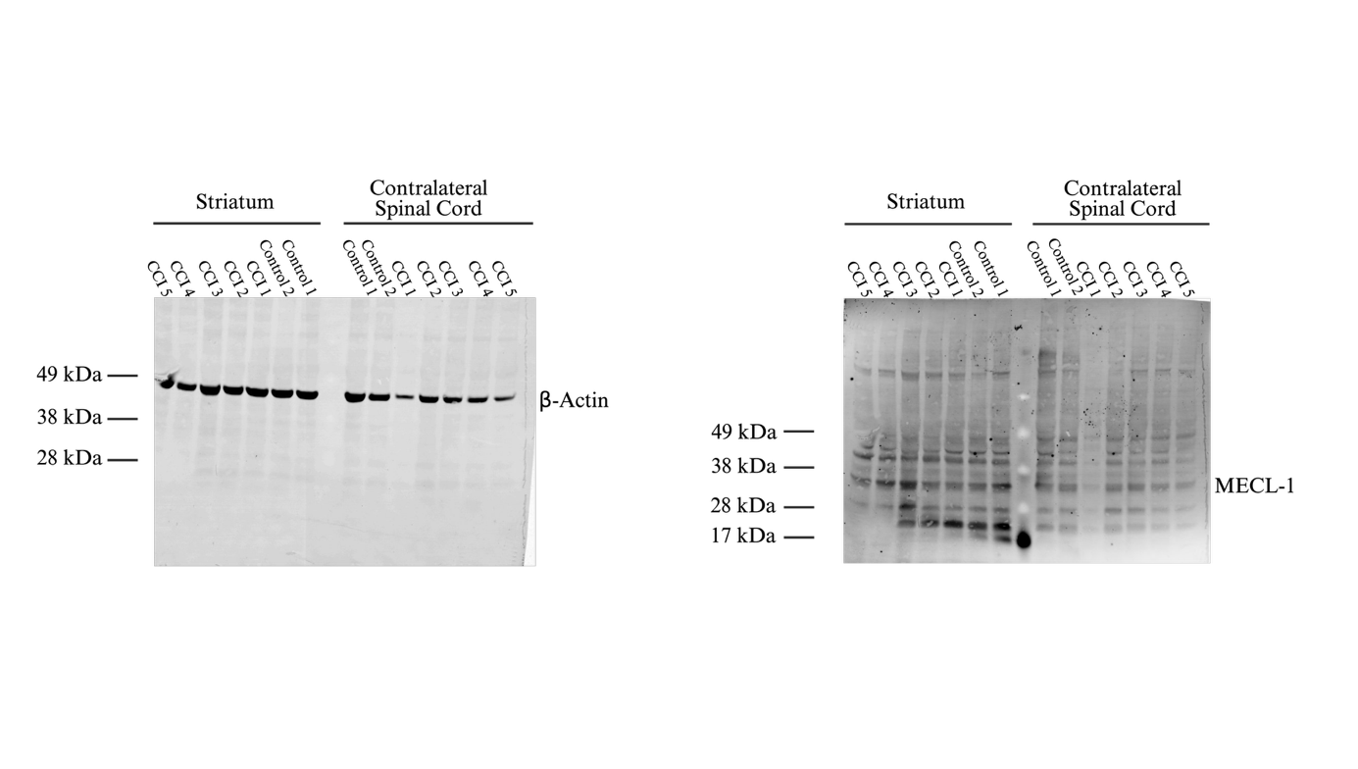
Supplemental Figure 17. Membrane after Western Blot Analysis of striatum and contralateral spinal cord treated with β-actin and MECL-1 antibody.
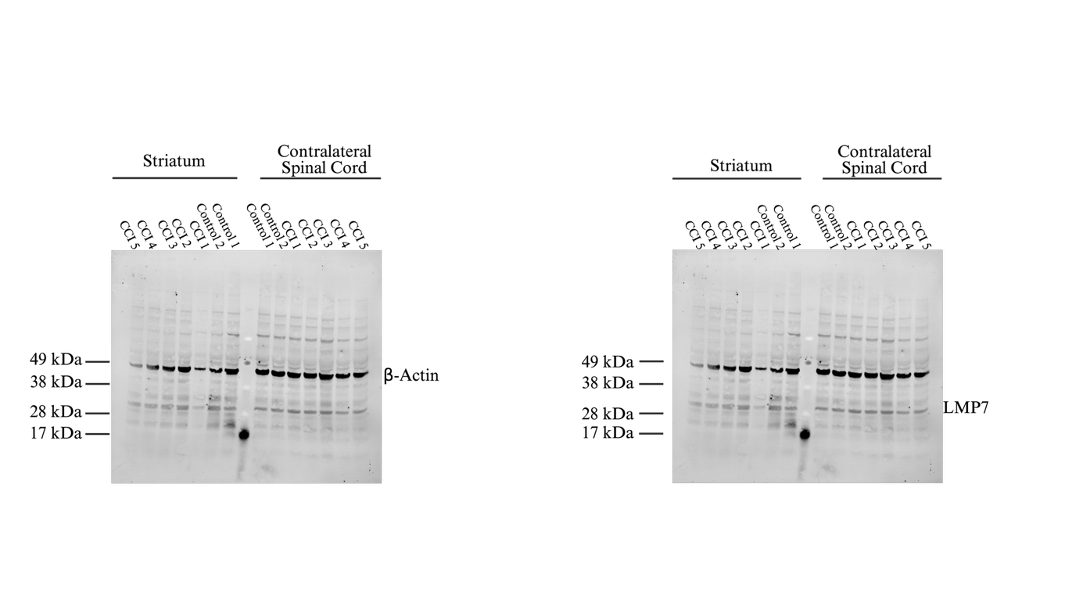
Supplemental Figure 18. Membrane after Western Blot Analysis of striatum and contralateral spinal cord treated with β-actin and LMP7 antibody.

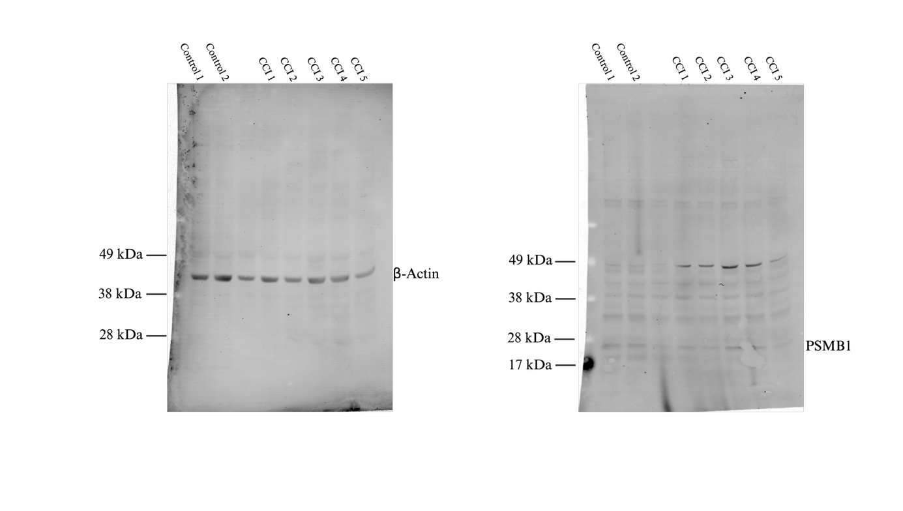
Supplemental Figure 19. Membrane after Western Blot Analysis of hippocampus treated with β-actin and β1 antibody. Well three is an error in pipetting and thus was excluded from the analysis.
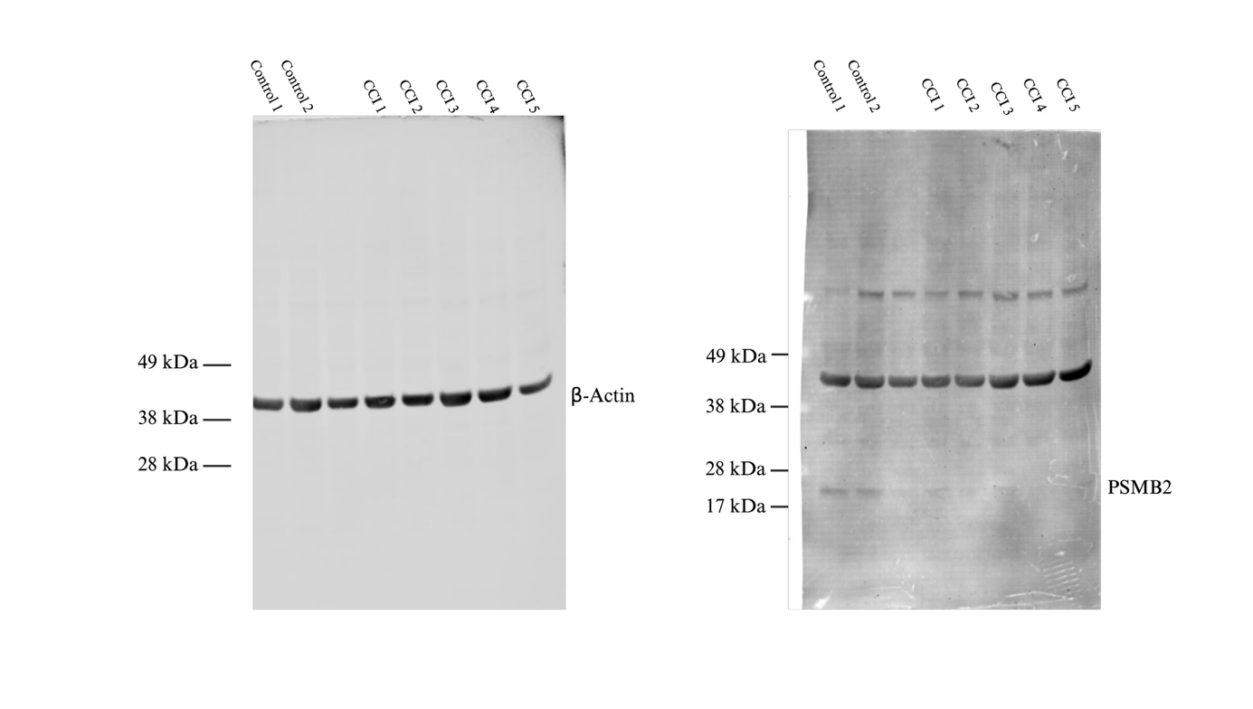
Supplemental Figure 20. Membrane after Western Blot Analysis of hippocampus treated with β-actin and β2 antibody. Well three is an error in pipetting and thus was excluded from the analysis.
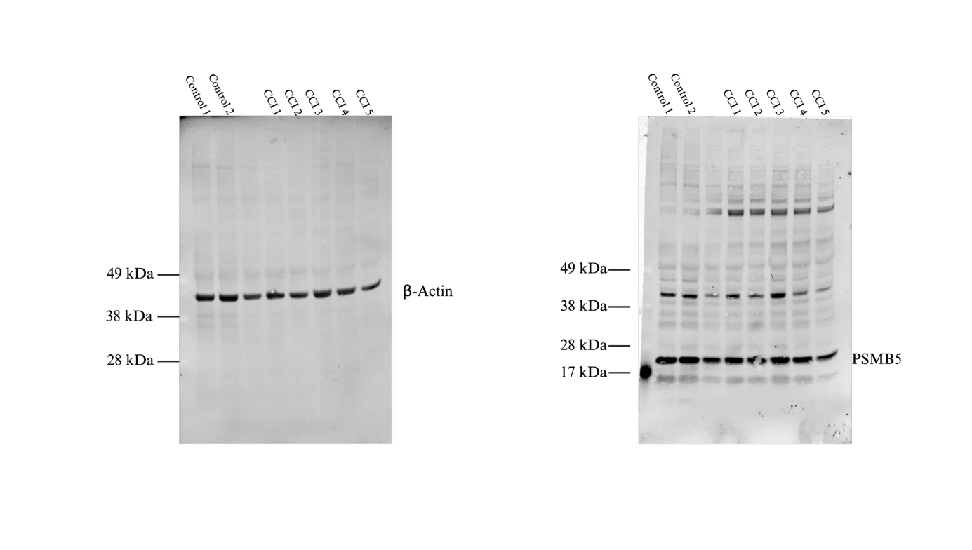
Supplemental Figure 21. Membrane after Western Blot Analysis of hippocampus treated with β-actin and β5 antibody. Well three is an error in pipetting and thus was excluded from the analysis.
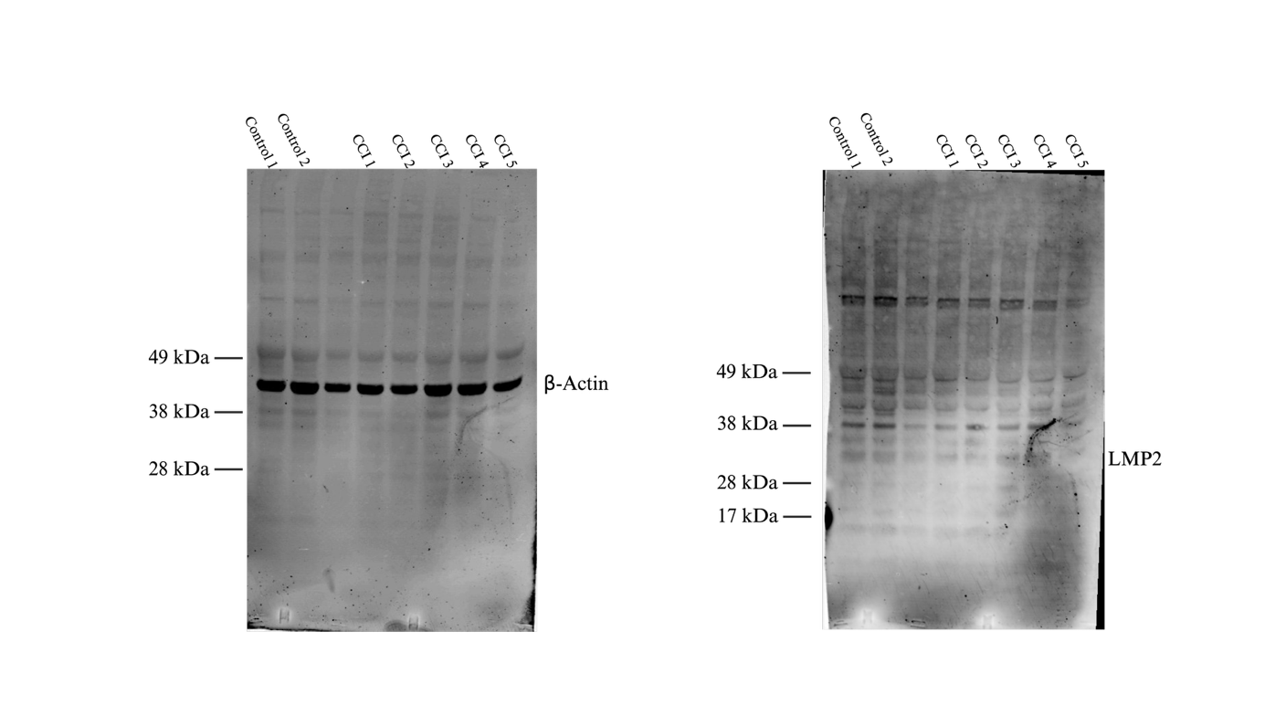
Supplemental Figure 22. Membrane after Western Blot Analysis of hippocampus treated with β-actin and LMP2 antibody. Well three is an error in pipetting and thus was excluded from the analysis.
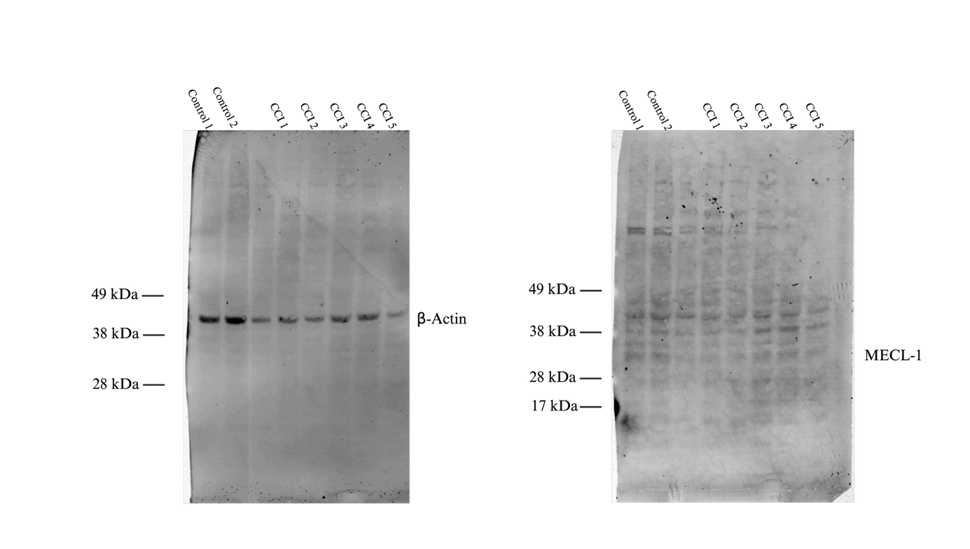
Supplemental Figure 23. Membrane after Western Blot Analysis of hippocampus treated with β-actin and MECL-1 antibody. Well three is an error in pipetting and thus was excluded from the analysis.
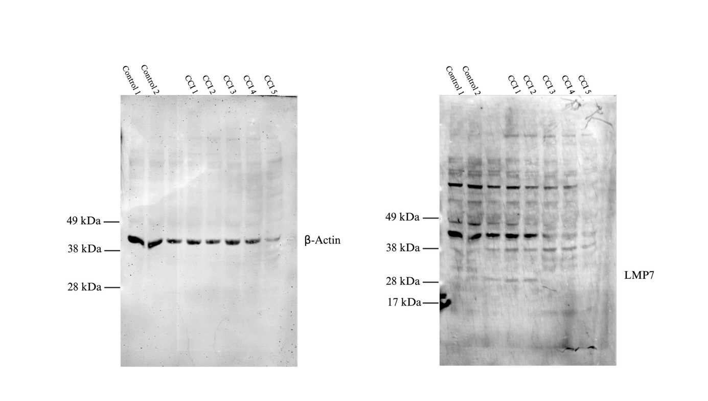
Supplemental Figure 24. Membrane after Western Blot Analysis of hippocampus treated with β-actin and LMP7 antibody. Well three is an error in pipetting and thus was excluded from the analysis.
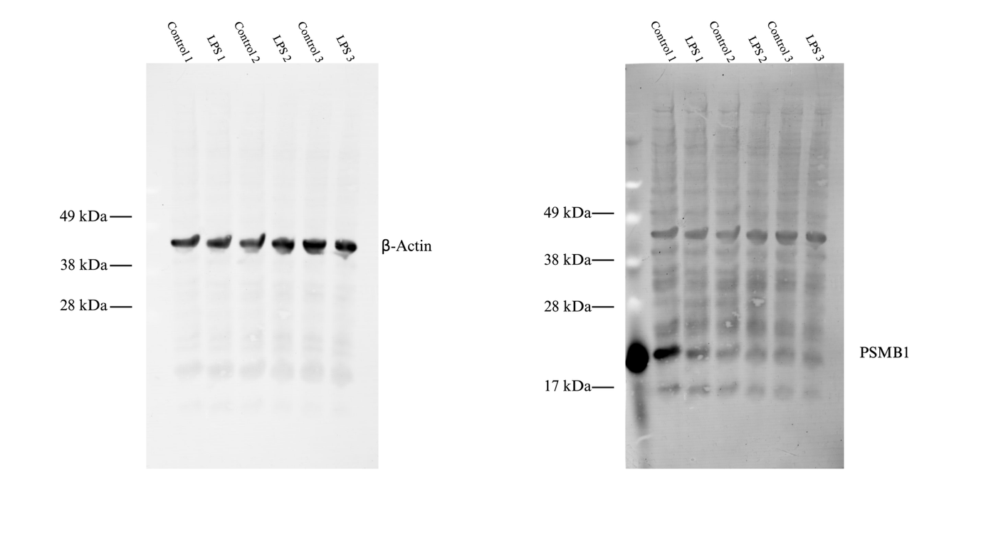
Supplemental Figure 25. Membrane after Western Blot Analysis of HMC3 cells (+/- LPS) treated with β-actin and β1 antibody.
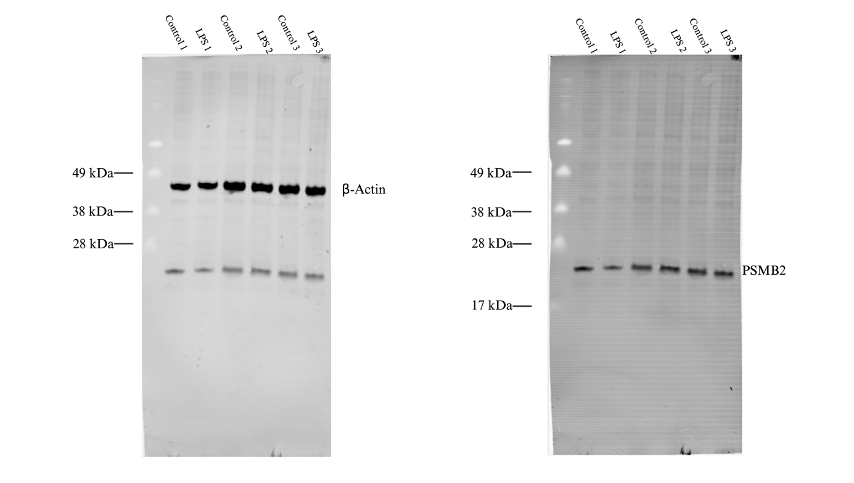
Supplemental Figure 26. Membrane after Western Blot Analysis of HMC3 cells (+/- LPS) treated with β-actin and β2 antibody.
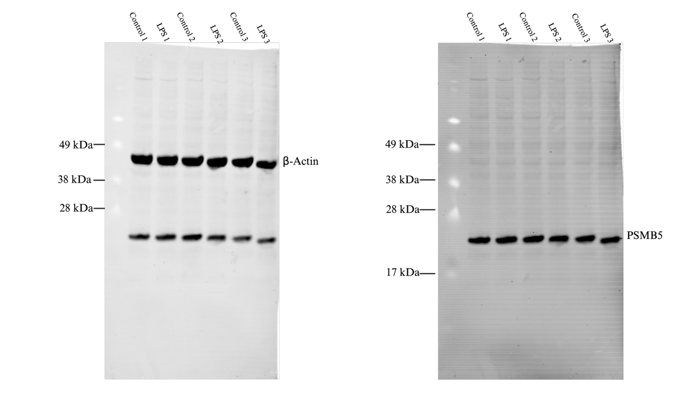
Supplemental Figure 27. Membrane after Western Blot Analysis of HMC3 cells (+/- LPS) treated with β-actin and β5 antibody.
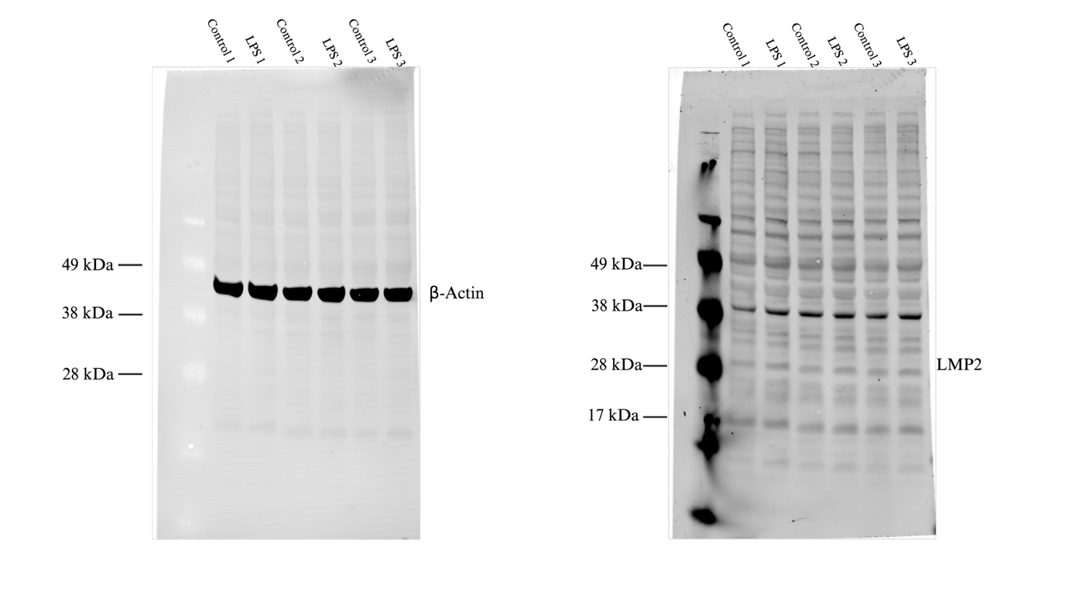
Supplemental Figure 28. Membrane after Western Blot Analysis of HMC3 cells (+/- LPS) treated with β-actin and LMP2 antibody.
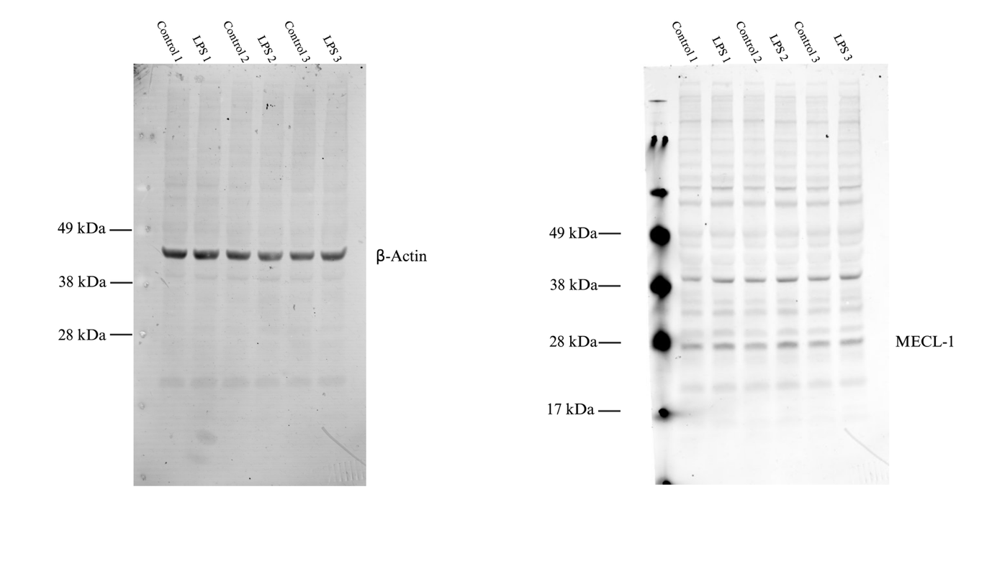
Supplemental Figure 29. Membrane after Western Blot Analysis of HMC3 cells (+/- LPS) treated with β-actin and MECL-1 antibody.
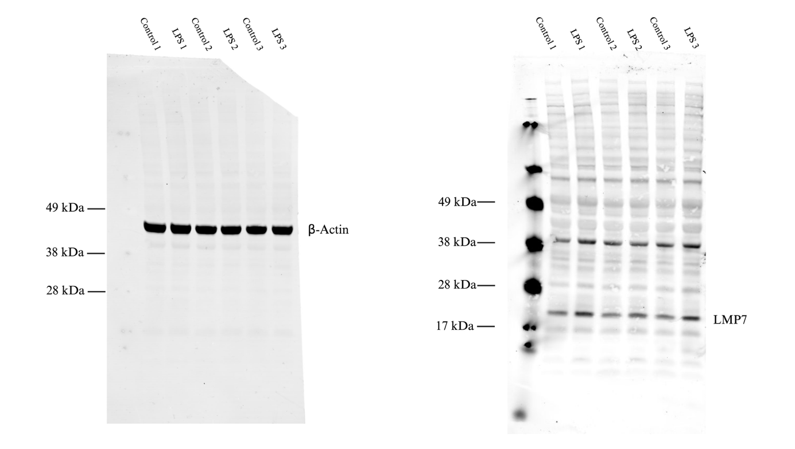
Supplemental Figure 30. Membrane after Western Blot Analysis of HMC3 cells (+/- LPS) treated with β-actin and LMP7 antibody.
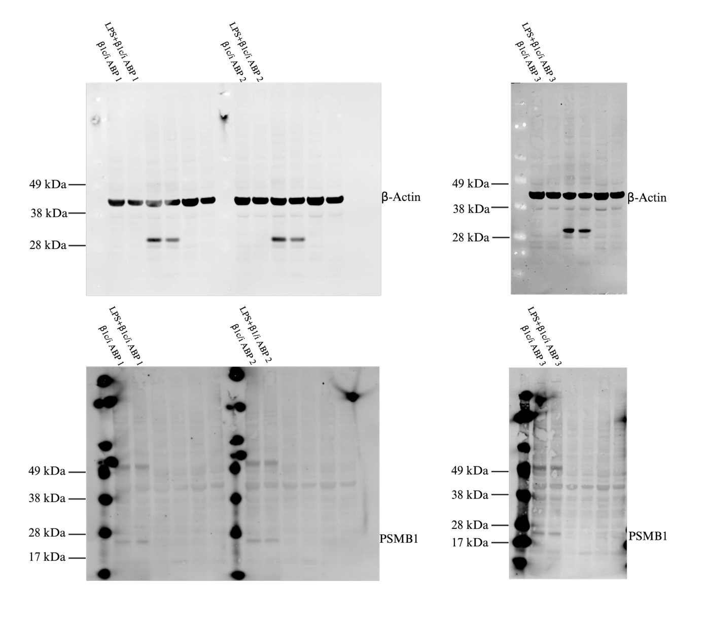
Supplemental Figure 31. SDS-PAGE with β1-specific activity-based probe. The results are presented as three biological replicates.
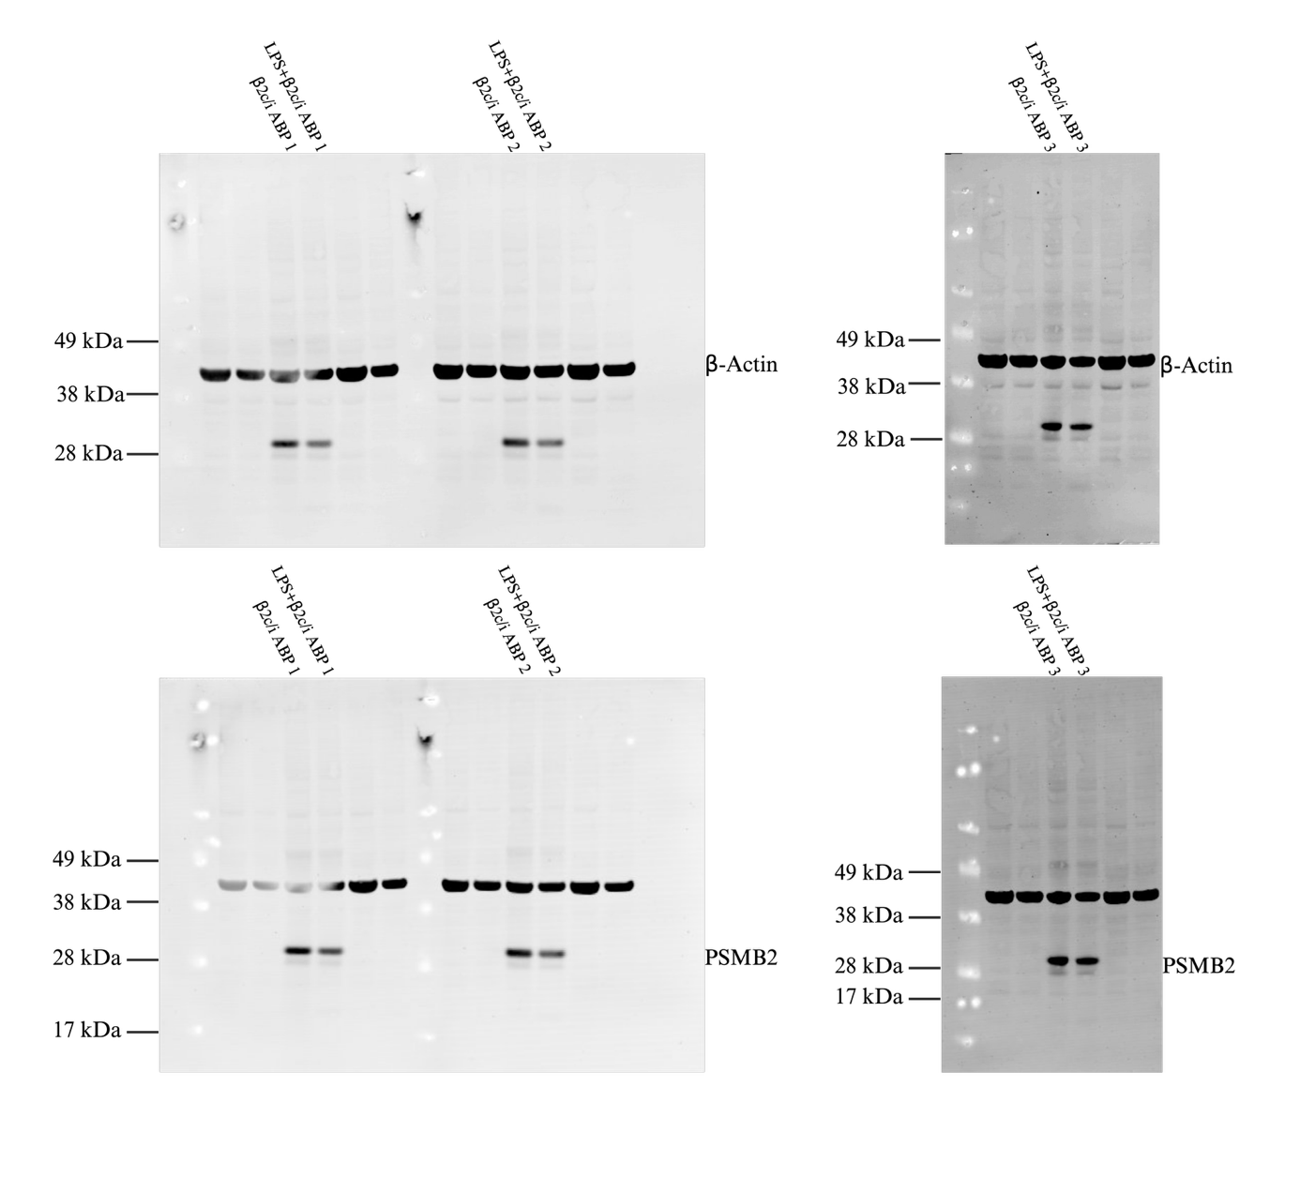
Supplemental Figure 32. SDS-PAGE with β2/β2i-specific activity-based probe. The results are presented as three biological replicates.
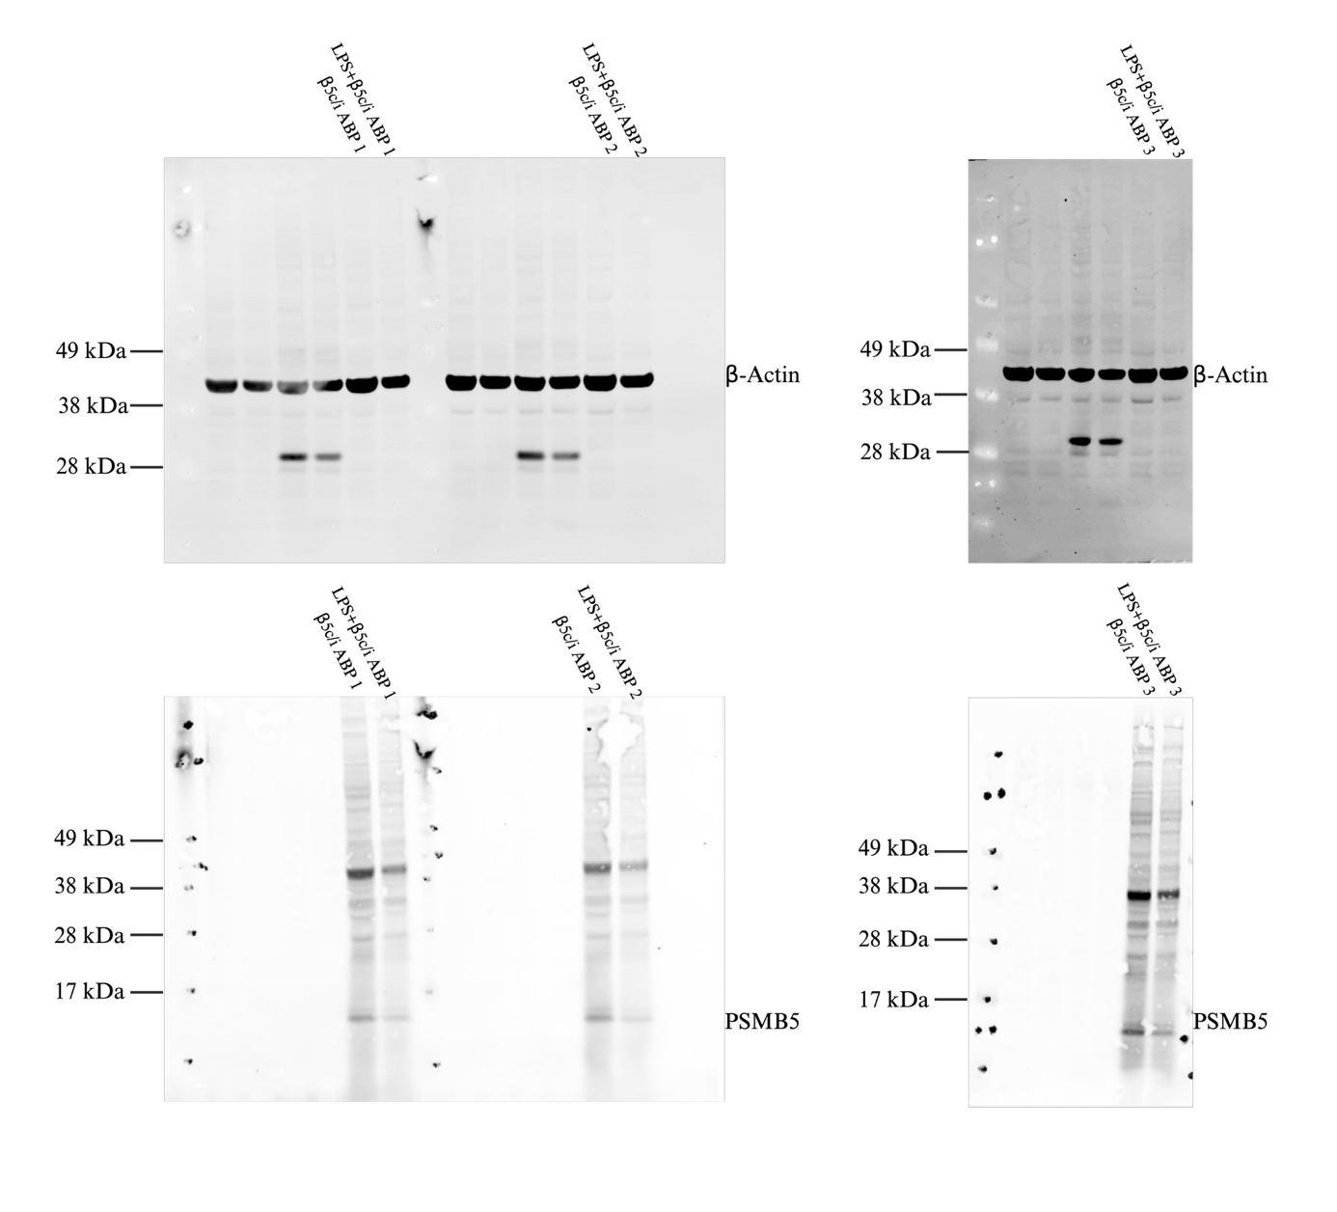
Supplemental Figure 33. SDS-PAGE with β5/β5i-specific activity-based probe. The results are presented as three biological replicates.

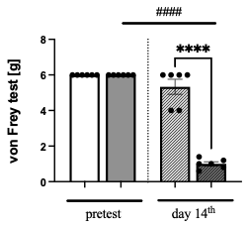
Supplemental Figure 34. Mechanical hypersensitivity assessed by the von Frey test in sham- and CCI-operated mice. Mechanical withdrawal thresholds were measured using calibrated von Frey filaments (0.6–6 g) before surgery and on day 14 after sham or chronic constriction injury (CCI). A positive response was defined as paw withdrawal or licking upon stimulation, and the lowest filament force eliciting a consistent response was recorded as the mechanical withdrawal threshold. The cut-off value was set at 6 g. CCI mice showed a significant reduction in withdrawal thresholds on day 14 after sciatic nerve injury compared with preoperative values, indicating increased mechanical hypersensitivity, whereas no significant changes were observed in sham-operated mice. Male CCI mice also exhibited significantly lower thresholds than sham controls at day 14. Statistical analysis was performed using one-way ANOVA with repeated measures followed by Tukey’s post hoc test for within-group comparisons over time, and Student’s t-test for between-group comparisons; ****p < 0.0001, ####p < 0.0001.

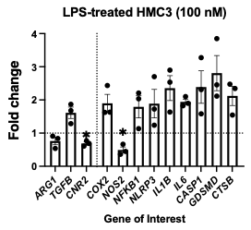
Supplemental Figure 35. Effect of LPS stimulation on expression of chosen pro-inflammatory and anti-inflammatory markers in HMC3 microglial cells. Cells were treated with 100 ng/ml LPS for 24h. Data were normalized to untreated HMC3 cells. Results were normalized to GAPDH expression (N = 3). All data are presented as mean ± SD; statistical significance was assessed using Welch’s t-test (*p <0.05, ** p<0.01, *** p<0.001).

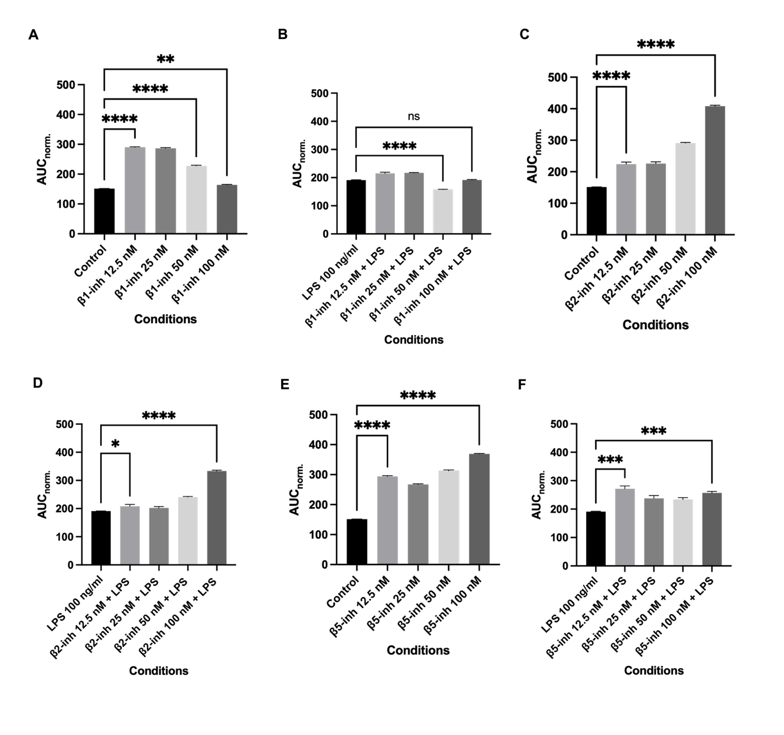
Supplemental Figure 35. Normalized propidine iodide intensity in HMC3 +/-LPS stimulated cells and treated with proteasome β-subunit inhibitors monitored every 2 hours for 24 hours. F-K. The results of propidine iodide-based cell viability assay on +/-LPS stimulated HMC3 cells and treated with β-subunit inhibitors. Statistical analysis was performed using one-way ANOVA (+/- SEM, N=3). Asterisks indicate statistically significant differences (*p <0.05, ** p<0.01, *** p<0.001, **** p<0.0001).

