Section 1: Clustering Solution Validation

Bootstrap cluster stability with cluster-wise Jaccard coefficients
The Jaccard coefficient measures similarity between two sets of data and is a commonly used technique to assess clustering stability [1]. Clusters with a stability score of less than 0.6 are regarded as unstable. Scores between 0.6 and 0.75 indicate that the cluster is measuring a pattern in the data. Clusters with stability scores greater than 0.85 are highly stable [2].
Table 1
Bootstrap cluster stability: Jaccard coefficients by cluster.
Cluster | n | Mean | Standard Deviation
Cluster 1 | 29 | 0.895 | 0.161
Cluster 2 | 48 | 0.789 | 0.158
Cluster 3 | 12 | 0.600 | 0.298
Cluster 4 | 19 | 0.628 | 0.199

Cluster 1 represented a highly stable group based on the Jaccard coefficient. Cluster 2 had acceptable stability, though to a lesser degree to Cluster 1. Clusters 3 and 4 were smaller and demonstrated a pattern but lacked stability.

Comparison of clustering algorithms
K-means clustering was selected as the clustering approach for this work because it generates cluster centroids that can be stored and later used to classify future participants based on nearest-centroid assignment, which is relevant to our goal for future longitudinal applications where changes in cluster membership over time may be evaluated. To evaluate whether the identified phenotypes were dependent on the choice of clustering algorithm, the primary k-means partition was compared with alternative clustering approaches using Gaussian mixture model (GMM) and hierarchical clustering with Ward’s linkage. The goal of this approach was to assess the degree to which cluster membership was based on the clustering algorithm selected. Both comparison methods were constrained to produce four clusters to allow direct comparison with the primary solution. Agreement between cluster assignments was assessed using adjusted Rand index (ARI) and Cramer's V.

Table 2
Agreement between alternative clustering methods to k-means solution.
Comparison method | ARI | Cramér’s V
GMM | 0.576 | 0.676
Ward (hierarchical) | 0.653 | 0.779
Note. ARI = adjusted Rand index; GMM = Gaussian mixture model. Both alternative methods were constrained to four clusters for direct comparison with the primary k-means solution.

Both alternative approaches demonstrated moderate agreement with the k-means solution, with Ward hierarchical clustering showing the highest agreement. An ARI of 0.65 indicates moderate overlap in cluster assignment, demonstrating that some participants were classified differently across methods. These differences may reflect individuals near cluster boundaries and differences in the assumptions underlying each clustering algorithm.
Comparison of clustering metrics across k = 2 to 8
A comparison of the gap statistic, silhouette coefficient, Calinski-Harabasz index, and Davies-Bouldin index was performed for solutions ranging from 2-8 clusters to evaluate candidate clustering solutions. Solutions producing single-member clusters were excluded due to concerns of over-segmentation and potential instability, resulting in the removal of k = 6-8. The two-cluster solution produced the highest silhouette coefficient and Calinski-Harabasz index but generated a coarse split that did not distinguish the gait types of interest and was therefore not retained. Among the remaining solutions (k = 3-5), the gap statistic increased with cluster number and exceeded its reference distribution at all k, supporting the presence of non-random structure; however, the improvement from k = 4 to k = 5 was small (0.924 vs. 0.957). Similarly, the Calinski-Harabasz index was comparable between k = 4 and k = 5 (76.666 vs. 76.800), indicating minimal improvement in cluster separation with the addition of a fifth cluster. Although k = 5 produced a slightly lower Davies-Bouldin index, this improvement was modest, and inspection of the fifth cluster showed that it was created by separating Cluster 4 (highest impairment) into two groups, which reduced the overall interpretability of the solution. K = 4 was selected as the preferred solution, as it provided comparable clustering performance to solutions with more clusters while maintaining a more interpretable clustering structure.
Table 3
Clustering validation metrics across candidate solutions (k = 2 to 8)
k | Gap | Gap SE | Silhouette | Calinski–Harabasz | Davies–Bouldin | Min. cluster size
2 | 0.824 | 0.053 | 0.433 | 99.208 | 0.940 | 37
3 | 0.876 | 0.056 | 0.312 | 79.679 | 1.039 | 22
4 | 0.924 | 0.052 | 0.348 | 76.666 | 1.014 | 12
5 | 0.957 | 0.058 | 0.342 | 76.800 | 0.975 | 9
6 | 0.905 | 0.053 | 0.348 | 71.114 | 0.843 | 1
7 | 0.915 | 0.057 | 0.324 | 69.219 | 0.901 | 1
8 | 0.871 | 0.058 | 0.324 | 66.292 | 0.908 | 1
Note. Gap = gap statistic; SE = standard error. Solutions with single-member clusters (k = 6 to 8) were excluded from consideration due to over-segmentation. k = 4 was selected as the preferred solution.

Section 2: Speed Residuals
This analysis re-examined the four-cluster solution after adjusting features that were highly correlated with stride velocity using residuals. The purpose of this work was to determine which cluster assignments were preserved after accounting for the influence of walking speed on gait features.
Each candidate feature was tested for a relationship with walking speed in the healthy control (HC) group (threshold: |r| > 0.3, p < 0.05). Features meeting this threshold were classified as speed-dependent and residualized while all others were retained in raw form. For each speed-dependent feature, a linear regression of the feature on stride velocity was fit within the HC group and applied to every HC and MS participant using that individual's own walking speed. The residual (observed - predicted) was retained as the speed-adjusted feature value. Full features are listed in Table 4.
Table 4
Speed-dependent features residualized against stride velocity.
Feature | r | p
Accelerometer amplitude, pre-swing | 0.796 | < .001
Stride length (% height) | 0.746 | < .001
Accelerometer amplitude, swing | 0.708 | < .001
Foot angle (avg) | −.651 | < .001
Accelerometer norm variability (SD) | 0.602 | < .001
Gyroscope amplitude, pre-swing | 0.532 | < .001
Cadence | 0.472 | .001
Gyroscope amplitude, swing | 0.444 | .001
Stride time variability (CV) | −.392 | .005
Double support (%) | −.336 | .018
Loading response (%) | −.308 | .031
Note. CV = coefficient of variation. Correlations reflect Pearson’s r between each feature and stride velocity in the healthy control group. Features with |r| > .30 and p < .05 were classified as speed-dependent and residualized.

Figure 1 shows the HC (blue points) and MS (red points) relationships between each speed-dependent feature and stride velocity, with the HC line of best fit in black. Grey shaded zones mark where residualizing relies on extrapolation, i.e., where MS stride velocity falls outside the HC-observed range.
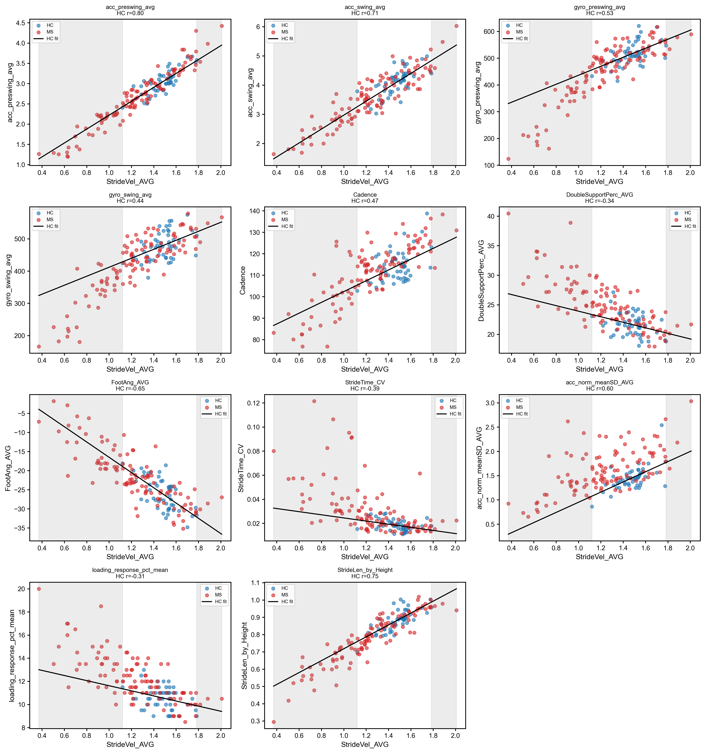
Figure 1: Relationships between stride velocity and gait features with significant correlations in the healthy control group.

Stride velocity was kept unadjusted in the final feature set to preserve overall gait speed as a distinct dimension, separate from the speed-independent deviations captured by the residualized features. The feature set was then z-scored and reduced by principal component analysis (PCA), retaining 80% of total variance (as was performed in the original pipeline). Capturing the speed-independent structure required more principal components than the original solution (6 vs. 3), because fewer features collapsed into a single PC1 speed/amplitude axis. PC loadings and interpretations are in Table 5. PC1 still represented a speed/severity axis, loading most strongly on stride velocity. PC2 captured the double-support and loading-response patterns previously absorbed into PC1. PC3 reflected gait variability (equivalent to PC2 in the original solution).
Table 5
Principal component loadings and interpretations.
PC | Variance explained (%) | Top loading features | Proposed interpretation
PC1 | 30.00 | Stride velocity, avg (0.84); stance variability, CV (−0.80); gyroscope amplitude, pre-swing, res. (0.77); stance, % stride (−0.75); gyroscope amplitude, swing, res. (0.73); stride time variability, CV, res. (−0.65); loading response, % stride, res. (−0.60); double support, % stride, res. (−0.60) | Overall speed/severity axis; mixes raw walking speed with residualized measures
PC2 | 17.30 | Accelerometer amplitude, swing, res. (0.79); double support, % stride, res. (0.67); loading response, % stride, res. (0.64); accelerometer amplitude, pre-swing, res. (0.56); stance, % stride (0.56) | Speed-independent double-support/loading-response pattern; no raw speed loading
PC3 | 14.30 | Gyroscope norm variability, mean SD (0.76); accelerometer norm variability, mean SD, res. (0.73); stride time variability, CV, res. (0.53); cadence, res. (0.48) | Gait variability axis (accelerometer/gyroscope variability)
PC4 | 11.10 | Stride length, % height, res. (0.70); foot angle, avg, res. (−0.62); stance asymmetry (−0.46) | Stride length/foot angle pattern (spatial gait characteristics)
PC5 | 6.10 | Stride time asymmetry (0.88) | Temporal asymmetry axis (single-feature-dominated component)
PC6 | 5.00 | Foot angle, avg, res. (0.55); stance asymmetry (0.47); cadence, res. (−0.38) | Residual foot angle/stance asymmetry
Note. PC = principal component; res. = residualized against stride velocity; CV = coefficient of variation. Values in parentheses are component loadings. Components retained 80% of total variance.

Cluster descriptive statistics are in Table 6. Cluster 4 remained the most impaired (highest EDSS and MSWS-12), while Clusters 1 and 2 had comparable EDSS and MSWS-12.
Table 6
Descriptive statistics per cluster.
Variable | Cluster 1 | Cluster 2 | Cluster 3 | Cluster 4 | Effect size | p | Post hoc
n | 48 | 29 | 14 | 17
Sex, male | 8 (16.7) | 7 (24.1) | 4 (28.6) | 3 (17.6) | V = 0.11 | .725
Age (years) | 44.3 (11.9) | 51.1 (9.2) | 49.2 (12.8) | 57.8 (11.6) | η² = 0.20 | < .001 | 1 < 4
EDSS | 3.0 [2.0, 4.0] | 3.0 [2.0, 3.5] | 3.8 [3.1, 4.4] | 6.0 [5.5, 6.0] | η² = 0.29 | < .001 | 1 < 3, 4; 2 < 4; 3 < 4
MSWS-12 (%) | 29.2 [21.7, 52.9] | 38.3 [25.0, 58.3] | 60.8 [52.1, 77.9] | 76.7 [70.0, 82.5] | η² = 0.27 | < .001 | 1 < 3, 4; 2 < 4
Note. Values are n (%) for sex, mean (SD) for age, and median [IQR] for EDSS and MSWS-12. EDSS = Expanded Disability Status Scale; MSWS-12 = 12-item Multiple Sclerosis Walking Scale; V = Cramér’s V; η² = eta squared. Post hoc column reports significant pairwise differences between clusters.

Adding additional principal components lowered the silhouette score (0.348 to 0.194). This was an expected result as removing shared speed-driven variance eliminates what previously made clusters appear tight along one dominant axis, producing the greater overlap seen in Figure 2.
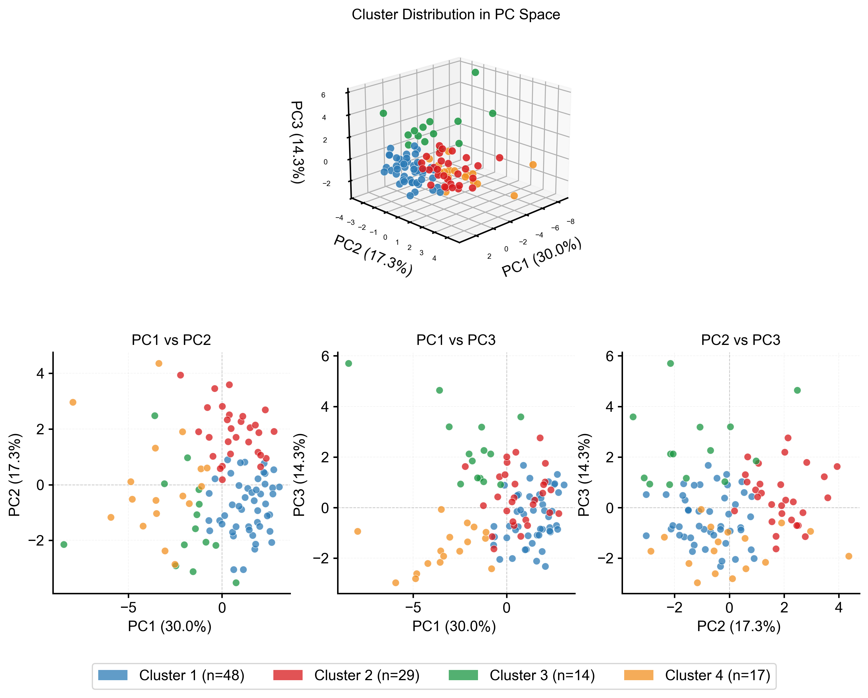
Figure 2: Clusters plotted along PC1, PC2, PC3.

Box plots of the top three PCs by cluster are shown in Figure 3. Clusters 1 and 2 were no longer separated by PC1. Cluster 3 (n = 14) remained the most distinct on the gait variability component (PC3 here; PC2 in the original solution).
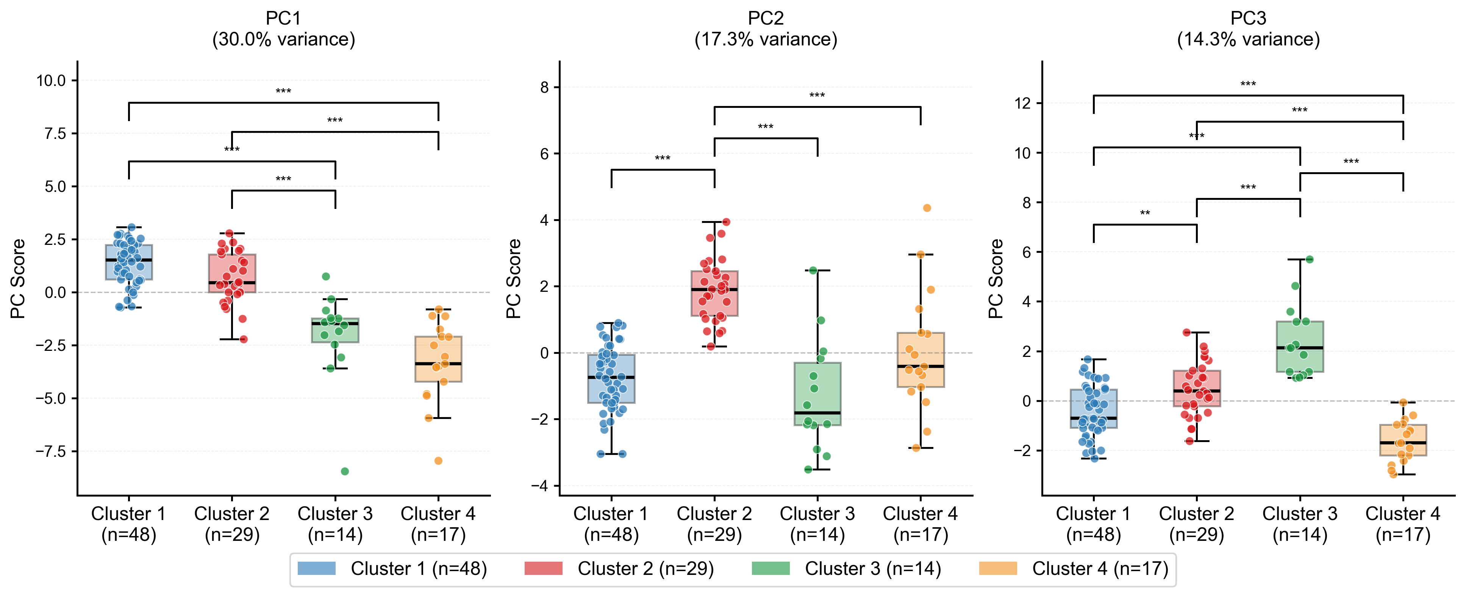
Figure 3: Comparisons of clusters across first three PCs.
The radar plot (Figure 4) shows each cluster's z-scores across all features. As before, Cluster 3 had the highest gait variability and Cluster 4 the highest overall impairment and asymmetry. Clusters 1 and 2 differed only subtly, where Cluster 2 appeared to have higher time spent in double support and stance, with marginally higher variability and asymmetry.
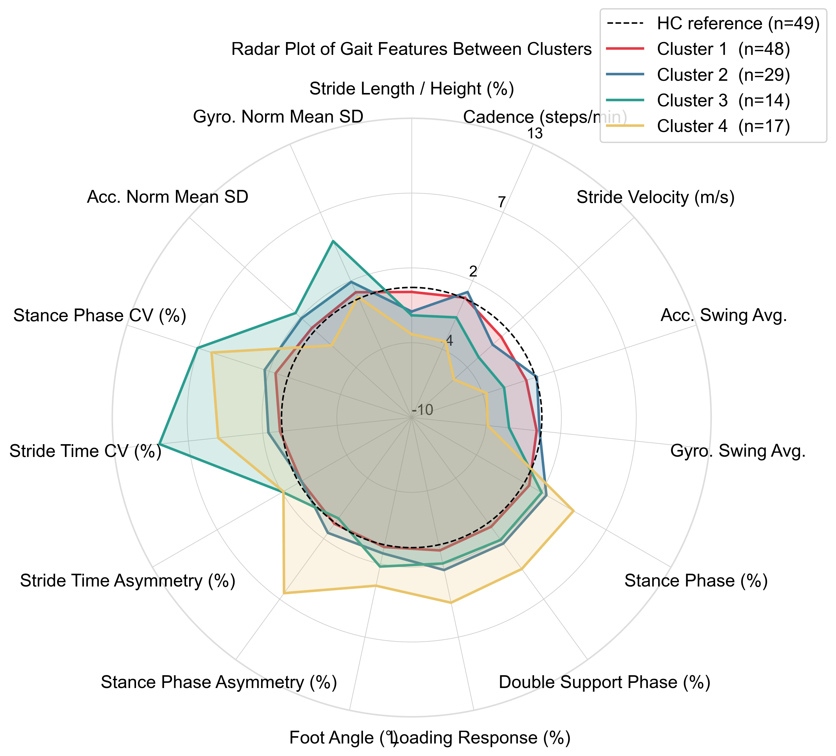
Figure 4: Radar plot comparing gait features to healthy controls.

Figure 5 displays cluster membership before and after residualization. Clusters 3 and 4 were largely stable with minimal movement of participants between clusters. Clusters 1 and 2 were significantly different than the solution presented in the manuscript, where 26 original Cluster 2 participants moved to Cluster 1, and 7 original Cluster 1 participants moved to Cluster 2.
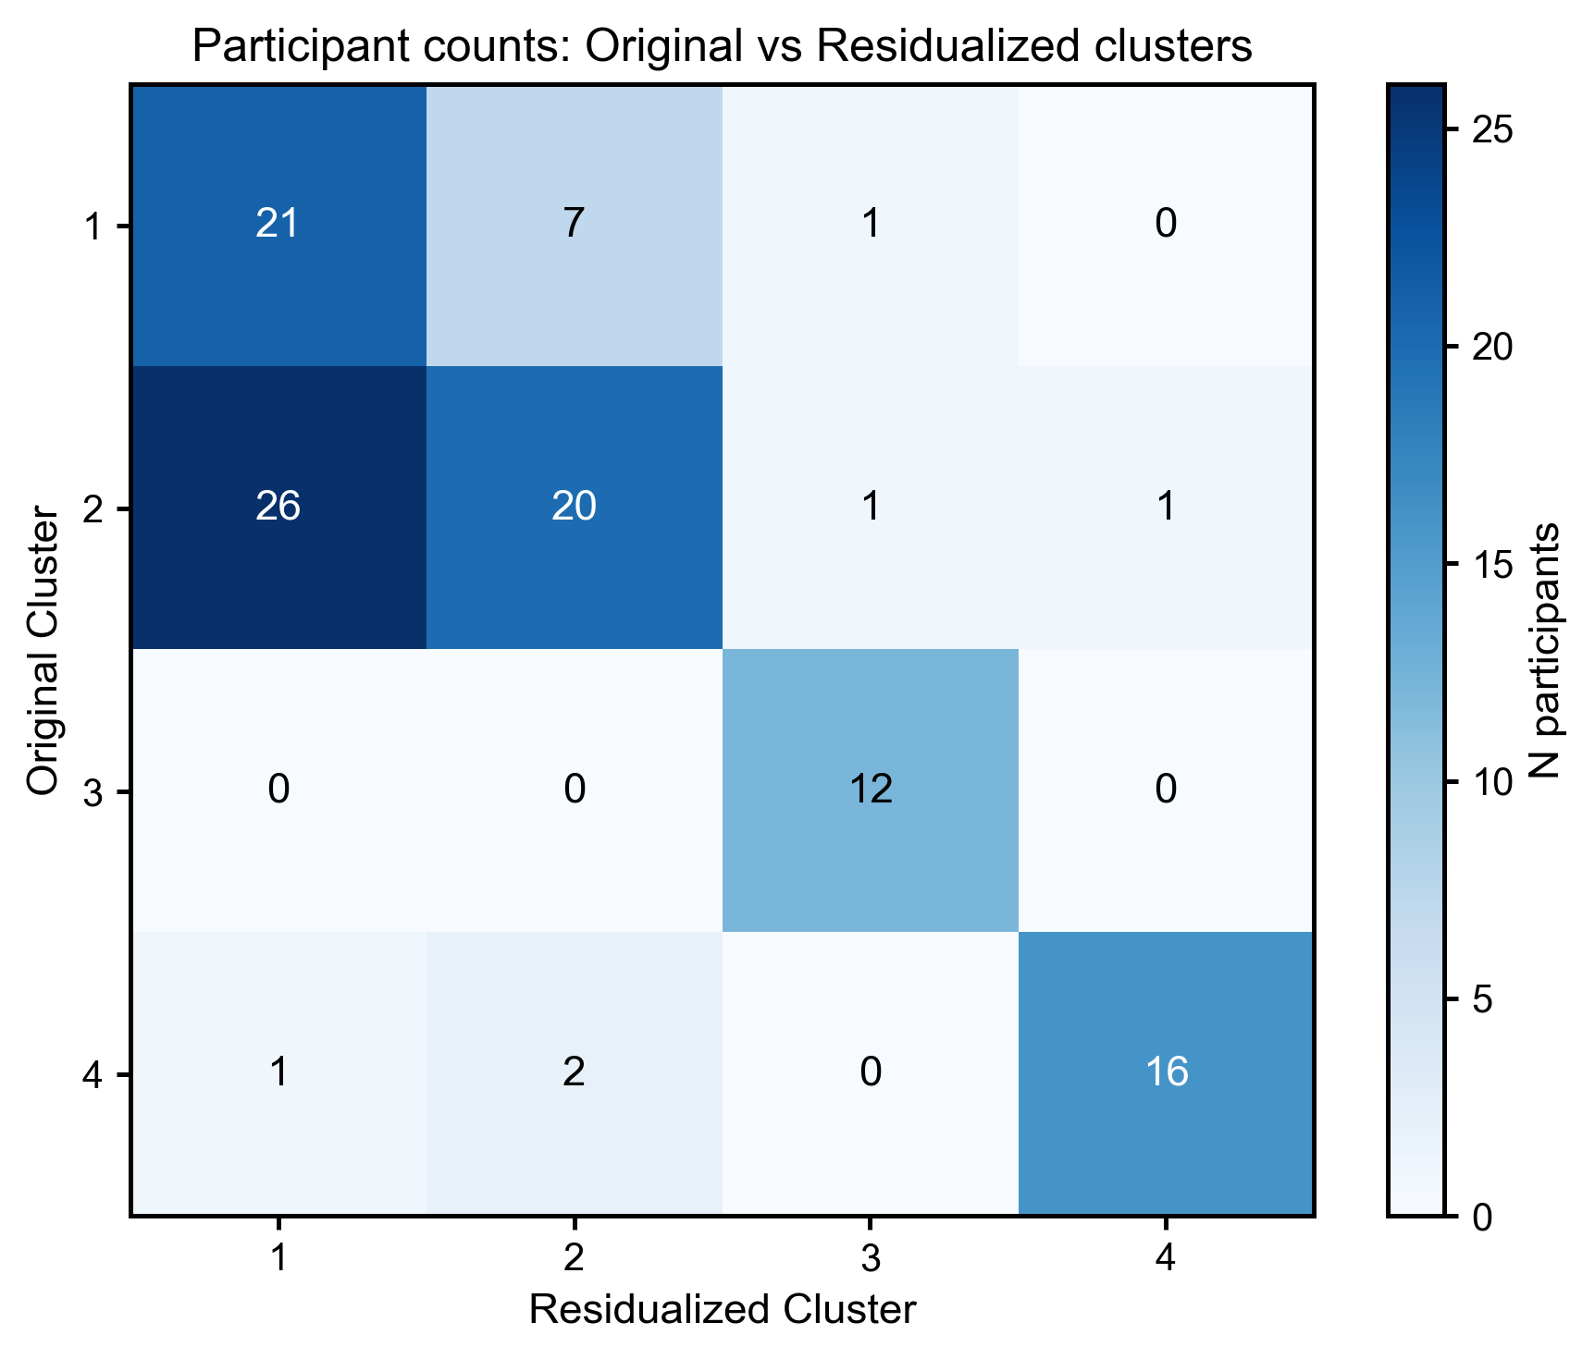
Figure 5: Heat map showing original cluster designation (vertical) vs. new cluster designation (horizontal).

Discussion
The purpose of this investigation was to evaluate the stability of the four-cluster solution after reducing the contribution of multiple spatiotemporal features that were correlated with stride velocity. Spatiotemporal features were residualized with respect to stride velocity, and the resulting feature set was used to re-examine cluster assignment. This analysis was performed to determine which aspects of the original clustering structure were preserved when the influence of correlated speed-related features was reduced.
The most impaired group (Cluster 4) and the high spatiotemporal variability group (Cluster 3) remained largely unchanged from the solution presented in the manuscript. Cluster 3 continued to be characterized by greater gait variability, while Cluster 4 remained the most impaired group, distinguished by greater stance phase asymmetry. Greater reassignment occurred between Clusters 1 and 2 (Figure 5), which may suggest that the separation of these lower-impairment groups was more sensitive to the inclusion of speed-related features.
Several considerations should be kept in mind when interpreting these findings. Stride velocity was retained in the feature set, and therefore this analysis does not represent a clustering solution independent of walking speed. Rather, it evaluates how the clustering structure changes after reducing the contribution of other features that contain potentially redundant information about walking speed. Additionally, the residualization models were developed using healthy controls and then applied to participants with MS, some of whom walked more slowly than any healthy control in the dataset (Figure 1). For these participants, residualized values involved extrapolation beyond the range observed in the healthy control group and should therefore be interpreted with caution.

References
1. Hennig C. Cluster-wise assessment of cluster stability. Comput Stat Data Anal. 2007;52:258–71. https://doi.org/10.1016/j.csda.2006.11.025.
2. Bivand RS, Pebesma E, Gómez-Rubio V. Applied Spatial Data Analysis with R: Second Edition. 2013. https://doi.org/10.1007/978-1-4614-7618-4.

