Source-Dependent Brown Carbon Optical Indicators in Philippine Emission Filters
Krishna E. Santos¹˒²* and Mylene G. Cayetano¹˒²
¹ Institute of Environmental Science and Meteorology, University of the Philippines Diliman, Quezon City 1101, Philippines
² Environmental Pollution Studies Laboratory, University of the Philippines Diliman, Quezon City 1101, Philippines
*Corresponding author: kesantos2@up.edu.ph; krishna.santos@yahoo.com
Online Resource 1
Supplementary Sampling Contexts and Supporting Optical Results
This file accompanies the main manuscript. Optical quantities, quality-control rules, source-group labels, and interpretive limitations follow the definitions in the main text.

Supplementary Figures
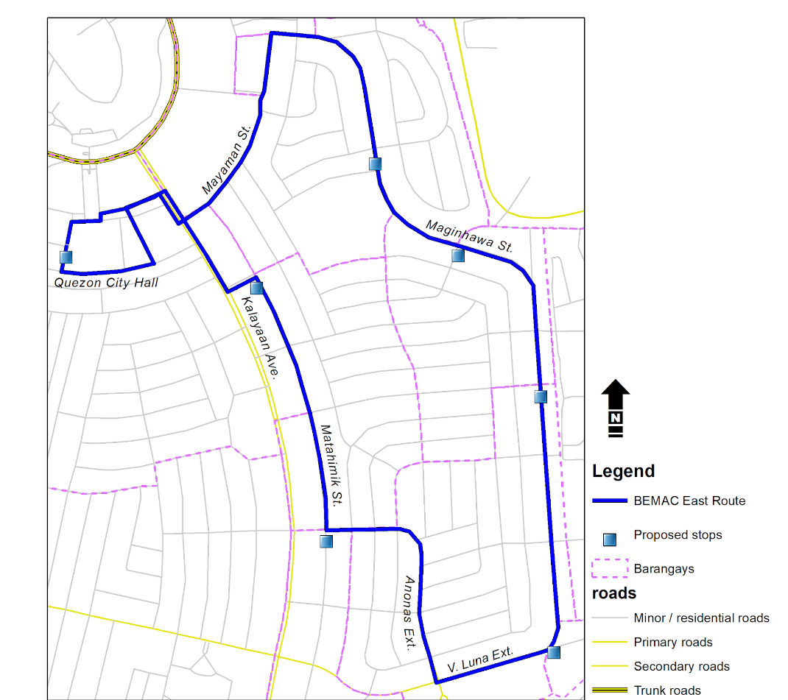
Fig. S1 Tricycle emission sampling route in Quezon City. The approximately 5.9-km route originated near Quezon City Hall and passed through residential and mixed-use roads used during in-use tricycle sampling
(a)
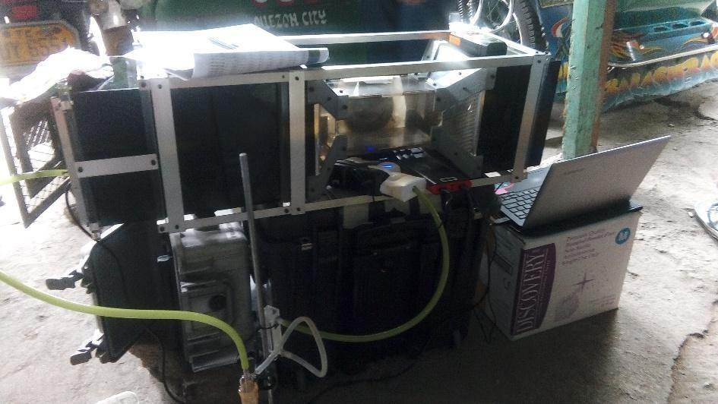
(b)
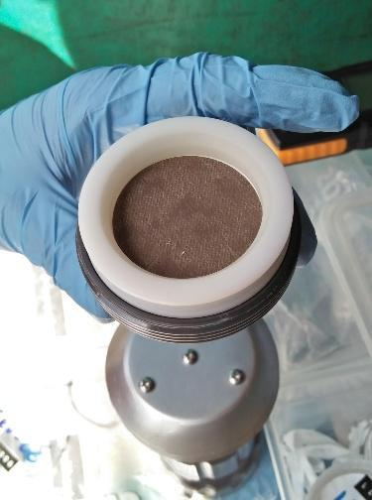
Fig. S2 Tricycle exhaust sampling materials: (a) portable wind-tunnel exhaust-capture setup coupled to the particulate matter sampler and (b) example particle-loaded 47-mm quartz-fiber filter after sampling
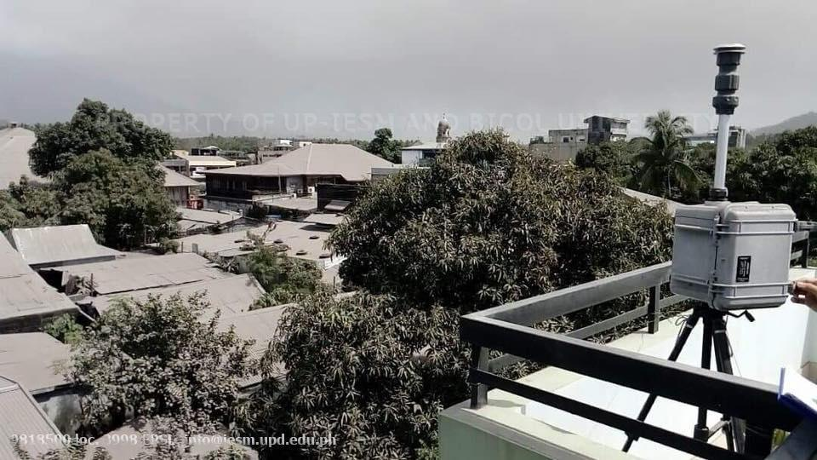
Fig. S3 Volcanic aerosol sampling during the 2018 Mayon eruption period. A MiniVol sampler collected eruption-influenced particulate matter under ash-affected conditions near Mayon Volcano
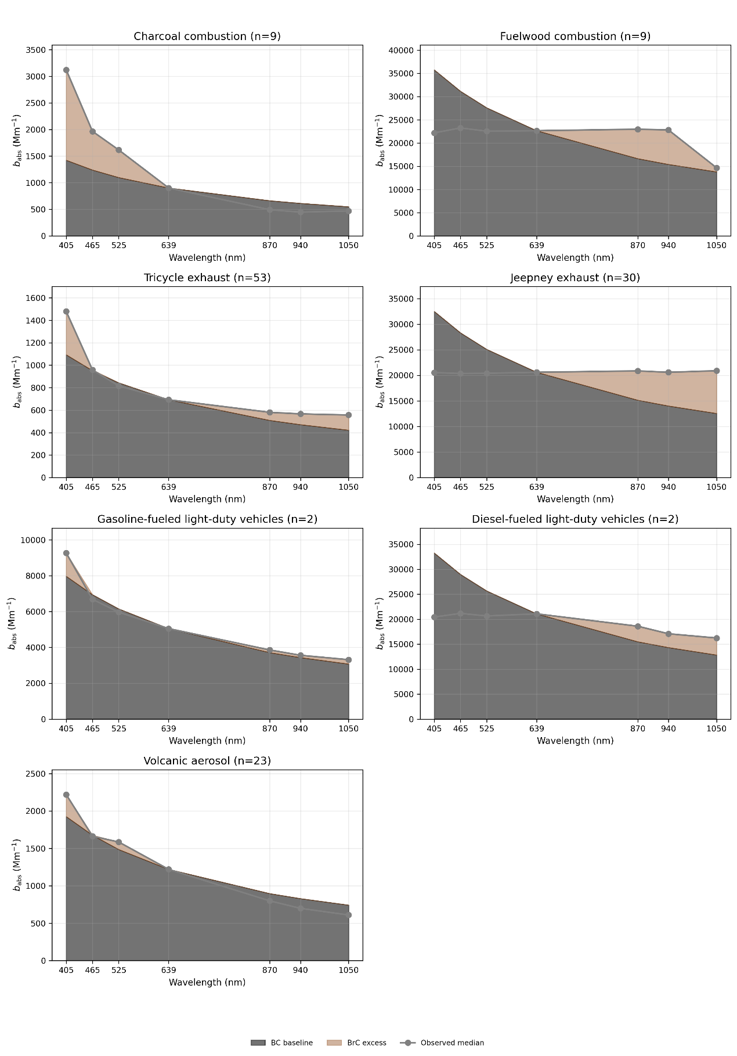
Fig. S4 Source-level median absorption spectra compared with an operational BC baseline anchored at 639 nm and calculated using an assumed BC absorption Ångström exponent of 1.0. Shaded excess is provided only as a spectral-shape visualization and not as direct chemical separation of BC and BrC

Supplementary Tables
Table S1 Median absorption spectra normalized to 639 nm by source group
Source group | n | 405 nm | 465 nm | 525 nm | 639 nm | 870 nm | 940 nm | 1050 nm
Charcoal combustion | 9 | 3.37 | 2.04 | 1.70 | 1.00 | 0.64 | 0.62 | 0.58
Fuelwood combustion | 9 | 0.99 | 1.00 | 1.00 | 1.00 | 1.01 | 1.02 | 0.64
Tricycle exhaust | 53 | 2.17 | 1.58 | 1.30 | 1.00 | 0.69 | 0.63 | 0.57
Jeepney exhaust | 30 | 0.99 | 0.99 | 0.99 | 1.00 | 1.01 | 1.00 | 1.01
Gasoline-fueled light-duty vehicles | 2 | 1.56 | 1.22 | 1.12 | 1.00 | 0.83 | 0.79 | 0.75
Diesel-fueled light-duty vehicles | 2 | 0.97 | 1.01 | 0.98 | 1.00 | 0.88 | 0.80 | 0.76
Volcanic aerosol | 23 | 1.87 | 1.38 | 1.31 | 1.00 | 0.65 | 0.57 | 0.50
Values are medians of filter-level absorption coefficients normalized to the corresponding 639-nm absorption coefficient (b_{abs,λ} / b_{abs,639}). The normalized value at 639 nm is 1.00 for every filter.
Table S2 Descriptive statistics of AAE₄₀₅₋₆₃₉ by source group
Source group | n | Median | IQR | Observed range
Charcoal combustion | 9 | 2.67 | 2.07-3.00 | 1.11-3.35
Fuelwood combustion | 9 | -0.03 | -0.06 to -0.01 | -0.08-0.27
Tricycle exhaust | 53 | 1.69 | 1.07-2.39 | -0.05-5.47
Jeepney exhaust | 30 | -0.03 | -0.06-0.05 | -0.19-1.82
Gasoline-fueled light-duty vehicles | 2 | 0.92 | 0.65-1.18 | 0.39-1.44
Diesel-fueled light-duty vehicles | 2 | -0.07 | -0.09 to -0.05 | -0.11 to -0.03
Volcanic aerosol | 23 | 1.37 | 1.30-1.55 | -0.46-1.66
AAE values were calculated from the original blank-corrected 405- and 639-nm absorption coefficients. Gasoline and diesel light-duty groups each contain n = 2 and are included for descriptive comparison only.

Table S3 BrC-proxy distribution by source group
Source group | n | Median | IQR | Observed range
Charcoal combustion | 9 | 237,101.87 | 119,638.49-388,458.92 | 109,192.49-849,870.53
Fuelwood combustion | 9 | 0.00 | 0.00-0.00 | 0.00-0.00
Tricycle exhaust | 53 | 74,471.54 | 29,494.33-249,303.99 | 0.00-3,111,897.57
Jeepney exhaust | 30 | 0.00 | 0.00-0.00 | 0.00-1,369,670.78
Gasoline-fueled light-duty vehicles | 2 | 449,360.36 | 228,202.12-670,518.61 | 7,043.87-891,676.85
Diesel-fueled light-duty vehicles | 2 | 0.00 | 0.00-0.00 | 0.00-0.00
Volcanic aerosol | 23 | 116,826.80 | 79,424.22-163,302.73 | 0.00-210,585.55
Values are expressed in ng m⁻³ BC-equivalent. The BrC proxy is an operational optical indicator and not a direct BrC mass concentration.
Table S4 Significant Holm-adjusted pairwise Mann-Whitney U comparisons for AAE405-639 and the BrC proxy
Variable | Significant source contrasts
AAE405-639 | Charcoal vs fuelwood; charcoal vs jeepney; charcoal vs volcanic; fuelwood vs tricycle; fuelwood vs volcanic; tricycle vs jeepney; jeepney vs volcanic
BrC proxy | Charcoal vs fuelwood; charcoal vs jeepney; fuelwood vs tricycle; fuelwood vs volcanic; tricycle vs jeepney; jeepney vs volcanic
Only contrasts remaining significant after Holm adjustment are listed. Comparisons involving the n = 2 light-duty vehicle groups were not emphasized for source interpretation.
Table S5 Repeated stratified 10% holdout summary for the five major source groups
Source group | Median BrC-proxy range across 1,000 subsets  (ng m⁻³ BC-equivalent)
Charcoal combustion | 192,079.09-254,441.74
Volcanic aerosol | 115,484.51-123,281.38
Tricycle exhaust | 66,661.26-98,747.02
Fuelwood combustion | 0.00
Jeepney exhaust | 0.00
All 1,000 iterations retained p < 0.05 for the five-group Kruskal-Wallis comparison, and charcoal had the highest median BrC proxy in every iteration. The n = 2 gasoline and diesel light-duty groups were excluded from the holdout analysis.
Table S6 Mass absorption efficiency coefficients used in archive processing
Wavelength (nm) | Mass absorption efficiency (m² g⁻¹)
405 | 8.14
465 | 7.68
525 | 7.23
639 | 6.69
870 | 5.78
940 | 5.55
1050 | 5.30
The coefficients were calculated by M.G. Cayetano for processing of the MABI measurements archived. The detailed coefficient calculation has not yet been published. These values are used for the BC-equivalent calculation and are not presented as quartz-specific calibration values.

