Supplementary Online Content – eFile 1
Mapping post-translational modifications across amyloid-β deposits in Alzheimer’s disease: A neuropathologic survey with in vitro functional analysis of nitration

Authors:
Sarah Basile^{1,2}, Fleur Schipper², Stefania Zimbone³, Sanne M.M. Vermorgen^{2,4}, Francesco Bellia⁵, Cristina Parisi¹, Salvo Sortino¹, Jochen Walter⁶, Maria Laura Giuffrida³, Annemieke J.M. Rozemuller², Jeroen J.M. Hoozemans², Agata Copani^{1,3}, Baayla D.C. Boon^{7,8}

Affiliations:
1. Department of Drug and Health Sciences (DSFS), University of Catania, 95125 Catania, Italy
2. Department of Pathology, Amsterdam UMC location VUmc, Amsterdam, the Netherlands
3. Institute of Crystallography (IC), National Research Council, 95126 Catania, Italy
4. Netherlands Brain Bank, Netherlands Institute for Neuroscience, 1105 BA, Amsterdam, The Netherlands
5. Department of Biomedical and Biotechnological Sciences (BIOMETEC), University of Catania, 95125 Catania, Italy
6. Center of Neurology, University Hospital Bonn, University of Bonn, Bonn, Germany
7. Alzheimer Center Amsterdam, Neurology, Vrije Universiteit Amsterdam, Amsterdam UMC location VUmc, Amsterdam, the Netherlands
8. Department of Neuroscience, Mayo Clinic Jacksonville, Jacksonville, FL, USA

Contents
eTables
eTable 1 Amyloid-β deposit annotations per case | 2
eTable 2 ESI-MS analysis of the Aβ-NO adducts | 3
eFigures
eFigure 1 Immunocytochemistry of CD68 on C57BL/6 BV2 cells | 4
eFigure 2 Quantification of 3-NT positivity in control vessels | 5
eFigure 3 Cell viability of BV2 microglia treated with nitrated and non-nitrated Aβ species | 6
eFigure 4 Cell viability of SH-SY5Y neuronal cells treated with nitrated and non-nitrated Aβ species | 7

eTable 1 Amyloid-β deposit annotations per case.
Case | Deposit group | Tissue type |  | Number of annotated amyloid-β deposits
Case | Deposit group | FF | FFPE | Diffuse | CCP | CGP | capCAA | lvCAA | lmvCAA | Control  vessels | Control parenchyma
1 | CCP | ✓ | ✓ | 5 | 10
2 | CCP | ✓ | ✓ |  | 10*
3 | CCP | ✓ | ✓ | 5 | 10
4 | CCP | ✓ | ✓ | 5 | 10
5 | CCP | ✓ | ✓ | 5 | 10
6 | CCP | ✓ | ✓ | 5 | 10
7 | CCP | ✓ | ✓ | 5 | 10
8 | CGP | ✓ | ✓ | 5 |  | 10
9 | CGP | ✓ | ✓ | 5 |  | 10
10 | CGP | ✓ | ✓ | 5 |  | 10
11 | CGP | ✓ | N/A | 5 |  | 10
12 | CAA | N/A | ✓ |  |  |  | 10 | 10 | 5
13** | CAA | ✓ | ✓ | 5 |  |  | 10 | 10 | 5
14** | CAA | ✓ | N/A | 5 |  |  | 10 | 10 | 5
15** | CAA | ✓ | N/A |  |  |  | 10 | 10 | 5
16 | CAA | ✓ | N/A | 5 |  |  | 10 | 10
17 | CAA | ✓ | ✓ |  |  |  | 10 | 10 | 5
18 | CAA | ✓ | N/A |  |  |  | 10 | 10
19 | CAA | ✓ | N/A | 5 |  |  | 10 | 10
20 | Control | ✓ | N/A |  |  |  |  |  |  | 3 | 10
21 | Control | ✓ | N/A |  |  |  |  |  |  | 3 | 10
22 | Control | ✓ | N/A |  |  |  |  |  |  | 6 | 10
23 | Control | ✓ | N/A |  |  |  |  |  |  | 4 | 10
24 | Control | N/A | ✓ |  |  |  |  |  |  |  | 10
25 | Control | N/A | ✓ |  |  |  |  |  |  |  | 10
26 | Control | N/A | ✓ |  |  |  |  |  |  |  | 10
27 | Control | N/A | ✓ |  |  |  |  |  |  |  | 10
28 | Control | N/A | ✓ |  |  |  |  |  |  |  | 10
Eighteen cases underwent double immunofluorescence analysis for Aβ_{aa1-8} and CD68. Because paired FFPE and FF tissue were not available for all cases, an alternative CAA case and distinct controls were selected for triple immunofluorescence on FF tissue, comprising 23 cases in total. CAA, cerebral amyloid angiopathy; capCAA, capillary cerebral amyloid angiopathy; CCP, classic core plaques; CGP, coarse-grained plaques; FF, fresh frozen; FFPE, formalin-fixed paraffin-embedded; lvCAA, large vessel cerebral amyloid angiopathy; lmvCAA, leptomeningeal vessel cerebral amyloid angiopathy; N/A, not available.
*For case 2, 5 classic cored plaques were annotated in thioflavin-S staining. **Cases 13–15 were excluded from Aβ_{N3pE} and thioflavin-S analyses due to technical issues.

eTable 2 ESI-MS analysis of the Aβ-NO adducts.
 | Aβ₆₋₁₆(NO₂)/Aβ₆₋₁₆ (‰) | SD
oAβ | 0 | 0
oAβ/BPTNO | 2,1 | 0,1
fAβ | 0 | 0
fAβ/BPTNO | 2,1 | 0,2
Relative area of the chromatographic peaks between Aβ_{6–16} (NO₂) and Aβ_{6–16} searched in the trypsin-treated samples containing of Aβ₁₋₄₂ oligomers (oAβ) or fibrils (fAβ), plus 1 µM BTP-NO (Aβ/BTP-NO) following irradiation. The ratio values were calculated using the integrated peak area of the extracted Ion chromatogram for each peptide. SD standard deviation.

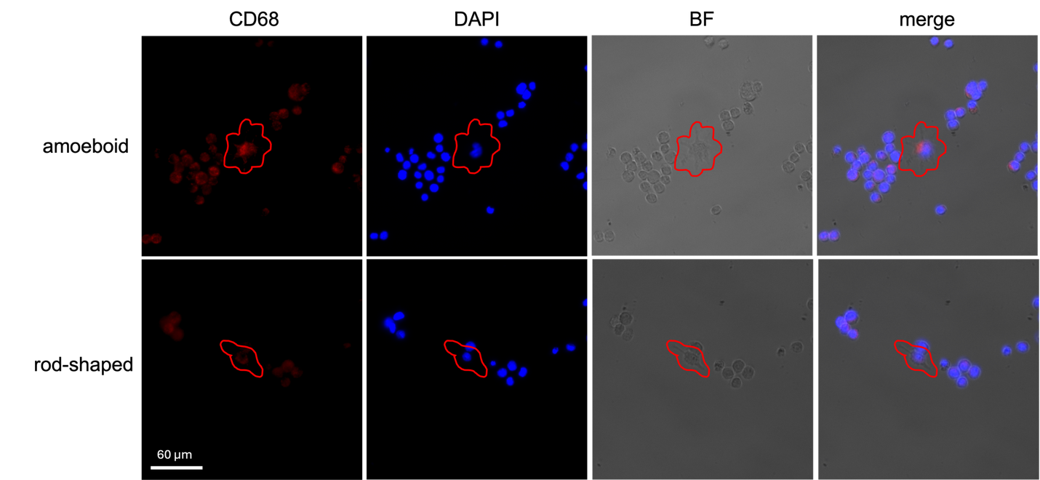

eFigure 1 Immunocytochemistry of CD68 on C57BL/6 BV2 cells.
Immunocytochemistry of CD68 on immortalized murine microglial C57BL/6 BV2 cells showing the amoeboid and rod-shaped phenotypes. The red circle depicts the specific microglia morphology. BF brightfield. Scale bar applies to all images in the same figure.
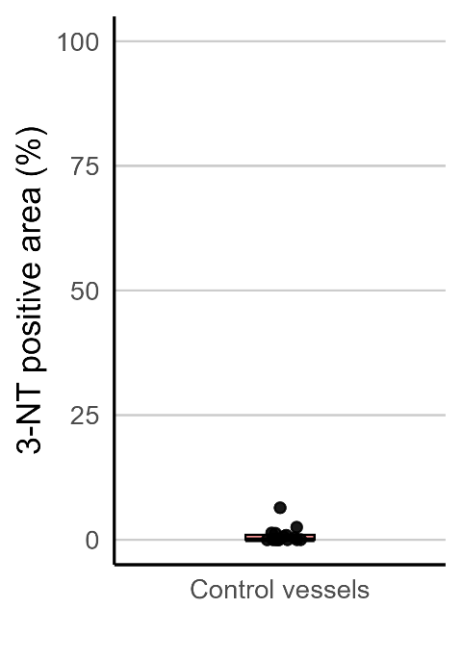

eFigure 2 Quantification of 3-NT positivity in control vessels.
Signal is expressed as the percentage of the annotated deposit area occupied by pixels with fluorescence intensity above the predefined threshold (positive area [%]). Each dot representing a single measurement within a subject (n=3-4 per subject), with a median and interquartile range (0%; 0.989).

eFigure 3 Cell viability of BV2 microglia treated with nitrated and non-nitrated Aβ species.
MTT Assay of BV2 microglia cells treated for 72 hours with Aβ oligomers, nitrated Aβ oligomers, Aβ fibrils, or nitrated Aβ fibrils. Bars represent mean ± SEM from two independent experiments (n=2-3 replicates per condition). No statistical significance was detected versus control by one-way ANOVA. Abbreviations: oAβ, Aβ oligomers

eFigure 4 Cell viability of SH-SY5Y neuronal cells treated with nitrated and non-nitrated Aβ species.
MTT assay of fully differentiated SH-SY5Y treated or not treated for 48 hours with pre-formed, nitrated or not, oligomers or fibrils of Aβ₁₋₄₂. Bars represent means ±SEM of three independent experiments with n=3 each. *p<0.05, **p<0.01, ***p<0.001, vs control by one-way ANOVA with post-hoc Tukey’s test. Abbreviations: oAβ, Aβ oligomers

