Supplementary Information
Multi-model assessment of global hydrogen trade under Paris-aligned scenarios
Author list
Jana Fakhreddine^{1,2}*, Siddharth Joshi², Luca Cassamassima², Oliver Fricko², Paul Dodds^{1,3}, and Isabela Butnar¹
Affiliations
¹Institute for Sustainable Resources, University College London, UK
²International Institute for Applied Systems Analysis, Austria
³Energy Institute, University College London, UK
*Corresponding Author: Jana Fakhreddine (jana.fakhreddine.22@ucl.ac.uk)

Supplementary figures
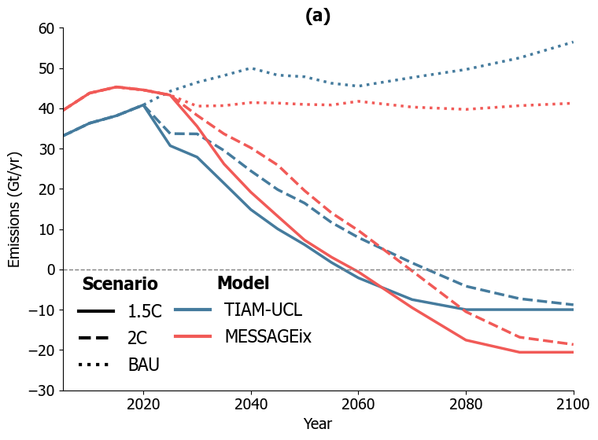 | 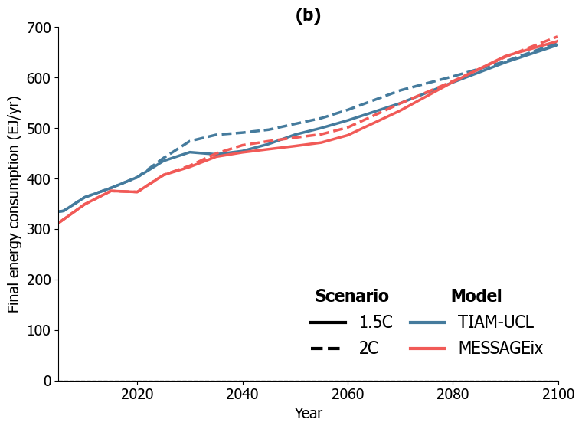
Figure 1.(a) Net CO₂ emissions (Gt/year) and (b) total final energy consumption (EJ/yr) in MESSAGEix and TIAM-UCL 1.5C and 2C scenarios (2005-2100)
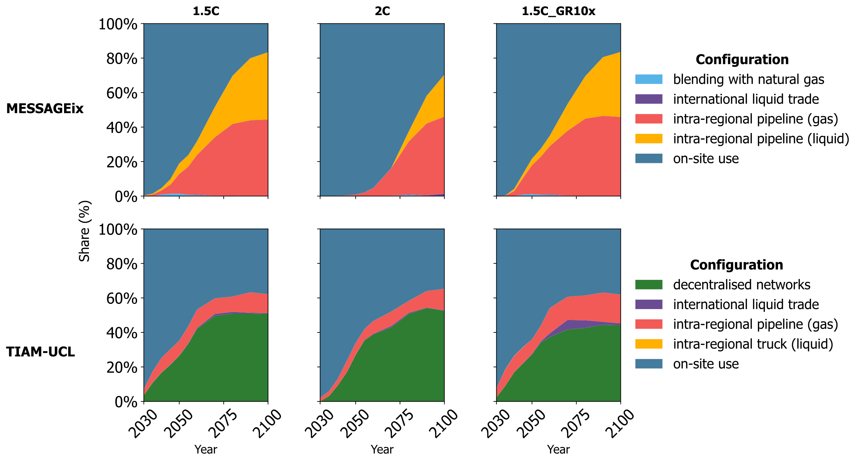
Figure 2. Evolution of global hydrogen supply chain configurations in MESSAGEix (top) and TIAM-UCL (bottom) in the 1.5C, 2C and 1.5C_GR10x scenarios
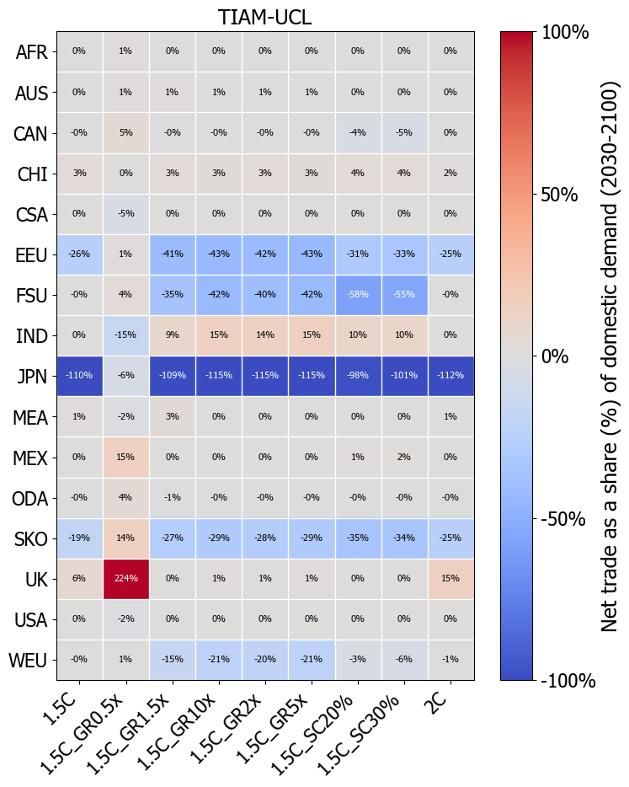
Figure 3. Net regional liquid hydrogen trade in TIAM-UCL from 2030 to 2100 as a share of domestic demand across modelled 1.5C (with sensitivities) and 2C scenarios. Positive values indicate a net exporter, negative values indicate a net importer.
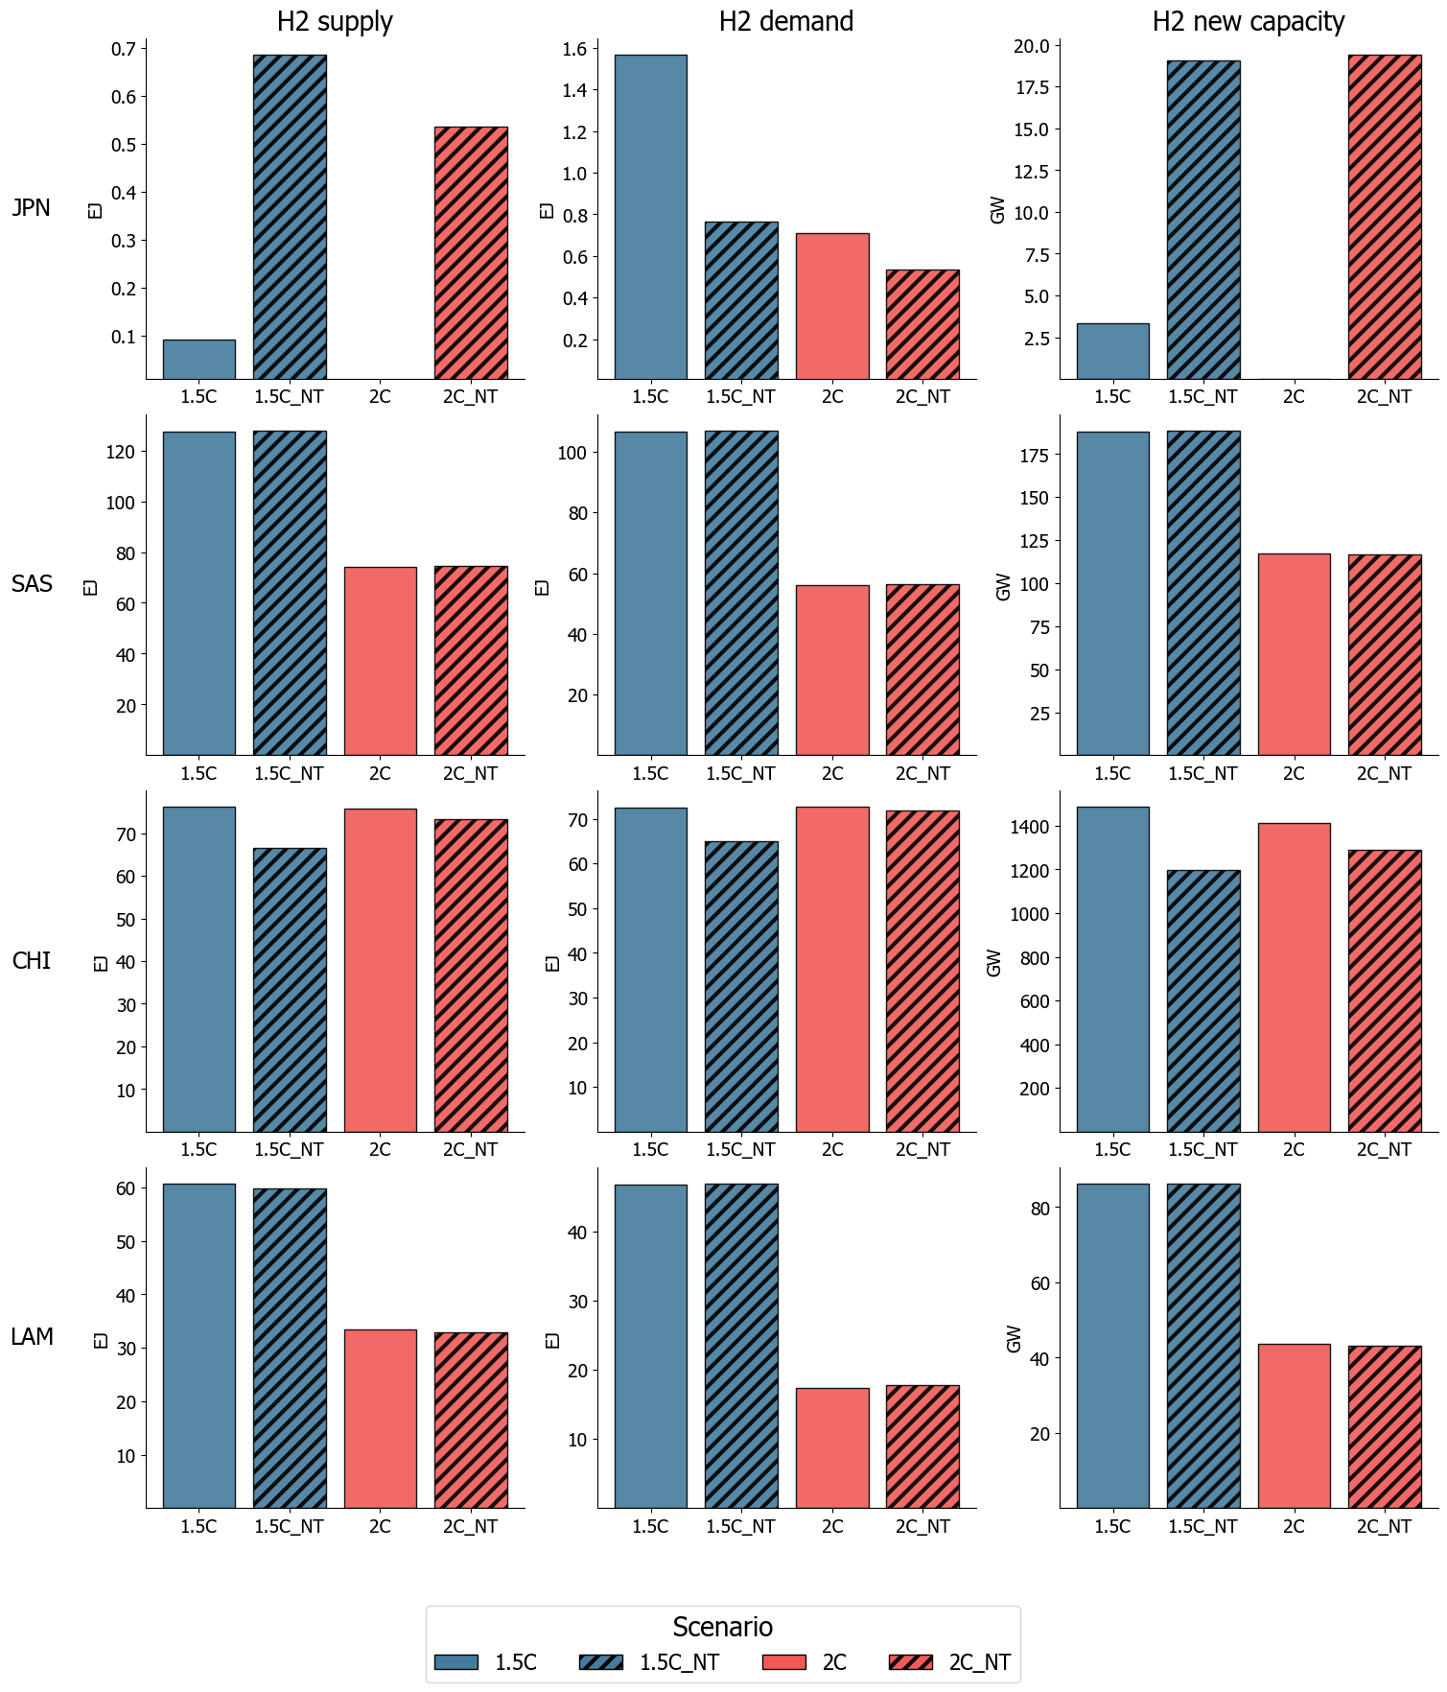
Figure 4. Change in cumulative hydrogen supply (EJ), demand (EJ), and capacity (GW) levels between in the NT scenarios in select major importers (JPN from TIAM-UCL and SAS from MESSAGEix) and exporters (CHI from TIAM-UCL and LAM from MESSAGEix) in 2030-2100
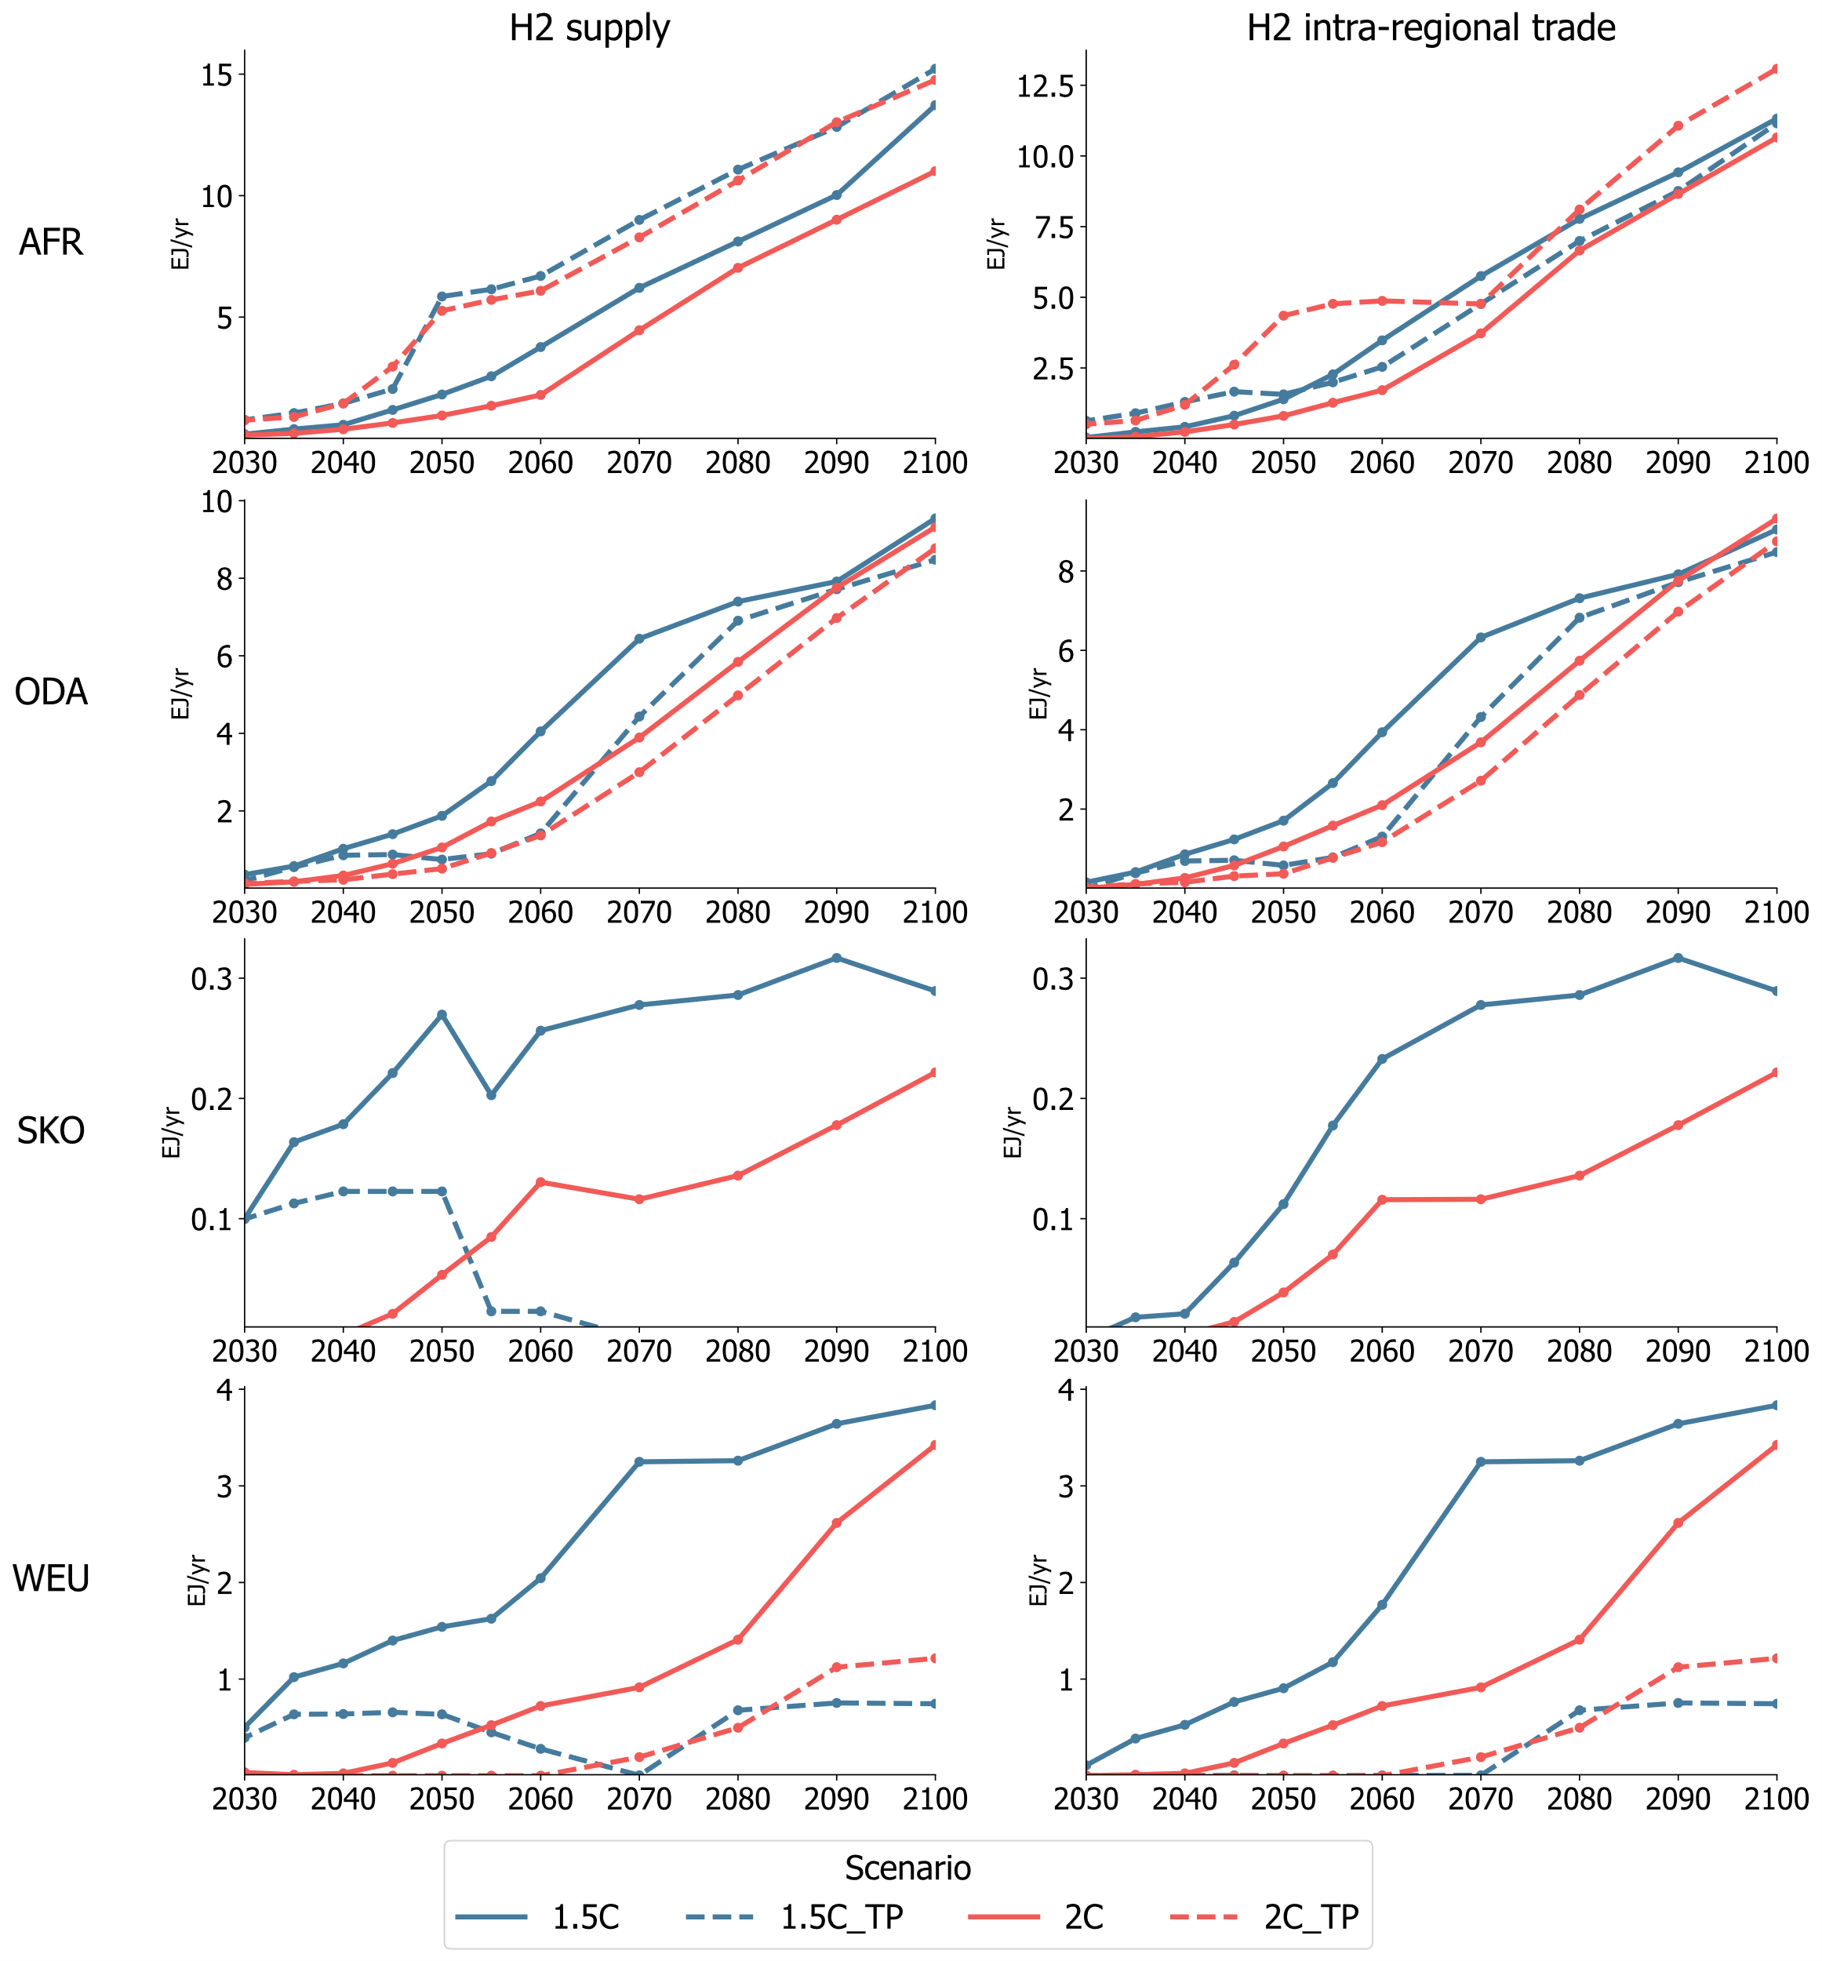
Figure 5. Change in annual hydrogen supply and intra-regional trade levels in the TP scenarios in select TIAM-UCL regions in 2030-2100 (EJ/yr)
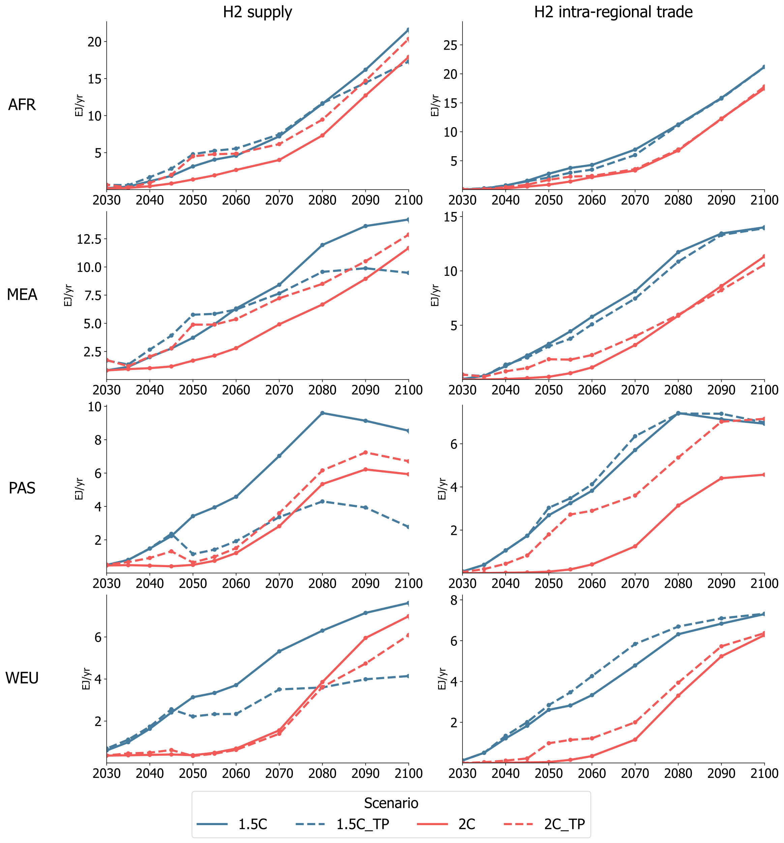
Figure 6. Change in annual hydrogen supply and intra-regional trade levels in the TP scenarios in select MESSAGEix regions in 2030-2100 (EJ/yr)
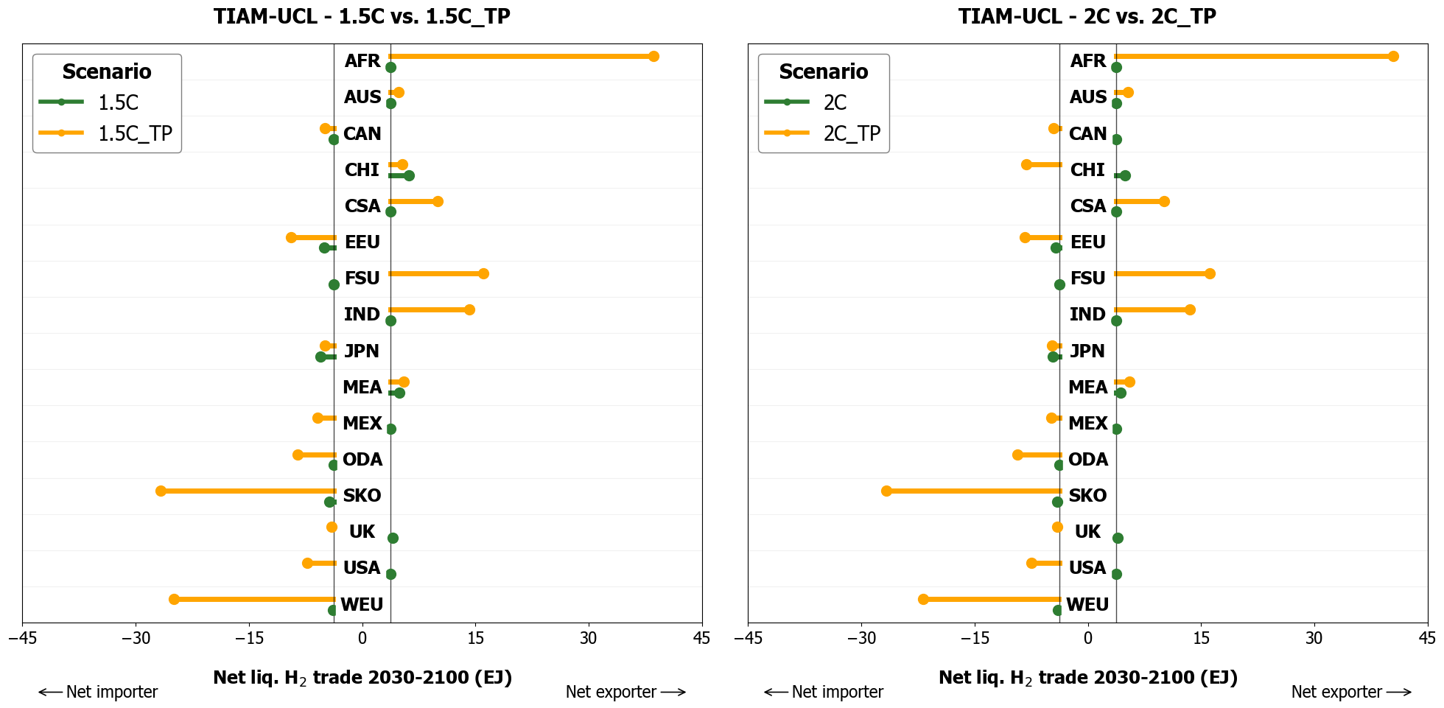
Figure 7. Change in net trade status and totals of TIAM-UCL regions between the scenarios with (1.5C_TP and 2C_TP) and without (1.5C and 2C) hydrogen trade policy targets

Supplementary data

Tecno-economic assumptions on hydrogen systems in TIAM-UCL and MESSAGEix

Hydrogen supply
Table 1 summarises the techno-economic assumptions used in TIAM-UCL and MESSAGEix for hydrogen production technologies, including technology investment costs, fixed operating costs, efficiency, capacity factor, start year, and lifetime. Note that these are baseline assumptions which are then regionalised in each model and applied to each region.
Table 1. Techno-economic assumptions for hydrogen production technologies in TIAM-UCL and MESSAGEix
Technology | Model | INVCOST (2005 million USD/Pj_a) |  | FIXOM (% of Capex) | Efficiency (%) |  | Capacity Factor (%) | Start year | Lifetime (years)
 |  | 2020 | 2050 |  | 2020 | 2050
Gas SMR | TIAM-UCL | 19.30 | 19.30 | 5.0% | 76% | 80% | 95% | 2005 | 30
Gas SMR | MESSAGEix | 22.47 | 17.46 | 3.8% | 69% | 69% | 90% | 2010 | 30
Gas SMR + CCS | TIAM-UCL | 30.89 | 28.76 | 4.0% | 66% | 74% | 90% | 2030 | 30
Gas SMR + CCS | MESSAGEix |  | 32.75 | 3.0% | 69% | 69% | 90% | 2030 | 30
Coal gasification | TIAM-UCL | 64.62 | 64.62 | 5.0% | 69% | 69% | 95% | 2005 | 30
Coal gasification | MESSAGEix | 65.95 | 51.23 | 3.8% | 60% | 60% | 90% | 2010 | 25
Coal gasification + CCS | TIAM-UCL |  | 60.57 | 5.0% | 59% | 63% | 90% | 2030 | 30
Coal gasification + CCS | MESSAGEix |  | 53.34 | 3.8% | 60% | 60% | 90% | 2030 | 25
Biomass gasification | TIAM-UCL | 81.12 | 49.37 | 7.0% | 50% | 50% | 95% | 2005 | 30
Biomass gasification | MESSAGEix | 114.16 | 88.68 | 3.8% | 55% | 55% | 90% | 2020 | 25
Biomass gasification + CCS | TIAM-UCL |  | 90.03 | 7.0% | 40% | 44% | 90% | 2030 | 30
Biomass gasification + CCS | MESSAGEix |  | 90.57 | 3.8% | 55% | 55% | 90% | 2030 | 25
Electrolysis | TIAM-UCL | 28.31 | 9.07 | 3.0% | 73% | 84% | 95% | 2005 | 30
Electrolysis | MESSAGEix | 31.39 | 22.70 | 4.0% | 80% | 80% | 95% | 2010 | 30

International hydrogen trade
Liquid hydrogen and ammonia can be traded in ships between TIAM-UCL’s 16 regions. A trade process is defined for each possible trade route (240 trade links in total), with model inputs of process capital cost, operating cost, and efficiency (summarised in Table 3). The assumptions used to calculate these techno-economic parameters are summarised in Table 2. These include assumptions on ship capacity, ship cost, fuel use, number of days to load and unload the cargo at port, boil-off gas losses during shipping and loading, and ship capital and operating costs. We calculated average shipping distances between the model’s 16 regions based on trade distance data from the CERDI database¹ and our own calculations of LNG trade route distances.
Table 2. Techno-economic assumptions used in TIAM-UCL to calculate international hydrogen trade costs
Parameter | Value | Source
Trade distance | Route-specific | CERDI database¹, own calculations
Ship Capacity | 11,000 tonnes | IEA ²
Ship speed | 30 km/hr | IEA ²
Load/unload days | 2 days | IEA ²
Ship CAPEX | 412 MUSD | IEA ²
Fuel use | 1,487 MJ/km | IEA ²
Boil-off losses (ship) | 0.2% per day | Johnston, et al. ^{3,}Al-Breiki and Bicer ⁴
Boil-off losses (loading) | 0.52% | Johnston, et al. ^{3,}Al-Breiki and Bicer ⁴
Liquid hydrogen trade in MESSAGEix is modelled through a global node: all exporting regions export liquid hydrogen into a single global node from which importing regions pull. Table 3 summarises key techno-economic assumptions for liquid hydrogen trade in ships in both TIAM-UCL and MESSAGEix
Table 3. Techno-economic assumptions on international hydrogen trade in MESSAGEix and TIAM-UCL
Parameter | MESSAGEix | TIAM-UCL
CAPEX cost (million USD/PJ_a) | 7.5-27.4 | 2.9-33.8
Fixed O&M (% of capex) | - | 4%
Efficiency (%) | 88% | 83-98%
Lifetime (years) | 25 | 25
Start year | 2030 | 2030

Intra-regional hydrogen transport
Table 4 summarises the techno-economic assumptions used in TIAM-UCL and MESSAGEix for intra-regional hydrogen transport and distribution technologies, including technology investment costs, fixed operating costs, efficiency, capacity factor, start year, and lifetime. Note that these are baseline assumptions which are then regionalised in each model and applied to each region.
Table 4. Techno-economic assumptions for intra-regional hydrogen transport and distribution technologies in TIAM-UCL and MESSAGEix
Technology | Model | INVCOST (2005 million USD/Pj_a) |  | FIXOM (% of Capex) | Efficiency (%) | Capacity Factor (%) | Start year | Lifetime (years)
 |  | 2020 | 2050
Intra-regional transport
Gas pipeline | TIAM-UCL | 8.00 | 7.00 | 3.0% | 88% | 70% | 2005 | 40
Gas pipeline | MESSAGEix | 6.98 | 6.98 | 11.4% | 85% | 50% | 2000 | 40
Liquid pipeline | MESSAGEix | 1.74 | 1.74 | 20.0% | 95% | 10% | 1995 | 40
Liquid truck | TIAM-UCL | 15.00 | 11.62 | 10.0% | 90% | 98% | 2005 | 20
Intra-regional distribution
Liquid truck | TIAM-UCL | 4.70 | 4.30 | 10.0% | 98% | 98% | 2005 | 20
Liq. refuelling station | TIAM-UCL | 25.00 | 19.00 | 5.0% | 98% | 98% | 2005 | 20
Gas refuelling station (incl. regasification) | TIAM-UCL | 35.00 | 27.00 | 5.0% | 94% | 98% | 2005 | 20
Liquefaction | TIAM-UCL | 8.80 | 8.80 | 7.0% |  | 96% | 2005 | 20
Liquefaction | MESSAGEix | 24.99 | 25.30 | 3.8% |  | 90% | 2010 | 30

Region definitions in TIAM-UCL and MESSAGEix
Table 5. TIAM-UCL region definitions
TIAM-UCL Region | Region full name | Countries included
AFR | Africa | Algeria, Angola, Benin, Botswana, Burkina Faso, Burundi, Cameroon, Cape Verde, Central African Republic, Chad, Comoros, Congo, Côte d'Ivoire, Democratic Republic of the Congo, Djibouti, Egypt, Equatorial Guinea, Eritrea, Ethiopia, Gabon, Gambia, Ghana, Guinea, Guinea-Bissau, Kenya, Lesotho, Liberia, Libya, Madagascar, Malawi, Mali, Mauritania, Morocco, Mozambique, Namibia, Niger, Nigeria, Rwanda, Sao Tome and Principe, Senegal, Seychelles, Sierra Leone, Somalia, South Africa, South Sudan, Sudan, Swaziland, Togo, Tunisia, Uganda, United Republic of Tanzania, Zambia, Zimbabwe
AUS | Australia | Australia, New Zealand
CAN | Canada | Canada
CSA | Central and South America | Anguilla, Antigua and Barbuda, Argentina, Aruba, Bahamas, Barbados, Belize, Bermuda, Bolivia, Brazil, Cayman Islands, Chile, Colombia, Costa Rica, Cuba, Dominica, Dominican Republic, Ecuador, El Salvador, Falkland Islands, Grenada, Guatemala, Guyana, Haiti, Honduras, Jamaica, Martinique, Netherlands Antilles, Nicaragua, Panama, Paraguay, Peru, Saint Kitts and Nevis, Saint Lucia, Saint Vincent and the Grenadines, Suriname, Trinidad and Tobago, Uruguay, Venezuela (Bolivarian Republic of)
CHI | China | China, Taiwan, Tibet
EEU | Eastern Europe | Bosnia and Herzegovina, Bulgaria, Croatia, Czech Republic, Hungary, Montenegro, Poland, Romania, Serbia, Slovakia, Slovenia, The former Yugoslav Republic of Macedonia
FSU | Former Soviet Union | Armenia, Azerbaijan, Belarus, Estonia, Georgia, Kazakhstan, Kyrgyzstan, Latvia, Lithuania, Republic of Moldova, Russian Federation, Tajikistan, Turkmenistan, Ukraine, Uzbekistan
IND | India | India
JAP | Japan | Japan
MEA | Middle East | Bahrain, Brunei Darussalam, Cyprus, Iran (Islamic Republic of), Israel, Jordan, Kuwait, Lebanon, Occupied Palestinian Territory, Oman, Qatar, Saudi Arabia, Syrian Arab Republic, Turkey, United Arab Emirates, Yemen
MEX | Mexico | Mexico
ODA | Other Developing Asia | Afghanistan, American Samoa, Bangladesh, Bhutan, Cambodia, Democratic People's Republic of Korea, Fiji, French Polynesia, Indonesia, Kiribati, Lao People's Democratic Republic, Malaysia, Maldives, Mauritius, Mongolia, Myanmar, Nepal, New Caledonia, Pakistan, Papua New Guinea, Philippines, Samoa, Singapore, Solomon Islands, Sri Lanka, Thailand, Timor-Leste, Tonga, Vanuatu, Vietnam
SKO | South Korea | Republic of Korea
UK | United Kingdom | United Kingdom
USA | USA | United States of America
WEU | Western Europe | Albania, Andorra, Austria, Belgium, Denmark, Faroe Islands, Finland, France, Germany, Gibraltar, Greece, Greenland, Iceland, Ireland, Italy, Luxembourg, Malta, Monaco, Netherlands, Norway, Portugal, San Marino, Spain, Sweden, Switzerland, Vatican

Table 6. MESSAGEix region definitions
MESSAGEix region | Region full name | Countries included
AFR | Sub-Saharan Africa | Angola, Benin, Botswana, British Indian Ocean Territory, Burkina Faso, Burundi, Cameroon, Cape Verde, Central African Republic, Chad, Comoros, Cote d’Ivoire, Congo, Democratic Republic of Congo, Djibouti, Equatorial Guinea, Eritrea, Ethiopia, Gabon, Gambia, Ghana, Guinea, Guinea-Bissau, Kenya, Lesotho, Liberia, Madagascar, Malawi, Mali, Mauritania, Mauritius, Mozambique, Namibia, Niger, Nigeria, Reunion, Rwanda, Sao Tome and Principe, Senegal, Seychelles, Sierra Leone, Somalia, South Africa, Saint Helena, Swaziland, Tanzania, Togo, Uganda, Zambia, Zimbabwe |
CHI | China | China
RCPA | Rest of Centrally Planned Asia and China | Cambodia, Korea (DPR), Laos (PDR), Mongolia, Viet Nam
EEU | Central and Eastern Europe | Albania, Bosnia and Herzegovina, Bulgaria, Croatia, Czech Republic, The former Yugoslav Rep. of Macedonia, Hungary, Poland, Romania, Slovak Republic, Slovenia, Yugoslavia, Estonia, Latvia, Lithuania
FSU | Former Soviet Union | Armenia, Azerbaijan, Belarus, Georgia, Kazakhstan, Kyrgyzstan, Republic of Moldova, Russian Federation, Tajikistan, Turkmenistan, Ukraine, Uzbekistan
LAM | Latin America and the Caribbean | Antigua and Barbuda, Argentina, Bahamas, Barbados, Belize, Bermuda, Bolivia, Brazil, Chile, Colombia, Costa Rica, Cuba, Dominica, Dominican Republic, Ecuador, El Salvador, French Guyana, Grenada, Guadeloupe, Guatemala, Guyana, Haiti, Honduras, Jamaica, Martinique, Mexico, Netherlands Antilles, Nicaragua, Panama, Paraguay, Peru, Saint Kitts and Nevis, Santa Lucia, Saint Vincent and the Grenadines, Suriname, Trinidad and Tobago, Uruguay, Venezuela
MEA | Middle East and North Africa | Algeria, Bahrain, Egypt (Arab Republic), Iraq, Iran (Islamic Republic), Israel, Jordan, Kuwait, Lebanon, Libya/SPLAJ, Morocco, Oman, Qatar, Saudi Arabia, Sudan, Syria (Arab Republic), Tunisia, United Arab Emirates, Yemen
NAM | North America | Canada, Guam, Puerto Rico, United States of America, Virgin Islands
PAO | Pacific OECD | Australia, Japan, New Zealand
PAS | Other Pacific Asia | American Samoa, Brunei Darussalam, Fiji, French Polynesia, Gilbert-Kiribati, Indonesia, Malaysia, Myanmar, New Caledonia, Papua, New Guinea, Philippines, Republic of Korea, Singapore, Solomon Islands, Taiwan (China), Thailand, Tonga, Vanuatu, Western Samoa
SAS | South Asia | Afghanistan, Bangladesh, Bhutan, India, Maldives, Nepal, Pakistan, Sri Lanka
WEU | Western Europe | Andorra, Austria, Azores, Belgium, Canary Islands, Channel Islands, Cyprus, Denmark, Faeroe Islands, Finland, France, Germany, Gibraltar, Greece, Greenland, Iceland, Ireland, Isle of Man, Italy, Liechtenstein, Luxembourg, Madeira, Malta, Monaco, Netherlands, Norway, Portugal, Spain, Sweden, Switzerland, Turkey, United Kingdom

Supplementary References
1 Bertoli, S., Goujon, M. & Santoni, O. The CERDI-seadistance database (2016).
2 IEA. The Future of Hydrogen. (International Energy Agency, Paris, 2019).
3 Johnston, C., Ali Khan, M. H., Amal, R., Daiyan, R. & MacGill, I. Shipping the sunshine: An open-source model for costing renewable hydrogen transport from Australia. International Journal of Hydrogen Energy 47, 20362–20377 (2022). https://doi.org/10.1016/j.ijhydene.2022.04.156
4 Al-Breiki, M. & Bicer, Y. Investigating the technical feasibility of various energy carriers for alternative and sustainable overseas energy transport scenarios. Energy Conversion and Management 209, 112652 (2020). https://doi.org/10.1016/j.enconman.2020.112652

