Supplementary Note 1. Baseline simulation parameters

Parameter | Value
Pupil views | 3; azimuths 0°, 120°, 240°
Full-FLFM view size | 64 × 64 pixels
Full-FLFM active rows | 64; relative frame rate 1×
SLIM squeeze factor s | 0.25
SLIM view size | 64 × 16 pixels
SLIM active rows | 16; relative frame rate 4×
Frame-rate-matched demagnification | q = s = 0.25
Frame-rate-matched view size | 16 × 16 pixels
Frame-rate-matched active rows | 16; relative frame rate 4×
Total pixels | 12,288 (full); 3,072 (SLIM); 768 (frame-rate-matched)
Sparse PSF sigma | 0.90 native pixels; FWHM ≈ 2.12 pixels
Disparity coefficient | 2.5 native pixels per normalized z unit
Signal photons | 1,500 per emitter
Background | 2% of total emitter signal
Crowding volume | 10 × 10 × 2 normalized units
Crowding realizations | 20 per K; K = 1, 2, 4, 8, 16
Dense native cutoff | $k_{N}$= 1
Illustrative view tilt | α = 20°
Dense FI threshold | 0.01 relative to full-FLFM DC FI
Camera resource model | Frame time ∝ active rows; columns assumed parallel
Single-emitter subpixel averaging | 4 × 4 lateral phase grid over one frame-rate-matched detector-pixel period; same physical offsets for all encoders

Supplementary Note 2. Robustness to squeeze factor and Fourier-slice tilt
To determine whether the conclusions of the baseline comparison depend on the specific squeeze factor $s$ = 0.25 or the illustrative Fourier-slice tilt $α$ = 20°, we repeated the sparse- and dense-scene calculations over a range of detector-compression factors and view tilts. All optical, photon-budget, noise, and camera-readout assumptions were otherwise unchanged from those used in the main text.
Dependence on squeeze factor
With $N$ = 64 native detector rows, we evaluated $s$ = 0.125, 0.1875, 0.25, 0.3125, 0.375, 0.5, 0.625, 0.75, and 1.0, such that $sN$ remained an integer. For each $s$, SLIM retained $N$ samples along the disparity-aligned detector coordinate and $sN$ rows along the squeezed coordinate, whereas frame-rate-matched FLFM used $sN$ × $sN$ samples per view. For the sparse-emitter calculation, the 4 × 4 lateral phase ensemble was rescaled at each $s$ to span one complete detector-pixel period of the frame-rate-matched output, while all other parameters were identical to those in Sec. 3.2. For the dense calculation, $α$ = 20° was fixed and the zero-thickness tilted-slice model and incoherent OTF weighting of Sec. 3.3 were retained.
The advantage of disparity-aware squeezing persists throughout the compressed regime and increases as the available row bandwidth becomes more restrictive (Supplementary Fig. S1a-c). At $s$ = 0.125, 0.25, 0.50, and 0.75, SLIM provides 8.79×, 2.40×, 1.28×, and 1.07× higher sparse-emitter axial FI/B, respectively, than frame-rate-matched FLFM. The corresponding 3D D-optimal FI/B ratios are 5.09×, 1.89×, 1.18×, and 1.05×. Both ratios approach unity as $s$ → 1, where anisotropic and isotropic detector compression become equivalent.
The dense-scene calculations show the same systematic trend. In the ideal Fourier-slice geometry, the hard axial-frequency ratio is exactly 1/$s$, because SLIM retains the native disparity-aligned spectral extent while frame-rate-matched FLFM reduces it by $s$. The SLIM-to-isotropic-control integrated-FI/B ratios are 3.28×, 1.86×, 1.17×, and 1.01× at $s$ = 0.125, 0.25, 0.50, and 0.75, respectively. The projected lateral hard-support area exhibits an even stronger geometric separation, with corresponding ratios of 25.6×, 11.0×, 3.61×, and 1.65×. Thus, the $s$ = 0.25 operating point used in the main text lies on a continuous family of detector-allocation trade-offs rather than representing an isolated favorable condition.
Dependence on view tilt
We next fixed $s$ = 0.25 and varied the Fourier-slice tilt from $α$= 5° to 40° (Supplementary Fig. S1d). Within the ideal zero-thickness slice model, changing $α$ rotates the same in-plane support and OTF envelope in three-dimensional Fourier space. Consequently, the integrated FI/B ratio between SLIM and frame-rate-matched FLFM remains 1.856 across the tested range. The absolute axial-frequency extent scales as $sin\left(α\right)$ for SLIM and $ssin\left(α\right)$for frame-rate-matched FLFM, so their ratio remains exactly 1/$s$ = 4. The lateral projection varies with tilt, but the SLIM advantage remains substantial: the projected hard-support-area ratio is 11.76× at $α$ = 5°, 11.03× at 20°, and 8.76× at 40°. The worst-direction hard-support radius remains approximately twice that of frame-rate-matched FLFM throughout the sweep.
Together, these simulations support the general interpretation of the main text: the benefit of SLIM arises from the anisotropic allocation of detector sampling between the disparity-sensitive and transverse coordinates. The advantage increases as detector compression becomes stronger and vanishes continuously as s approaches unity. Its axial-frequency scaling is geometric and does not depend on the particular illustrative view tilt in the present idealized Fourier-slice model. The invariance of integrated FI/B with $α$, however, follows from the zero-thickness slice approximation; finite-thickness 3D OTF support, aberrations, and view-dependent transfer functions in a real microscope may introduce additional angle dependence.
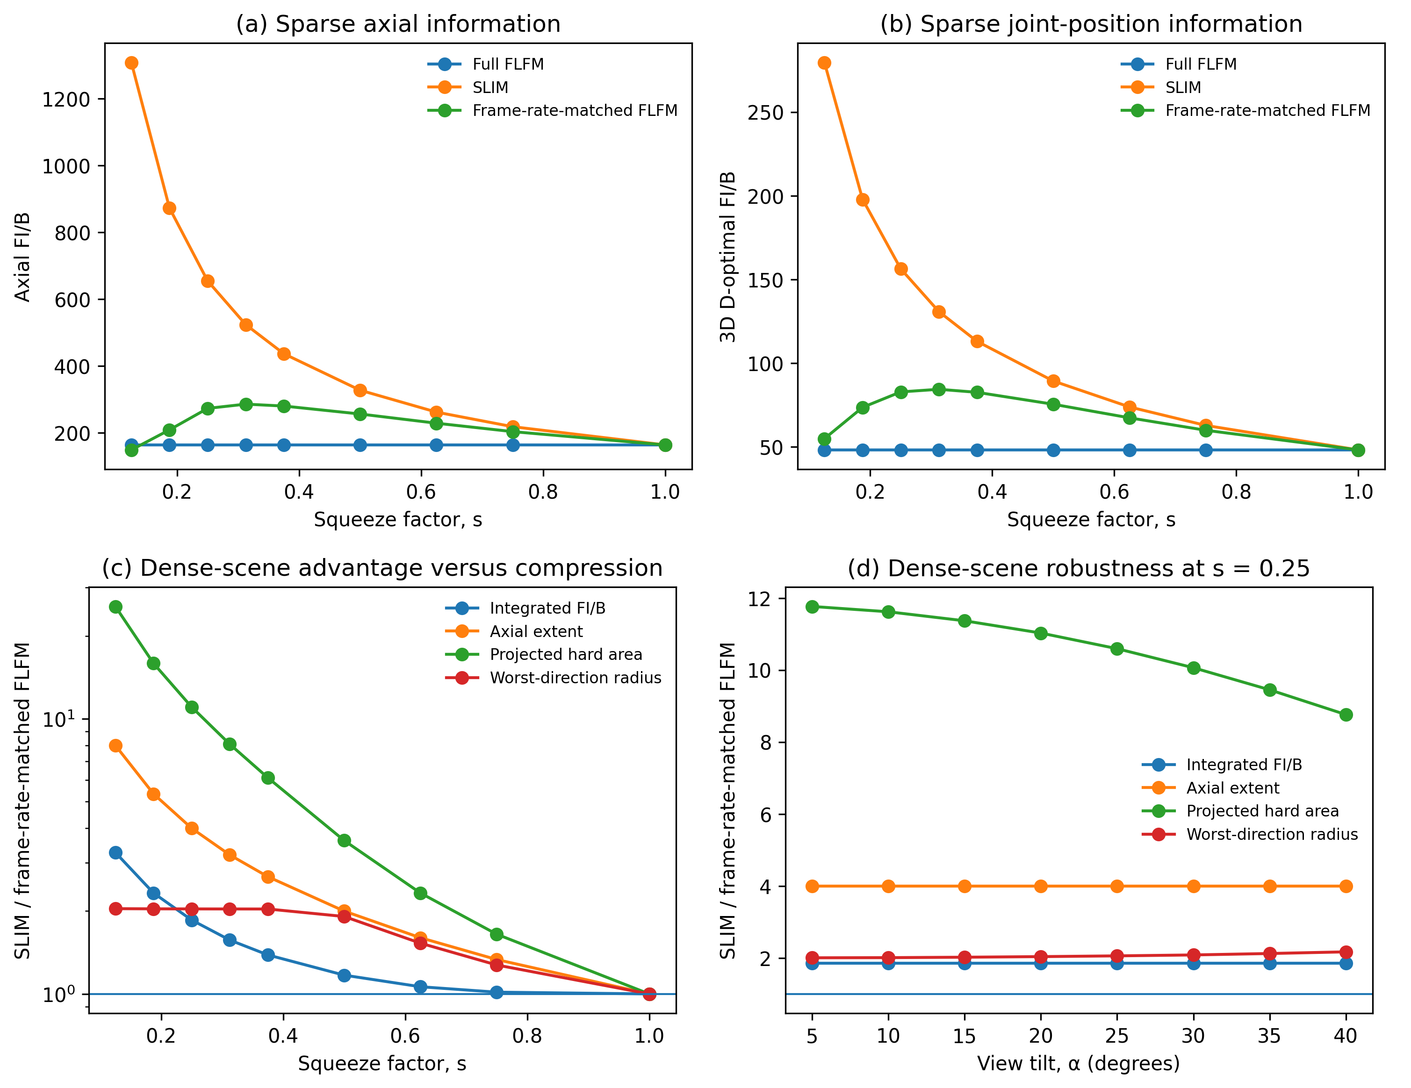
Supplementary Figure S1. Robustness of the Fisher-information advantage to squeeze factor and Fourier-slice tilt. (a) Effective axial FI/B for an isolated emitter as a function of squeeze factor s. (b) 3D D-optimal position FI/B versus $s$. The detector-phase ensemble is rescaled at each $s$ to span one complete frame-rate-matched output-pixel period. (c) Dense-scene SLIM-to-frame-rate-matched-FLFM ratios for integrated Fourier-mode FI/B, hard axial-frequency extent, projected hard-support area, and worst-direction projected hard-support radius at $α$ = 20°. The axial-frequency ratio follows 1/$s$, while all metrics converge to unity as $s$ → 1. (d) Dependence of the same dense-scene ratios on Fourier-slice tilt $α$ at $s$ = 0.25. The axial-frequency and integrated-FI/B ratios remain 4.0 and 1.86, respectively, over the idealized tilt sweep, whereas the projected hard-support-area advantage remains greater than 8.7× from 5° to 40°.

