Gel Electrophoresis Images of Resistance Genes in Bacterial Isolates Recovered from Herbal Preparations Sold in Alimosho LGA, Lagos State

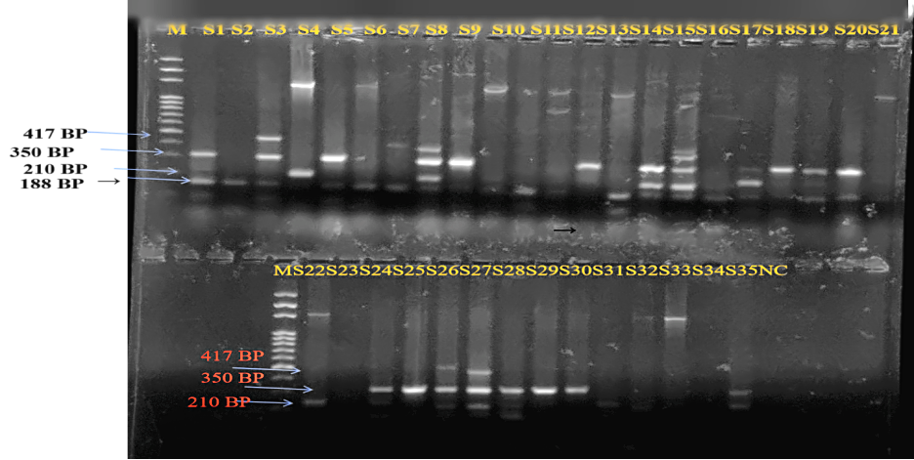

Figure S1: Representative Gel images showing positive Multiplex amplification of QnrA (188 bp), tetA (210 bp), sul1 (350 bp), and QnrS (417 bp) genes in multi drug resistant bacterial isolates recovered from herbal mixtures. Lane 1: 100bp Molecular weigh marker, NC: Negative control (nuclease free water), S1-35: PCR amplicons.
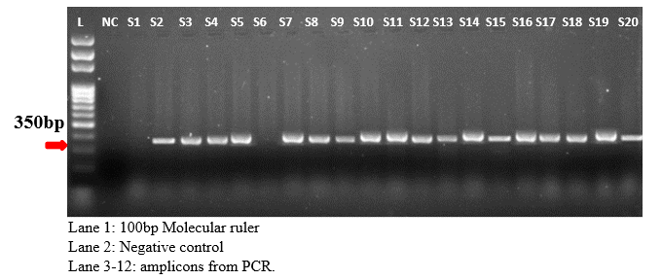
Figure S2: Representative Gel images showing positive amplification of sul1 genes in multi drug resistant bacterial isolates recovered from herbal mixtures. Lane 1: 100bp Molecular weigh marker, Lane 2: Negative control (nuclease free water), Lane 3-20: PCR amplicons.
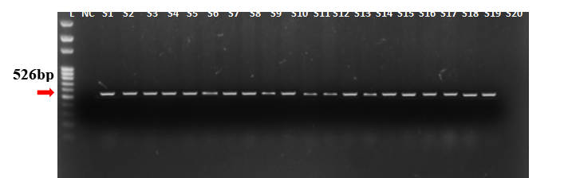
Figure S3: Representative Gel images showing positive amplification of ant(3)-La genes in multi drug resistant bacterial isolates recovered from herbal mixtures. Lane 1: 100bp Molecular weigh marker, Lane 2: Negative control (nuclease free water), Lane 3-20: PCR amplicons.

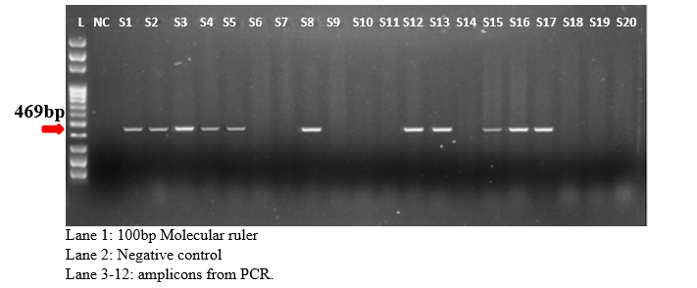
Figure S4: Representative Gel images showing positive amplification of QnrB genes in multi drug resistant bacterial isolates recovered from herbal mixtures. Lane 1: 100bp Molecular weigh marker, Lane 2: Negative control (nuclease free water), Lane 3-20:

