Supplementary Materials
Ultra-weak photon emission as a dual-axis probe of dynamized water: physicochemical characterization and germination bioassay

Supplementary Methods. Optical measurement geometry of the Berthold LUMAT LB9508
The Berthold LUMAT LB9508 (Berthold Technologies, Bad Wildbad, Germany) operates in single-photon counting mode with a PMT detector (spectral detection window 380–630 nm). Samples are introduced in borosilicate glass tubes into a light-tight chamber held at 20 °C; output is normalised by acquisition duration and detector area (RLU s⁻¹ cm⁻²). This configuration was applied identically across both study arms.
Supplementary Fig. S4. Optical geometry of the Berthold LUMAT LB9508.
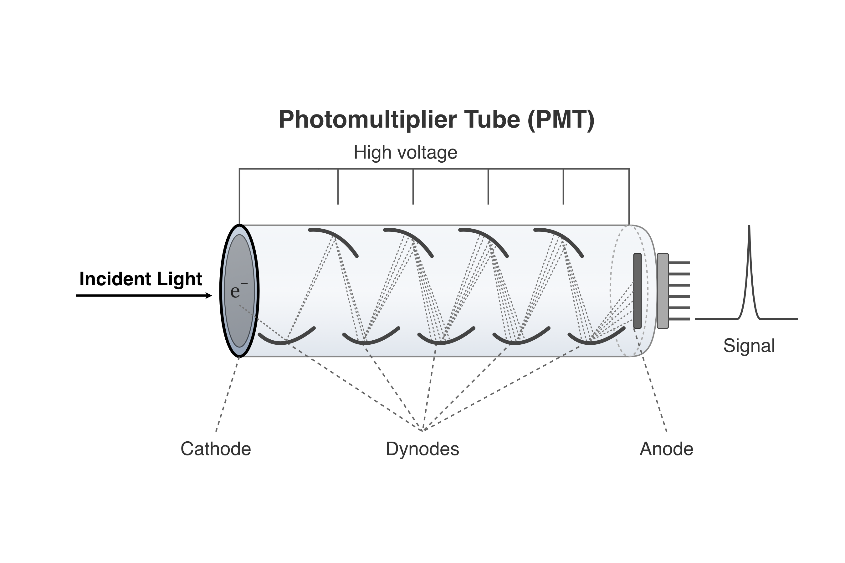
Fig. S4A — Signal acquisition chain. Schematic of the PMT detection chain: incident photon → photocathode → dynode cascade → anode → counting pulse, normalised to RLU s⁻¹ cm⁻².
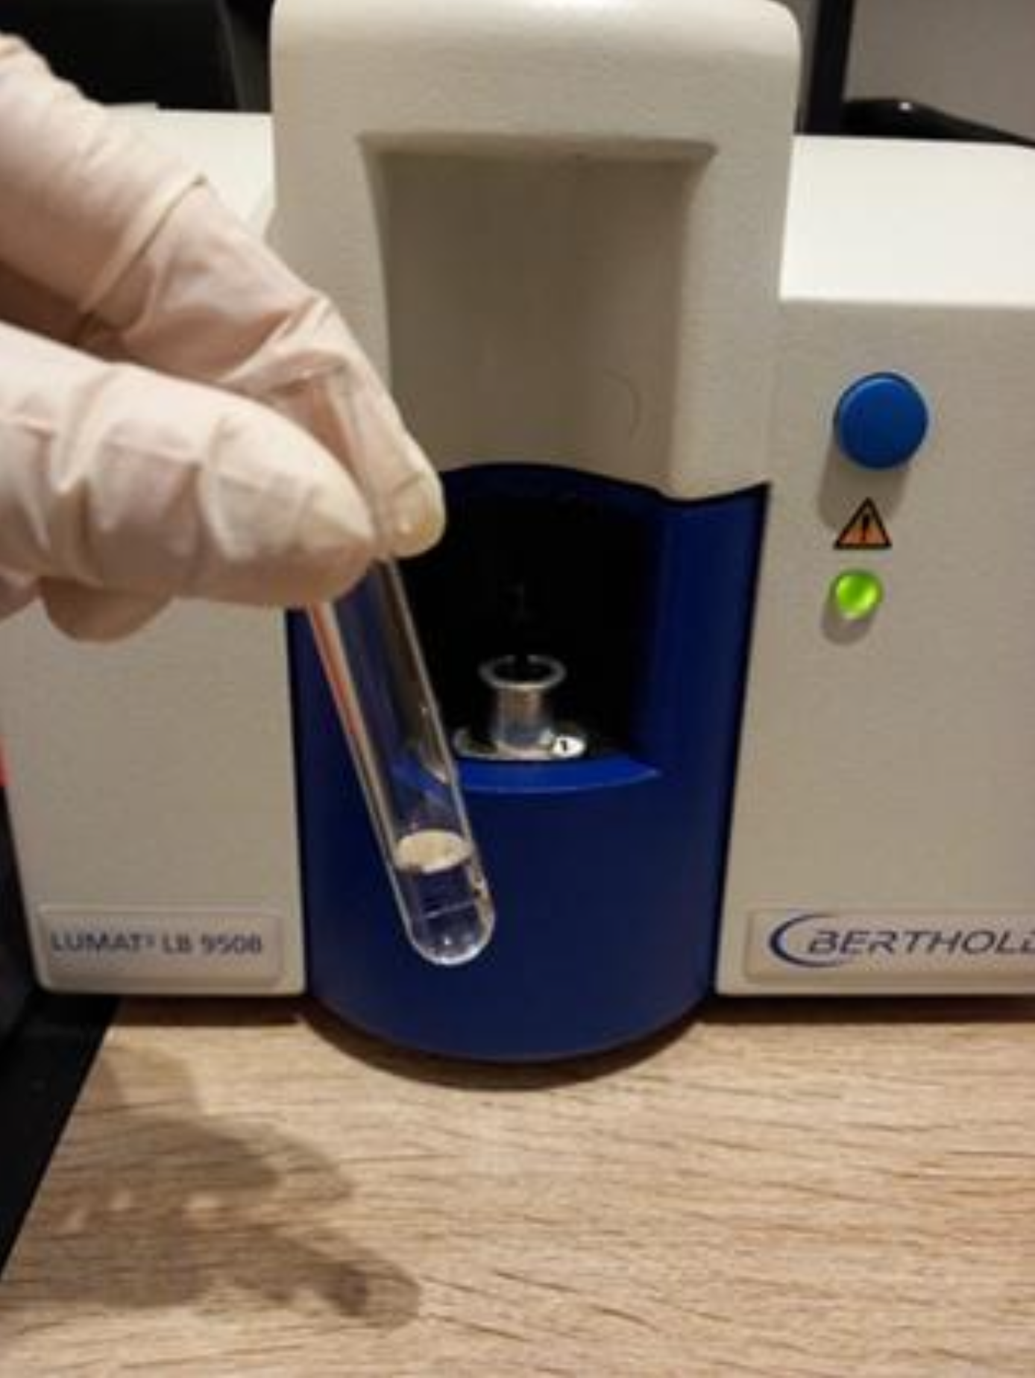
Fig. S4B — External view. Front-access aperture for borosilicate tube insertion; light-tight measurement housing. Image credit: Salières (2025a), adapted with permission.
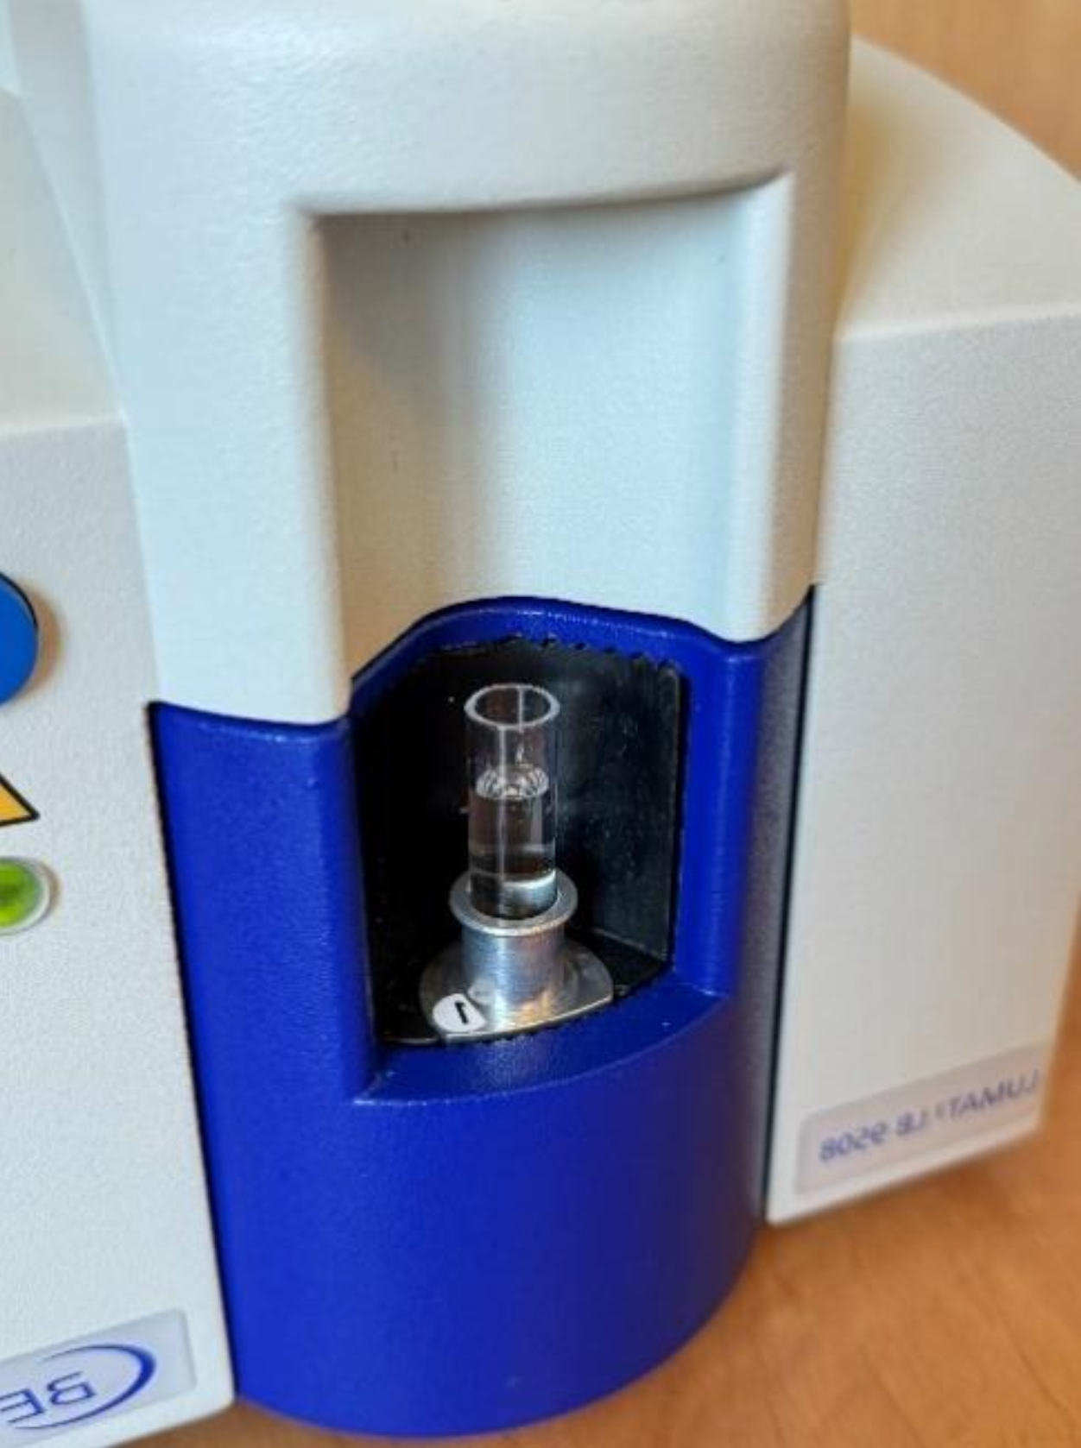
Fig. S4C — Open chamber. Cylindrical sample holder with PMT positioned below the sample compartment. Image credit: Salières (2025a), adapted with permission.
The three figures below provide qualitative photographic documentation of the germination bioassay described in §2.3–2.4 and §4.4–4.5 of the main text. No morphological measurements were performed on these images; quantitative data are reported exclusively in the main text (Fig. 4, Fig. 5, Table 1). Images are included to illustrate the macroscopic developmental context of the UPE signal differential.

Supplementary Fig. S1. Medicago sativa germination chambers at D3 — aerial view
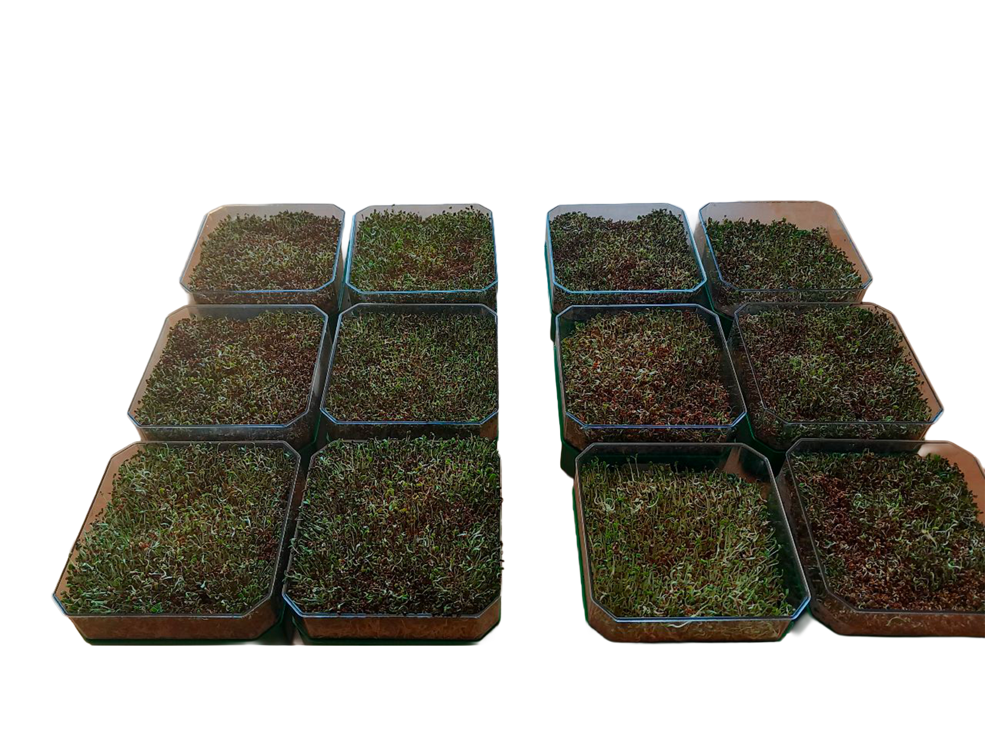
Supplementary Fig. S1. Aerial view of the 12 germination chambers at D3 (3 days post-seeding). Medicago sativa (alfalfa). Left: 6 germinators irrigated with technologically dynamized water (TDW; Biodynamizer®-processed mains water applied within 30 min of preparation). Right: 6 germinators irrigated with tap water (TW; same municipal supply as TDW pre-processing). At D3, early seedling emergence is visible in both groups; hypocotyl and cotyledon development is underway. The TDW group shows slightly more homogeneous green coloration and marginally denser aerial biomass; the TW group shows more pronounced reddish-brown tints in several trays, consistent with slower or less uniform germination progress. These early morphological differences are subtle; the UPE signal differential is already measurable at this time point (Table 1, main text: median TDW = 2,868 RLU s⁻¹ cm⁻², TW = 857 RLU s⁻¹ cm⁻², ratio 3.3, Cliff δ = 1.0). Seeds sourced from a single commercial batch (10 g per germinator); watering initiated the evening before D1 (100 mL overnight imbibition with assigned water type, ~12 h); 50 mL per session applied post-measurement at D1–D5; temperature 20 ± 2 °C, ISTA 2021 protocol.

Supplementary Fig. S2. Medicago sativa germination chambers at D6 — aerial view
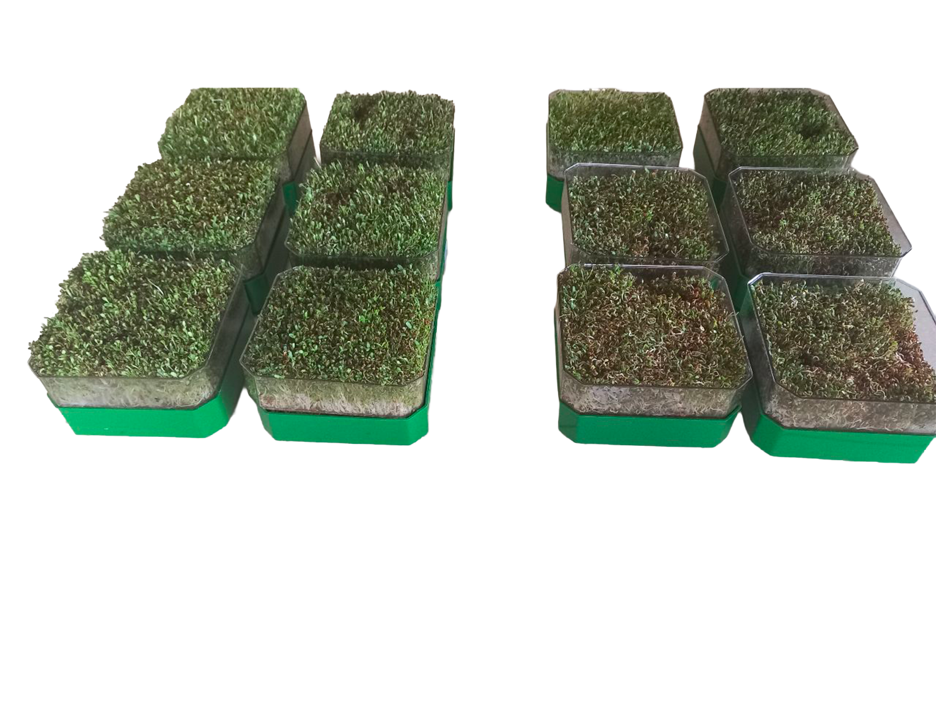
Supplementary Fig. S2. Aerial view of the 12 germination chambers at D6 (6 days post-seeding, primary endpoint). Medicago sativa (alfalfa). Left: 6 germinators irrigated with TDW. Right: 6 germinators irrigated with TW. Same conditions as Supplementary Fig. S1. At D6, the morphological differential between the two groups is visually salient: the TDW group displays dense, uniformly green aerial growth with well-developed trifoliate leaves and substantially greater canopy height; the TW group shows markedly lower aerial density, shorter stem height, and a pronounced mix of yellowish and brownish areas consistent with delayed or partially inhibited development. This qualitative morphological contrast is directionally concordant with the UPE differential reported at D6 in the primary quantitative comparison (Fig. 4, main text: Mann-Whitney U = 36, p = 5.1 × 10⁻³, Cliff δ = 1.0; median TDW = 9,107 RLU s⁻¹ cm⁻²; median TW = 2,140 RLU s⁻¹ cm⁻²; ratio 4.3). No morphological quantification was performed in this study.

Supplementary Fig. S3. Medicago sativa root development at D6 — lateral view
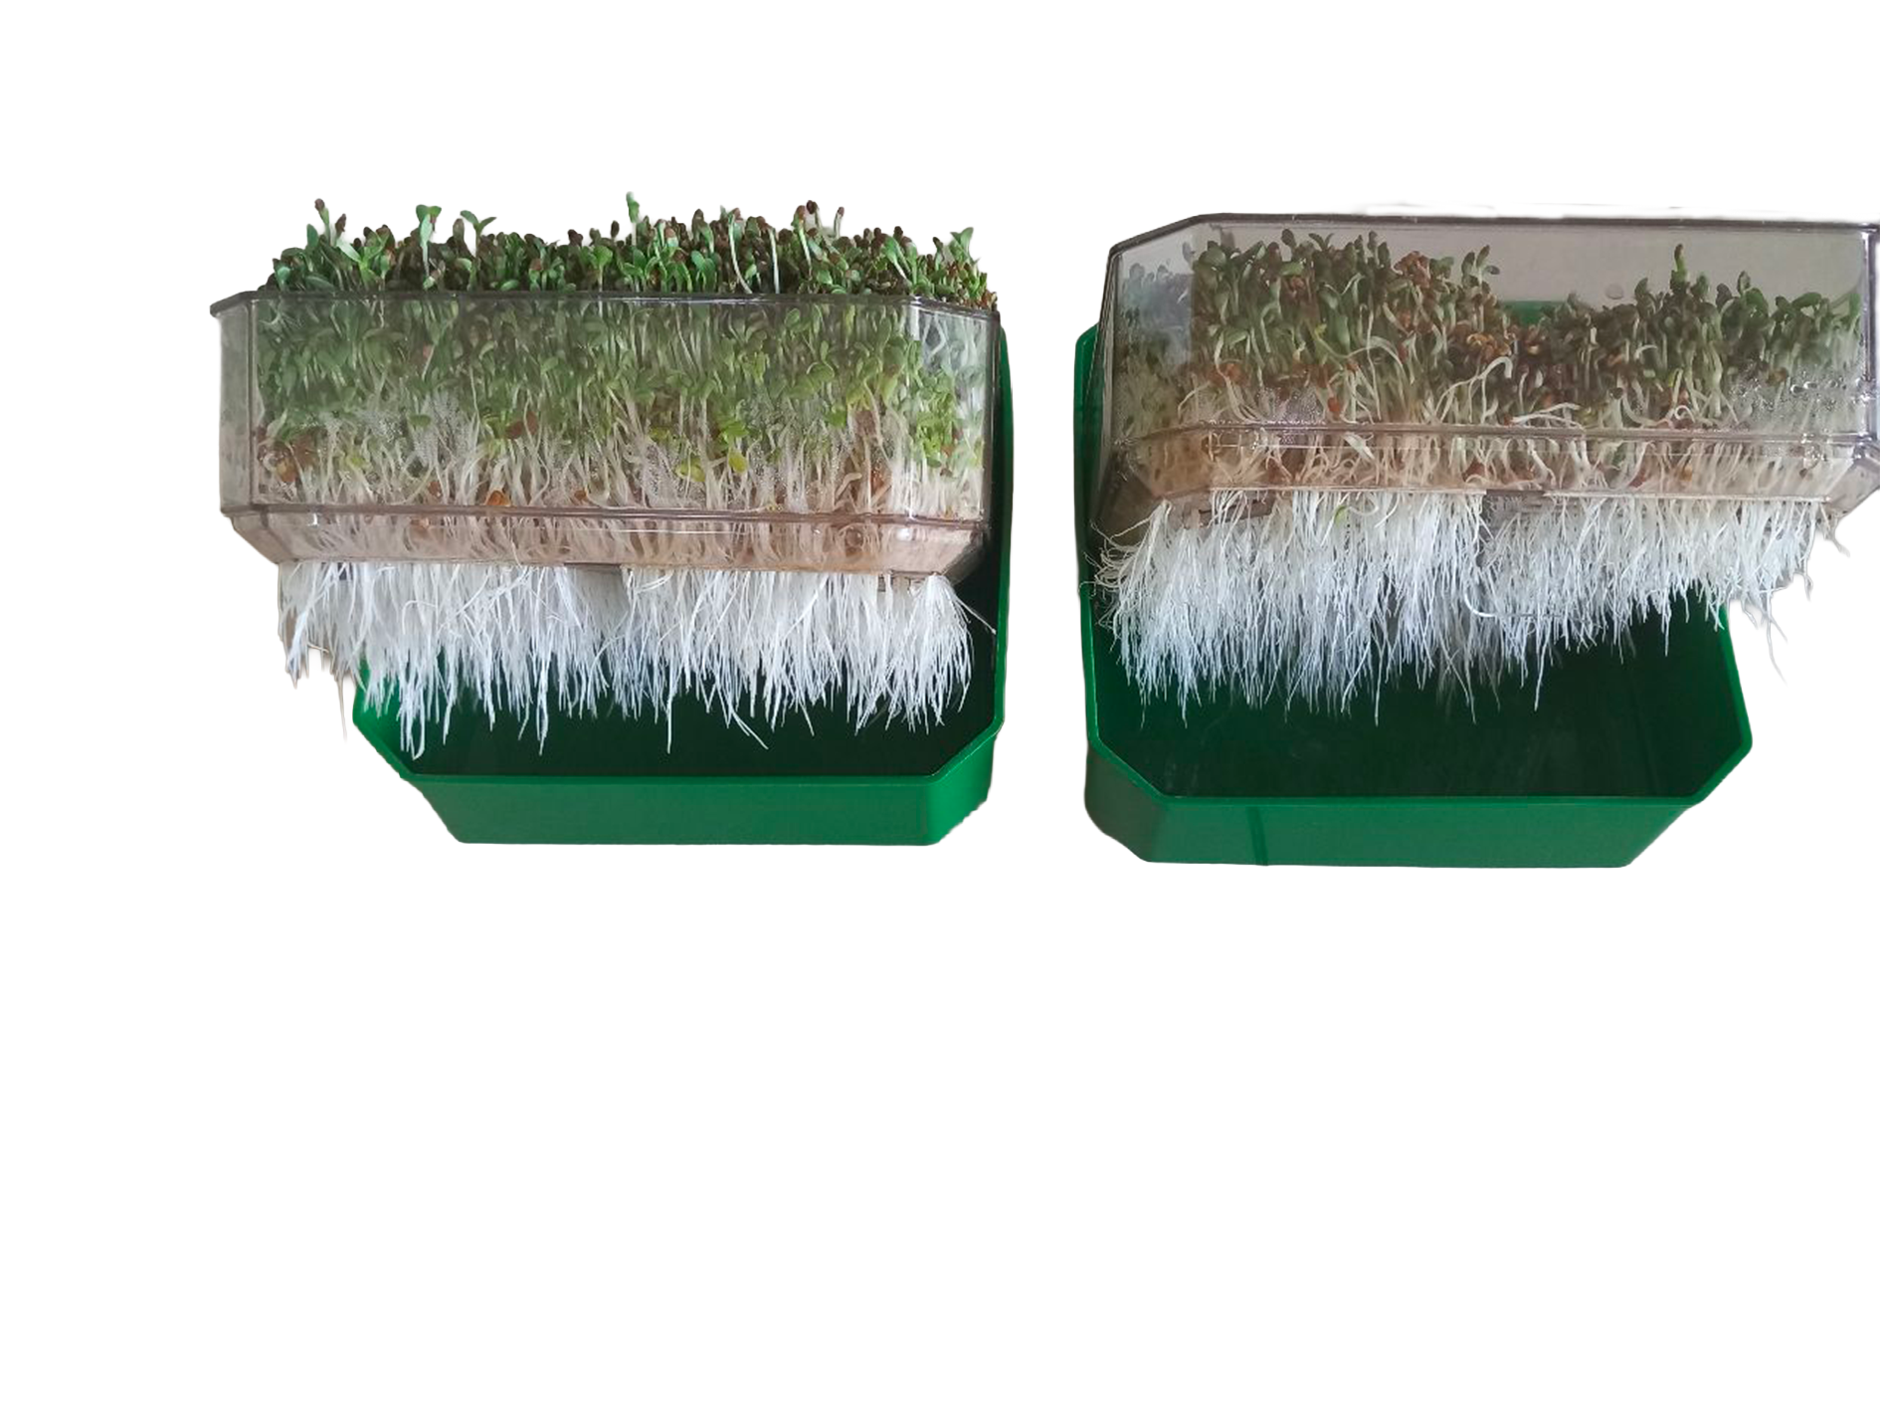
Supplementary Fig. S3. Lateral view of root development at D6 in representative germination chambers. Medicago sativa (alfalfa). Each germinator consists of a transparent-bottomed tray elevated on a solid-bottomed support tray, allowing root mass to be visualised through the base without extraction. Left: one TDW-irrigated germinator (representative of n = 6). Right: one TW-irrigated germinator (representative of n = 6). The TDW germinator displays an abundant dense white radicle mass extending substantially below the transparent base of the growing tray; the TW germinator shows a visibly shorter and less dense root mass. Aerial growth (visible above the tray rim) is also more developed in the TDW germinator, consistent with Supplementary Fig. S2. Root length was not quantified; radicle image analysis constitutes a candidate morphological endpoint for future dedicated work. Date of acquisition: 07/06/2026 (D6 of the June 2026 campaign).

Supplementary Table S1. Raw UPE data — physicochemical arm (water arm, N = 47 samples)
Per-sample mean photon flux density (background-subtracted RLU s⁻¹ cm⁻²) for all 47 independent water measurements across four campaigns (November 2025 – April 2026). Background subtraction applied per session (empty test-tube mean; per-session values ranged 24–42 RLU s⁻¹ cm⁻²). Delay: time elapsed between water preparation and luminometric acquisition (0 h = measured within 30 min). Kinetics series (February 2026) track the same preparation over multiple days. SNR = UPE mean / σ_bg, where σ_bg = 5.6 RLU s⁻¹ cm⁻² (inter-session SD of empty test-tube background). Abbreviations: TDW, technologically dynamized water; TW, tap water; GDW, geologically dynamized water; MBW, mineral bottled water; OW, osmosed water.
ID | Date | Type | Delay (h) | Series | UPE mean (RLU s⁻¹ cm⁻²) | SD | SNR
S01 | 04/11/2025 | TW | 0 | cross-sectional | 43 | 6 | 7.7
S02 | 04/11/2025 | MBW | 0 | cross-sectional | 45 | 10 | 8.0
S03 | 04/11/2025 | OW | 0 | cross-sectional | 47 | 11 | 8.4
S04 | 04/11/2025 | TDW | 0 | cross-sectional | 603 | 61 | 107.8
S05 | 04/11/2025 | TDW | 0 | cross-sectional | 440 | 40 | 78.7
S06 | 04/11/2025 | TDW | 0 | cross-sectional | 420 | 62 | 75.1
S07 | 01/12/2025 | TW | 0 | cross-sectional | 25 | 6 | 4.5
S08 | 01/12/2025 | TDW | 0 | cross-sectional | 369 | 57 | 66.0
S09 | 10/02/2026 | TW | 0 | TW-kinetics-s1 | 14 | 5 | 2.5
S10 | 10/02/2026 | TDW | 0 | TDW-kinetics-s1 | 418 | 10 | 74.7
S11 | 11/02/2026 | TW | 24 | TW-kinetics-s1 | 12 | 6 | 2.1
S12 | 11/02/2026 | GDW | 0 | GDW-kinetics | 330 | 10 | 59.0
S13 | 11/02/2026 | TDW | 0 | TDW-kinetics-s2 | 395 | 13 | 70.6
S14 | 11/02/2026 | TDW | 24 | TDW-kinetics-s1 | 326 | 10 | 58.3
S15 | 12/02/2026 | TW | 48 | TW-kinetics-s1 | 16 | 6 | 2.9
S16 | 12/02/2026 | GDW | 24 | GDW-kinetics | 325 | 8 | 58.1
S17 | 12/02/2026 | TDW | 24 | TDW-kinetics-s2 | 379 | 18 | 67.7
S18 | 12/02/2026 | TDW | 48 | TDW-kinetics-s1 | 177 | 10 | 31.6
S19 | 13/02/2026 | TW | 72 | TW-kinetics-s1 | 27 | 5 | 4.8
S20 | 13/02/2026 | GDW | 48 | GDW-kinetics | 225 | 10 | 40.2
S21 | 13/02/2026 | TDW | 48 | TDW-kinetics-s2 | 252 | 7 | 45.0
S22 | 13/02/2026 | TDW | 72 | TDW-kinetics-s1 | 106 | 10 | 18.9
S23 | 14/02/2026 | TW | 96 | TW-kinetics-s1 | 19 | 6 | 3.4
S24 | 14/02/2026 | GDW | 72 | GDW-kinetics | 107 | 9 | 19.1
S25 | 14/02/2026 | TDW | 72 | TDW-kinetics-s2 | 148 | 8 | 26.5
S26 | 14/02/2026 | TDW | 96 | TDW-kinetics-s1 | 31 | 11 | 5.5
S27 | 15/02/2026 | GDW | 96 | GDW-kinetics | 23 | 10 | 4.1
S28 | 15/02/2026 | TDW | 96 | TDW-kinetics-s2 | 23 | 12 | 4.1
S29 | 15/02/2026 | TDW | 120 | TDW-kinetics-s1 | 19 | 12 | 3.4
S30 | 16/02/2026 | GDW | 120 | GDW-kinetics | 26 | 10 | 4.6
S31 | 16/02/2026 | TDW | 120 | TDW-kinetics-s2 | 26 | 12 | 4.6
S32 | 16/02/2026 | TDW | 144 | TDW-kinetics-s1 | 22 | 12 | 3.9
S33 | 17/02/2026 | GDW | 144 | GDW-kinetics | 11 | 10 | 2.0
S34 | 17/02/2026 | TDW | 144 | TDW-kinetics-s2 | 11 | 12 | 2.0
S35 | 17/02/2026 | TDW | 168 | TDW-kinetics-s1 | 7 | 12 | 1.3
S36 | 18/02/2026 | GDW | 168 | GDW-kinetics | 18 | 10 | 3.2
S37 | 18/02/2026 | TDW | 168 | TDW-kinetics-s2 | 18 | 12 | 3.2
S38 | 13/04/2026 | TW | 0 | cross-sectional | 11 | 6 | 2.0
S39 | 13/04/2026 | TDW | 0 | cross-sectional | 424 | 37 | 75.8
S40 | 14/04/2026 | TW | 0 | cross-sectional | 19 | 6 | 3.4
S41 | 14/04/2026 | TDW | 0 | cross-sectional | 443 | 53 | 79.2
S42 | 15/04/2026 | TW | 0 | cross-sectional | 19 | 6 | 3.4
S43 | 15/04/2026 | TDW | 0 | cross-sectional | 460 | 34 | 82.2
S44 | 16/04/2026 | TW | 0 | cross-sectional | 6 | 6 | 1.1
S45 | 16/04/2026 | TDW | 0 | cross-sectional | 463 | 45 | 82.8
S46 | 17/04/2026 | TW | 0 | cross-sectional | 12 | 6 | 2.1
S47 | 17/04/2026 | TDW | 0 | cross-sectional | 453 | 42 | 81.0
Primary comparison (§2.1): TDW at t₀ (relaxation delay = 0) vs TW (relaxation delay = 0), n = 11 TDW (S04–S06 + S08 + S10 + S13 + S39 + S41 + S43 + S45 + S47) vs n = 11 TW (S01 + S07 + S09 + S38 + S40 + S42 + S44 + S46 + two additional TW measurements from the February kinetics series: S09 [delay = 0], S11 [delay = 24 h]). Kinetics series (§2.2): S09–S37 (February 2026 longitudinal tracking).

Supplementary Table S2. Raw UPE data — germination bioassay arm (N = 84 germinator-session observations)
Per-germinator mean photon flux density (background-subtracted RLU s⁻¹ cm⁻²) for each measurement session (D0–D6) in the June 2026 germination campaign. Each value represents the mean of 11 consecutive 1-minute sub-acquisitions from a single germinator, background-subtracted using the empty test-tube value from the same session. SD = standard deviation across sub-acquisitions. Germinators G01–G06 were irrigated with TDW (technologically dynamized water); G07–G12 with TW (tap water, control). D0 (2026-05-30) was acquired on the day of seeding before the first irrigation; both groups show identical UPE at D0 (median = 222 RLU s⁻¹ cm⁻², SD < 1.2 across all 12 germinators), confirming that random group assignment produced balanced groups before any treatment was applied. D0 is excluded from primary and longitudinal comparisons. Primary comparison is at D6 (§2.3); longitudinal profile is reported across D1–D6 (§2.4, Table 1). Sampling was destructive: each germinator was measured once per session.
Session | Date | Germ. | Cond. | UPE mean (RLU s⁻¹ cm⁻²) | SD
D0 | 2026-05-30 | G01 | TDW | 222 | 1.0
D0 | 2026-05-30 | G02 | TDW | 222 | 0.8
D0 | 2026-05-30 | G03 | TDW | 222 | 1.1
D0 | 2026-05-30 | G04 | TDW | 222 | 0.7
D0 | 2026-05-30 | G05 | TDW | 222 | 0.6
D0 | 2026-05-30 | G06 | TDW | 222 | 0.8
D0 | 2026-05-30 | G07 | TW | 222 | 0.8
D0 | 2026-05-30 | G08 | TW | 222 | 0.8
D0 | 2026-05-30 | G09 | TW | 222 | 0.9
D0 | 2026-05-30 | G10 | TW | 221 | 1.2
D0 | 2026-05-30 | G11 | TW | 222 | 0.9
D0 | 2026-05-30 | G12 | TW | 222 | 0.9
D1 | 2026-06-01 | G01 | TDW | 687 | 24.3
D1 | 2026-06-01 | G02 | TDW | 697 | 23.3
D1 | 2026-06-01 | G03 | TDW | 690 | 20.8
D1 | 2026-06-01 | G04 | TDW | 691 | 30.5
D1 | 2026-06-01 | G05 | TDW | 689 | 23.4
D1 | 2026-06-01 | G06 | TDW | 682 | 22.0
D1 | 2026-06-01 | G07 | TW | 277 | 35.4
D1 | 2026-06-01 | G08 | TW | 263 | 47.1
D1 | 2026-06-01 | G09 | TW | 246 | 57.2
D1 | 2026-06-01 | G10 | TW | 261 | 28.0
D1 | 2026-06-01 | G11 | TW | 246 | 55.7
D1 | 2026-06-01 | G12 | TW | 252 | 44.8
D2 | 2026-06-02 | G01 | TDW | 2579 | 74.8
D2 | 2026-06-02 | G02 | TDW | 2657 | 55.4
D2 | 2026-06-02 | G03 | TDW | 2657 | 38.9
D2 | 2026-06-02 | G04 | TDW | 2673 | 26.7
D2 | 2026-06-02 | G05 | TDW | 2654 | 27.0
D2 | 2026-06-02 | G06 | TDW | 2651 | 42.0
D2 | 2026-06-02 | G07 | TW | 366 | 32.6
D2 | 2026-06-02 | G08 | TW | 360 | 19.9
D2 | 2026-06-02 | G09 | TW | 328 | 61.8
D2 | 2026-06-02 | G10 | TW | 353 | 31.8
D2 | 2026-06-02 | G11 | TW | 344 | 34.4
D2 | 2026-06-02 | G12 | TW | 359 | 25.5
D3 | 2026-06-03 | G01 | TDW | 2891 | 41.4
D3 | 2026-06-03 | G02 | TDW | 2866 | 48.8
D3 | 2026-06-03 | G03 | TDW | 2869 | 86.9
D3 | 2026-06-03 | G04 | TDW | 2866 | 37.4
D3 | 2026-06-03 | G05 | TDW | 2875 | 44.6
D3 | 2026-06-03 | G06 | TDW | 2858 | 41.4
D3 | 2026-06-03 | G07 | TW | 855 | 35.7
D3 | 2026-06-03 | G08 | TW | 877 | 22.1
D3 | 2026-06-03 | G09 | TW | 847 | 37.6
D3 | 2026-06-03 | G10 | TW | 859 | 11.8
D3 | 2026-06-03 | G11 | TW | 827 | 40.8
D3 | 2026-06-03 | G12 | TW | 864 | 11.7
D4 | 2026-06-04 | G01 | TDW | 5715 | 54.4
D4 | 2026-06-04 | G02 | TDW | 5741 | 38.0
D4 | 2026-06-04 | G03 | TDW | 5757 | 28.9
D4 | 2026-06-04 | G04 | TDW | 5761 | 8.8
D4 | 2026-06-04 | G05 | TDW | 5756 | 10.8
D4 | 2026-06-04 | G06 | TDW | 5737 | 17.8
D4 | 2026-06-04 | G07 | TW | 860 | 17.0
D4 | 2026-06-04 | G08 | TW | 857 | 17.9
D4 | 2026-06-04 | G09 | TW | 870 | 9.3
D4 | 2026-06-04 | G10 | TW | 850 | 22.3
D4 | 2026-06-04 | G11 | TW | 859 | 24.1
D4 | 2026-06-04 | G12 | TW | 847 | 27.5
D5 | 2026-06-05 | G01 | TDW | 7826 | 44.9
D5 | 2026-06-05 | G02 | TDW | 7808 | 36.4
D5 | 2026-06-05 | G03 | TDW | 7807 | 55.8
D5 | 2026-06-05 | G04 | TDW | 7789 | 69.7
D5 | 2026-06-05 | G05 | TDW | 7805 | 65.3
D5 | 2026-06-05 | G06 | TDW | 7797 | 55.7
D5 | 2026-06-05 | G07 | TW | 2115 | 35.7
D5 | 2026-06-05 | G08 | TW | 2086 | 39.7
D5 | 2026-06-05 | G09 | TW | 2066 | 22.1
D5 | 2026-06-05 | G10 | TW | 2099 | 84.4
D5 | 2026-06-05 | G11 | TW | 2053 | 53.5
D5 | 2026-06-05 | G12 | TW | 2034 | 44.0
D6 | 2026-06-06 | G01 | TDW | 9065 | 26.4
D6 | 2026-06-06 | G02 | TDW | 9082 | 23.3
D6 | 2026-06-06 | G03 | TDW | 9126 | 58.6
D6 | 2026-06-06 | G04 | TDW | 9113 | 56.7
D6 | 2026-06-06 | G05 | TDW | 9101 | 75.4
D6 | 2026-06-06 | G06 | TDW | 9144 | 87.0
D6 | 2026-06-06 | G07 | TW | 2278 | 174.9
D6 | 2026-06-06 | G08 | TW | 2148 | 156.8
D6 | 2026-06-06 | G09 | TW | 2132 | 105.4
D6 | 2026-06-06 | G10 | TW | 2192 | 71.4
D6 | 2026-06-06 | G11 | TW | 2074 | 150.0
D6 | 2026-06-06 | G12 | TW | 2038 | 137.0
SD reflects within-germinator repeatability across 11 consecutive 1-minute sub-acquisitions within a single measurement session. The high SD at D1 in the TW group reflects early-germination photon count variability in the low-signal range; all values exceed SNR ≥ 3. The near-zero SD at D0 reflects the instrumental noise floor before metabolic photon emission diverges between groups.

Supplementary Table S3. Physicochemical characterisation of TDW vs TW — Independent laboratory analyses (CEBEDEAU, 2019)
Independent physicochemical analyses performed by CEBEDEAU (Centre de Recherche et d’Expertise pour l’Eau, Liège, Belgium), commissioned by Dynamized Technologies SA, conducted by Robert Bech. Two analytical campaigns were conducted: R-19-2107 (19 August 2019) and R-19-2952 (11 December 2019). The Biodynamizer® device was installed at CEBEDEAU premises under conditions validated by a Dynamized Technologies representative. These analyses were performed on a geographically independent installation (Rhode-Saint-Genèse, Belgium, municipal supply) from the device used in the present study (Nice, France, municipal supply), providing an external replication of the device class under different source water chemistry.
Table S3a. Physicochemical parameters — TW vs TDW (mean of triplicate measurements, R-19-2107 §3.1.1)
Parameter | TW (control) | TDW (dynamized) | Difference
Conductivity (μS/cm) | 666 | 647 | −3%
Total Hardness — TH (°F) | 29.68 | 28.79 | −3%
Ca dissolved (mg/L) | 88.9 | 87.0 | −2%
Mg dissolved (mg/L) | 12.3 | 11.7 | −5%
Si (mg/L) | 7.7 | 7.8 | +1%
P-PO₄ (mg/L) | <0.02 | 0.05 | trace
Temperature (°C) | 24.2 | 23.6 | −0.6
All values are means of triplicate measurements (Ca, Mg, Si, P-PO₄ from single measurement due to sample volume constraints).
Table S3b. CaCO₃ precipitation potential — marble test (R-19-2107 §3.1.2, ASTM 2330C)
Test performed at CEBEDEAU laboratory: 3 Erlenmeyers (250 mL), 500 mg pure CaCO₃ per flask, hermetically sealed, agitated at 25 °C ± 1 °C for 72 h in separate incubators per water type. Analyses performed on 0.45 µm filtered samples.
Water | Alkalinity before (°F) | Alkalinity after (°F) | p | Hardness before (°F) | Hardness after (°F) | p | CaCO₃ precipitated
TW (control) | 21.2 | 21.4 | 0.308 | 29.68 | 29.62 | 0.128 | not significant
TDW (dynamized) | 20.8 | 19.90 | significant | 28.79 | 27.13 | significant | ~16 mg CaCO₃ equiv/L
TDW shows active carbonate precipitation capacity; TW does not. This result is discussed in §3.1c of the main text.
Table S3c. Dissolved O₂ kinetic monitoring — on-site measurement (R-19-2107 §3.3)
Samples drawn directly on-site from the device outlet by CEBEDEAU personnel; 2.5 L glass beakers, with precautions to prevent air injection during collection. Two LDO101 Hach Lange probes immersed simultaneously. This protocol eliminates transport artefacts and constitutes the methodologically controlled dissolved O₂ assessment. Single test, indicative value only (no triplicates).
Water | Linear fit (mgO₂/L vs time) | R² | Duration | Inter-curve differences
TW (control) | y = −0.3485x + 15.226 | 0.963 | 72 h | Within sensor precision (±0.2 mgO₂/L) throughout
TDW (dynamized) | y = −0.4259x + 18.950 | 0.903 | 72 h | Within sensor precision (±0.2 mgO₂/L) throughout
Both waters show similar linear O₂ desorption kinetics over 72 h; no sustained differential in dissolved O₂ content. This null result is discussed in §3.1c of the main text.
Table S3d. Metal leaching from the Biodynamizer® device (R-19-2952)
Water samples analyzed for metal content after stagnation within the device: T0 = inlet water before the device; T1 = water stagnant for 1 h; T24 = water stagnant for 24 h.
Parameter | T0 | T1 (1 h) | T24 (24 h) | Agri-food standard | Potable water standard
Ag (mg/L) | <0.001 | <0.001 | <0.001 | 0.1 | —
Cu (mg/L) | 0.002 | 0.031 | <1.000 | 2 | 2
Zn (mg/L) | 0.10 | 0.21 | 0.36 | — | 5
All metal concentrations are well below Wallonian regulatory limits. Standards: agri-food = Belgian AFSCA agri-food sector limits (Annex 2 of the Circular on water quality control); potable water = Annex XXXI of the Belgian Water Code. Dash (—) = no applicable standard for that parameter/category in the CEBEDEAU report.

