Supplementary Materials

Supplementary Table 1 Inconsistency analysis of direct versus indirect evidence for the comparative detection rates of cardiac sarcoidosis across imaging modalities.

Comparison | Number of studies | NMA estimate | Direct estimate | Indirect estimate |  | Inconsistency (difference) | Lower 95% CI | Upper 95% CI |  | p value
¹⁸F-FDG PET/MRI vs. ¹⁸F-FDG PET/CT | 1 | -0.09 | 0 | -0.24 | 0.24 |  | -0.48 | 0.97 | 0.51
⁶⁷Ga scintigraphy vs. ¹⁸F-FDG PET/CT | 1 | -0.73 | -0.73 | - | - |  | - | - | -
CMR-LGE vs. ¹⁸F-FDG PET/CT | 5 | 0.18 | 0.18 | - | - |  | - | - | -
T2w CMR vs. ¹⁸F-FDG PET/CT | 1 | -0.47 | -0.47 | -0.49 | 0.02 |  | -0.38 | 0.41 | 0.94
¹⁸F-FLT PET vs. ¹⁸F-FDG PET/CT | 2 | 0 | 0 | - | - |  | - | - | -
⁶⁸Ga-DOTANOC PET/CT vs. ¹⁸F-FDG PET/CT | 1 | 0.11 | 0.11 | - | - |  | - | - | -
⁶⁸Ga-DOTATOC PET/CT vs. ¹⁸F-FDG PET/CT | 0 | -0.02 | - | -0.02 | - |  | - | - | -
^{99m}TC MIBI vs. ¹⁸F-FDG PET/CT | 1 | -0.49 | -0.40 | -0.60 | 0.20 |  | -0.40 | 0.81 | 0.51
¹⁸F-FDG PET/MRI vs. ⁶⁷Ga scintigraphy | 0 | 0.65 | - | 0.65 | - |  | - | - | -
¹⁸F-FDG PET/MRI vs. CMR-LGE | 1 | -0.27 | -0.30 | 0.15 | -0.45 |  | -1.78 | 0.88 | 0.51
¹⁸F-FDG PET/MRI vs. T2w-CMR | 0 | 0.39 | - | 0.39 | - |  | - | - | -
¹⁸F-FDG PET/MRI vs. ¹⁸F-FLT PET/CT | 0 | -0.09 | - | -0.09 | - |  | - | - | -
¹⁸F-FDG PET/MRI vs. ⁶⁸Ga-DOTANOC PET/CT | 0 | -0.19 | - | -0.19 | - |  | - | - | -
¹⁸F-FDG PET/MRI vs. ⁶⁸Ga-DOTATOC PET/CT | 0 | -0.07 | - | -0.07 | - |  | - | - | -
¹⁸F-FDG PET/MRI vs. ^{99m}TC-MIBI | 1 | 0.40 | 0.40 | - | - |  | - | - | -
⁶⁷Ga scintigraphy vs. CMR-LGE | 0 | -0.92 | - | -0.92 | - |  | - | - | -
⁶⁷Ga scintigraphy vs. T2w-CMR | 0 | -0.26 | - | -0.26 | - |  | - | - | -
⁶⁷Ga scintigraphy vs. ¹⁸F-FLT PET/CT | 0 | -0.74 | - | -0.74 | - |  | - | - | -
⁶⁷Ga scintigraphy vs. ⁶⁸Ga-DOTANOC PET/CT | 0 | -0.84 | - | -0.84 | - |  | - | - | -
⁶⁷Ga scintigraphy vs. ⁶⁸Ga-DOTATOC PET/CT | 0 | -0.72 | - | -0.72 | - |  | - | - | -
⁶⁷Ga scintigraphy vs. ^{99m}TC-MIBI | 0 | -0.25 | - | -0.25 | - |  | - | - | -
CMR-LGE vs. T2w-CMR | 1 | 0.66 | 0.66 | 0.55 | 0.11 |  | -2.55 | 2.76 | 0.94
CMR-LGE vs. ¹⁸F-FLT-PET/CT | 0 | 0.18 | - | 0.18 | - |  | - | - | -
CMR-LGE vs. ⁶⁸Ga-DOTANOC PET/CT | 0 | 0.08 | - | 0.08 | - |  | - | - | -
CMR-LGE vs. ⁶⁸Ga-DOTATOC PET/CT | 1 | 0.20 | 0.20 | - | - |  | - | - | -
CMR-LGE vs. ^{99m}TC-MIBI | 1 | 0.67 | 0.70 | 0.36 | 0.34 |  | -0.67 | 1.35 | 0.51
T2w-CMR vs. ¹⁸F-FLT-PET/CT | 0 | -0.47 | - | -0.47 | - |  | - | - | -
T2w-CMR vs. ⁶⁸Ga-DOTANOC PET/CT | 0 | -0.58 | - | -0.58 | - |  | - | - | -
T2w-CMR vs. ⁶⁸Ga-DOTATOC PET/CT | 0 | -0.46 | - | -0.46 | - |  | - | - | -
T2w-CMR vs. ^{99m}TC MIBI | 0 | 0.01 | - | 0.01 | - |  | - | - | -
¹⁸F-FLT PET vs. ⁶⁸Ga-DOTANOC PET/CT | 0 | -0.10 | - | -0.10 | - |  | - | - | -
¹⁸F-FLT PET vs. ⁶⁸Ga-DOTATOC PET/CT | 0 | 0.02 | - | 0.02 | - |  | - | - | -
¹⁸F-FLT PET vs. ^{99m}TC MIBI | 0 | 0.49 | - | 0.49 | - |  | - | - | -
⁶⁸Ga-DOTANOC PET/CT vs. ⁶⁸Ga-DOTATOC PET/CT | 0 | 0.12 | - | 0.12 | - |  | - | - | -
⁶⁸Ga-DOTANOC PET/CT vs. ^{99m}TC MIBI | 0 | 0.59 | - | 0.59 | - |  | - | - | -
⁶⁸Ga-DOTATOC PET/CT vs. ^{99m}TC MIBI | 0 | 0.47 | - | 0.47 | - |  | - | - | -

Abbreviations: NMA, network meta-analysis; CI, confidence interval.

A
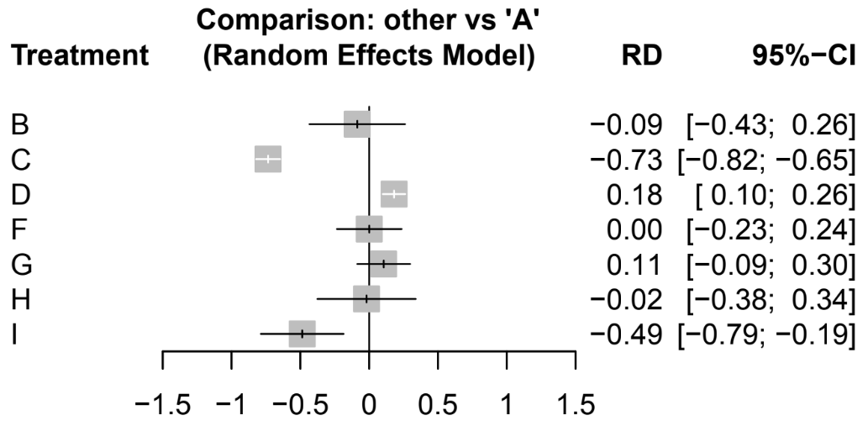
B
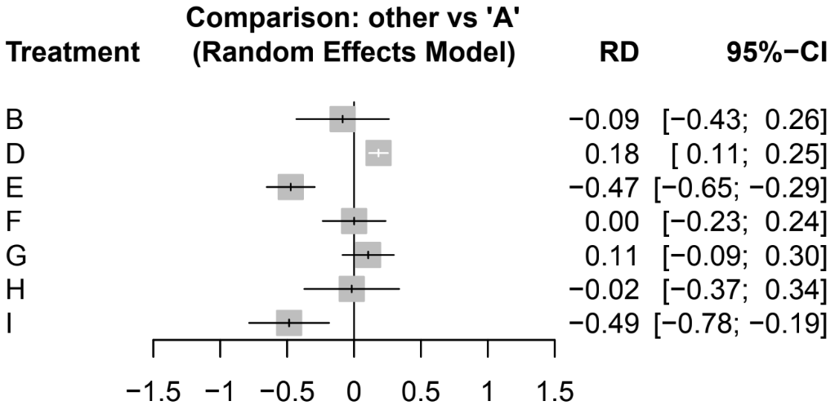

C
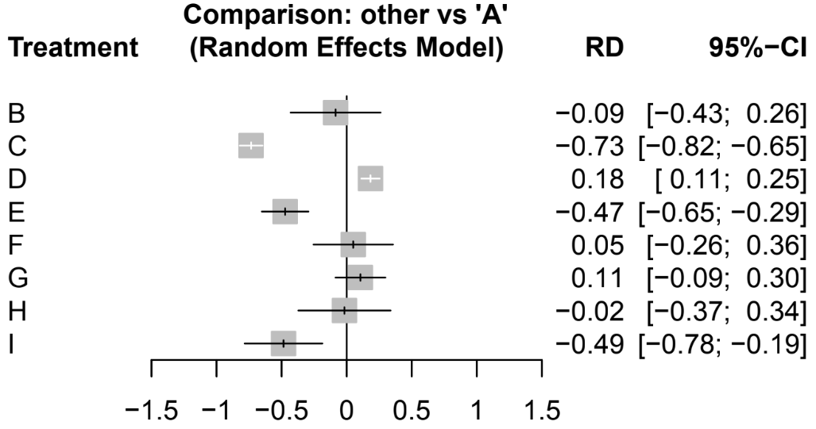
D
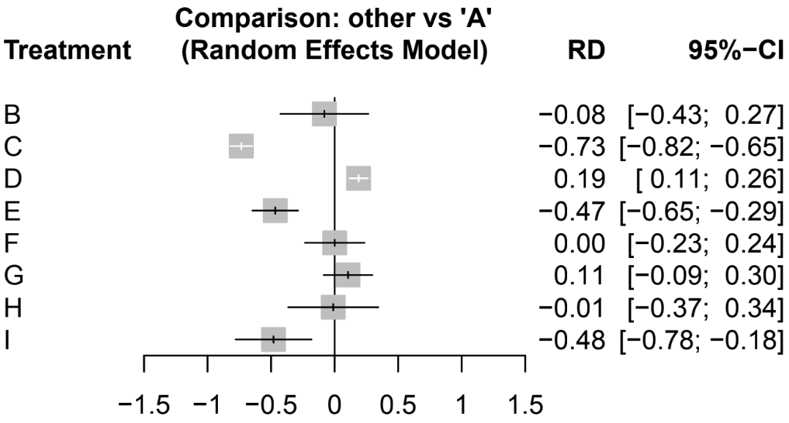

E
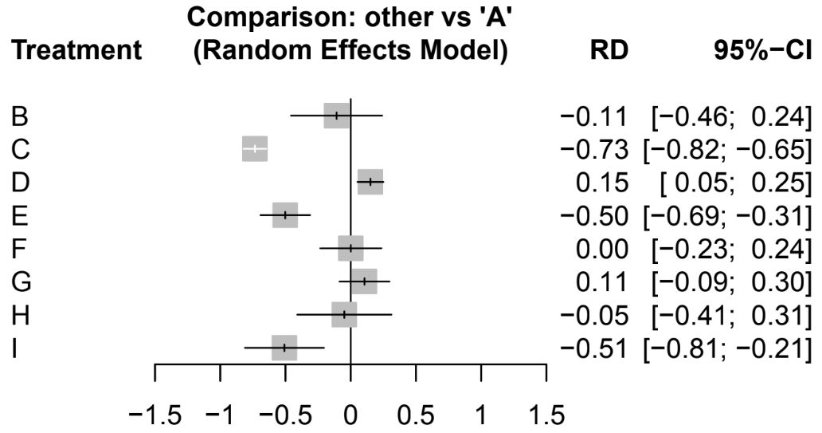
F
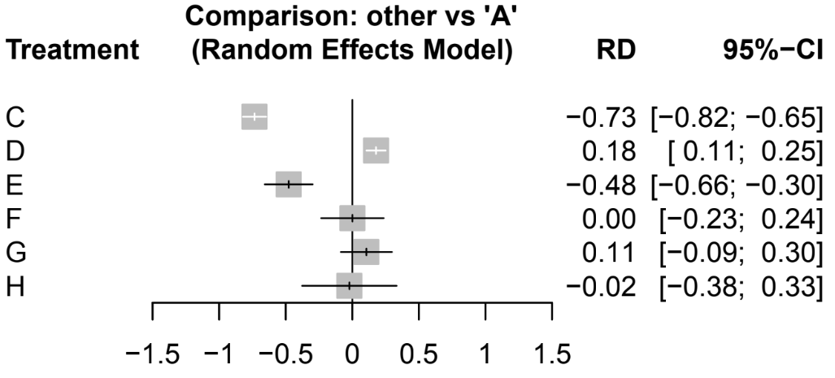
G
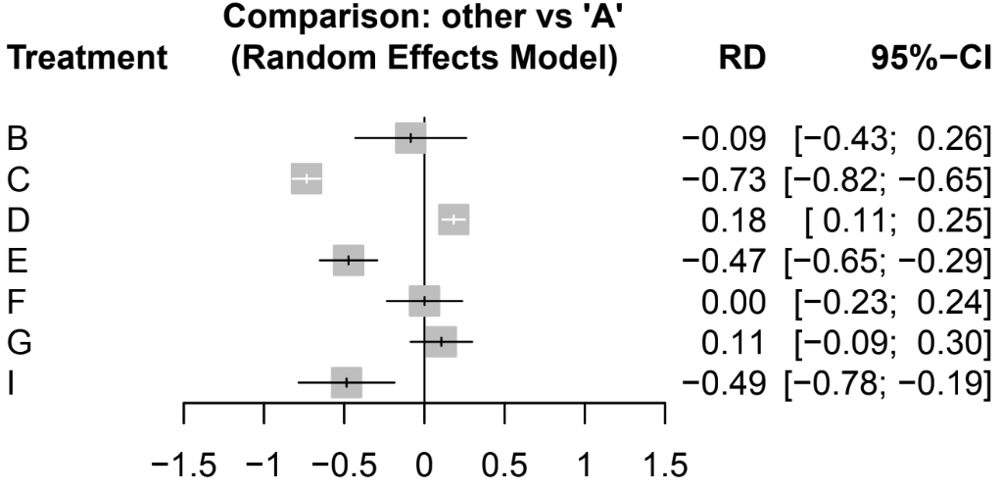
H
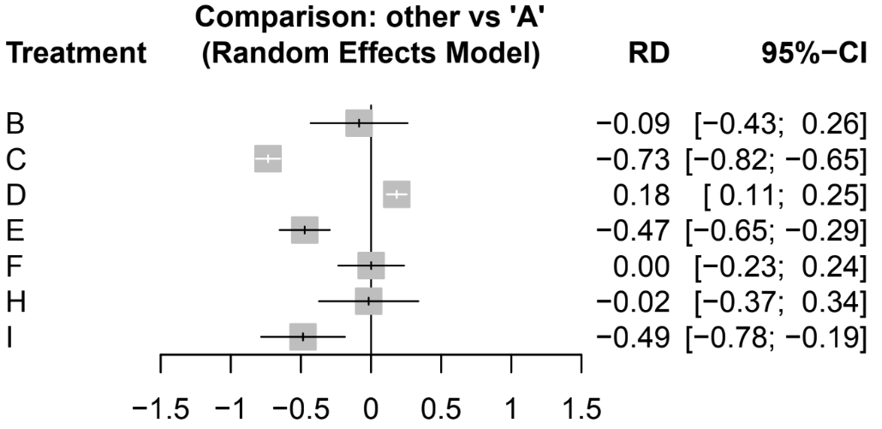
I
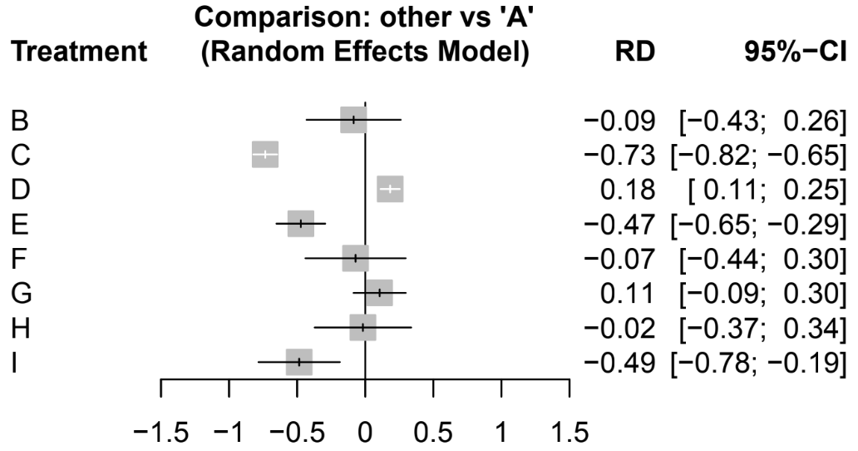
J
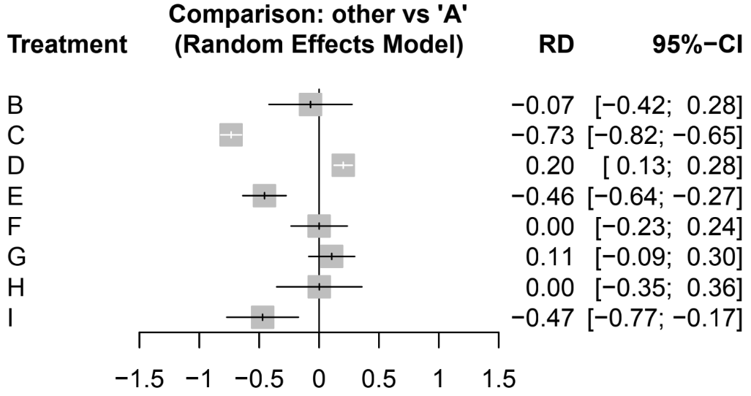
Supplementary Fig. 1 Leave-one-out sensitivity analyses across the ten included studies. Each study was sequentially removed and the network meta-analysis repeated, with studies ordered alphabetically (A–I). Forest plots display pooled effect estimates and 95% confidence intervals following each exclusion. The negligible variation in effect estimates across iterations confirms the robustness of the primary results and excludes undue influence from any single study.

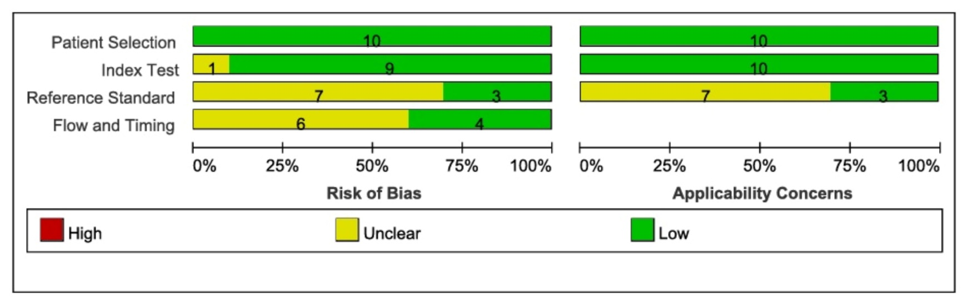
Supplementary Fig. 2 QUADAS-2 risk of bias and applicability concerns across the four assessment domains (patient selection, index test, reference standard, and flow and timing) for the ten included studies. Bars indicate the number of studies rated as low (green), unclear (yellow), or high (red) risk in each domain.
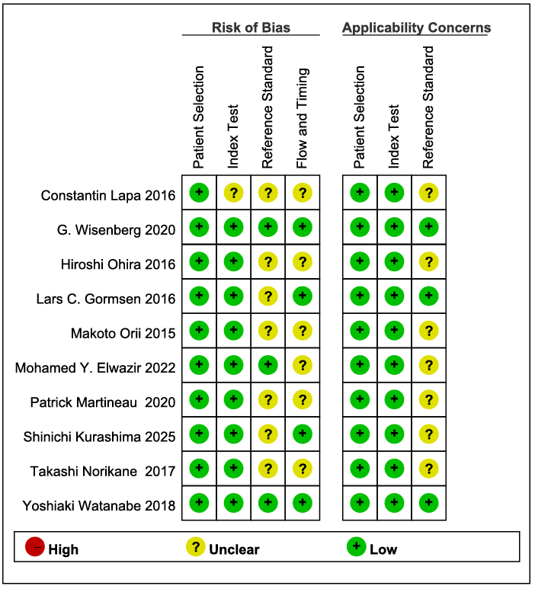
Supplementary Fig. 3 Methodological quality assessment of included studies using the QUADAS-2 tool. Risk of bias and applicability concerns are reported for each of the ten included studies across four domains: patient selection, index test, reference standard, and flow and timing.
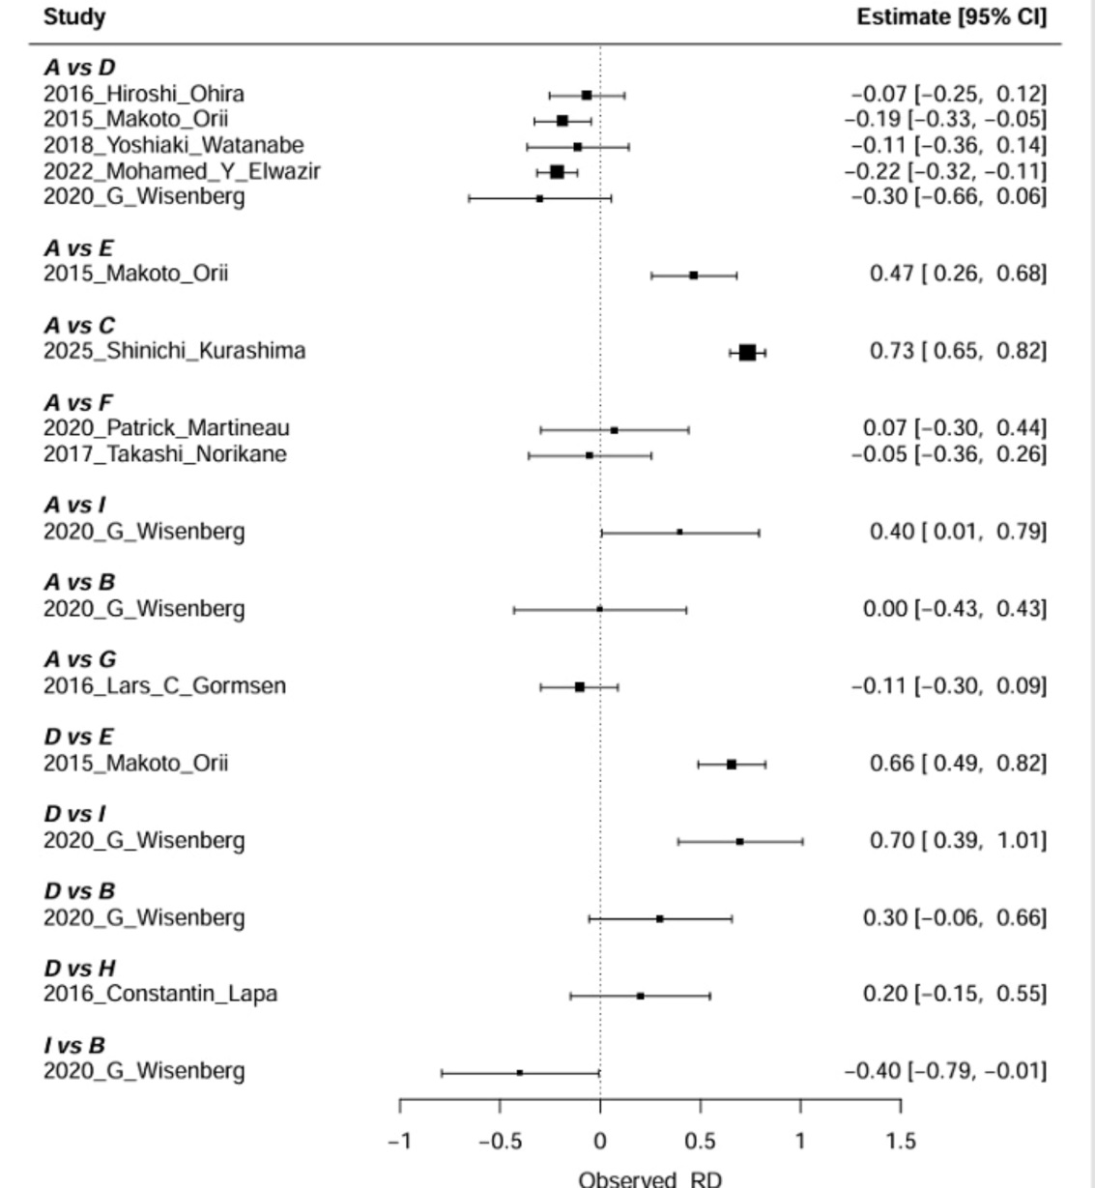

Supplementary Fig. 4 Random-effects network meta-analysis forest plot of risk differences (RDs) for detection rate versus the reference node, 18F-FDG PET/CT (A). Grey squares represent point estimates and horizontal lines the 95% confidence intervals. A positive RD denotes a detection rate superior to that of the reference node, whereas a negative RD indicates a correspondingly lower value. Modality codes are as defined in the legend of Fig. 2 A.

