Journal of Pest Science
Supplemental Information
Endophytic entomopathogenic fungi remodel phyllosphere microbiome and metabolome to suppress Spodoptera frugiperda and enhance parasitoid biocontrol

Zhengkai Yang¹, Ziyu Han¹, Xiao Zou², Xiuxian Shen³, Xiangyu Ji¹, Dongsheng Li¹, Yao Huang¹, Yuanchan Yu¹, Shimin Chen¹, Feiran Wang¹, Xiaofei Yu⁴, Maofa Yang^{1,4*}.

¹ Institute of Entomology of Guizhou University, Guizhou Key Laboratory of Agricultural Biosecurity, Guiyang 550025, China;
² Institute of Fungus Resources, College of Life Sciences, Guizhou University, Guiyang 550025, China;
³The Talent Team Project of Guizhou Academy of Agricultural Sciences (GAAS-Emerging team-〔2026〕03), Guizhou Tea Research Institute, Guiyang, 550006, China;
⁴College of Tobacco Science of Guizhou University, Guizhou Provincial Key Laboratory for Tobacco Quality Improvement and Efficiency Enhancement, Guiyang 550025, China.
*Corresponding author: Mao-fa Yang, Institute of Entomology of Guizhou University, Guizhou Key Laboratory of Agricultural Biosecurity, Guiyang 550025, China (Email: mfyang@gzu.edu.cn).

1Supplementary Materials
1.1 Supplementary Material S1
Study organisms
Maize (Zea mays L.) cultivar ‘Jinyu 579’, purchased from Guizhou Jinnong Technology Co., Ltd., was utilized as the host plant. All seeds were sown in 30 cm-diameter plastic pots filled with organic potting soil (Xianghui Zhizuo, Hunan; organic matter content ≥ 30%, pH 6.5–7.5). Two sowing densities were set for different experimental purposes: 10 seeds per pot for rearing Spodoptera frugiperda, and 1 seed per pot for measuring maize growth and developmental traits. Potted maize seedlings were incubated under a 14 h light / 10 h dark photoperiod at 25 ± 1 °C and 70 ± 5% relative humidity, in accordance with the procedures described previously.
Spodoptera litura larvae were collected from maize fields in Gechuan Village, Xingren Town, Kaili City, Guizhou Province, China (26°03′3.6048″ N, 108°05′51.7776″). The larvae were reared on fresh maize leaves in 100-mesh nylon cages (120 cm × 45 cm × 45 cm) at the Natural Enemy Propagation Center of Guizhou University for multiple consecutive generations, and the laboratory colony was ready for subsequent experiments.
Microplitis manilae was originally collected from asparagus fields in Xinmeng Village, Mozhong Town, Duyun City, Guizhou Province, China in August 2021 (25°55′53″ N, 107°55′14″). Adult parasitoids were maintained in 10 mL glass test tubes supplied with 10% honey water as a nutritional supplement. Mating was permitted within 24 h post-eclosion; mated female wasps were transferred into round plastic containers (17.8 cm diameter, 13 cm height) for parasitization assays, with second-instar S. litura larvae provided as hosts. Both S. litura and M. manilae were cultured in identical artificial climate chambers under constant conditions: temperature of 25 ± 1 °C, relative humidity of 50 ± 5%, and a 14 h light : 10 h dark photoperiod (L:D).
Fungal strains Beauveria bassiana GZUIFR-GL5 (deposit number PV622731 in the China Center for Type Culture Collection, hereafter abbreviated as GL-5) and Cordyceps cateniannulata GZUIFR04XS8 (GenBank accession No. MZ452634, hereafter abbreviated as H8) were both provided by the Institute of Fungal Resources, Guizhou University. The two strains were preserved in PDA (Potato Dextrose Agar) cryovials containing 20% glycerol and stored at −80 °C.

1.2 Supplementary Material S2
Insect Rearing and Life History Observation
Three treatments were designed in this study, including the blank control (CK), GL-5 inoculation, and H8 inoculation groups. For each treatment, 100 newly hatched Spodoptera frugiperda larvae were randomly collected and individually transferred into transparent 12-well bioassay plates (outer dimension: 12.5 × 8.5 × 2.3 cm; single well inner size: 2.3 × 1.7 cm) using a soft fine brush. Larvae were fed daily with fresh maize leaves harvested from the corresponding treatment groups until pupation to ensure adequate nutrition.
Larval developmental duration (larval, prepupal, and pupal stages) and survival rate were recorded daily. Pupal length, width, and body weight were measured on the second day after pupation. Newly emerged adults were supplied with 10% (v/v) honey solution for feeding. Multiple adult life-history traits were subsequently evaluated, including adult longevity, female fecundity, pre-oviposition period, and oviposition period. All insects were reared in a controlled artificial climate chamber under standardized conditions: 25 ± 1 °C, 70 ± 5% relative humidity, and a 16 h light / 8 h dark photoperiod.
Age-Stage, Two-Sex Life Table Analysis
Raw life-history data of all individuals were recorded and integrated according to the theory of age-stage, two-sex life table and the analytical method established by Chi HsinZenodo. The computer program TWOSEX-MSChart was used to calculate all life table statistical parameters.
The population and life table indices obtained for each treatment were as follows: Age-stage specific fecundity (f_{xj}), where x = age in days, j = developmental stage); Age-specific survival rate (l_{x}); Age-stage specific survival rate (s_{xj}); Age-specific fecundity (m_{x}); Age-stage specific life expectancy (e_{xj}); Age-stage specific reproductive value (v_{xj}); Adult pre-oviposition period (APOP); Total pre-oviposition period counted from birth (TPOP); Oviposition period (OP); Core population parameters: net reproductive rate (R0), intrinsic rate of increase (r), finite rate of increase (λ), and mean generation time (T).

1.3 Supplementary Material S3

1. Preparation of Leaf Enzyme Extract
Fresh leaf tissue (0.4 g) was weighed and ground thoroughly in a pre-cooled mortar with 10 mL ice-cold phosphate buffer (50 mmol/L, pH 7.8) to prepare crude enzyme extract. The homogenate was centrifuged at 14,000 r/min for 25 min at 4 °C, and the resulting supernatant was collected for the determination of antioxidant enzyme activities.
2. Catalase (CAT) Activity Assay
Briefly, 0.4 mL crude enzyme supernatant and 0.4 mL phosphate buffer were added sequentially into a 10 mL centrifuge tube and pre-incubated in a water bath at 28 °C for 4 min. The reaction was initiated by adding 0.6 mL 100 mmol/L H₂O₂ solution. For the blank control, the enzyme solution was inactivated by boiling in a water bath for 5 min. The absorbance value was recorded every 1 min for a total of 3 min at a wavelength of 240 nm.
3. Peroxidase (POD) Activity Assay
The reaction buffer consisted of 50 mmol/L phosphate buffer (pH 7.0) supplemented with 10 mmol/L guaiacol and 5 mmol/L H₂O₂, and the reaction mixture was pre-equilibrated in a water bath at 20 °C. A total of 2.8 mL reaction buffer was mixed with 0.2 mL enzyme supernatant in a 10 mL centrifuge tube. The absorbance was recorded at 470 nm at 1-min intervals for 4 consecutive minutes.
4. Superoxide Dismutase (SOD) Activity Assay
Briefly, 0.2 g fresh leaf tissue was homogenized with 2 mL pre-cooled phosphate buffer (50 mmol/L, pH 7.8) in an ice-cold mortar. The homogenate was centrifuged at 13,000 r/min at 5 °C, and the supernatant was stored on ice pending measurement. SOD activity was quantified based on its inhibitory effect on the photochemical reduction of nitroblue tetrazolium (NBT). The 3 mL reaction mixture contained reaction buffer, 0.4 mL methionine solution, 0.2 mL enzyme extract, and an equal volume of sodium carbonate solution. The tubes containing reaction solution were exposed to 15 W fluorescent light for a 20-min photoreaction. The spectrophotometer was zeroed with a blank sample, and absorbance was detected at 560 nm.
5. Glutathione S-Transferase (GST) Extraction and Assay
Cells or bacterial pellets were collected in centrifuge tubes and centrifuged to discard the supernatant. Approximately 5 × 10⁶ cells/bacteria were resuspended in 1 mL extraction solution. Cells were lysed by sonication on ice (power: 300 W, 3 s sonication, 7 s interval, total sonication duration: 3 min). The lysate was centrifuged at 12,000 rpm for 15 min at 4 °C, and the supernatant was retained on ice for testing.
Alternative extraction protocol: Extraction buffer was added at a volume ratio of 500–1000 μL buffer per 10⁴ cells.
The microplate reader was pre-warmed for 30 min and set to 37 °C; absorbance was measured at 340 nm.
6. Acetylcholinesterase (AChE) Extraction and Assay
Cells or bacterial pellets were collected into centrifuge tubes and centrifuged to remove supernatant. Roughly 5 × 10⁶ cells/bacteria were resuspended in 1 mL extraction solution, followed by sonication lysis on ice (power: 200 W, 3 s sonication, 10 s interval, 30 cycles total). The lysate was centrifuged at 12,000 rpm for 10 min at 4 °C, and the supernatant was kept on ice for measurement.
The microplate reader was pre-incubated for 30 min, and absorbance was determined at 412 nm.
7. Carboxylesterase (CarE) Extraction and Assay
Cells or bacterial pellets were harvested in centrifuge tubes and centrifuged to discard supernatant. Around 5 × 10⁶ cells/bacteria were resuspended in 1 mL extraction solution and lysed via sonication on ice (power: 200 W, 3 s sonication, 10 s interval, 30 cycles total). The homogenate was centrifuged at 12,000 rpm for 10 min at 4 °C, and the supernatant was stored on ice pending assay.
The microplate reader was pre-warmed for more than 30 min, and absorbance was measured at 450 nm.
8. Cytochrome P450 (CYP450) Extraction and Assay
Cells or bacterial pellets were collected into centrifuge tubes and centrifuged to discard the supernatant. Approximately 5 × 10⁶ cells were resuspended in 1 mL of extraction solution and lysed via ultrasonic fragmentation on ice (power: 200 W, 3 s of sonication with 10 s intervals, 30 cycles in total). The lysate was centrifuged at 12,000 rpm for 10 min at 4 °C, and the resulting supernatant was preserved on ice for subsequent determination.
The microplate reader was pre-warmed for more than 30 min, and absorbance was measured at 450 nm.

1.4 Supplementary Material S4
Sample Preparation
Maize leaves were collected on day 12 after sowing. For each treatment, 9 maize plants were randomly selected, and their fresh leaf tissues were pooled and homogenized into a single composite sample. The mixed samples were immediately snap-frozen in liquid nitrogen and stored at −80 °C for subsequent microbial community and metabolome sequencing analyses.
DNA Extraction, PCR Amplification and Sequencing
Total genomic DNA was extracted from leaf samples using the FastDNA™ SPIN Kit for Soil (MP Biomedicals, Solon, Ohio, USA) following the manufacturer’s instructions. DNA concentration and purity were quantified with a NanoDrop 2000 spectrophotometer (Thermo Fisher Scientific, Waltham, Massachusetts, USA). The extracted DNA from maize leaves was diluted 10-fold before amplification.
For construction of the 16S rRNA gene library, the V5–V7 hypervariable region was amplified using the primer pair 799F and 1193R. Each DNA template was amplified in triplicate alongside a sterile water negative control in a total reaction volume of 25 μL. The PCR system was composed of 12.5 μL 2× EasyTaq PCR SuperMix (TransGen Biotech, Beijing, China), 1.25 μL forward primer (10 μM), 1.25 μL barcoded reverse primer (10 μM), 1.25 μL template DNA, and 8.75 μL ddH₂O.
The thermal cycling program was set as follows: initial denaturation at 94 °C for 3 min; 28 cycles of 94 °C for 30 s, 55 °C for 30 s, and 72 °C for 90 s; followed by a final extension step at 72 °C for 90 s. PCR products were stored at 4 °C until purification.
Triplicate PCR products from each sample were pooled together, and bacterial 16S rRNA amplicons were purified from 1% agarose gel using a Gel Extraction Kit (Omega Bio-tek Inc., Norcross, Georgia, USA). Purified DNA was quantified with the Quant-iT™ PicoGreen™ dsDNA Assay Kit (Thermo Fisher Scientific), and all amplicons were normalized to an equal molar concentration and pooled. Sequencing libraries were constructed with the Illumina TruSeq DNA PCR-Free Library Preparation Kit (Illumina, San Diego, California, USA), and paired-end sequencing was performed on the Illumina NovaSeq-PE 250 platform.
Processing of 16S rRNA Gene Amplicon Sequences
Raw paired-end reads were quality-checked using FastQC v.0.10.1 and merged via the fastq_mergepairs script in USEARCH 11.0.667. Reads were demultiplexed and assigned to individual samples based on unique barcodes as specified in QIIME 1.9.1. After barcode and primer trimming, low-quality reads were filtered out, and non-redundant unique reads were identified using VSEARCH 2.12.0. Unique sequences with ≥97% sequence similarity were clustered into the same operational taxonomic unit (OTU). Representative sequences of each OTU were selected via the UPARSE algorithm, and taxonomic classification was performed using the classify.seqs command in mothur against the SILVA 138 reference database. OTUs classified as host plastids, cyanobacteria, or other taxa absent from all samples were removed from the final dataset.

2 Supplementary Figure

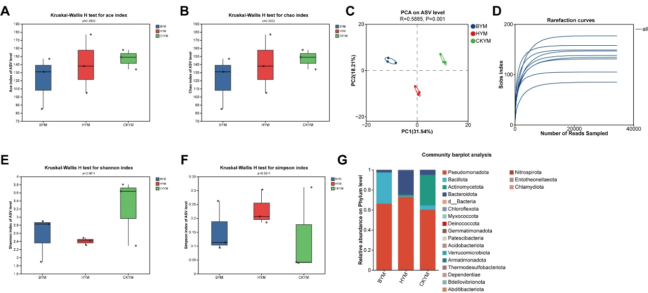
Figure S1. Alpha and beta diversity of bacterial communities in maize leaves under different fungal treatments. (A–B) Ace and Chao richness indices; (E–F) Shannon and Simpson diversity indices, tested by Kruskal-Wallis H test. (C) Principal component analysis (PCA) of bacterial communities at ASV level (R² = 0.588, P = 0.001). (D) Rarefaction curves of all samples. (G) Relative abundance of bacterial communities at the phylum level. BYM, Beauveria bassiana GL-5-treated maize; HYM, Cordyceps cateniannulata H8-treated maize; CKYM, control maize.

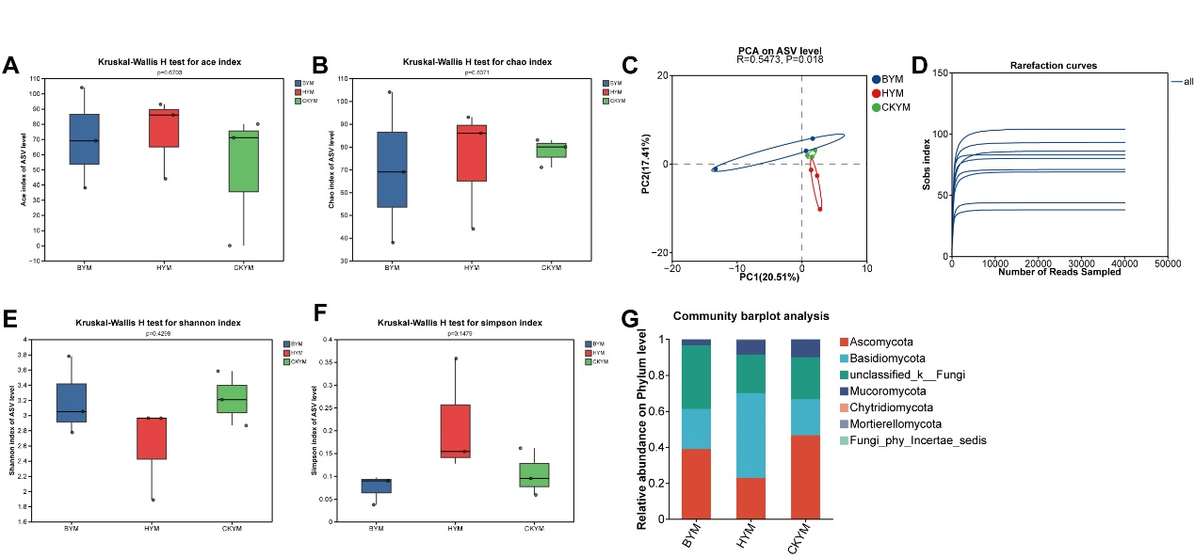
Figure S2. Alpha and beta diversity of fungal communities in maize leaves under different fungal treatments. (A–B) Ace and Chao richness indices; (E–F) Shannon and Simpson diversity indices, tested by Kruskal-Wallis H test. (D) Principal component analysis (PCA) of fungal communities at ASV level (R² = 0.3473, P = 0.018). (C) Rarefaction curves of all samples. (G) Relative abundance of fungal communities at the phylum level. BYM, Beauveria bassiana GL-5-treated maize; HYM, Cordyceps cateniannulata H8-treated maize; CKYM, control maize.

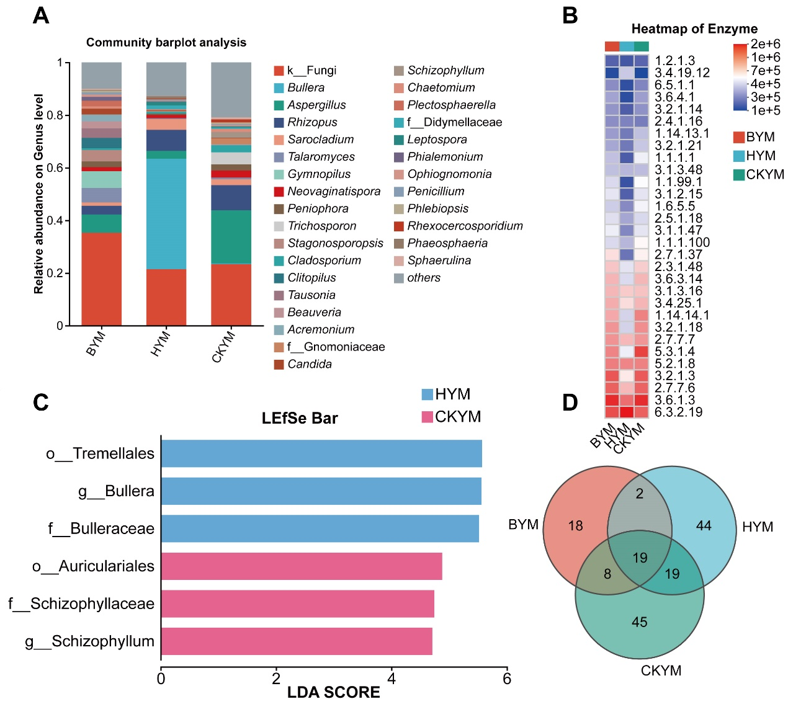
Figure S3. Fungal community composition and differential taxa in maize leaves under different fungal treatments. (A) Relative abundance of fungal communities at the genus level. (B) Heatmap of predicted functional enzyme profiles. (C) LEfSe bar plot showing differentially enriched fungal taxa with LDA score > 3. (D) Venn diagram illustrating the number of shared and unique OTUs among the three groups. BYM, Beauveria bassiana GL-5-treated maize; HYM, Cordyceps cateniannulata H8-treated maize; CKYM, control maize.

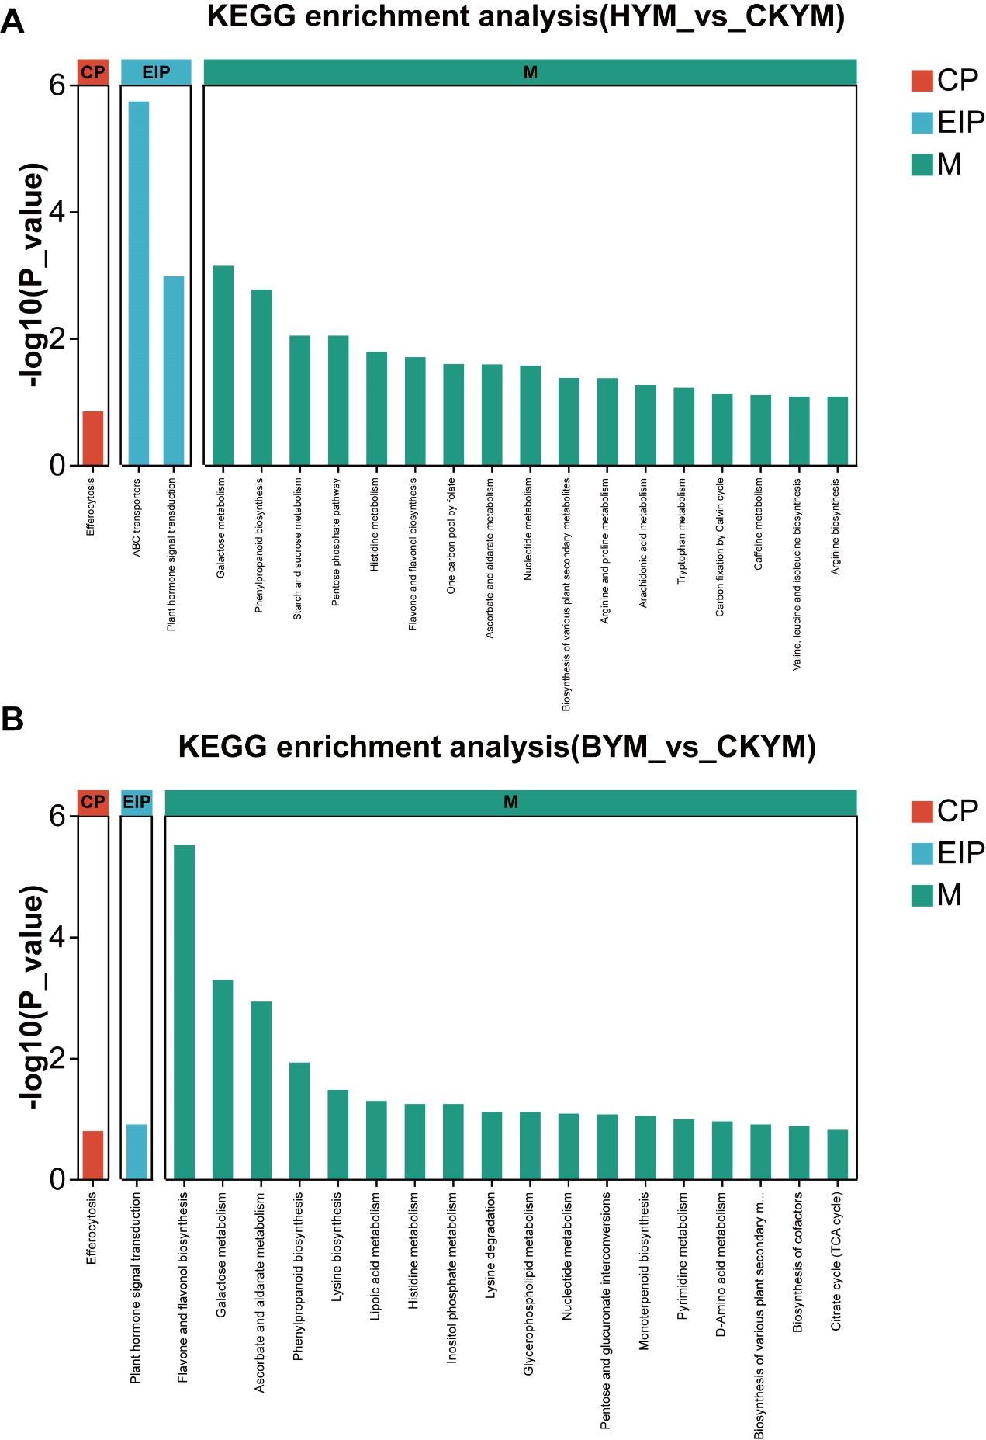
Figure S4. KEGG pathway enrichment analysis of differential metabolites in maize leaves under entomopathogenic fungal treatments. (A) KEGG enrichment of differential metabolites between HYM and CKYM. (B) KEGG enrichment of differential metabolites between BYM and CKYM. The y-axis represents -Log10(P-value) indicating enrichment significance. Pathway categories are color-coded: CP, cellular processes (red); EIP, environmental information processing (blue); M, metabolism (green). BYM, Beauveria bassiana GL-5-treated maize; HYM, Cordyceps cateniannulata H8-treated maize; CKYM, control maize.

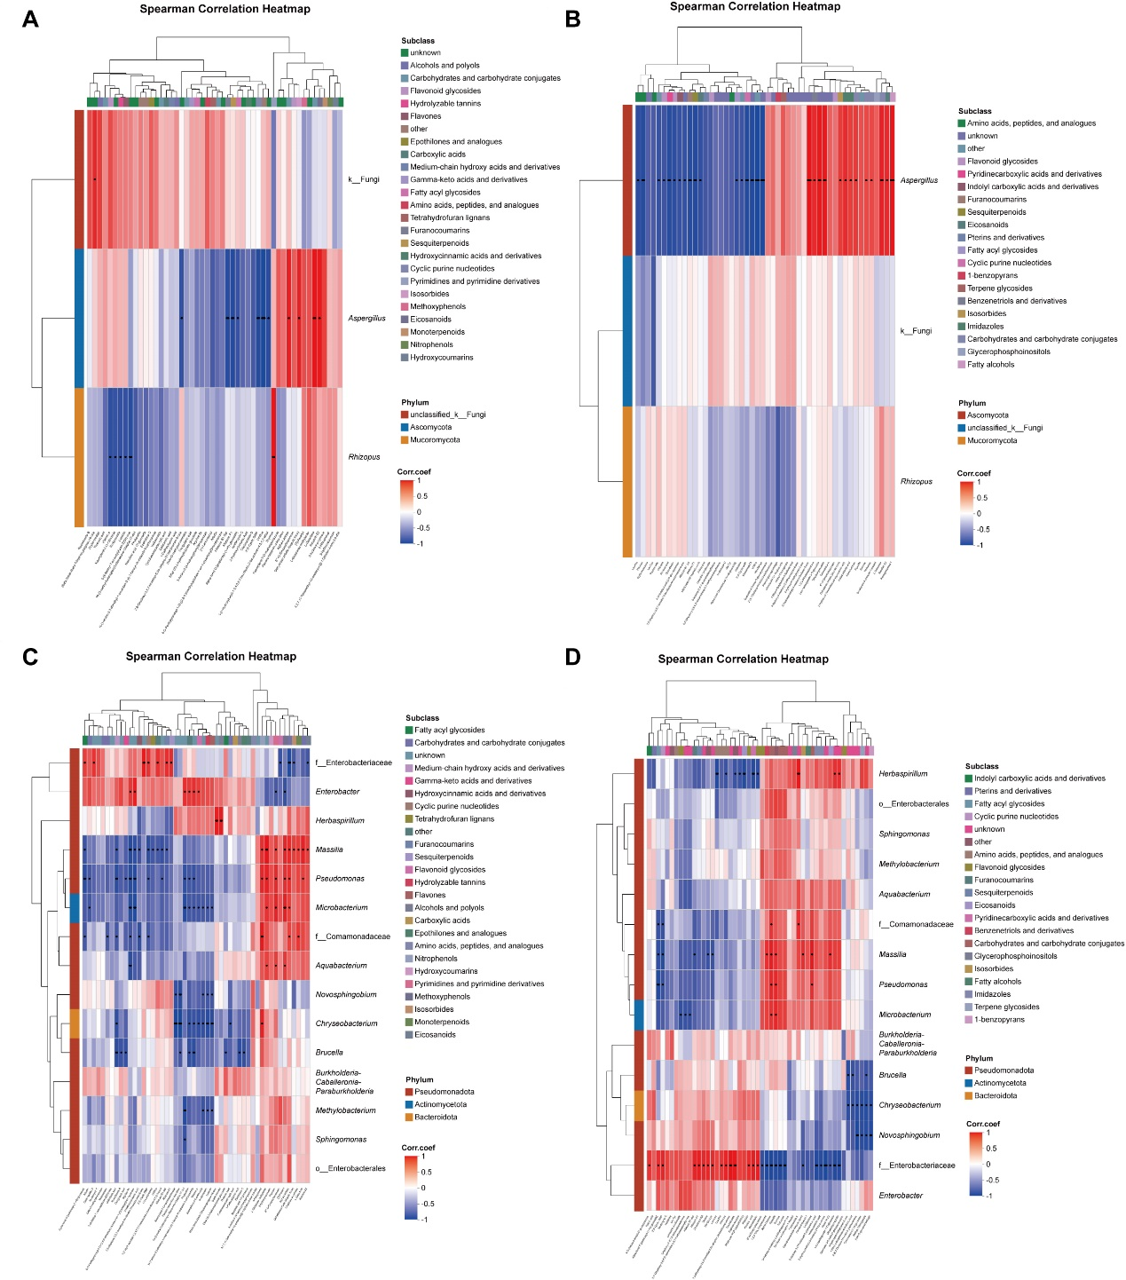
Figure S5. Spearman correlation heatmaps between microbial communities and metabolite subclasses in maize leaves. Rows represent differential metabolites grouped by chemical subclasses; columns represent dominant fungal and bacterial taxa at genus level. The color gradient corresponds to Spearman’s correlation coefficient (red = positive correlation, blue = negative correlation). Black dots mark statistically significant correlations (P < 0.05). (A) Correlation heatmap for fungal genus Aspergillus; (B) Correlation heatmap for fungal genus Rhizopus; (C) Correlation heatmap for core beneficial bacterial genera (Sphingomonadales, Enterobacteriaceae); (D) Correlation heatmap for phyllosphere bacterial genus Pseudomonas and associated taxa.

