Supplementary Information
Scene-Guard preserves scene-manipulation disruption under JPEG recompression
Min Shi, Yingnan Zhang, Hemin Yin & Yanzhe Zhang
This Supplementary Information contains detailed primary-SSDM, baseline, refinement, component-ablation, compression-aware and generic-perturbation control results referenced as Supplementary Tables S1–S7 in the main manuscript.
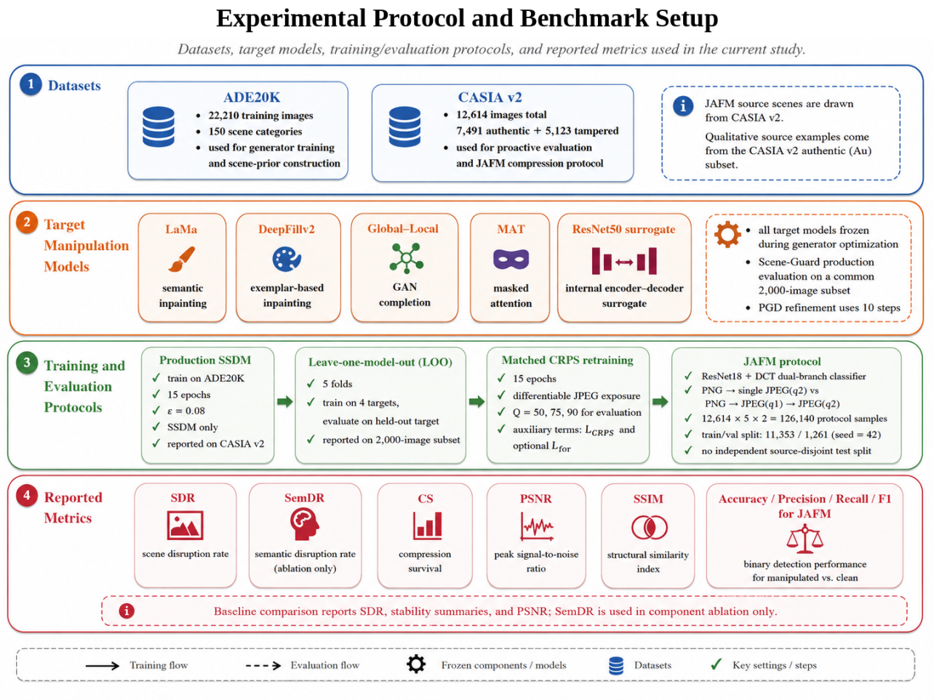
Supplementary Fig. S1 | Experimental Protocol and Benchmark Setup.
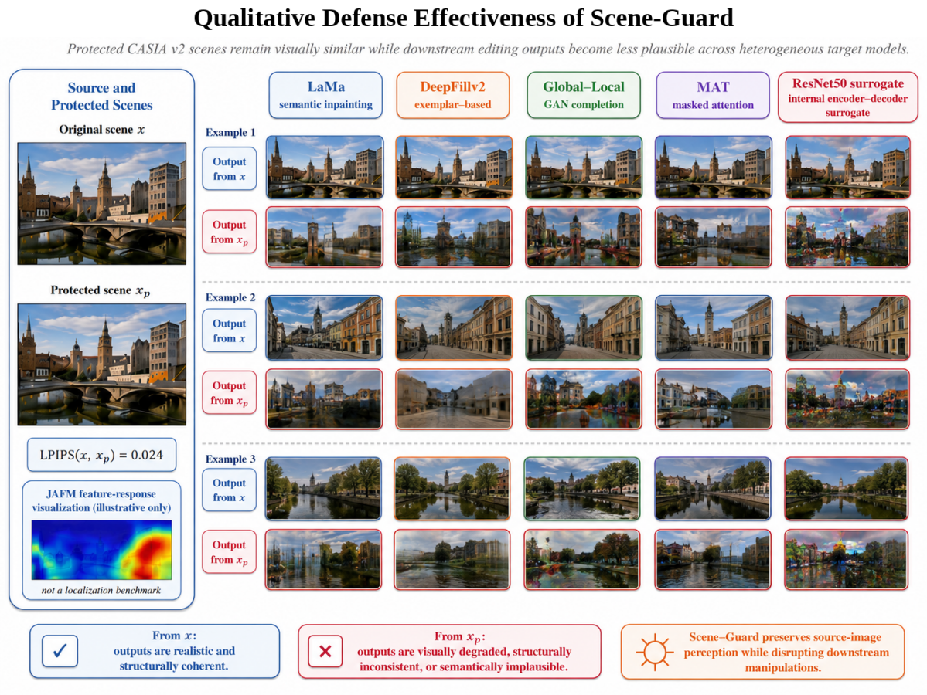
Supplementary Fig. S2 | Qualitative Defense Effectiveness of Scene-Guard.
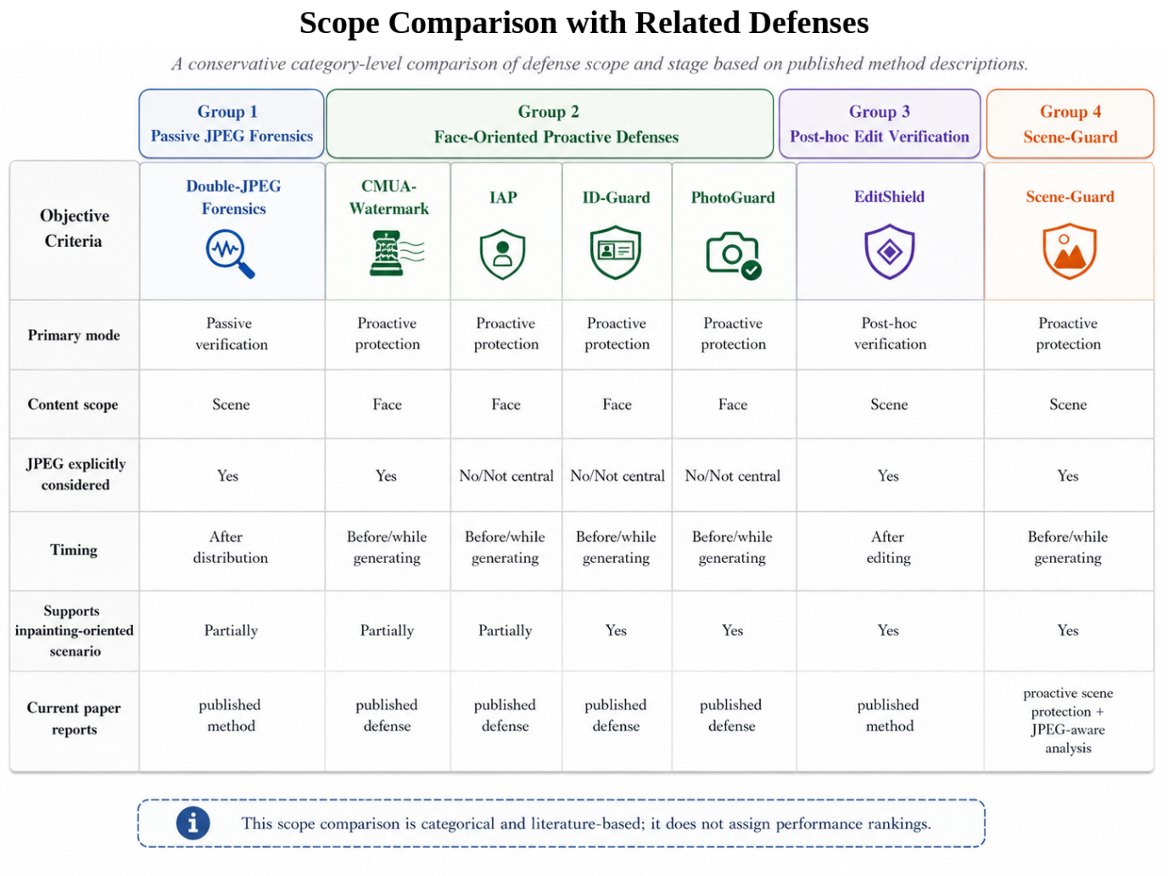
Supplementary Fig. S3 | Scope Comparison with Related Defenses.

Supplementary Table S1 | Primary SSDM checkpoint fidelity, target-specific disruption and JPEG compression survival.
The primary SSDM checkpoint was evaluated on 12,614 CASIA v2 images at ε = 0.08. SDR is reported for each frozen target model, and compression survival (CS) gives the retained disruption after JPEG recompression. The fifth target is the internal ResNet50 encoder-decoder surrogate described in the main Methods.
a. Source-image fidelity.
Metric | Value
PSNR (dB) | 23.20
SSIM | 0.466

b. Target-specific SDR.
Target model | SDR mean | SDR SD
LaMa | 0.5099 | 0.1575
DeepFillv2 | 0.4729 | 0.1533
Global–Local | 0.5178 | 0.1640
MAT | 0.5014 | 0.1621
ResNet50 surrogate | 0.4965 | 0.1530
Average | 0.4997 | 0.1580

c. Compression survival after JPEG recompression.
QF | LaMa | DeepFillv2 | Global–Local | MAT | ResNet50 surrogate | Mean
90 | 0.95 | 0.95 | 0.96 | 0.95 | 0.95 | 0.954
75 | 0.94 | 0.95 | 0.94 | 0.95 | 0.94 | 0.944
50 | 0.89 | 0.89 | 0.89 | 0.89 | 0.88 | 0.889
Supplementary Table S2 | Detailed baseline comparison across the five target models.
All values correspond to the common 2,000-image baseline-comparison run at ε = 0.08. The four adapted baselines use their 20-step optimization protocols described in the main Methods; Scene-Guard (G) is the one-pass generator result from the same baseline-comparison run. The separate 10-step Scene-Guard refinement experiment is reported in Supplementary Table S3.
a. Target-wise SDR.
Method | LaMa | DeepFillv2 | Global–Local | MAT | ResNet50 surrogate | Average
No Defense | 0.000 | 0.000 | 0.000 | 0.000 | 0.000 | 0.000
CMUA-Watermark | 0.442 | 0.404 | 0.477 | 0.420 | 0.426 | 0.434
PhotoGuard | 0.423 | 0.361 | 0.386 | 0.373 | 0.380 | 0.385
IAP | 0.442 | 0.372 | 0.398 | 0.384 | 0.391 | 0.397
ID-Guard (adapted) | 0.459 | 0.407 | 0.469 | 0.426 | 0.438 | 0.440
Scene-Guard (G) | 0.445 | 0.408 | 0.444 | 0.426 | 0.427 | 0.430

b. Aggregate cross-model stability and source-image fidelity.
Method | Mean SDR | Worst SDR | Across-target SD | Range | PSNR (dB)
No Defense | 0.000 | 0.000 | 0.000 | 0.000 | –
CMUA-Watermark | 0.434 | 0.404 | 0.025 | 0.073 | 23.62
PhotoGuard | 0.385 | 0.361 | 0.021 | 0.061 | 23.88
IAP | 0.397 | 0.372 | 0.024 | 0.070 | 23.81
ID-Guard (adapted) | 0.440 | 0.407 | 0.022 | 0.062 | 23.54
Scene-Guard (G) | 0.430 | 0.408 | 0.013 | 0.036 | 22.38

Supplementary Table S2a | Original vs. adapted settings of the four baseline protection methods.
The table summarizes how each face-oriented baseline was adapted to the common scene-manipulation benchmark and records the optimization choices used to avoid artificially weakening the compared methods.
Method | Original setting (as published) | Adapted setting (this work) | Hyper-params (ours) | Adaptation rationale | Official code / checkpoint
CMUA-Watermark (AAAI 2022) | Cross-model universal watermark trained on 128 face images; targets 4 face-editing GANs (StarGAN, AttGAN, AGGAN, HiSD); iterative attack with automatic per-model step-size search and two-level perturbation fusion | Per-image PGD maximizing the equal-weight mean of MSE(pert_out, orig_out) over all five surrogate manipulators | ε=0.08, T=20, α=0.01, δ₀~U(-0.1ε, 0.1ε) | Original pipeline requires facial attributes/landmarks and face-editing GANs, undefined for scene-level manipulation; replacing the universal (one-δ-for-all-images) formulation with per-image optimization strictly increases per-image attack capacity | Official code exists (VDIGPKU/CMUA-Watermark); face-specific pipeline, not executable on scene imagery
PhotoGuard (ICML 2023) | Encoder attack against the Stable-Diffusion-v1.5 VAE encoder, targeted at a gray-image latent; ε=0.1, 40 PGD steps, α=0.1; plus a stronger diffusion attack back-propagating through 4 denoising steps | Encoder-attack objective transplanted to the surrogate output space: maximize MSE between frozen VGG16-conv features of perturbed vs. clean manipulator output; single surrogate (LaMa), mirroring the original single-encoder scope | ε=0.08, T=20, α=0.01; encoder = VGG16 features[:10], frozen, random init | Surrogate manipulators have no latent-diffusion encoder to attack; α·T = 0.20 > 2ε = 0.16, so the step budget fully traverses the ε-ball and step count is not the binding constraint | Official code exists (MadryLab/photoguard); targets SDM directly, not applicable to surrogate manipulators
IAP (arXiv 2303.11625) | Trained encoder-decoder generator that embeds an identity message into a cross-model adversarial example; feature-level correlation disruption loss; spectral diffusion for message robustness; decoder recovers the message for traceability | Per-image PGD disruption: maximize MSE(pert_out, orig_out) + 0.1·gradient-smoothing regularizer; single surrogate (LaMa) | ε=0.08, T=20, α=0.01 | Identity-message embedding is undefined without face identities; only the disruption objective transfers to scenes | Code not available to us at adaptation time
ID-Guard (arXiv 2409.13349) | Universal perturbation generator (single forward pass); Identity Destruction Module (face masks, VGGFace Grad-CAM heatmap, ArcFace identity loss, feature confusion); dynamic weighting (MGDA / KPI-based); gradient-prior PGD: 10 iterations, step 0.01 | Per-image PGD over all five surrogates with KPI-style dynamic weights β=(1-p)^γ, uniform prior weights | ε=0.08, T=20, α=0.01, γ=2.0 | IDM components require face parsing and face-recognition networks undefined on scene imagery; the transferable component (S-II-style dynamic weighting) is preserved; per-image optimization again strengthens the baseline vs. its universal formulation | Not publicly released
Fairness note. All baselines use the same ε = 0.08 perturbation budget and 20 PGD steps in the common 2,000-image comparison; Scene-Guard refinement uses 10 steps. The scene-level adaptations retain each baseline’s transferable objective while removing face-specific components that are undefined for scene imagery.
Supplementary Table S3 | Target-wise paired PGD-refinement evaluation.
This 2,000-image matched evaluation uses the same generator outputs before and after 10 test-time PGD refinement steps. Its pre-refinement mean SDR is 0.441 and is distinct from the 0.430 Scene-Guard (G) estimate in the separate baseline-comparison run.
The +3.5% average in the relative-change row denotes the paired Generator-only to G+PGD change within this matched refinement evaluation; it is distinct from the separate Table 1 reference-comparison run.
Setting | LaMa | DeepFillv2 | Global–Local | MAT | ResNet50 surrogate | Average | PSNR (dB)
Generator only | 0.441 | 0.411 | 0.485 | 0.443 | 0.424 | 0.441 | 22.38
G + PGD refine | 0.448 | 0.415 | 0.540 | 0.450 | 0.429 | 0.456 | 22.31
Relative change | +1.6% | +1.0% | +11.4% | +1.6% | +1.2% | +3.5% | −0.07

Supplementary Table S4 | SSDM component and test-time refinement ablation.
Each configuration was trained from random initialization for 15 epochs using 2,000 ADE20K training images and evaluated on 2,000 CASIA v2 images at ε = 0.08. SemDR = 1 − cosine(scene embedding) is computed on the manipulation outputs M_k(x) and M_k(x_p), not on the source images. Across-target SD is the population standard deviation (NumPy std with ddof = 0) of the five per-target mean SDR values. CS@75 denotes compression survival at JPEG quality 75. These values are intended for within-ablation comparisons and should not be compared directly with the primary-SSDM-checkpoint values in Supplementary Table S1.
Configuration | SDR | SemDR | Across-target SD | CS@75 | PSNR (dB) | SSIM
Full | 0.2862 | 0.2627 | 0.0110 | 0.9689 | 26.06 | 0.6639
w/o semantic adversarial term | 0.3968* | 0.0070 | 0.0092 | 0.3449 | 23.09 | 0.5038
w/o structural term | 0.2905 | 0.2471 | 0.0069 | 0.9853 | 26.00 | 0.6426
w/o semantic mask | 0.2971 | 0.2396 | 0.0062 | 1.0209 | 25.55 | 0.6374
w/o multi-model training | 0.2561 | 0.1565 | 0.0077 | 0.8924 | 26.87 | 0.6976
Generator only | 0.2802 | 0.2343 | 0.0087 | 0.9702 | 26.06 | 0.6639
Generator + PGD refinement | 0.5155 | 0.1730 | 0.0207 | 0.9475† | 23.07 | 0.4538
*The higher raw SDR after removing the semantic adversarial term should not be interpreted as improved protection: SemDR falls from 0.2627 to 0.0070 and PSNR drops from 26.06 to 23.09 dB, indicating non-semantic distortion rather than successful semantic disruption.
†The G+PGD CS@75 value was obtained in a separate supplementary QF=75 evaluation on 500 CASIA v2 images; it was not present in the original 2,000-image ablation result file and should be interpreted as a supplementary compression check.

Supplementary Table S5 | Matched CRPS compression-aware retraining ablation.
Five variants were trained for 15 epochs. Each variant was evaluated over 30,000 rows (5 target models × 3 JPEG qualities × 2,000 images). SDR_jpeg is the mean post-JPEG SDR. CS is the mean of the per-sample ratio SDR_jpeg/SDR_clean; it is reported instead of the ratio of aggregate means because the two aggregation procedures are mathematically different.
a. Aggregate clean-image fidelity and mean post-JPEG disruption.
Variant | SDR_clean | SDR_jpeg | CS | PSNR (dB) | SSIM
SSDM only | 0.4693 | 0.4605 | 0.981 | 23.99 | 0.4134
JPEG exposure | 0.4649 | 0.4684 | 1.014 | 23.80 | 0.4215
JPEG + consistency | 0.4644 | 0.4681 | 1.014 | 23.85 | 0.4220
JPEG + JAFM feature regularization | 0.4631 | 0.4666 | 1.013 | 23.84 | 0.4243
Full CRPS | 0.4622 | 0.4664 | 1.015 | 23.83 | 0.4242

b. Post-JPEG SDR by JPEG quality.
Variant | QF 50 | QF 75 | QF 90 | Cross-quality range
SSDM only | 0.4479 | 0.4637 | 0.4699 | 0.0220
JPEG exposure | 0.4701 | 0.4682 | 0.4670 | 0.0032
JPEG + consistency | 0.4704 | 0.4675 | 0.4665 | 0.0039
JPEG + JAFM feature regularization | 0.4684 | 0.4662 | 0.4652 | 0.0032
Full CRPS | 0.4688 | 0.4660 | 0.4645 | 0.0043
JPEG-quality SDR values are displayed to four decimal places; consequently, a range recomputed from the displayed rounded values may differ from the reported range by 0.0001.

Supplementary Table S6 | Target-wise post-JPEG SDR for the matched CRPS variants.
Values are averaged over JPEG qualities 50, 75 and 90 for each target model in the matched CRPS evaluation.
Target model | SSDM only | JPEG exposure | JPEG + consistency | JPEG + JAFM feature regularization | Full CRPS
LaMa | 0.4986 | 0.4637 | 0.4637 | 0.4622 | 0.4619
DeepFillv2 | 0.4362 | 0.4435 | 0.4431 | 0.4416 | 0.4415
Global–Local | 0.4620 | 0.4996 | 0.4991 | 0.4977 | 0.4970
MAT | 0.4540 | 0.4700 | 0.4696 | 0.4677 | 0.4680
ResNet50 surrogate | 0.4518 | 0.4654 | 0.4652 | 0.4637 | 0.4637
JPEG-aware variants improve DeepFillv2, Global–Local, MAT and the ResNet50 surrogate relative to SSDM-only, while LaMa remains strongest under SSDM-only training. The table therefore supports a compression-stability claim rather than a claim that every CRPS variant improves every target.
Supplementary Table S7 | Paired generic-perturbation control at ε = 0.08.
A separate 2,000-image run tests whether strong generic source distortion alone can account for the observed output divergence. Scene-Guard is compared with uniform, Gaussian-matched and sign perturbation controls under the same fixed-mask five-target protocol. All methods are evaluated in one process with the same target instances, including the same randomly initialized auxiliary decoder; because that decoder is untrained, these values support within-run paired comparisons only and are not pooled with Table 1 or Supplementary Table S2.
Method | Mean SDR | Across-target SD | SemDR | PSNR (dB) | SSIM
Scene-Guard | 0.4359 | 0.0179 | 0.7936 | 22.38 | 0.5425
Uniform control | 0.2762 | 0.0082 | 0.0300 | 26.88 | 0.6588
Gaussian-matched control | 0.3301 | 0.0097 | 0.0386 | 25.19 | 0.5912
Sign control | 0.4306 | 0.0131 | 0.0583 | 22.16 | 0.4656
The uniform and Gaussian-matched controls yield lower SDR and near-zero SemDR. The sign control is the strongest generic control: its raw SDR is close to Scene-Guard (0.4306 vs 0.4359), but its SemDR is 0.0583 versus 0.7936 (13.6× lower) and its source fidelity is slightly worse. The control therefore shows that strong generic distortion can reproduce much of raw structural divergence without reproducing the semantic output shift. This supports the manuscript's use of SDR together with SemDR and fidelity rather than SDR alone.
Run configuration: ε = 0.08, n = 2,000 images; deterministic per-batch random-number generation uses seed 1000 + 64 × batch index. The internal untrained decoder realization is shared across all four methods in this paired run.

