Supplementary Information
Preterm Formula versus Human Milk Fortifier for Fortification of Mother’s Own Milk in Very Low Birth Weight Infants: The PREMFORT Trial
Contents: Appendix 1, Trial protocol; Appendix 2, CONSORT 2025 checklist; Appendix 3, Nutritional composition of fortified mother’s own milk; Appendix 4, Randomization; Appendix 5, Statistical methods; Appendix 6, Intervention acquisition-cost analysis; Appendix 7, Additional analyses (adjusted regression, interaction model, per-stratum estimates, secondary growth outcomes) and Figures S1–S4 (intervention algorithm, cost, nutrient adequacy, growth-velocity distribution).

Appendix 1. Trial Protocol
The full trial protocol, as approved by the Institutional Ethics Committee of Government Medical College, Chhatrapati Sambhajinagar and registered with the Clinical Trials Registry–India (CTRI/2025/07/089932), is provided as a separate submission file. No amendments were made to the primary outcome, sample-size assumptions, or analysis plan after the trial commenced.

Appendix 2. CONSORT 2025 Checklist
The completed CONSORT 2025 checklist, together with applicable items of the CONSORT-Children and Adolescents (CONSORT-C) 2026 extension and recommendations for non-inferiority trials, is provided as a separate submission file (PREMFORT_CONSORT_Checklist.docx). The CONSORT participant flow diagram is presented as Figure 1 of the main manuscript.

Appendix 3. Nutritional Composition of Fortified Mother’s Own Milk
Values are expressed per 100 mL of prepared feed. Fortification basis: 1 g fortifier per 25 mL milk (4 g per 100 mL feed). Preterm milk (PTM) values represent median 7–28-day composition; per-100 mL ESPGHAN 2022 targets assume an enteral intake of approximately 150 mL/kg/day. The two commercial bovine-milk-based fortifiers (Lactodex and PreNAN) are broadly similar in macronutrient and mineral content but differ in vitamin D and selected micronutrients (e.g., zinc, folate, riboflavin); the Dexolac preterm formula used alone falls well below targets for calcium, phosphorus, vitamin D, and iron, providing the rationale for co-administered supplementation in the PTF group.
Nutrient (unit) | ESPGHAN target (per kg/day) | ESPGHAN target (per 100 mL)* | Preterm milk (PTM) | PTM + Lactodex HMF | PTM + PreNAN HMF | PTM + Dexolac PTF
Energy (kcal) | 115–140 | 76.7–93.3 | 70 | 83.5 | 86 | 89.6
Protein (g) | 3.5–4.0 | 2.3–2.7 | 1.35 | 2.43 | 2.55 | 2.01
Fat (g) | 4.8–8.1 | 3.2–5.4 | 3.25 | 3.41 | 4.05 | 4.17
Carbohydrate (g) | 11–15 | 7.3–10.0 | 6.20 | 8.16 | 7.80 | 8.39
MINERALS
Sodium (mEq) | 3.0–5.0 | 2.0–3.3 | 0.98 | 1.31 | 2.26 | 1.05
Potassium (mEq) | 2.3–4.6 | 1.5–3.1 | 1.28 | 2.20 | 2.27 | 1.65
Chloride (mEq) | 3.0–5.0 | 2.0–3.3 | 1.41 | 2.48 | 2.13 | 1.86
Calcium (mmol) | 3.0–5.0 | 2.0–3.3 | 0.69 | 2.27 | 2.28 | 1.32
Phosphorus (mmol) | 2.2–3.7 | 1.5–2.5 | 0.48 | 1.50 | 1.61 | 0.89
Magnesium (mmol) | 0.4–0.5 | 0.27–0.33 | 0.12 | 0.41 | 0.25 | 0.18
Iron (mg) | 2.0–3.0 | 1.3–2.0 | NR | 1.20 | 1.44 | 0.40
Zinc (mg) | 2.0–3.0 | 1.3–2.0 | 0.34 | 0.50 | 1.10 | 0.74
Copper (µg) | 120–230 | 80–153 | 42.5 | 99.7 | 82 | 62.9
Manganese (µg) | 1–15 | 0.67–10 | NR | 6.8 | 4.8 | 1.6
Iodine (µg) | 11–55 | 7.3–36.7 | NR | NR | 9.4 | 5.0
Selenium (µg) | 2.8–9.3 | 1.9–6.2 | NR | NR | 2.2 | NR
VITAMINS
Vitamin A (IU) | 1333–3300 | 889–2200 | 800 | 1598 | 1687 | 946
Vitamin D (IU) | 400–700 | 267–467 | NR | 531 | 112 | 24
Vitamin E (mg) | 2.2–11 | 1.47–7.33 | 1.2 | 4.6 | 4.2 | 1.8
Vitamin K (µg) | 4.4–28 | 2.9–18.7 | NR | 4.4 | 6.0 | 2.7
Vitamin C (mg) | 17–43 | 11.3–28.7 | NR | 20.0 | 15.0 | 4.0
Vitamin B1 (µg) | 140–290 | 93–193 | 25 | 99 | 145 | 55
Vitamin B2 (µg) | 200–430 | 133–287 | NR | 80 | 160 | 41
Vitamin B6 (µg) | 70–290 | 47–193 | NR | 100 | 80 | 26
Vitamin B12 (µg) | 0.1–0.6 | 0.067–0.40 | 0.08 | 0.28 | 0.24 | 0.13
Folate (µg) | 23–100 | 15.3–66.7 | 5.9 | 55.9 | 35.9 | 14.9
Niacin (mg) | — | — | NR | — | 1.12 | —
Pantothenic acid (mg) | — | — | NR | — | 0.52 | —
Biotin (µg) | — | — | NR | — | 2.6 | —
Choline (mg) | — | — | 15.5 | 15.5 | 21.9 | 18.7
Inositol (mg) | — | — | NR | — | 3.4 | —
L-Carnitine (mg) | Not specified | — | 0.85 | 0.85 | 2.8 | 1.25
OTHER BIOACTIVE COMPONENTS
Lactoferrin | Not specified | — | Native | No | No | No
HMO | Not specified | — | Native | No | No | No
DHA (mg) | 30–65 | 20–43.3 | Native | As PTM | 5.6 | 2.4
ARA (mg) | 30–100 | 20–66.7 | Native | As PTM | — | 3.48
*Per-100 mL ESPGHAN targets assume approximately 150 mL/kg/day enteral intake. NR, not reported on label; “—”, not specified/not applicable. PTM, preterm milk; PTF, preterm formula; HMF, human milk fortifier. All fortifier columns represent PTM plus the indicated fortifier at 4 g/100 mL. PreNAN values were recomputed from the manufacturer’s nutrition label as PTM plus 4 × the per-gram-powder value, with unit conversions (vitamin A µg RE → IU; vitamin D µg → IU; B-vitamins mg → µg). DHA and ARA values for products indicate the added amount unless otherwise specified.

Appendix 4.

Randomization
Randomization used stratified block randomization with two gestational-age strata (stratum 1, <30 weeks; stratum 2, 30 to <34 weeks) and variable block sizes of 4, 6, and 8 to preserve allocation concealment and balance. Within each stratum, infants were allocated 1:1 to HMF or PTF. The allocation sequence was computer-generated before recruitment by an independent investigator using a fixed random seed to permit reproducibility and independent verification, and was concealed using sequentially numbered, opaque, sealed envelopes opened only at the time of enrollment.

Appendix 5. Statistical Methods
The primary outcome, weight growth velocity (g/kg/day), was calculated using the Patel exponential model. The between-group difference (PTF minus HMF) was estimated with a two-sided 90% confidence interval corresponding to the prespecified one-sided α of 0.05, and non-inferiority was concluded when the lower confidence limit exceeded the margin of −2 g/kg/day. Continuous secondary outcomes were compared using the Mann–Whitney U test with Hodges–Lehmann median differences; categorical outcomes were compared using the Fisher exact test with odds ratios and 95% confidence intervals. Analyses were performed in R version 4.6.1.
The randomized population comprised all 164 infants. Because the primary growth endpoint requires a discharge or 40-week weight, one preterm-formula infant who died before the endpoint could not contribute a growth-velocity value; the primary analysis therefore included the 163 infants with an observed endpoint (HMF 83, PTF 80), and all 164 infants were retained for clinical outcomes. All 164 randomized infants constituted the intention-to-treat population; the primary growth endpoint was evaluable for 163 infants because one preterm-formula infant died before the endpoint, so the primary analysis used the evaluable population. There were no protocol deviations, so the per-protocol population among infants with an ascertainable primary endpoint coincided with the evaluable primary-analysis population. A prespecified sensitivity analysis incorporated the deceased infant’s observed growth velocity up to death; the two analyses gave the same conclusion. For categorical outcomes requiring survival to a later assessment (bronchopulmonary dysplasia, retinopathy of prematurity), the infant who died before that assessment was excluded (evaluable denominators).

Appendix 6. Intervention Acquisition-Cost Analysis
A patient-level intervention acquisition-cost analysis was undertaken from the hospital perspective, restricted to direct product costs (fortifier, preterm formula, and supplements). This is a cost analysis, not a cost-effectiveness or full economic evaluation, and was appropriate because the primary outcome met the non-inferiority criterion. Costs were estimated, not directly measured: milk volume was assumed to be 150 mL/kg/day throughout the fortification period, using the mean of enrolment and endpoint weights as the representative weight, multiplied by each infant’s fortification duration and the unit prices below. Iron was administered to both groups and excluded. All 164 randomized infants were included (the infant who died had 17 days of exposure). Unit prices were obtained from institutional procurement (2026).
Table S6.1. Unit costs and sources of fortification products (institutional procurement, 2026)
Product | Manufacturer | Pack size | Unit price (INR) | Group
Lactodex Human Milk Fortifier | Raptakos, Brett & Co. Ltd. | 50 g | 1552.00 | HMF
Dexolac Special Care Preterm Formula | Danone India Pvt. Ltd. | 400 g | 699.00 | PTF
Calcimax-P syrup | Meyer Organics Pvt. Ltd. | 200 mL | 175.00 | PTF
Vitomin D3 drops (400 IU/mL) | Cipla Ltd. | 30 mL | 84.31 | PTF
A to Z Multivitamin Drops | Alkem Laboratories Ltd. | 15 mL | 70.50 | PTF
Note. Unit prices are institutional procurement prices (2026). Per-infant totals below are derived from these prices together with each infant’s enrollment weight and actual fortification duration; if institutional prices differ, updating this table updates the aggregate calculation.
Table S6.2. Intervention acquisition cost per infant
Group | Median (IQR), INR | Mean ± SD, INR
HMF (n=83) | 4 255 (2 393–6 172) | 4 838 ± 2 747
PTF (n=81) | 486 (304–765) | 580 ± 321
Note. Wilcoxon rank-sum P<0.001; Hodges–Lehmann location shift (HMF − PTF) INR 3 832 (95% CI 3 159–4 701). Based on mean costs, PTF saved a mean of INR 4 258 per infant, an 88.0% reduction in intervention acquisition cost, despite additional mineral and vitamin supplementation. Costs are estimated (assumed 150 mL/kg/day; representative weight = mean of enrolment and endpoint weights) and reflect direct product costs only, excluding indirect healthcare and societal costs. Iron cost was excluded because iron supplementation was common to both groups.
Budget-impact scenario. Applying the mean per-infant saving of INR 4 258 to the approximately 450 VLBW infants admitted to the unit annually gives a projected institutional saving of about INR 1.9 million (≈19.2 lakh) per year. This is a scenario/budget-impact projection, not an observed study finding; it assumes that the per-infant costs apply to the annual VLBW population and that all such infants are eligible for and receive fortification, which will not be the case for every admission.

Appendix 7. Additional Analyses
Table S7.1. Adjusted linear regression for weight growth velocity (g/kg/day)
Term | Estimate | 90% CI
PTF vs HMF | −0.67 | −1.09 to −0.25
Stratum 30–<34 wk vs <30 wk | 2.02 | 1.56 to 2.48
Respiratory support (yes vs no) | −0.33 | −0.82 to 0.16
Intercept | 12.78 | 12.21 to 13.36
Note. Ordinary least-squares model in the evaluable population (n=163): adjusted R² = 0.29; residual SE = 1.58 on 159 df. The PTF estimate remained above the −2 g/kg/day margin after adjustment.
Table S7.2. Treatment-by-stratum interaction model
Term | Estimate | 90% CI | P
PTF vs HMF (within <30 wk) | −1.07 | −1.82 to −0.32 | 0.019
Stratum 30–<34 wk vs <30 wk (HMF) | 1.87 | 1.25 to 2.49 | <0.001
PTF × stratum 30–<34 wk (interaction) | 0.49 | −0.41 to 1.38 | 0.369
Note. Evaluable population (n=163). The non-significant interaction term (P=0.37) indicates that the relative treatment effect did not differ meaningfully across gestational-age strata. The within-stratum confidence intervals in this model are derived from the pooled residual variance of the full evaluable sample (ordinary least squares, assuming a common error variance across strata) and are therefore narrower than the direct within-stratum comparisons in Table S7.3 and Figure 2, which use each stratum's own (Welch) variance. The point estimates are identical (e.g., −1.07 g/kg/day for the <30-week stratum in both analyses); only the precision differs. Non-inferiority within the <30-week subgroup is judged from the direct within-stratum estimate (90% CI −2.02 to −0.12; Table S7.3 and Figure 2), which crosses the −2 g/kg/day margin, rather than from this model-based interval (90% CI −1.82 to −0.32).

Table S7.3. Growth velocity by gestational-age stratum and treatment group
Stratum | Group | n | Mean ± SD (g/kg/day)
<30 weeks | HMF | 26 | 12.7 ± 1.96
<30 weeks | PTF | 23 | 11.6 ± 2.00
30 to <34 weeks | HMF | 57 | 14.5 ± 1.42
30 to <34 weeks | PTF | 57 | 14.0 ± 1.34
Note. Evaluable population (n=163). Per-stratum estimates are descriptive and were not powered as independent non-inferiority comparisons. Corresponding per-stratum mean differences (PTF − HMF) were −1.07 g/kg/day (90% CI, −2.02 to −0.12) for <30 weeks and −0.59 g/kg/day (90% CI, −1.02 to −0.16) for 30 to <34 weeks; both are displayed in Figure 2 of the main manuscript. In the <30-week stratum the 90% confidence interval crossed the −2 g/kg/day non-inferiority margin, so non-inferiority was not demonstrated within this subgroup; per-stratum estimates were descriptive and were not powered as independent non-inferiority comparisons.
Table S7.4. Secondary growth and nutritional outcomes
Outcome | HMF | PTF | Median diff. (95% CI)* | P
Length velocity, cm/wk | 0.88 (0.65–1.00) | 0.80 (0.64–1.06) | 0.00 (−0.10 to 0.09) | 0.848
Head-circumference velocity, cm/wk | 0.50 (0.44–0.62) | 0.49 (0.39–0.62) | −0.01 (−0.05 to 0.04) | 0.645
Weight at discharge, g | 1495 (1458–1553) | 1493 (1439–1536) | −10 (−30 to 15) | 0.453
Length at discharge, cm | 39.5 (39.0–40.5) | 39.5 (38.5–40.5) | 0.00 (−0.50 to 0.00) | 0.394
Head circumference at discharge, cm | 29.0 (28.5–29.5) | 29.0 (28.0–29.6) | 0.00 (−0.50 to 0.50) | 0.793
Duration of fortification, d | 17 (9–26) | 18.5 (10.75–28.25) | 1 (−2 to 4) | 0.397
Length of hospital stay, d | 27 (15–37) | 28 (17–38) | 1 (−3 to 5) | 0.466
Note. Values are median (interquartile range) in the evaluable population. *Hodges–Lehmann median difference (PTF − HMF) with 95% CI; P values from the Mann–Whitney U test. No between-group difference was statistically significant.

Figure S1. Clinical algorithm summarizing the two fortification strategies, from eligibility through fortification and outcome assessment.
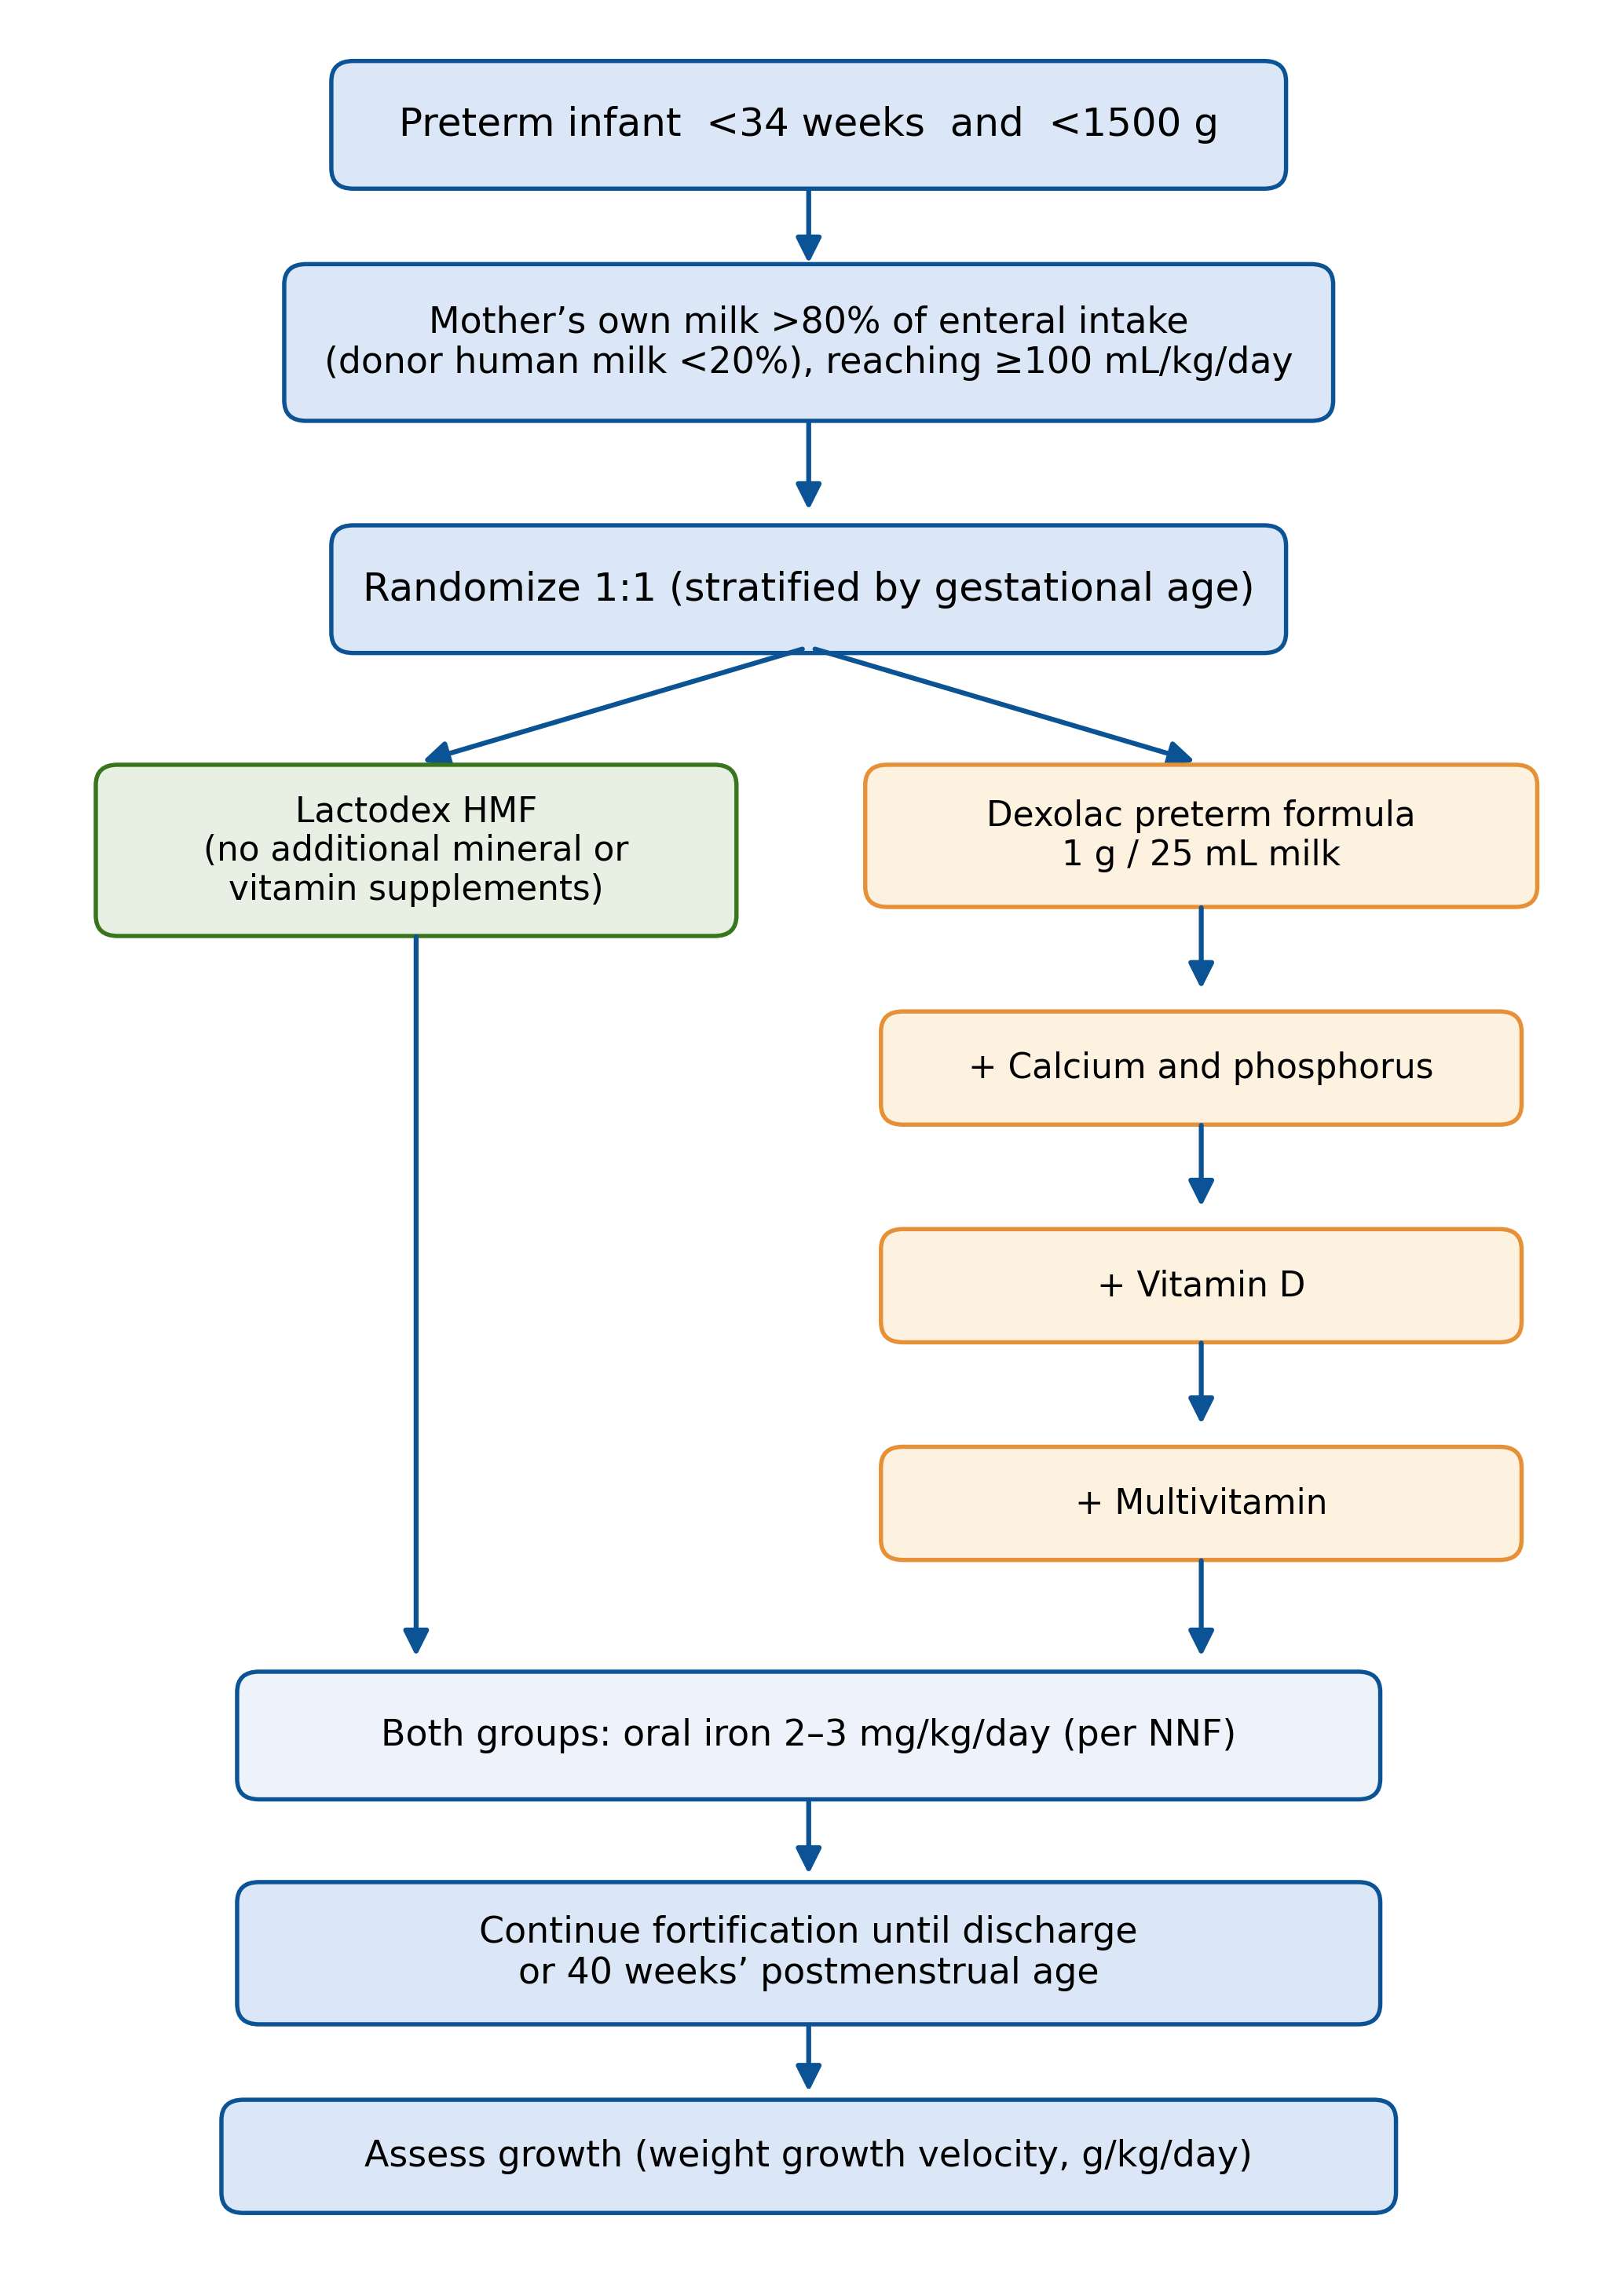

Figure S2. Intervention acquisition cost per infant by group (mean values).
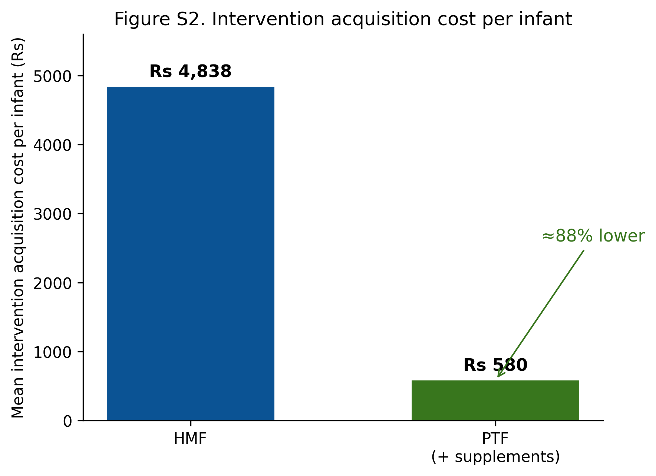
Figure S3. Nutrient adequacy of fortified mother’s own milk, expressed as a percentage of the ESPGHAN 2022 target (midpoint), per 100 mL, for Lactodex HMF, PreNAN HMF, and Dexolac preterm formula (before supplementation). The two commercial fortifiers were broadly comparable in macronutrient and major mineral delivery, with larger differences in selected micronutrients, particularly vitamin D (lower with PreNAN than Lactodex); the preterm formula alone is markedly deficient in calcium, phosphorus, vitamin D, and iron.
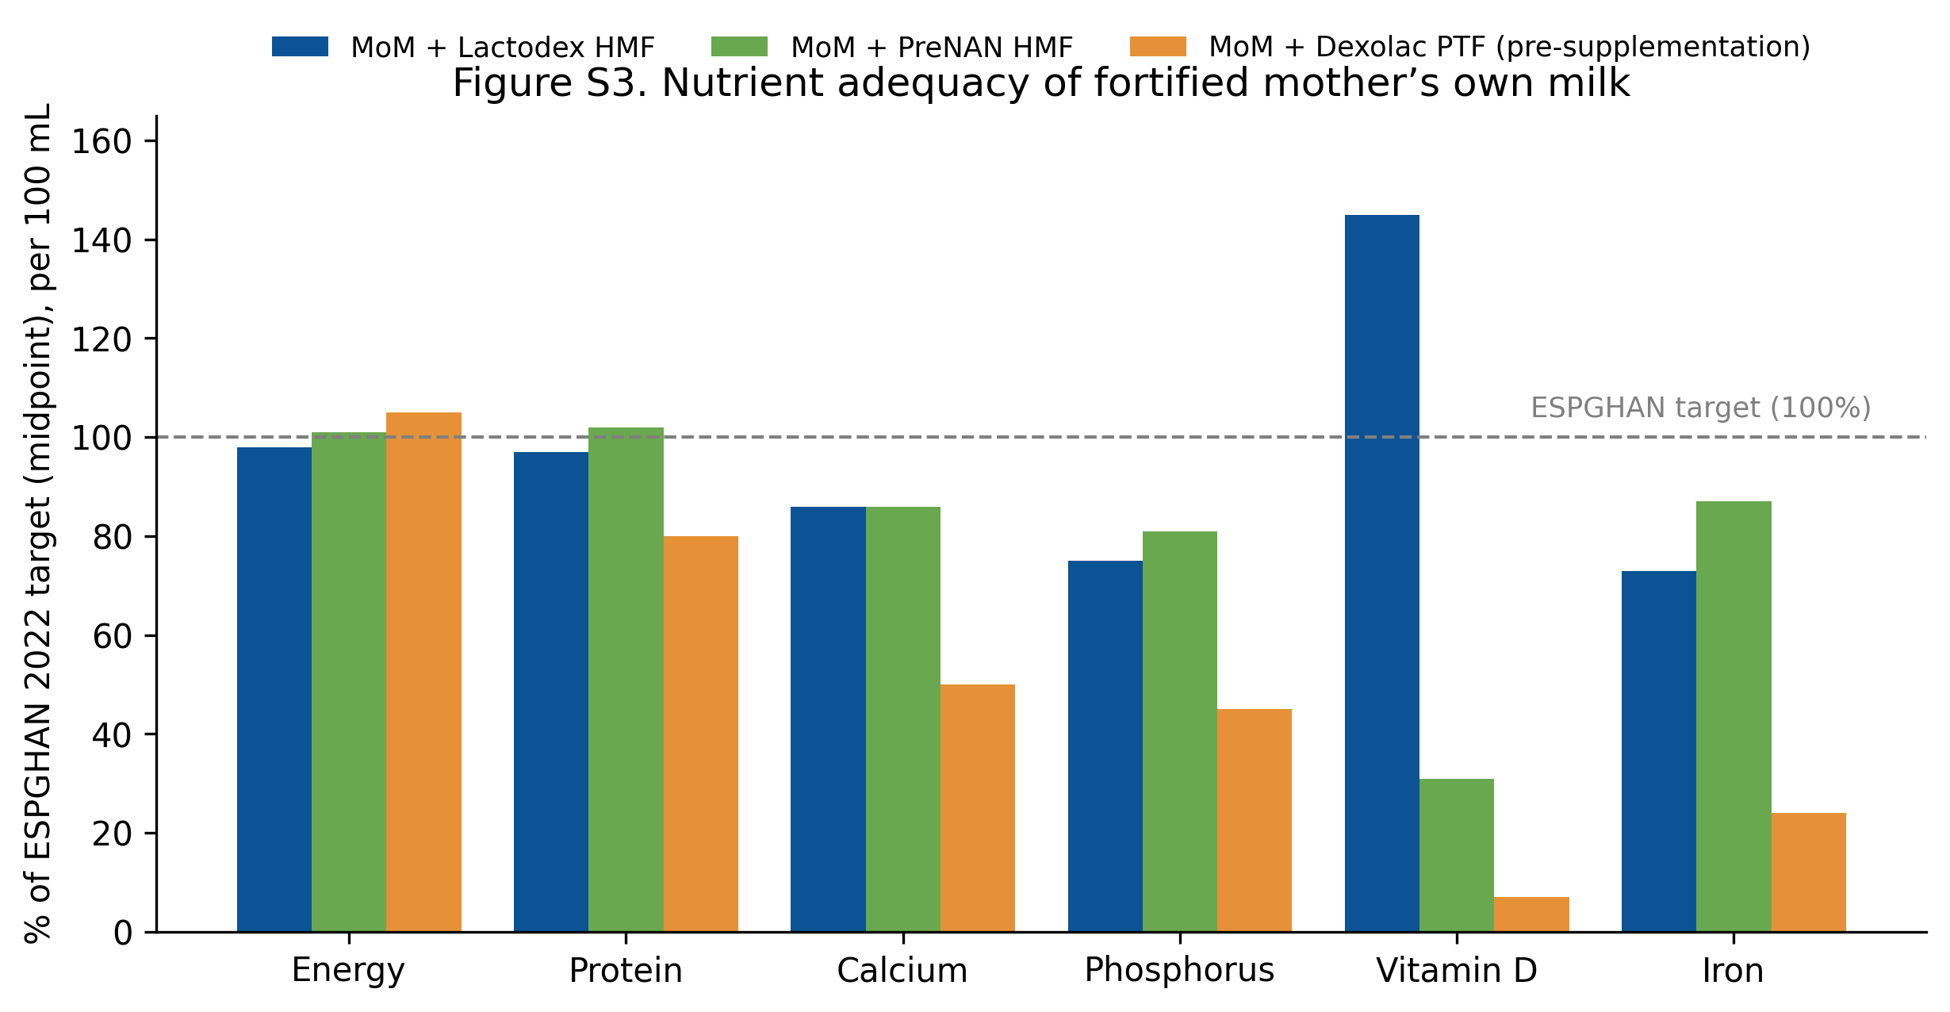
Figure S4. Distribution of weight growth velocity (g/kg/day) by fortification group (evaluable population, n=163), shown as violin plots with superimposed box plots (median, interquartile range) and individual data points.
