Supplementary Table.1 Information of primer sequences for qRT-PCR assays
GENE  h-TM7SF3-F  h-TM7SF3-R  h-CX3CR1-F  h-CX3CR1-R  h-β-actin-F  h-β-actin-R  h-CD163-F  h-CD163-R  h-TGFB1-F  h-TGFB1-R  h-TNF-F  h-TNF-R  h-CD86-F  h-CD86-R  h-CX3CL1-F  h-CX3CL1-R  m-Tm7sf3-F  m-Tm7sf3-R  m-Cx3cr1-F  m-Cx3cr1-R  m-Tnf-F  m-Tnf-R  m-Mgl2-F  m-Mgl2-R  m-Fizz1-F  m-Fizz1-R  m-Nos2-F  m-Nos2-R  m-Cx3cl1-F  m-Cx3cl1-R | Sequence (5' → 3')  CCAGCAAACCTAGGCTATGCGA  GCAACATCTCCTCAGTGAGGTC  ACTTTGAGTACGATGATTTGGCT  GGTAAATGTCGGTGACACTCTT  GGACTTCGAGCAAGAGATGG  AGCACTGTGTTGGCGTACAG  TTTGTCAACTTGAGTCCCTTCAC  TCCCGCTACACTTGTTTTCAC  CTGTACATTGACTTCCGCAAG  TGTCCAGGCTCCAAATGTAG  CCTCTCTCTAATCAGCCCTCTG  GAGGACCTGGGAGTAGATGAG  CTGCTCATCTATACACGGTTACC  GGAAACGTCGTACAGTTCTGTG  ACCACGGTGTGACGAAATG  TGTTGATAGTGGATGAGCAAAGC  TCCAGCGACGGTTTCCTTG  GTCACATTGCTTGAAATATGGCG  GAGTATGACGATTCTGCTGAGG  CAGACCGAACGTGAAGACGAG  CTGAGGTCAATCTGCCCAAGTAC  CTTCACAGAGCAATGACTCCAAAG  TTCAAGAATTGGAGGCCACT  CAGACATCGTCATTCCAACG  CCTGCTGGGATGACTGCTA  TGGGTTCTCCACCTCTTCAT  CCAAGCCCTCACCTACTTCC  CTCTGAGGGCTGACACAAGG  CTGGCCGCGTTCTTCCATT  GCACATGATTTCGCATTTCGT

Supplementary Table.2 The correlation between the mRNA expression of TM7SF3 and the key genes of macrophage activation in TCGA-STAD dataset.
Description | Gene | P-Value | Spearman. R
Macrophage activation | NMI | 1.8e-06 | 0.23
Macrophage activation | TICAM1 | 7.7e-05 | 0.19
Macrophage activation | CX3CR1 | 2.8e-05 | 0.21
Macrophage activation | SBNO2 | 1.3e-08 | 0.28
Macrophage activation | GRN | 4.6e-08 | 0.27
Macrophage activation | IFI35 | 0.00022 | 0.18
Macrophage activation | IFNG | 1.1e-05 | 0.22
Macrophage activation | PLCG2 | 0.015 | 0.12
Macrophage activation | TREM2 | 1.5e-05 | 0.21
Macrophage activation | SUCNR1 | 2.7e-12 | 0.34
Macrophage activation | SYK | 6.8e-19 | 0.42
Macrophage activation | TYROBP | 0.045 | 0.099
Macrophage activation | DYSF | 0.037 | 0.1
Macrophage activation | HAVCR2 | 1.2e-13 | 0.36
Macrophage activation | FER1L5 | 0.14 | -0.073
Macrophage activation | IL33 | 0.82 | -0.011
Macrophage activation | LBP | 0.092 | -0.083
Macrophage activation | TREX1 | 0.79 | 0.013

Supplementary Table.3 The correlation between the mRNA expression of TM7SF3 and tumor-produced chemokines and corresponding receptors on macrophages in TCGA-STAD dataset.
Description | Chemokines | P-Value | Spearman. R | Receptor | P-Value | Spearman. R
Recruitment of macrophages | CCL2 | 0.88 | -0.0073 | CCR2 | 3.5e-07 | 0.25
Recruitment of macrophages | CCL3 | 0.00093 | 0.16 | CCR1 | 3.6e-11 | 0.32
Recruitment of macrophages | CCL3 | 0.00093 | 0.16 | CCR5 | 1.4e-07 | 0.26
Recruitment of macrophages | CCL5 | 0.033 | 0.11 | CCR5 | 1.4e-07 | 0.26
Recruitment of macrophages | CCL15 | 0.49 | 0.035 | CCR1 | 3.6e-11 | 0.32
Recruitment of macrophages | CCL26 | 0.55 | 0.03 | CX3CR1 | 2.8e-05 | 0.21
Recruitment of macrophages | CXCL8 | 0.0085 | 0.13 | CXCR1 | 0.0017 | 0.15
Recruitment of macrophages | CXCL8 | 0.0085 | 0.13 | CXCR2 | 0.0033 | 0.14
Recruitment of macrophages | CXCL12 | 0.32 | 0.05 | CXCR4 | 0.0041 | 0.14
Recruitment of macrophages | CX3CL1 | 0.05 | 0.097 | CX3CR1 | 2.8e-05 | 0.21
Polarization of macrophages | CCL2 | 0.88 | -0.0073 | CCR2 | 3.5e-07 | 0.25
Polarization of macrophages | CCL3 | 0.00093 | 0.16 | CCR1 | 3.6e-11 | 0.32
Polarization of macrophages | CCL3 | 0.00093 | 0.16 | CCR5 | 1.4e-07 | 0.26
Polarization of macrophages | CCL5 | 0.033 | 0.11 | CCR5 | 1.4e-07 | 0.26
Polarization of macrophages | CXCL12 | 0.32 | 0.05 | CXCR4 | 0.0041 | 0.14
Polarization of macrophages | CX3CL1 | 0.05 | 0.097 | CX3CR1 | 2.8e-05 | 0.21

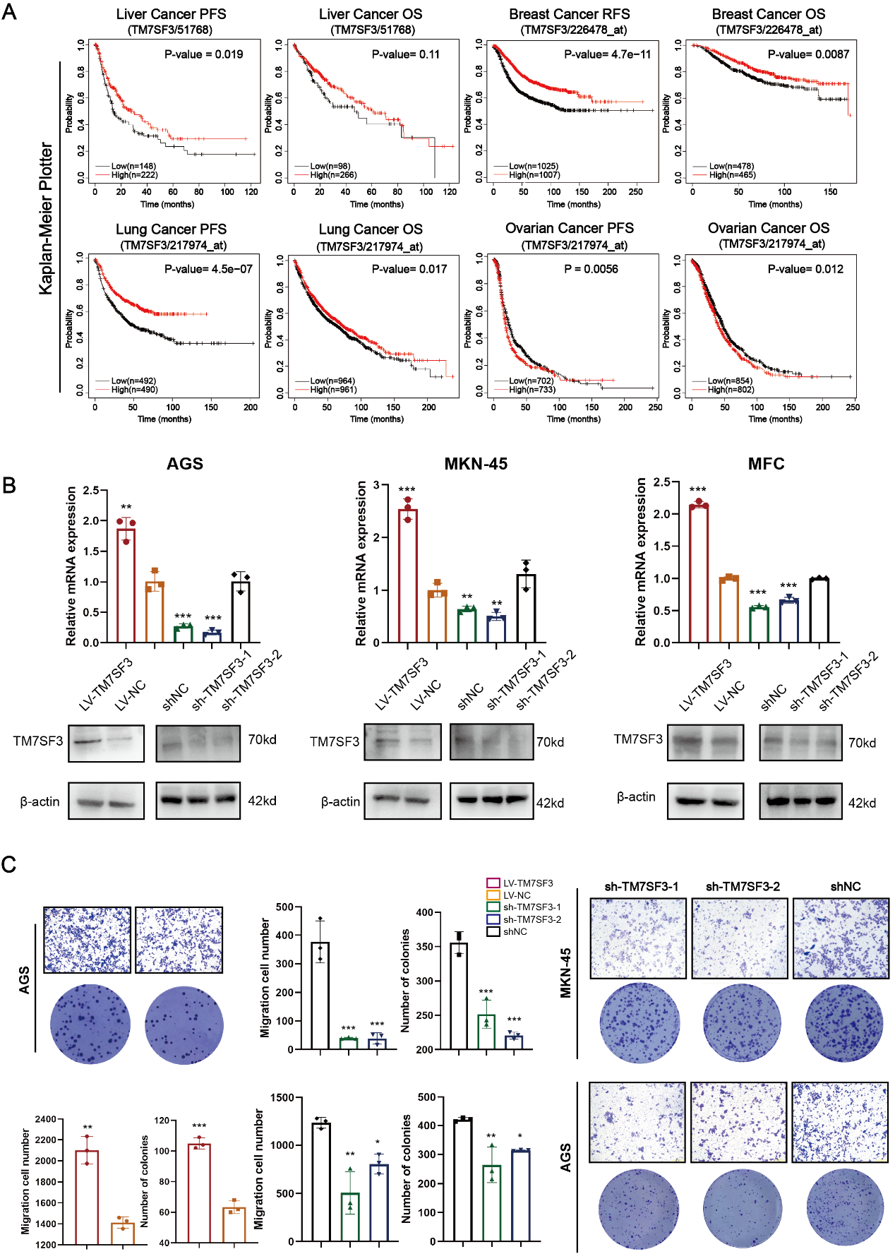
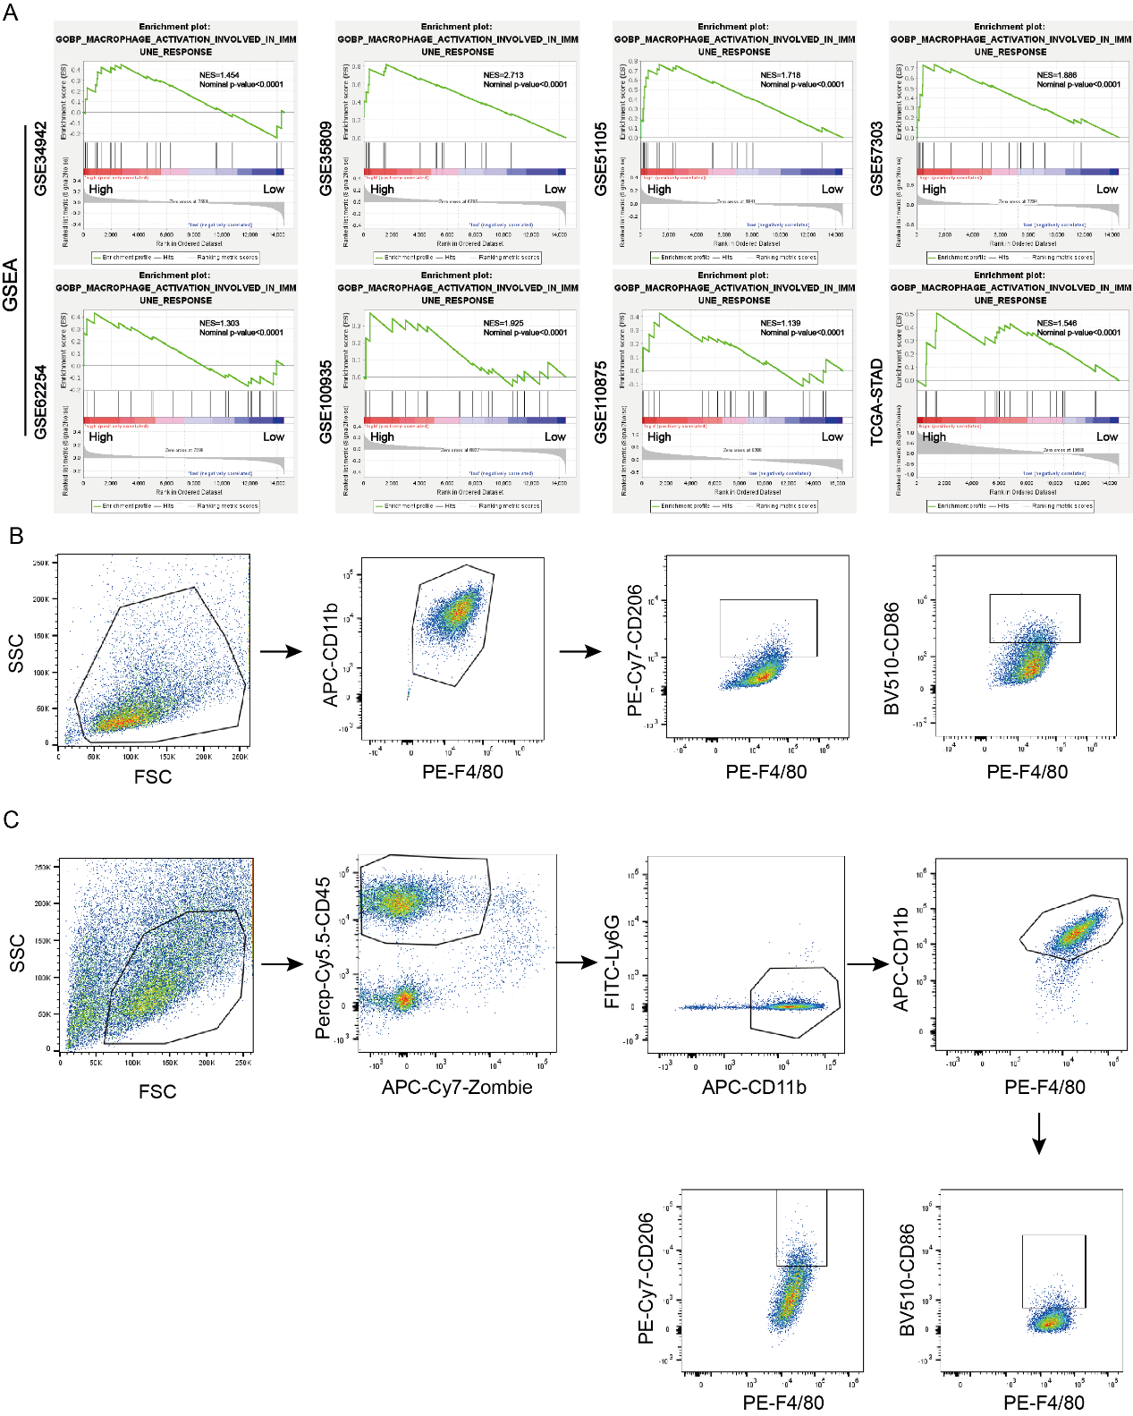
Supplementary Figure.1 (A) The relationship between the infiltration of diverse immune cells and survival prognosis of GC patients from the TCGA-STAD database. (B) qRT-PCR and western blot analysis confirmed the successful establishment of TM7SF3-overexpressing and TM7SF3-knockdown AGS, MKN-45, and MFC cell lines. (C) Transwell and colony formation assays of AGS and MKN-45 cells.

Supplementary Figure.2 (A) Using GSEA to explore the interaction between TM7SF3 and macrophage in these GC-GEO datasets, which were averagely divided into two groups according to the expression level of TM7SF3. (B-C) Flow cytometric gating strategy for macrophage polarization in vitro and in vivo.
Supplementary Figure.3 The relationship between the infiltration of diverse immune cells and survival prognosis of GC patients from the TCGA-STAD database.
Supplementary Figure.4 The functional analysis of macrophage involved in the GC tumor tissues and the normal tissues. (A)The normal and tumor tissues of GC patients from the GEO and TCGA-STAD datasets were used to the Gene Set Enrichment Analysis (GSEA). (B&C) GSEA revealed that the activation of macrophage was significant enriched in the GC tumor tissues compared to the normal tissues. (NES, normalized enrichment score, NOM, nominal).
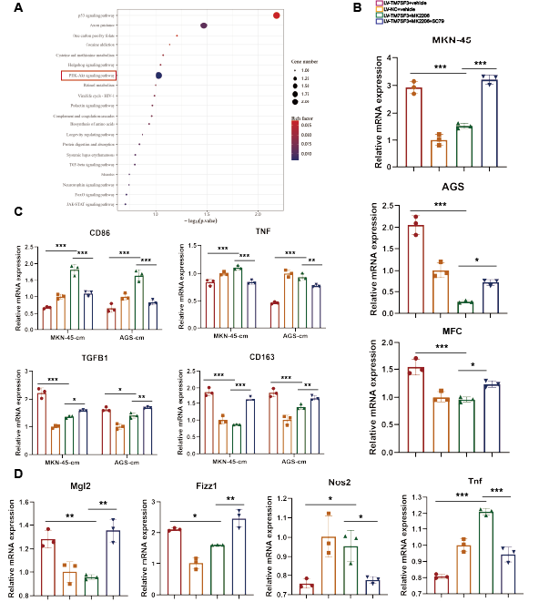
Supplementary Figure.5 (A) KEGG enrichment analysis of differentially expressed genes identified several significantly enriched signaling pathways. (B) qRT-PCR analysis of CX3CL1 expression of GC cells treated with MK2206 (10 μM) and SC79 (10 μM) for 24h . (C) qRT-PCR analysis of M1 and M2 markers of THP-1 and BMDMs cultured medium of MKN-45, AGS, MFC cells treated with MK2206 and SC79.
Supplementary Figure.6 Drug response of GC cell lines with TM7SF3 expression level was evaluated by using the CTRP and CCLE databases. (A) Using the mRNA and protein expression level of TM7SF3 in GC cell lines from the CCLE dataset to divided these cells into the TM7SF3-high cells and TM7SF3-low cells. (B) A volcano plot shows the associations between the candidate drugs and the drug response of IC50 values between the TM7SF3-high cells and TM7SF3-low cells. Red dots represent up-regulated drugs and green dot represents down-regulated drugs depending on the TM7SF3 expression level. (C) The differential analysis of IC50 value of these candidate drugs between the TM7SF3-high cells and TM7SF3-low cells. (D) The correlation analysis between drug IC50 value of the candidate drugs and TM7SF3 expression level in GC cell lines, P<0.05 means the correlation is significant. (E) The correlation analysis between drug IC50 value of trametinib and TM7SF3 expression level in GC cell lines. (F) The Heat map from drug response scores of candidate drugs in the TM7SF3-high cells and TM7SF3-low cells. (G) The drug-response analysis of Trametinib in the TM7SF3-high cells and TM7SF3-low cells.

