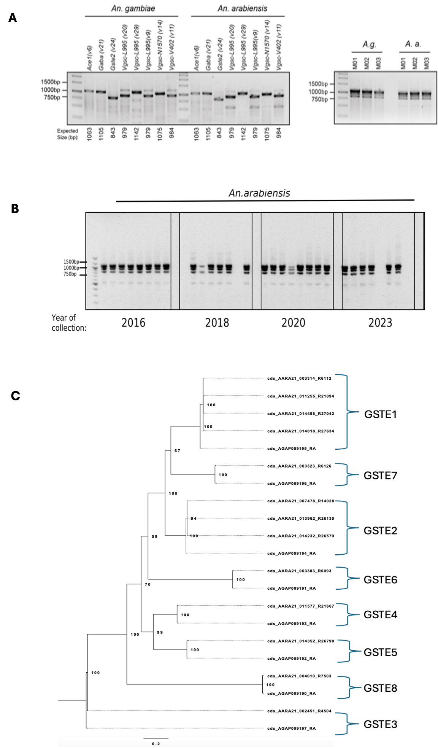Supplementary file2, A-C | Design of multiplex PCR for IR panel for An. gambiae s.l. A.Gel electrophoresis plot of the singleplex PCR of each target and multiplex PCR (pooled targets) in An. gambiae s.s and An. arabiensis. B. Gel electrophoresis plot of multiplex PCR in archived An. arabiensis samples from 2016-2023. C. Phylogenetic tree of different Glutathione S-transferase epsilon (Gste) in An. arabiensis.
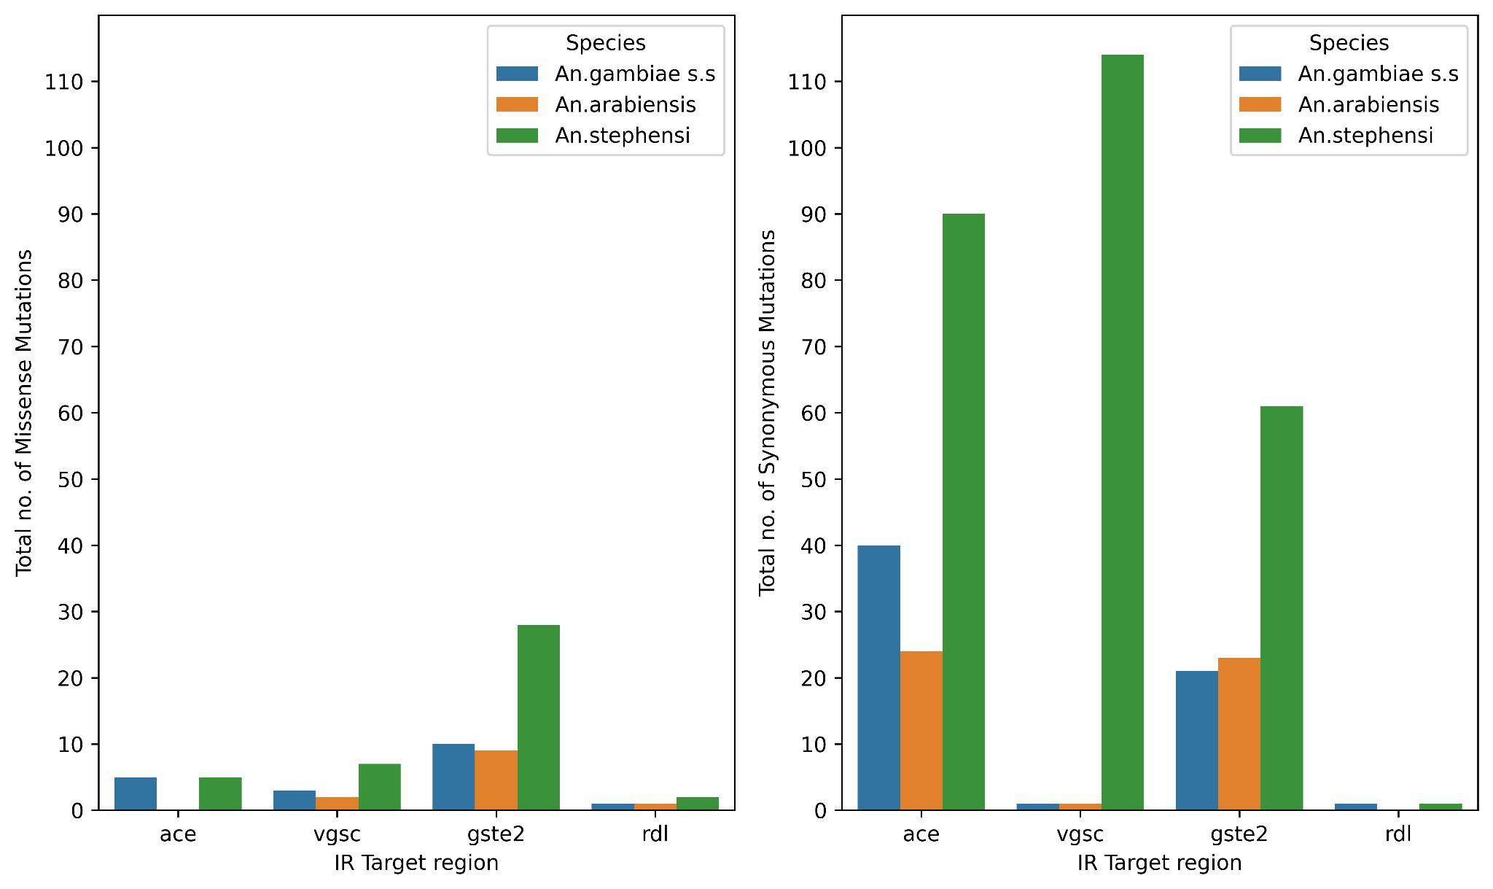
Supplementary file2, D | Total number of synonymous and missense mutations per target region in An. gambiae s.s, An. arabiensis and An. stephensi.

