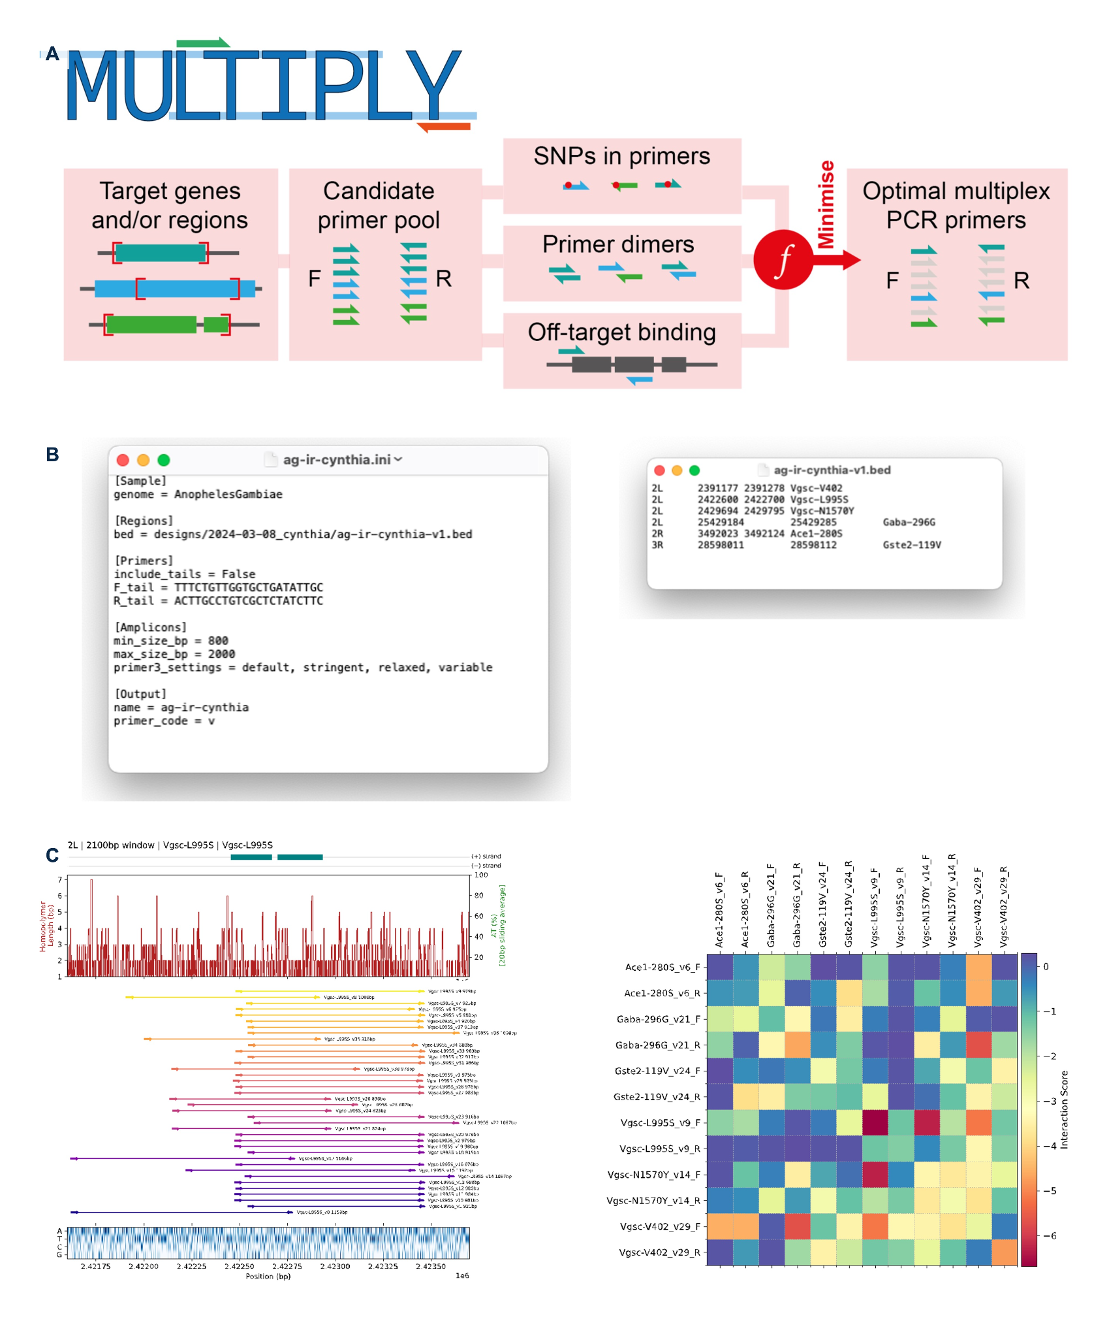

Supplementary file1, A-C | Design and evaluation of multiplex PCR primers using MULTIPLY. A. Overview of the MULTIPLY workflow for designing multiplex PCR primers. Candidate primers are generated for the target regions and optimized by minimizing primer SNPs, primer–dimer formation, and off-target binding to produce the final multiplex primer set. B. Example input files required for MULTIPLY, including the configuration (.ini) file specifying PCR parameters (e.g., amplicon size and primer settings) and the BED file defining the genomic target regions. C. Representative output showing primer placement across the target genomic region (left) and the primer interaction matrix (right), which was used to evaluate primer compatibility and minimize primer–dimer formation for optimal multiplex PCR performance.

