Supplementary Material
Supplementary Table 1: STROBE Statement—Checklist of items that should be included in reports of cross-sectional studies

 | Item No | Recommendation | Page reported
Title and abstract | 1 | (a) Indicate the study’s design with a commonly used term in the title or the abstract | 1-2
Title and abstract | 1 | (b) Provide in the abstract an informative and balanced summary of what was done and what was found | 2
Introduction
Background/rationale | 2 | Explain the scientific background and rationale for the investigation being reported | 4
Objectives | 3 | State specific objectives, including any prespecified hypotheses | 4
Methods
Study design | 4 | Present key elements of study design early in the paper | 4-5
Setting | 5 | Describe the setting, locations, and relevant dates, including periods of recruitment, exposure, follow-up, and data collection | 5-8
Participants | 6 | (a) Give the eligibility criteria, and the sources and methods of selection of participants | 5
Variables | 7 | Clearly define all outcomes, exposures, predictors, potential confounders, and effect modifiers. Give diagnostic criteria, if applicable | 5-8
Data sources/ measurement | 8* | For each variable of interest, give sources of data and details of methods of assessment (measurement). Describe comparability of assessment methods if there is more than one group | 5-8
Bias | 9 | Describe any efforts to address potential sources of bias | 8 and 13
Study size | 10 | Explain how the study size was arrived at | 5
Quantitative variables | 11 | Explain how quantitative variables were handled in the analyses. If applicable, describe which groupings were chosen and why | 5 and 8
Statistical methods | 12 | (a) Describe all statistical methods, including those used to control for confounding | 7-8
Statistical methods | 12 | (b) Describe any methods used to examine subgroups and interactions | NA
Statistical methods | 12 | (c) Explain how missing data were addressed | NA
Statistical methods | 12 | (d) If applicable, describe analytical methods taking account of sampling strategy | NA
Statistical methods | 12 | (e) Describe any sensitivity analyses | NA
Results
Participants | 13* | (a) Report numbers of individuals at each stage of study—eg numbers potentially eligible, examined for eligibility, confirmed eligible, included in the study, completing follow-up, and analysed | 5 and 8
Participants | 13* | (b) Give reasons for non-participation at each stage
Participants | 13* | (c) Consider use of a flow diagram
Descriptive data | 14* | (a) Give characteristics of study participants (eg demographic, clinical, social) and information on exposures and potential confounders | 8, Table 1
Descriptive data | 14* | (b) Indicate number of participants with missing data for each variable of interest
Outcome data | 15* | Report numbers of outcome events or summary measures | 8-10, Table 2, (Fig 1,2,3 and 42)
Main results | 16 | (a) Give unadjusted estimates and, if applicable, confounder-adjusted estimates and their precision (eg, 95% confidence interval). Make clear which confounders were adjusted for and why they were included | 9-10, Table 2
Main results | 16 | (b) Report category boundaries when continuous variables were categorized | 5, 8 and 9Table 2
Main results | 16 | (c) If relevant, consider translating estimates of relative risk into absolute risk for a meaningful time period | NA
Other analyses | 17 | Report other analyses done—eg analyses of subgroups and interactions, and sensitivity analyses | Supplementary table
Discussion
Key results | 18 | Summarise key results with reference to study objectives | 10 - 11
Limitations | 19 | Discuss limitations of the study, taking into account sources of potential bias or imprecision. Discuss both direction and magnitude of any potential bias | 13
Interpretation | 20 | Give a cautious overall interpretation of results considering objectives, limitations, multiplicity of analyses, results from similar studies, and other relevant evidence | 13
Generalisability | 21 | Discuss the generalisability (external validity) of the study results | 13
Other information
Funding | 22 | Give the source of funding and the role of the funders for the present study and, if applicable, for the original study on which the present article is based | 14

Supplementary Figure 1: Flow diagram outlining how AFRO-SARC thresholds were derived
Distributions of muscle assessments:
Sex-specific distributions of muscle function measures among adults aged ≥40 years by country
Reference population:
Young internal reference group, aged 40 – 49 years representing adults near peak muscle strength and physical performance
Generation of country-specific candidate thresholds:
Explore sex-specific 1 SD, 1.5SD and 2SD below the mean for grip strength and gait speed, and 10th and 25th slowest centile for chair-rise time
Assessment of cross-country comparability and pooling data:
Assess measurement consistencies across all countries for all muscle function measures
Derivation of AFRO-SARC combined thresholds:
Calculate low muscle function measures, and sarcopenia prevalence, and explore associations with clinical outcomes

Supplementary Figure 2: Age-related trajectories for A) grip strength, B) gait speed, and C) chair rise time, stratified by sex and country. Lines represent smoothed estimates with shaded 95% confidence intervals.
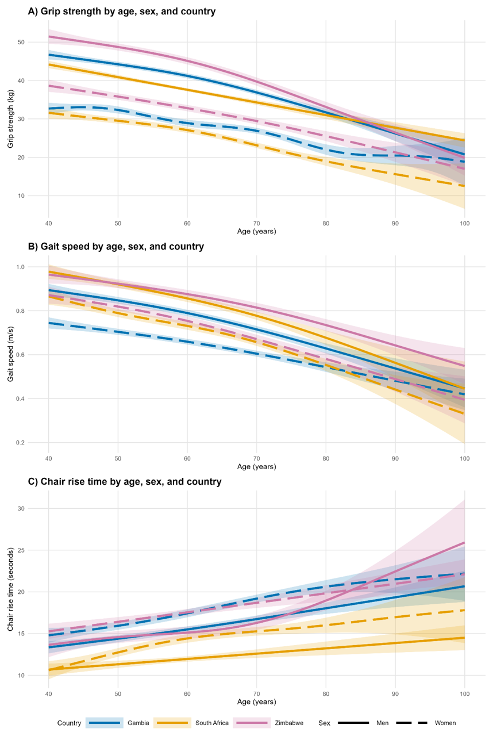

Supplementary Table 2: Prevalence of low physical function, defined using the newly proposed thresholds
 |  |  | Men |  |  |  | Women
 |  |  | All  (n=2318) | The Gambia (n=1030) | South Africa (n=844) | Zimbabwe (n=444) | All  (n=2622) | The Gambia (n=1188) | South Africa (n=989) | Zimbabwe (n=445)
Low grip strength* | All |  | 14.6% (338) | 11.4% (117) | 20.7% (175) | 10.4% (46) | 16.6% (435) | 13.3.% (158) | 24.4% (241) | 8.1% (36)
Low grip strength* | Age | 40-54 years | 5.1% (43) | 1.4% (5) | 11.1% (37) | 0.6% (1) | 4.0% (35) | 2.6% (10) | 7.0% (23) | 1.2% (2)
Low grip strength* |  | 55 – 69 years | 10.4% (86) | 5.5% (19) | 18.7% (61) | 3.8% (6) | 10.6% (91) | 8.4% (31) | 16.6% (56) | 2.7% (4)
Low grip strength* |  | >70 years | 32.4% (209) | 27.8% (93) | 41.6% (77) | 31.2% (39) | 34.5% (309) | 26.8% (117) | 50.3% (162) | 22.1% (30)
Slow gait speed** | All |  | 5.6% (132) | 5.2% (53) | 5.9% (48) | 6.1% (31) | 12.8% (343) | 12.4% (146) | 12.6% (123) | 14.0% (74)
Slow gait speed** | Age | 40-54 years | 2.1% (18) | 1.1% (4) | 3.0% (10) | 2.4% (4) | 4.0% (35) | 3.4% (13) | 4.0% (13) | 5.2% (9)
Slow gait speed** |  | 55 – 69 years | 3.1% (26) | 2.3% (8) | 3.6% (11) | 4.0% (7) | 8.5% (74) | 6.8% (25) | 9.1% (30) | 11.1% (19)
Slow gait speed** |  | >70 years | 13.2% (88) | 12.4% (41) | 15.6% (27) | 12.4% (20) | 25.2% (234) | 25.5% (108) | 24.6% (80) | 25.4% (46)
Slow chair rise*** | All |  | 20.5% (290) | 18.9% (187) |  | 24.2% (103) | 18.4% (285) | 16.9% (190) |  | 22.3% (95)
Slow chair rise*** | Age | 40-54 years | 10.9% (55) | 8.7% (30) |  | 15.5% (25) | 6.8% (37) | 3.5% (13) |  | 14.2% (24)
Slow chair rise*** |  | 55 – 69 years | 15.5% (77) | 13.1% (44) |  | 20.5% (33) | 18.6% (95) | 15.8% (57) |  | 25.3% (38)
Slow chair rise*** |  | >70 years | 38.4% (158) | 36.8% (113) |  | 43.3% (45) | 31.0% (153) | 31.2% (120) |  | 30.6% (33)
*n’s for grip strength: men – all (n=2318), The Gambia (n=1030), South Africa (n=844), Zimbabwe (n=444); women – all (n=2622), The Gambia (n=1188), South Africa (n=989), Zimbabwe (n=445). **n’s for gait speed: men – all (n=2345), The Gambia (n=1026), South Africa (n=813), Zimbabwe (n=506); women – all (n=2684), The Gambia (n=1178), South Africa (n=979), Zimbabwe (n=527). ***n’s for chair rise time: men – all(n=1414), The Gambia (n=988), Zimbabwe (n=426); women – all (n=1551), The Gambia (n=1124), Zimbabwe (n=427)

Supplementary Table 3: Centiles and mean (SD) by sex and country of maximum grip strength

 | n | 10th | 25th | 50th | 75th | 90th | Mean | SD
Males
The Gambia
40.00-49.99 | 249 | 36.0 | 40.0 | 46.0 | 52.0 | 56.0 | 46.3 | 8.3
50.00-59.99 | 244 | 32.0 | 38.0 | 42.0 | 48.0 | 52.0 | 42.9 | 8.1
60.00-69.99 | 202 | 30.0 | 36.0 | 41.0 | 46.0 | 52.0 | 41.1 | 8.6
70.00-79.99 | 246 | 26.0 | 30.0 | 34.0 | 40.5 | 46.0 | 35.3 | 7.9
>80.00 | 89 | 18.0 | 24.0 | 30.0 | 34.0 | 42.0 | 29.9 | 8.5
Overall | 1030 | 28.0 | 34.0 | 40.0 | 46.0 | 52.0 | 40.4 | 9.7
South Africa
40.00-49.99 | 224 | 32.0 | 36.0 | 42.0 | 48.0 | 53.0 | 42.0 | 9.0
50.00-59.99 | 233 | 26.0 | 32.0 | 38.0 | 44.0 | 48.0 | 37.6 | 8.9
60.00-69.99 | 202 | 24.0 | 30.0 | 36.0 | 40.0 | 46.0 | 35.7 | 9.1
70.00-79.99 | 155 | 22.0 | 26.0 | 32.0 | 38.0 | 42.0 | 32.5 | 8.5
>80.00 | 30 | 16.5 | 24.0 | 28.0 | 34.0 | 37.1 | 27.7 | 7.9
Overall | 844 | 25.0 | 31.0 | 36.1 | 42.0 | 48.0 | 37.0 | 9.6
Zimbabwe
40.00-49.99 | 113 | 39.0 | 44.0 | 48.0 | 56.8 | 60.8 | 50.1 | 9.4
50.00-59.99 | 134 | 36.0 | 40.0 | 48.0 | 54.0 | 58.0 | 47.6 | 9.6
60.00-69.99 | 72 | 32.2 | 38.0 | 45.0 | 50.0 | 54.0 | 44.0 | 10.1
70.00-79.99 | 68 | 24.5 | 30.3 | 35.5 | 44.5 | 49.0 | 37.1 | 9.3
>80.00 | 57 | 19.0 | 22.2 | 29.0 | 34.0 | 41.0 | 28.9 | 8.0
Overall | 444 | 28.0 | 35.0 | 44.0 | 51.0 | 58.0 | 43.7 | 11.7
Females
The Gambia
40.00-49.99 | 280 | 24.0 | 28.0 | 32.0 | 36.0 | 40.0 | 32.5 | 6.4
50.00-59.99 | 282 | 22.0 | 26.0 | 30.0 | 34.0 | 38.0 | 30.2 | 5.8
60.00-69.99 | 189 | 22.0 | 24.0 | 28.0 | 32.0 | 34.0 | 28.1 | 5.4
70.00-79.99 | 352 | 18.0 | 22.0 | 26.0 | 30.0 | 32.0 | 25.6 | 6.0
>80.00 | 85 | 14.0 | 18.0 | 20.0 | 24.0 | 26.0 | 20.3 | 4.7
Overall | 1188 | 20.0 | 24.0 | 28.0 | 32.0 | 38.0 | 28.3 | 6.8
South Africa
40.00-49.99 | 204 | 22.0 | 27.0 | 32.0 | 36.0 | 40.0 | 31.5 | 6.8
50.00-59.99 | 241 | 20.0 | 23.0 | 28.0 | 34.0 | 37.0 | 28.6 | 7.0
60.00-69.99 | 222 | 18.0 | 22.0 | 26.0 | 31.0 | 37.0 | 26.9 | 7.6
70.00-79.99 | 261 | 16.0 | 18.0 | 22.0 | 26.0 | 28.0 | 22.1 | 5.8
>80.00 | 61 | 12.0 | 16.0 | 18.0 | 21.0 | 24.0 | 18.3 | 5.5
Overall | 989 | 17.0 | 21.0 | 26.0 | 32.0 | 36.0 | 26.5 | 7.8
Zimbabwe
40.00-49.99 | 112 | 30.0 | 32.3 | 36.2 | 40.1 | 47.0 | 37.2 | 7.0
50.00-59.99 | 114 | 24.0 | 30.0 | 34.0 | 38.0 | 42.0 | 33.8 | 7.1
60.00-69.99 | 83 | 22.0 | 27.0 | 32.0 | 36.0 | 40.2 | 31.7 | 6.9
70.00-79.99 | 94 | 19.0 | 24.0 | 28.2 | 32.0 | 36.0 | 28.0 | 7.1
>80.00 | 42 | 14.0 | 17.0 | 23.0 | 29.0 | 33.0 | 23.0 | 7.7
Overall | 445 | 22.0 | 27.0 | 32.0 | 37.0 | 42.0 | 32.0 | 8.3

Supplementary Table 4: Centiles and mean (SD) by sex and country of maximum gait speed

 | n | 10th | 25th | 50th | 75th | 90th | Mean | SD
Males
The Gambia
40.00-49.99 | 251 | 0.69 | 0.76 | 0.87 | 0.97 | 1.12 | 0.88 | 0.17
50.00-59.99 | 245 | 0.63 | 0.74 | 0.83 | 0.92 | 1.11 | 0.84 | 0.18
60.00-69.99 | 200 | 0.62 | 0.70 | 0.79 | 0.88 | 0.97 | 0.79 | 0.14
70.00-79.99 | 246 | 0.51 | 0.60 | 0.70 | 0.79 | 0.91 | 0.70 | 0.16
>80.00 | 84 | 0.35 | 0.50 | 0.60 | 0.69 | 0.81 | 0.59 | 0.19
Overall | 1026 | 0.55 | 0.67 | 0.78 | 0.89 | 1.02 | 0.79 | 0.19
South Africa
40.00-49.99 | 220 | 0.66 | 0.80 | 0.92 | 1.07 | 1.17 | 0.92 | 0.23
50.00-59.99 | 226 | 0.65 | 0.76 | 0.88 | 0.96 | 1.07 | 0.87 | 0.20
60.00-69.99 | 194 | 0.63 | 0.73 | 0.82 | 0.95 | 1.06 | 0.83 | 0.18
70.00-79.99 | 143 | 0.47 | 0.60 | 0.73 | 0.84 | 0.96 | 0.73 | 0.20
>80.00 | 30 | 0.29 | 0.41 | 0.56 | 0.73 | 0.89 | 0.59 | 0.23
Overall | 813 | 0.57 | 0.71 | 0.83 | 0.96 | 1.11 | 0.84 | 0.22
Zimbabwe
40.00-49.99 | 116 | 0.70 | 0.78 | 0.92 | 1.04 | 1.24 | 0.93 | 0.22
50.00-59.99 | 139 | 0.68 | 0.79 | 0.90 | 1.01 | 1.14 | 0.91 | 0.19
60.00-69.99 | 89 | 0.52 | 0.69 | 0.80 | 0.96 | 1.07 | 0.81 | 0.22
70.00-79.99 | 88 | 0.53 | 0.65 | 0.77 | 0.93 | 1.18 | 0.80 | 0.22
>80.00 | 74 | 0.33 | 0.54 | 0.67 | 0.79 | 0.87 | 0.65 | 0.21
Overall | 506 | 0.57 | 0.69 | 0.82 | 0.99 | 1.15 | 0.84 | 0.23
Females
The Gambia
40.00-49.99 | 281 | 0.58 | 0.63 | 0.71 | 0.79 | 0.86 | 0.71 | 0.12
50.00-59.99 | 285 | 0.53 | 0.59 | 0.67 | 0.74 | 0.82 | 0.67 | 0.12
60.00-69.99 | 188 | 0.49 | 0.56 | 0.66 | 0.73 | 0.82 | 0.65 | 0.13
70.00-79.99 | 349 | 0.42 | 0.49 | 0.57 | 0.66 | 0.73 | 0.58 | 0.13
>80.00 | 75 | 0.31 | 0.36 | 0.49 | 0.59 | 0.68 | 0.48 | 0.15
Overall | 1178 | 0.46 | 0.55 | 0.64 | 0.73 | 0.81 | 0.64 | 0.14
South Africa
40.00-49.99 | 203 | 0.64 | 0.73 | 0.83 | 0.93 | 1.03 | 0.83 | 0.19
50.00-59.99 | 235 | 0.50 | 0.64 | 0.78 | 0.89 | 1.00 | 0.76 | 0.21
60.00-69.99 | 216 | 0.50 | 0.58 | 0.73 | 0.83 | 0.98 | 0.72 | 0.19
70.00-79.99 | 267 | 0.37 | 0.51 | 0.64 | 0.75 | 0.85 | 0.64 | 0.22
>80.00 | 58 | 0.30 | 0.37 | 0.53 | 0.65 | 0.72 | 0.52 | 0.17
Overall | 979 | 0.44 | 0.58 | 0.73 | 0.85 | 0.97 | 0.72 | 0.22
Zimbabwe
40.00-49.99 | 120 | 0.60 | 0.75 | 0.83 | 0.98 | 1.17 | 0.86 | 0.21
50.00-59.99 | 122 | 0.50 | 0.67 | 0.80 | 0.95 | 1.14 | 0.80 | 0.24
60.00-69.99 | 104 | 0.47 | 0.62 | 0.75 | 0.89 | 0.98 | 0.75 | 0.22
70.00-79.99 | 127 | 0.33 | 0.48 | 0.65 | 0.78 | 0.89 | 0.64 | 0.22
>80.00 | 54 | 0.26 | 0.42 | 0.56 | 0.67 | 0.77 | 0.55 | 0.19
Overall | 527 | 0.40 | 0.58 | 0.75 | 0.89 | 1.01 | 0.74 | 0.24

Supplementary Table 5: Centiles and mean (SD) by sex and country of maximum chair rise time

 | n | 10th | 25th | 50th | 75th | 90th | Mean | SD
Males
The Gambia
40.00-49.99 | 250 | 9.8 | 11.6 | 13.4 | 15.7 | 17.7 | 13.6 | 3.0
50.00-59.99 | 234 | 11.0 | 12.5 | 14.1 | 16.6 | 18.6 | 14.5 | 2.9
60.00-69.99 | 197 | 11.4 | 13.4 | 14.8 | 16.7 | 19.7 | 15.2 | 3.2
70.00-79.99 | 236 | 13.3 | 14.8 | 16.9 | 19.0 | 21.0 | 17.1 | 3.6
>80.00 | 71 | 14.5 | 15.9 | 17.8 | 21.6 | 21.2 | 18.5 | 3.9
Overall | 988 | 11.1 | 12.9 | 14.9 | 17.5 | 19.9 | 15.3 | 3.6
South Africa
40.00-49.99 | 218 | 7.0 | 8.2 | 10.1 | 11.6 | 13.8 | 10.1 | 2.7
50.00-59.99 | 218 | 6.2 | 9.0 | 10.6 | 12.1 | 15.3 | 11.0 | 3.9
60.00-69.99 | 187 | 6.3 | 8.6 | 11.0 | 13.6 | 16.1 | 11.2 | 3.8
70.00-79.99 | 136 | 7.6 | 10.6 | 13.0 | 15.9 | 19.2 | 13.3 | 4.4
>80.00 | 18 | 6.8 | 8.2 | 15.2 | 18.9 | 21.0 | 14.2 | 5.9
Overall | 777 | 6.7 | 8.8 | 10.7 | 13.2 | 16.1 | 11.3 | 3.9
Zimbabwe
40.00-49.99 | 112 | 8.3 | 11.6 | 14.1 | 16.5 | 18.9 | 14.2 | 4.4
50.00-59.99 | 134 | 8.8 | 12.0 | 14.3 | 17.0 | 20.1 | 14.7 | 4.5
60.00-69.99 | 76 | 10.1 | 12.8 | 15.5 | 18.5 | 21.8 | 15.8 | 5.0
70.00-79.99 | 71 | 11.3 | 14.0 | 16.2 | 18.9 | 22.0 | 16.8 | 5.3
>80.00 | 33 | 12.6 | 16.8 | 20.6 | 24.0 | 27.3 | 20.5 | 5.8
Overall | 426 | 10.0 | 12.5 | 15.1 | 18.2 | 27.8 | 15.5 | 5.1
Females
The Gambia
40.00-49.99 | 279 | 11.7 | 13.3 | 15.4 | 17.9 | 19.7 | 15.6 | 3.3
50.00-59.99 | 277 | 12.4 | 14.3 | 16.0 | 18.5 | 21.3 | 16.6 | 4.0
60.00-69.99 | 183 | 12.9 | 14.7 | 16.8 | 20.3 | 23.3 | 17.8 | 4.4
70.00-79.99 | 324 | 14.7 | 16.7 | 19.1 | 22.1 | 25.5 | 19.9 | 4.8
>80.00 | 61 | 15.5 | 16.9 | 19.9 | 23.5 | 28.8 | 21.2 | 5.4
Overall | 1124 | 12.8 | 14.6 | 17.1 | 20.0 | 23.4 | 17.7 | 4.6
South Africa
40.00-49.99 | 205 | 7.3 | 9.1 | 10.4 | 12.1 | 14.9 | 10.9 | 3.4
50.00-59.99 | 228 | 8.0 | 9.7 | 11.1 | 13.8 | 16.6 | 12.0 | 3.8
60.00-69.99 | 193 | 8.6 | 10.4 | 12.2 | 14.7 | 17.8 | 13.0 | 4.4
70.00-79.99 | 230 | 9.9 | 11.5 | 13.2 | 16.3 | 20.5 | 14.4 | 4.6
>80.00 | 44 | 10.0 | 12.1 | 14.4 | 18.1 | 24.3 | 15.6 | 5.1
Overall | 900 | 8.1 | 10.0 | 12.0 | 14.7 | 17.9 | 12.8 | 4.4
Zimbabwe
40.00-49.99 | 115 | 9.3 | 12.7 | 15.3 | 18.8 | 22.9 | 16.0 | 5.2
50.00-59.99 | 120 | 10.5 | 13.4 | 16.3 | 20.1 | 23.5 | 16.7 | 5.1
60.00-69.99 | 84 | 11.1 | 14.0 | 18.3 | 22.1 | 27.8 | 18.5 | 6.3
70.00-79.99 | 82 | 12.4 | 15.4 | 18.1 | 22.1 | 25.8 | 18.8 | 6.2
>80.00 | 26 | 12.4 | 17.4 | 19.3 | 23.0 | 25.4 | 19.5 | 5.8
Overall | 427 | 10.8 | 13.6 | 17.0 | 20.8 | 25.1 | 17.4 | 5.7

Supplementary Table 6: Prevalence of low muscle function measures defined using AFRO-SARC thresholds *
 |  | All |  | The Gambia |  | South Africa |  | Zimbabwe
 |  | Men (n=2239) | Women (n=2537) | Men (n=1015) | Women (n=1159) | Men  (n=786) | Women (n=945) | Men (n=438) | Women (n=433)
All |  | 2.3% (51) | 3.7% (93) | 2.7% (27) | 2.7% (31) | 2.0% (16) | 5.2% (49) | 1.8% (8) | 3.0% (13)
Age | 40 - 54 years | 0.2%  (2/829) | 0.2%  (2/854) | 0.3%  (1/347) | 0%  (0/378) | 0.3%  (1/321) | 0.6%  (2/317) | 0%  (0/161) | 0%  (0/159)
 | 55 - 69 years | 0.5%  (4/797) | 1.7%  (14/839) | 0.6%  (2/343) | 0.8%  (3/368) | 0.3%  (1/298) | 3.1%  (10/348) | 0.6%  (1/156) | 0.7%  (1/148)
 | ≥ 70 years | 7.3%  (45/613) | 9.1%  (77/844) | 7.4%  (24/325) | 6.8%  (28/413) | 8.4%  (14/167) | 12.1%  (37/305) | 5.8%  (7/121) | 9.5%  (12/126)
*AFRO-SARC defined as low muscle strength (using low grip strength) and poor physical performance (slow gait speed)

Supplementary Figure 3: Distribution of a) grip strength, b) gait speed and c) chair rise time by country
a) 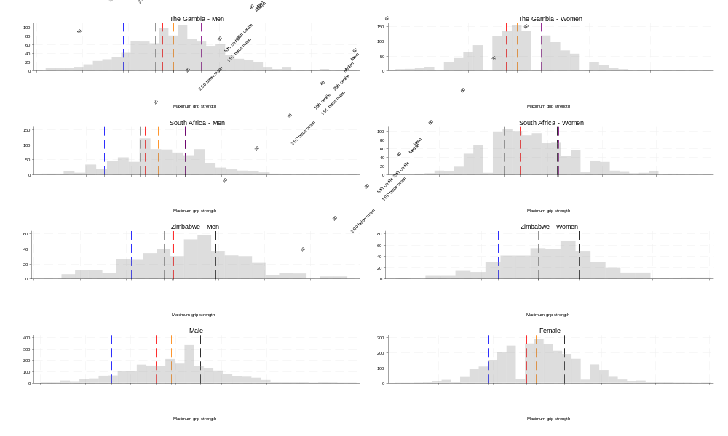
b)

c) 