Supplementary Information
Seismic activity temporarily reshapes fin whale foraging radii

Xiaozhao Zhou^{1#}, Jian xu.^{1#}, Wen Zhang³, Jun Wang³, Ruixue Xia⁴, Yuan Niu¹, Xuefeng Zhang^{4*}

1 School of Marine Science and Technology, Tianjin University, Tianjin,China;
2 College of Meteorology and Oceanography, National University of Defense Technology, Changsha, China;
3 School of Mathematics, Tianjin University, Tianjin, China;
4 Yazhou Bay Innovation Institute, Hainan Tropical Ocean University, China;

# These authors contributed equally to this work and should be considered co-first authors.
* Correspondence: xuefeng.zhang@hntou.edu.cn.

Supplementary Table 1 Results of multifactor analysis of variance
Source of Variation | Sum of Squares (SS) | Degrees of Freedom (df) | F-Value | P-value
Factor A | 0.956899 | 1 | 6.221203 | 0.019908
Factor D | 0.957056 | 2 | 3.111111 | 0.062895
Factor E | 1.111442 | 5 | 1.445191 | 0.244426
Factor B×C | 49.266886 | 35 | 9.151565 | 0.000030

Supplementary Figure 1 Interaction effect analysis diagram of the central longitude (Factor B) and latitude (Factor C).
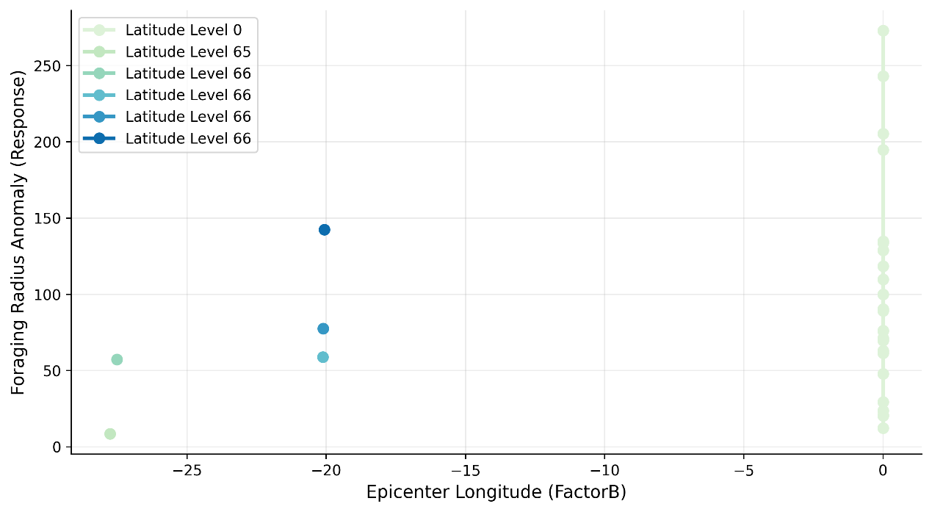

Supplementary Figure 2: Spatial distribution of seismic events in the study area from 2012 to 2014. The dots indicate the epicenter coordinates, with their size scaled to earthquake magnitude. The orange line marks the location of the Central Indian Ridge.
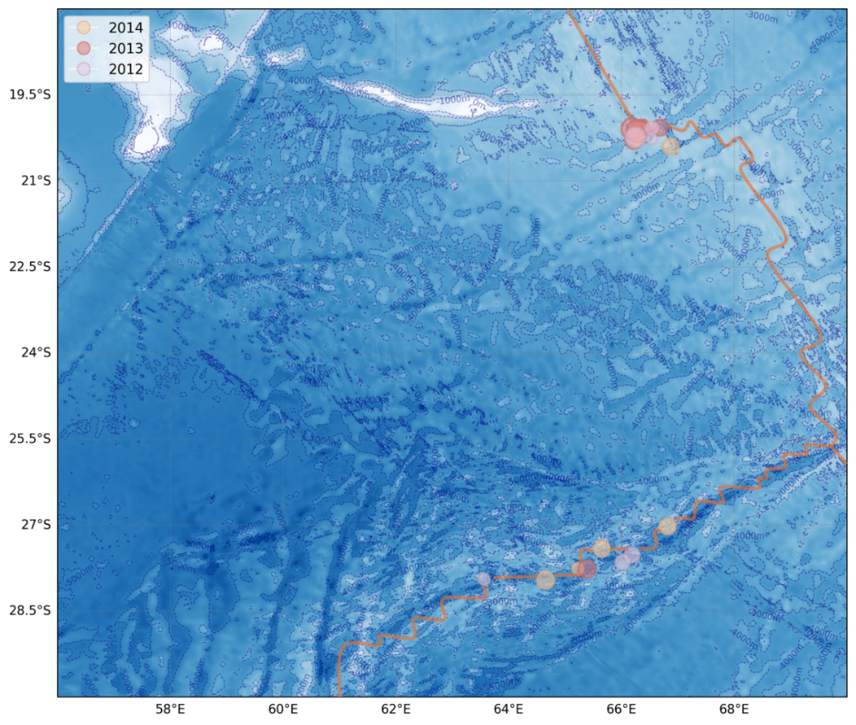

Supplementary Figure 3 Time-frequency spectra of the synthesized fin whale acoustic signals. The data correspond to a virtual sound source located at 65.5°E, 27.55°S, and 345 m depth, with the receiving angle set to 90°. Panels (a) and (b) show the signals recorded by the two hydrophones. Spectrogram parameters: Hann window with a length (w) of 1024 points and an overlap of 98%. In panel (a), a complete vocalization followed by the onset of the next call is visible, while panel (b) displays a full vocalization in the broadband segment during the latter half. Each vocalization has a duration of approximately 0.8–1 s, consistent with the characteristics of fin whale backbeat pulses.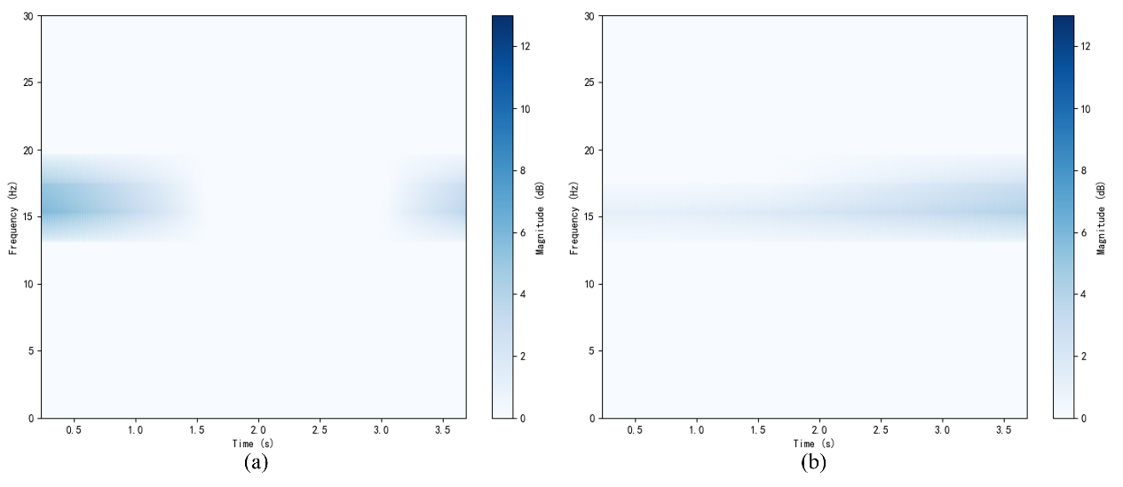

Supplementary Table 2 Evaluation results of prediction performance on the test set
 | RMSE | MAE | CPR(%)
Longitude | 0.0182° | 0.0106° | 100.00
Latitude | 0.0217° | 0.0126° | 100.00
Depth | 27.7614m | 17.2942m | 87.05

Supplementary Figure 4 Study area location. This figure shows the bathymetry of the study area as well as coastlines and islands within the region. The orange curve roughly marks the location of the Southwest Indian Ridge.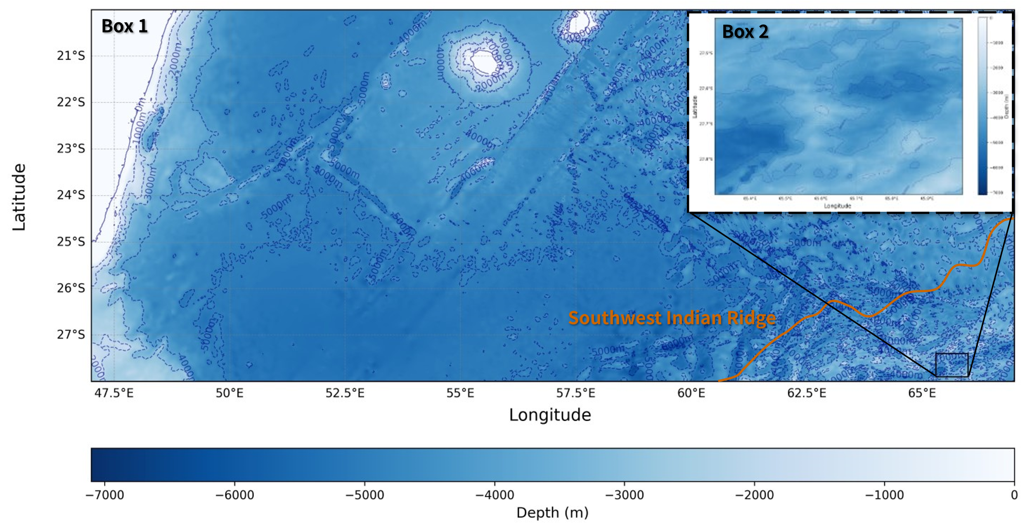

Supplementary Table 3 Evaluation results of prediction performance on the test set
Time | Epicenter Latitude(°S) | Epicenter Longitude(°E) | Hypocenter Depth (km) | Magnitude
2012.11.2 | 27.522 | 66.191 | 10.0 | 4.4
2013.3.19 | 20.128 | 66.283 | 10.0 | 5.0
2013.4.24 | 20.070 | 66.679 | 10.0 | 4.5
2013.5.20 | 27.767 | 65.386 | 10.1 | 4.6
2013.6.13 | 20.114 | 66.340 | 10.0 | 4.7

Supplementary Figure 5 Acoustic signal characteristics of whales. (a) Spectrogram of signals recorded at RR47 station from 06:17 to 06:27 on May 28, 2013. Spectrogram parameters: Hann window, $w$=512, overlap=98%. (b) Spectrogram of signals recorded at RR47 station from 16:33 to 16:45 on May 28, 2013. Spectrogram parameters: Hann window, $w$ =1024, overlap=98%.
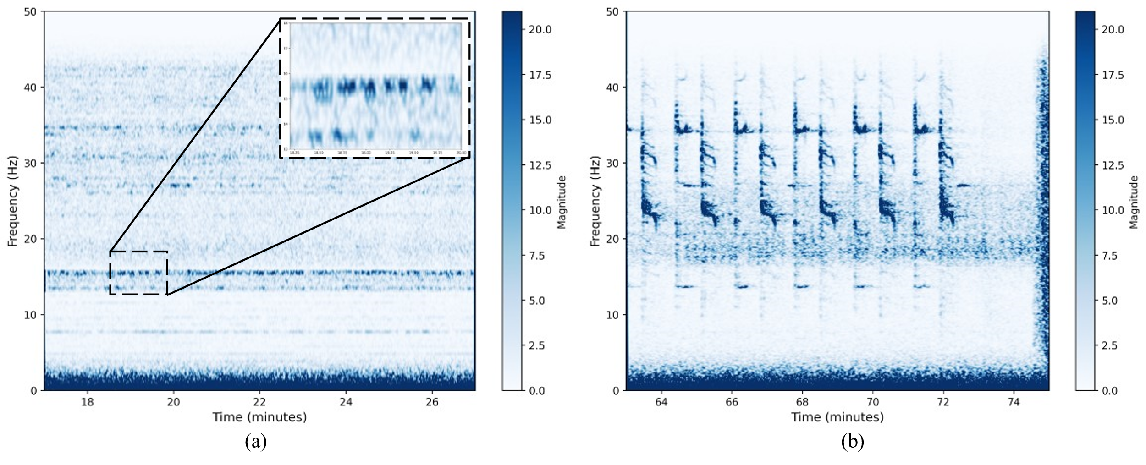

Supplementary Table 4 OM2D edgelength parameters and ENV files input parameters
Parameters | Variable name |  | Box 1 | Box 2
Minimum edgelength | min_el |  | 8000 | 250
Maximum edgelength | max_el |  | 23000 | 800
Maximum edgelength nearshore | max_el_ns |  | 2000 | 400
Feature size | R |  | 2 | 2
Mesh grade | grade |  | 0.64 | 0.32
Slope parameter | 𝛼 |  | 0 | 25
Inputs for KRAKEN |  | Inputs for FIELD 3D
Number of media | 1 | Type of calculation |  |  | STD
Top option | CVW | Receivers’ depth range(m) |  |  | [1, 6000]
Bottom option | V | Number of receiver depths |  |  | 60
RMS roughness | 0 | Receivers’ radial distance range(km) |  |  | 70
Max depth of receiver(m) | 6000 | Receiver range increment(m) |  |  | 70
Bottom layer sound speeds(m/s) | [1700, 1800] | Min receiver angle(deg) |  |  | [-180, 180]

Supplementary Figure 6 The three-dimensional coordinate point distribution of the simulated fin whale acoustic signal. The blue surface represents the seabed, with darker colors indicating greater water depth. White triangles denote the geographic coordinates of seismometers in the SWIR array, and the red polyline shows the moving track of the simulated sound source.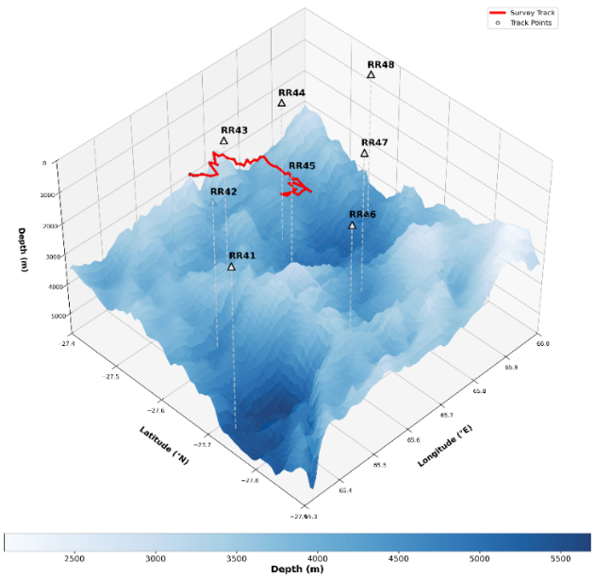

Supplementary Table 5 Network architecture
Layers | Output size | CTFusion-Net
Input layer | 32×2×549 | Dual-channel 1D acoustic field input
Convolution layer (1) | 32×32×549 | 3×1 conv, stride 1, padding 1, ReLU activation
Pooling layer (1) | 32×32×274 | 2×1 max pool, stride 2
Convolution layer (2) | 32×64×274 | 3×1 conv, stride 1, padding 1, ReLU activation
Pooling layer (2) | 32×64×137 | 2×1 max pool, stride 2
Dimension transformation | 32×137×64 | Permute dimensions forTransformer input
Multi-head attention | 32×137×64 | 8 attention heads, embedding dim 64
Transformer encoder | 32×137×64 | $$[\begin{matrix}\text{Multi-}\text{h}\text{ead }\text{a}\text{ttention} \\ \text{Feed Forward Network} \\ \text{Residual + LayerNorm}\end{matrix}]×6$$
Flatten layer | 32×137×64 | Reshape for regression
Dropout | 32×137×64 | Dropout (p = 0.5)
Classification Layer | 32×3 | fully-connected, linear output  (Longitude, Latitude, Depth)

