Human disturbances amplify airborne potential health risks by reshaping viromes and microbiomes
Hu Li ^{1,2}, Yan-Yan Zhou ¹, Meng-Ke Gao ¹, Xiao-Ru Yang ^{1,2}, Dong Zhu^{1,2,4}, Yong-Guan Zhu ^{1,2,3}, Jian-Qiang Su ^{1,2} *
¹ State Key Laboratory of Regional and Urban Ecology, Institute of Urban Environment, Chinese Academy of Sciences, Xiamen 361021, People’s Republic of China.
² University of Chinese Academy of Sciences, Beijing 101499, People’s Republic of China.
³ State Key Laboratory of Regional and Urban Ecology, Research Center for Eco-Environmental Sciences, Chinese Academy of Sciences, Beijing 100085, People’s Republic of China.
⁴ Zhejiang Key Laboratory of Urban Environmental Processes and Pollution Control, CAS Haixi Industrial Technology Innovation Center in Beilun, Ningbo 315830, People’s Republic of China
Corresponding author: Jian-Qiang Su, E-mail: jqsu@iue.ac.cn
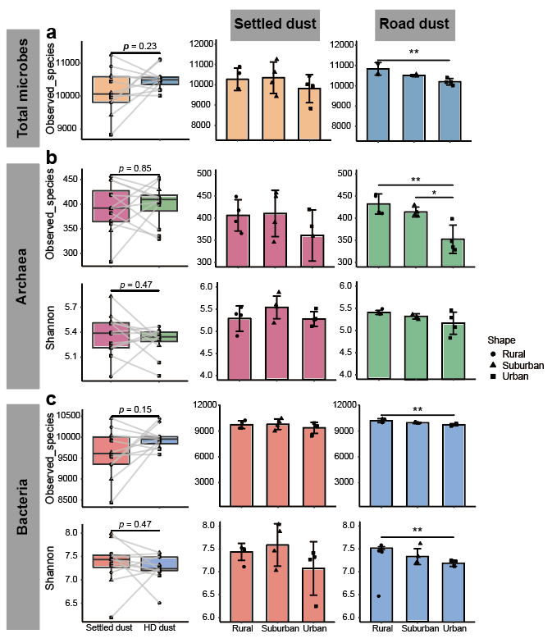
Figure S1 Alpha-diversity of microbial communities in settled dust and road dust across urbanization gradients. a, total microbial observed species index. b, Archaeal observed species and Shannon indices. c, Bacteria observed species and Shannon indices. * and ** indicate significant differences at p < 0.05 and < 0.01, respectively.

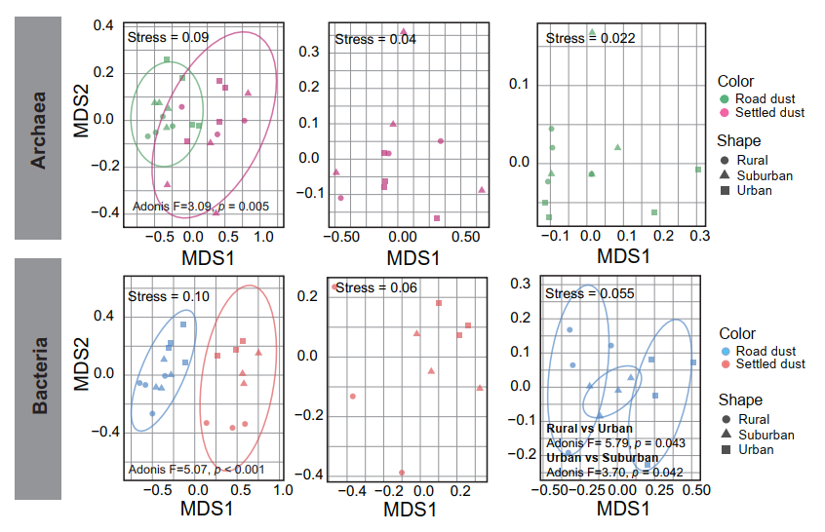
Figure S2 Beta-diversity of archeal and bacterial communities in settled dust and road dust across urbanization gradients. 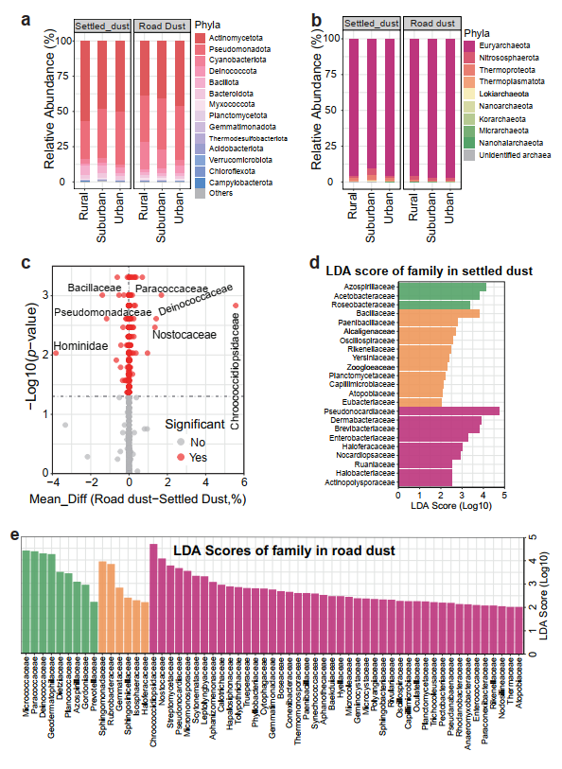
Figure S3 Community compositions of microbes in settled dust and road dust across urbanization gradients. a, Community compositions of bacteria at the phylum level. b, Community compositions of archaea at the phylum level. c, Variant microbial families between settled dust and road dust at p < 0.05 level. Variant microbial families in settled dust (d) and road dust (e) among urbanization gradients. Mean_Diff in plot c represents mean_difference.

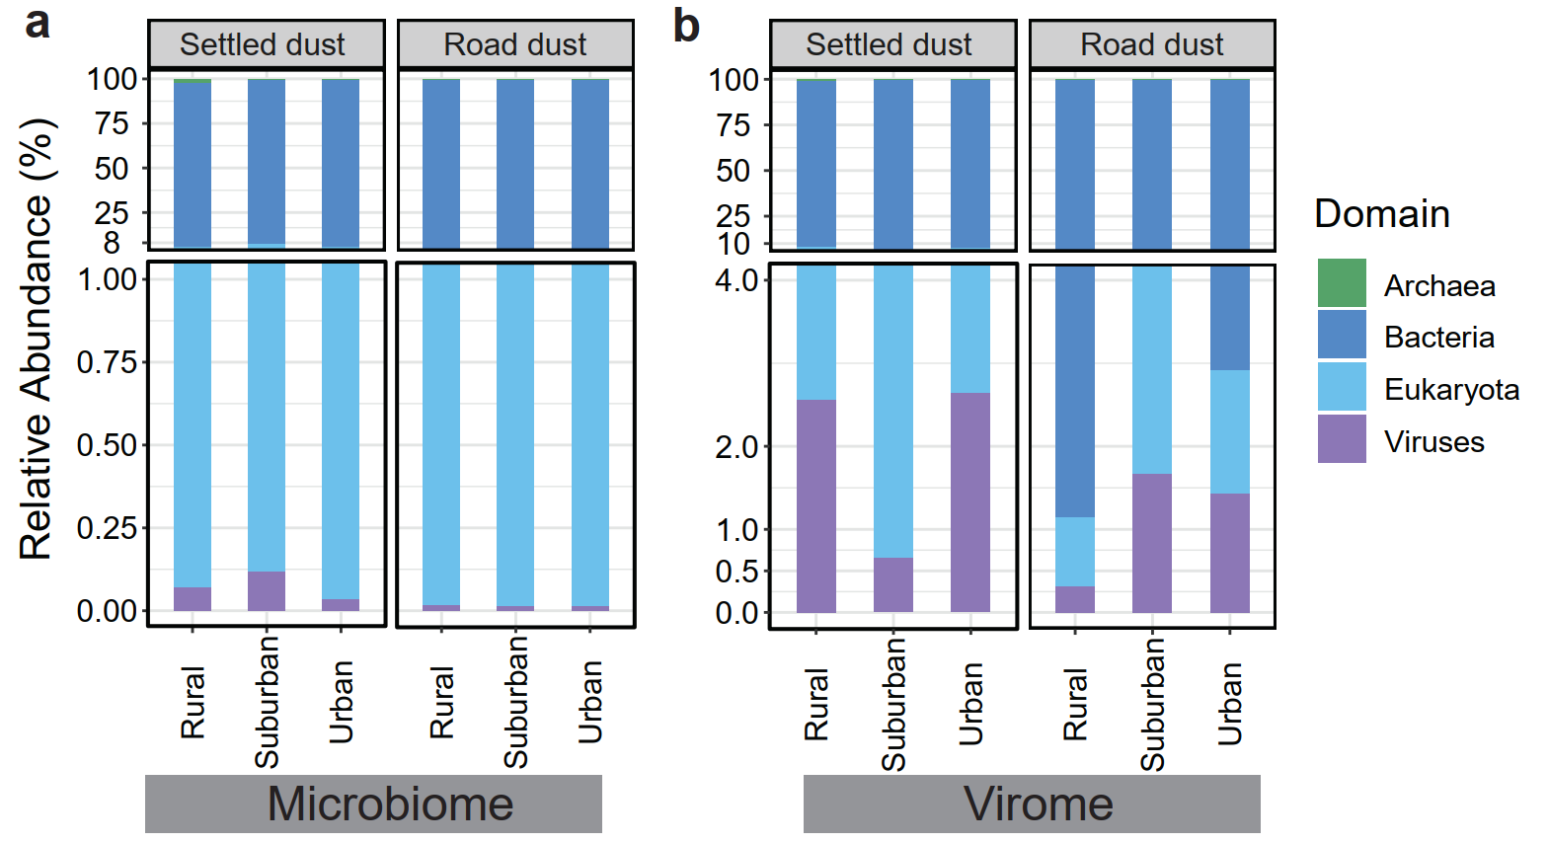
Figure S4 Relative abundance of microorganisms, including bacteria, archaea, eukaryota, and viruses in the metagenomes (a) and viromes (b).
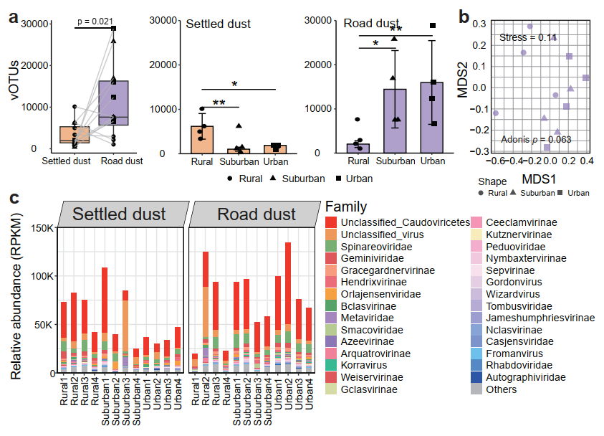
Figure S5 Viral communities in settled dust and road dust across urbanization gradients. a, Numbers of viral OTUs (vOTUs). b, Viral community patterns in road dust. c, Community compositions of viruses in settled dust and road dust. * and ** indicate significant differences at p < 0.05 and < 0.01, respectively.

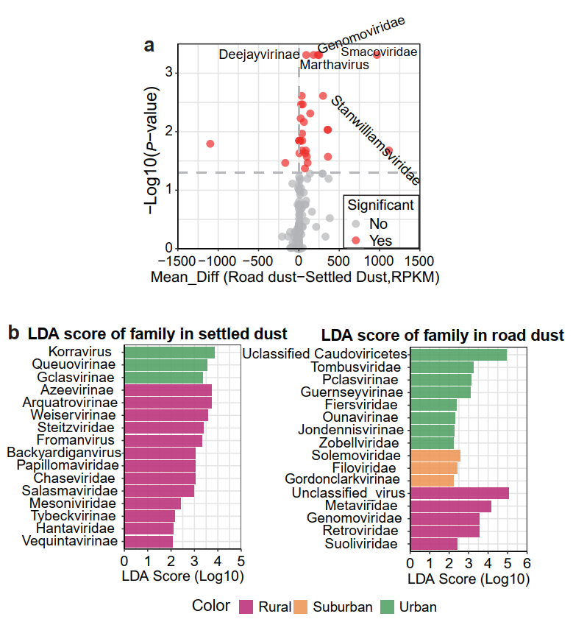
Figure S6 Variant viral families between settled dust and road dust (a) and among areas with different urbanization gradients (b).

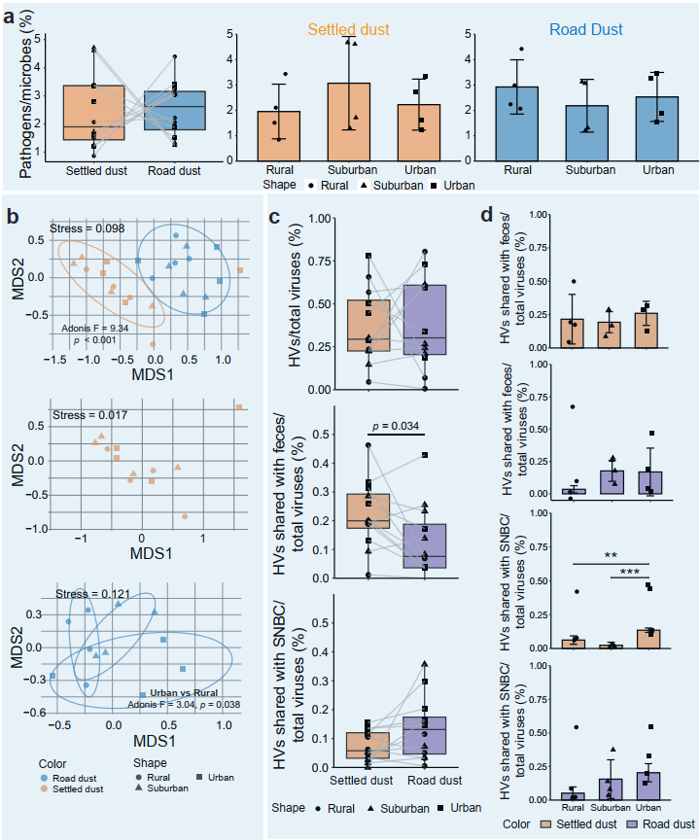
Figure S7 Ratio of potential pathogens and homoviruses in settled dust and road dust. a, Ratio of potential pathogens in total microbial communities. b, Community patterns of potential pathogens based on pathogens/total microbes. c, Ratio of homoviruses in total viral communities in settled dust and road dust. d, Ratio of homoviruses in total microbial communities across urbanization gradients. ** and *** indicate significant differences at p < 0.01 and < 0.001, respectively.

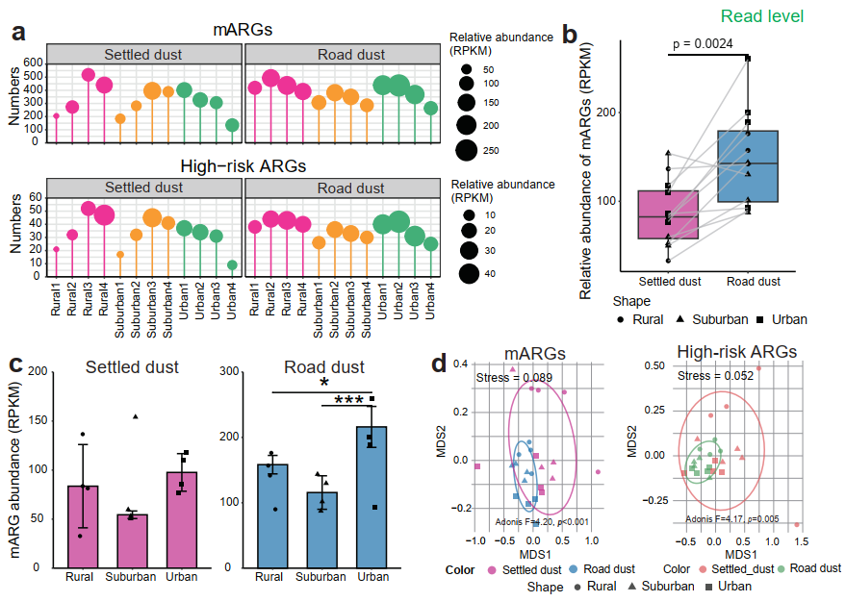
Figure S8 Microbial ARGs and high-risk ARGs at the read level. a, Number and relative abundance of mARGs and high-risk ARGs in each sampling site. b, Relative abundance of mARGs in settled dust and road dust. c, Relative abundance of mARGs across urbanization gradients. d, Profiles of mARGs and high-risk ARGs in settled dust and road dust across urbanization gradients. * and *** indicate significant differences at p < 0.05 and < 0.001, respectively.

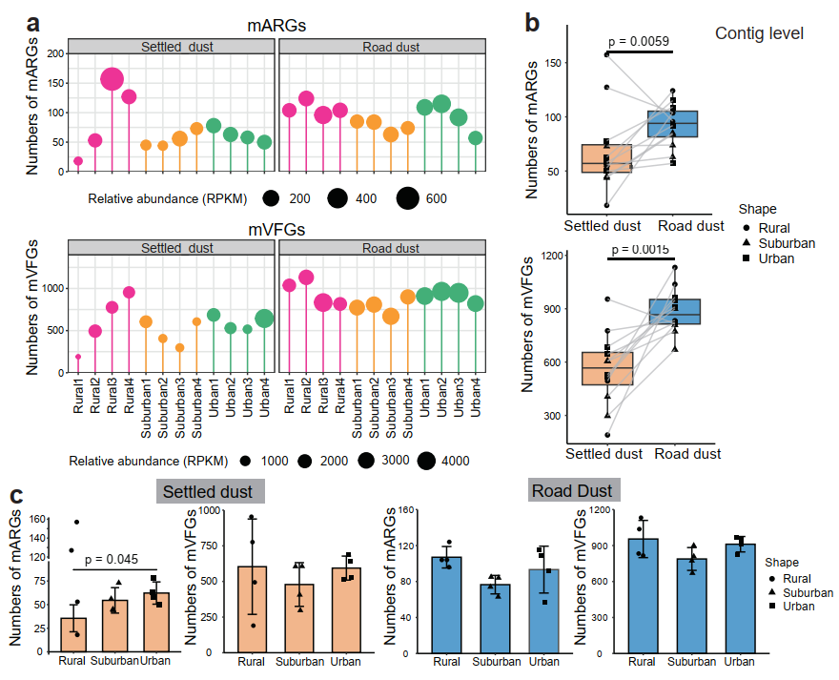
Figure S9 Microbial ARGs and VFGs at the contig level. a, Number and relative abundance of mARGs and mVFGs at each sampling site. b, Relative abundance of mARGs and mVFGs in settled dust and road dust. c, Relative abundance of mARGs and vFGs in settled dust and road dust across urbanization gradients.

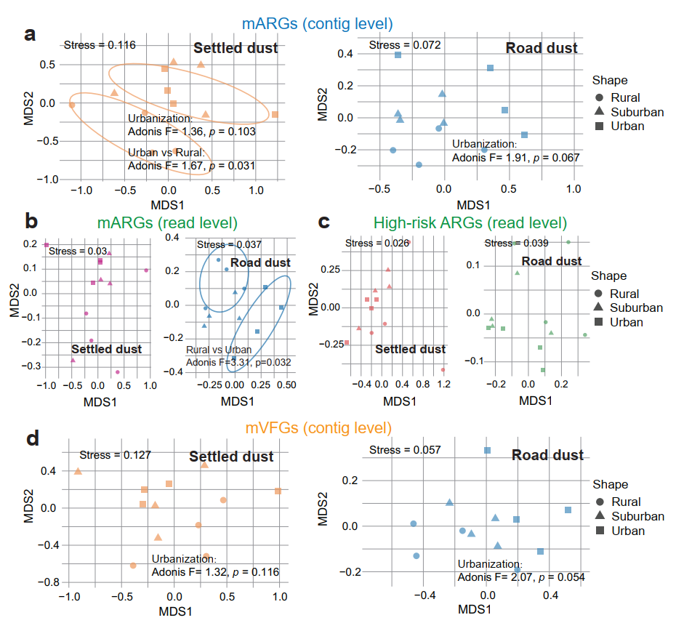
Figure S10 Profiles of mARGs at the contig level (a), mARGs at the read level (b) high-risk ARGs at the read level (c), and mVFGs at the contig level (d) in settled dust and road dust across urbanization gradients.

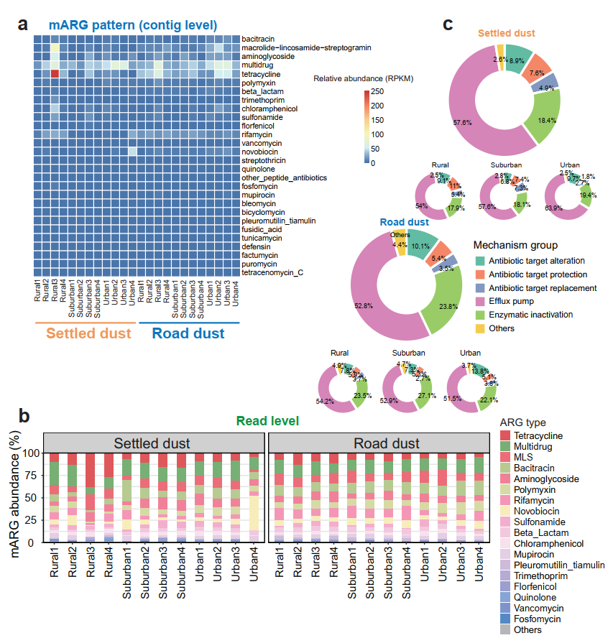
Figure S11 Composition of microbial ARGs. a, Compositions of mARGs at the contig level at each sampling site. b, Compositions of mARGs at the read level at each sampling site. c, Mechanism of ARG resistance associated with total microbes.

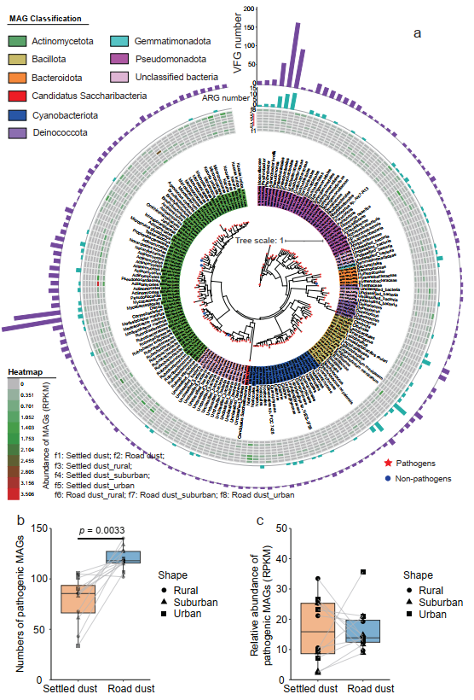
Figure S12 Phylogenetic tree and classification of bacterial MAGs. a, MAG classification, and ARGs, VFGs carried by bacterial MAGs. Number (b) and relative abundance (c) of pathogenic MAGs in settled dust and road dust.
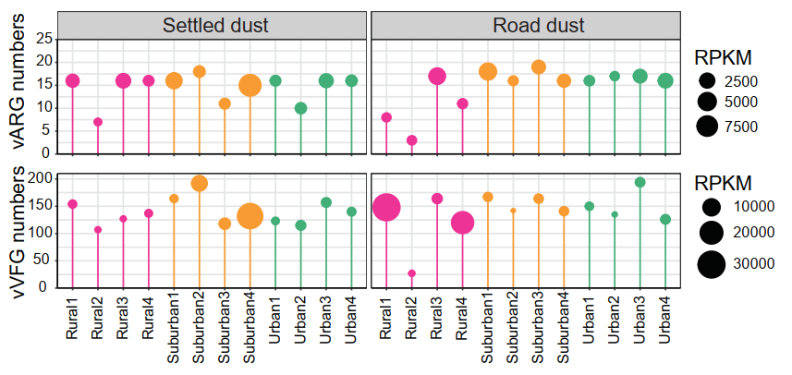
Figure S13 Number and relative abundance of viral ARGs (vARGs) and VFGs (vVFGs) in each sampling site.
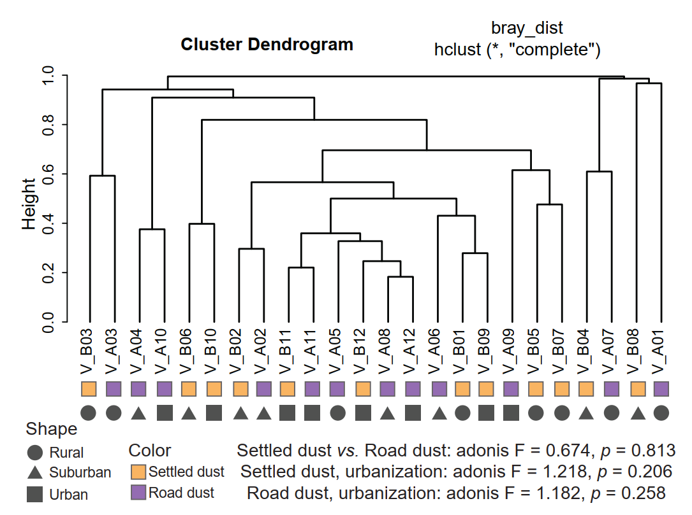
Figure S14 Cluster analysis of viral VFGs in settled dust and road dust across urbanization gradients.

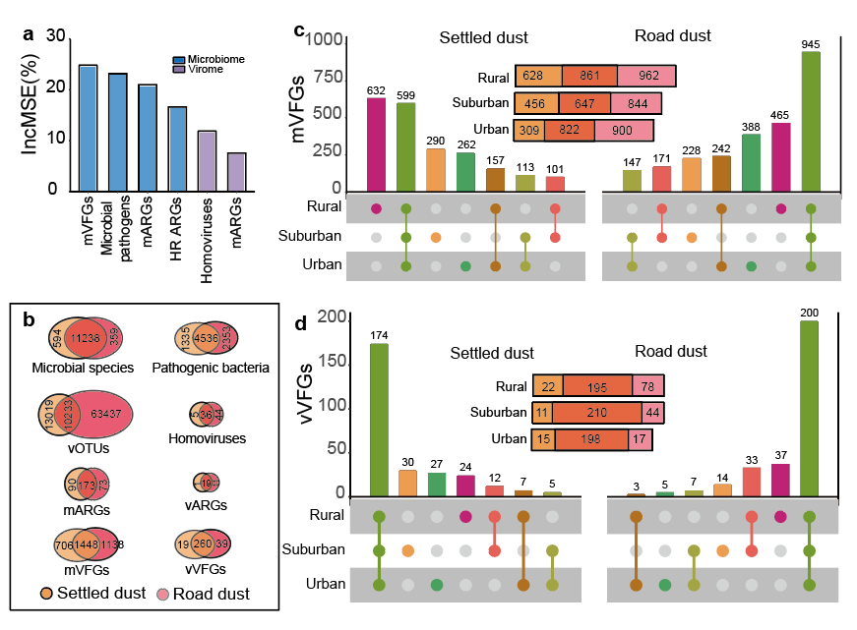
Figure S15 Microbial cross-habitat connectivity across urbanization gradients. a, Relative contribution of factors to airborne microbial health risks determined using random forest analysis. b, Veen plot showing shared microbes, vOTUs, and ARGs and VFGs they carry between settled dust and road dust. c, Veen plot showing shared microbial VFGs (mVFGs)/viral VFGs (vVFGs) between settled dust and road dust across urbanization gradients, and upset plot showing shared airborne microbial species among areas with different urbanization gradients.
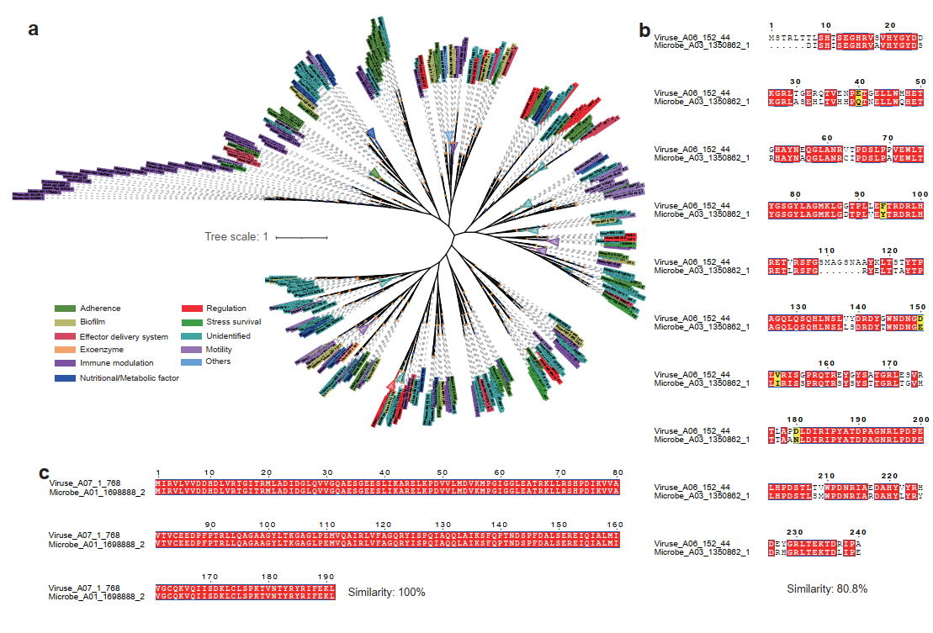
Figure S16 Phylogenetic tree of VFGs. a, Phylogenetic tree of homologous VFGs between virome and metagenome. b, The minimal similarity of homologous ARGs between the virome and the metagenome. c, The max similarity of homologous ARGs between virome and metagenome.

