Supplementary materials of “Integrated genomic and functional characterization of salt stress adaptation and plant growth-promoting traits in the newly isolated Kosakonia cowanii strainT6-2”
Journal name: Archives of Microbiology
Estiak Ahmmed^{1,2†}, Qingzhen Xiong^{1†}, Xinyue Yang¹, Baofu Qin¹, Hong Xu^{1,2*}, Lixin Zhang^{1,2*}
¹College of Life Sciences, Northwest A&F University, Yangling, Shaanxi 712100, China
²Shaanxi Belt and Road Joint Laboratory on Dryland Biological Resources and Green Smart Agriculture, College of Life Sciences, Northwest A&F University, Yangling, Shaanxi 712100, China
e-mail: estiak.92@nwafu.edu.cn ORCID: https://orcid.org/0009-0009-7097-4760 (Estiak Ahmmed); xiongqingzhen2018@163.com (Qingzhen Xiong); 1993708167@qq.com (Xinyue Yang); qbf@nwsuaf.edu.cn (Baofu Qin)
† These authors have contributed equally and share first authorship
*Corresponding authors:
Hong Xu; e-mail: xuhong732007@nwsuaf.edu.cn ORCID: https://orcid.org/0000-0001-8468-9586
Lixin Zhang; e-mail: zhanglixin@nwafu.edu.cn ORCID: https://orcid.org/0000-0002-0152-1663

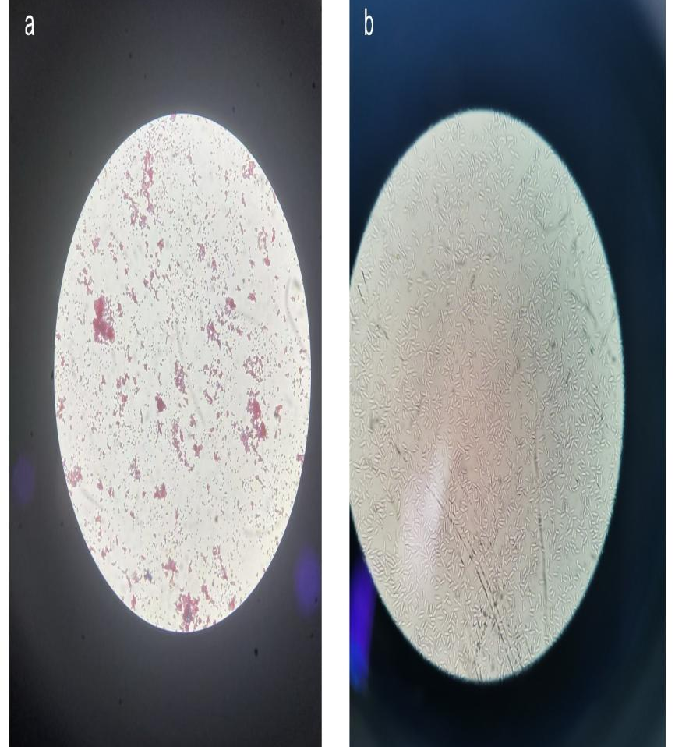

Fig. S1 The Gram staining picture of Kosakonia cowanii strain T6-2 observed in a common optical microscope. (a) 400X magnification (b) 200X magnification
1 GCGTACGGCT GCTACCTGCA GTCGAACGGT AACAGGAAGC AGCTTGCTGC TTTGCTGACG
61 AGTGGCGGAC GGGTGAGTAA TGTCTGGGAA ACTGCCTGAT GGAGGGGGAT AACTACTGGA
121 AACGGTAGCT AATACCGCAT AACGTCGCAA GACCAAAGAG GGGGACCTTC GGGCCTCTTG
181 CCATCAGATG TGCCCAGATG GGATTAGCTA GTAGGTGGGG TAACGGCTCA CCTAGGCGAC
241 GATCCCTAGC TGGTCTGAGA GGATGACCAG CCACACTGGA ACTGAGACAC GGTCCAGACT
301 CCTACGGGAG GCAGCAGTGG GGAATATTGC ACAATGGGCG CAAGCCTGAT GCAGCCATGC
361 CGCGTGTATG AAGAAGGCCT TCGGGTTGTA AAGTACTTTC AGCGGGGAGG AAGGCGATGT
421 GGTTAATAAC CGCGTCGATT GACGTTACCC GCAGAAGAAG CACCGGCTAA CTCCGTGCCA
481 GCAGCCGCGG TAATACGGAG GGTGCAAGCG TTAATCGGAA TTACTGGGCG TAAAGCGCAC
541 GCAGGCGGTC TGTCAAGTCG GATGTGAAAT CCCCGGGCTC AACCTGGGAA CTGCATCCGA
601 AACTGGCAGG CTTGAGTCTC GTAGAGGGGG GGTAGAATTC CAGGTGTAGC GGTGAAATGC
661 GTAGTAGATC TGGAGCGAAC TACCGGTGGC GAAGGTCGTC CCCCTGGACG AAGACTGACG
721 CTCAGGTGCG AAAGCGTGGG GAGCAAACAG GATTAGATAC CCTGGTAGTG CACGCCGTAA
781 ACGATGTCGA CTTGGAGGTT GTGCCCTTGA GGCGTGGCTT CCGGAGCTAA CGCGATAAGT
841 CGACCGCCTG GGGAGTACGG CCGCAAGGTT AAAACTCAAA TGAATTGACG GGGGCCCGCA
901 CAAGCGGTGG AGCATGTGGT TTAATTCGAT GCAACGCGAA GAACCTTACC TGGTCTTGAC
961 ATCCACAGAA CTTTCCAGAG ATGGATTGGT GCCTTCGGGA ACTGTGAGAC AGGTGCTGCA
1021 TGGCTGTCGT CAGCTCGTGT TGTGAAATGT TGGGTTAAGT CCCGCAACGA GCGCAACCCT
1081 TATCCTTTGT TGCCAGCGGT TCGGCCGGGA ACTCAAAGGA GACTGCCAGT GATAAACTGG
1141 AGGAAGGTGG GGATGACGTC AAGTCATCAT GGCCCTTACG ACCAGGGCTA CACACGTGCT
1201 ACAATGGCGC ATACAAAGAG AAGCGATCTC GCGAGAGCCA GCGGACCTCA TAAAGTGCGT
1261 CGTAGTCCGG ATTGGAGTCT GCAACTCGAC TCCATGAAGT CGGAATCGCT AGTAATCGTG
1321 AATCAGAATG TCACGGTGAA TACGTTCCCG GGCCTTGTAC ACACCGCCCG TCCCACCATG
1381 GGAGTGGGTT GCAAAAGAAG TAGGTAGCTT AACCTTCGGG AGGGCGCTAC CACGTGTATA
1441 CCA

Fig. S2 16S rRNA gene, partial sequence of Kosakonia cowanii strain T6-2 (GenBank accession no. PP837988.1)

Primer | Sequence (5’- 3’)
proV-F | TTGCGGTGGAGGCAGATACAGC
proV-R | CCCACGTACTGTTGCTCTTCAGC
proW-F | TGATTACGCTGGCTCTGGTGCAG
proW-R | TCGGCACCAGGTAGACAAACGTG
otsA-F | CTCCAGCCAAACCAGACACCTGG
otsA-R | ATCGAATTGCACCGCCTGACAGC
otsB-F | GCGATAGTGCAGTGCGAATGCAG
otsB-R | AACCGTATCGTTTCCCGCTTCAG
ProC-F | AAGGGATGATCCACCCGGTAGTC
ProC-R | GTTTCCAGCACCATCTTCGCCG
putA-F | GAAAACGGTGCCAACACCTCG
putA-R | GATGCGACCTTCGCCATAGAGTG
nhaA-F | GGCATTTCGCTCTTCTGCTG
nhaA-R | GGCGAGCGACGAGATAAAGA
putP-F | ATTACTTCACCGGGCGGTTTTG
putP-R | ACAATGCCGGAAGCACAGTACT
proY-F | TGTTCGCCTATGGCGGTATC
ProY-R | CTGGTTCCACGGGTAGATCG
osmV-F | CAGCGGCATGGATACGGTTACA
osmV-R | ATCTCCATCAGCTCTTCCGCAG
nhaA2-F | GGGAGATGGGCGTGCTTAAT
nhaA2-R | TCCAGTAGGGAGAGGTGAGC
betA-F | CGGTTATCAGCAAGAGGGCT
betA-R | ATGATGGTCAGGTTGGAGCG
betB-F | CCGAACGATCCGGCTATCAA
betB-R | CCAGGCACCGTTATCGAACT
mtlD-F | GGATGGAGCTGACCGACAAT
mtlD-R | TCTCATCAAGGATCGCGTCG
IICBA-F | CGCTGGCCTCTATCTTCGTT
IICBA-R | GCCAGCAGGATACCCATACC
sordh-F | TCAACTCCAAGTCGGGCAAA
sordh-R | GGAACATTGGCGACTTCAGC
SrlB-F | CATGCTGATCACCTTCCGGG
SrlB-R | GCAGTCACGGGGTAGTGTTT

Tab S1 Primer sequences used for RT-qPCR analysis of salt stress-responsive and plant growth-promoting genes in Kosakonia cowanii strain T6-2

Gene | Gene ID | Function
betA | GE003990 | Glycine-betaine synthesis (salt tolerance)
betB | GE003991 | Betaine aldehyde dehydrogenase (glycine-betaine synthesis)
proV | GE001205 | glycine betaine/proline transport system ATP-binding protein
proY | GE003572 | Proline/glycine betaine transport system permease
proC | GE003586 | L-proline biosynthetic process (osmoprotectant)
otsA | GE002017 | Trehalose synthesis (salt tolerance)
otsB | GE002016 | Trehalose-6-phosphate phosphatase (trehalose synthesis)
kdpD | GE003280 | Potassium transport regulator (osmoregulation)
putA | GE002969 | Proline dehydrogenase / pyrroline-5-carboxylate dehydrogenase
nhaA | GE003867 | Sodium/proton antiporter (salt tolerance)
nhaA-2 | GE001130 | Na⁺/H⁺ antiporter (salt tolerance)
putP | GE002968 | Proline transporter (Osmoprotectant uptake)
osmV | GE002603 | Aminotransferase (IAA biosynthesis)
IICBA | GE000410 | Phosphotransferase system (PTS) for sugar transport (subunit for mannitol gene)
srlB | GE001179 | Glucitol/sorbitol metabolism
mtlD | GE000409 | Mannitol dehydrogenase
sordh | GE001178 | Sorbitol dehydrogenase
Table S2. Genes associated with salt tolerance, osmoprotection, and related metabolic functions identified in the genome of Kosakonia cowanii strain T6-2

Fig. S3 Standard Curve of IAA production assay of strain T6-2

Phosphorus solubilization assay
IPA medium consisted of 10 g glucose, 0.3 g MgSO₄·7H₂O, 0.5 g (NH₄)₂SO₄, 0.3 g NaCl, 2.0 g Ca₃(PO₄)₂, 0.3 g KCl, 0.03 g MnSO₄·H₂O, 0.03 g FeSO₄·7H₂O, and 15 g agar in 1L distilled water (Pang et al., 2022), whereas, modified Monkina organic phosphorous agar medium which consisted of glucose 10.0 g, (NH₄)₂SO₄ 0.5 g, MgSO₄·7H₂O 0.3 g, NaCl 0.3 g, KCl 0.3 g, FeSO₄·7H₂O 0.03 g, MnSO₄·H₂O 0.03 g, lecithin 0.2 g, CaCO₃ 1.0 g, yeast extract 0.5 g, and agar 15.0 g in 1000 mL distilled water.

