Supporting Information for
Development of optical biosensor for the detection of glutamine in human biofluids using merocyanine dye as a sensor
Vijayakumar Sathya,ª Appadurai Deepa,ª Lakshmi Kandhan Sangeetha,ª Venkatesan Srinivasadesikan,^{b} Shyi-Long Lee,^{c} Vediappen Padminiª*
ªDepartment of Organic Chemistry, School of Chemistry, Madurai Kamaraj University, Madurai-625021, Tamilnadu, India.
^{b}Division of Chemistry, Department of Sciences and Humanities, Vignan's Foundation for Science, Technology and Research, Vadlamudi, Guntur, 522 213, Andhra Pradesh, India.
^{c}Department of Chemistry and Biochemistry, National Chung-Cheng University, Chia-Yi, 621, Taiwan.
E-mail: padmini.chem@mkuniversity.org
CONTENT
- Synthetic protocol for Merocyanine dye molecule
- ¹H NMR for the synthesized Merocyanine dye molecule
- ¹³C NMR for the synthesized Merocyanine dye molecule
- ESI-Mass Spectra the synthesized Merocyanine dye molecule
- ESI-Mass Spectra the synthesized Merocyanine dye with glutamine
- UV-Visible and emission spectral characterization for synthesized Merocyanine dye molecule
- Competitive experiment with glutamine
- Effect of pH effect on fluorescent property of dye molecule
- Stoichiometry determination through Jobs’ plot
- Color changes observed through naked eye and UV Lamp for the detection of glutamine
- Determination of Quantum yield for Merocyanine dye
- Determination of Limit of Detection (LOD)
- NMR titration
- Test strip method
- Real sample analysis of glutamine in human biofluids by standard addition method
- References

- Synthetic protocol for Merocyanine dye molecule

Figure.S1. Synthetic route of merocyanine dye. ^{[1]}
- ¹H NMR spectrum for the synthesized Merocyanine dye molecule
Figure S2. ¹H NMR Spectrum of synthesized Merocyanine dye.

- ¹³C NMR spectrum for the synthesized Merocyanine dye molecule

Figure S3. ¹³C NMR Spectrum of synthesized Merocyanine dye.

- ESI-Mass Spectrum the synthesized Merocyanine dye molecule
Figure S4. ESI-Mass Spectrum for synthesized Merocyanine dye.

- ESI-Mass Spectrum the synthesized Merocyanine dye with glutamine
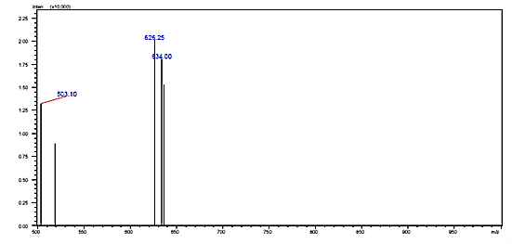

Figure S5. ESI-Mass Spectrum for synthesized Merocyanine dye with glutamine.

- UV- Vis and emission spectral characterization for synthesized Merocyanine dye molecule

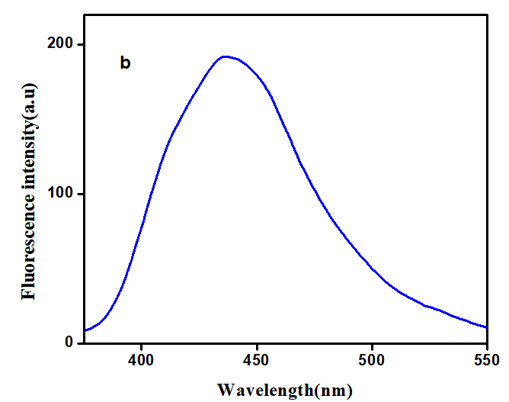
Figure S6. (a) UV-vis spectrum and (b) Emission spectrum of merocyanine dye [Concentration of dye is 1 x 10⁻⁵ M, at pH 7.2, Phosphate buffer]

- Competitive experiment with glutamine

Figure.S7: Competitive experiment toward the fluorescence TURN-ON effect of glutamine in the presence of interfering biomolecules.
 | Probe + Glutamine + Creatinine | 10. | Probe + Glutamine + Cd ⁺
 | Probe + Glutamine + Creatine | 11. | Probe + Glutamine + Ca²⁺
 | Probe + Glutamine + Tryptophan | 12. | Probe + Glutamine + Ag⁺
 | Probe + Glutamine + Cysteine | 13. | Probe + Glutamine + Na⁺
 | Probe + Glutamine + Urea | 14. | Probe + Glutamine + K⁺
 | Probe + Glutamine + Proline | 15. | Probe + Glutamine + Fe³⁺
 | Probe + Glutamine + Ascorbic Acid | 16. | Probe + Glutamine + Zn²⁺
 | Probe + Glutamine + Histidine | 17. | Probe + Glutamine + Cu²⁺
 | Probe + Glutamine + Co²⁺ | 18. | Probe + Glutamine

- Effect of pH effect on fluorescent property of dye with glutamine

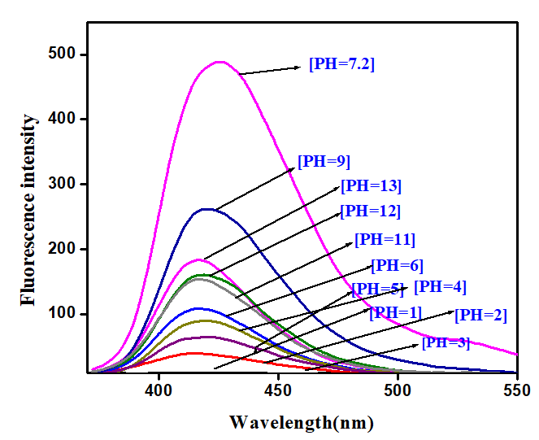
Figure S8. (a). Effect of pH on fluorescent intensity of merocyanine dye with glutamine while varying the pH from 2 to 13. (b) .Corresponding fluorescent spectra.

- Stoichiometry determination through Jobs’ plot
Figure S9. Job’s plot for the determination of stoichiometry of dye: glutamine. [For this study both the dye and glutamine were fixed at same concentration i.e. 1x 10⁻³ M, in pH 7.2 phosphate buffer. Initially the emission changes of dye alone were observed. And then the emission changes for the mixture of dye and glutamine (From 0.1 to 1.0 mole fraction) were determined. Based on the intersect position (0.5 mole fraction) of these two lines, the stoichiometry dye: glutamine of developed sensor was determined as 1:1.

- Color changes observed through naked eye and UV Lamp for the detection of glutamine
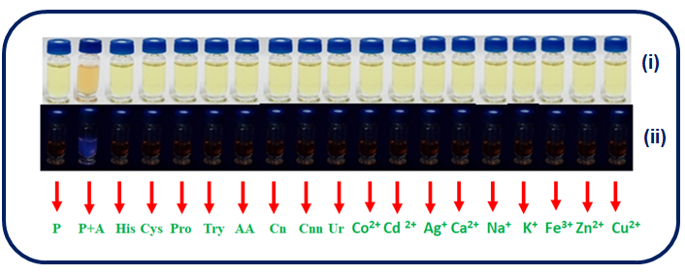

 | P | - | Merocyanine |  | Co²⁺
 | P+A | - | Merocyanine dye + glutamine |  | Cd²⁺
 | His | - | Histidine |  | Ag²⁺
 | Cys | - | Cysteine |  | Ca²⁺
 | Cnn | - | Creatinine |  | Na⁺
 | Pro | - | Proline |  | K⁺
 | Try | - | Tryptophan |  | Fe³⁺
 | AA | - | Ascorbic Acid |  | Zn²⁺
 | Cn | - | Creatine |  | Cu²⁺
 | Ur | - | Urea

Figure S10. Colorimetric and fluorimetric response of fluorescent dye after addition of glutamine at pH 7.2 under naked eye (i) as well as UV-Lamp detection (ii).
- Determination of Quantum yield for Merocyanine dye
Determination of fluorescence quantum yields (ɸ) for merocyanine dye were worked out by integrating the area under the curves using the following equation. Rhodamine 6G in ethanol was chosen as a standard for this probe, which has the quantum yield value of 0.91. The absorption value of dye was taken from the UV spectra. (Main article Figure 1)The concentration of probe 1x10⁻⁵ M and the integrated area were calculated from the absorption spectra of dye (Figure S4.) at wavelength of 512 nm at pH=7.2 and its compared with standard quantum yields. Rhodamine 6g in ethanol was taken as a standard, which has the quantum yield of 0.93. Thus the quantum yield of merocyanine dye was calculated as 0.87. ^{[2]}

ɸ_{u} = ɸ_{s}I_{u}A_{s}ʎ_{exs}ɳ_{u}
I_{s}A_{u}ʎ_{exu}ɳ_{s}

Where,
- ɸ- The quantum yield
- I -Integrated area under the corrected emission spectra
- A -Absorbance at the excitation wavelength
- λ_{ex} -The excitation wavelength
- η -The refractive index of the solution
- u & s – The unknown and standard, respectively

- Determination of Limit of Detection (LOD)
The LOD calculated by using following formula,

LOD=3S_{a}/b

Where,
- S_{a} -The standard deviation
- b -The slope of the calibration curve. The standard deviation can be estimated by the standard deviation of either y-intercept, of regression lines.^{[3, 4]}
The Linear equation for the variation of glutamine concentration at pH 7.2 is LOD=9.6x10⁻⁸M.
- NMR titration

Figure S11. Comparative ¹H NMR spectra of probe with analyte.
- Test strip method
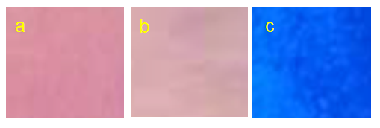

Figure S12. Photographs of test strips detections (a) Dye ; (b) Dye + other interfering
biomolecules ; (c) Dye + glutamine under the UV lamp.

- Real sample analysis of glutamine in human biofluids by standard addition method

The human biofluids like blood serum and urine were used for real sample testing. The blood and urine samples (each 5 mL) were collected from medicinal lab. The human serum was isolated by centrifuging the blood sample in an REMI centrifuge machine with the rotation of 3,000 rpm at 1hr time interval. Then, the isolated human blood serum was initially kept at 0⁰C for 2hrs and it was further preserved at -4⁰C before testing. First, a known concentration of merocyanine (5µM) was added into human serum solution. Then, different concentrations of glutamine like 20µM, 40µM, 60µM, 80µM & 100-120µM, were spiked that the serum sample and incubated for 15mins. After the incubation period, the fluorescence studies were carried out under optimized conditions and the spectral changes are noted in Table.15.1. (Experimental section: Real sample analysis). Then, the recovery of the biosensor was calculated based on the change in fluorescent intensity of merocyanine molecule while spiking known concentrations of glutamine into human serum and buffer solution containing 1x10⁻⁵ M of merocyanine as shown in Fig.13.
The known concentration of merocyanine molecule (5µM) was taken and different concentrations of human urine serum like 20µM, 40µM, 60µM, 80µM &100-160µM was added and incubated for 15mins. After the incubation period, the fluorescence studies were carried out under optimized conditions and the spectral changes are noted in Table.15.2. (Experimental section: Real sample analysis). Then, the recovery of the biosensor was calculated based on the change in fluorescent intensity of merocyanine molecule while spiking known concentrations of glutamine into urine and buffer solution containing 1x10⁻⁵ M of merocyanine as shown in Fig.14.^{[61]}

Table 15.1: Detection of glutamine in human serum of blood sample at various concentration ranges.
Sample  (blood) | Amount of glutamine determined  in buffer(pH=7.2) | Fluorescent intensity determined in in buffer(pH=7.2) | Amount of glutamine spiked in human serum | Fluorescent intensity  determined in human serum | Recovery (in %)
A | 20 µM | 250 | 20 µM | 193 | 77
B | 40 µM | 308 | 40 µM | 250 | 81
C | 60 µM | 353 | 60 µM | 308 | 88
D | 80 µM | 387 | 80 µM | 350 | 90
E | 100 µM | 418 | 100 µM | 387 | 92
F | 120 µM | 447 | 120 µM | 421 | 94
G | 140 µM | 463 | 140 µM | 446 | 96
H | 160 µM | 476 | 160 µM | 476 | 100
I | 180 µM | 481 | 180 µM | 478 | 99

Table 15.2: Detection of glutamine in human urine sample at various concentration ranges.
Sample  (urine) | Amount of glutamine determined  in buffer(pH=7.2) | Fluorescent intensity determined  in buffer(pH=7.2) | Fluorescent intensity  determined in human urine | Recovery (in %)
A | 20 µM | 250 | 247 | 99
B | 40 µM | 308 | 306 | 99
C | 60 µM | 353 | 352 | 100
D | 80 µM | 387 | 384 | 100
E | 100 µM | 418 | 418 | 100
F | 120 µM | 447 | 446 | 100
G | 140 µM | 463 | 448 | 96
H | 160 µM | 476 | 478 | 100
I | 180 µM | 481 | 478 | 99

Recovery (%) = [Fluorescent intensity of glutamine added/ Fluorescent intensity of glutamine determined] X 100.
- B-H plot
Figure. S13. B-H plot of probe with analyte.

- References
- K. Ponnuvel, J. Ramamoorthy, G. Sivaraman, V.Padmini, ChemistrySelect, 2018, 3, 12150 –12154.
- D. Magde, R. Wong, P.G. Seybold, Photochemistry and Photobiology, 2002, 75, 327-334.
- A. Shrivastava, B.G. Vipin, Chronicles of Young Scientists, 2011, 2, 21-25.
- A. D. Arulraj, A. Vijayan, M. Vasantha, Spectrochim Acta A, 2015, 148, 355–361.

