Supplementary material
eAppendix 1. Modeling Details of the Economic Cost of CKD 2
eAppendix 2. National data description 5
eTable 1. Parameter values and data sources 6
eAppendix 3. Provincial data description 6
eAppendix 4. China Health Burden of CKD 7
eAppendix 5. Yearly Cost per Person Attributed to CKD in China, in international dollars at constant 2023 prices 8
eTable 2. Projected total CKD cases in China, 2025–2060, with 95% confidence intervals (millions) 8
eTable 3. Regression results of the treatment cost of CKD 8
eAppendix 6. Imputation 9
eTable 4. Projected Economic Burden of CKD in China from 2025 to 2060, using discount rates of 2% 10
eTable 5. Projected Economic Burden of CKD in China from 2025 to 2060, using discount rates of 0% 11
eTable 6. Projected Economic Burden of CKD in China from 2025 to 2060, using discount rates of 3% 12
eFigure 3. Economic cost of CKD as a Percentage of GDP in China from 2025 to 2060: using discount rates of 0%, 2% and 3% 14
eFigure 4. Projected Per Capita Loss Attributable CKD in China from 2025 to 2060: using discount rates of 0%, 2% and 3% 14
eTable 7. Projected GDP losses attributable to CKD by province in 2025 (in millions of 2023 INT$) 15
eFigure 5. Prevalence of CKD by Province in China in 2025 16
eTable 8. Projected Number of CKD Patients by Province in Mainland China, 2025 and 2060 17
eTable 9. Projected Economic Burden of CKD Across Provinces in Mainland China from 2025 to 2060, using discount rates of 0% 17
eTable 10. Projected Economic Burden of CKD Across Provinces in Mainland China from 2025 to 2060, using discount rates of 3% 18
eFigure 6. Treatment Costs of CKD in Chinese Provinces 20
eReferences 20

eAppendix 1. Modeling Details of the Economic Cost of CKD
We sought to quantify the economic consequences of CKD through both healthcare expenditures and productivity losses associated with morbidity and mortality. For each stage of CKD, our analysis proceeded as follows:
Step 1. We estimated the disease burden of CKD, including mortality and morbidity, by projecting historical data from 1990 to 2023 to 2060 using our own modeling framework. We also estimated treatment-related costs.
Step 2. We developed economic projections under two scenarios: a baseline scenario, in which gross domestic product (GDP) is projected to evolve based on current estimates and projected trends in CKD prevalence, and a counterfactual scenario, in which CKD prevalence is assumed to be absent from the outset of the projection period.
The economic projections are derived from a macroeconomic production framework and can be decomposed into two main components:
a) Projections of effective labor supply.
b) Projections of physical capital accumulation.
Step 3. We calculated the economic loss as the discounted cumulative difference in projected annual GDP between these two scenarios by discount rate.
The following subsections provide further details of Step 2, including uncertainty and sensitivity analyses, provincial-level heterogeneity in CKD burden, and decomposition of healthcare costs.
Production function
Consider an economy that evolves over discrete time periods t = 1,2,...,n. Building upon the Lucas framework,¹ we extend the model to obtain the following production function
$$\begin{aligned}{\text{Y}}_{\text{t}}\text{=}{\text{A}}_{\text{t}}{\text{K}}_{\text{t}}^{\text{α}}{\text{H}}_{\text{t}}^{\text{1-}\text{α}}\#\left(\text{1}\right)\end{aligned}$$
here ${\text{Y}}_{\text{t}}$ denotes gross domestic product (GDP) at time t；${\text{A}}_{\text{t}}$ represents total factor productivity (TFP), capturing the level of technology at each point in time and assumed to evolve exogenously; ${\text{K}}_{\text{t}}^{ }$ denotes the stock of physical capital，${\text{H}}_{\text{t}}^{ }$ refers to human capital，defined as the product of labor force size and average annual income; and $\text{α}$ represents the elasticity of output with respect to capital. The aggregate production function acknowledges that output is generated not only by physical capital and raw labor,² as in the Solow framework underlying the original EPIC model,³ but also by effective labor, with health being a critical determinant.
The capital accumulation equation is given by
$$\begin{aligned}{\text{K}}_{\text{t}\text{+1}}\text{=}\left(\text{1-}\text{δ}\right){\text{K}}_{\text{t}}\text{+}{\text{Y}}_{\text{t}}\text{-}{\text{C}}_{\text{t}}\text{-}\text{T}{\text{C}}_{\text{t}}\text{=}\left(\text{1-}\text{δ}\right){\text{K}}_{\text{t}}\text{+}{\text{γ}}_{\text{t}}{\text{Y}}_{\text{t}}\#\left(\text{2}\right)\end{aligned}$$
where $\text{δ}$ is the depreciation rate，${\text{γ}}_{\text{t}}$ is the saving rate，$\text{T}{\text{C}}_{\text{t}}$ denotes ongoing treatment expenditures for CKD, and ${\text{C}}_{\text{t}}$ represents consumption. Accordingly, the saving rate can be expressed as
$$\begin{aligned}{\text{γ}}_{\text{t}}\text{=1-}\frac{{\text{C}}_{\text{t}}\text{+}\text{T}{\text{C}}_{\text{t}}}{{\text{Y}}_{\text{t}}}\#\left(\text{3}\right)\end{aligned}$$
It is worth noting that total output is allocated to three purposes: covering treatment expenditures for CKD (including inpatient and outpatient costs), financing consumption, and capital accumulation.
Individuals of age-sex group $\left(\text{a}\text{,}\text{s}\right)$ with age $\text{a}$ and sex $\text{s}$ are endowed with ${\text{h}}_{\text{t}}^{\left(\text{a}\text{,}\text{s}\right)}$ units of human capital and supply ${\text{l}}_{\text{t}}^{\left(\text{a}\text{,}\text{s}\right)}$ units of labor from age 15 up to their retirement. Children younger than 15 and retirees older than the age of $\text{R}$ do not work. $\text{R}$ varies across countries and serves as the upper bound of labor supply in the theoretical framework (for instance, in some countries individuals above the age of 80 may continue working) . In our simulations, we used labor projections data from the International Labour Organization, and positive values for the labor force exist for cohorts older than 65. We discretized age less than 65 into 13 groups every five years and discretized all ages older than 65 into 1 group. Thus, we have 28 age-sex groups marked as G. Aggregate human capital in the production function (1) is then defined as the sum over the age-sex-time-specific effective labor supply of each age-sex group:
Ht=a,s∈G​hta,slta,sNta,s#4
where ${\text{N}}_{\text{t}}^{\left(\text{a}\text{,}\text{s}\right)}$ denotes the number of individuals in age-sex group $\left(\text{a}\text{,}\text{s}\right)$. Note that aggregate human capital increases with a larger working-age population (higher ${\text{N}}_{\text{t}}^{\left(\text{a,s}\right)}$ for working cohorts), with higher per-group human-capital endowments ${\text{h}}_{\text{t}}^{\left(\text{a,s}\right)}$, and with greater effective labor supply ${\text{l}}_{\text{t}}^{\left(\text{a,s}\right)}$.
We adopted the approach of Mincer⁴ and formulated the average human capital for each age-sex group at age $\text{a}$ using an exponential function of education and work experience.
$$\begin{aligned}{\text{h}}_{\text{t}}^{\left(\text{a}\text{,}\text{s}\right)}\text{=}\text{exp}\left[{\text{η}}_{\text{1}}\left(\text{y}{\text{s}}_{\text{t}}^{\left(\text{a}\text{,}\text{s}\right)}\right)\text{+}{\text{η}}_{\text{2}}\left(\text{a}\text{-}\text{y}{\text{e}}_{\text{t}}^{\left(\text{a}\text{,}\text{s}\right)}\text{-5}\right)\text{+}{\text{η}}_{\text{3}}{\left(\text{a}\text{-}\text{y}{\text{e}}_{\text{t}}^{\left(\text{a}\text{,}\text{s}\right)}\text{-5}\right)}^{\text{2}}\right]\#\left(\text{5}\right)\end{aligned}$$
where ${\text{η}}_{\text{1}}$ is the semi-elasticity of human capital with respect to average years of education as given by $\text{y}{\text{s}}_{\text{t}}^{\left(\text{a,s}\right)}$, and ${\text{η}}_{\text{2}}$ and ${\text{η}}_{\text{3}}$ are the semi-elasticities of human capital with respect to the experience of the workforce $\left(\text{a-y}{\text{e}}_{\text{t}}^{\left(\text{a,s}\right)}\text{-5}\right)$ and the experience of the workforce squared ${\left(\text{a-y}{\text{e}}_{\text{t}}^{\left(\text{a,s}\right)}\text{-5}\right)}^{\text{2}}$, respectively. Here, we assumed a school entry age of 5 years throughout.

Impact of CKD on labor supply
Following the frameworks established by Bloom et al.⁵ and Chen et al.^{6,7}, the labor supply at age-sex group $\left(\text{a}\text{,}\text{s}\right)$ and time t, denoted ${\text{L}}_{\text{t}}^{\left(\text{a,x}\right)}$, is modeled as the product of the effective labor supply rate ${\text{l}}_{\text{t}}^{\left(\text{a,s}\right)}$ and the population size ${\text{N}}_{\text{t}}^{\left(\text{a,s}\right)}$:
$$\begin{aligned}{\text{L}}_{\text{t}}^{\left(\text{a}\text{,}\text{x}\right)}\text{=}{\text{l}}_{\text{t}}^{\left(\text{a}\text{,}\text{s}\right)}{\text{N}}_{\text{t}}^{\left(\text{a}\text{,}\text{s}\right)} \text{with} {\text{N}}_{\text{t}}^{\left(\text{a}\text{,}\text{s}\right)}\text{=}\left[\text{1-}{\text{σ}}_{\text{t}\text{-1}}^{\left(\text{a}\text{-1,}\text{s}\right)}\right]{\text{N}}_{\text{t}\text{-1}}^{\left(\text{a}\text{-1,}\text{s}\right)}\#\left(\text{6}\right)\end{aligned}$$
where ${\text{σ}}_{\text{t}}^{\left(\text{a,s}\right)}$ is the overall mortality rate of the age-sex group with age $\text{a}$ and sex s at time t. Mortality and morbidity reduce effective labor supply. The reduction of the population size ${\text{N}}_{\text{t}}^{\left(\text{a}\text{,}\text{s}\right)}$ captures the mortality effect.
Let ${\text{σ}}_{\text{r}\text{,}\text{t}}^{\left(\text{a}\text{,}\text{s}\right)}$ denote the mortality rate of people in each age-sex group due to CKD and let ${\text{σ}}_{\text{-}\text{r}\text{,}\text{t}}^{\left(\text{a}\text{,}\text{s}\right)}$ be the overall mortality rate due to causes other than CKD. Then we have
$$\begin{aligned}\left(\text{1-}{\text{σ}}_{\text{t}}^{\left(\text{a}\text{,}\text{s}\right)}\right)\text{=}\left(\text{1-}{\text{σ}}_{\text{r}\text{,}\text{t}}^{\left(\text{a}\text{,}\text{s}\right)}\right)\left(\text{1-}{\text{σ}}_{\text{-}\text{r}\text{,}\text{t}}^{\left(\text{a}\text{,}\text{s}\right)}\right)\#\left(\text{7}\right)\end{aligned}$$
Next, we examined the mortality effect of CKD. In general, it reduces the labor supply by diminishing the population ${\text{N}}_{\text{t}}^{\left(\text{a}\text{,}\text{s}\right)}$ (through the mortality rate ${\text{σ}}_{\text{r}\text{,}\text{t}}^{\left(\text{a}\text{,}\text{s}\right)}$). In the counterfactual scenario where CKD is eliminated from time t = 0 onward, the evolution of the labor supply is defined similarly to Equation (6), but with an adjusted overall mortality rate (${\text{σ}}_{\text{-}\text{r}\text{,}\text{t}}^{\left(\text{a}\text{,}\text{s}\right)}$ instead of ${\text{σ}}_{\text{t}}^{\left(\text{a}\text{,}\text{s}\right)}$). For simplicity, we assumed that the number of births remains identical in both scenarios at any given time t.
To assess the counterfactual scenario, the population evolves according to non-CKD mortality alone:
$$\begin{aligned}{\overline{\text{N}}}_{\text{t}}^{\left(\text{a}\text{,}\text{s}\right)}\text{=}\left[\text{1-}{\text{σ}}_{\text{-}\text{r}\text{,}\text{t}\text{-1}}^{\left(\text{a}\text{-1,}\text{s}\right)}\right]{\overline{\text{N}}}_{\text{t}\text{-1}}^{\left(\text{a}\text{-1,}\text{s}\right)}\text{,}{\overline{\text{N}}}_{\text{0}}^{\left(\text{a}\text{,}\text{s}\right)}\text{=}{\text{N}}_{\text{0}}^{\left(\text{a}\text{,}\text{s}\right)}\text{,}{\overline{\text{N}}}_{\text{t}}^{\left(\text{0,}\text{s}\right)}\text{=}{\text{N}}_{\text{t}}^{\left(\text{0,}\text{s}\right)}\#\left(\text{8}\right)\end{aligned}$$
This framework allows quantification of the labor supply gains attributable to CKD elimination, as the counterfactual population size ${\overline{\text{N}}}_{\text{t}}^{\left(\text{a}\text{,}\text{s}\right)}$will tend to exceed the observed ${\text{N}}_{\text{t}}^{\left(\text{a}\text{,}\text{s}\right)}$. Over time, the cumulative impact manifests as a meaningful difference in effective labor supply.
Following Bloom et al.⁵, the loss of labor due to mortality accumulates over the years according to
$$\begin{aligned}{\overline{\text{N}}}_{\text{t}}^{\left(\text{a}\text{,}\text{s}\right)}\text{=}\frac{{\text{N}}_{\text{t}}^{\left(\text{a}\text{,}\text{s}\right)}}{\prod_{\text{τ}\text{=0}}^{\text{min}\left\{\text{t}\text{,}\text{a}\right\}\text{-1}}{\left[\text{1-}{\text{σ}}_{\text{r}\text{,}\text{t}\text{-1-}\text{τ}}^{\left(\text{a}\text{-1-}\text{τ}\text{,}\text{s}\right)}\right]}}\#\left(\text{9}\right)\end{aligned}$$
The reduction of the labor participation rate ${\text{l}}_{\text{t}}^{\left(\text{a,s}\right)}$ captures the morbidity effect because people with an illness typically reduce their labor supply, either by reducing working hours or by leaving the workforce.
In a counterfactual scenario where the disease has been eradicated, according to research by Bloom et al.⁵, the labour participation rate ${\overline{\text{l}}}_{\text{t}}^{\left(\text{a,s}\right)}$in this counterfactual scenario can be calculated as:
$$\begin{aligned}{\overline{\text{l}}}_{\text{t}}^{\left(\text{a}\text{,}\text{s}\right)}\text{≈}\frac{{\text{l}}_{\text{t}}^{\left(\text{a}\text{,}\text{s}\right)}}{\prod_{\text{τ}\text{=0}}^{\text{min}\left\{\text{t}\text{,}\text{a}\right\}\text{-1}}{\left[\text{1-}{\text{p}}^{\text{τ}}{\text{σ}}_{\text{r}\text{,}\text{t}\text{-1-}\text{τ}}^{\left(\text{a}\text{-1-}\text{τ}\text{,}\text{s}\right)}{\text{ξ}}^{\left(\text{a}\text{-1-}\text{τ}\text{,}\text{s}\right)}\right]}}\#\left(\text{10}\right)\end{aligned}$$
where ${\text{ξ}}^{\left(\text{a}\text{-1-}\text{τ}\text{,}\text{s}\right)}$ measures the size of the morbidity effect relative to the relevant mortality rate, and $\text{p}$ is the probability of a patient not recovering from CKD morbidity in each year.
Because the impact of morbidity is hard to estimate directly, following Chen et al.⁷, we first defined the relative effect for each age-sex group:
$$\begin{aligned}{{\text{ξ}}^{ }}_{\text{t}}^{\left(\text{a}\text{,}\text{s}\right)}\text{=}\frac{{\text{YL}{\text{D}}^{ }}_{\text{t}}^{\left(\text{a}\text{,}\text{s}\right)}}{{\text{YL}{\text{L}}^{ }}_{\text{t}}^{\left(\text{a}\text{,}\text{s}\right)}}\#\left(\text{11}\right)\end{aligned}$$
where ${\text{YL}{\text{D}}^{ }}_{\text{t}}^{\left(\text{a}\text{,}\text{s}\right)}$ represents the years lived with CKD and ${\text{YL}{\text{L}}^{ }}_{\text{t}}^{\left(\text{a}\text{,}\text{s}\right)}$ represents the years of life lost due to CKD. Notice that ${{\text{ξ}}^{ }}_{\text{t}}^{\left(\text{a}\text{,}\text{s}\right)}$ can be calculated from the prediction results of the preceding BAPC model.
In sum, by reducing the prevalence of CKD, the counterfactual scenario is associated with an increase in labor supply as compared with the status quo scenario. We approximated the change in labor supply (at time t for each age-sex group) by
$$\begin{aligned}\text{Δ}{\text{L}}_{\text{t}}^{\left(\text{a}\text{,}\text{s}\right)}\text{≈}{\text{l}}_{\text{t}}^{\left(\text{a}\text{,}\text{s}\right)}{\text{N}}_{\text{t}}^{\left(\text{a}\text{,}\text{s}\right)}\sum_{\text{τ}\text{=0}}^{\text{min}\left\{\text{t}\text{,}\text{a}\right\}\text{-1}}{{\text{σ}}_{\text{r}\text{,}\text{t}\text{-1-}\text{τ}}^{\left(\text{a}\text{-1-}\text{τ}\text{,}\text{s}\right)}}\left[\text{1+}{\text{p}}^{\text{τ}}{\text{ξ}}^{\left(\text{a}\text{-1-}\text{τ}\text{,}\text{s}\right)}\right]\#\left(\text{12}\right)\end{aligned}$$
For the more general case of a partial reduction in the prevalence of CKD by a factor $\text{ρ}$, we obtained the loss of labor for each age-sex group at time t as
$$\text{Δ}{\text{L}}_{\text{t}}^{\left(\text{a}\text{,}\text{s}\right)}\left(\text{ρ}\right)\text{≈}{\text{t}}_{\text{t}}^{\left(\text{a}\text{,}\text{s}\right)}{\text{N}}_{\text{t}}^{\left(\text{a}\text{,}\text{s}\right)}\sum_{\text{τ}\text{=0}}^{\text{min\{}\text{t}\text{,}\text{a}\text{\}-1}}{\text{ρ}}{\text{σ}}_{\text{t}\text{,}\text{t}\text{-1-}\text{τ}}^{\left(\text{a}\text{-1-}\text{τ}\text{,}\text{s}\right)}\left[\text{1+}{\text{p}}^{\text{τ}}{\text{ζ}}^{\left(\text{a}\text{-1-}\text{τ}\text{,}\text{s}\right)}\right]\text{.}$$
In the counterfactual scenario, the aggregate human capital should take into account the loss of labor supply attributable to CKD and is therefore composed of the following component:
Ht=a,s∈G​hta,s(Lta,x+ΔLta,s)
Impact of CKD on physical capital accumulation
CKD adversely affects the aggregation of physical capital, given that a portion of savings is allocated to defray treatment expenses. In alignment with the methodologies proposed by Bloom et al⁵. and Chen et al.⁷, the accumulation of physical capital in the hypothetical scenario can be articulated as follows:
$$\begin{aligned}{\overset{‾}{\text{K}}}_{\text{t}\text{+1}}\text{=}{\overset{‾}{\text{γ}}}_{\text{t}}{\overset{‾}{\text{Y}}}_{\text{t}}\text{+}\left(\text{1-}\text{δ}\right){\overset{‾}{\text{K}}}_{\text{t}}\#\left(\text{13}\right)\end{aligned}$$
$$\begin{aligned}{\overset{‾}{\text{γ}}}_{\text{t}}{\overset{‾}{\text{Y}}}_{\text{t}}\text{=}{\overset{‾}{\text{I}}}_{\text{t}}\text{=}{\overset{‾}{\text{Y}}}_{\text{t}}\text{-}{\overset{‾}{\text{C}}}_{\text{t}}\text{=}{\text{γ}}_{\text{t}}{\overset{‾}{\text{Y}}}_{\text{t}}\text{+}\text{χT}{\text{C}}_{\text{t}}\#\left(\text{14}\right)\end{aligned}$$
where variables with an overbar correspond to the CKD-eliminated scenario, and $\text{χ}$ denotes the share of treatment costs financed by reallocating savings. Thus, the counterfactual saving rate is defined by
$$\begin{aligned}{\overset{‾}{\text{γ}}}_{\text{t}}\text{=}\frac{{\text{γ}}_{\text{t}}{\overset{‾}{\text{Y}}}_{\text{t}}\text{+}\text{χT}{\text{C}}_{\text{t}}}{{\overset{‾}{\text{Y}}}_{\text{t}}}\#\left(\text{15}\right)\end{aligned}$$

eAppendix 2. National data description
Population
Population data for China by five-year age groups prior to 2017 were obtained from the World Population Prospects 2024.⁸ For the period after 2017, population data were drawn from the Global Fertility, Mortality, Migration, and Population Forecasts 2017–2100 published by the Institute for Health Metrics and Evaluation (IHME), University of Washington, which also reports data in five-year age groups.⁹
GDP projection
The GDP estimates (in constant 2023 international dollars or INT$) up to 2020 are from the World Bank database.¹⁰ For China's GDP data from 2021 to 2060, long-term projections were generated using a Logistic growth model.
Physical capital
Physical capital stock (in constant 2021 INT$) of China was obtained from the Penn World Table projections.¹¹
Mortality/morbidity
The age-sex-specific mortality and morbidity of CKD,(measured in years of life lost and years of life lost to disability, as well as total YLL and YLD up to 2023, were obtained from the most recent Global Burden of Disease (GBD) estimates.¹² To extend the estimates beyond 2023, we employed a Bayesian Age-Period-Cohort (BAPC) model to project prevalence, mortality, YLD, YLL, and DALYs for the period 2022–2060, disaggregated by five-year age groups and sex .
Education
Age-specific educational attainment data were obtained from the Barro-Lee Educational Attainment Database,¹³ which reports educational attainment by five-year age-sex groups up to 2010. Missing values were supplemented through linear interpolation. For 2010–2030, we calculated the historical average annual growth rates for each age-sex group and assumed that educational attainment continued to increase at the same rates. Because the Barro-Lee database provides information at five-year intervals, linear interpolation was further employed to generate annual estimates. For 2030–2060, we projected educational attainment by assuming that each age-sex group followed the same growth trajectory as observed during 2010–2030.
Labor participation
The labor participation rates (by five-year age-sex groups) of China are from the International Labour Organization database for 2010–2020.¹⁴ For estimates beyond 2020, we estimated the labor participation rates for the five-year age groups using a logistic regression.
Saving rate
We obtained saving rates and health expenditures from the World Bank database.¹⁵ The saving rate was set as the average value observed over the most recent 10-year period (2014–2023).
Treatment costs
Utilizing data from the CHARLS database,¹⁶ a multivariate regression model was employed to isolate the treatment costs for CKD patients.
Parameter values and data sources
eTable 1 shows parameter values and data sources in the model, where definitions for parameters are consistent with Bloom et al. (2020)⁵ and Chen et al. (2022)⁷.

eTable 1. Parameter values and data sources
Definition
Depreciation rate | 0.05 | Grossmann et al. (2013)¹⁷
Mincer elasticity of education | 0.091 | Psacharopoulos and Patrinos. (2018)¹⁸
First-degree Mincer elasticity of experience | 0.1301 | Heckman et al.(2006)¹⁹
Second-degree Mincer elasticity of experience | -0.0023 | Heckman et al. (2006)¹⁹
Fraction of treatment cost financed out of savings | 0.4431 | World Bank (2022)¹⁵
Share of Physical Capital per Capita | 1/3 | Bloom et al (2018)²⁰

eAppendix 3. Provincial data description
Population
To estimate the population of provinces, we calculated the proportion of each province's population relative to the national total using the Seventh National Population Census (2020). These fixed proportions were then applied to the projected national population totals to derive annual provincial population counts from 2025 to 2060.²¹
GDP projection
Historical provincial GDP data (2015-2024) were obtained from the National Bureau of Statistics of China.²² To ensure methodological consistency with national-level forecasts, we employed the same logistic regression framework used for the national model to project future GDP trajectories for each province.
Physical capital
Due to the absence of official statistics regarding provincial physical capital stocks, we derived these estimates indirectly. First, we calculated the national average productivity. Using this baseline, we back-calculated the theoretical capital demand for each province according to Equation (1).
$$K_{i}^{\text{theoretical}}={\left[\frac{Y_{i}}{A_{\text{nation}}H_{i}^{1-α}}\right]}^{\frac{1}{α}}$$
Subsequently, we normalized the physical capital estimates across all provinces to ensure that the aggregate of provincial physical capital aligned with the national total:
Ki=Knational×Kitheoreticalj​Kjtheoretical
Morbidity
To estimate provincial CKD prevalence, we used the latest surveillance data from the China CDC as the baseline. Future rates were projected by applying the annualized growth trends observed in the GBD 2023 dataset (2014–2023), with the annual growth rate capped at 2%.
Other data
All other data sources are consistent with national data.

eAppendix 4. China Health Burden of CKD
Supplementary eFigure 1-2 depict the health burden of CKD and its projected trends from 2025 to 2060, based on data from the GBD 2023.¹² The fan shows the predictive distribution between the 5% and 95% quantile, whereby the shaded bands show prediction intervals in increments of 10%. The vertical dashed line indicates where prediction started.
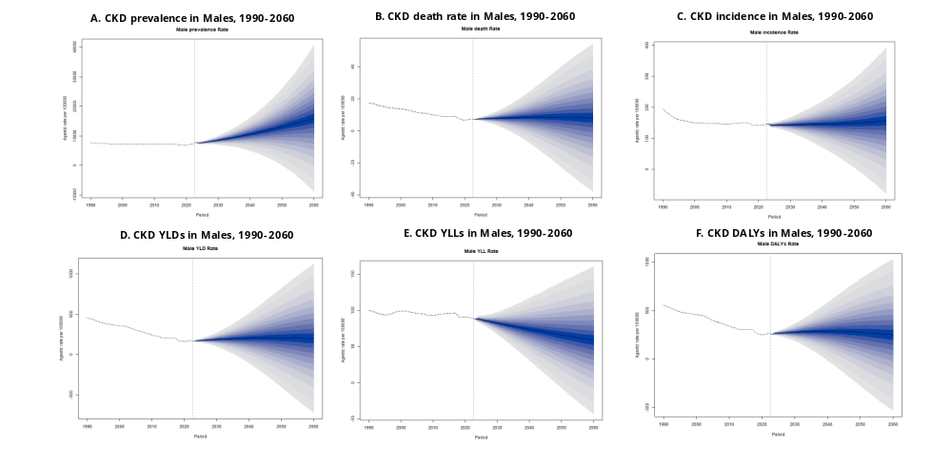
eFigure 1. Historical and projected epidemiological trends of CKD among males from 1990 to 2060
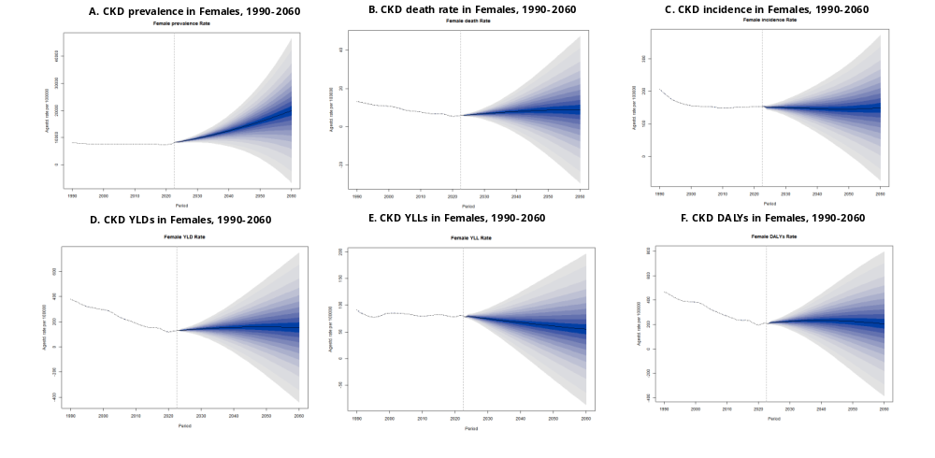
eFigure 2. Historical and projected epidemiological trends of CKD among females from 1990 to 2060

eAppendix 5. Yearly Cost per Person Attributed to CKD in China, in international dollars at constant 2023 prices

eTable 2. Projected total CKD cases in China, 2025–2060, with 95% confidence intervals (millions)
year | CKD cases (millions)
2025 | 118.86(113.12-124.59)
2026 | 121.65(113.94-129.36)
2027 | 124.53(114.39-134.67)
2028 | 127.44(114.47-140.41)
2029 | 130.31(114.13-146.48)
2030 | 133.16(113.45-152.88)
2031 | 136.09(112.50-159.68)
2032 | 139.11(111.28-166.94)
2033 | 142.16(109.75-174.58)
2034 | 145.16(107.83-182.50)
2035 | 148.13(105.55-190.72)
2036 | 151.16(102.97-199.36)
2037 | 154.29(100.10-208.49)
2038 | 157.46(96.88-218.04)
2039 | 160.56(93.25-227.87)
2040 | 163.60(89.21-237.99)
2041 | 166.67(84.83-248.52)
2042 | 169.82(80.10-259.54)
2043 | 172.99(74.98-270.99)
2044 | 176.06(69.42-282.71)
2045 | 179.05(63.43-294.66)
2046 | 182.00(57.05-306.96)
2047 | 184.98(50.27-319.69)
2048 | 187.95(43.08-332.81)
2049 | 190.80(35.45-346.14)
2050 | 193.51(27.41-359.62)
2051 | 196.16(18.96-373.37)
2052 | 198.79(10.12-387.46)
2053 | 201.38(0.87-401.89)
2054 | 203.85(0.00-416.48)
2055 | 206.18(0.00-431.17)
2056 | 208.43(0.00-446.07)
2057 | 210.65(0.00-461.27)
2058 | 212.83(0.00-476.80)
2059 | 214.92(0.00-492.47)
2060 | 216.89(0.00-508.27)

The estimated total annual cost attributable to CKD was INT $13,881(95% CI INT $8,990-18,773) per person. When adjusted for comorbidities and demographic factors, the cost estimate decreased to INT $9,771.18 (95% CI: INT$1,839.67–17,702.70) per person. eTable 3 shows the detailed regression results of annual treatment costs for CKD.

eTable 3. Regression results of the treatment cost of CKD
Characteristic | Outpatient | Hospitalization | Out-of-pocket payments | Total annual cost
Probability | 7,102.00** | 2,992.43** | 1,139.21** | 9,771.18**
Wave(reference group = Wave 1)
Wave2 | 416.00 | 706.58** | 163.48 | 1,141.05
Wave3 | 418.28 | 117.52 | 87.39 | 581.85
Sex(reference group = Female)
Male | 154.99 | 340.02*** | 53.84 | 529.14
Age(reference group = 50-54 yr)
55-59 yr | -143.39 | 205.51 | -9.53 | -2,354.28***
60-64 yr | 727.29* | 457.15*** | 100.92 | -2,300.28***
≥65yr | 1,520.51*** | 830.65*** | 159.71* | -1,158.14*
Educational level a (reference group = Below primary school )
Primary school graduate | 235.12 | 16.84 | -41.34 | 244.33
Middle-school graduate | 824.21 | 135.34 | 95.88 | 958.79
High-school graduate or more | 90.40 | 436.40 | 19.23 | 509.76
Marital status b(reference = Separated/Divorced/Widowed/Never married)
Married | 562.86 | 397.40*** | 102.44** | 1,008.17**
Household registration c (reference group = Urban)
Rural | 431.06 | 102.09 | 14.71 | -612.79
Number of children raised | 40.43 | 39.55 | 14.48 | 29.59
Percentage of household consumption expenditure spent on health cared | 0.06*** | 0.05*** | 0.01*** | 0.11***
Systolic blood pressure e | 14.59** | 1.78 | 1.13 | -15.05*
CES-D-10 depression score f | 71.89*** | 29.80*** | 12.93*** | 106.80***
Diabetes or high blood sugar g | 1,898.39** | 1,407.95*** | 336.90*** | 3,352.66***
Dyslipidemia h | 1,225.39* | 353.36 | 150.39** | 1,639.58**
Stroke i | 299.33 | 1,020.48*** | 193.97 | 1,283.69
*p<0.05; **p<0.01; ***p<0.001
Note: Data are based on a total of 23,891 person-years. For each characteristic, such as sex and marital status, the probability of CKD was calculated from the regression of the predicted probability of CKD on indicator variables for the categories taken by that characteristic, such as “male” and “female” in the case of sex and “unmarried” and “married” in the case of marital status. Missing data are indicated as follows: a. 17 missing values for education level; b. 4 missing values for marital status; c. 238 missing values for household registration; d. 4,777 missing values for percentage of household consumption expenditure spent on health care; e. 7,452 missing values for systolic blood pressure; f: 2,209 .missing values for CES-D-10 depression score; g: 1,802 missing values for diabetes or high blood sugar; h: 2,021 missing values for dyslipidemia; i: 1,687 missing values for stroke.

eAppendix 6. Imputation
eTables 4-6 present the annual losses of human capital, economic costs, the proportion of GDP loss attributable to CKD, and per capita losses in China from 2025 to 2060 under discount rates of 2%, 0%, and 3%, respectively.

eTable 4. Projected Economic Burden of CKD in China from 2025 to 2060, using discount rates of 2%
Year |  | Loss of human capital of 2023 INT$ | Economic cost in millions of  2023 INT$ (95%CI) | Percentage of GDP (95%CI) | Per capita loss in  2023 INT$ (95%CI)
2025 |  | 602,149.7 | 1,625 (1,625-1,625) | 0.005 (0.001-0.005) | 1.13 (1.13-1.13)
2026 |  | 1,185,061.3 | 9,633 (214-16,242) | 0.028 (0.001-0.048) | 6.73 (0.15-11.35)
2027 |  | 1,747,400.0 | 18,792 (7,143-28,783) | 0.053 (0.021-0.082) | 13.14 (5.00-20.13)
2028 |  | 2,289,808.4 | 29,554 (14,406-41,541) | 0.082 (0.040-0.116) | 20.70 (10.09-29.11)
2029 |  | 2,810,873.9 | 42,076 (26,081-55,814) | 0.114 (0.071-0.151) | 29.54 (18.31-39.17)
2030 |  | 3,310,532.6 | 55,927 (40,478-71,716) | 0.149 (0.108-0.191) | 39.34 (28.48-50.46)
2031 |  | 3,789,275.0 | 70,129 (54,210-86,301) | 0.184 (0.141-0.226) | 49.47 (38.24-60.88)
2032 |  | 4,233,847.3 | 84,447 (65,300-102,875) | 0.217 (0.168-0.265) | 59.77 (46.21-72.80)
2033 |  | 4,658,442.8 | 98,977 (81,490-115,298) | 0.252 (0.206-0.293) | 70.29 (57.88-81.89)
2034 |  | 5,061,949.2 | 113,468 (94,433-130,711) | 0.284 (0.237-0.327) | 80.89 (67.32-93.18)
2035 |  | 5,445,998.3 | 126,948 (110,499-145,709) | 0.314 (0.274-0.361) | 90.87 (79.10-104.31)
2036 |  | 5,812,377.5 | 140,667 (124,597-157,871) | 0.346 (0.306-0.388) | 101.14 (89.59-113.52)
2037 |  | 6,136,635.6 | 153,497 (138,120-171,240) | 0.374 (0.336-0.417) | 110.88 (99.78-123.70)
2038 |  | 6,440,625.4 | 165,790 (152,249-180,051) | 0.401 (0.367-0.434) | 120.34 (110.52-130.70)
2039 |  | 6,725,075.8 | 177,174 (162,787-194,453) | 0.424 (0.390-0.467) | 129.27 (118.77-141.88)
2040 |  | 6,992,752.7 | 188,152 (172,705-203,631) | 0.448 (0.411-0.485) | 138.01 (126.68-149.36)
2041 |  | 7,248,913.6 | 198,404 (184,856-212,160) | 0.470 (0.438-0.503) | 146.34 (136.35-156.49)
2042 |  | 7,465,544.3 | 208,197 (196,239-221,780) | 0.491 (0.463-0.523) | 154.45 (145.58-164.53)
2043 |  | 7,659,246.6 | 216,463 (202,853-231,592) | 0.509 (0.476-0.544) | 161.55 (151.38-172.83)
2044 |  | 7,834,015.4 | 224,019 (210,978-239,141) | 0.525 (0.494-0.559) | 168.23 (158.44-179.58)
2045 |  | 7,995,340.4 | 230,941 (218,165-244,624) | 0.539 (0.509-0.570) | 174.56 (164.91-184.91)
2046 |  | 8,148,011.4 | 237,628 (225,177-250,766) | 0.553 (0.524-0.583) | 180.86 (171.37-190.86)
2047 |  | 8,259,403.7 | 242,484 (229,428-254,598) | 0.563 (0.532-0.591) | 185.88 (175.87-195.17)
2048 |  | 8,347,295.2 | 247,050 (234,725-260,324) | 0.572 (0.543-0.603) | 190.80 (181.29-201.06)
2049 |  | 8,416,077.1 | 250,988 (238,536-264,843) | 0.580 (0.551-0.612) | 195.38 (185.68-206.16)
2050 |  | 8,472,934.8 | 254,344 (241,857-267,292) | 0.586 (0.558-0.617) | 199.63 (189.82-209.79)
2051 |  | 8,526,179.9 | 257,064 (245,027-269,950) | 0.592 (0.565-0.622) | 203.50 (193.97-213.70)
2052 |  | 8,546,873.8 | 259,144 (248,539-271,382) | 0.596 (0.571-0.624) | 206.99 (198.53-216.77)
2053 |  | 8,552,695.0 | 260,571 (250,605-273,295) | 0.598 (0.576-0.627) | 210.08 (202.05-220.33)
2054 |  | 8,549,194.7 | 261,520 (251,604-273,170) | 0.600 (0.578-0.627) | 212.88 (204.81-222.36)
2055 |  | 8,541,713.5 | 262,203 (251,760-272,868) | 0.602 (0.578-0.625) | 215.57 (206.98-224.34)
2056 |  | 8,534,676.2 | 262,512 (253,369-271,938) | 0.602 (0.581-0.623) | 218.04 (210.45-225.87)
2057 |  | 8,500,525.6 | 262,233 (252,886-271,705) | 0.600 (0.579-0.622) | 220.11 (212.26-228.06)
2058 |  | 8,459,224.2 | 261,625 (254,766-271,349) | 0.598 (0.583-0.621) | 221.98 (216.16-230.23)
2059 |  | 8,417,468.2 | 260,742 (253,772-270,207) | 0.596 (0.580-0.618) | 223.67 (217.70-231.79)
2060 |  | 8,373,835.1 | 259,561 (251,366-269,303) | 0.593 (0.575-0.616) | 225.16 (218.04-233.60)
Cumulative | 232,091,973.0 |  | 6,449,366 (5,337,287-7,370,323) | 0.435 (0.361-0.498) | 5,594.46 (4,629.80-6,393.34)

eTable 5. Projected Economic Burden of CKD in China from 2025 to 2060, using discount rates of 0%
Year | Loss of human capital of 2023 INT$ | Economic cost in millions of  2023 INT$ (lower and upper  bound) | Percentage of GDP (lower and upper bound) | Per capita loss in  2023 INT$ (lower  and upper bound)
2025 | 602,149.7 | 1,625 (1,625-1,625) | 0.005 (0.005-0.005) | 1.13 (1.13-1.13)
2026 | 1,208,763.0 | 9,825 (218-16,567) | 0.029 (0.001-0.049) | 6.87 (0.15-11.58)
2027 | 1,817,995.3 | 19,551 (7,431-29,945) | 0.055 (0.022-0.085) | 13.67 (5.19-20.95)
2028 | 2,429,963.3 | 31,363 (15,287-44,083) | 0.087 (0.042-0.122) | 21.98 (10.71-30.89)
2029 | 3,042,580.3 | 45,544 (28,231-60,415) | 0.123 (0.077-0.164) | 31.97 (19.82-42.40)
2030 | 3,655,095.8 | 61,747 (44,691-79,180) | 0.164 (0.119-0.211) | 43.44 (31.44-55.71)
2031 | 4,267,339.2 | 78,976 (61,049-97,188) | 0.206 (0.160-0.254) | 55.72 (43.07-68.57)
2032 | 4,863,359.9 | 97,003 (75,010-118,171) | 0.249 (0.193-0.305) | 68.66 (53.08-83.64)
2033 | 5,458,108.3 | 115,966 (95,478-135,089) | 0.294 (0.242-0.342) | 82.36 (67.80-95.94)
2034 | 6,049,498.0 | 135,605 (112,856-156,212) | 0.340 (0.283-0.392) | 96.67 (80.45-111.36)
2035 | 6,638,641.2 | 154,749 (134,698-177,619) | 0.383 (0.334-0.441) | 110.78 (96.42-127.15)
2036 | 7,226,960.4 | 174,901 (154,921-196,292) | 0.429 (0.380-0.482) | 125.77 (111.39-141.15)
2037 | 7,782,738.1 | 194,671 (175,170-217,175) | 0.474 (0.427-0.528) | 140.63 (126.54-156.89)
2038 | 8,331,635.2 | 214,466 (196,951-232,915) | 0.517 (0.475-0.563) | 155.68 (142.97-169.07)
2039 | 8,873,595.4 | 233,778 (214,795-256,577) | 0.561 (0.515-0.616) | 170.56 (156.72-187.20)
2040 | 9,411,324.1 | 253,229 (232,439-274,061) | 0.604 (0.554-0.653) | 185.74 (170.49-201.02)
2041 | 9,951,205.3 | 272,365 (253,768-291,249) | 0.646 (0.602-0.690) | 200.89 (187.17-214.82)
2042 | 10,453,564.1 | 291,527 (274,782-310,545) | 0.688 (0.648-0.732) | 216.27 (203.85-230.37)
2043 | 10,939,289.8 | 309,163 (289,724-330,771) | 0.727 (0.680-0.778) | 230.73 (216.22-246.86)
2044 | 11,412,681.8 | 326,354 (307,356-348,383) | 0.764 (0.719-0.815) | 245.08 (230.82-261.62)
2045 | 11,880,654.5 | 343,166 (324,183-363,499) | 0.800 (0.756-0.848) | 259.39 (245.04-274.76)
2046 | 12,349,666.1 | 360,166 (341,293-380,078) | 0.838 (0.794-0.885) | 274.11 (259.75-289.27)
2047 | 12,768,870.2 | 374,876 (354,690-393,603) | 0.869 (0.823-0.914) | 287.37 (271.89-301.72)
2048 | 13,162,844.5 | 389,572 (370,138-410,505) | 0.902 (0.858-0.950) | 300.89 (285.88-317.06)
2049 | 13,536,730.8 | 403,698 (383,670-425,982) | 0.933 (0.887-0.984) | 314.26 (298.66-331.60)
2050 | 13,900,747.0 | 417,280 (396,793-438,521) | 0.962 (0.916-1.012) | 327.51 (311.43-344.17)
2051 | 14,267,863.8 | 430,175 (410,033-451,739) | 0.990 (0.945-1.040) | 340.55 (324.59-357.61)
2052 | 14,588,542.8 | 442,330 (424,228-463,218) | 1.017 (0.976-1.066) | 353.31 (338.85-370.00)
2053 | 14,890,449.2 | 453,659 (436,310-475,815) | 1.042 (1.002-1.093) | 365.75 (351.76-383.61)
2054 | 15,182,041.7 | 464,418 (446,811-485,107) | 1.066 (1.026-1.113) | 378.04 (363.71-394.88)
2055 | 15,472,132.9 | 474,945 (456,029-494,263) | 1.089 (1.045-1.133) | 390.47 (374.92-406.35)
2056 | 15,768,571.3 | 485,015 (468,123-502,429) | 1.111 (1.072-1.151) | 402.85 (388.82-417.31)
2057 | 16,019,586.0 | 494,189 (476,574-512,041) | 1.132 (1.091-1.173) | 414.81 (400.02-429.80)
2058 | 16,260,585.8 | 502,903 (489,717-521,596) | 1.151 (1.121-1.193) | 426.70 (415.51-442.55)
2059 | 16,503,928.2 | 511,231 (497,565-529,789) | 1.170 (1.138-1.212) | 438.54 (426.83-454.47)
2060 | 16,746,744.6 | 519,093 (502,703-538,578) | 1.187 (1.149-1.231) | 450.28 (436.07-467.19)
Cumulative | 357,716,447.6 | 10,177,055 (8,073,390-12,040,659) | 0.687 (0.545-0.813) | 8,828.0 (7,003.3-10,444.6)

eTable 6. Projected Economic Burden of CKD in China from 2025 to 2060, using discount rates of 3%
Year | Loss of human capital of 2023 INT$ | Economic cost in millions of  2023 INT$ (lower and upper  bound) | Percentage of GDP (lower and upper bound) | Per capita loss in  2023 INT$ (lower  and upper bound)
2025 | 602,149.7 | 1,625 (1,625-1,625) | 0.005 (0.005-0.005) | 1.13 (1.13-1.13)
2026 | 1,173,556.1 | 9,539 (212-16,084) | 0.028 (0.001-0.048) | 6.66 (0.15-11.24)
2027 | 1,713,634.9 | 18,429 (7,005-28,227) | 0.053 (0.019-0.080) | 12.90 (4.90-19.74)
2028 | 2,223,760.0 | 28,702 (13,990-40,342) | 0.080 (0.039-0.112) | 20.11 (9.81-28.26)
2029 | 2,703,292.9 | 40,465 (25,083-53,678) | 0.110 (0.068-0.146) | 28.40 (17.60-37.68)
2030 | 3,152,917.4 | 53,263 (38,551-68,301) | 0.141 (0.103-0.181) | 37.48 (27.12-48.05)
2031 | 3,573,829.1 | 66,141 (51,127-81,394) | 0.173 (0.134-0.213) | 46.67 (36.07-57.42)
2032 | 3,954,356.3 | 78,872 (60,990-96,084) | 0.203 (0.157-0.247) | 55.81 (43.17-68.00)
2033 | 4,308,681.6 | 91,545 (75,371-106,640) | 0.232 (0.191-0.271) | 65.02 (53.52-75.73)
2034 | 4,636,435.7 | 103,929 (86,495-119,723) | 0.260 (0.217-0.300) | 74.09 (61.66-85.35)
2035 | 4,939,773.1 | 115,147 (100,227-132,165) | 0.285 (0.248-0.327) | 82.43 (71.74-94.61)
2036 | 5,220,910.1 | 126,352 (111,918-141,806) | 0.310 (0.274-0.348) | 90.85 (80.47-101.96)
2037 | 5,458,655.9 | 136,538 (122,861-152,322) | 0.333 (0.299-0.370) | 98.64 (88.75-110.04)
2038 | 5,673,437.6 | 146,042 (134,113-158,603) | 0.352 (0.324-0.383) | 106.01 (97.35-115.13)
2039 | 5,866,492.0 | 154,554 (142,005-169,627) | 0.370 (0.340-0.407) | 112.76 (103.60-123.76)
2040 | 6,040,770.5 | 162,538 (149,193-175,909) | 0.388 (0.355-0.419) | 119.22 (109.44-129.03)
2041 | 6,201,262.8 | 169,728 (158,140-181,497) | 0.403 (0.375-0.430) | 125.19 (116.64-133.87)
2042 | 6,324,578.3 | 176,378 (166,248-187,885) | 0.416 (0.392-0.443) | 130.84 (123.34-139.38)
2043 | 6,425,680.3 | 181,601 (170,182-194,293) | 0.427 (0.400-0.457) | 135.53 (127.01-145.00)
2044 | 6,508,492.6 | 186,115 (175,281-198,678) | 0.435 (0.410-0.465) | 139.76 (131.63-149.20)
2045 | 6,578,030.5 | 190,003 (179,492-201,260) | 0.443 (0.419-0.470) | 143.62 (135.67-152.13)
2046 | 6,638,554.8 | 193,606 (183,462-204,310) | 0.450 (0.427-0.475) | 147.36 (139.63-155.50)
2047 | 6,663,978.0 | 195,645 (185,112-205,418) | 0.454 (0.430-0.476) | 149.97 (141.90-157.46)
2048 | 6,669,504.4 | 197,393 (187,545-207,999) | 0.457 (0.434-0.482) | 152.45 (144.85-160.65)
2049 | 6,659,175.2 | 198,593 (188,740-209,556) | 0.459 (0.436-0.484) | 154.59 (146.92-163.12)
2050 | 6,639,074.3 | 199,295 (189,511-209,440) | 0.460 (0.437-0.483) | 156.42 (148.74-164.39)
2051 | 6,615,933.1 | 199,470 (190,130-209,469) | 0.459 (0.438-0.483) | 157.91 (150.51-165.82)
2052 | 6,567,602.0 | 199,133 (190,983-208,536) | 0.458 (0.440-0.480) | 159.05 (152.55-166.57)
2053 | 6,508,269.0 | 198,284 (190,701-207,967) | 0.456 (0.438-0.477) | 159.86 (153.75-167.67)
2054 | 6,442,444.1 | 197,074 (189,603-205,853) | 0.453 (0.435-0.472) | 160.42 (154.34-167.56)
2055 | 6,374,313.4 | 195,671 (187,878-203,630) | 0.448 (0.431-0.467) | 160.87 (154.46-167.41)
2056 | 6,307,225.9 | 194,000 (187,243-200,965) | 0.445 (0.429-0.460) | 161.14 (155.52-166.92)
2057 | 6,220,998.7 | 191,912 (185,071-198,844) | 0.440 (0.423-0.456) | 161.08 (155.35-166.90)
2058 | 6,130,667.5 | 189,608 (184,637-196,655) | 0.434 (0.422-0.450) | 160.88 (156.65-166.86)
2059 | 6,041,178.7 | 187,134 (182,131-193,927) | 0.428 (0.417-0.444) | 160.53 (156.23-166.35)
2060 | 5,951,515.0 | 184,477 (178,653-191,402) | 0.421 (0.408-0.437) | 160.02 (154.97-166.03)
Cumulative | 189,711,131.4 | 5,202,598 (4,384,904-5,863,427) | 0.351 (0.296-0.395) | 3,636.6 (3,002.3-4,155.6)

eFigures 3-4 show the projected economic cost of CKD as a percentage of GDP and the per capita loss attributable to CKD in China from 2025 to 2060, using discount rates of 0%, 2%, and 3%.

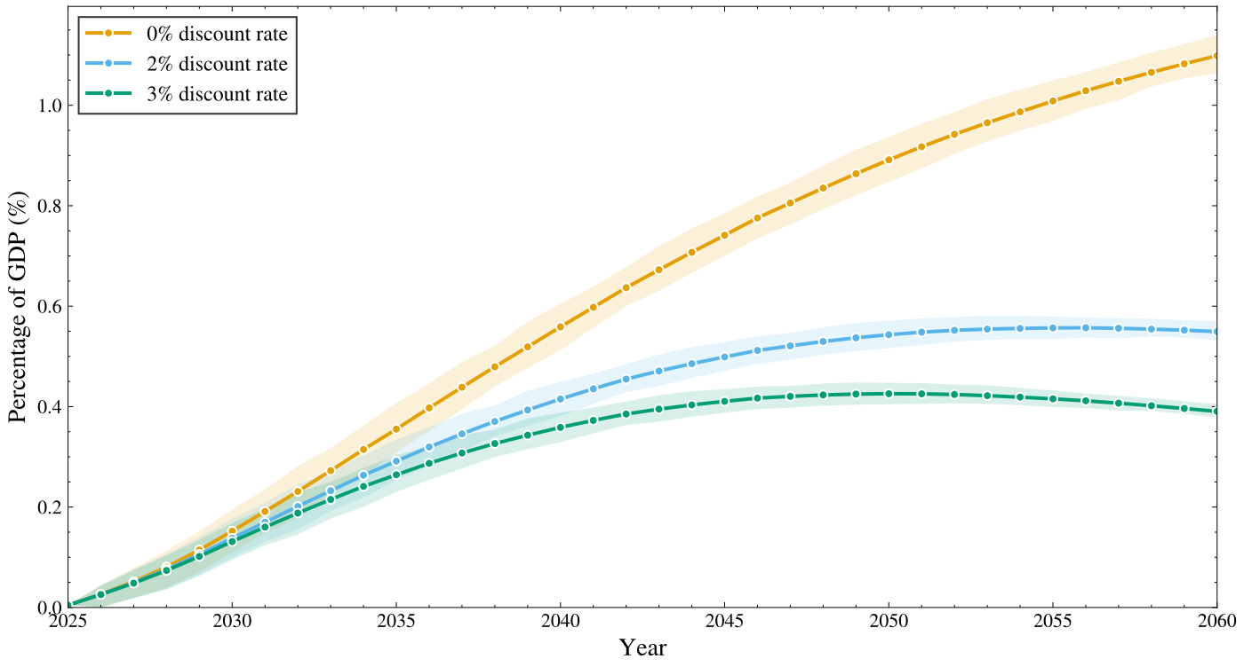

eFigure 3. Economic cost of CKD as a Percentage of GDP in China from 2025 to 2060: using discount rates of 0%, 2% and 3%
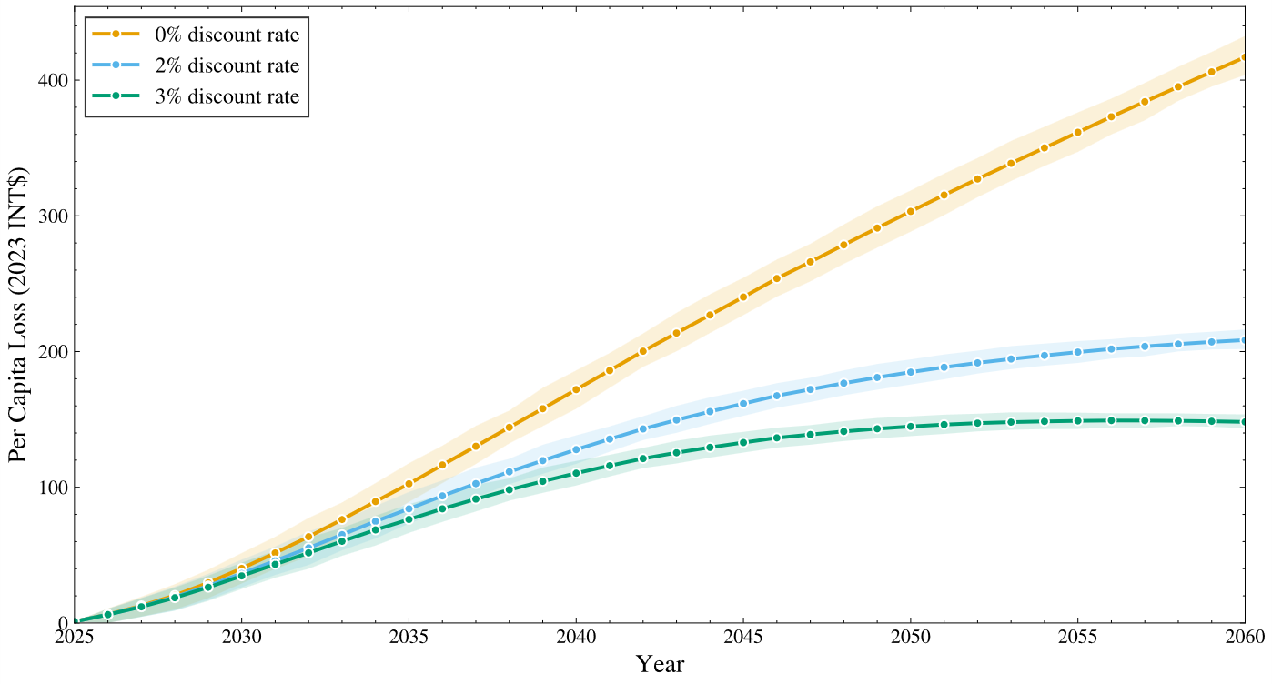

eFigure 4. Projected Per Capita Loss Attributable CKD in China from 2025 to 2060: using discount rates of 0%, 2% and 3%

eTable 7. Projected GDP losses attributable to CKD by province in 2025 (in millions of 2023 INT$)
Province | Economic cost in millions of 2023 INT$ (2025)
Shanghai Municipality | 43.26
Yunnan Province | 25.29
Inner Mongolia Autonomous Region | 21.06
Beijing Municipality | 39.94
Jilin Province | 11.47
Sichuan Province | 51.68
Tianjin Municipality | 14.44
Ningxia Hui Autonomous Region | 4.41
Anhui Province | 40.41
Shandong Province | 78.73
Shanxi Province | 20.40
Guangdong Province | 113.82
Guangxi Zhuang Autonomous Region | 22.96
Xinjiang Uygur Autonomous Region | 16.46
Jiangsu Province | 109.46
Jiangxi Province | 27.32
Hebei Province | 37.94
Henan Province | 50.65
Zhejiang Province | 72.28
Hainan Province | 6.37
Hubei Province | 48.01
Hunan Province | 42.54
Gansu Province | 10.39
Fujian Province | 46.22
Tibet Autonomous Region | 2.22
Guizhou Province | 18.13
Liaoning Province | 26.04
Chongqing Municipality | 25.70
Shaanxi Province | 28.43
Qinghai Province | 3.16
Heilongjiang Province | 13.17
Total | 1072.39

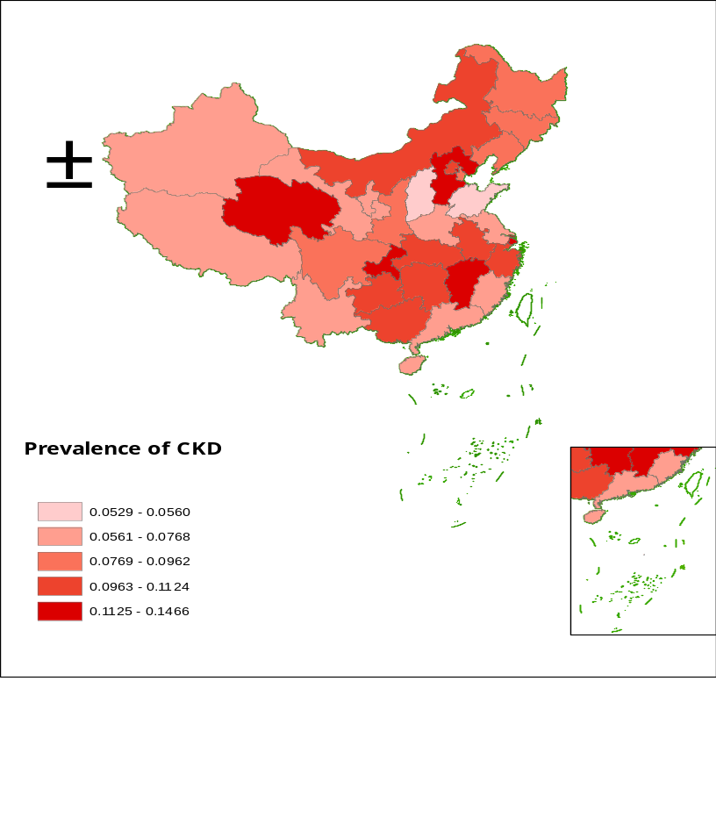

eFigure 5. Prevalence of CKD by Province in China in 2025

eTable 8. Projected Number of CKD Patients by Province in Mainland China, 2025 and 2060
Province | Number of Patients with CKD in 2025 (95% CI) | Number of Patients with CKD in 2060 (95% CI)
Shanghai Municipality | 3,451,176 (3,450,853-3,451,509) | 3,668,505 (2,682,709-6,156,868)
Yunnan Province | 3,464,449 (3,463,827-3,465,110) | 3,667,619 (2,616,976-6,467,258)
Inner Mongolia Autonomous Region | 2,725,010 (2,724,695-2,725,327) | 2,908,738 (2,110,553-5,039,377)
Beijing Municipality | 2,255,565 (2,255,278-2,255,826) | 2,379,039 (1,665,164-4,134,166)
Jilin Province | 2,351,798 (2,351,476-2,352,103) | 2,505,820 (1,789,312-4,462,432)
Sichuan Province | 7,216,396 (7,215,334-7,217,500) | 7,672,144 (5,451,177-13,298,908)
Tianjin Municipality | 1,280,095 (1,279,909-1,280,281) | 1,358,632 (980,792-2,370,462)
Ningxia Hui Autonomous Region | 531,073 (530,969-531,172) | 563,738 (399,005-971,414)
Anhui Province | 6,876,538 (6,875,710-6,877,311) | 7,326,933 (5,332,411-12,707,509)
Shandong Province | 5,457,449 (5,456,079-5,458,753) | 5,818,632 (4,171,217-10,311,263)
Shanxi Province | 1,987,599 (1,987,135-1,988,058) | 2,122,952 (1,508,442-3,772,702)
Guangdong Province | 9,825,535 (9,823,879-9,827,227) | 10,442,859 (7,401,162-17,760,793)
Guangxi Zhuang Autonomous Region | 5,165,317 (5,164,687-5,166,009) | 5,485,294 (3,951,492-9,778,704)
Xinjiang Uygur Autonomous Region | 1,951,589 (1,951,250-1,951,926) | 2,075,150 (1,511,859-3,573,467)
Jiangsu Province | 6,028,471 (6,027,347-6,029,599) | 6,425,987 (4,657,512-11,152,584)
Jiangxi Province | 5,666,037 (5,665,462-5,666,642) | 6,013,432 (4,324,754-10,355,233)
Hebei Province | 9,328,267 (9,327,314-9,329,272) | 9,950,973 (7,076,324-17,845,075)
Henan Province | 7,704,488 (7,703,148-7,705,813) | 8,223,390 (5,982,531-14,639,990)
Zhejiang Province | 7,367,018 (7,366,162-7,367,881) | 7,825,818 (5,538,720-13,986,887)
Hainan Province | 768,042 (767,910-768,178) | 810,811 (578,869-1,435,540)
Hubei Province | 6,192,188 (6,191,421-6,192,935) | 6,546,509 (4,666,487-11,638,894)
Hunan Province | 7,481,699 (7,480,779-7,482,578) | 7,960,849 (5,645,047-13,982,020)
Gansu Province | 1,676,775 (1,676,443-1,677,105) | 1,780,092 (1,270,964-3,122,014)
Fujian Province | 3,059,473 (3,058,927-3,060,007) | 3,252,316 (2,286,241-5,683,785)
Tibet Autonomous Region | 277,376 (277,329-277,427) | 296,326 (212,908-515,699)
Guizhou Province | 4,228,691 (4,228,189-4,229,196) | 4,490,918 (3,210,326-7,831,425)
Liaoning Province | 3,998,273 (3,997,743-3,998,866) | 4,265,529 (3,056,863-7,322,064)
Chongqing Municipality | 4,220,521 (4,220,093-4,220,948) | 4,512,534 (3,284,994-7,735,605)
Shaanxi Province | 3,739,522 (3,739,011-3,740,055) | 3,998,723 (2,891,642-6,788,018)
Qinghai Province | 881,623 (881,547-881,700) | 936,701 (677,927-1,664,782)
Heilongjiang Province | 2,677,444 (2,676,982-2,677,860) | 2,842,173 (1,985,930-5,103,920)

eTable 9. Projected Economic Burden of CKD Across Provinces in Mainland China from 2025 to 2060, using discount rates of 0%
Province | Cumulative Economic cost in millions of  2023 INT$ (lower and upper  bound) | Percentage of total GDP in 2025-2060 (lower and upper bound) | Per capita loss (lower and upper bound)
Shanghai Municipality | 135,440.64 (112,883.76-155,900.82) | 0.388 (0.323-0.447) | 5,424.17 (4,520.80-6,243.57)
Yunnan Province | 264,029.84 (242,475.78-280,507.56) | 1.294 (1.188-1.375) | 5,570.60 (5,115.84-5,918.25)
Inner Mongolia Autonomous Region | 174,418.57 (156,594.93-189,552.46) | 1.024 (0.919-1.113) | 7,223.85 (6,485.65-7,850.65)
Beijing Municipality | 96,189.68 (79,765.95-111,309.84) | 0.298 (0.247-0.345) | 4,376.20 (3,628.99-5,064.10)
Jilin Province | 187,028.86 (173,027.85-197,471.61) | 2.012 (1.862-2.124) | 7,738.31 (7,159.02-8,170.37)
Sichuan Province | 514,238.12 (468,046.31-550,827.79) | 1.228 (1.118-1.315) | 6,121.32 (5,571.47-6,556.87)
Tianjin Municipality | 74,345.55 (65,119.08-82,397.12) | 0.637 (0.558-0.706) | 5,340.47 (4,677.70-5,918.83)
Ningxia Hui Autonomous Region | 39,143.94 (35,708.25-41,813.00) | 1.099 (1.002-1.174) | 5,413.12 (4,938.01-5,782.22)
Anhui Province | 468,049.98 (424,703.21-503,369.01) | 1.429 (1.296-1.536) | 7,639.14 (6,931.68-8,215.59)
Shandong Province | 379,357.19 (338,384.88-414,901.44) | 0.595 (0.530-0.650) | 3,721.69 (3,319.74-4,070.40)
Shanxi Province | 151,851.95 (138,711.65-161,965.39) | 0.920 (0.840-0.982) | 4,331.88 (3,957.02-4,620.39)
Guangdong Province | 637,922.56 (569,146.35-696,849.45) | 0.696 (0.621-0.760) | 5,042.31 (4,498.69-5,508.09)
Guangxi Zhuang Autonomous Region | 400,517.51 (368,985.29-424,039.72) | 2.160 (1.990-2.286) | 7,958.42 (7,331.87-8,425.83)
Xinjiang Uygur Autonomous Region | 142,437.09 (129,769.54-152,355.31) | 1.071 (0.976-1.146) | 5,487.80 (4,999.75-5,869.94)
Jiangsu Province | 323,868.12 (273,690.27-368,552.97) | 0.365 (0.309-0.416) | 3,806.40 (3,216.66-4,331.58)
Jiangxi Province | 397,395.18 (361,835.70-426,148.14) | 1.795 (1.634-1.925) | 8,759.30 (7,975.50-9,393.06)
Hebei Province | 708,142.77 (651,401.48-751,606.75) | 2.303 (2.118-2.443) | 9,453.62 (8,696.13-10,033.86)
Henan Province | 569,959.48 (521,390.74-607,682.66) | 1.385 (1.267-1.476) | 5,713.26 (5,226.41-6,091.39)
Zhejiang Province | 411,339.91 (359,982.57-456,164.08) | 0.705 (0.617-0.782) | 6,345.44 (5,553.19-7,036.91)
Hainan Province | 55,860.73 (50,899.35-59,761.17) | 1.088 (0.991-1.163) | 5,519.10 (5,028.91-5,904.48)
Hubei Province | 390,566.89 (350,291.44-425,155.67) | 1.005 (0.902-1.094) | 6,735.97 (6,041.35-7,332.51)
Hunan Province | 514,401.14 (467,062.18-552,690.86) | 1.493 (1.355-1.604) | 7,711.10 (7,001.47-8,285.08)
Gansu Province | 134,864.84 (124,885.03-142,121.41) | 1.603 (1.484-1.689) | 5,368.96 (4,971.66-5,657.84)
Fujian Province | 179,509.10 (155,459.90-200,696.07) | 0.481 (0.416-0.537) | 4,304.22 (3,727.58-4,812.24)
Tibet Autonomous Region | 20,350.94 (18,570.61-21,740.45) | 1.137 (1.038-1.215) | 5,556.39 (5,070.32-5,935.78)
Guizhou Province | 323,501.89 (297,892.90-342,940.05) | 2.205 (2.030-2.337) | 8,355.86 (7,694.40-8,857.94)
Liaoning Province | 293,396.81 (268,237.07-313,196.30) | 1.390 (1.271-1.484) | 6,861.35 (6,272.96-7,324.38)
Chongqing Municipality | 258,100.14 (231,088.92-281,007.68) | 1.239 (1.109-1.349) | 8,020.10 (7,180.76-8,731.92)
Shaanxi Province | 254,466.88 (230,647.06-274,287.63) | 1.106 (1.002-1.192) | 6,411.97 (5,811.76-6,911.41)
Qinghai Province | 68,178.06 (62,695.47-72,320.80) | 2.667 (2.452-2.829) | 11,463.27 (10,541.44-12,159.82)
Heilongjiang Province | 220,277.51 (204,664.37-231,644.72) | 2.066 (1.919-2.172) | 6,888.67 (6,400.40-7,244.15)

eTable 10. Projected Economic Burden of CKD Across Provinces in Mainland China from 2025 to 2060, using discount rates of 3%
Province | Cumulative Economic cost in millions of  2023 INT$ (lower and upper  bound) | Percentage of total GDP in 2025-2060 (lower and upper bound) | Per capita loss (lower and upper bound)
Shanghai Municipality | 71,775.73 (63,005.12-79,345.26) | 0.205 (0.180-0.227) | 2,874.50 (2,523.25-3,177.64)
Yunnan Province | 158,156.88 (141,765.82-173,600.74) | 0.775 (0.694-0.851) | 3,336.84 (2,991.03-3,662.69)
Inner Mongolia Autonomous Region | 100,452.06 (90,626.39-108,930.94) | 0.590 (0.532-0.639) | 4,160.40 (3,753.45-4,511.56)
Beijing Municipality | 50,689.72 (44,366.55-56,117.40) | 0.157 (0.137-0.174) | 2,306.16 (2,018.48-2,553.09)
Jilin Province | 113,900.36 (101,278.71-126,429.01) | 1.226 (1.090-1.360) | 4,712.62 (4,190.40-5,230.99)
Sichuan Province | 303,395.95 (273,261.91-331,178.04) | 0.725 (0.652-0.791) | 3,611.52 (3,252.82-3,942.24)
Tianjin Municipality | 41,561.77 (37,320.44-45,152.12) | 0.356 (0.320-0.387) | 2,985.51 (2,680.84-3,243.41)
Ningxia Hui Autonomous Region | 23,188.92 (20,865.24-25,319.98) | 0.651 (0.585-0.711) | 3,206.74 (2,885.40-3,501.44)
Anhui Province | 274,766.26 (246,994.16-300,289.83) | 0.838 (0.754-0.917) | 4,484.52 (4,031.24-4,901.09)
Shandong Province | 216,033.19 (195,383.73-233,260.14) | 0.339 (0.307-0.366) | 2,119.40 (1,916.82-2,288.40)
Shanxi Province | 89,915.97 (81,051.51-97,916.61) | 0.545 (0.491-0.593) | 2,565.03 (2,312.16-2,793.27)
Guangdong Province | 363,851.95 (327,969.08-394,128.31) | 0.397 (0.357-0.430) | 2,875.99 (2,592.36-3,115.30)
Guangxi Zhuang Autonomous Region | 242,781.09 (216,225.26-268,930.81) | 1.309 (1.166-1.450) | 4,824.14 (4,296.48-5,343.75)
Xinjiang Uygur Autonomous Region | 84,159.96 (75,818.04-91,845.99) | 0.633 (0.570-0.691) | 3,242.51 (2,921.11-3,538.64)
Jiangsu Province | 174,455.60 (155,121.74-191,319.52) | 0.197 (0.175-0.216) | 2,050.37 (1,823.14-2,248.56)
Jiangxi Province | 235,416.10 (211,243.10-257,987.88) | 1.064 (0.955-1.165) | 5,188.99 (4,656.17-5,686.51)
Hebei Province | 427,291.46 (380,869.13-472,213.51) | 1.389 (1.238-1.535) | 5,704.29 (5,084.55-6,303.99)
Henan Province | 339,871.53 (305,084.93-372,459.97) | 0.826 (0.741-0.905) | 3,406.86 (3,058.16-3,733.53)
Zhejiang Province | 229,684.35 (205,994.19-249,649.21) | 0.394 (0.353-0.428) | 3,543.18 (3,177.73-3,851.16)
Hainan Province | 33,011.30 (29,734.53-36,035.76) | 0.643 (0.579-0.702) | 3,261.56 (2,937.81-3,560.37)
Hubei Province | 224,422.87 (202,401.76-243,464.93) | 0.578 (0.521-0.626) | 3,870.54 (3,490.75-4,198.95)
Hunan Province | 302,713.71 (271,736.78-330,792.14) | 0.879 (0.788-0.960) | 4,537.81 (4,073.46-4,958.72)
Gansu Province | 82,118.47 (72,976.32-91,014.70) | 0.975 (0.867-1.081) | 3,269.13 (2,905.18-3,623.29)
Fujian Province | 99,043.98 (88,888.24-107,688.32) | 0.265 (0.238-0.288) | 2,374.86 (2,131.34-2,582.12)
Tibet Autonomous Region | 12,072.03 (10,852.92-13,191.83) | 0.675 (0.607-0.738) | 3,296.02 (2,963.16-3,601.76)
Guizhou Province | 195,547.76 (174,257.58-216,299.43) | 1.333 (1.188-1.474) | 5,050.88 (4,500.98-5,586.88)
Liaoning Province | 174,548.70 (156,692.24-190,978.72) | 0.827 (0.742-0.905) | 4,081.98 (3,664.39-4,466.21)
Chongqing Municipality | 148,302.00 (133,455.69-161,177.00) | 0.712 (0.640-0.773) | 4,608.27 (4,146.95-5,008.35)
Shaanxi Province | 148,539.66 (134,091.81-161,700.00) | 0.646 (0.583-0.703) | 3,742.85 (3,378.80-4,074.46)
Qinghai Province | 41,315.18 (36,745.16-45,831.87) | 1.616 (1.437-1.793) | 6,946.62 (6,178.23-7,706.05)
Heilongjiang Province | 135,252.64 (119,772.98-150,621.10) | 1.268 (1.123-1.413) | 4,229.71 (3,745.62-4,710.32)

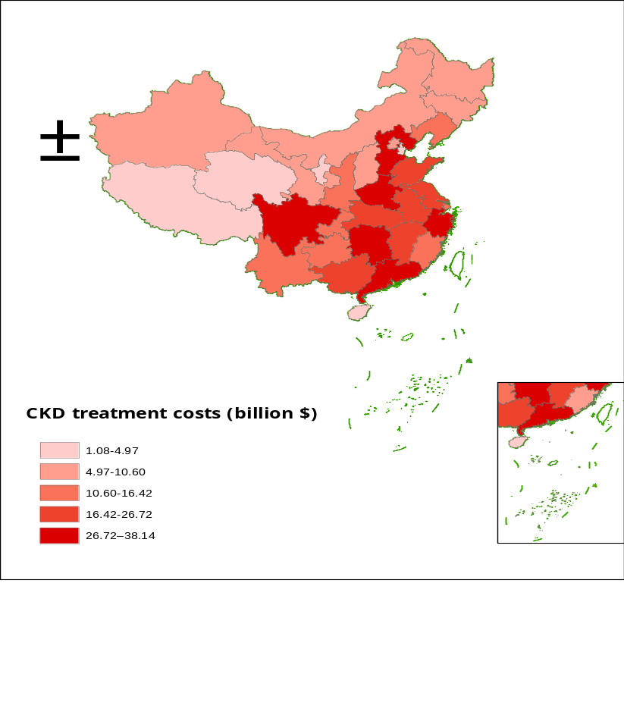

eFigure 6. Treatment Costs of CKD in Chinese Provinces

eReferences
1. Lucas RE. On the mechanics of economic development. J Monet Econ. 1988;22(1):3-42.
2. Solow RM. A contribution to the theory of economic growth. Q J Econ. 1956;70(1):65-94.
3. Abegunde D, Stanciole A. An estimation of the economic impact of chronic noncommunicable diseases in selected countries. Published online 2006.
4. Mincer J. Schooling, Experience, and Earnings. National Bureau of Economic Research Inc.; 1974.
5. Bloom DE, Chen S, Kuhn M. The economic burden of chronic diseases: estimates and projections for China, Japan, and South Korea. J Econ Ageing. 2020;17:100163. doi:10.1016/j.jeoa.2018.09.002
6. Chen S, Kuhn M, Prettner K. The macroeconomic burden of noncommunicable diseases in the United States: Estimates and projections. PLOS ONE. 2018;13(11):e0206702. doi:10.1371/journal.pone.0206702
7. Chen S, Cao Z, Prettner K. Estimates and projections of the global economic cost of 29 cancers in 204 countries and territories from 2020 to 2050. JAMA Oncol. 2023;9(4):465-472.
8. United Nations. World Population Prospects 2024: Ten Key Messages. Published online 2024.
9. Institute for Health Metrics and Evaluation (IHME). Global Fertility, Mortality, Migration, and Population Forecasts 2017‑2100. Published online 2020. https://ghdx.healthdata.org/record/ihme-data/global-population-forecasts-2017-2100
10. World Bank. World Bank database, GDP, PPP (constant 2021 International $). Published online 2022. https://data.worldbank.org/indicator/NY.GDP.MKTP.PP.KD?name_desc=false&locations=CN
11. University of Groningen, University of California D. Capital stock at Current Purchasing Power Parities for China [CKSPPPCNA666NRUG]. 2025. https://fred.stlouisfed.org/series/CKSPPPCNA666NRUG
12. Global Burden of Disease Collaborative Network. Global Burden of Disease Study 2023 (GBD 2023) Results. Published online 2024. https://vizhub.healthdata.org/gbd-results/
13. Barro RJ, Lee JW. A new data set of educational attainment in the world, 1950–2010. J Dev Econ. 2013;104:184-198.
14. International Labour Organization. Labour force by sex and age (thousands). Published online 2022. https://ilostat.ilo.org/data/
15. World Bank. World Bank database, gross savings (% of GDP). Published online 2024. https://data.worldbank.org/indicator/NY.GNS.ICTR.ZS?locations=CN
16. China Health and Retirement Longitudinal Study (CHARLS). China Health and Retirement Longitudinal Study Wave 4. Published online 2024. http://charls.pku.edu.cn
17. Grossmann V, Steger T, Trimborn T. Dynamically optimal R&D subsidization. J Econ Dyn Control. 2013;37(3):516-534. doi:10.1016/j.jedc.2012.10.007
18. Psacharopoulos G, Patrinos HA. Returns to investment in education: a decennial review of the global literature. Educ Econ. 2018;26(5):445-458. doi:10.1080/09645292.2018.1484426
19. Heckman JJ, Lochner LJ, Todd PE. Earnings functions, rates of return and treatment effects: The Mincer equation and beyond. Handb Econ Educ. 2006;1:307-458. doi:10.1016/S1574-0692(06)01007-5
20. Bloom DE, Chen S, McGovern ME. The economic burden of noncommunicable diseases and mental health conditions: results for Costa Rica, Jamaica, and Peru. Rev Panam Salud Publica. 2018;42:e18.
21. National Bureau of Statistics of China. Communiqué of the Seventh National Population Census (No. 1)—Basic information of the Seventh National Population Census. 2021. http://www.stats.gov.cn/
22. National Bureau of Statistics of China. National Data: Regional Gross Domestic Product. https://data.stats.gov.cn/adv.htm?m=advquery&cn=E0103

