EXTENDED DATA FIGURES

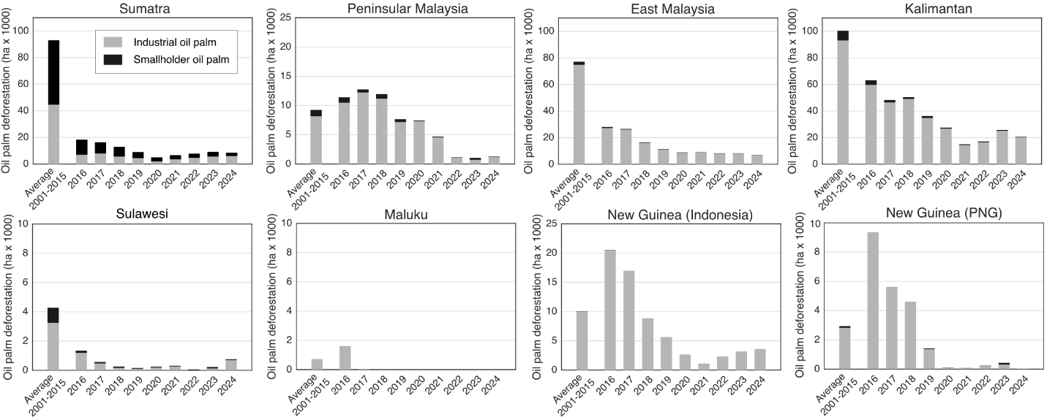
Extended Data Figure 1. Annual old-growth evergreen forest conversion to oil palm by producer type and region. Bars show industrial-scale conversion (grey) and smallholder-driven conversion (black) for the top eight regions in Indonesia, Malaysia, and Papua New Guinea. The first bar in each panel represents the mean annual forest conversion for 2001-2015, followed by yearly mapped areas for 2016-2024.

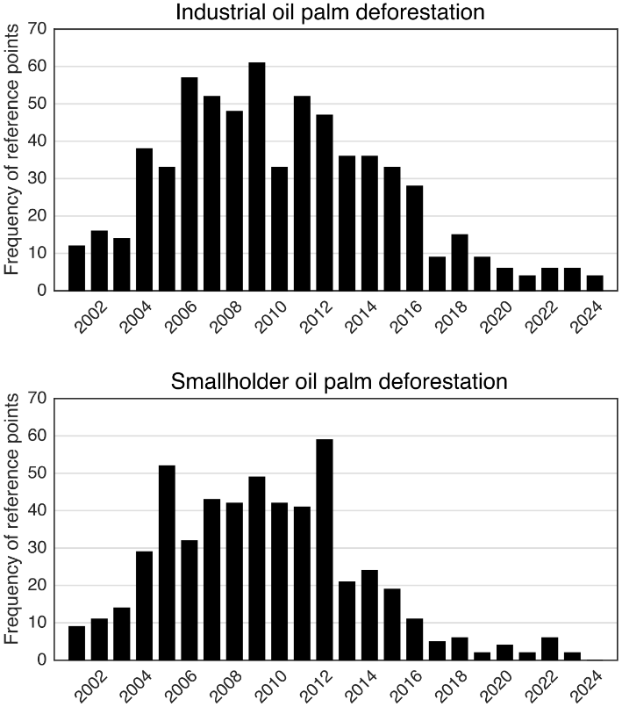
Extended Data Figure 2. Temporal distribution of old-growth forest loss in the validation dataset. The trend in forest loss is based on the reference data obtained by visual interpretation of the validation points. Each bar shows the frequency of reference points assigned to a given year of forest loss.

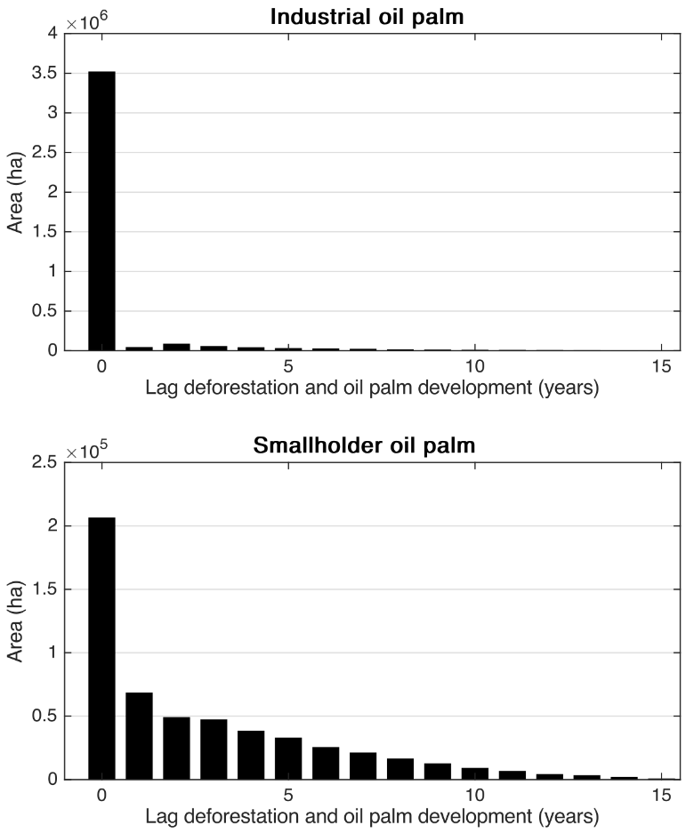
Extended Data Figure 3. Lag between old-growth forest loss and oil palm establishment. Distribution of the time lag (years) between old-growth forest loss and oil palm development for industrial (top) and smallholder (bottom) plantations in Indonesia and Malaysia. Lag is defined as the difference between the year of forest loss and the year of oil palm establishment from 2000 based on published year-of-conversion datasets^{17,29}.
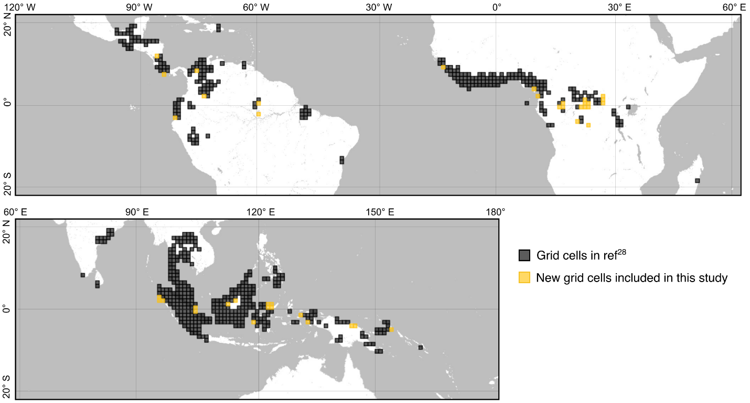
Extended Data Figure 4. Grid cells of 100×100 km covering the 2024 oil palm layer. Grid cells in black show the regions where oil palm was detected for the 2021 oil palm extent²⁹. The 41 grid cells in orange represent regions where oil palm was detected for the first time in this study.

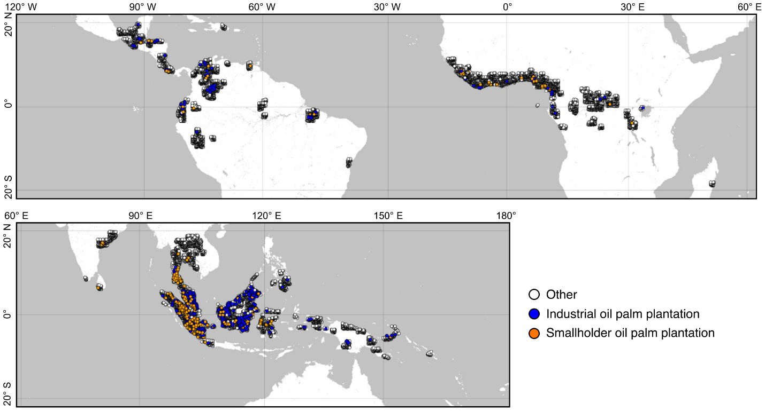
Extended Data Figure 5. Distribution of the 22,832 reference points used to validate the global oil palm map. Points represent visually interpreted reference samples across the tropics for three classes: industrial oil palm plantations (blue), smallholder oil palm plantations (orange), and other land cover (white).

Extended Data Table 1. Mapped area (ha) of oil palm by prior land cover (non-old-growth forest and old-growth forest), plantation type (industrial and smallholder), and period of forest loss (2001–2015 and 2016–2024). Areas are reported at global and continental scales and for the 30 countries with the highest oil palm deforestation.
Country | Non-forest to industrial | Non-forest to industrial 2016-2024 | Non-forest to smallholder | Non-forest to smallholder 2016-2024 | Forest to industrial 2001-2015 | Forest to industrial 2016-2024 | Forest to smallholder 2001-2015 | Forest to smallholder 2016-2024
World | 14,287,351 | 1,189,696 | 6,741,424 | 2,549,052 | 3,732,041 | 636,918 | 953,019 | 82,532
America | 1,224,078 | 126,162 | 313,912 | 138,188 | 86,401 | 4,109 | 15,732 | 2,307
Africa | 468,291 | 103,464 | 225,137 | 582,477 | 57,825 | 23,509 | 23,833 | 11,639
Asia and Pacific | 12,594,982 | 960,069 | 6,202,375 | 1,828,386 | 3,587,814 | 609,300 | 913,454 | 68,586
Indonesia | 7,769,478 | 730,801 | 4,407,932 | 1,125,212 | 2,249,619 | 406,922 | 854,955 | 59,858
Malaysia | 4,552,464 | 199,103 | 1,034,779 | 304,858 | 1,264,070 | 176,919 | 51,790 | 7,204
Papua New Guinea | 93,358 | 21,303 | 41,613 | 9,898 | 42,296 | 21,622 | 1,791 | 240
Peru | 29,685 | 3,342 | 14,366 | 6,565 | 33,277 | 2,676 | 7,543 | 956
Brazil | 188,069 | 8,900 | 15,104 | 10,399 | 28,038 | 316 | 3,166 | 733
Cameroon | 66,524 | 3,310 | 20,173 | 22,199 | 15,806 | 6,367 | 7,214 | 2,943
Gabon | 12,503 | 28,634 | 281 | 199 | 19,222 | 7,849 | 357 | 199
Myanmar | 31,823 | 1,549 | 3,053 | 1,296 | 23,808 | 1,716 | 1,289 | 715
Guatemala | 145,190 | 15,520 | 4,473 | 3,804 | 18,745 | 612 | 461 | 87
Dem Rep of the Congo | 66,323 | 9,695 | 23,698 | 10,982 | 4,260 | 1,741 | 11,010 | 3,916
Nigeria | 96,751 | 49,152 | 17,007 | 208,846 | 9,406 | 5,402 | 1,064 | 1,991
Cambodia | 11,988 | 401 | 72 | 4,382 | 6,086 | 1,181 | 406 | 229
Liberia | 34,518 | 4,763 | 6,459 | 4,402 | 4,426 | 1,834 | 741 | 297
Mexico | 35,778 | 17,948 | 40,568 | 19,647 | 2,697 | 226 | 1,175 | 118
Ecuador | 95,562 | 7,244 | 96,861 | 40,092 | 2,380 | 97 | 1,366 | 187
Cote d'Ivoire | 101,158 | 3,847 | 104,786 | 173,027 | 841 | 209 | 2,428 | 1,050
Thailand | 91,118 | 3,361 | 636,780 | 290,487 | 240 | 6 | 2,835 | 298
Philippines | 25,179 | 2,403 | 47,745 | 25,654 | 1,658 | 695 | 313 | 18
Colombia | 484,708 | 49,812 | 47,742 | 34,700 | 960 | 161 | 826 | 162
Uganda | 5,396 | 76 | 735 | 94 | 1,702 | 7 | 187 | 6
Ghana | 33,891 | 563 | 16,075 | 50,086 | 1,477 | 82 | 199 | 524
Honduras | 115,462 | 6,244 | 55,669 | 12,459 | 242 | 6 | 600 | 43
Rep of the Congo | 3,673 | 262 | 217 | 78 | 642 | 11 | 98 | 44
Costa Rica | 43,177 | 1,628 | 22,930 | 3,873 | 50 | 2 | 503 | 14
Laos | 0 | 0 | 118 | 2,464 | 0 | 0 | 210 | 509
Sierra Leone | 20,111 | 1,192 | 29,291 | 27,040 | 0 | 1 | 208 | 90
Guinea | 5,372 | 120 | 3,725 | 6,749 | 41 | 0 | 37 | 24
India | 3,620 | 10 | 24,474 | 48,346 | 26 | 0 | 49 | 18
Central African Rep | 2,287 | 1,521 | 47 | 250 | 1 | 5 | 68 | 16
Venezuela | 42,013 | 1,923 | 8,763 | 4,555 | 2 | 0 | 52 | 2

Extended Data Table 2. Accuracy assessment of old-growth forest replaced by oil palm. Accuracy metrics for the land-cover change map depicting conversion of old-growth forest and non-forest to industrial and smallholder oil palm for the periods 2001–2015 and 2016–2024. Metrics include user accuracy (UA) and producer accuracy (PA), each reported with 95% confidence intervals. Area mapped and area estimates (with 95% confidence intervals) are also provided for each class.
 | UA | PA | Mapped area (Mha) | Estimated area (Mha)
Other | 99.7 (99.6, 99.8) | 99.5 (99.4, 99.6) | 419.60 | 420.24 (419.70, 420.78)
Forest^{ǂ} cleared, not replaced by oil palm (2001-2024) | 96.0 (95.2, 96.7) | 97.8 (97.4, 98.3) | 17.25 | 16.91 (16.76, 17.07)
Non-Forest replaced by  industrial oil palm* | 94.6 (92.8, 96.4) | 93.3 (91.5, 95.1) | 15.48 | 15.69 (15.28, 16.10)
Forest replaced by industrial oil palm (2001-2015) | 90.2 (87.7, 92.6) | 90.9 (87.4, 94.4) | 3.73 | 3.70 (3.53, 3.87)
Forest replaced by industrial oil palm (2016-2024) | 82.4 (74.6, 90.3) | 88.2 (82.1, 94.2) | 0.64 | 0.60 (0.53, 0.66)
Non-Forest replaced by smallholder oil palm* | 75.3 (70.7, 79.8) | 84.2 (80.6, 87.8) | 9.29 | 8.31 (7.76, 8.85)
Forest replaced by smallholder oil palm (2001-2015) | 80.4 (77.0, 83.9) | 53.4 (46.8, 59.9) | 0.95 | 1.44 (1.26, 1.61)
Forest replaced by smallholder oil palm (2016-2024) | 73.7 (59.5, 87.9) | 49.0 (32.8, 65.2) | 0.08 | 0.12 (0.08, 0.16)
ǂForest refers to old growth intact forests or old-growth evergreen forests that have been selectively logged in the 1970s through 1990s.
*Plantations that already existed in 2000 or were established in non-forest in 2001-2024. Non-Forest refers to areas not classified as old-growth evergreen forest. This class includes cleared lands, areas devoid of trees (such as grasslands), as well as non-old growth forest types, such as young forest regrowth and agroforests.

