One-pot Synthesis Quinazoline Derivatives Using Copper Nano Catalyst Stabilized on Graphene Oxide Functionalized by N¹,N²-bis((pyridine-2-yl)methyl)benzene-1,2-diamine

Alahyar Emami-Nori, Zahra Karamshahi, Ramin Ghorbani-Vaghei*
Department of Organic Chemistry, Faculty of Chemistry, Bu-Ali Sina University, PO Box 65174, Hamadan, Iran
*Corresponding author; E-mail: rgvaghei@yahoo.com & ghorbani@basu.ac.ir

Table of Contents | Page number
S1. Characterization data for C₁ | 2
S2. Characterization data for C₂ | 5
S3. Characterization data for C₃ | 8
S4. Characterization data for C₄ | 11
S5. Characterization data for C₅ | 14

S1. Characterization data for 6-Chloro-2-(4-(dimethylamino)phenyl)-4-phenylquinazoline (C1) (Table 7, entry 5):

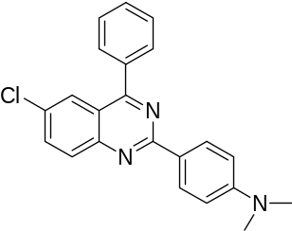

Yellow solid, mp: 159-161 ºC. IR (KBr, ν_{max}, cm⁻¹): 1162, 1184, 1364, 1389, 1418, 1528, 1559, 1601. ¹H NMR (400 MHz, CDCl₃): δ_{H} (ppm) 3.092 (s, CH₃, 6H), 6.81-8.59 (m, Ar-H, 12H). ¹³C NMR (100 MHz, CDCl₃): δ_{C} (ppm) 40.2 (2CH₃), 111.6, 121.6, 125.4, 125.7 (C-Ar), 128.6, 129.9, 130.03, 130.06, 131.4, 134.1, 137.4, 150.7, 152.2, 160.9, 167.1. MS: m/z 359.2. Anal. Calcd. for C₂₂H₁₈ClN₃: C, 77.74; H, 5.04; N, 11.68. Found: C, 77.00; H, 4.68; N, 11.33.

Fig. S1 The FT-IR spectrum of product (C₁)

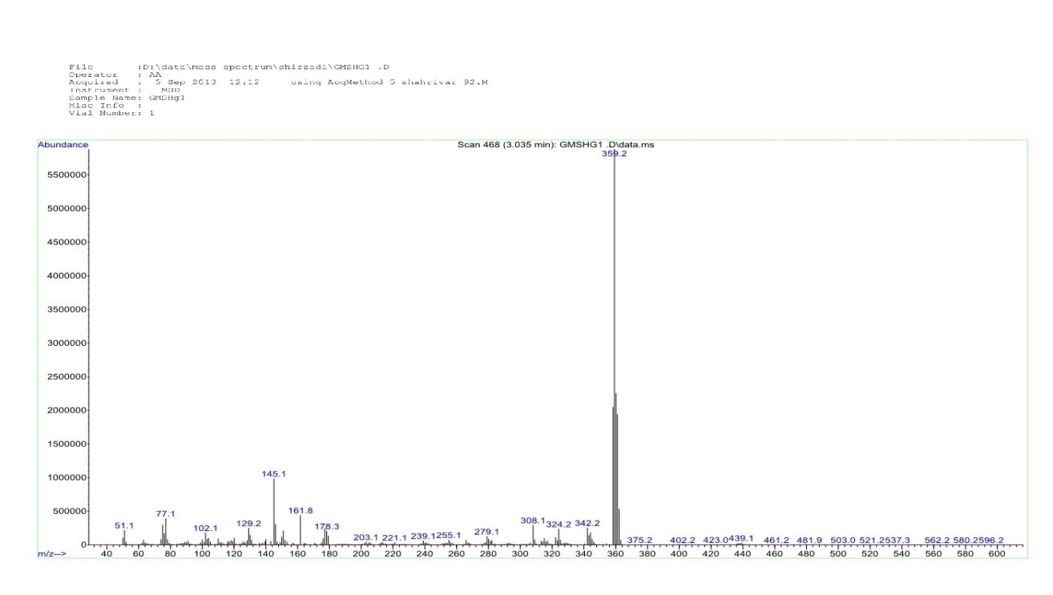

Fig. S2 The mass spectrum of product (C₁)

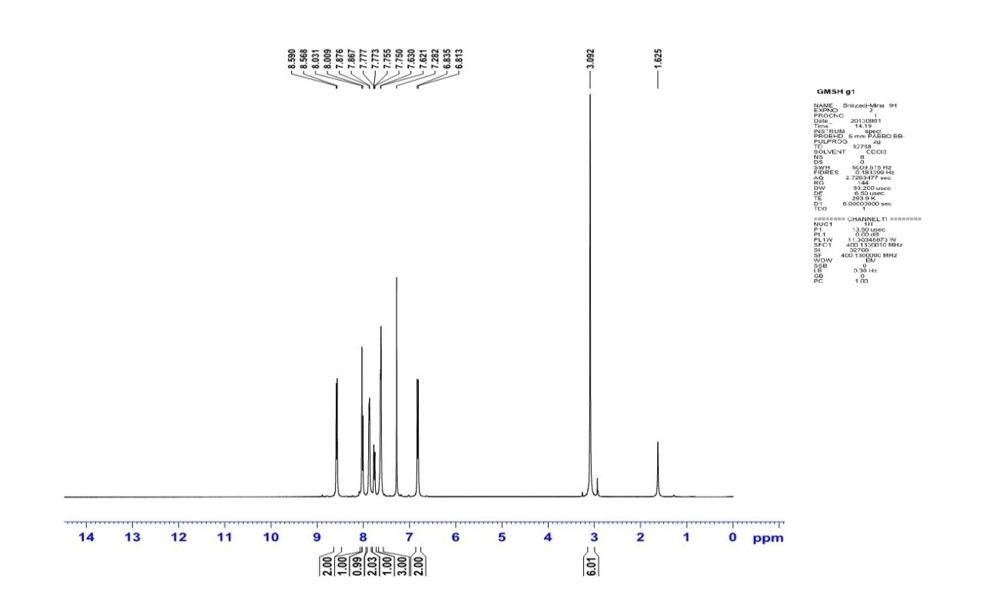

Fig. S3 The ¹H NMR (400 MHz) spectrum of product (C₁)

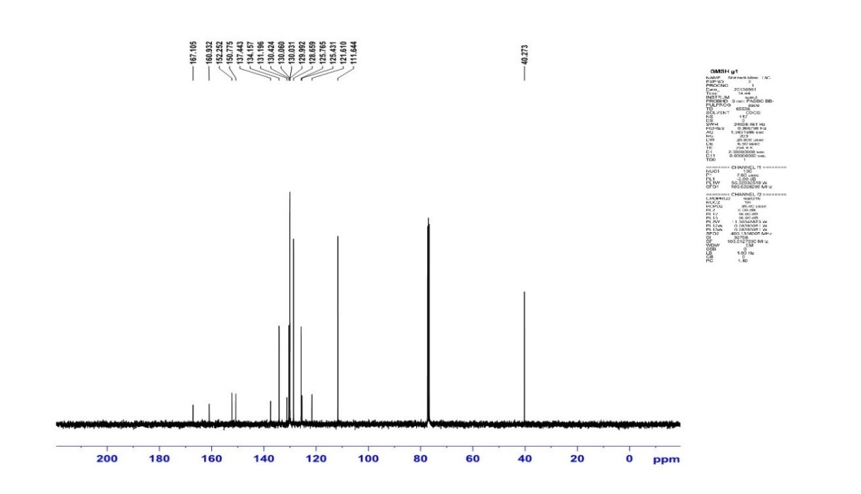

Fig. S4 The ¹³C NMR (100 MHz) spectrum of product (C₁)

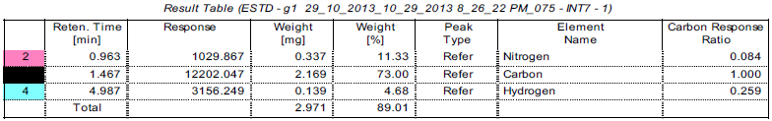

Fig. S5 The CHNS analysis of product (C₁)

S2. Characterization data for 6-Chloro-2-(3-methoxyphenol)-4-phenylquinazoline (C2) (Table 7, entry 6):

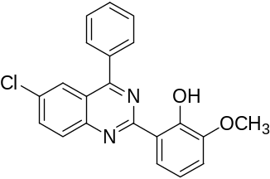

Yellow solid, mp: 249-250 ºC. IR (KBr, ν_{max}, cm⁻¹): 800, 1381, 1479, 1534, 1558. ¹H NMR (400 MHz, CDCl₃): δ_{H} (ppm) 3.9 (s, CH₃, 3H), 6.9-8.3 (m, Ar-H, 11H), 14.04 (s, OH, 1H). ¹³C NMR (100 MHz, CDCl₃): δ_{C} (ppm) 56.1 (OCH₃), 114.5, 118.2, 119.1, 121.3 (C-Ar), 121.6, 126.1, 128.9, 129.4, 130.0, 130.7, 133.0, 135.3, 136.2, 148.2, 148.9, 151.2, 161.1, 167.4. MS: m/z 362. Anal. Calcd. for C₂₁H₁₅ClN₂O₂: C, 69.52; H, 4.17; N, 7.72. Found: C, 69.09; H, 4.01; N, 7.69.

Fig. S6 The FT-IR spectrum of product (C₂)

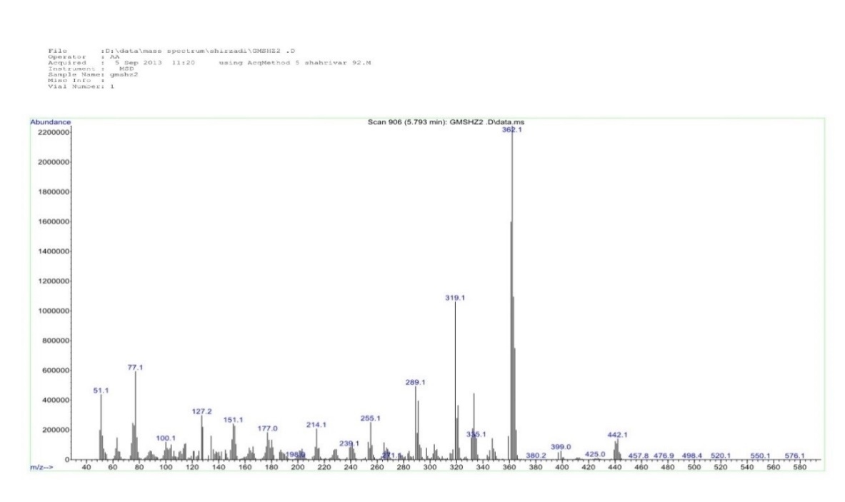

Fig. S5 The mass spectrum of product (C₂)

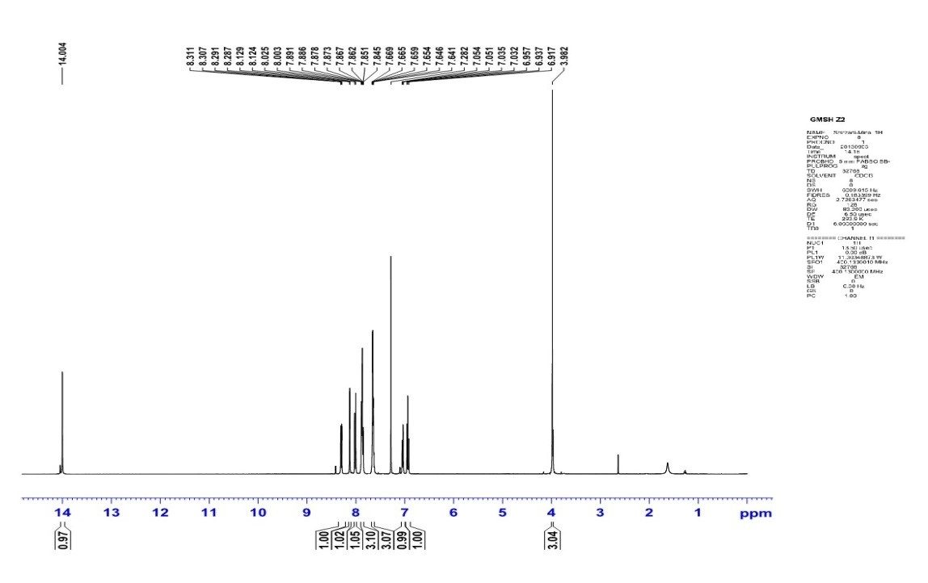

Fig. S9 The ¹H NMR (400 MHz) spectrum of product (C₂)

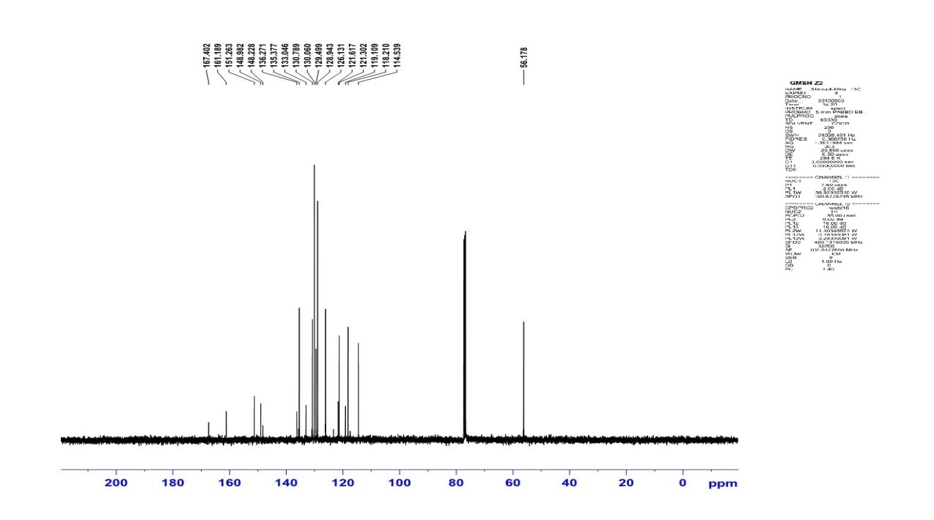

Fig. S10 The ¹³C NMR (100 MHz) spectrum of product (C₂)

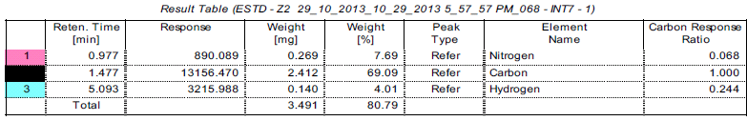
Fig. S11 The CHNS analysis of product (C₂)

S3. Characterization data 6-Chloro-4-phenyl-2-(3-bromophenyl)quinazoline (C3) (Table 7, entry 7):

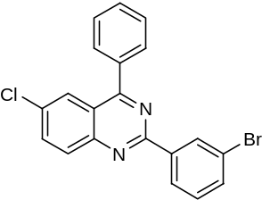

White solid, mp: 190-191 ºC. IR (KBr, ν_{max}, cm⁻¹): 800, 1382, 1480, 1534, 1557. ¹H NMR (400 MHz, CDCl₃): δ_{H} (ppm) 7.3-8.8 (m, Ar-H, 12H). ¹³C NMR (100 MHz, CDCl₃): δ_{C} (ppm) 122.3 (C-Ar), 122.9, 125.8, 127.2, 128.8, 130.0, 130.1, 130.3, 130.9, 131.6, 133.0, 133.6, 134.7, 136.8, 139.8, 150.3, 158.9, 167.7. MS: m/z 395. Anal. Calcd. for C₂₀H₁₂BrClN₂: C, 60.71; H, 3.06; N, 7.08. Found: C, 60.44; H, 2.89; N, 6.66.

Fig. S12 The FT-IR spectrum of product (C₃)

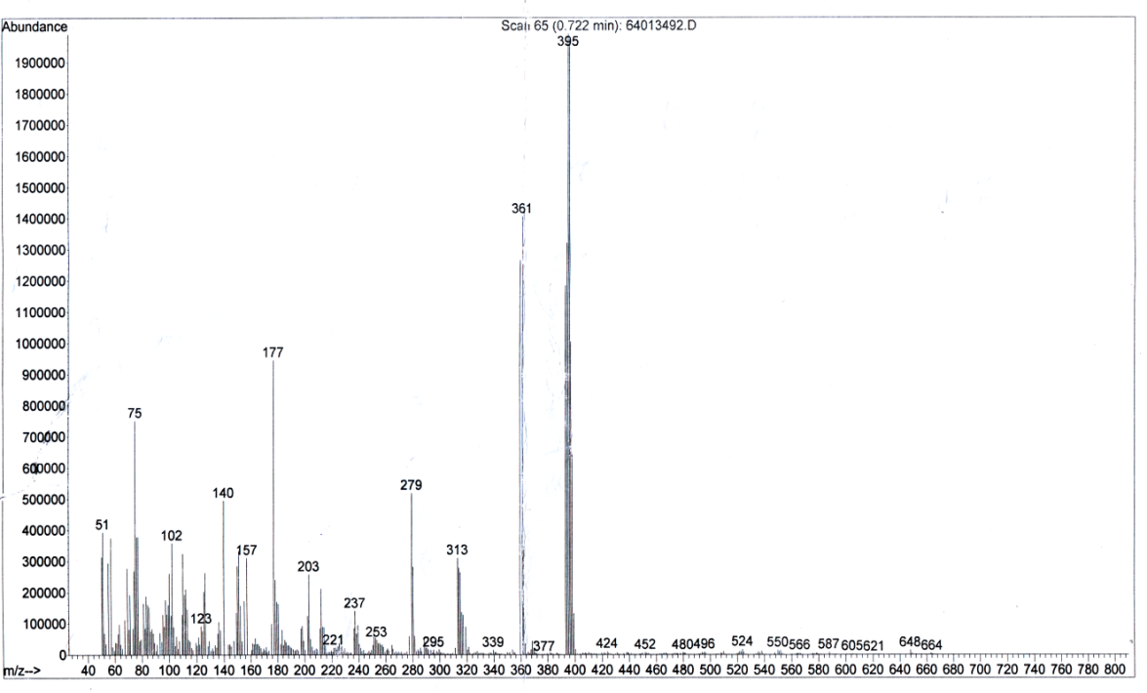

Fig. S13 The mass spectrum of product (C₃)

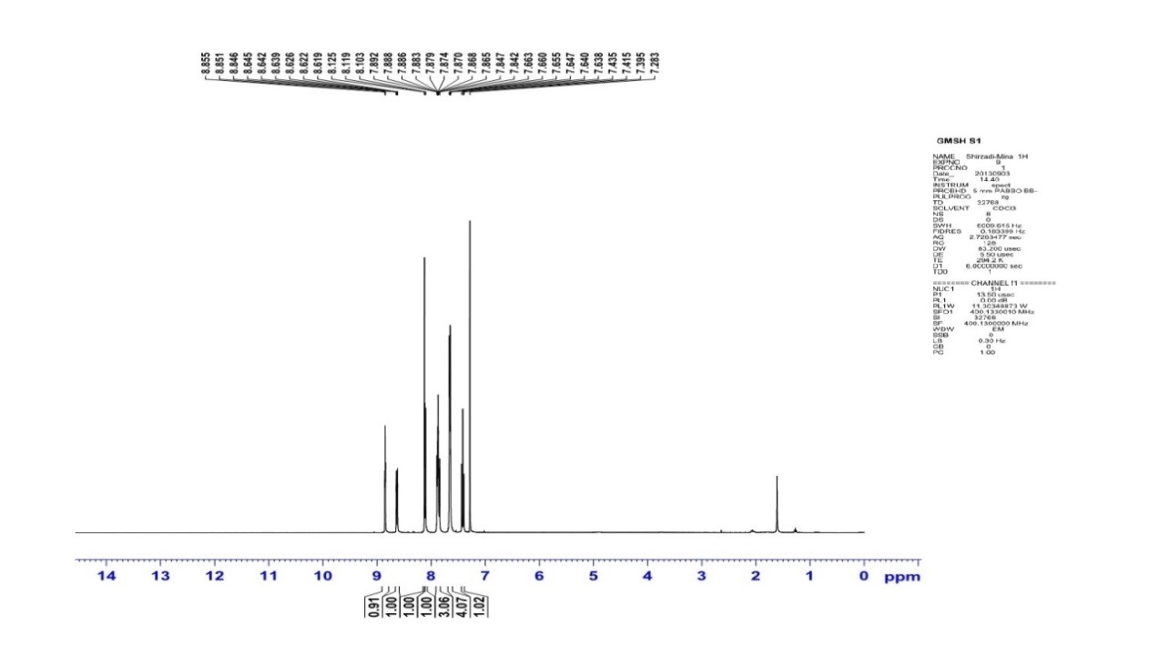

Fig. S14 The ¹H NMR (400 MHz) spectrum of product (C₃)

Fig. S15 The ¹³C NMR (100 MHz) spectrum of product (C₃)

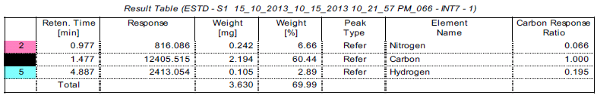
Fig. S16 The CHNS analysis of product (C₃)

S4. Characterization data 6-Chloro-4-phenyl-2-(3,4,5-trimethoxyphenyl)quinazoline (C4) (Table 7, entry 9):

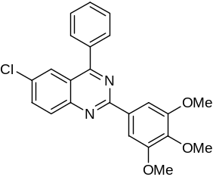

Pale yellow solid, mp: 164-165 ºC. IR (KBr, ν_{max}, cm⁻¹): 1123, 1386, 1413, 1506, 1536, 1555, 1590. ¹H NMR (400 MHz, CDCl₃): δ_{H} (ppm) 3.96-4.03 (m, 3OCH₃, 9H), 7.28-8.10 (m, Ar-H, 10H). ¹³C NMR (100 MHz, CDCl₃): δ_{C} (ppm) 40.9 (OCH₃), 56.2 (OCH₃), 60.9 (OCH₃), 105.8, 122.0 (C-Ar), 125.8, 128.7, 130.0, 130.2, 130.7, 132.4, 133.2, 134.5, 137.0, 140.5, 150.4, 153.3, 159.9, 167.4. MS: m/z 406.2. Anal. Calcd. for C₂₃H₁₉ClN₂O₃: C, 67.9; H, 4.71; N, 6.89. Found: C, 67.16; H, 4.53; N, 6.69.

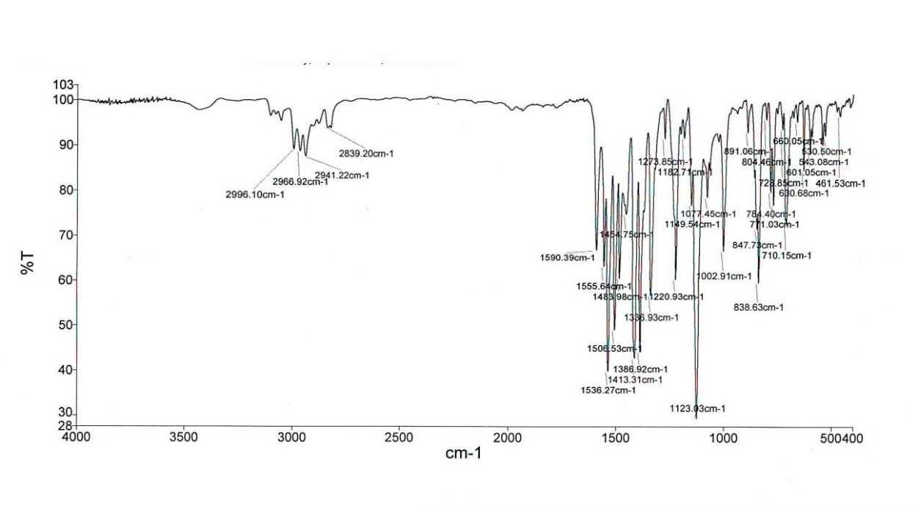

Fig. S17 The FT-IR spectrum of product (C₄)

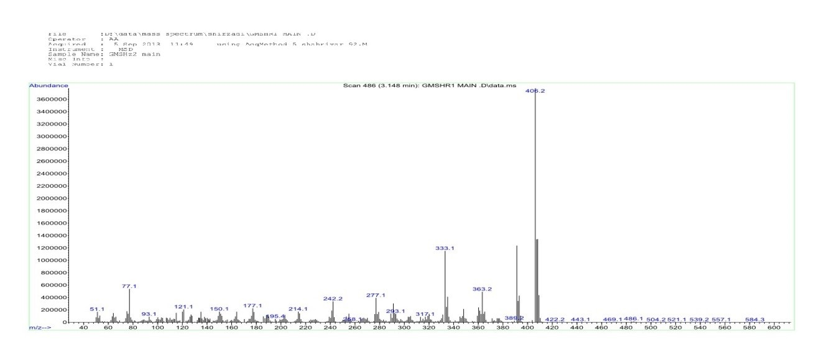
Fig. S18 The mass spectrum of product (C₄)

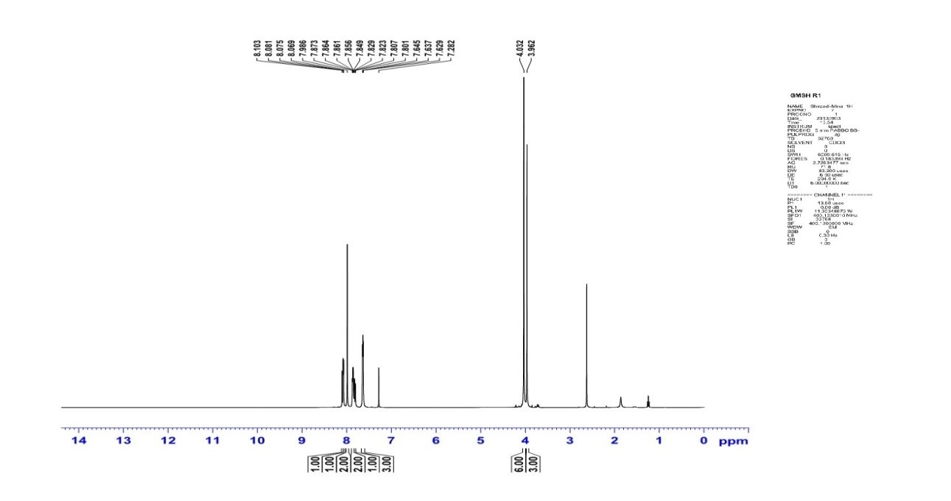

Fig. S19 The ¹H NMR (400 MHz) spectrum of product (C₄)

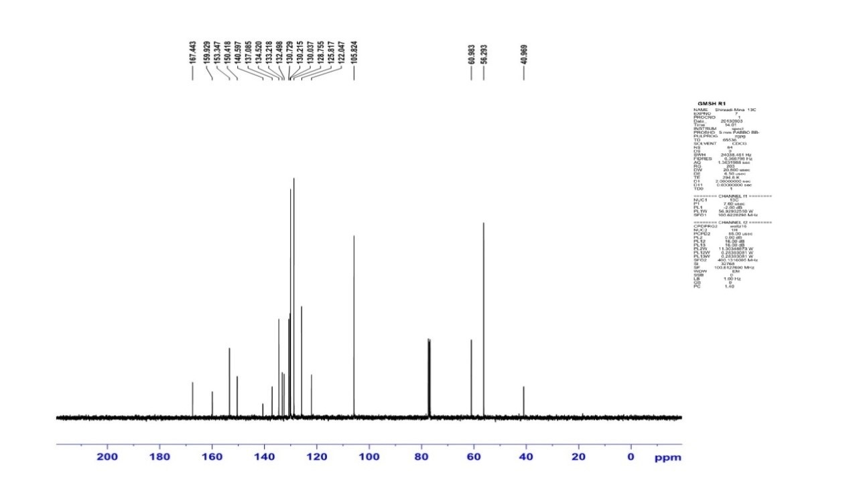

Fig. S20 The ¹³C NMR (100 MHz) spectrum of product (C₄)
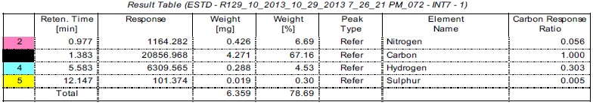
Fig. S20 The CHNS analysis of product (C₄)

S5. Characterization data for 6-chloro-4-phenyl-2-(thiophen-2-yl)quinazoline (c5) (Table 7, entry 10):

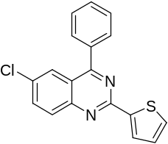

White solid, mp: 219-220 ºC. IR (KBr, ν_{max}, cm⁻¹): 703, 844, 1384, 1436, 1477, 1540. ¹H NMR (400 MHz, CDCl₃): δ_{H} (ppm) 7.19-8.21(m, Ar-H, 11H). ¹³C NMR (100 MHz, CDCl₃): δ_{C} (ppm) 122.0, 125.9, 128.3, 128.7, 129.6, 130.0, 130.2, 130.3, 130.4, 132.3, 134.6, 136.7, 143.7, 150.3, 157.4, 167.6. MS: m/z 322.

Fig. S21 The FT-IR spectrum of product (C₅)

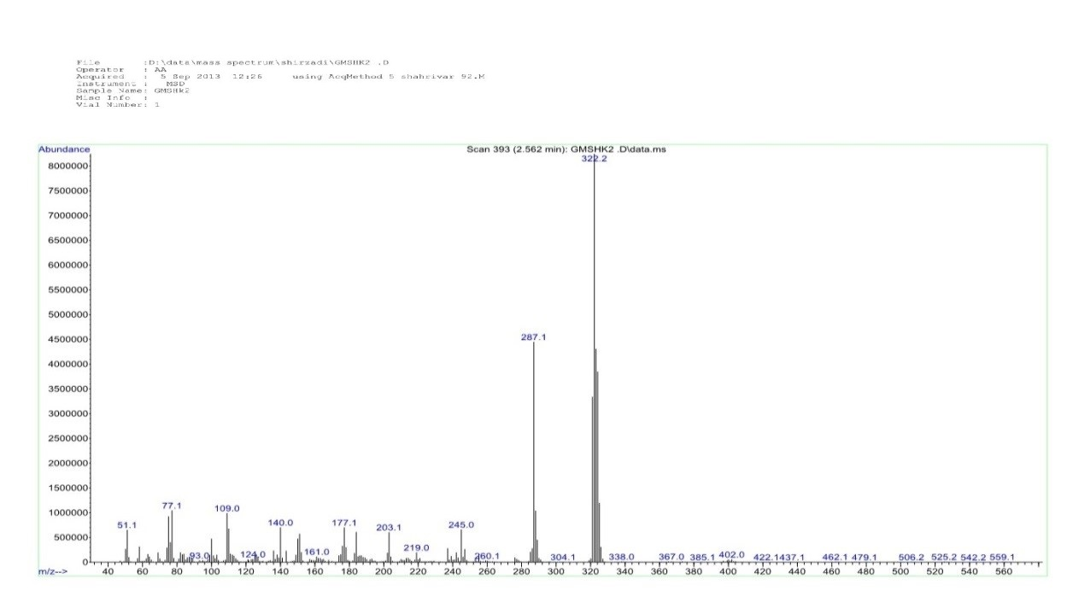

Fig. S22 The mass spectrum of product (C₅)

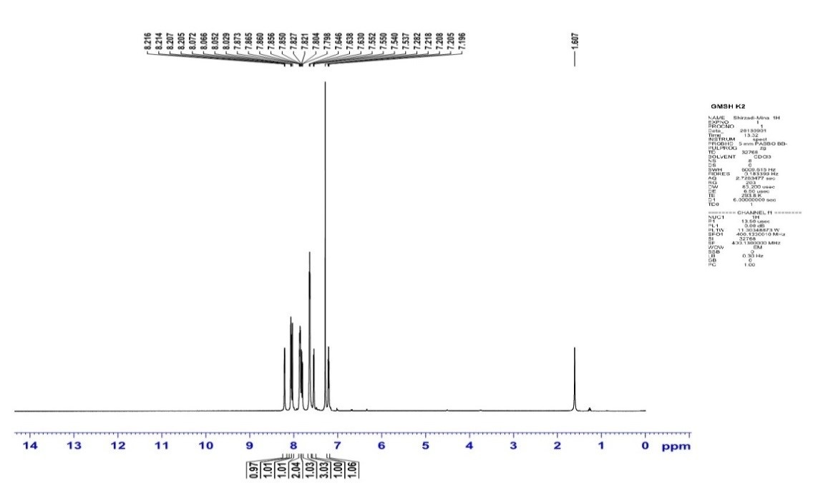

Fig. S23 The ¹H NMR (400 MHz) spectrum of product (C₅)

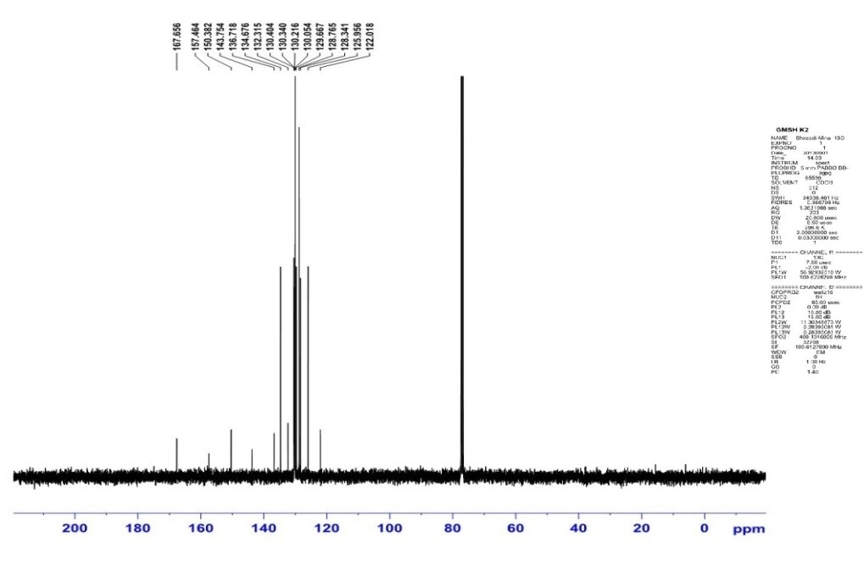

Fig. S24 The ¹³C NMR (100 MHz) spectrum of product (C₅)

