Supplementary materials
Nanoceria-to-Curcumin Molar Ratio as a Critical Engineering Parameter for Biocompatible Redox-Active Nanoconjugates
Nikita N. Chukavin^{a, *}, Viktoriia A. Anikina^{b}, Darya A. Vinnik^{c}, Nikita A. Pivovarov^{d}, Boris A. Bokl^{e}, Anton L. Popov^{f}
Institute of Theoretical and Experimental Biophysics of the Russian Academy of Sciences, Pushchino, Russia
*Corresponding author: Nikita N. Chukavin (chukavinnik@gmail.com)
ORCID: ª0000-0001-8431-4485, ^{b}0000-0002-5028-2064, ^{c}0009-0004-8978-6923, ^{d}0009-0005-1997-0845, ^{e}0009-0002-4046-8890, ^{f}0000-0003-2643-4846
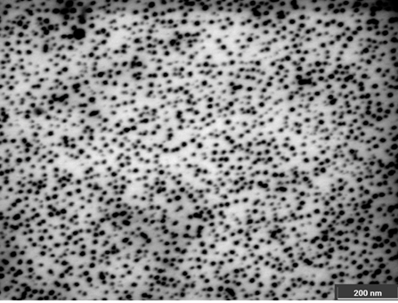
Fig. S1 SEM image of the nanoceria-curcumin. Scale bar is equal to 200 nm

