Supporting Information
Unveiling the Activity Descriptors for Metal Nanoclusters-N₄C as Electrocatalysts through Machine Learning and Experimental Validation
Arupjyoti Pathak^{1,2}, Srijib Das^{3,4}, Mukaddar Sk^{1,2}, Tapas Kuila^{3,4}, Om Jadhav⁵, Samrit Kumar Maity⁵, Aniruddha Kundu⁶* and Ranjit Thapa^{1,2}*
¹ Department of Physics, SRM University - AP, Amaravati 522240, Andhra Pradesh, India
²Asian Consortium on Computational Materials Science - Global Research Centre, SRM University - AP, Amaravati 522240, Andhra Pradesh, India
³ Electric Mobility & Tribology Research Group, CSIR- Central Mechanical Engineering Research Institute, Durgapur 713209, India
⁴ Academy of Scientific and Innovative Research (AcSIR), Ghaziabad, 201002, India
⁵ Centre for Development of Advanced Computing (C-DAC), Pune 411008, Maharashtra, India
⁶ Centre for Interdisciplinary Research, SRM University - AP, Amaravati 522240, Andhra Pradesh, India
*Corresponding Authors: ranjit.phy@gmail.com; write2aknow@gmail.com
Arupjyoti Pathak and Srijib Das contributed equally to this work.
Contents:
- Section S1: Calculation of adsorption free energies of molecules/intermediates
- Section S2: Figures and tables
- Section S3: Linear correlation between electronic parameters and the ΔG_{OOH}
- Section S4: Machine learning algorithms basics understanding with their overview.
- Section S5: Machine learning code used for analysis.
- Section S6: Experimental characterisation details and plots.
- References

Section S1: Calculation of adsorption free energies of molecules/intermediates
The adsorption free energies of molecules and intermediates were calculated as follows:
In alkaline conditions, the Oxygen Evolution Reaction (OER) proceeds as follows¹:
$4{OH}^{- }⟶ O_{2 }$ $+ {2H}_{2}$O$\left(l\right)$+ ${4e}^{-}$
The pathway is as follows,
$4{OH}^{- }$+ * …G (1)
${OH}^{*}+ 3{OH}^{- }+$ $e^{-}$ …G (2)
$O^{*}{+ H}_{2}$O$\left(l\right) + 2{OH}^{- }+$ ${2e}^{-}$ …G (3)
${OOH}^{*}{+ H}_{2}$O$\left(l\right) + {OH}^{- }+$ ${3e}^{-}$ …G (4)
$O_{2 }$ $+ {2H}_{2}$O$\left(l\right)$+ ${4e}^{-}$ + * …G (5)
Where * represents the free surface and H₂O(l) denotes liquid water. The Gibbs free energy of an intermediate is determined using the equation G=E+ZPE-TS-neU, where E denotes the DFT energy, ZPE stands for the zero-point energy, TS represents the entropy term, n is the number of electrons transferred, and U is the applied potential at the electrode². For adsorbed intermediates, the contributions of ZPE and TS are minimal and can be disregarded. The equilibrium potential U₀ is 0.40 V versus SHE in an alkaline environment with a pH of 14. The elementary reaction steps for the OER and ORR, which are used to plot the free energy profile, are as follows:
G (1) – G (1) …(1)
G (2) – G (1) …(2)
G (3) – G (1) …(3)
G (4) – G (1) …(4)
G (5) – G (1) …(5)
We employed the following free energy relations for ions and molecules to determine the total free energy of the overall reaction, fixing it at 4.92 eV:
$G_{H_{2}O(l)}=G_{H_{2}O(g)}+RT\ln\left(\frac{p}{p_{0}}\right)$ …(E1)
$G_{O_{2(g)}}=2G_{H_{2}O(l)}-2G_{H_{2}}+4.92$ …(E2)
$G_{{OH}^{-}}=G_{H_{2}O(l)}-G_{H^{+}}$ …(E3)
$G_{H^{+}}=\frac{1}{2}G_{H_{2}}- k_{B}$T ln 10 $×$ pH …(E4)
Where, R is the gas constant, T=298.15K, p=0.035 bar, and p₀= 1 bar, K_{B} = 8.6173332 × 10⁻⁵ eV, pH=14. The DFT energies, entropy terms, and zero-point energies for free molecules are provided in the table below.
Molecules | TS | ZPE | G | E(DFT)
O₂ | 0.64 | 0.242 | -9.83864
H₂O | 0.67 | 0.592 | -14.3001 | -14.2221
OH | 0.41 | 0.271 | -10.0115
H₂ | 0.41 | 0.26 | -6.92078 | -6.77078
O | 0.32 | 0.121 | -4.91932
H⁺ | 0.205 | 0.13 | -4.28862

Table S1: The DFT energies (E), entropy terms (TS), and standard zero-point energy (ZPE) values for the free molecules. From the DFT energy (E) of H₂O and H₂ we have calculated for the rest of them using the formulas E1, E2, E3, E4.

Section S2: Figures and tables
Table S2: Ni-N average Bond length comparison of each system with the average ionic radii of Ni+N
Systems | Ni-N Bond Lengths (Å) | Average ionic radii of Ni+N
Ni₅@N₄C | 1.881 | 2.15 Å
Ni₇@N₄C | 2.037 | 2.15 Å
Ni₉@N₄C | 1.978 | 2.15 Å
Ni₁₁@N₄C | 1.942 | 2.15 Å
Ni₁₃@N₄C | 1.822 | 2.15 Å
Ni₁₅@N₄C | 1.822 | 2.15 Å
Ni₁₇@N₄C | 1.796 | 2.15 Å
Ni₁₉@N₄C | 1.914 | 2.15 Å
Ni₂₁@N₄C | 1.942 | 2.15 Å
Ni₂₃@N₄C | 1.971 | 2.15 Å
Ni₂₅@N₄C | 1.786 | 2.15 Å
Ni₂₇@N₄C | 2.042 | 2.15 Å
Ni₂₉@N₄C | 2.005 | 2.15 Å
Ni₃₁@N₄C | 1.837 | 2.15 Å
Ni₃₃@N₄C | 1.829 | 2.15 Å
Ni₃₅@N₄C | 1.83 | 2.15 Å
Ni₃₇@N₄C | 1.862 | 2.15 Å
Ni₃₈@N₄C | 1.922 | 2.15 Å

Table S3: Bader charge values of site 3Ni on Ni₁₉@N₄C, before and after adsorption for different intermediate states.
Intermediates  On Site | Before adsorption | After adsorption | Charge transferred
OH* | 9.8097 e | 9.5227 e | 0.287 e
O* | 9.8097 e | 9.4907 e | 0.319 e
OOH* | 9.8097 e | 9.4687 e | 0.341 e
Table S4: Bader charge values of site 3-Co on Co₃₁@N₄C, before and after adsorption for different intermediate states.
Intermediates  On Site | Before adsorption | After adsorption | Charge transferred
OH* | 9.0260 e | 8.7320 e | 0.294 e
O* | 9.0260 e | 8.636 e | 0.390 e
OOH* | 9.0260 e | 8.647 e | 0.379 e

Table S5: Bader charge values of site 1-Fe on Fe₂₉@N₄C, before and after adsorption for different intermediate states.
Intermediates  On Site | Before adsorption | After adsorption | Charge transferred
OH* | 7.9752 e | 7.6982 e | 0.277 e
O* | 7.9752 e | 7.6742 e | 0.301 e
OOH* | 7.9752 e | 7.6612 e | 0.314 e

Table S6: Bader charge values transferred to Ni₁₉ nanocluster from the N₄C during system formation.
Total bader charge on N₄C before bonding with Ni₁₉ | Total bader charge on N₄C after bonding with Ni₁₉ | Charge transferred
571.5463 e | 569.9999 e | 1.5464 e

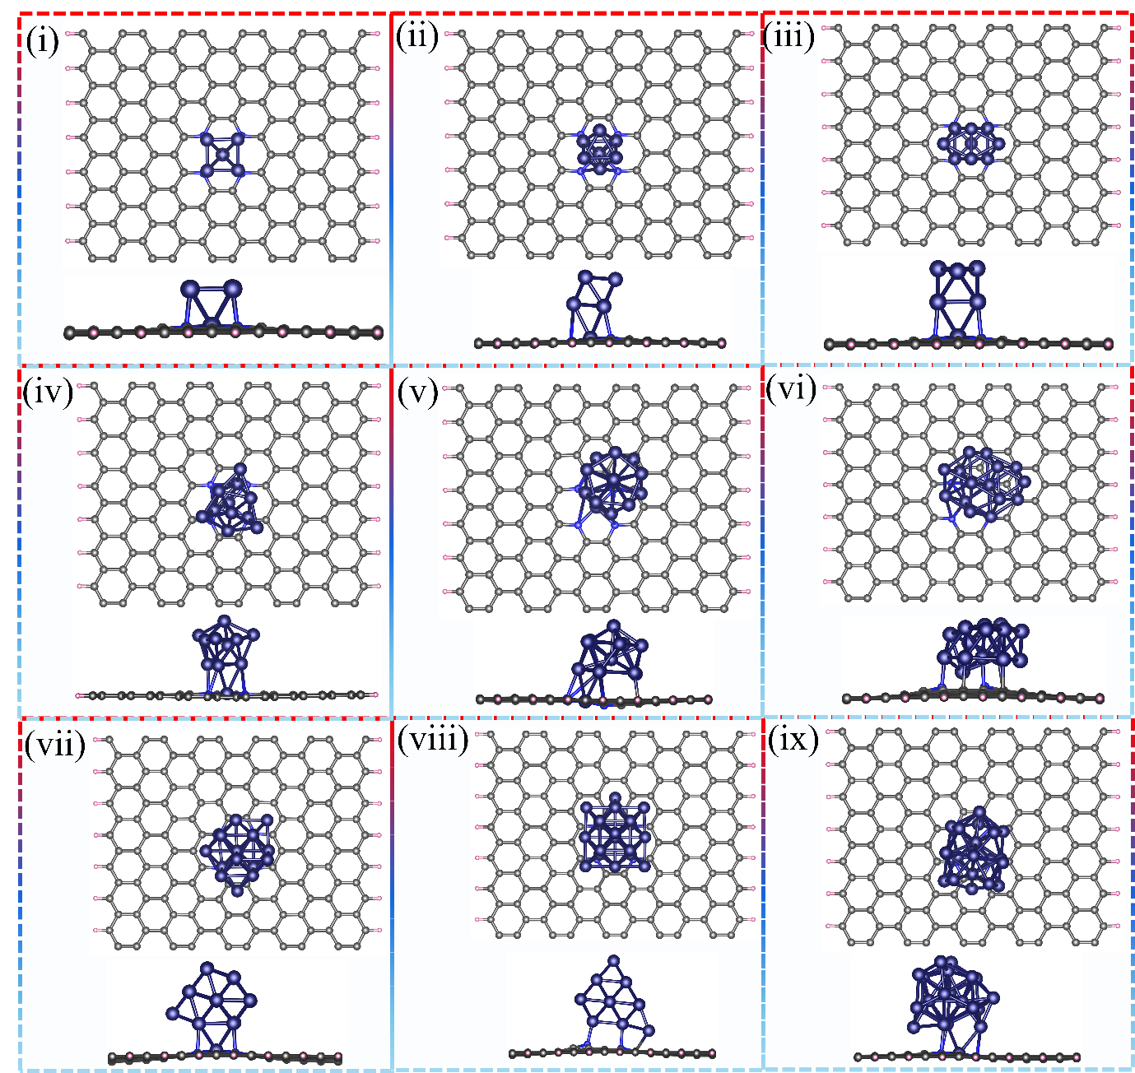
Figure S1(a): Optimised structure of catalysts (Top view and side view) (i) Co₅NC@NGC, (ii) Co₇@N₄C (iii) Co₉@N₄C, (iv) Co₁₁@N₄C, (v) Co₁₃@N₄C, (vi) Co₁₅@N₄C, (vii) Co₁₇@N₄C, (viii) Co₁₉@N₄C, (ix) Co₂₁@N₄C.
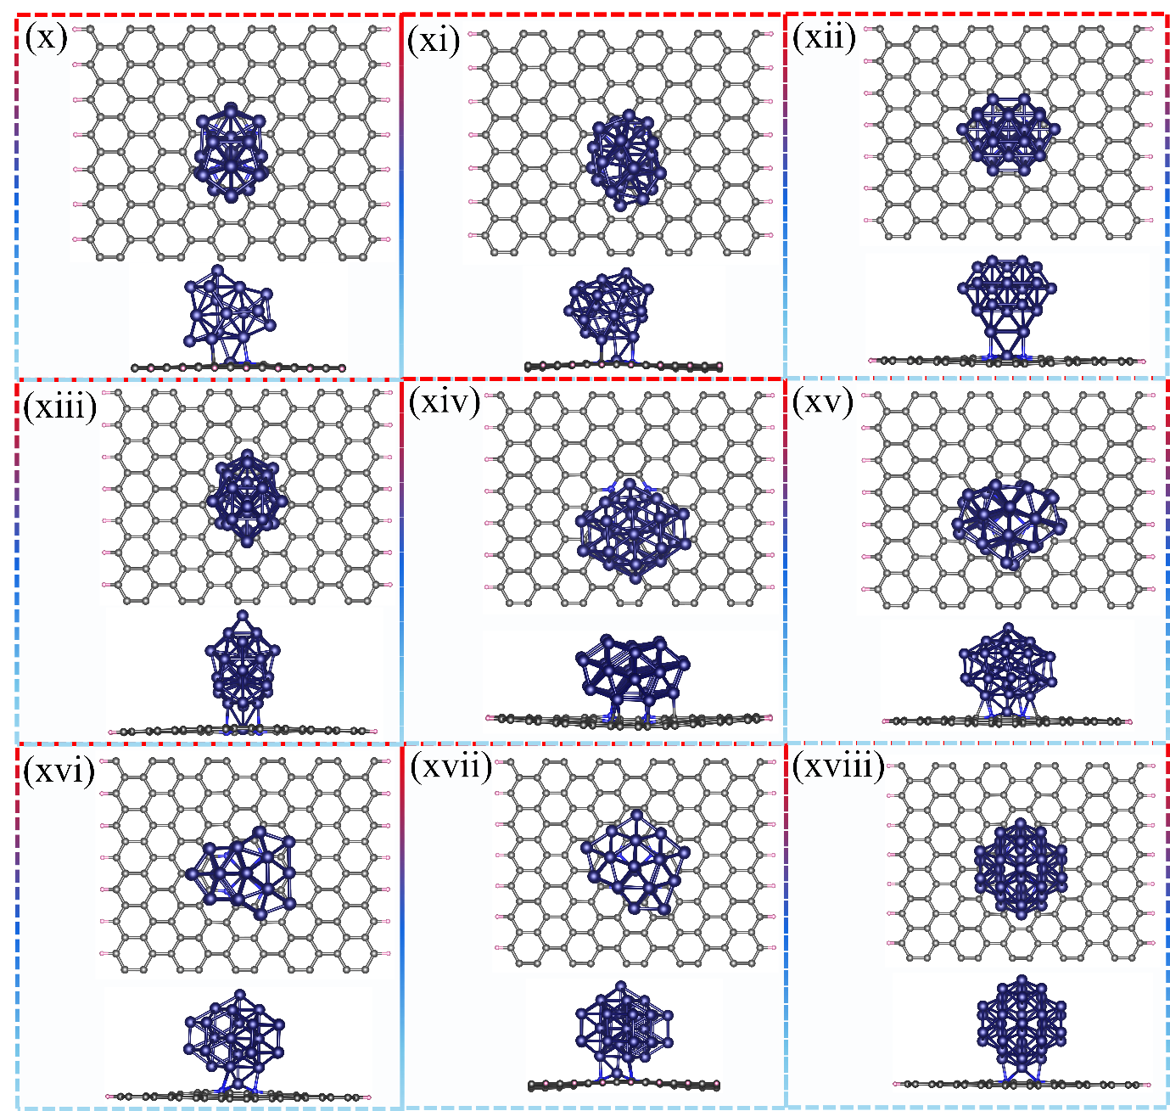
Figure S1(b): Optimised structure of catalysts (Top view and side view) (x) Co₂₃@N₄C, (xi) Co₂₅@N₄C, (xii) Co₂₇@N₄C, (xiii) Co₂₉@N₄C, (xiv) Co₃₁@N₄C, (xv) Co₃₃@N₄C, (xvi) Co₃₅@N₄C, (xvii) Co₃₇@N₄C, (xviii) Co₃₈@N₄C.
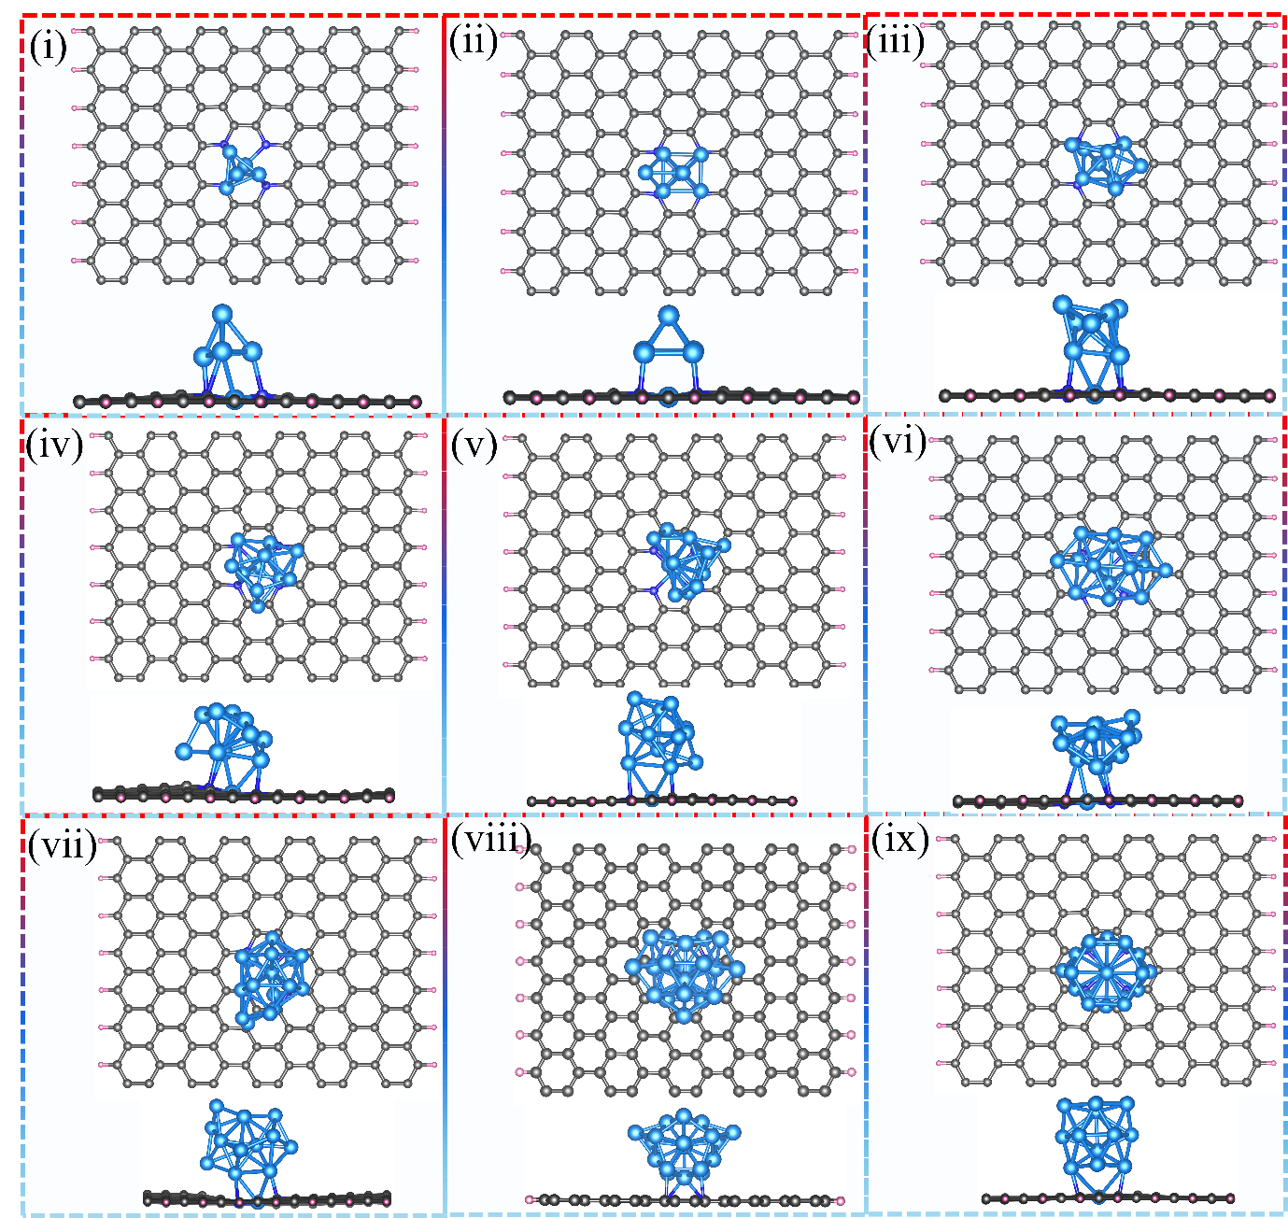
Figure S2(a): Optimised structure of catalysts (Top view and side view) (i) Ni₅@N₄C, (ii) Ni₇@N₄C (iii) Ni₉@N₄C, (iv) Ni₁₁@N₄C, (v) Ni₁₃@N₄C, (vi) Ni₁₅@N₄C, (vii) Ni₁₇@N₄C, (viii) Ni₁₉@N₄C, (ix) Ni₂₁@N₄C.

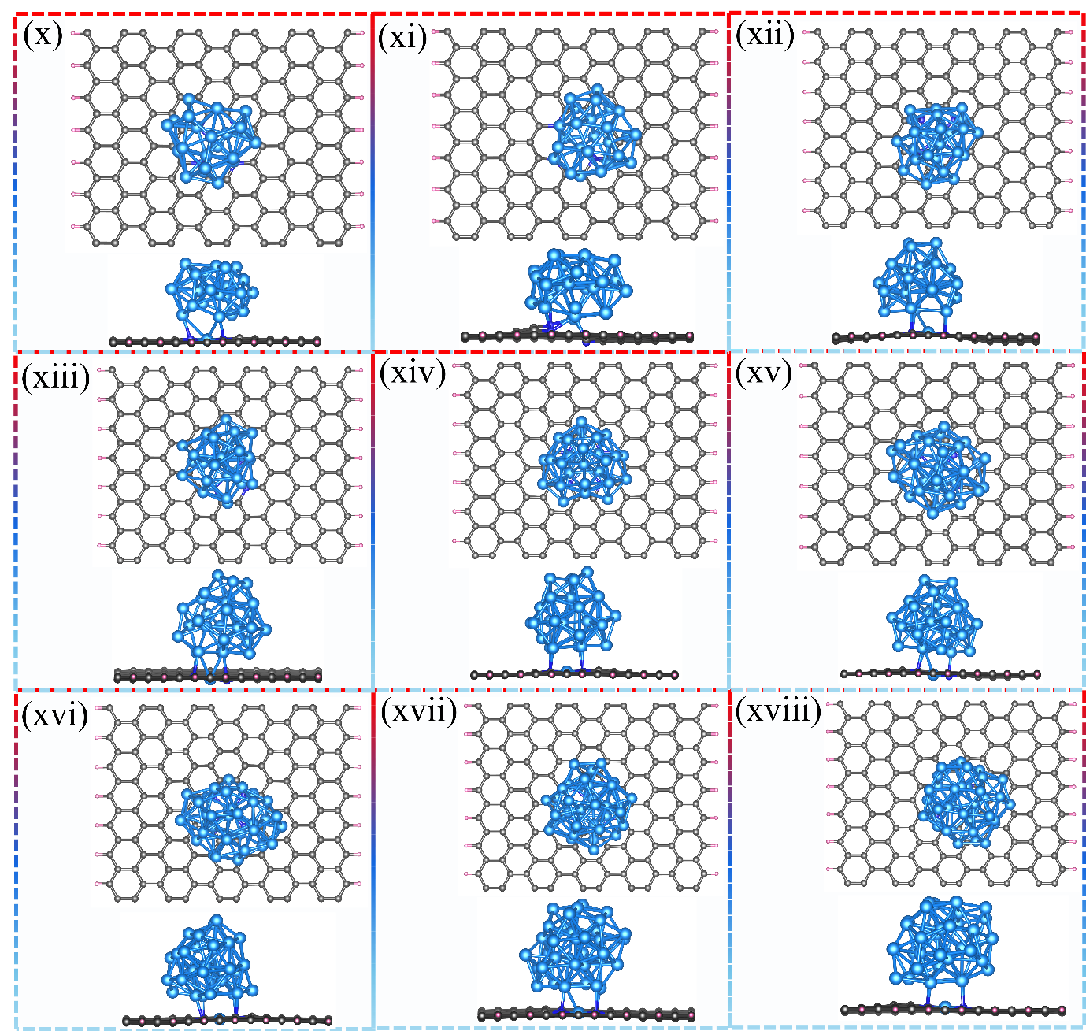
Figure S2(b): Optimised structure of catalysts (Top view and side view) (x) Ni₂₃@N₄C, (xi) Ni₂₅@N₄C (xii) Ni₂₇@N₄C, (xiii) Ni₂₉@N₄C, (xiv) Ni₃₁@N₄C, (xv) Ni₃₃@N₄C, (xvi) Ni₃₅@N₄C, (xvii) Ni₃₇@N₄C, (xviii) Ni₃₈@N₄C.
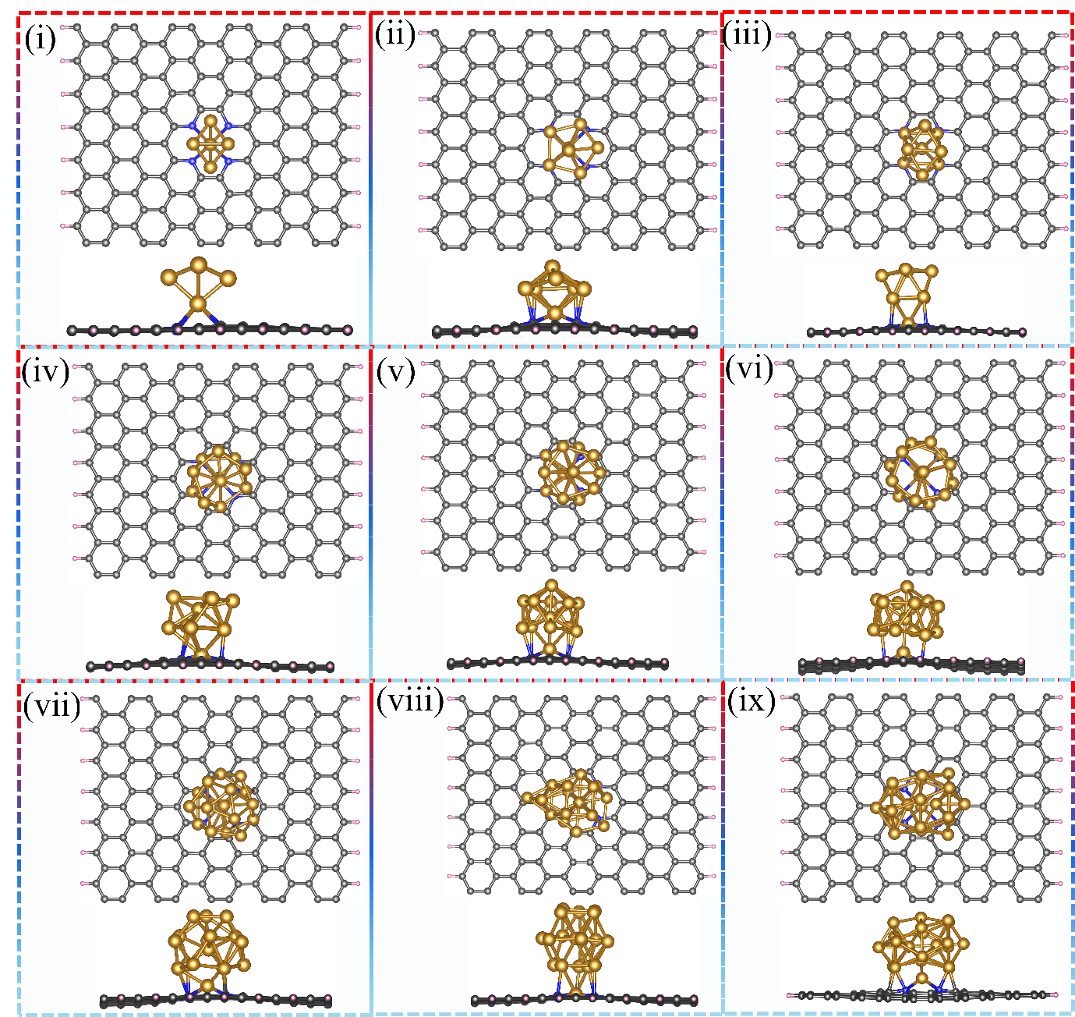
Figure S3(a): Optimised structure of catalysts (Top view and side view) (i) Fe₅@N₄C, (ii) Fe₇@N₄C (iii) Fe₉@N₄C, (iv) Fe₁₁@N₄C, (v) Fe₁₃@N₄C, (vi) Fe₁₅@N₄C, (vii) Fe₁₇@N₄C, (viii) Fe₁₉@N₄C, (ix) Fe₂₁@N₄C.

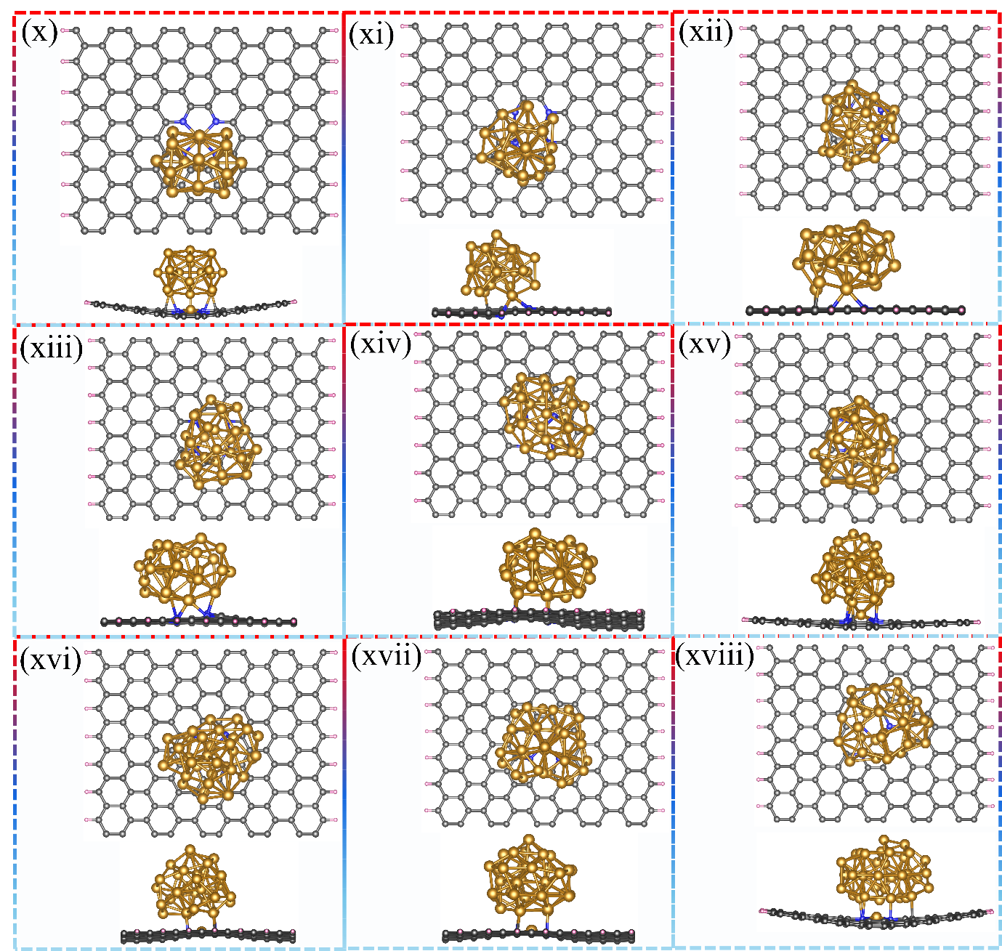
Figure S3(b): Optimised structure of catalysts (Top view and side view) (x) Fe₂₃@N₄C, (xi) Fe₂₅@N₄C, (xii) Fe₂₇@N₄C, (xiii) Fe₂₉@N₄C, (xiv) Fe₃₁@N₄C, (xv) Fe₃₃@N₄C, (xvi) Fe₃₅@N₄C, (xvii) Fe₃₇@N₄C, (xviii) Fe₃₈@N₄C.
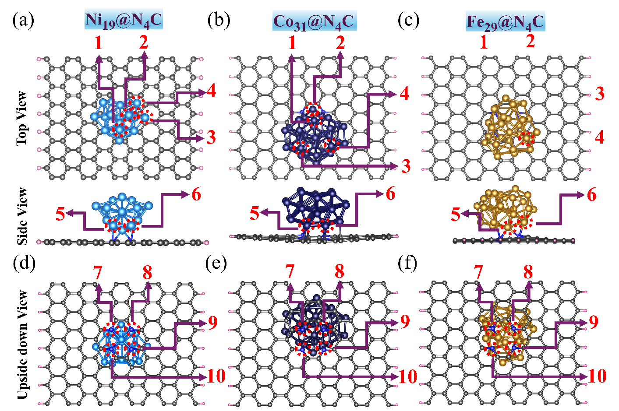
Figure S4: Highlighted catalytic active sites on (a) Ni₁₉@N₄C, (b) Co₃₁@N₄C and (b) Fe₂₉@N₄C, with active sites 1-6 indicated; (d-f) Highlighted nitrogen atoms (in upside down view of the catalyst) forming interfacial N-metal bond of (d) Ni₁₉@N₄C, (e) Co₃₁@N₄C, and (f) Fe₂₉@N₄C.
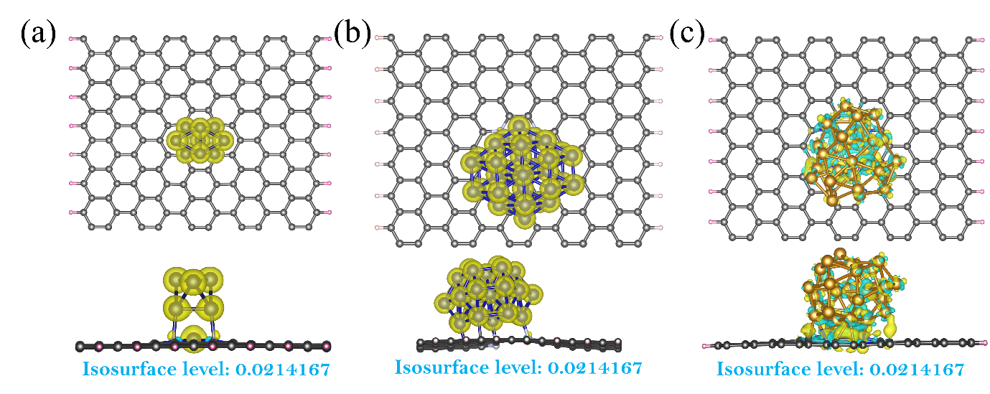Figure S5: Charge density difference plots of (a) Co₉@N₄C, (b) Co₃₁@N₄C and (c) Fe₂₉@N₄C.

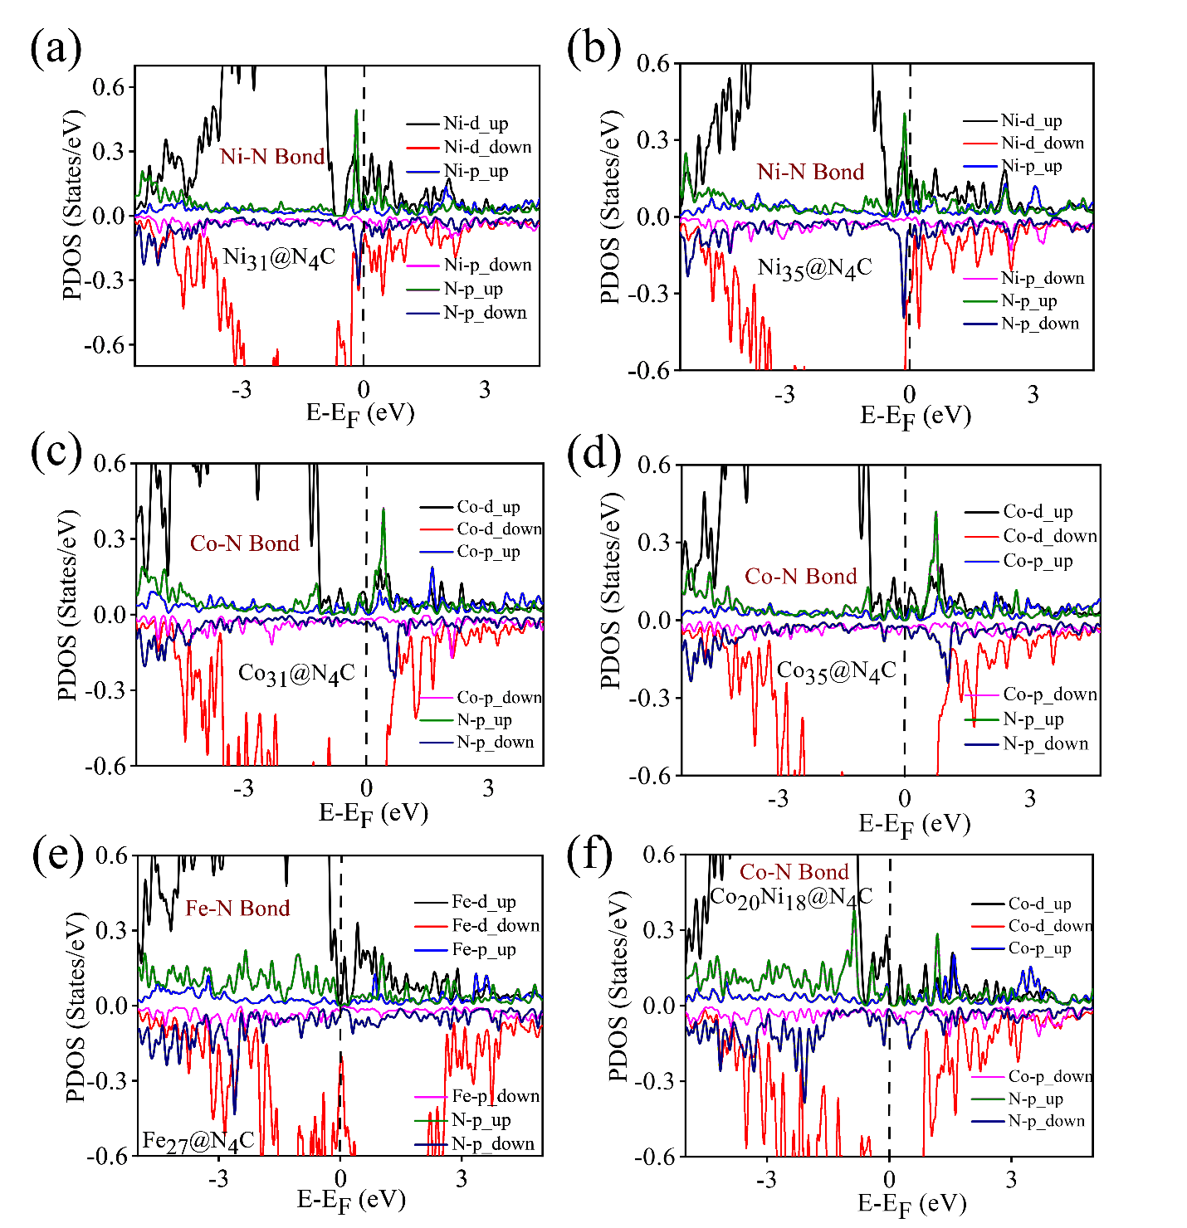
Figure S6: PDOS analysis plots of Metal-Nitrogen orbital hybridization (a) Ni₃₁@N₄C, (b) Ni₃₅@N₄C, (c) Co₃₅@N₄C, (d) Co₃₁@N₄C, (e) Fe₂₇@N₄C, (f) NiCo₃₈@N₄C
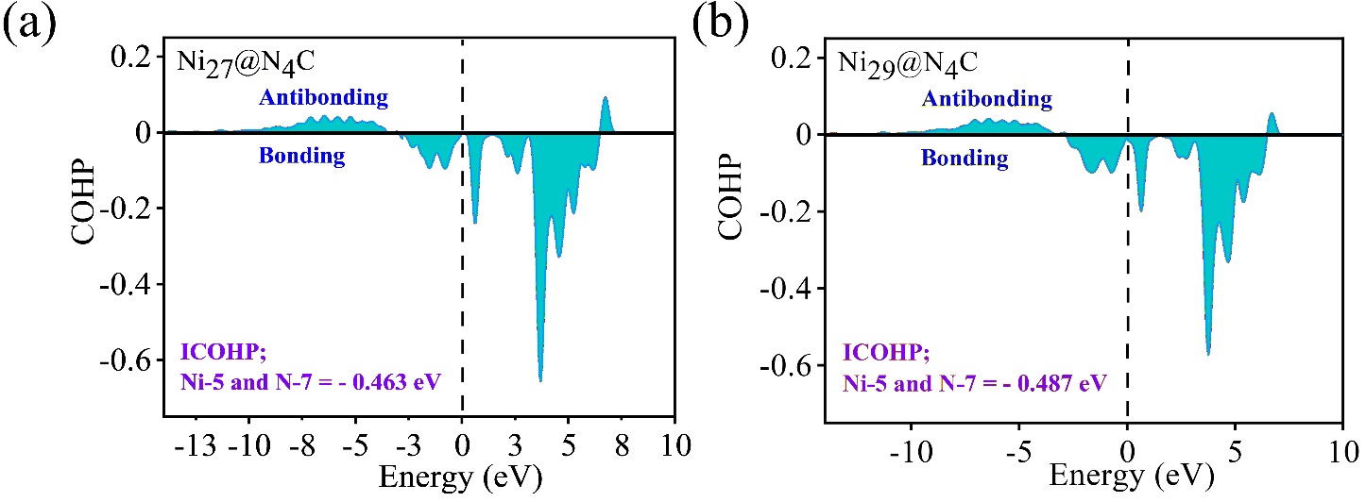Figure S7: Crystal Orbital Hamilton Population (COHP) plots with ICOHP values between nitrogen-metal of (a) Ni₂₇@N₄C and, (b) Ni₂₉@N₄C.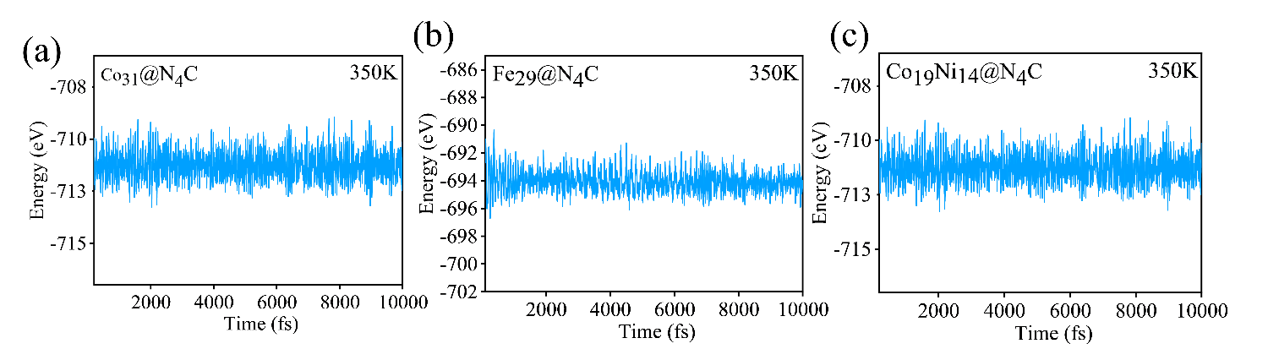Figure S8: AIMD plots of (a) Co₃₁@N₄C, (b) Fe₂₉@N₄C and (c) Co₁₉Ni₁₄@N₄C at 350K temperature.
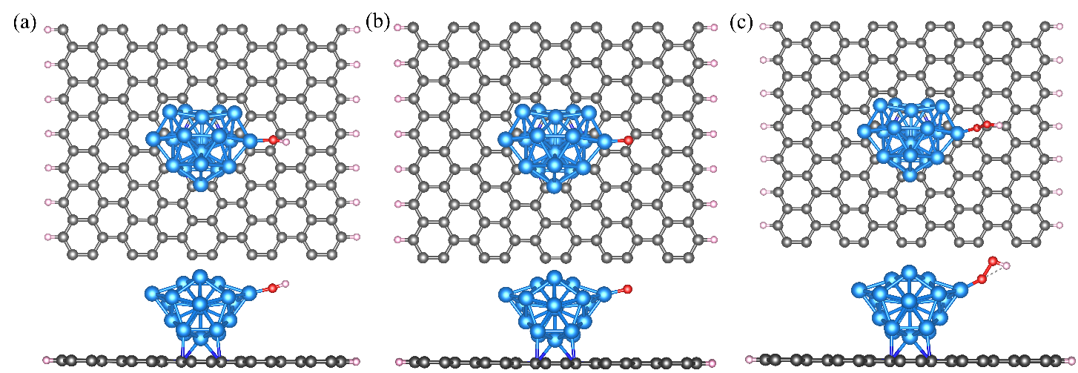
Figure S9: Optimised structures of (a) *OH, (b) *OH and (c) *OOH on the catalyst Ni₁₉@N₄C.
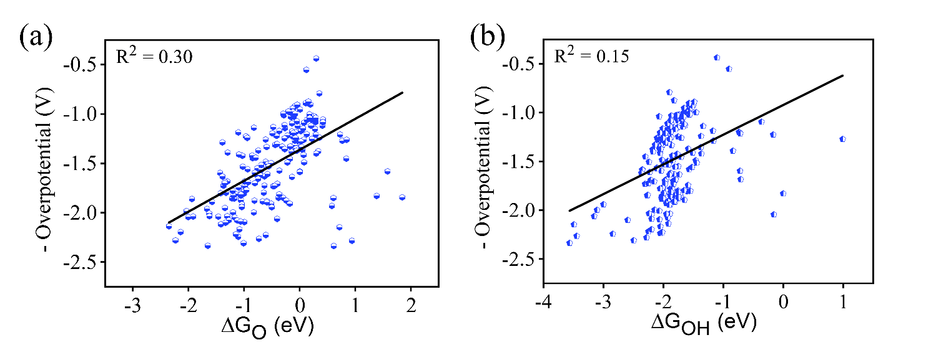
Figure S10: (a) negative overpotential vs ΔG_{O}, (b) negative overpotential vs ΔG_{OH} plots of M_{n}@N₄C systems.
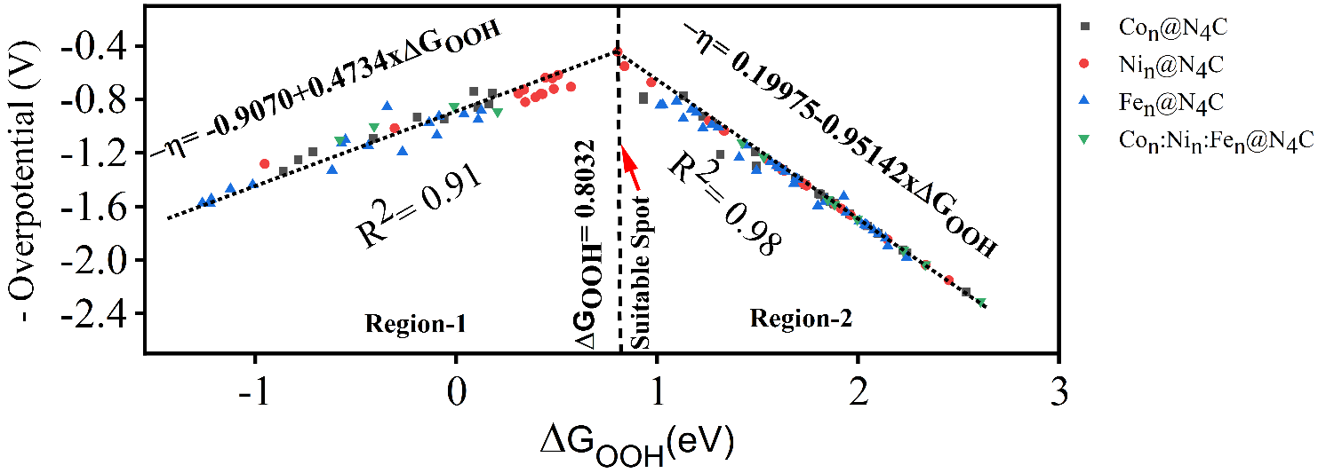Figure S11: Volcano plot with equations.

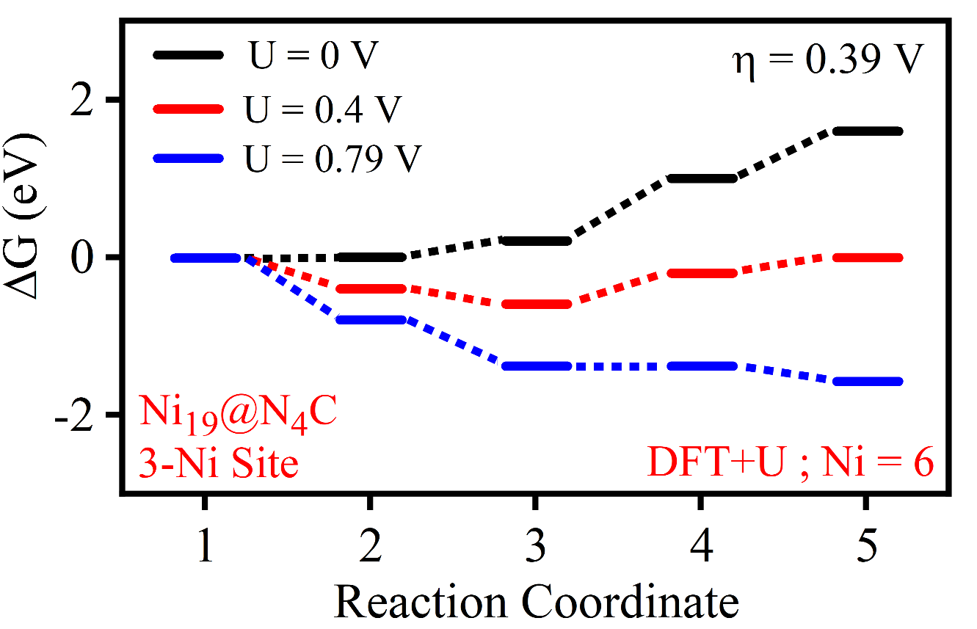
Figure S12: Hubbard U corrected Free energy profile of OER for the best site 3-Ni site at Ni₁₉@N₄C.
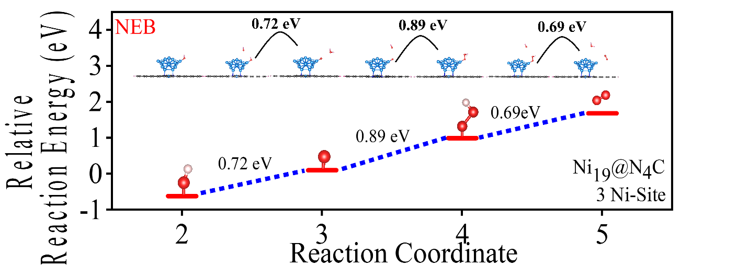
Figure S13: Nudge elastic band analysis for the kinetic barrier and energy gap between the reaction steps (whether the steps were endothermic or exothermic is not evaluated) for the best active site 3-Ni at Ni₁₉@N₄C for OER to check for the PDS.

Figure S14: (a) COHP plot of Ni-O in O* of Ni₁₉@N₄C, (b) COHP plot of Ni-O in OH* of Ni₁₉@N₄C.
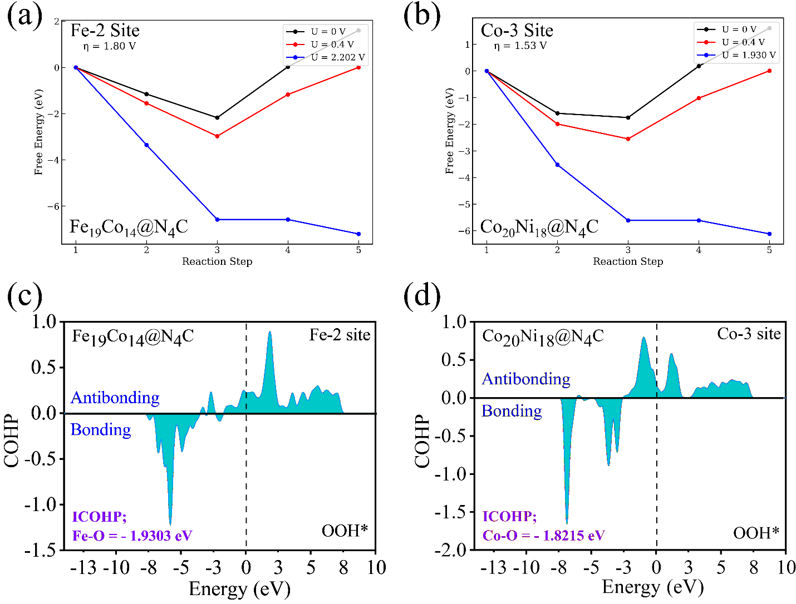Figure S15: (a) Free energy profile of OER of Fe-2 site in Fe₁₉Co₁₄@N₄C, (b) Free energy profile of OER of Co-3 site in Co₂₀Ni₁₈@N₄C, (c) COHP plot of Fe-O in Fe₁₉Co₁₄@N₄C, (d) COHP plot of Co-O in Co₂₀Ni₁₈@N₄C.
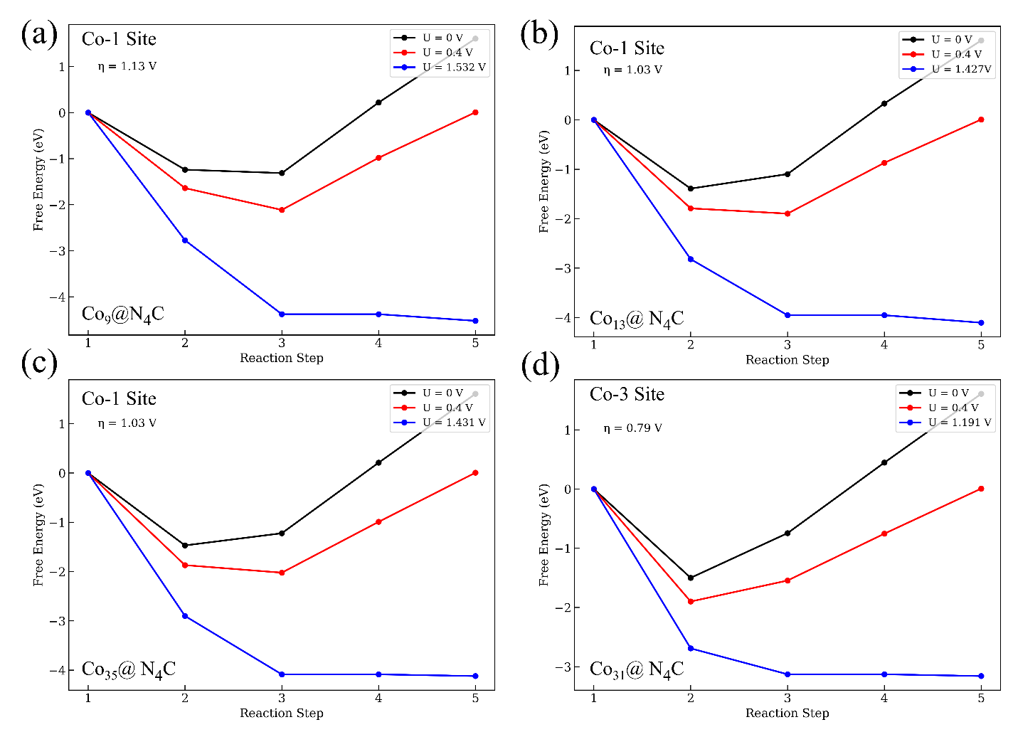
Figure S16: Free energy profile of OER for good sites -(a) Co-1 site of Co₉@N₄C, (b) Co-1 site of Co₁₃@N₄C, (c) Co-1 site of Co₃₅@N₄C, (d) Co-3 site of Co₃₁@N₄C.
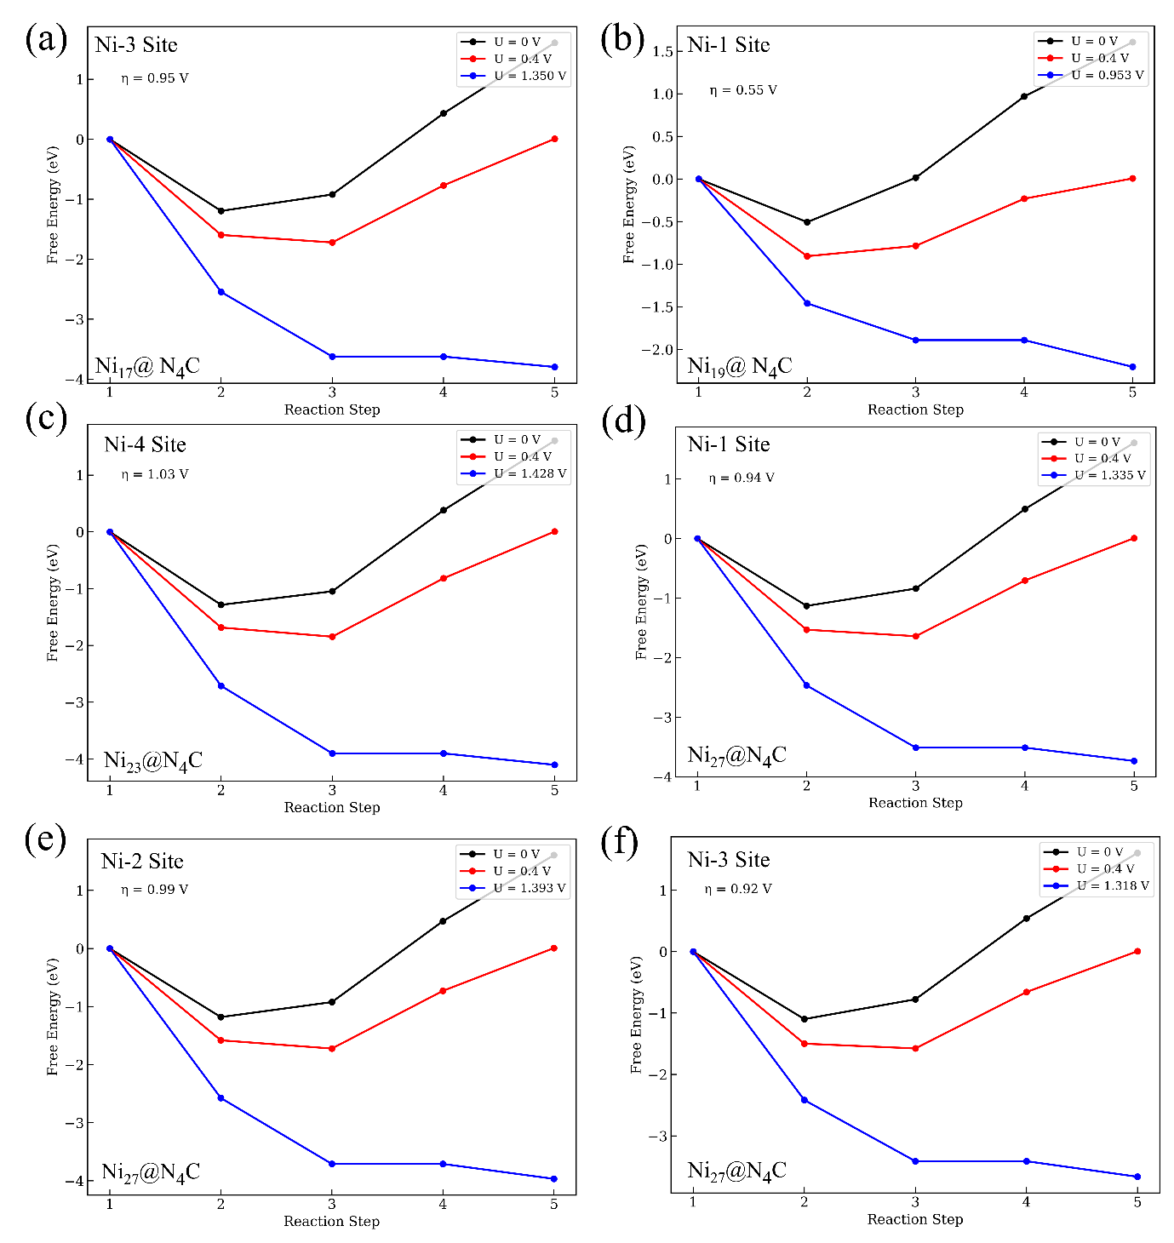
Figure S17: Free energy profile of OER for good sites -(a) Ni-3 site of Ni₁₇@N₄C, (b) Ni-1 site of Ni₁₉@N₄C, (c) Ni-4 site of Ni₂₃@N₄C, (d) Ni-1 site of Ni₂₇@N₄C, (e) Ni-2 site of Ni₂₇@N₄C, (f) Ni-3 site of Ni₂₇@N₄C.

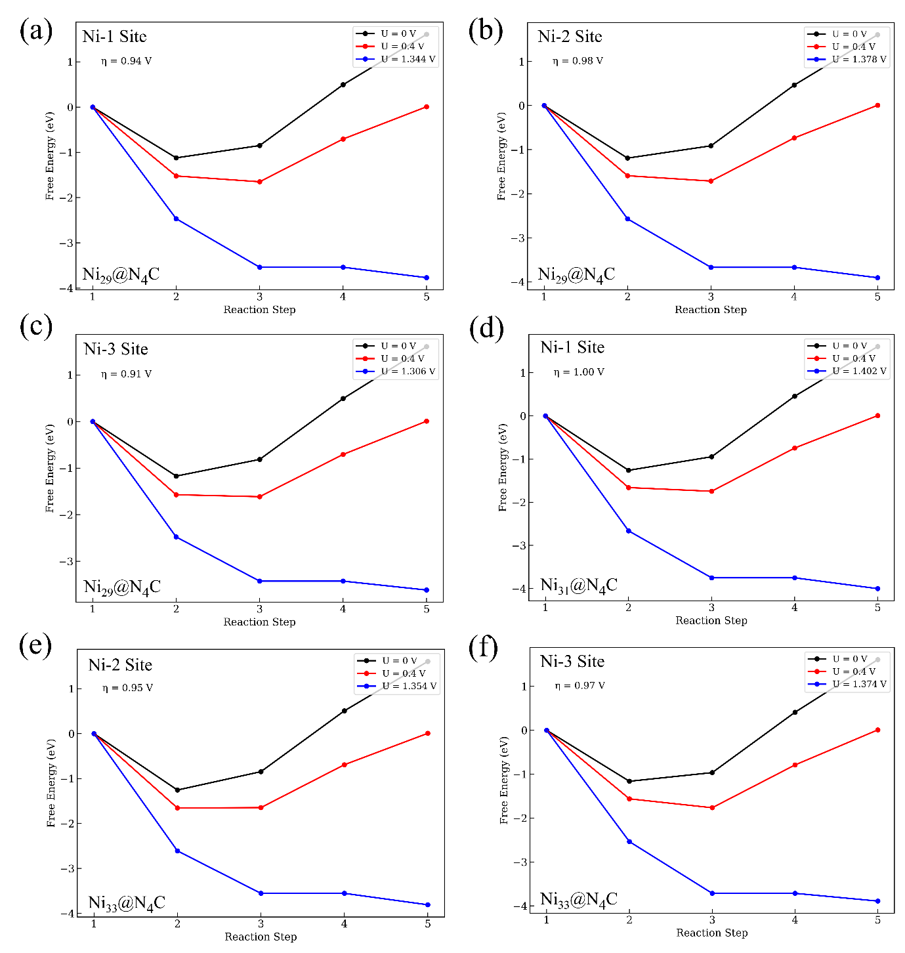
Figure S18: Free energy profile of OER for good sites -(a) Ni-1 site of Ni₂₉@N₄C, (b) Ni-2 site of Ni₂₉@N₄C, (c) Ni-3 site of Ni₂₉@N₄C, (d) Ni-1 site of Ni₃₁@N₄C, (e) Ni-2 site of Ni₃₃@N₄C, (f) Ni-3 site of Ni₃₃@N₄C.

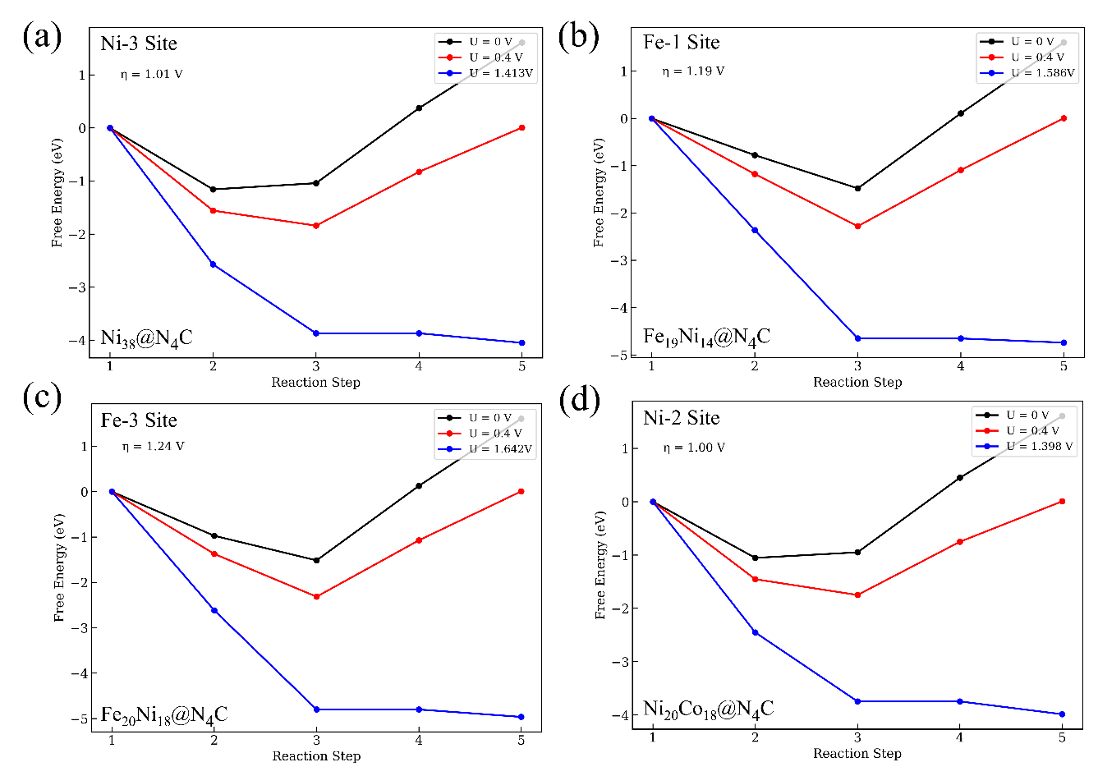
Figure S19: Free energy profile of OER for good sites -(a) Ni-3 site of Ni₃₈@N₄C, (b) Fe-1 site of Fe₁₉Ni₁₄@N₄C, (c) Fe-3 site of Fe₂₀Ni₁₈@N₄C, (d) Ni-2 site of Ni₂₀Co₁₈@N₄C.

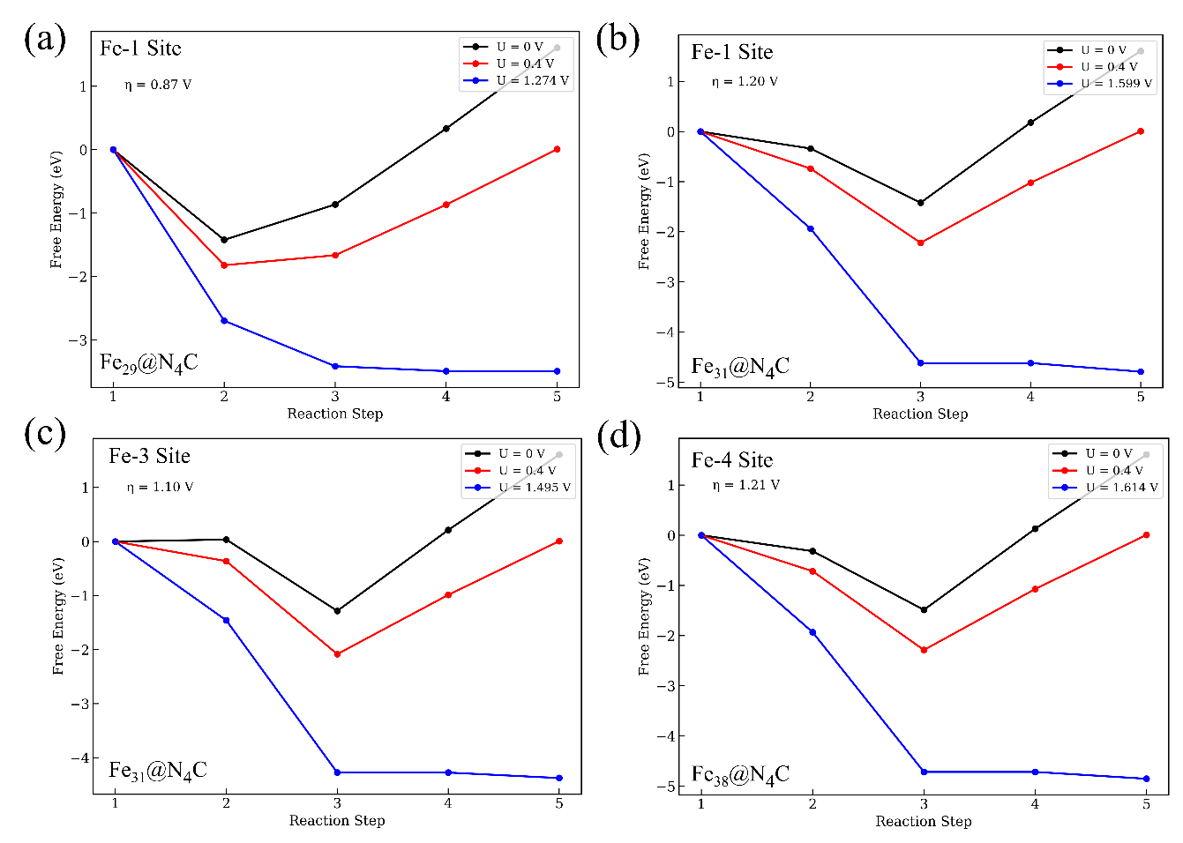
Figure S20: Free energy profile of OER for good sites -(a) Fe-1 site of Fe₂₉@N₄C, (b) Fe-1 site of Fe₃₁@N₄C, (c) Fe-3 site of Fe₃₁@N₄C, (d) Fe-4 site of Fe₃₈@N₄C.

Section 3: Linear correlation between electronic parameters and the ΔG_{OOH}
'd-band center': R² = 0.0718, Pearson r = -0.2679
'd-occupancy': R² = 0.0909, Pearson r = 0.3015
'd at Fermi': R² = 0.0139, Pearson r = -0.1177
'd-up center': R² = 0.0078, Pearson r = -0.0882
'd-down center': R² = 0.0693, Pearson r = -0.2633
'd-up occupancy': R² = 0.0192, Pearson r = 0.1386
'd-down occupancy': R² = 0.0693, Pearson r = -0.2633
'd-up at Fermi': R² = 0.0169, Pearson r = -0.1301
'd-down at Fermi': R² = 0.0092, Pearson r = 0.0961
'Wd corrected d-band': R² = 0.0904, Pearson r = -0.3006
'Upper d-band edge': R² = 0.0145, Pearson r = -0.1206
'd-frontier': R² = 0.0065, Pearson r = 0.0808
'd-frontier up': R² = 0.0000, Pearson r = 0.0068
'd-frontier down': R² = 0.0052, Pearson r = 0.0718
'd_xy_up_occ': R² = 0.0192, Pearson r = 0.1386
'd_xy_down_occ': R² = 0.0540, Pearson r = -0.2324
'd_yz_up_occ': R² = 0.0195, Pearson r = 0.1395
'd_yz_down_occ': R² = 0.0626, Pearson r = -0.2501
'd_z2_up_occ': R² = 0.0179, Pearson r = 0.1337
'd_z2_down_occ': R² = 0.0701, Pearson r = -0.2648
'd_xz_up_occ': R² = 0.0204, Pearson r = 0.1427
'd_xz_down_occ': R² = 0.0736, Pearson r = -0.2714
'd_x2y2_up_occ': R² = 0.0113, Pearson r = 0.1064
'd_x2y2_down_occ': R² = 0.0494, Pearson r = -0.2222
'd_xy_occ': R² = 0.0771, Pearson r = 0.2777
'd_yz_occ': R² = 0.0838, Pearson r = 0.2894
'd_z2_occ': R² = 0.0977, Pearson r = 0.3126
'd_xz_occ': R² = 0.0986, Pearson r = 0.3140
'd_x2y2_occ': R² = 0.0646, Pearson r = 0.2542
'd_xy_fermi': R² = 0.0305, Pearson r = -0.1746
'd_yz_fermi': R² = 0.0293, Pearson r = -0.1712
'd_z2_fermi': R² = 0.0051, Pearson r = 0.0716
'd_xz_fermi': R² = 0.0017, Pearson r = -0.0413
'd_x2y2_fermi': R² = 0.0015, Pearson r = 0.0384
'd_xy_up_fermi': R² = 0.0000, Pearson r = 0.0055
'd_xy_down_fermi': R² = 0.0307, Pearson r = 0.1751
'd_yz_up_fermi': R² = 0.0109, Pearson r = -0.1044
'd_yz_down_fermi': R² = 0.0248, Pearson r = 0.1573
'd_z2_up_fermi': R² = 0.0170, Pearson r = -0.1302
'd_z2_down_fermi': R² = 0.0123, Pearson r = -0.1108
'd_xz_up_fermi': R² = 0.0173, Pearson r = -0.1317
'd_xz_down_fermi': R² = 0.0009, Pearson r = 0.0298
'd_x2y2_up_fermi': R² = 0.0022, Pearson r = -0.0465
'd_x2y2_down_fermi': R² = 0.0018, Pearson r = -0.0429
't2g_band_center': R² = 0.0783, Pearson r = -0.2798
'eg_band_center': R² = 0.0637, Pearson r = -0.2523
'zc_band_center': R² = 0.0650, Pearson r = -0.2549
't2g_fermi': R² = 0.0275, Pearson r = -0.1657
'eg_fermi': R² = 0.0044, Pearson r = 0.0662
'zc_fermi': R² = 0.0074, Pearson r = -0.0861
't2g_occ': R² = 0.0928, Pearson r = 0.3046
'eg_occ': R² = 0.0849, Pearson r = 0.2914
'zc_occ': R² = 0.1022, Pearson r = 0.3198
't2g_up_center': R² = 0.0089, Pearson r = -0.0944
'eg_up_center': R² = 0.0062, Pearson r = -0.0789
'zc_up_center': R² = 0.0051, Pearson r = -0.0712
't2g_down_center': R² = 0.0697, Pearson r = -0.2640
'eg_down_center': R² = 0.0648, Pearson r = -0.2546
'zc_down_center': R² = 0.0650, Pearson r = -0.2549
't2g_up_occ': R² = 0.0214, Pearson r = 0.1464
'eg_up_occ': R² = 0.0156, Pearson r = 0.1248
'zc_up_occ': R² = 0.0194, Pearson r = 0.1391
't2g_down_occ': R² = 0.0705, Pearson r = -0.2655
'eg_down_occ': R² = 0.0643, Pearson r = -0.2536
'zc_down_occ': R² = 0.0768, Pearson r = -0.2771
't2g_up_fermi': R² = 0.0131, Pearson r = -0.1144
'eg_up_fermi': R² = 0.0172, Pearson r = -0.1311
'zc_up_fermi': R² = 0.0173, Pearson r = -0.1315
't2g_down_fermi': R² = 0.0245, Pearson r = 0.1564
'eg_down_fermi': R² = 0.0097, Pearson r = -0.0986
'zc_down_fermi': R² = 0.0045, Pearson r = 0.0668
'bader_charge': R² = 0.0035, Pearson r = 0.0593

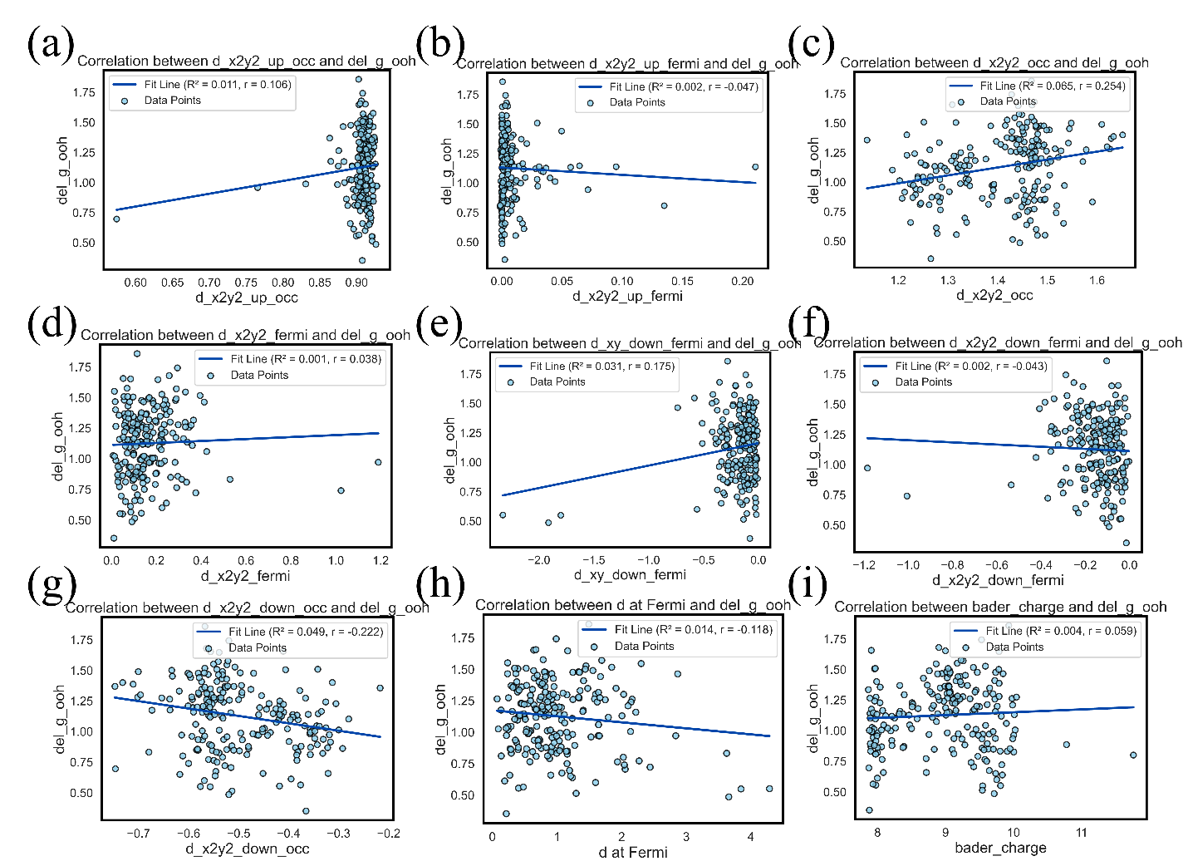
Figure S21: Linear correlation between electronic features and ΔG_{OOH}.

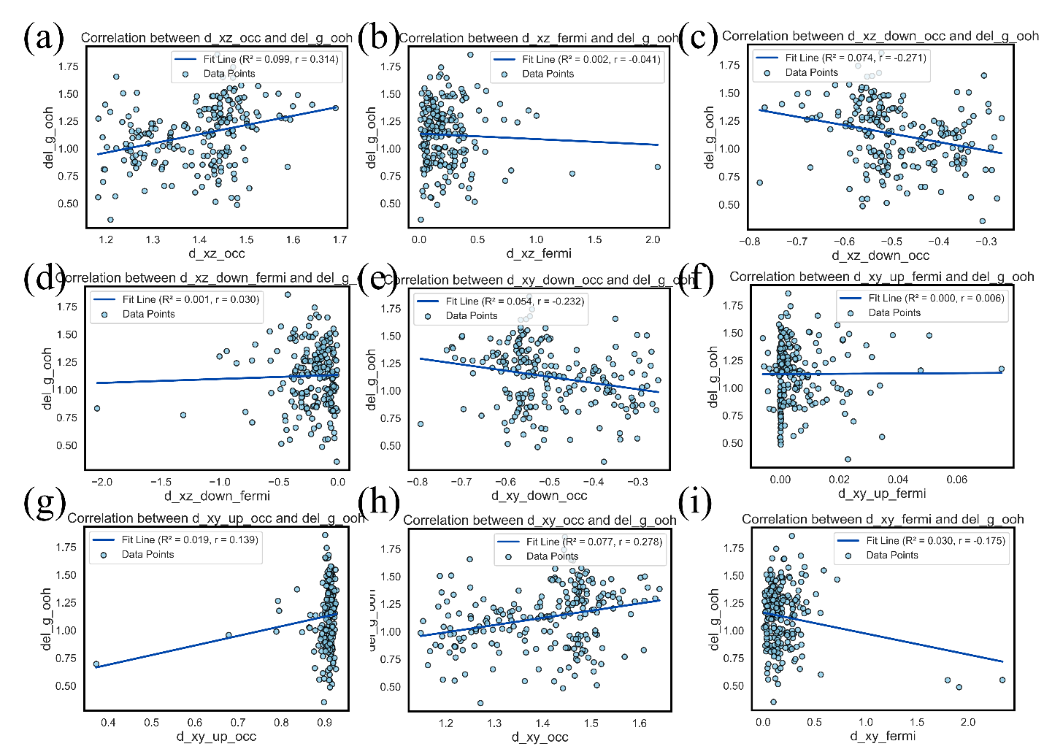
Figure S22: Linear correlation between electronic features and ΔG_{OOH}.

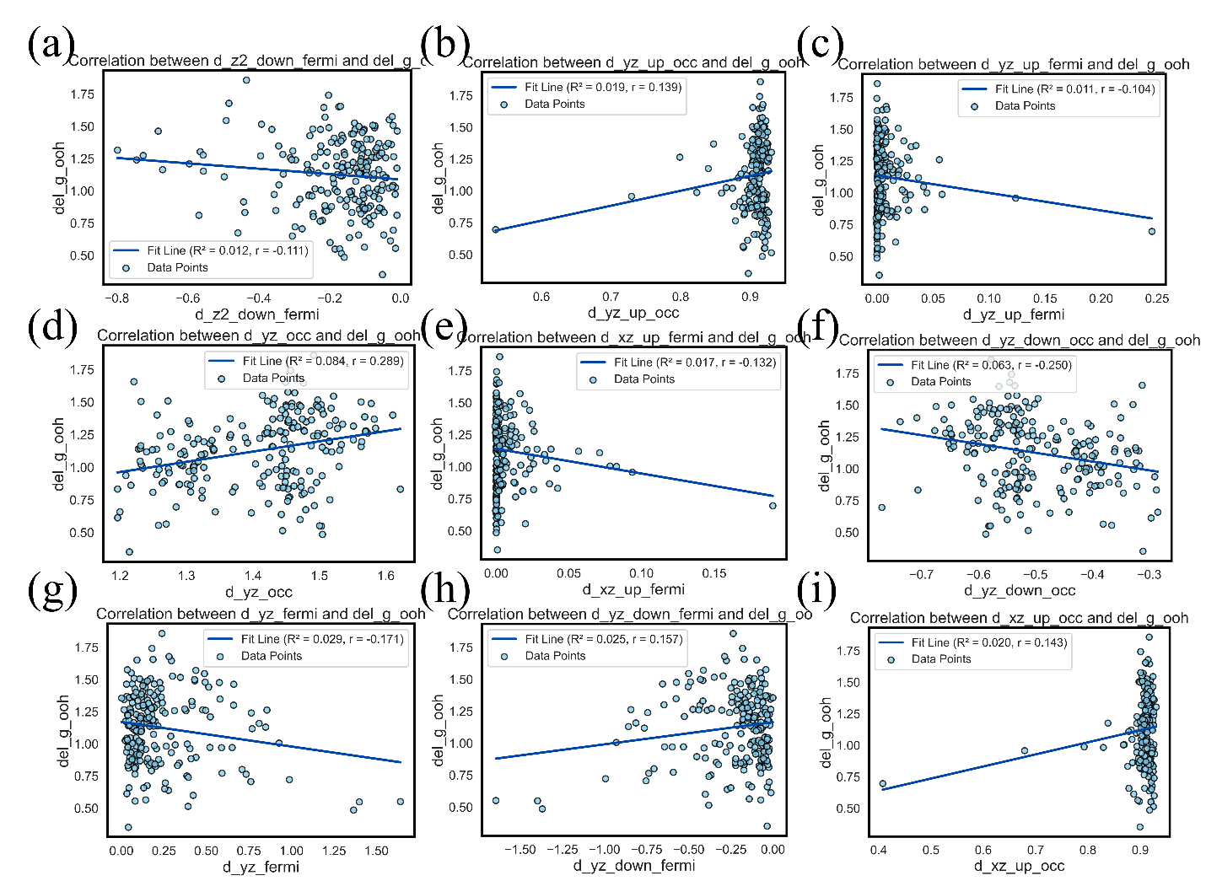
Figure S23: Linear correlation between electronic features and ΔG_{OOH}.

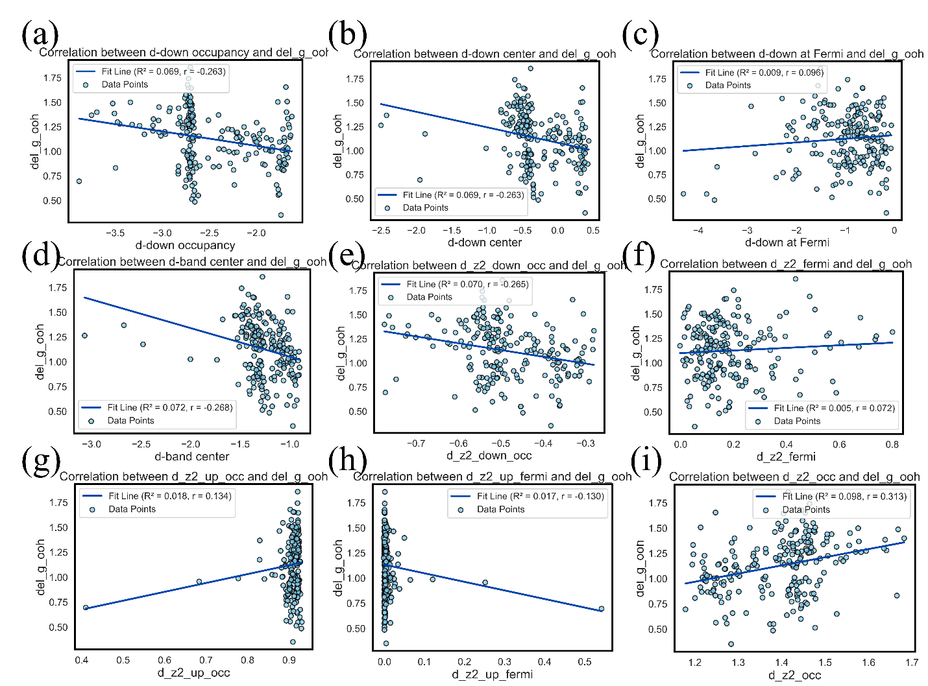
Figure S24: Linear correlation between electronic features and ΔG_{OOH}.

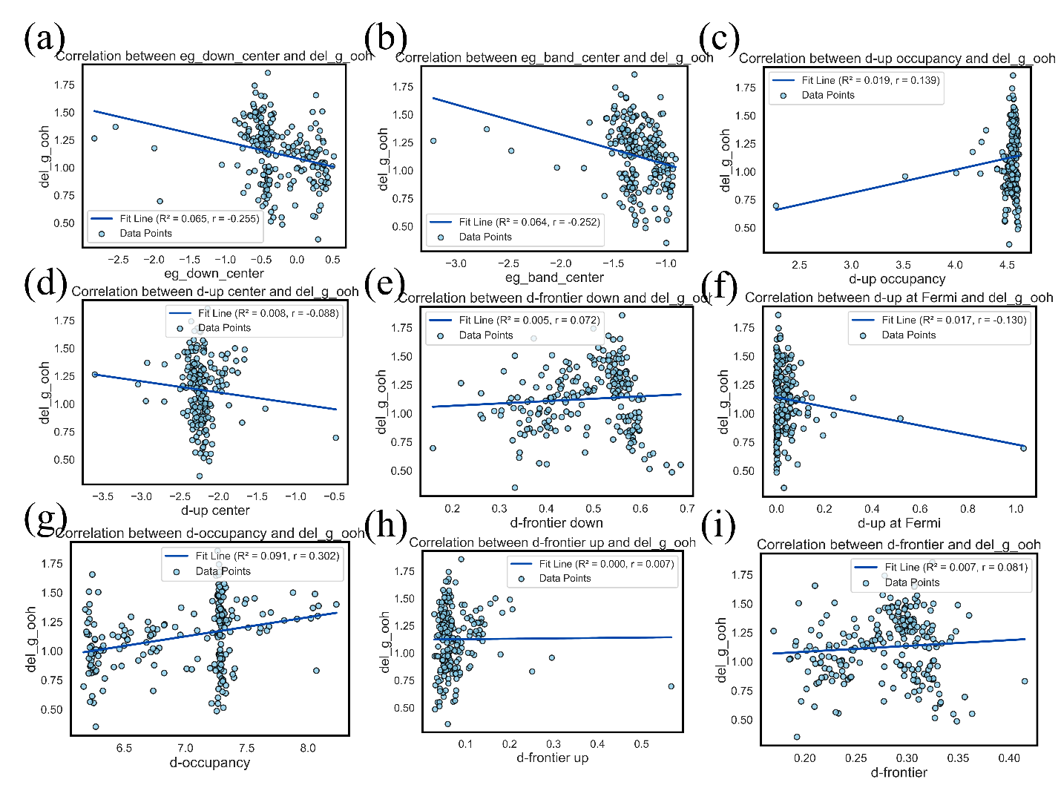
Figure S25: Linear correlation between electronic features and ΔG_{OOH}.

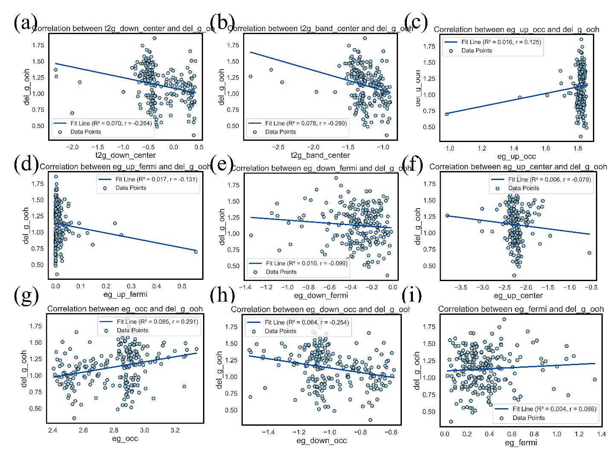
Figure S26: Linear correlation between electronic features and ΔG_{OOH}.

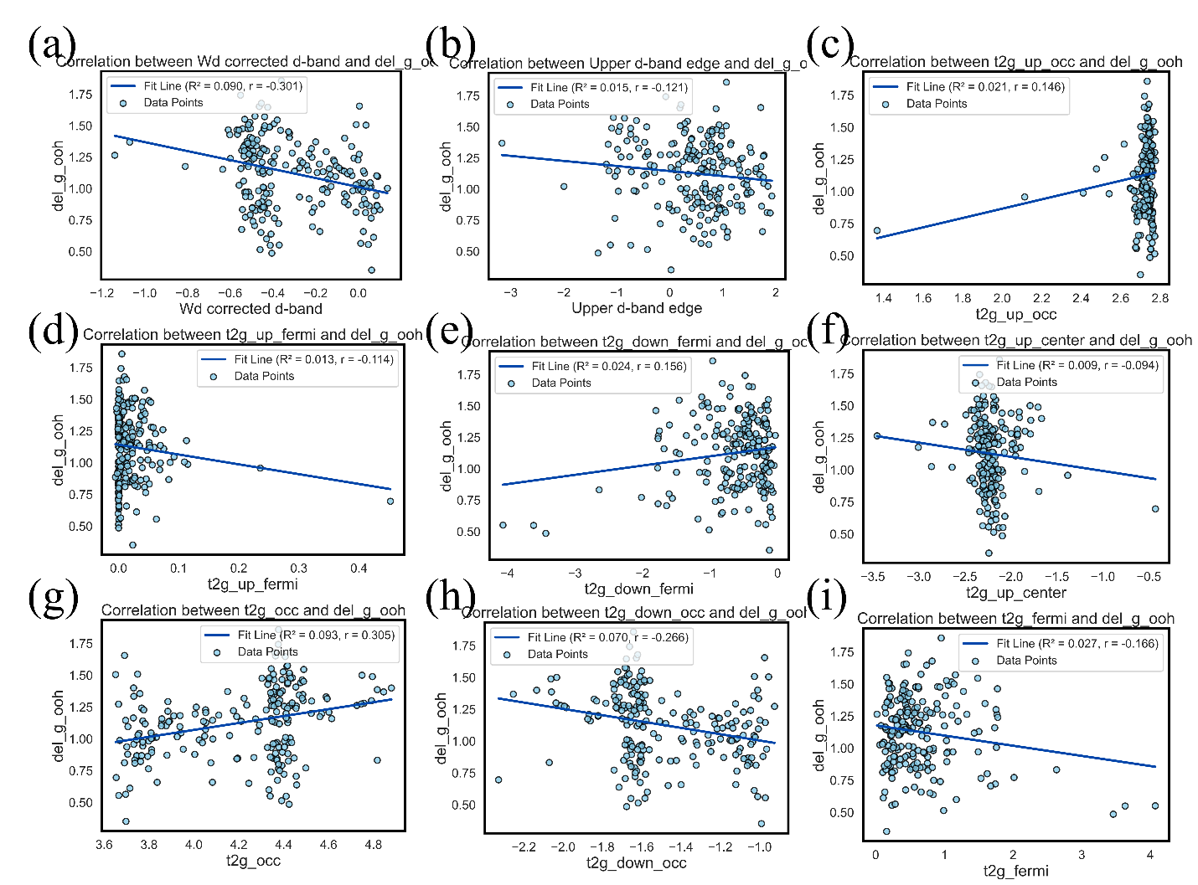
Figure S27: Linear correlation between electronic features and ΔG_{OOH}.

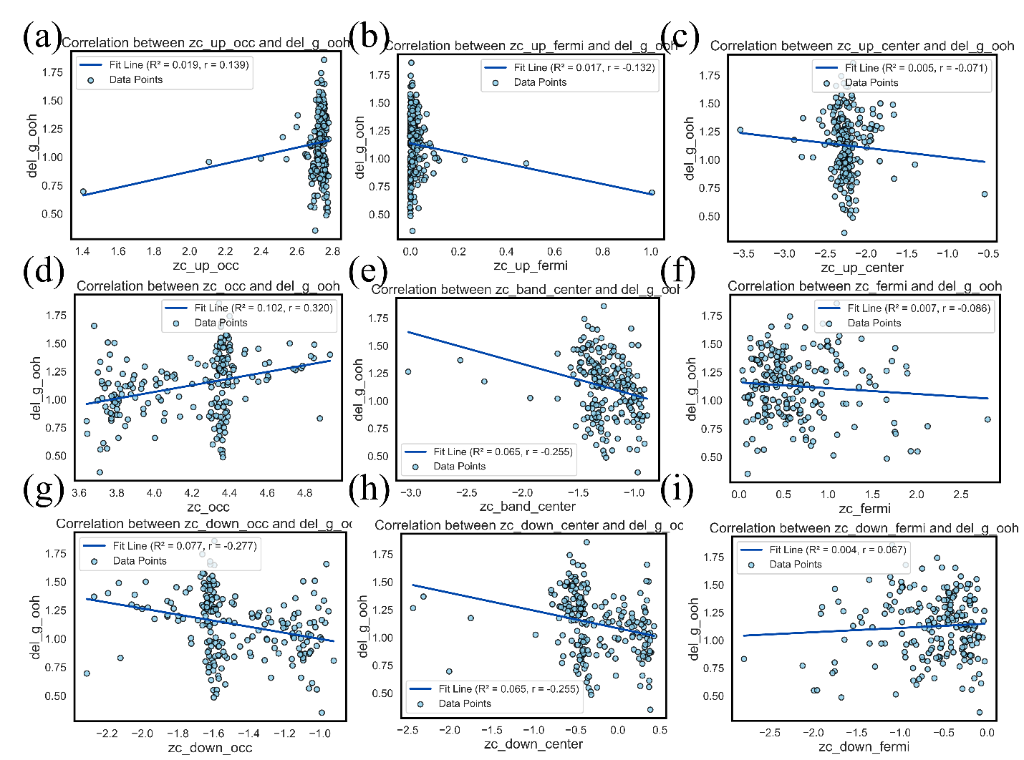
Figure S28: Linear correlation between electronic features and ΔG_{OOH}.

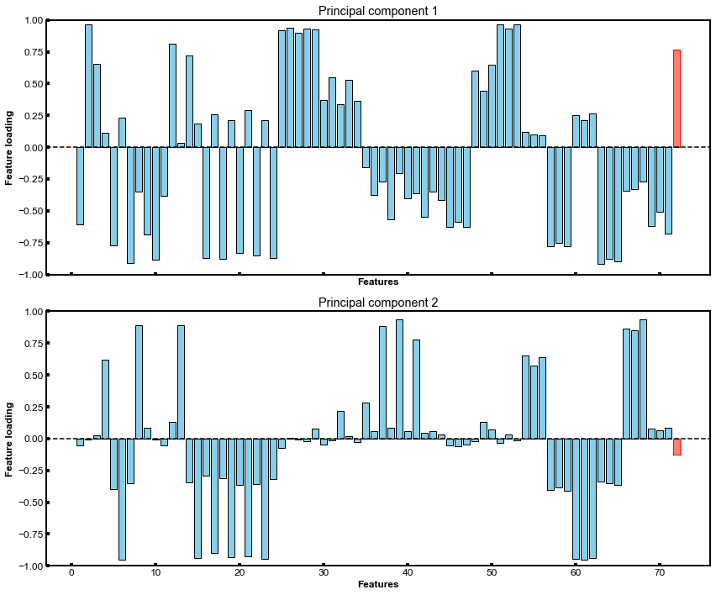Figure S29: PCA plot.

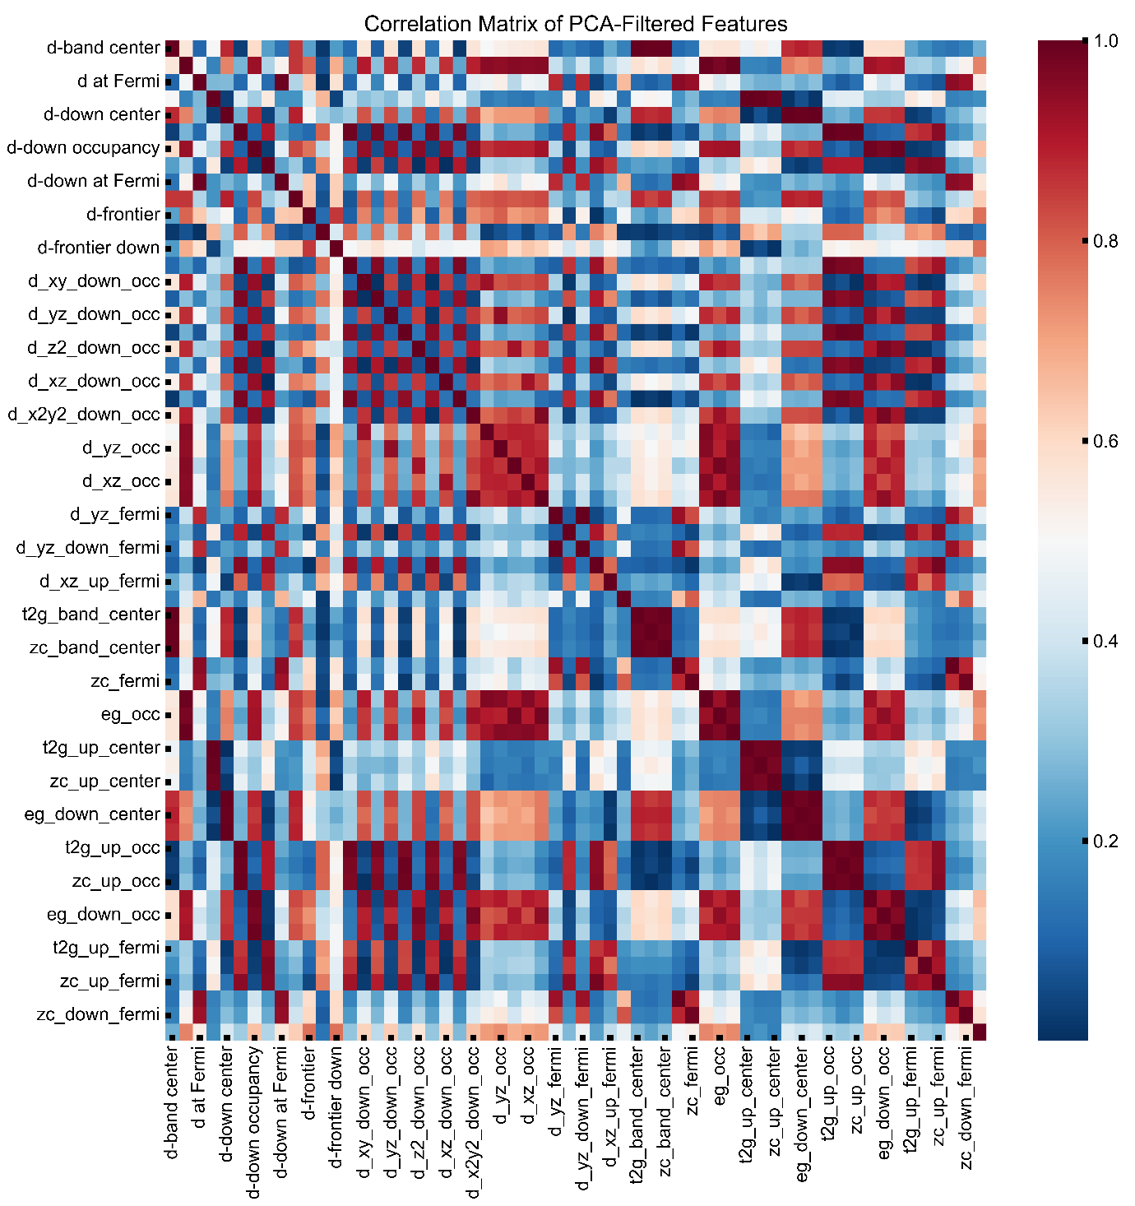Figure S30: Correlation matrix of the electronic features.

Figure S31: (a) Ridge, (b) KNN (b) Lasso and (c) SVR models performance.
Figure S32: SHAP feature importance for (a) RFR, (b) XGR, (c) MLR, (d) BRR models.

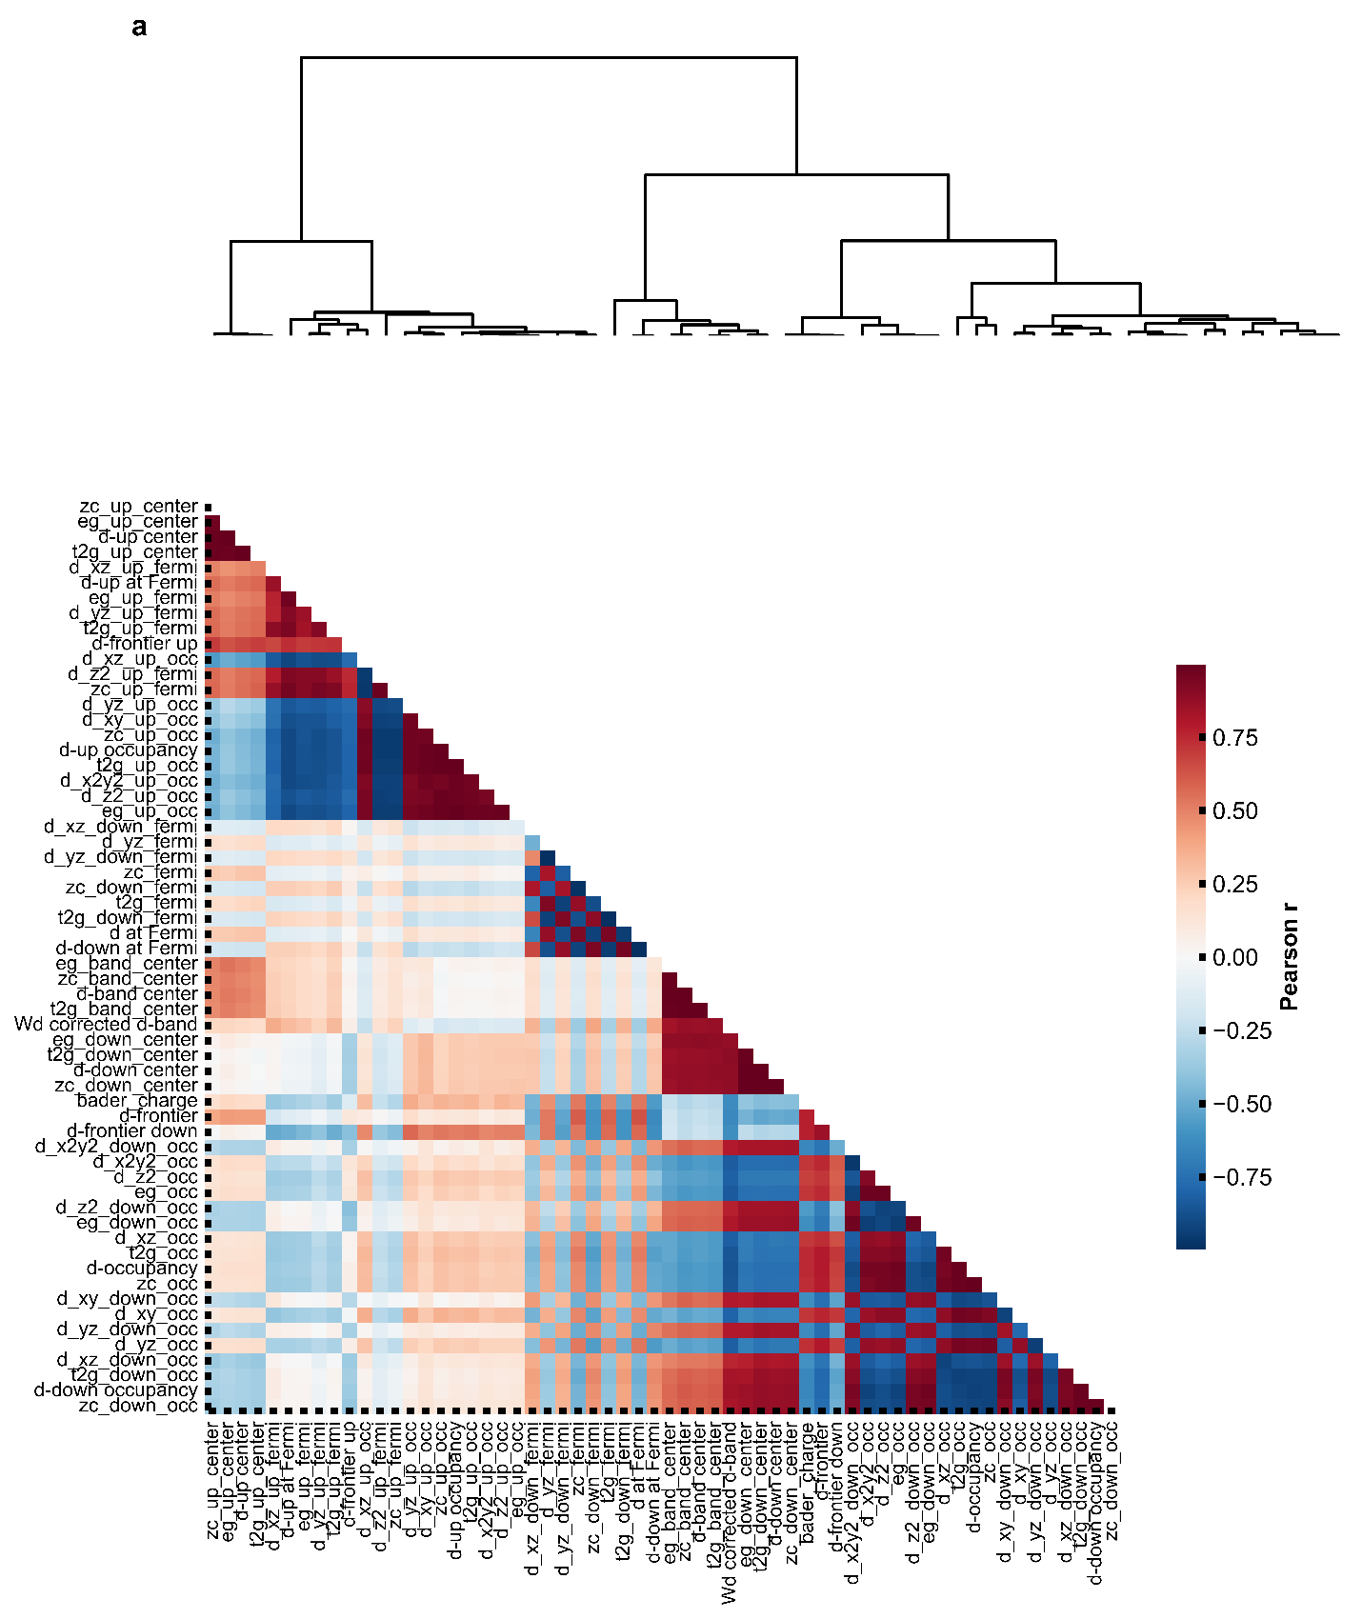Figure S33: Correlation matrix with dendrogram.
Figure S34: Learning curves of (a) RFR, (b) XGR, (c) MLR and (d) Ridge models.

Section S4: Machine Learning Algorithms.
This part discusses the machine-learning models used for regression and briefly summarises the ideas and the mathematical form of each.
1. Support Vector Regression (SVR)
Unlike regular linear regression, Support Vector Regression (SVR) attempts to find a function that has at most ε deviation from the actually obtained targets yi for all the training data, instead of minimizing the squared error for each point. Support Vector Regression gives a linear function with some possible exceptions for those points whose error is bigger than ε (called the ε-tube). The errors for those points that are in the ε-tube are tolerated. This property is explained through Karush-Kuhn-Tucker (KKT) conditions of the optimization algorithm used to find the optimal linear function. The set of points in the ε-tube for which the errors are tolerated, are called support vectors. Regular SVR mostly uses a kernel trick that maps an input vector x into the higher-dimensional feature space via some nonlinear function φ(x). So, the algorithm learns a linear model in the feature space, but the model in the original input space is nonlinear.
The SVR prediction function in the feature space is:
f(x) = w · φ(x) + b
where, w is the weight vector, and b is the bias.
So, the SVR model is obtained by solving:
Minimize ($\frac{1}{2}$||w||² + C Σ (ξᵢ + ξᵢ*)
Subject to:
yᵢ – (w · φ(xᵢ) + b) ≤ ε + ξ_{i}
(w · φ(x_{i}) + b) – y_{i} ≤ ε + ξ_{i}*
ξᵢ ≥ 0, ξᵢ* ≥ 0
In this model, C > 0 is a hyperparameter, which controls the flatness of the function and thus plays an important role, much similar to the role of λ in Ridge and Lasso regressions.
The slack variables ξ_{i} and ξ_{i}* are used to measure the deviations for those points that are actually outside the ε-tube.
2. Multiple Linear Regression (MLR)
MLR models target variable y to have linear relationship with multiple input variables x₁, x₂, ..., x_{p}. In a compact matrix notation, the MLR prediction model looks like:
ŷ = θ₀ + θ₁x₁ + θ₂x₂ + … + θ_{p}x_{p}
Here, θ₀ is the intercept and θⱼ values are the regression coefficients.
The parameters of the model, i.e. the values of θ₀ and θⱼ are selected such that they provide the best fit for the given data. In mathematical terms, we are looking for the parameter vector θ = (θ₀, θ₁, …, θ_{p})^{T}, which minimizes the MSE between actual y_{i} values and predicted ŷ_{i} values:
J(θ) = (1 / 2n) Σ (y_{i} – ŷ_{i})²
If the feature matrix X is non-singular, then we can use the closed-form Ordinary Least Squares (OLS) solution:
θ = (XᵀX)⁻¹ X^{T}y
where, X is the design matrix (feature matrix with an extra column of 1s appended for the intercept term) and y is the target vector.
3. Random Forest Regression (RFR)
Random Forest (RF) regression model is an ensemble approach that uses a collection of decision trees. The idea is to build a large number of uncorrelated trees, and combine their outputs. The final output is taken as the average of the individual outputs. Introducing randomness into trees in this manner helps avoid overfitting and makes the overall predictions more stable.
Random Forest model introduces randomness in two ways:
Bootstrapping: Each tree is trained with a bootstrap sample of the dataset. This means each tree sees a random subsample of the data (drawn with replacement).
Random Feature Selection: At each node, when a split is being attempted, RF chooses a random subset of features and considers only those for splitting.
Parameters:
n_estimatorsint, default=100
Which denotes the number of trees in the forest.
To make a prediction on a new sample, the given sample is passed through all the trees. For each tree, we have a prediction. The final prediction is the average of the outputs of all these trees.
4. K-Nearest Neighbors (KNN)
K-Nearest Neighbors (KNN) regression model is a simple, non-parametric and instance-based algorithm. It does not explicitly learn a model from the data, rather it stores the training data and uses it ‘as is’ during prediction.
In order to predict the output for a new point x_new, we do as follows:
Compute Distances: For x_new, we compute the distance (say, Euclidean) to all training points.
Choose Neighbours: Pick the K points with the smallest distances to x_new.
Average Their Values: We average the values of these K neighbours to get our prediction:
ŷ_new = ($\frac{1}{k}$) $Σ$ yᵢ (over the selected neighbours)
The value of K is a tuning parameter in KNN.
Small K → more sensitive to noise (high variance)
Large K → smoother predictions but miss local structure (high bias).
5. Ridge Regression
Ridge regression is an extension of MLR that includes a regularization term. It was introduced to address some of the commonly observed issues in MLR like multicollinearity and overfitting. The solution to the ridge regression model has the following property: it solves the objective function and in turn shrinks the regression coefficients (θ) towards zero. This added constraint in the ridge regression helps improve the model performance by lowering the variance of the model.
The regularization term is also called L2 penalty and it is the sum of squares of the coefficients, i.e. $Σ$ θ_{j}² (j = 1 to p). Note that unlike Lasso, ridge regression does not set any coefficients exactly equal to zero but shrinks them all by equal proportions.
The objective function is of the form:
J_Ridge(θ) = ($\frac{1}{2n}$) $Σ$ (y_{i} – ŷ_{i})² + α $Σ$ θ_{j}²
α ≥ 0 is the tuning parameter called the regularization parameter, which controls the extent of regularization. Larger the value of α, more biased the model will be. The intercept term (θ₀) is typically excluded from the penalty.
6. Lasso Regression
Lasso Regression (Least Absolute Shrinkage and Selection Operator) is a regularized version of the standard regression model that penalizes the absolute size of the regression coefficients. It works by adding an L1 penalty term to the loss function. The L1 term is the sum of absolute values of the coefficients, i.e. $Σ$ |θ_{j}|.
A unique feature of the Lasso regression model is that it can force some of the coefficients to be exactly equal to zero. Thus, the model performs variable selection, i.e. picking a subset of features that are most relevant in explaining the target variable. The Lasso regression is therefore especially helpful in dealing with high-dimensional datasets where there can be many redundant and irrelevant features.
The optimization problem is defined as:
J_Lasso(θ) = ($\frac{1}{2n}$) $Σ$ (y_{i} – ŷ_{i})² + α $Σ$ |θ_{j}|
α ≥ 0 is a hyperparameter, which is used to control the degree of regularization in the model. Larger the α, higher will be the chance of setting coefficients to zero, which means sparser the model will be.
7. Bayesian Ridge Regression (BRR)
Bayesian Ridge Regression (BRR) can be described as a probabilistic formulation of linear regression. It does not compute a single set of model parameters, but rather a full posterior distribution of them.
BRR assumes a prior distribution for the coefficients (θ) as well as the noise term (ɛ). This makes BRR a Bayesian model, which allows it to give uncertainties in the predictions.
The two priors are as follows:
Prior on Coefficients (θ):
The weights are given an isotropic Gaussian prior:
p(θ | α) = N(θ | 0, α⁻¹ I)
This is mathematically equivalent to the L2 regularization, where α corresponds to the precision (inverse variance) of the coefficient distribution.
Prior on Noise (ε):
The noise term is given a Gaussian prior:
ɛ ~ N(0, β⁻¹)
β is the precision of the noise. Unlike Ridge and Lasso regressions, we do not need to set α and β by hand. BRR instead tries to estimate them as hyperparameters from the data, by maximum marginal likelihood (Type-II maximum likelihood). The final prediction then corresponds to the mean of the posterior predictive distribution.

Table S7: Data in an Excel spreadsheet of the 25 final features for Machine Learning:
Feature Importance for all final 14 features:
ALL Feature Importances (Normalized Values) for RFR
d-frontier down 0.235921
d-occupancy 0.141334
d-up occupancy 0.139806
d-down center 0.077493
d-frontier up 0.071657
bader_charge 0.060661
d_xz_down_fermi 0.054584
Wd corrected d-band 0.043213
d_xz_up_fermi 0.038789
d-band center 0.034106
d-frontier 0.028164
d at Fermi 0.027722
d_yz_fermi 0.026807
d-up center 0.019744

Model Performances for unseen data:
Seed | Model | RMSE | R²
49 | RFR | 0.0944 | 0.8673
49 | XGR | 0.1229 | 0.7751
49 | SVR | 0.1302 | 0.7476
27 | KNN | 0.1644 | 0.4898
13 | MLR | 0.1819 | 0.4114
13 | Ridge | 0.1919 | 0.3451
58 | BRR | 0.1995 | 0.2241
27 | LASSO | 0.2311 | -0.0081

Table S8: Verification Set: 10 active sites 72 parameters from where 25 parameters from where 14 are taken for validation from catalysts: Co₁₇@N₄C, Ni₂₃@N₄C, Fe₂₇@N₄C, Fe₁₉Co₁₄@N₄C.
Table S9: Predicted vs DFT calculated values of the verification set for parity plot:
RFR | XGR | SVR | KNN | MLR | Ridge | BRR | LASSO | DFT_Actual
1.26443 | 1.3562 | 1.256049 | 1.171025 | 1.161612 | 1.044722 | 1.041807 | 1.121458 | 1.207
1.080397 | 1.014299 | 0.990557 | 0.906372 | 1.021638 | 0.971929 | 1.008619 | 1.121458 | 0.999
1.401711 | 1.446882 | 1.353326 | 1.393669 | 1.744986 | 1.747862 | 1.492176 | 1.121458 | 1.551
0.812036 | 0.812075 | 0.971264 | 0.878354 | 1.053384 | 1.02886 | 1.035487 | 1.121458 | 0.568
1.371352 | 1.451404 | 1.285195 | 1.372397 | 1.867672 | 1.910136 | 1.5995 | 1.121458 | 1.432
1.257196 | 1.095545 | 1.03541 | 1.176131 | 1.020592 | 0.953384 | 0.986671 | 1.121458 | 1.259
1.274159 | 1.256608 | 1.25463 | 1.368434 | 1.665053 | 1.680297 | 1.474556 | 1.121458 | 1.383
1.204844 | 1.212788 | 1.17684 | 1.211076 | 1.102725 | 0.989165 | 0.98562 | 1.121458 | 1.281
1.171883 | 1.119761 | 1.011551 | 1.167529 | 1.015629 | 0.957358 | 0.994638 | 1.121458 | 1.375
0.839929 | 0.852025 | 0.911302 | 0.842652 | 1.009739 | 0.732239 | 0.820245 | 1.121458 | 0.877

Section S5: Machine Learning Code:
import os
import warnings
import numpy as np
import pandas as pd
import matplotlib.pyplot as plt
import matplotlib.gridspec as gridspec
import matplotlib as mpl
import seaborn as sns
from scipy.cluster import hierarchy
from scipy.spatial.distance import squareform
import shap

# Machine Learning Module
from sklearn.preprocessing import StandardScaler
from sklearn.decomposition import PCA
from sklearn.model_selection import train_test_split
from sklearn.metrics import mean_squared_error, r2_score
from sklearn.linear_model import LinearRegression, Ridge, Lasso, BayesianRidge
from sklearn.svm import SVR
from sklearn.ensemble import RandomForestRegressor
from xgboost import XGBRegressor
from sklearn.neighbors import KNeighborsRegressor

warnings.filterwarnings("ignore")

# --- Configuration & Global Settings ---
TRAINING_DATA_PATH = 'data_ml.csv'
VERIFICATION_DATA_PATH = 'verification.csv'
OUTPUT_DIR = 'ml_results'

for sub_dir in ['plots', 'data', 'shap']:
os.makedirs(os.path.join(OUTPUT_DIR, sub_dir), exist_ok=True)

# Matplotlib publication settings
mpl.rcParams.update({
'font.family': 'sans-serif',
'font.sans-serif': ['Arial', 'Helvetica', 'DejaVu Sans'],
'font.size': 14,
'axes.linewidth': 2.0,
'xtick.direction': 'in',
'ytick.direction': 'in',
'xtick.major.width': 2.0,
'ytick.major.width': 2.0
})

# --- 1. Data Loading & Preprocessing ---
def load_and_preprocess(filepath):
df = pd.read_csv(filepath)
df.replace([np.inf, -np.inf], np.nan, inplace=True)
df.dropna(inplace=True)
df.reset_index(drop=True, inplace=True)

# Features (0-71), Target (72)
X = df.iloc[:, :72]
y = df.iloc[:, 72]
return X, y

X_raw, y = load_and_preprocess(TRAINING_DATA_PATH)

scaler = StandardScaler()
X_scaled = pd.DataFrame(scaler.fit_transform(X_raw), columns=X_raw.columns)
X_scaled.to_csv(os.path.join(OUTPUT_DIR, 'data', 'standardized_features.csv'), index=False)

# --- 2. Dimensionality Reduction (PCA) ---
pca = PCA()
X_pca = pca.fit_transform(X_scaled)

explained_variance = np.sum(pca.explained_variance_ratio_[:2])

loadings = pca.components_.T
pc1_loadings = loadings[:, 0]
pc2_loadings = loadings[:, 1]

# Filter features based on PCA loadings threshold
loading_threshold = 0.10
sig_features_mask = (np.abs(pc1_loadings) > loading_threshold) | (np.abs(pc2_loadings) > loading_threshold)
sig_feature_names = X_raw.columns[sig_features_mask]
X_pca_filtered = X_scaled[sig_feature_names]

# --- 3. Hierarchical Clustering & Collinearity Filtering ---
def plot_dendrogram_heatmap(X_data, output_path):
corr = X_data.corr()
dist_linkage = hierarchy.linkage(squareform(1 - corr.abs()), method='ward')

fig = plt.figure(figsize=(12, 14))
gs = gridspec.GridSpec(2, 2, width_ratios=[1, 8], height_ratios=[2, 8], wspace=0.05, hspace=0.05)

ax_dendro = fig.add_subplot(gs[0, 1])
dendro = hierarchy.dendrogram(dist_linkage, no_labels=True, ax=ax_dendro, color_threshold=0, above_threshold_color='black')
ax_dendro.axis('off')
ax_dendro.text(-0.05, 1.1, 'a', transform=ax_dendro.transAxes, fontsize=15, fontweight='bold', va='top', ha='right')

ax_matrix = fig.add_subplot(gs[1, 1])
dendro_idx = dendro['leaves']
corr_sorted = corr.iloc[dendro_idx, dendro_idx]

mask = np.triu(np.ones_like(corr_sorted, dtype=bool))
sns.heatmap(corr_sorted, mask=mask, cmap="RdBu_r", center=0, square=True,
cbar_kws={"shrink": .5, "label": "Pearson r"}, ax=ax_matrix)

ax_matrix.tick_params(axis='x', rotation=90, labelsize=10)
ax_matrix.tick_params(axis='y', rotation=0, labelsize=10)

plt.savefig(output_path, bbox_inches='tight', dpi=600)
plt.close()

plot_dendrogram_heatmap(X_pca_filtered, os.path.join(OUTPUT_DIR, 'plots', 'Hierarchical_Clustering.png'))

# Drop highly correlated features
corr_matrix = X_pca_filtered.corr().abs()
correlation_threshold = 0.90
upper_tri = corr_matrix.where(np.triu(np.ones(corr_matrix.shape), k=1).astype(bool))
to_drop = [column for column in upper_tri.columns if any(upper_tri[column] > correlation_threshold)]

X_final = X_pca_filtered.drop(columns=to_drop)
final_features = list(X_final.columns)

# --- 4. 100-Epoch Seed Optimization ---
models = {
'MLR': LinearRegression(),
'Ridge': Ridge(random_state=42),
'LASSO': Lasso(random_state=42, max_iter=2000),
'BRR': BayesianRidge(),
'SVR': SVR(),
'RFR': RandomForestRegressor(random_state=42, n_estimators=150),
'XGR': XGBRegressor(random_state=42),
'KNN': KNeighborsRegressor()
}

results = []
n_seeds = 100

for i in range(n_seeds):
X_train, X_test, y_train, y_test = train_test_split(X_final, y, test_size=0.2, random_state=i)
for name, model in models.items():
model.fit(X_train, y_train)
y_pred = model.predict(X_test)
rmse = np.sqrt(mean_squared_error(y_test, y_pred))
r2 = r2_score(y_test, y_pred)
results.append({'seed': i, 'model': name, 'rmse': rmse, 'r2': r2})

results_df = pd.DataFrame(results)
best_results_idx = results_df.groupby('model')['rmse'].idxmin()
best_results = results_df.loc[best_results_idx].reset_index(drop=True)

# Extract the optimal seed for each model dynamically
best_seeds = dict(zip(best_results['model'], best_results['seed']))
best_results.to_csv(os.path.join(OUTPUT_DIR, 'data', 'best_model_performance.csv'), index=False)

# --- 5. Model Evaluation & Parity Plots (Using Best Seeds) ---
for model_name, model_instance in models.items():
current_best_seed = best_seeds[model_name]

X_train, X_test, y_train, y_test = train_test_split(X_final, y, test_size=0.2, random_state=current_best_seed)

model_instance.fit(X_train, y_train)
y_pred_train = model_instance.predict(X_train)
y_pred_test = model_instance.predict(X_test)

fig, ax = plt.subplots(figsize=(8, 8))

ax.scatter(y_train, y_pred_train, c='#ff69b4', marker='o', alpha=0.8, edgecolors='k', s=80,
label=f'Training: $R^2$={r2_score(y_train, y_pred_train):.2f}')
ax.scatter(y_test, y_pred_test, c='#0047ab', marker='s', alpha=0.8, edgecolors='k', s=100,
label=f'Testing: $R^2$={r2_score(y_test, y_pred_test):.2f}')

all_vals = np.concatenate([y_train, y_test, y_pred_train, y_pred_test])
lims = [all_vals.min() - 0.5, all_vals.max() + 0.5]

ax.plot(lims, lims, 'k--', alpha=0.75, zorder=0)
ax.set_xlim(lims)
ax.set_ylim(lims)

ax.set_xlabel(r'DFT $\Delta$G$_{\mathrm{OOH}}$ (eV)', fontweight='bold')
ax.set_ylabel(r'Predicted $\Delta$G$_{\mathrm{OOH}}$ (eV)', fontweight='bold')
ax.set_title(f'{model_name} Parity', fontweight='bold')
ax.legend(loc='upper left', frameon=False)

plt.tight_layout()
plt.savefig(os.path.join(OUTPUT_DIR, 'plots', f'{model_name}_parity.png'), dpi=600)
plt.close()

# --- 6. RFR Feature Importance Radar Plot (Using Best Seed) ---
if 'RFR' in models:
rfr_seed = best_seeds['RFR']
X_train_rfr, _, y_train_rfr, _ = train_test_split(X_final, y, test_size=0.2, random_state=rfr_seed)

rfr_model = RandomForestRegressor(random_state=42, n_estimators=150)
rfr_model.fit(X_train_rfr, y_train_rfr)

top_n = 10
importances = pd.Series(rfr_model.feature_importances_, index=X_final.columns).nlargest(top_n)
importances_norm = 0.25 * importances.values / importances.values.max()
features = importances.index.tolist()

features += [features[0]]
importances_norm = np.append(importances_norm, importances_norm[0])

angles = np.linspace(0, 2 * np.pi, top_n, endpoint=False).tolist()
angles += [angles[0]]

fig, ax = plt.subplots(figsize=(8, 8), subplot_kw=dict(polar=True))
ax.set_xticks(angles[:-1])
ax.set_xticklabels(features[:-1], fontsize=12)

ax.bar(angles[:-1], importances_norm[:-1], width=(2 * np.pi / top_n) * 0.8,
color='#0047AB', alpha=0.9, edgecolor='white', linewidth=2, bottom=0)

ax.set_ylim(0, 0.45)
ax.set_yticks(np.arange(0.1, 0.5, 0.1))
ax.set_yticklabels([f'{r:.1f}' for r in np.arange(0.1, 0.5, 0.1)], color="black", size=10)
ax.spines['polar'].set_visible(False)

plt.savefig(os.path.join(OUTPUT_DIR, 'plots', 'RFR_Radar_Importance.png'), dpi=600)
plt.close()

# --- 7. SHAP Interpretability Analysis (Using Best Seeds) ---
for name, model in models.items():
current_best_seed = best_seeds[name]

X_train, X_test, y_train, y_test = train_test_split(X_final, y, test_size=0.2, random_state=current_best_seed)
model.fit(X_train, y_train)

try:
if name in ['RFR', 'XGR']:
explainer = shap.TreeExplainer(model)
shap_values = explainer.shap_values(X_test)
elif name in ['MLR', 'Ridge', 'LASSO', 'BRR']:
explainer = shap.LinearExplainer(model, X_train)
shap_values = explainer.shap_values(X_test)
else:
X_summary = shap.kmeans(X_train, 20)
explainer = shap.KernelExplainer(model.predict, X_summary)
shap_values = explainer.shap_values(X_test, nsamples=100)

plt.figure(figsize=(10, 6))
shap.summary_plot(shap_values, X_test, show=False)
plt.savefig(os.path.join(OUTPUT_DIR, 'shap', f'{name}_SHAP_Beeswarm.png'), dpi=600, bbox_inches='tight')
plt.close()
except Exception:
pass

# --- 8. External Validation Pipeline (Using Best Seeds) ---
if os.path.exists(VERIFICATION_DATA_PATH):
df_predict = pd.read_csv(VERIFICATION_DATA_PATH)
df_predict.replace([np.inf, -np.inf], np.nan, inplace=True)
df_predict.dropna(inplace=True)

output_df = pd.DataFrame(index=df_predict.index)
string_cols = df_predict.select_dtypes(exclude=[np.number]).columns
for col in string_cols:
output_df[col] = df_predict[col]

X_predict_raw = df_predict.select_dtypes(include=[np.number])
if "DFT_Actual" in X_predict_raw.columns:
output_df["DFT_Actual"] = X_predict_raw["DFT_Actual"]
X_predict_raw = X_predict_raw.drop(columns=["DFT_Actual"])

X_predict_scaled = pd.DataFrame(scaler.transform(X_predict_raw[X_raw.columns]), columns=X_raw.columns)
X_predict_final = X_predict_scaled[final_features]

for name, model in models.items():
current_best_seed = best_seeds[name]

X_t, _, y_t, _ = train_test_split(X_final, y, test_size=0.2, random_state=current_best_seed)
model.fit(X_t, y_t)
output_df[name] = model.predict(X_predict_final)

output_df.to_csv(os.path.join(OUTPUT_DIR, 'data', 'predicted_validation_values.csv'), index=False)

# External Validation Parity Plot
fig, ax = plt.subplots(figsize=(7, 7))
styles = {
"RFR": ("#0343DF", "o"), "XGR": ("#2CA02C", "D"),
"SVR": ("black", "s"), "KNN": ("#FF7F0E", "p")
}

plotted_min, plotted_max = [], []
for col_name, (color, marker) in styles.items():
if col_name in output_df.columns:
y_true = output_df["DFT_Actual"]
y_pred = output_df[col_name]
r2 = r2_score(y_true, y_pred)

ax.scatter(y_true, y_pred, c=color, marker=marker,
label=f"{col_name} ($R^2 = {r2:.2f}$)", edgecolor="white", s=85, alpha=0.85)
plotted_min.extend([y_true.min(), y_pred.min()])
plotted_max.extend([y_true.max(), y_pred.max()])

pad = 0.2
min_limit = min(plotted_min) - pad
max_limit = max(plotted_max) + pad

ax.plot([min_limit, max_limit], [min_limit, max_limit], color="black", linestyle="--", zorder=1)
ax.set_xlim(min_limit, max_limit)
ax.set_ylim(min_limit, max_limit)
ax.set_xlabel(r"DFT $\Delta$G$_{\mathrm{OOH}}$ (eV)", fontweight="bold")
ax.set_ylabel(r"Predicted $\Delta$G$_{\mathrm{OOH}}$ (eV)", fontweight="bold")
ax.legend(loc="upper left", frameon=False, ncol=2)

plt.tight_layout()
plt.savefig(os.path.join(OUTPUT_DIR, 'plots', 'Validation_Parity_Plot.png'), dpi=600)
plt.close()

Section S6: Experimental Characterisations and Plots:
1. Materials:
NiCl₂·6H₂O, CoCl₂·6H₂O, FeCl, dicyandiamide (DCDA) and D-glucose were purchased from Merck India.
2. Synthesis Procedure of NGC, NiNC@NGC, CoNC@NGC, FeNC@NGC:
NGC was prepared via a one-step pyrolysis method.³ Initially, 2 mmol of D-glucose was thoroughly mixed with 80 mmol of dicyandiamide (DCDA) using a mortar and pestle. The resulting mixture was then transferred to a tube furnace and pyrolyzed at 900 °C for 4 hours under a nitrogen atmosphere. Subsequently, the same procedure was employed for the preparation of NiNC@NGC, except that 0.2 mmol of NiCl₂·6H₂O was added. Similarly, 0.2 mmol of CoCl₂·6H₂O and 0.2 mmol of FeCl were used for the synthesis of CoNC@NGC and FeNC@NGC, respectively.
3. Phase Assignment and Crystallographic Analysis:
For NiNC@NGC, three distinct peaks at 44.01°, 51.38°, and 75.58° are observed, which can be attributed to the (111), (200), and (220) facets of Ni nanoclusters, respectively, in good agreement with the standard JCPDS card No. 89-7128. For CoNC@NGC, the diffraction peaks observed at 44.12°, 51.44°, and 75.76° correspond well to the (111), (200), and (220) facets of cobalt nanoclusters, consistent with JCPDS card No. 15-0806. In the case of FeNC@NGC, two prominent peaks at 44.52° and 50.70° are attributed to the (111) and (200) facets of iron clusters, in good agreement with JCPDS card No. 06-0696. Additionally, a minor hump at 43.51° is observed, which can be ascribed to the inevitable formation of Fe-C species during the pyrolysis process, as referenced by JCPDS card No. 13-0298
4. Morphological and Diffraction Analyses:
To further investigate the morphological and crystallographic characteristics, transmission electron microscopy (TEM) and high-resolution TEM (HR-TEM) were conducted. The HR-TEM images (Figure S35e-h) clearly show densely distributed metallic nanoclusters on the NGC support, with variation in nanoparticle size from 5nm - 70nm. The lattice fringes in Figure S35i verifies the presence of Ni (111) plane with an interlayer d-spacing of 0.204 nm. The NGC support exhibits the C (002) plane with a d-spacing of 0.35 nm, which is in good agreement with PXRD results. The good crystallinity of NGC was achieved after covering multiple layers around the Ni core to stabilize its structure, enhance electrical conductivity and encapsulation of the core, making it highly promising for OER electrocatalytic activity. In addition, the selected area electron diffraction (SAED) pattern further confirms the presence of Ni (111) and Ni (200) crystallographic planes and shows good agreement with PXRD and HR-TEM analyses (Figure S35j).
5. Spectral Deconvolution and Peak Assignments:
High-resolution XPS analysis was performed to evaluate the chemical composition and bonding nature of the NGC support. The deconvoluted C 1s spectrum of NGC shows three peaks centred at ~285.09 eV, ~286.53 eV, and ~288.94 eV, which can be assigned to sp2-hybridised carbon (-C=C), ether-like carbon (-C-O=C) and hydroxyl/amino-functionalized carbon (C-OH/C-N), respectively (Figure S38a). High-resolution N 1s spectra reveal the presence of multiple nitrogen functionalities such as pyridinic-N, pyrrolic-N, graphitic-N, and N-oxide species (Figure S38b,c).
In addition, two types of oxygen species are also observed at ~532.76 eV and ~534.26 eV, which can be attributed to adsorbed oxygenated species and chemisorbed H₂O, respectively. After the anchoring of individual metal nanoclusters on NGC support, XPS of three different catalysts was performed. The Ni 2p spectrum exhibits a pair of peaks at ~854.36 eV and ~871.57 eV, corresponding to Ni 2p₃/₂ and Ni 2p₁/₂, respectively. The high-resolution Ni 2p spectra were further deconvoluted into four pairs of peaks. The peaks appearing at ~852.52 eV and ~870.34 eV are assigned to a Ni-Ni coordinated environment and are ascribed to zero-valent Ni (Ni⁰) formation (Figure S36a). The appearance of Ni⁰ further confirms the successful formation of Ni nanoclusters. The peaks at ~854.17 and ~855.40 eV (Ni 2p3/2) and at ~ 872.83 eV (Ni 2p1/2) can be ascribed to higher-valent Ni species, which are ascribed to Ni-Nx coordination and partial surface oxidation. In addition, a pair of shake-up satellite peaks is also observed at ~860.54 and ~875.93 eV. The N 1s spectrum shows distinct peaks corresponding to pyridinic-N, pyrrolic-N, graphitic-N, and N-oxide species, which is similar to the N species in NGC. An additional peak appearing at ~399.6 eV is attributed to Ni-Nx bonding configurations, which indicates the important role of nitrogen coordination to anchor and stabilise the Ni nanoclusters (Figure S36b). The C 1s spectrum (Figure S36c) shows deconvoluted peaks for sp² hybridised C=C, C-O/C-N, and C=O functionalities, confirming the N-doped graphitic carbon support. For CoNC@NGC (Figure S36d-f), the Co 2p spectrum exhibits distinct peaks at ~781.56 and ~797.27 eV assigned to Co 2p_{3/2} and Co 2p_{1/2} doublets. Small peak at ~779.80 and ~794.8 eV is attributed to the Co-Co coordinated state, which arises due to the formation of Co⁰ state.
The peaks at ~781.7 and ~797.4 eV corresponds to the Co-N_{x} species, whereas the peak centred at ~785.1 and ~801.2 eV credited to the higher valence state of Co along with a pair of satellite peaks for Co 2p_{3/2} and Co 2p_{1/2}. Additional contributions corresponding to Co-N_{x} coordination confirm the strong interaction of Co nanoclusters with the nitrogen-doped carbon matrix. Similarly, the N 1s spectrum demonstrates pyridinic-N, pyrrolic-N, graphitic-N, and Co-N_{x} bonding states, validating the dual role of nitrogen in tuning the electronic structure and anchoring Co centres. The C 1s profile again confirms the graphitic carbon backbone with oxygen- and nitrogen-containing surface functionalities. Similarly, For FeNC@NGC (Figure S36g-i), the Fe 2p spectrum shows two peaks at ~710.6 and ~723.7 eV attributed to the Fe 2p_{3/2} and Fe2p_{1/2} doublets, along with prominent Fe⁰ contributions at ~708.19 and ~721.14eV that confirm the predominant metallic nature of Fe nanoclusters. The fitted profiles also indicate Fe-N_{x} coordination with higher valency, underscoring role of N-species in stabilising Fe sites. Additionally, the N 1s spectrum reveals pyridinic, Fe-N_{x,} pyrrolic, graphitic, and N-oxide species, while the C 1s spectrum confirms a graphitic carbon framework with oxygen/nitrogen heteroatoms. Therefore, the O 1s spectra of all synthesised catalysts (Figure S39) reveal two dominant O-species: adsorbed oxygen and chemisorbed H₂O, both arising from partial aerobic oxidation. Therefore, XPS results confirm the coexistence of metallic nanoclusters (Ni, Co, Fe) and their corresponding higher-valent states stabilised by strong M-N_{x} coordination within the N-doped graphitic carbon framework.
6. Physicochemical Characterisations:
The powder X-ray diffraction (XRD) patterns were recorded with Cu-Kα radiation (λ = 0.15418 nm) by a Rigaku miniflex 600 (Japan), and the scanning angle range is 10°-90°. Field emission scanning electron microscopy (FE-SEM) were recorded with an Apreo 2 SEM (Thermosceintific, USA). High-resolution transmission electron microscopy (HR-TEM) images and selected area electron diffraction (SAED) patterns were obtained at 200 kV using a JEM-2100 Plus (JEOL Japan).XPS analysis was conducted using a Thermo Scientific K-Alpha instrument (USA) with an Al K-α X-ray source (1486.8 eV) with the following parameters (Spot Size: 400 µm, Lens Mode: Standard, Analyser Mode CAE: Pass Energy 50.0 eV, Energy Step Size: 0.100 eV)
7. Electrochemical Experiments:
Catalysts ink preparation: 1.4 mg of the catalyst is dispersed in 110 µl of Ethanol: Water mixture (1:1). Then, 7 µl of Nafion solution was added to it. 8.5 µl of the ink was drop cast onto the RDE (GCE diameter = 5 mm, Pine Research instrumentation) such that the average loading should be ~ 0.50 mg cm⁻². Commercial Ag/AgCl and Pt-spring had been used as reference and counter electrodes, respectively, for oxygen evolution reaction (OER) in 1M KOH electrolyte solution. Pine Wave Driver 100 EIS Potentiostat/Galvanostat electrochemical workstation (Pine Research Instrumentation, USA) was used to conduct electrochemical experiments such as cyclic voltammetry (CV) and linear sweep voltammetry (LSV). Rotating disk electrode (RDE; GC disk area: 0.196 cm²) analysis was performed in the same instrument attached with the PINE RDE rotor system.
Electrochemical data analysis:
All the potentials were calibrated against the reversible hydrogen electrode (vs RHE) according to the following equation:
$E_{RHE}=E_{ref}+E_{{Ag}/{AgCl}}+0.059pH$ (1)
All the data had been presented with iR-compensation according to the following equation and presented in Figure S31:
$E\left(iR free\right)=E{(measured)}-{(R}_{U}×i)$ (2)
[R_{U} = Uncompensated resistance of the solution, i = current]
Mass activity was calculated by using the following equation:
$Mass activity={\operatorname{Current}\left(i\right)}/{Average mass loading}$ (Unit Ag⁻¹) (3)
Overpotential calculation for OER:
The overpotential values for each electrocatalytic experiment were calculated using the following relation, where “E_{obs}” signifies iR-free potential value (vs RHE)
$η{(OER)}=\left(E_{obs}-1.23\right) V \text{vs }R\text{HE}$ (4)
η₁₀ refers to the overpotential required to achieve a current density of 10 mA cm⁻², which serves as a standard benchmark for evaluating electrocatalytic OER performance.
Electrokinetic analysis (Tafel Slope):
The Tafel slope was determined by fitting the linear region of the potential versus log (current density) plot using the Tafel equation (as given below), under the assumption that the concentration of reactive species at the electrode–electrolyte interface is equal to that in the bulk solution.
$η=b×\log{(\frac{j}{j_{0}})}$ (5)
where “b” refers to the Tafel slope value, “j” denoted the current density value, and “j₀” is the exchange current density.
Electrochemical impedance spectroscopy (EIS):
Electrochemical impedance spectroscopy (EIS) measurements were conducted within the frequency ranges from 10⁵ (Higher Frequency Limit) to 1 Hz (Lower Frequency Limit) with an AC amplitude of 10 mV at 700 mV versus RHE for OER. From the EIS curve each Nyquist plot is fitted via Z-view 4 software.
Electrochemical Double Layer Capacitance (C_{dl}):
First, cyclic voltammograms (CV) at five different scan rates (50, 100, 150, 200, 250 and 300 mV s⁻¹) had been recorded in the non-faradaic region OER (1.12–1.32 V vs RHE) for OER. From the CV diagrams, the difference between anodic and cathodic current densities (ΔJ) had been plotted against varying scan rates. The slope/2 of this ΔJ versus scan rate plot gave the value of electrochemical double-layer capacitance (C_{dl}).
Electrochemical Active Surface Area (EASA):
The electrochemical active surface areas (EASA) were measured by determining the electrochemical double layer capacitance (C_{dl}) using the following equation.
$EASA=\frac{C_{dl}}{C_{s}}$ (6)
where “C_{s}” denotes a specific capacitance value of 0.040 mF cm^{─2}.

Faradaic Efficiency (FE):
For the RRDE experiment, ~1.5 mg catalyst was added to a solution containing 110 µl of H₂O+Ethanol (1:1). Then 7 µl of 5% Nafion solution was added in to that solution. The above mixture was ultra sonicated for ~30 min to prepare a homogeneous catalyst ink. Later, 9 µl of homogeneous ink was drop-casted over the GCE disk of RRDE set up with Disk OD = 5.5 mm; Ring OD = 8.50 mm; Ring ID = 6.50 mm and Collection Efficiency of 38%. RRDE experiment was performed with PARSTAT-3000A-DX Bi-Potentiostat (AMETEK, Princeton, USA) to determine the Faradaic efficiency. The Pt ring was used with a constant potential of 0.42 V versus RHE to reduce the as-formed O₂ in in situ. The FE was calculated from the following expression:⁴
$$FE=I_{ring}/(I_{disk}×N)×100\%$$
where, “I_{ring}” and “I_{disk}” are the ring and disk current in mA respectively; “N” is the collection efficiency having a constant value of 0.38.

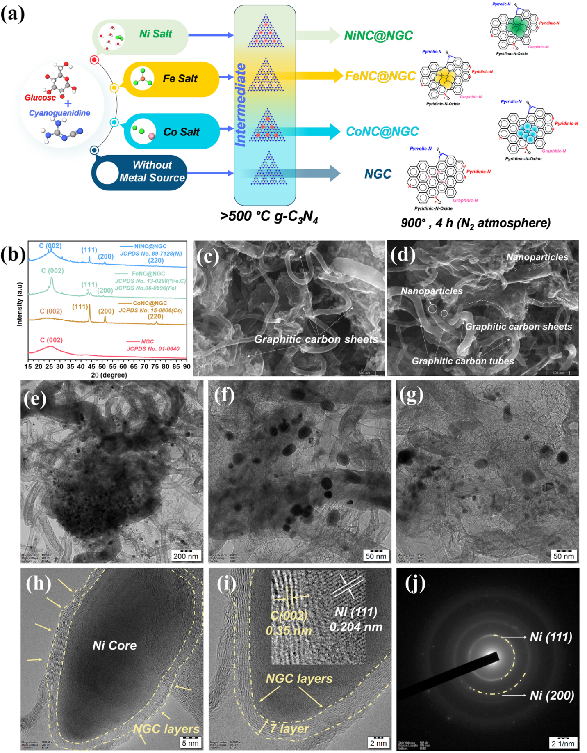
Figure S35: (a) schematic illustration for the synthesis of NiNC@NGC, CoNC@NGC, FeNC@NGC, and NGC, (b) PXRD of the different synthesized catalysts, (c, d) FESEM images of the NiNC@NGC, (e, f, g) TEM image of the as synthesized NiNC@NGC, (h) HRTEM image of NiNC@NGC, (i) HRTEM image showing the Ni nanocluster is wrapped by 7-10 layers of NGC layers, (j) corresponding SAED pattern of NiNC@NGC.
Figure S36. Deconvoluted high-resolution XPS spectra of NiNC@NGC catalyst (a) Ni 2p, (b) N 1s, (c) C 1s, Deconvoluted high-resolution XPS spectra of CoNC@NGC catalyst (d) Co 2p, (e) N 1s, (f) C 1s, Deconvoluted high-resolution XPS spectra of FeNC@NGC catalyst(g) Fe 2p, (h) N 1s, (i) C 1s.

Figure S37: XPS survey spectrum of four different synthesized catalysts.

Figure S38: Deconvoluted high-resolution XPS spectra of NGC (a) C 1s, (b) N1s, (c) O 1s.

Figure S39: Deconvoluted high-resolution O 1s XPS spectra of NGC (a) NiNC@NGC, (b) CoNC@NGC, and (c) FeNC@NGC.
Figure S40: LSV polarization curve of different catalysts (solid line represents the curve with 100% iR correction, and dotted line represents the LSV curve without iR correction).
Figure S41: OER polarization curve of commercial RuO₂ catalyst in 1 M KOH at 1600 rpm.

(a)
(b)
(c)
(d)
Figure S42: Fitted Nyquist plot (inset: equivalent circuit model) of different catalysts, (a) NiNC@NGC, (b) CoNC@NGC, (c) FeNC@NGC, and (d) NGC.

(a)
(b)
(c)
Figure S43: CV curve in non-faradaic region of three catalyst in 1M KOH electrolyte at 1600 rpm, (a) NiNC@NGC, (b) CoNC@NGC, and (c) FeNC@NGC.

Table S10: OER EIS fitting parameters of different catalysts.
Catalyst | R1(Ω) | CPE1-T | CPE1-P | R2(Ω)
NiNC@NGC | 8.843 | 4.48E-5 | 0.834 | 42.3
CoNC@NGC | 7.14 | 1.9E-5 | 0.908 | 115.3
FeNC@NGC | 7.535 | 2.47E-5 | 0.86 | 372
NGC | 6.96 | 8.96E-5 | 0.78 | 800

References
1. Kapse, S., Janwari, S., Waghmare, U. V. & Thapa, R. Energy parameter and electronic descriptor for carbon based catalyst predicted using QM/ML. Appl. Catal. B Environ. 286, 119866 (2021).
2. Atkins, P. W., Paula, J. D. & Keeler, J. Atkins’ Physical Chemistry. (Oxford University Press, 2023).
3. Li, Y. et al. Implanting Ru nanoclusters into N-doped graphene for efficient alkaline hydrogen evolution. Carbon 183, 362–367 (2021).
4. Kerschbaumer, A. et al. How to use a rotating ring-disc electrode (RRDE) subtraction method to investigate the electrocatalytic oxygen reduction reaction? https://doi.org/10.1039/D2CY01744J (2023) doi:10.1039/D2CY01744J.

