Epigenome-wide DNA methylation signatures associated with combined hormonal contraceptive use

Mirac Nur Musaoglu, Lea Zillich, Susanne Edelmann, Erika Comasco, Birgit Derntl, Ann-Christin S. Kimmig* and Vanessa Nieratschker*

Supplementary Figures

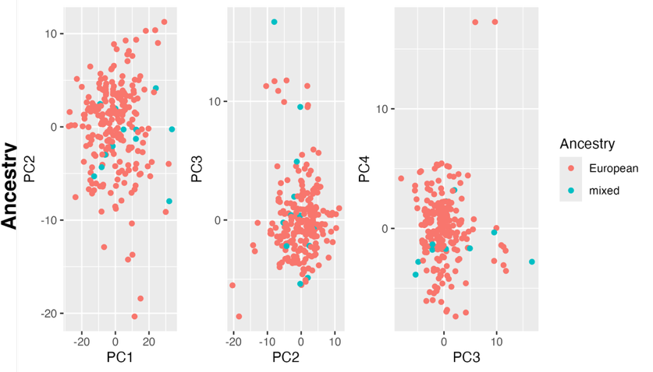
Supplementary Figure 1: Principal component analysis of genome-wide DNA methylation profiles compared to ancestry.
Scatterplots show the first four principal components (PC1–PC4), calculated from the epigenome-wide DNA methylation data. Samples are colored according to self-report ancestry group (European or mixed European), revealing no clear clustering by ancestry. This suggested that ancestry-related population structure did not substantially contribute to variation in DNA methylation levels.

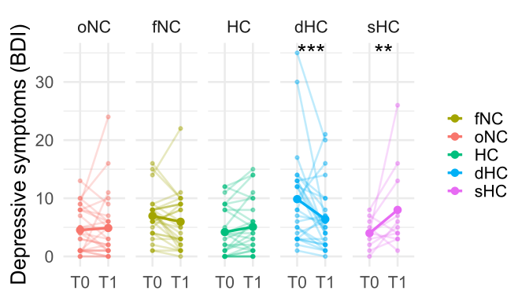
Supplementary Figure 2: Depressive symptoms across five hormonal states
The figure shows depressive symptoms measured by BDI-II at baseline and follow-up across different hormonal groups. Each point represents the total BDI score for one participant at a given time point, with thin lines connecting repeated measurements from the same participant. Large points indicate group-level means at each time point. oNC: participants at periovulatory phase, fNC: participants at follicular phase, HC: long-term combined hormonal contraceptive users, dHC: discontinuers, sHC: staters. T0: baseline and T1: follow-up measurement. Asterisk indicates significant changes in depressive symptoms within groups from T0 to T1. *** p< 0.001 and ** p<0.01 based on uncorrected p-values.

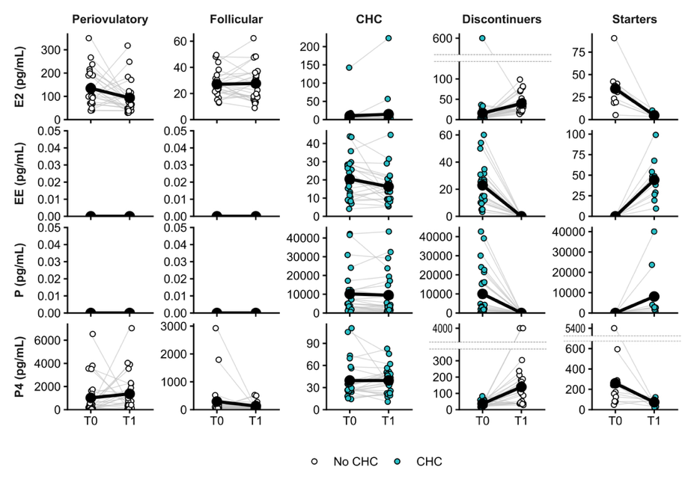
Supplementary Figure 3: Endogenous and exogenous sex hormone concentrations across different hormonal groups.
Individual hormone concentrations are shown at baseline (T0) and follow-up (T1) across five hormonal profile groups: periovulatory, early follicular, combined hormonal contraceptive users (CHC), discontinuers, and starters. Each point represents one participant at a given time point, and thin grey lines connect repeated measurements within participants. Large black points and lines indicate group means over time. Point fill indicates CHC intake status at the respective time point. Dashed horizontal lines denote axis breaks introduced for the visualization of panels with extreme values. E2 = estradiol; EE = ethinyl estradiol; P = progestin; P4 = progesterone; CHC = combined hormonal contraceptive.

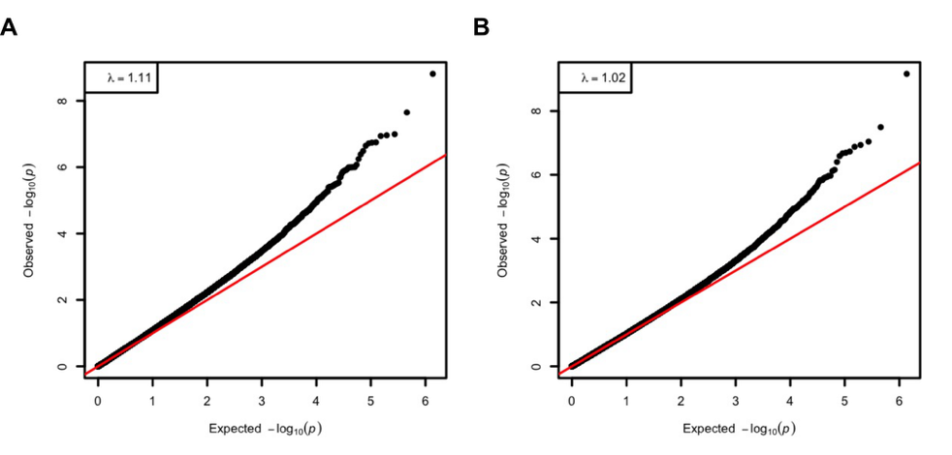
Supplementary Figure 4: Quantile-quantile plot of genomic inflation in epigenome-wide DNA methylation related to current CHC-use
Quantile-quantile plot showing a deviation in the tail A. before (λ = 1.11) and B. after Bacon correction (λ = 1.02) with acceptable genomic inflation.

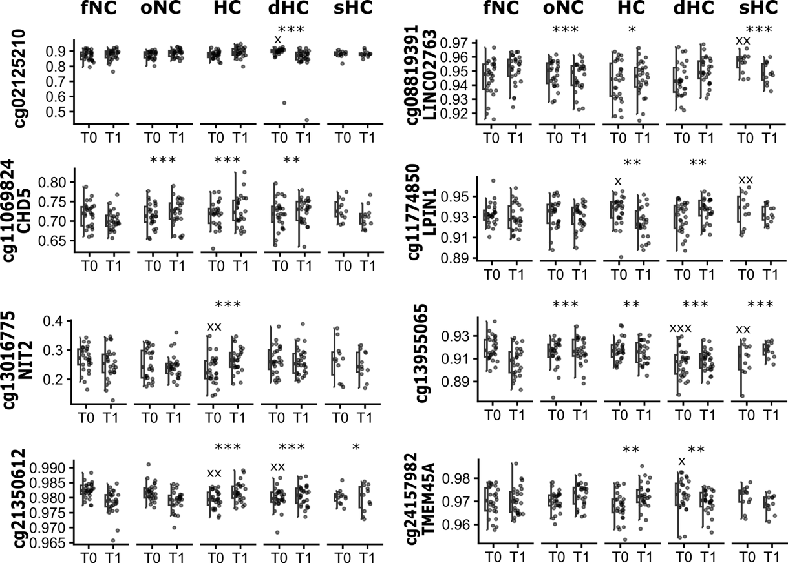

Supplementary Figure 5: Differentially methylated probes associated with hormonal group trajectories.

Boxplots show the distribution of methylation levels within each group at baseline and follow-up for 8 other DMPs associated with hormonal group and time interaction. x indicates a significant baseline difference compared with the follicular-phase naturally cycling (fNC) group, whereas * indicates a significant difference in the change in methylation levels over time relative to the fNC group. ^{x}p < 0.05, ^{xx}p < 0.01, ^{xxx}p < 0.001, *p < 005, **p < 0.01, ***p < 0.001

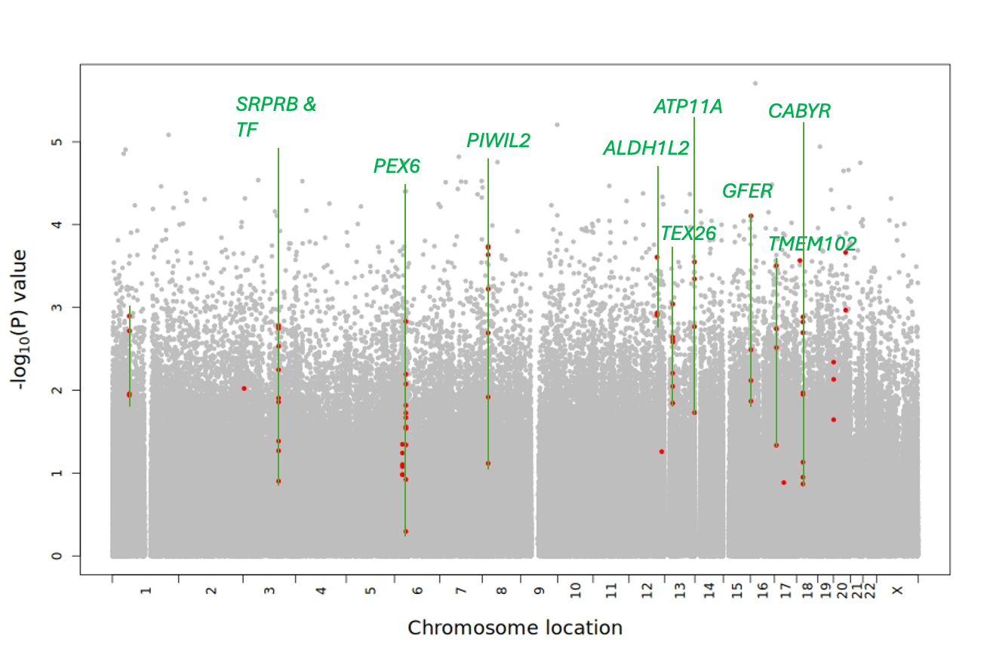
Supplementary Figure 6: Baseline differentially methylated regions across fNC, oNC and HC.
The baseline group differences were associated with 10 DMRs. Green lines outline the neighboring probes constituting each DMR (after filtering), and annotated genes are indicated. ALDH1L2: Aldehyde dehydrogenase 1 family member L2. ATP11A: ATPase phospholipid transporting 11A. CABYR: Calcium binding tyrosine phosphorylation regulated. GFER: Growth factor, augmenter of liver regeneration. GNMT: Glycine N-methyltransferase. PIWIL2: Piwi-like RNA-mediated gene silencing 2. SRPRB: SRP receptor subunit beta. TEX26: Testis-Expressed Protein 26. TF: Transferrin. TMEM102: Transmembrane protein 102.

