Supporting information

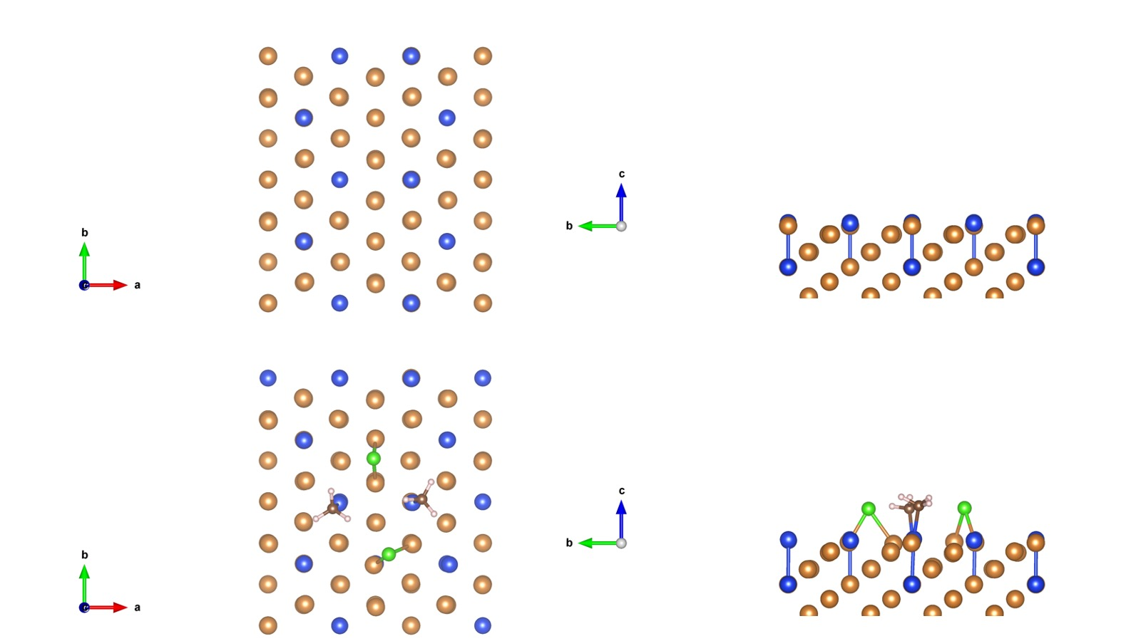
Figure S1. Ball and stick visualization of before adsorption (top) and after adsorption (bottom).

