Supplementary Figures for:
Seasonal variations affect the ecosystem functioning and microbial assembly processes in plantation forests
Min Wang†, Abolfazl Masoudi†, Can Wang, Liqiang Zhao, Jia Yang, Zhijun Yu*, Jingze Liu*
Hebei Key Laboratory of Animal Physiology, Biochemistry and Molecular Biology, Ministry of Education Key Laboratory of Molecular and Cellular Biology, College of Life Sciences, Hebei Normal University, Shijiazhuang, Hebei 050024, P. R. China
Email address:
Min Wang: wangmin0811@stu.hebtu.edu.cn
Abolfazl Masoudi: abolfazl.masoudi@hebtu.edu.cn
Can Wang: wangcan@stu.hebtu.edu.cn
Liqian Zhao: zhaoliqiang123@163.com
Jia yang: yangjia9011@163.com
Zhijun Yu: yuzhijun@hebtu.edu.cn
Jingze Liu: liujingze@hebtu.edu.cn
Address: College of Life Sciences, Hebei Normal University, 20 Nanerhuan East Road, Shijiazhuang, Hebei Province, China
*Corresponding Author: Tel/fax: +86 311 80787519, yuzhijun@hebtu.edu.cn (ZY), liujingze@hebtu.edu.cn (JL)
† These authors contributed equally

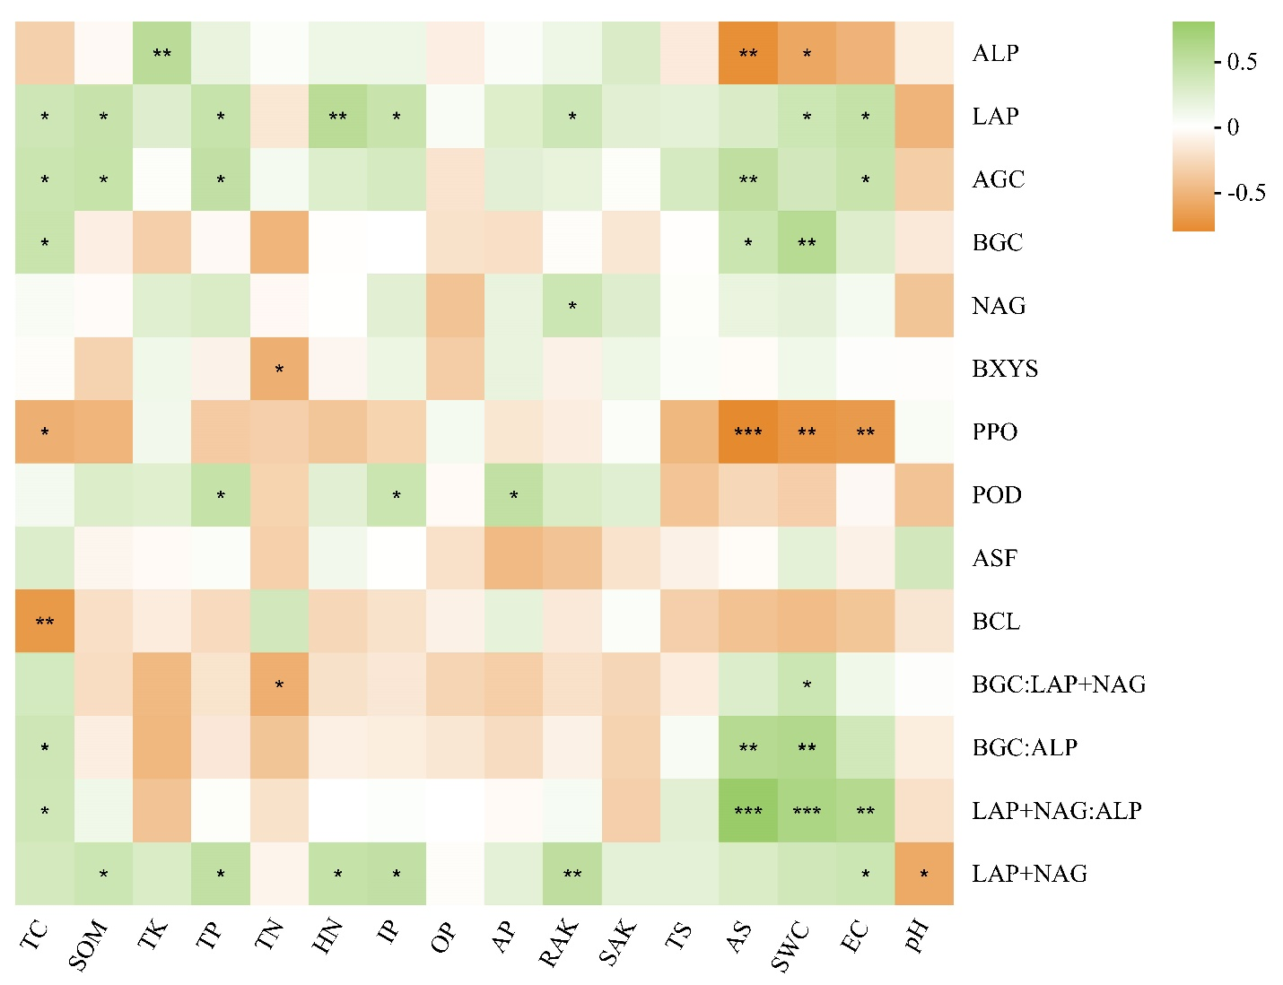

Supplementary Figure 1:
Associations (Spearman's P) between the relative abundances of edaphic parameters and ecoenzymatic activities (EEAs) and stoichiometry (EES). The correlation coefficients ranging from negative to positive are indicated by color intensity changing from light orange to light green, as shown by the figure scale. * P < 0.05, **P < 0.01, ***P < 0.001. The results showed that a negative association of soil pH with LAP + NAG. In addition, the result could clearly show the significant and positive association between soil moisture and C:P, N:P, and C: N ratios (P < 0.05).

Abbreviations:
SWC, Soil water content; TC, total carbon; EC, soil electrical conductivity, SOM, soil organic matter, TK, total potassium, RAK, rapidly available potassium, SAK, slow-available potassium, TP, total phosphorus, TN, total nitrogen, HN, soil hydrolyzed nitrogen, IP, inorganic phosphorus; OP, organic phosphorus, AP, available phosphorus, TS, total sulfur; AS, available sulfur; BGC, β-Glucosidase; BXYS, β- xylosidase; BCL, β-cellobiosidase; LAP, Leucine Aminopeptidase; AGC, ɑ-Glucosidase; NAG, N-acetyl-β-D-glucosidase; ALP, Alkaline phosphatase; ASF, Arylsulfatase; PPO, Polyphenol oxidase; POD, Peroxidase; EEA, ecoenzymatic activity; EES: ecoenzymatic stoichiometry

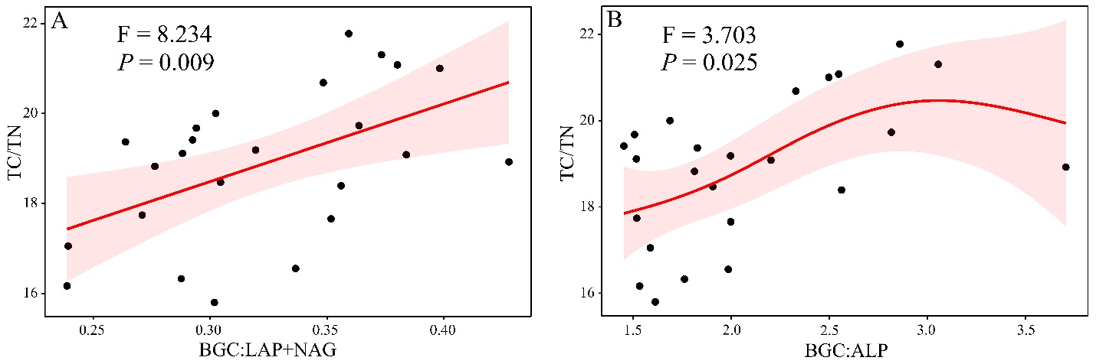
Supplementary Figure 2:
Relationship between ecoenzymatic activities (EEAs) and stoichiometry (EES) with soil properties evaluated using a generalized additive model. Among all, the association of TC/TN with BGC: LAP+NAG (C: N) (A) and BGC: ALP (C:P) (B) was statistically significant, which are presented. Non-significant associations were not included in this picture.

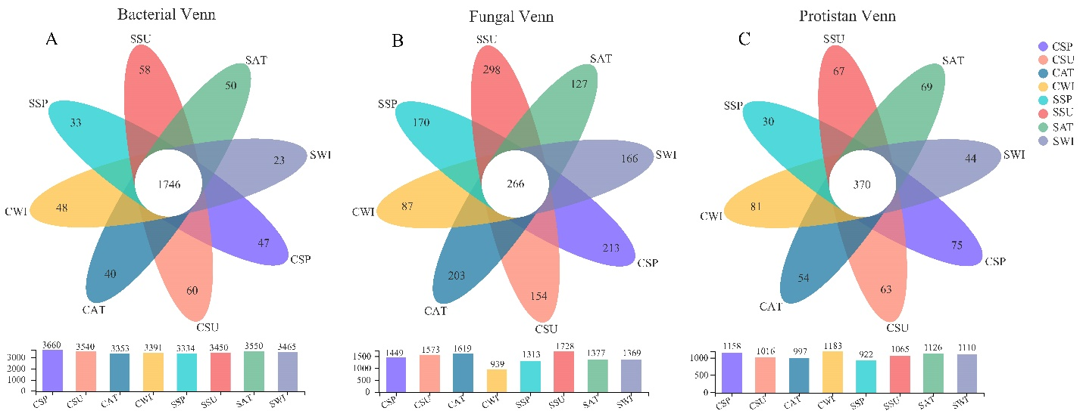

Supplementary Figure 3:
Venn diagram presenting the number of share and unique OTUs in different plantation types with four distinct seasons. (A) bacterial Venn, (B) fungal Venn, and (C) protistan Venn. The highest number of unique bacterial and fungal OTUs were detected at the Chinese scholar tree in summer (SSU), whereas the highest number of unique protistan OTUs was detected at the Chinese pine tree plot in winter (CWI). Interestingly, the lowest number of bacterial, fungal, and protistan OTUs were observed in winter, in which the Chinese pine plot was composed of the lowest fungal OTUs. In contrast, the Chinese scholar tree plot contained the lowest number of bacterial and protistan OTUs. The fungal Venn diagram revealed that SSU samples yielded the maximum number of unique OTUs (298 OTUs), whereas the minimum number of unique OTUs (87 OTUs) was from CWI samples. The core fungal community was 266 OTUs in all soil samples. The number of OTU appeared the minimum value in CWI samples, but the maximum value was found in SSU samples. These results might indicate that plantation types as an essential factor to shape microbial lineages in soils with seasonal transitions. Abbreviations: C (Chinese pine tree plot), S (Chinese scholar tree plot), SP (spring), SU (summer), AT (autumn), and WI (winter).

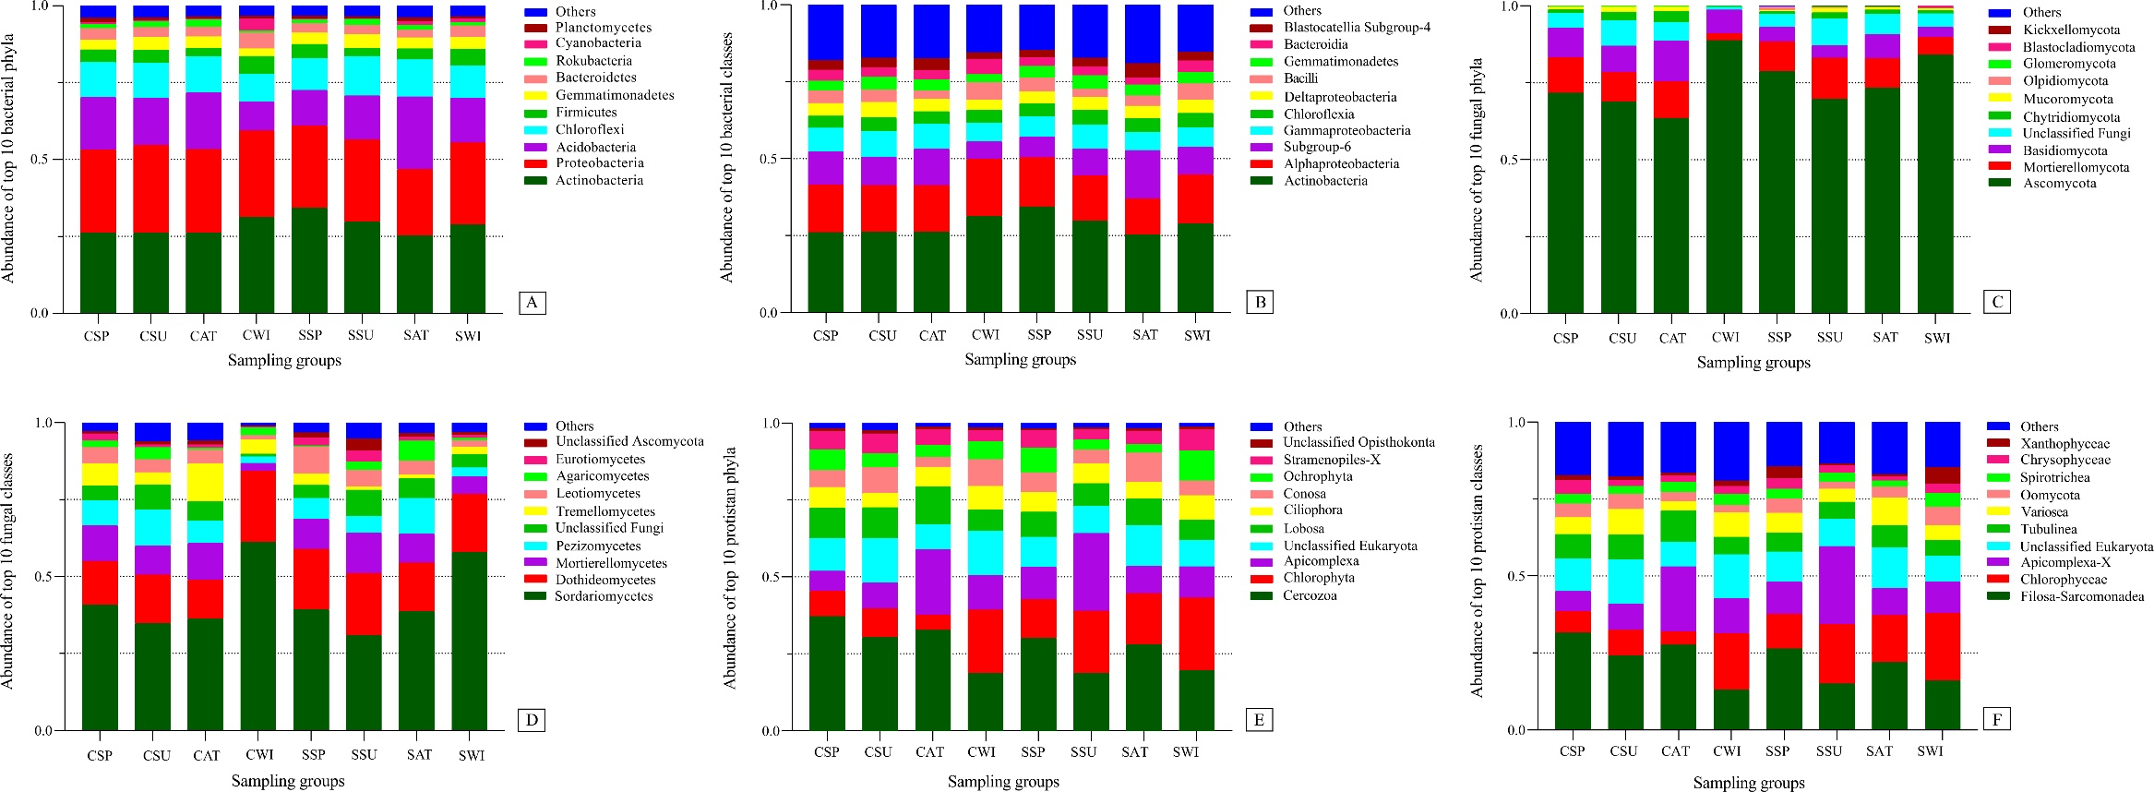
Supplementary Figure 4:
Detection of the top 10 dominant microbial phyla and classes by 16S rRNA (bacteria A, B), ITS1 (fungi C, D), and 18S rRNA (protists E, F). Abbreviations: C (P. tabulaeformis), S (S. japonica), SP (spring), SU (summer), AT (autumn), and WI (winter).
The abundance of ectomycorrhizal (ECM) fungi (and thus the Basidiomycota) showed seasonal variations, in which its abundance was dropped in winter for both plant species. We realized that the relative abundance of ectomycorrhizal (ECM) fungi was higher than mycorrhizal (AM) fungi at both experimental plots. Interestingly, the relative abundance of both fungal groups was more elevated in autumn. Surprisingly, the difference in abundance of ECM fungi decreased for both plant species from spring to summer (CP: 12.33%, CS: 15.95%).
Abbreviations: C (Chinese pine tree plot), S (Chinese scholar tree plot), SP (spring), SU (summer), AT (autumn), and WI (winter).

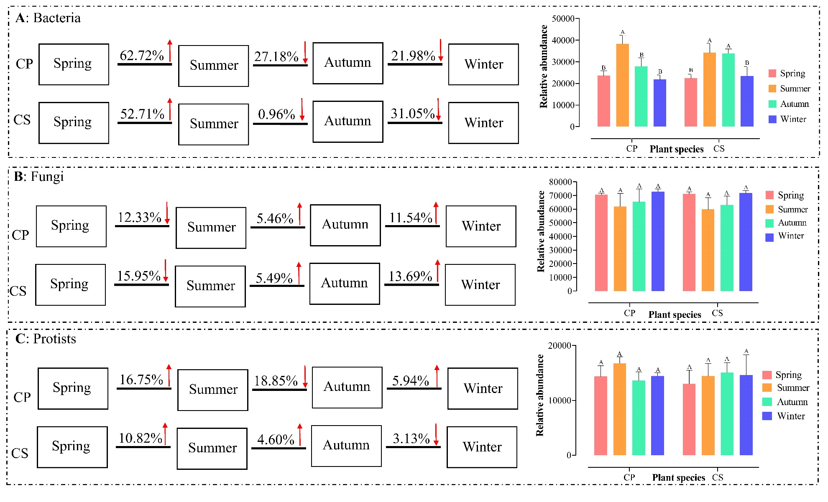
Supplementary Figure 5:
Seasonal trends of microbial communities based on the relative abundance of microbial genera. The results showed that the relative abundance of bacterial and protists genera increased with the transition from spring to summer. The significant increase of bacterial genera as prey might be a good reason for increasing the relative abundance of protist genera as predators. Seasonal transition from summer to autumn decreased the relative abundance of bacterial genera significantly, whereas the relative abundance of fungal genera was increased non-significantly. The relative abundance of protist genera showed a different trend in which the relative abundance of protist lineages decreased with changing the season from summer to autumn. In contrast, the relative abundance of protist genera increased with the season's transition from summer to autumn.
Remarkably, the relative abundance of bacterial and fungal genera showed totally different trends with changing the season from autumn to winter. Bacterial abundance was decreased, whereas fungal abundance increased in the cold season. The abundance of protist genera increased at the Chinese pine tree plot, whereas their abundance decreased at the Chinese scholar tree plot. Taken together, our result showed that the relative abundance of bacterial genera was significantly fluctuated with seasonal transition compared with the relative abundance of fungal and protist genera. Also, the relative abundance of bacterial genera was highest in the warmer season compared to colder seasons. The data represent the means of three replicates with standard errors. Significant differences (t-test, P_{adjust} < 0.05) among different seasons and plantations are labeled with different letters.
Abbreviations: CP (Chinese pine tree plot), CS (Chinese scholar tree plot).

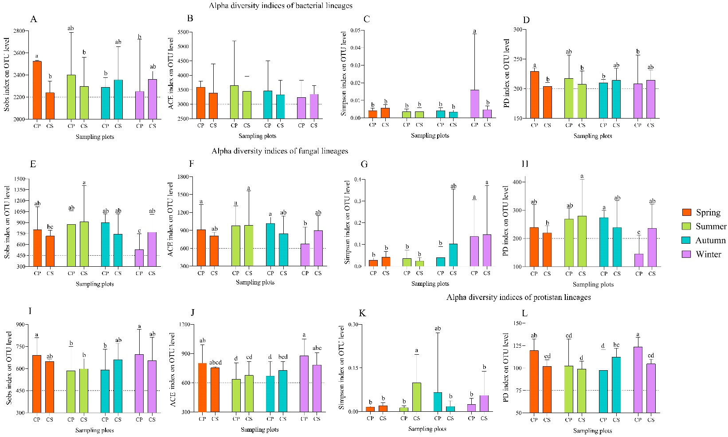
Supplementary Figure 6:
Microbial α-diversity indices for bacterial lineages (A, B, C, and D), fungal lineages (E, F, G, and H), and protistan lineages (I, J, K, and L).
Abbreviations: Sob (observed species), ACE (abundance-based coverage estimator, non-parametric method based on abundance), Simpson index and phylogenetic diversity index (PD), C (Chinese pine tree plot), S (Chinese scholar tree plot), SP (spring), SU (summer), AT (autumn), and WI (winter).

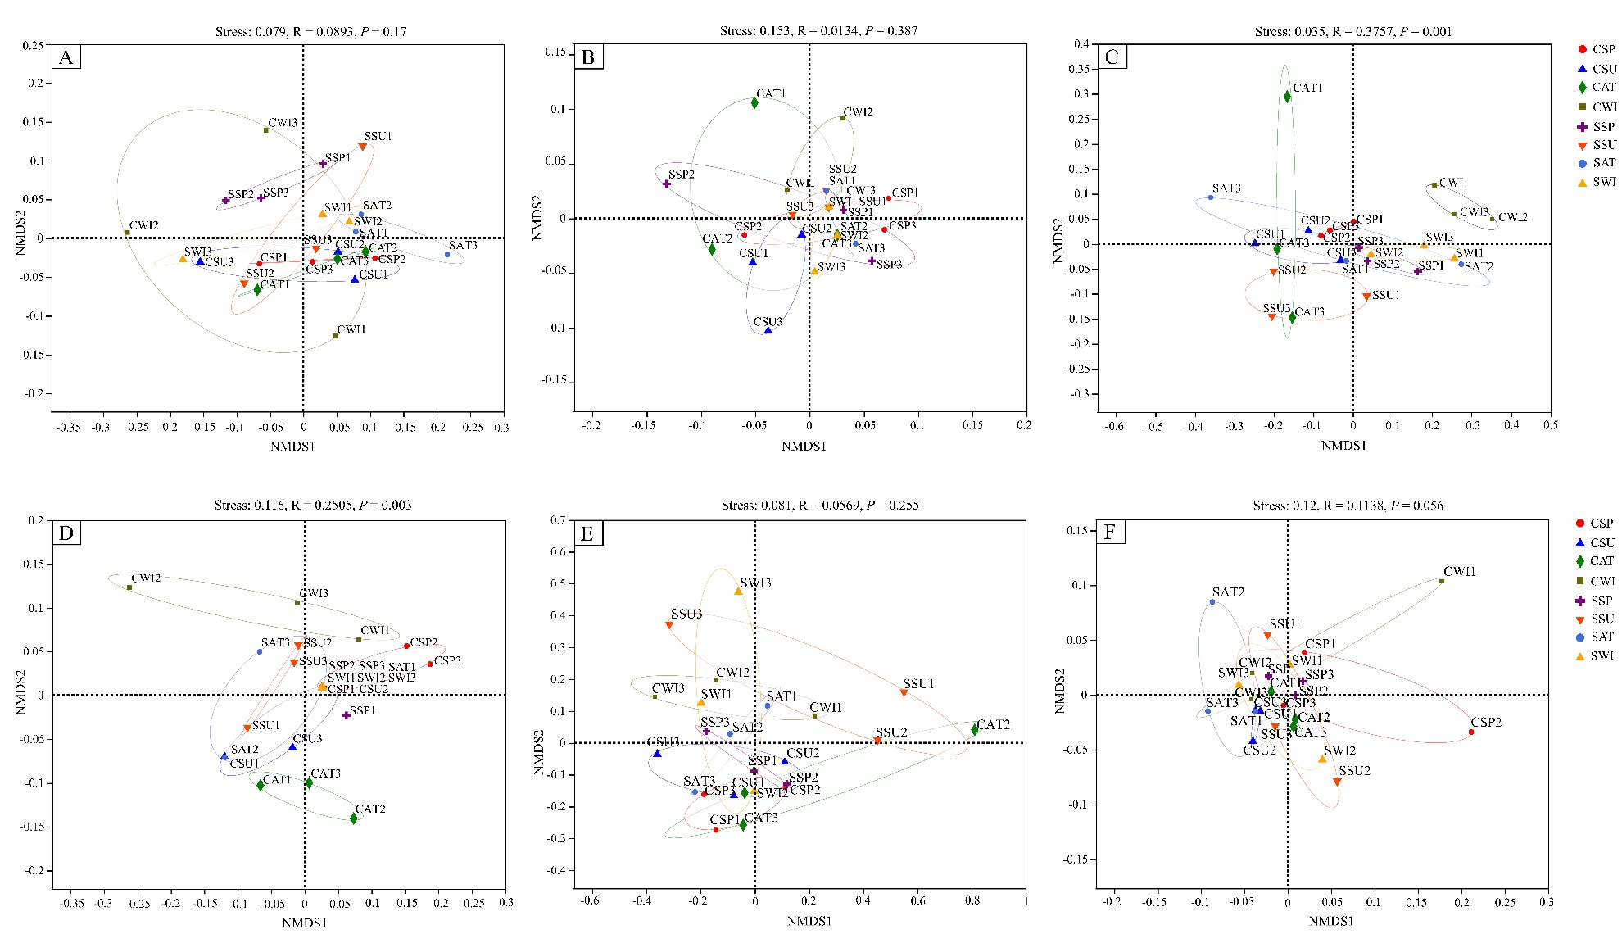
Supplementary Figure 7:
Non-metric multidimensional scaling (NMDS) plot for different seasons and plant species. (A) bacterial NMDS plot based on the weighted UniFrac, (B) bacterial NMDS plot based on the unweighted UniFrac, (C) fungal NMDS plot based on the weighted UniFrac, (D) fungal NMDS plot based on the unweighted UniFrac, (E) protists NMDS plot based on the weighted UniFrac, and (F) protists NMDS plot based on the unweighted UniFrac. The samples were clustered by seasons and plant species and represented with different colors. The ellipses represent the centroid's standard error for each group of soil samples with a confident limit of 95%.
Abbreviations: C (Chinese pine tree plot), S (Chinese scholar tree plot), SP (spring), SU (summer), AT (autumn), and WI (winter).

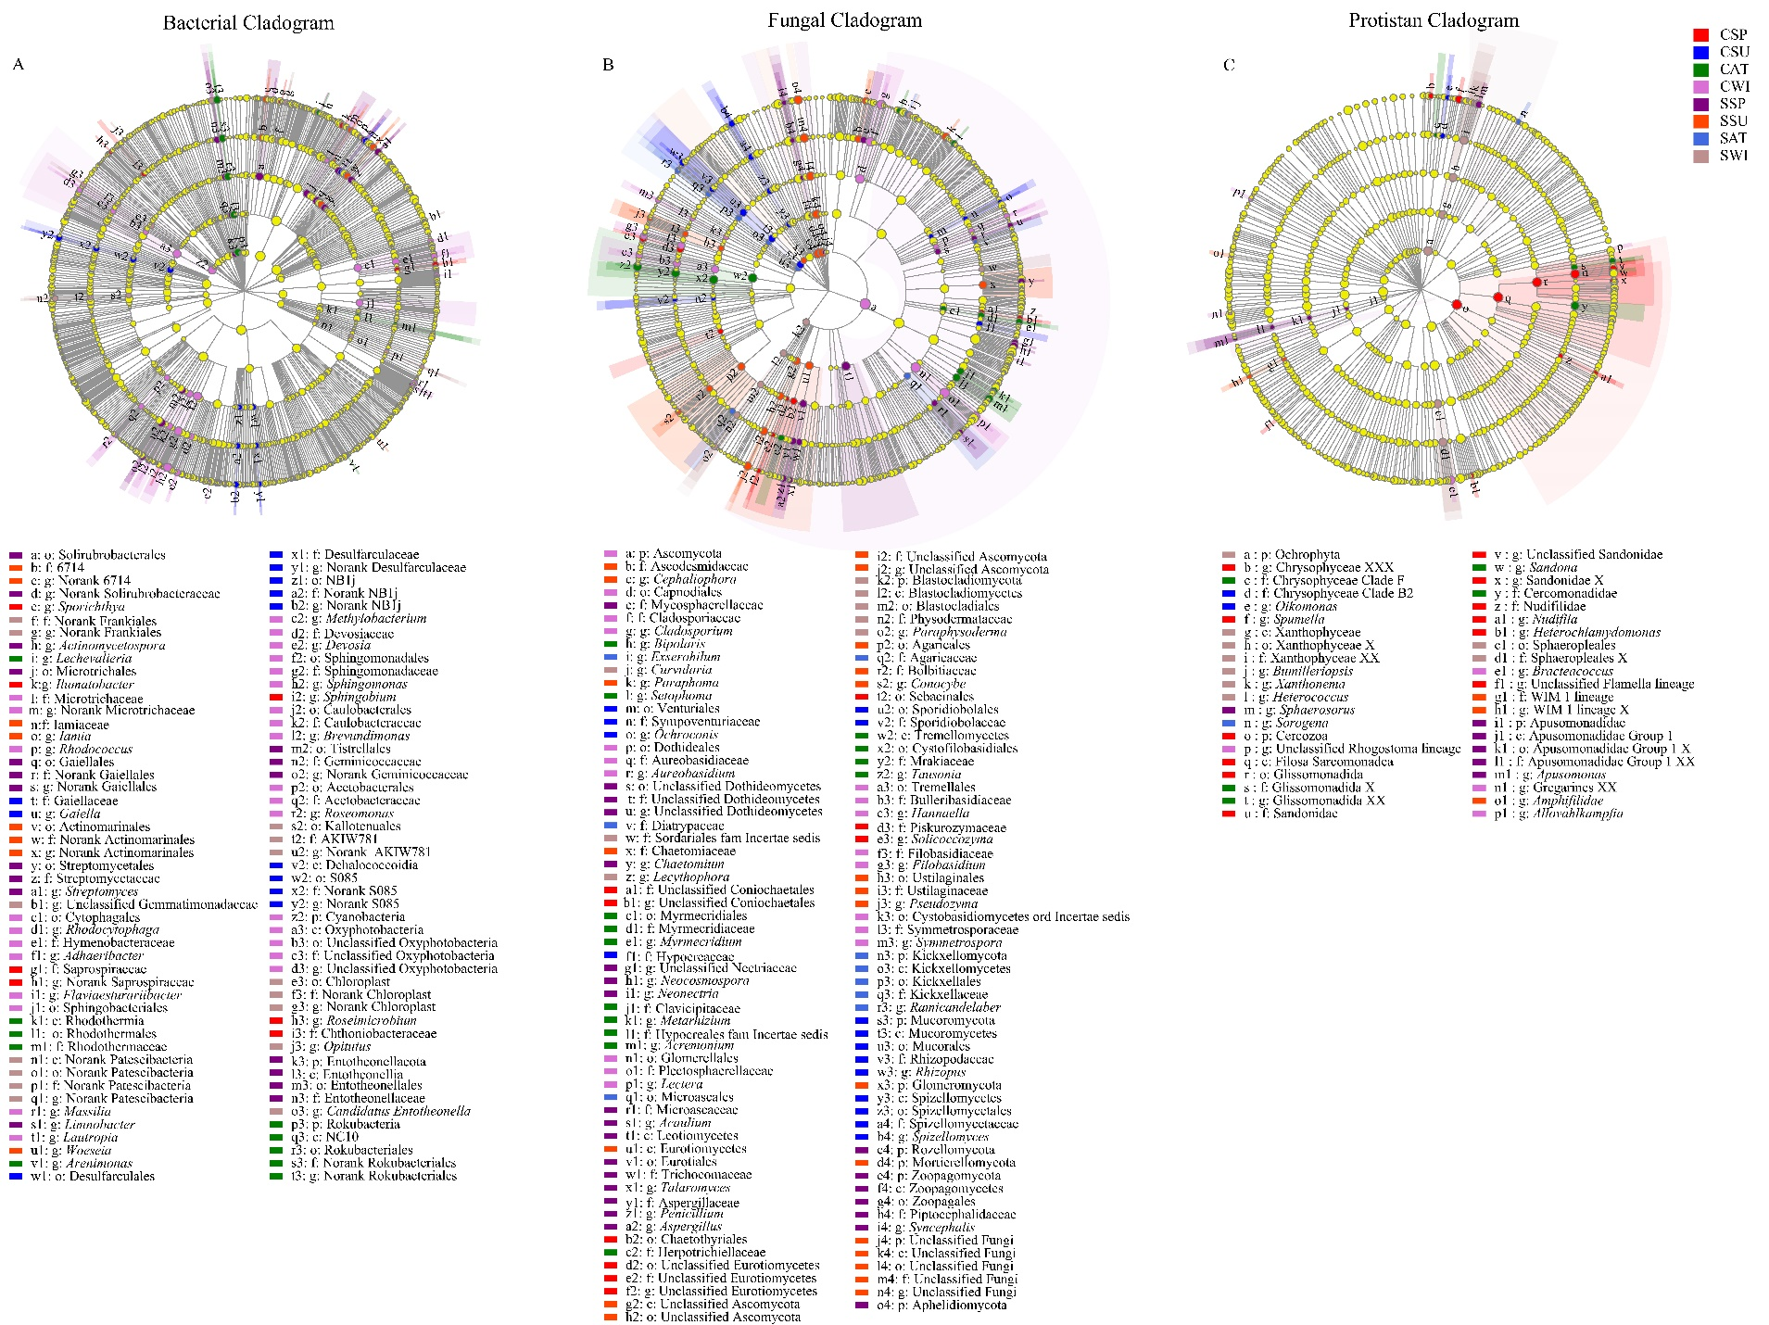
Supplementary Figure 8:
Differentially abundant microbial groups (based on LEfSe) were observed in response to different plantation types and distinct seasons with relative abundances of greater than 1% of the entire communities. Cladogram plotted from LEfSe analysis shows the taxonomic levels represented by rings with phyla in the innermost ring and genera in the outermost ring. Each circle is a member within that level. Those taxa in each level are colored by different plantation types and various seasons for which it is more abundant (P < 0.05; LDA score 4.0). The cladogram showed interesting results. For instance, considering the CP plot, the abundance of the Mucoromycotina fungal symbiosis phylum was high in summer, which recently highlighted that this group forms an intimate symbiosis with liverworts as well (Rimington et al., 2019). Considering insect-associated fungi, Metarhizum, which is newly recognized as a plant symbiont with the capability of transferring insect nitrogen to plant (Behie et al., 2017), was detected as a biomarker in autumn at the CP plot. Considering the CS plot, Glomeromycota (most arbuscular fungi are categorized in this phylum) was recognized as a biomarker in summer. Considering bacterial taxa in the CP plot, the highest number of biomarkers was recorded in winter, in which the vital group of Cyanobacteria was included.
Abbreviations: C (Chinese pine tree plot), S (Chinese scholar tree plot), SP (spring), SU (summer), AT (autumn), and WI (winter).

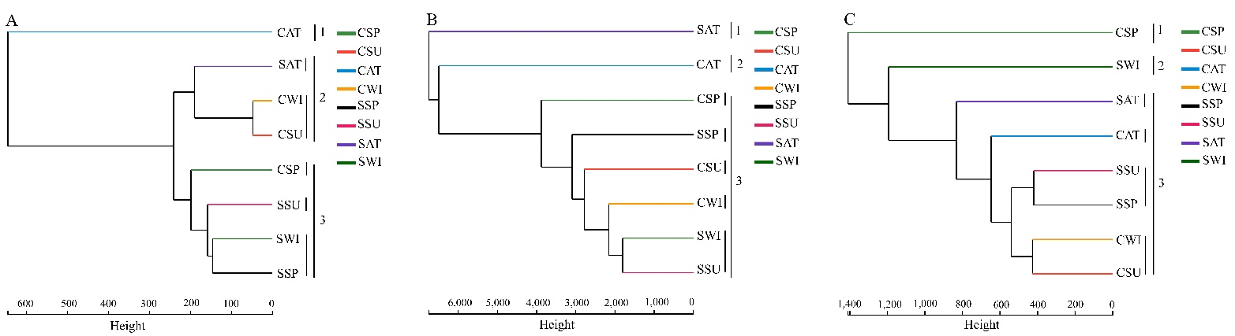
Supplementary Figure 9:
Comparison of soil microbial community clustering from different plantation types and seasons using hierarchical clustering analysis (UPGMA using the Bray-Curtis dissimilarities). (A) bacterial, (B) fungal, and (C) protists hierarchical clustering.
Abbreviations: C (Chinese pine tree plot), S (Chinese scholar tree plot), SP (spring), SU (summer), AT (autumn), and WI (winter).

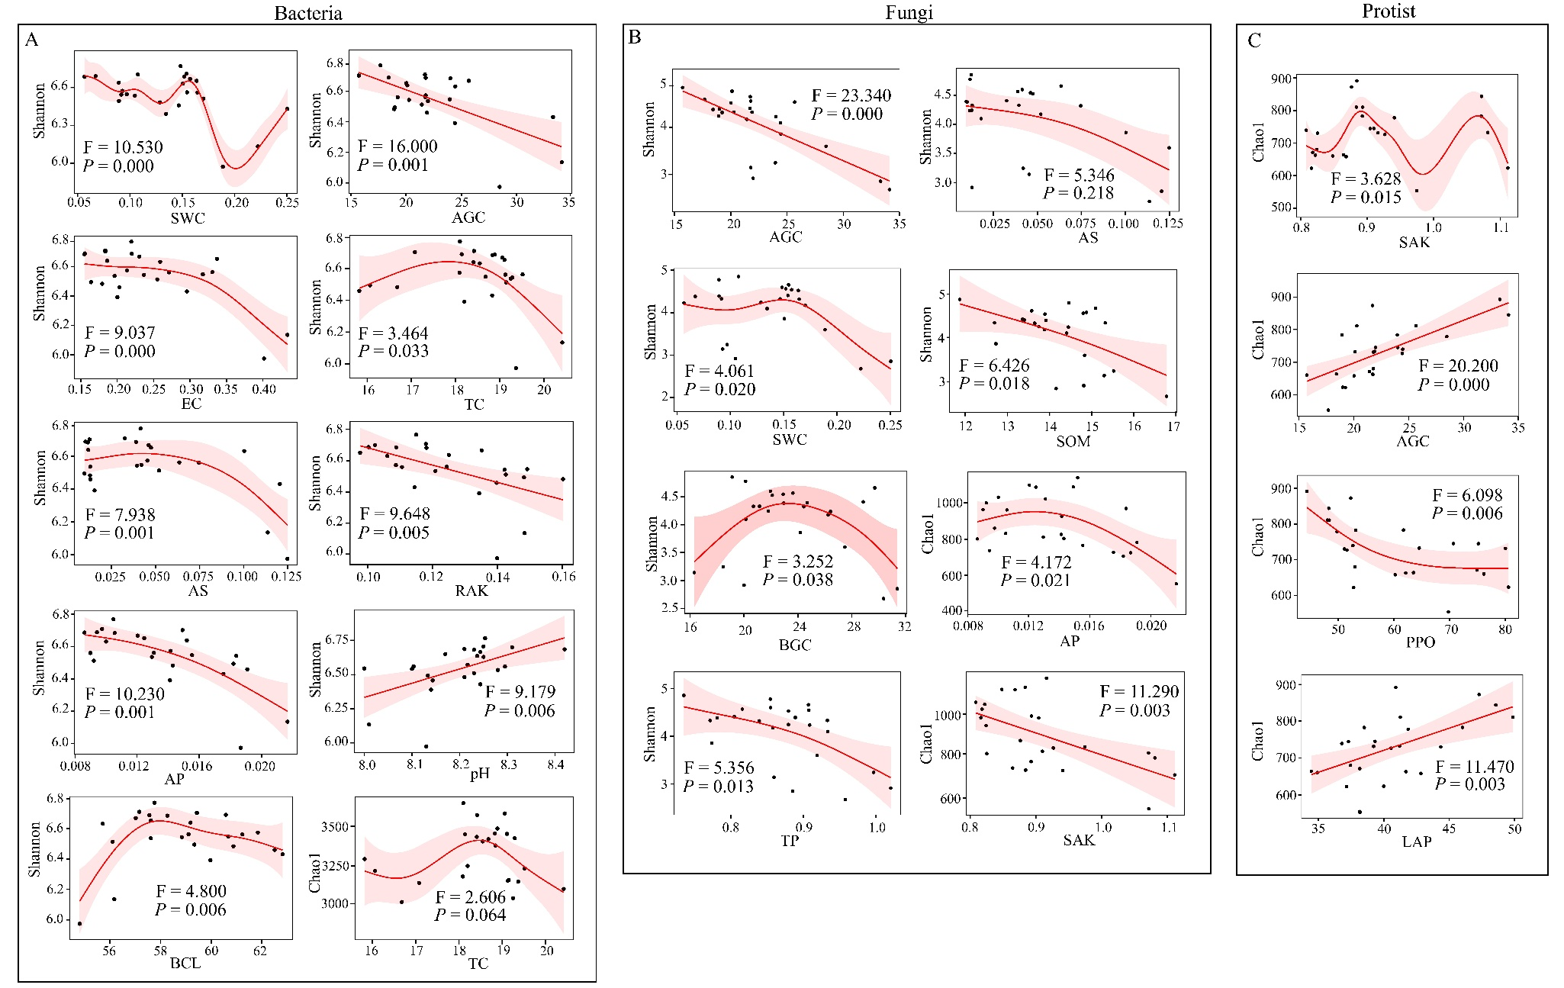
Supplementary Figure 10:
The generalized additive model finds a significant association between microbial richness (Chao1), and microbial diversity (Shannon) with edaphic parameters and enzymes activities. (A) All the possible and significant associations of bacterial richness and diversity with edaphic parameters and enzyme activities. (B) All the potential and significant association of fungal richness and diversity with edaphic parameters and enzyme activities. (C) All the possible and significant associations of protists richness and diversity with edaphic parameters and enzyme activities. The results showed that the highest bacterial Shannon diversity was observed at the lower concentration of soil parameters like SWC, AGC, EC, AS, RAK, AP, and BCL. The highest bacterial Shannon diversity peaked at the alkaline level (pH = 8.4). We realized that TC had the same impact on the bacterial Shannon diversity and Chao1 richness, which peaked in the middle concentration of TC. The highest fungal Shannon diversity was recorded at the lower concentration of AGC, AS, SOM, and TP, whereas this index peaked at the middle value of soil moisture (SWC). The fungal richness peaked at the lower concentration of AP and SAK. None of the soil factors were showed a significant effect on the protists' Shannon diversity, whereas protists richness showed opposite trends. The richness of Protists peaks in high concentrations of LAP and AGC (N-cycling enzymes), whereas its richness peaks in the lower concentration of the PPO enzyme. Moreover, GAM results indicated the positive association of protists' richness with hydrolase enzymes like those that were related to N-cycling enzymes (LAP and ALP enzymes), whereas high protists richness was observed at a low concentration of polyphenol oxidase (PPO). PPO is an effective enzyme to degrade lignin as a significant component of SOM (Sinsabaugh, 2010). Thus, it seems that the high richness of protists can be observed at the high level of SOM. Our results verified the spatiotemporal variation of soil phenol oxidase and peroxidase activities. Some studies showed that the activity of these two enzymes either become undetectable or dipped in summer (Criquet et al., 2000; Sinsabaugh et al., 2005; Finzi et al., 2006; Weintraub et al., 2007), probably as a result of changes in carbon availability (Sinsabaugh, 2010) or moisture limitation (Toberman et al., 2008). Another group of studies found no significant seasonal variation (Sinsabaugh et al., 2003; Boerner et al., 2005; Kellner et al., 2009). Decker et al. (1999) showed Hydrolase activities generally correlated with soil organic matter (SOM) and nutrient availabilities, whereas phenol oxidase activity correlated with soil pH and was more challenging to model. As an interesting point of view, unlike bacterial and fungal richness, two hydrolytic enzymes of N-cycling enzymes (AGC and LAP) were positively correlated with four protist alpha diversity indices (Spearman correlation, P < 0.05) (Fig. 2). In line with this result, there was a negative association between bacterial (Fig. S10A) and fungal (Fig. S10B) Shannon diversities with the AGC concentration. In contrast, a positive association between the AGC concentration and protists richness was observed (Fig. S10C). Also, the GAM analysis showed the high protists richness in the low concentration of PPO, and the positive association between protists richness and the LAP concentration was recorded (Fig. S10C.
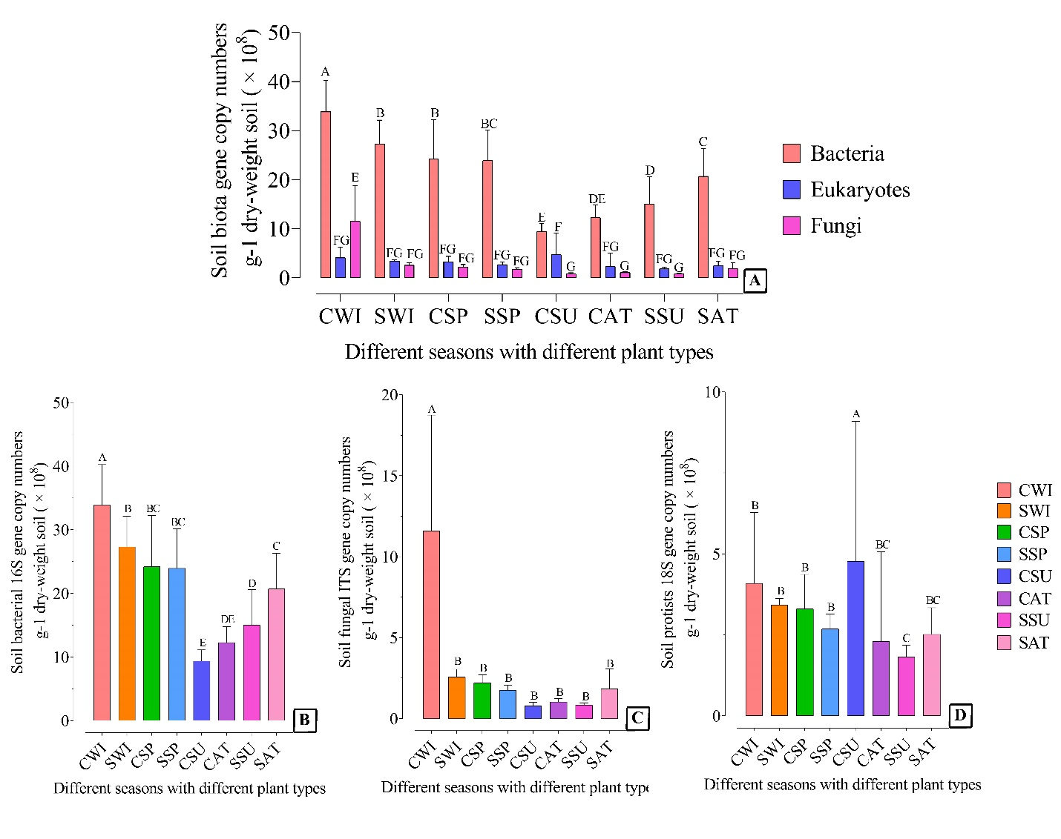
Supplementary Figure 11:
The abundance of soil biota in different plantation types and distinct seasons using real-time quantitative PCR. Interestingly, the highest gene copy numbers of bacteria were observed in winter and spring, whereas the bacterial gene copy numbers were significantly dropped in summer and in autumn (Fig. S11B). No significant difference was observed for fungal gene copy numbers for all samples except CWI samples (Fig. S11C). The gene copy number of soil protists was higher for CWI samples, whereas the gene copy number of soil protists was higher for CSU samples (Fig. S11D). Briefly, all reactions were carried out in three technical replicates for each soil replicate (In total, nine replicates for three soil samples of each experimental plot) to ensure accuracy. The reactions were prepared in a final volume of 20 μL contained one μL of template DNA, 0.8 μL of each primer (5 μM), 7.4 μL ddH₂O, and ten μL of 2x Taq™ Plus Master Mix (Vazyme Biotech Co., Ltd, Nanjing, China). Standard curves were constructed with a 10-fold serial dilution of perceived copy numbers of plasmids (pMD18-T, 2692 bp) containing 16S rRNA, ITS1, and 18S genes fragments, and they were linear from 7.66 × 10² to 7.66 10⁸ copies/μL (R² >0.99, E = 106.98%), 4.84 × 10³ to 4.84 × 10⁷ copies/μL (R² > 0.98, E = 98.44%), 5.60 × 10² to 5.60 × 10⁵ copies/μL (R² > 0.99, E = 109.93%), respectively.
Abbreviations: C (Chinese pine tree plot), S (Chinese scholar tree plot), SP (spring), SU (summer), AT (autumn), and WI (winter).

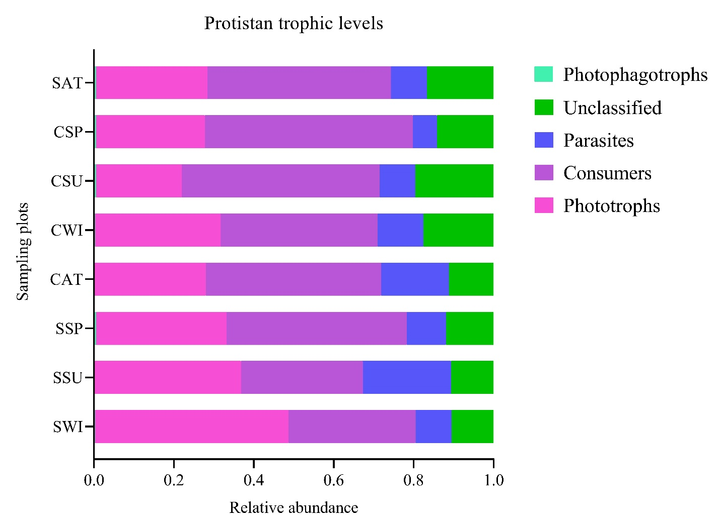
Supplementary Figure 12:
Life history strategy (photophagotrophs, parasites, consumers, and phototroph) of protistan lineages for each plantation types and distinct seasons. The major protistan lineages were assigned to their dominant mode of energy acquisition: either photophagotrophs, parasites, consumers, or phototroph.
Abbreviations: C (Chinese pine tree plot), S (Chinese scholar tree plot), SP (spring), SU (summer), AT (autumn), and WI (winter).

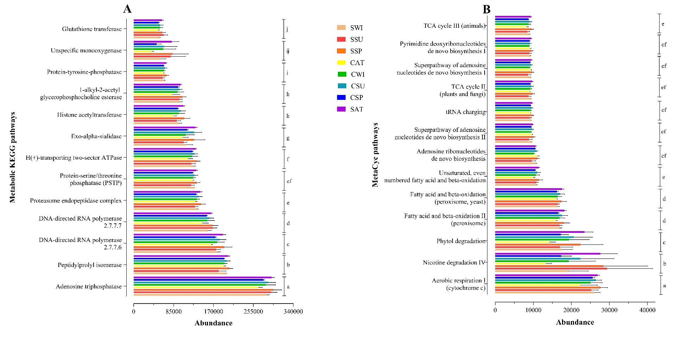

Supplementary Figure 13:
PICRUSt2 analysis predicted potential functional pathways of the top 13 metabolic KEGG pathways (A), and MetaCyc pathways (B). Comparison of significantly differentially abundant of metabolic KEGG pathways (F_{12, 103} = 479.5115, P < 0.0001) and MetaCyc pathways (F_{12, 103} = 83.2610, P < 0.0001) identified using different letters (Tukey HSD test, P < 0.05).

Abbreviations: C (Chinese pine tree plot), S (Chinese scholar tree plot), SP (spring), SU (summer), AT (autumn), and WI (winter).

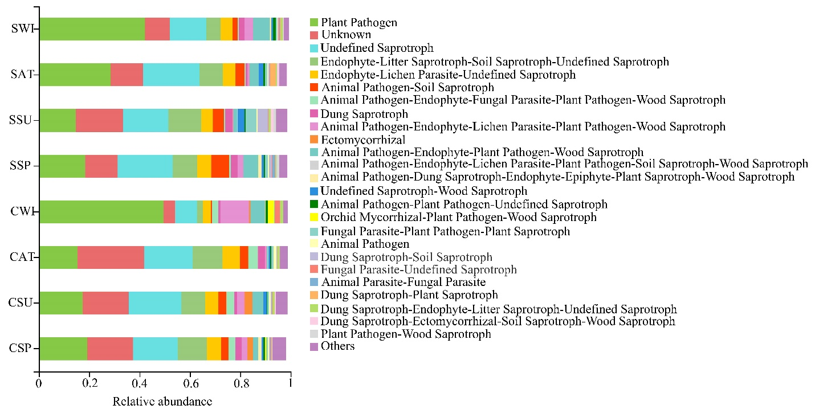

Supplementary Figure S14:
Frequency distribution of ecological guilds in soil fungi in different plantations and seasons. FUNGuild (Nguyen et al., 2016) was used to predict the functional and/or ecological guilds for fungal taxa (OTUs assigned to different guilds appear in each corresponding category). The bar plot shows the relative frequencies (number of OTUs) for each functional guild in each sampling plot for different seasons.
The results showed that the abundance of 'Arbuscular fungi' was higher at the CS plot than that of the CP plot. And, we realized that seasonal impact on the abundance of this group of fungi [SSU vs. CWI, P = 0.0026; SSU vs. CSU, P = 0.0036; SSU vs. CSP, P = 0.0085; SSU vs. SWI, P = 0.0103; SSU vs. SSP, P = 0.0105; SSU vs. SAT, P = 0.0339]. The frequency of the 'Ericoid Mycorrhizal' group was statistically differed among sampling sites (F_{7, 15} = 4.7392, P = 0.0220). The abundance of this group was higher at the CP plot compared with the CS plot in April. The results showed that the abundance of the 'Endophyte' group significantly differed among sampling sites (F_{7, 15} = 5.2228, P = 0.0166), and the high abundance of this group was recorded for SSU in July. For instance, the result showed that 'plant pathogen was the most abundant functional group, which was its abundance significantly differed among two plots (F_{7, 23} = 4.0589, P = 0.0097). The abundance of ‘Ectomycorrhizal’ taxa was the highest at the CP plot in spring and summer seasons compared with the CS plot [CSP vs. CWI, P = 0.0183; CSP vs. SAT, P = 0.0183; CSP vs. SSP, P = 0.0103; CSP vs. SSU, P = 0.0183; CSP vs. SWI, P = 0.0183; CSP vs. CAT, P = 0.0420]. As an interesting pattern, our result showed seasons impact the abundance of a certain fungal trophic group. For instance, the 'Symbiotroph' group's abundance was higher at the CP plot in April (CSP) and July (CSU). In fact, the frequency of this group increased in turning from April to January.
Abbreviations: C (Chinese pine tree plot), S (Chinese scholar tree plot), SP (spring), SU (summer), AT (autumn), and WI (winter).

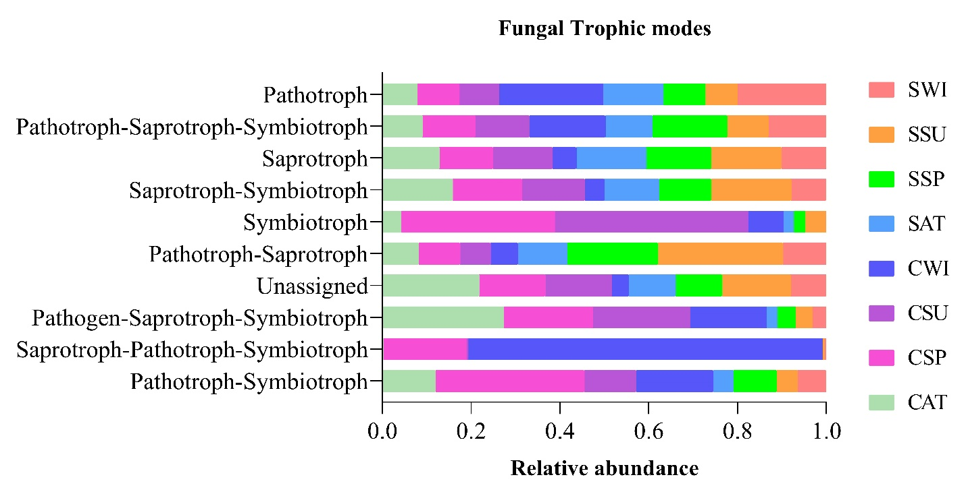
Supplementary Figure 15:
Fungal trophic mode from two different plantations with seasonal variations. The nine common fungal trophic modes (mean relative abundance >1%) were detected as well as unassigned categories. The results showed that the 'Symbiotroph' lifestyle dominated trophy in the CP plot in spring and summer. The named category of 'Pathotroph' tended to be relatively more abundant in the CP plot in winter, whereas 'Saprotroph' was found to be a high abundance in the CS plot in summer. Interestingly, the abundance of the 'Pathotroph-Saprotroph-Symbiotroph' category tended to be high in the CP plot in winter.

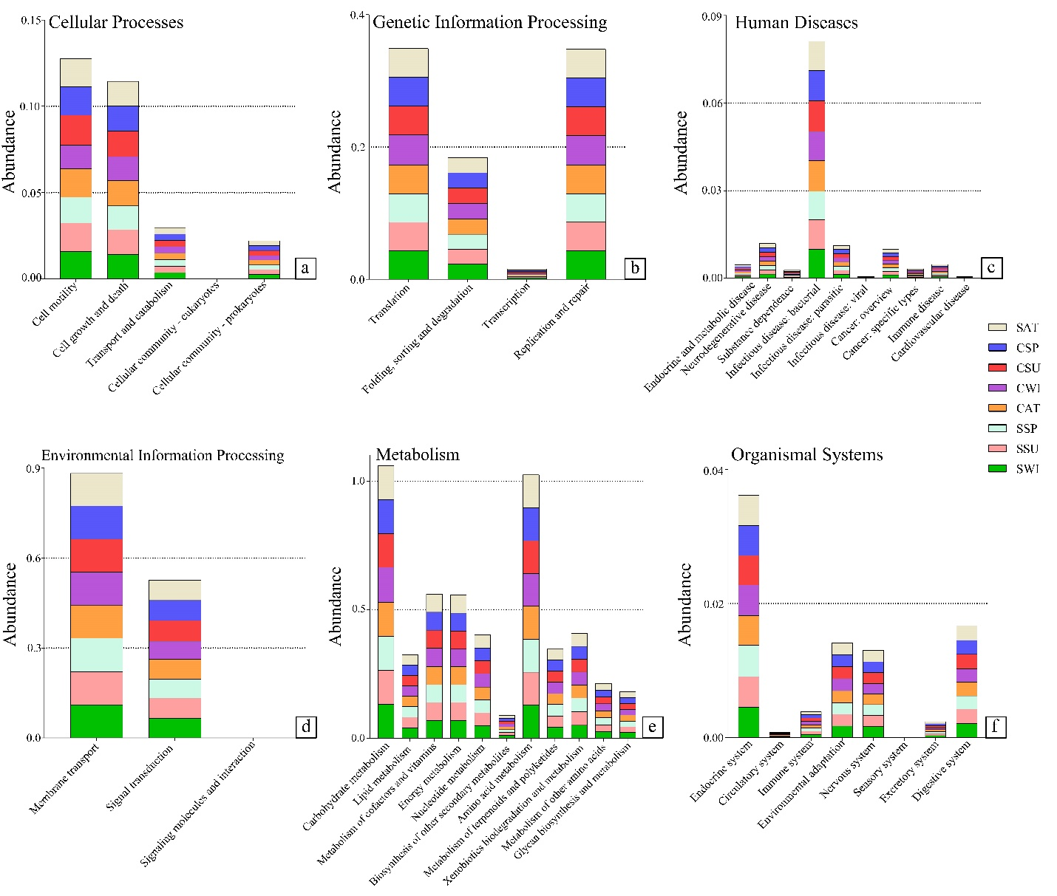
Supplementary Figure 16:
Predicted bacterial functions using Tax4fun. Comparisons of the top six predicted bacterial predominant gene pathways among different plantation types and distinct seasons.

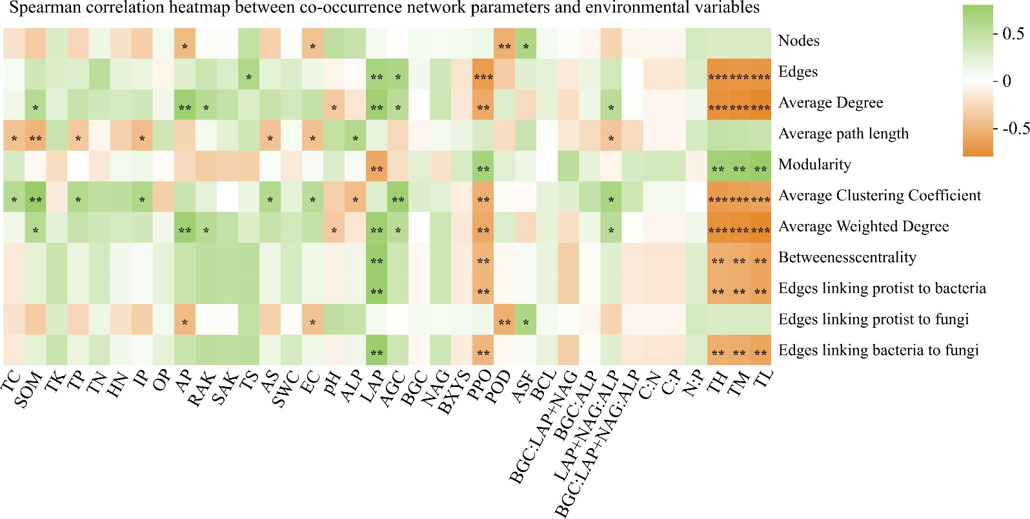
Supplementary Figure 17:
Linkage between co-occurrence network parameters and environmental variables. Different network parameters were linked with different environmental variables, among which parameters associated with temperature appeared to be the strongest. Green represents positive correlations, and orange represents negative correlations. * indicates P-value < 0.05, ** indicates P-value < 0.01, and *** indicates P-value < 0.001.
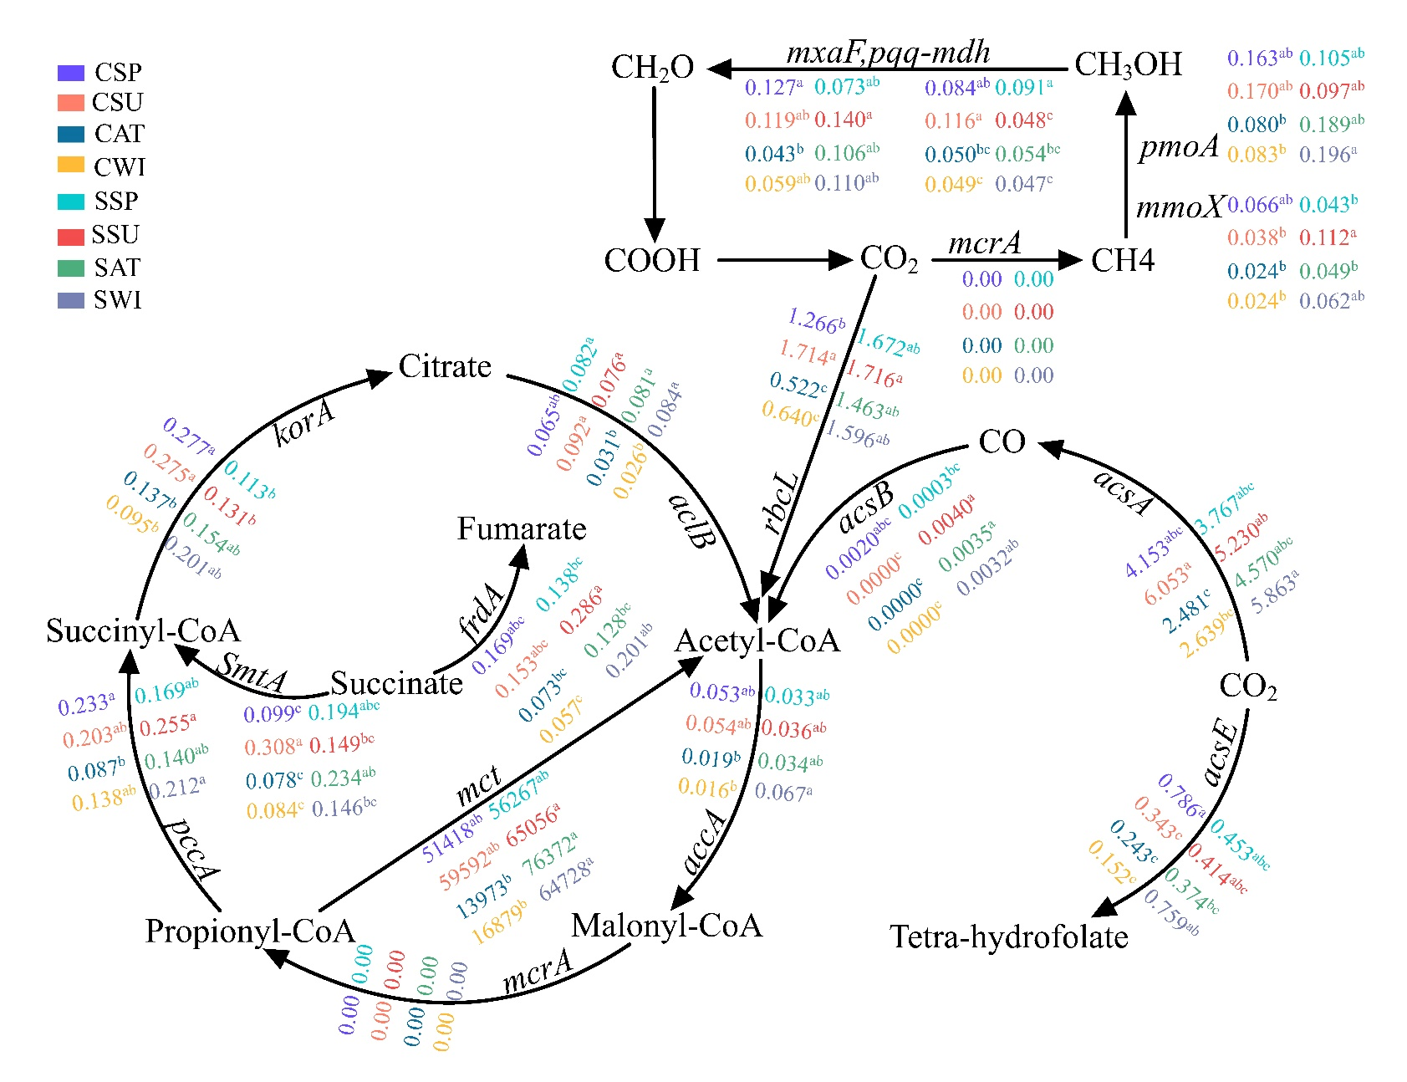
Supplementary Figure 18:
Reconstruction of the complete C-fixation cycle based on the relative abundance of involved genes. Different letters indicate the relative abundance of genes is statistically significant between two afforested plots with seasonal variations.
Abbreviations: C (Chinese pine plot tree), S (Chinese scholar plot tree), SP (spring), SU (summer), and AT (autumn), and WI (winter).
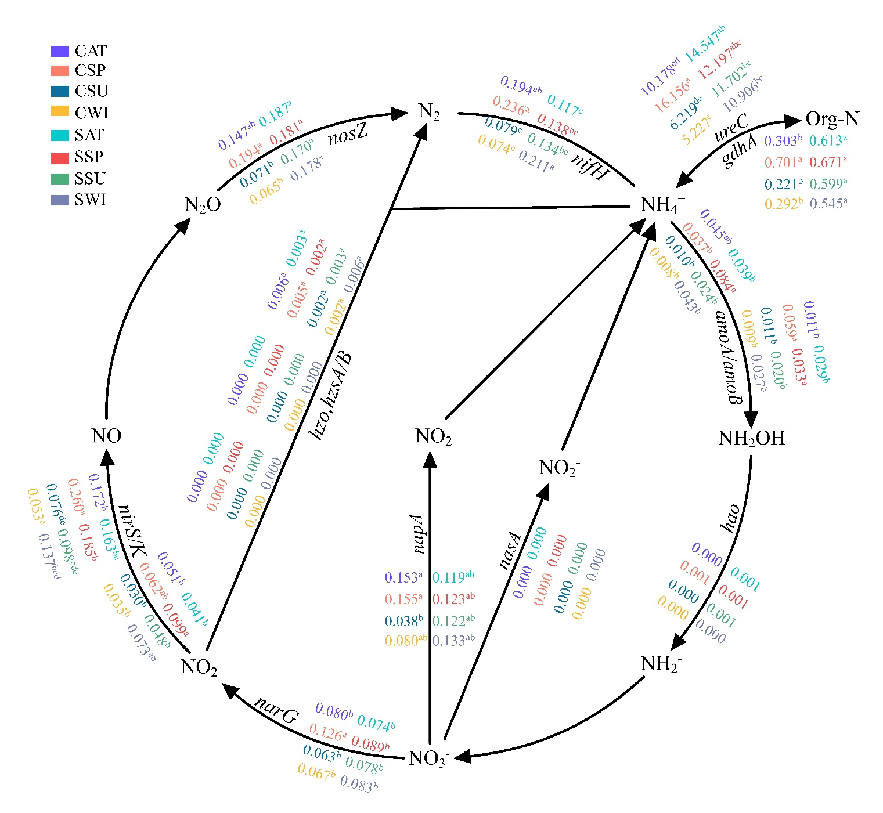
Supplementary Figure 19:
Reconstruction of the complete nitrogen cycle based on gene relative abundance. Different letters indicate the relative abundance of genes is statistically significant between two afforested plots with seasonal variations.
Abbreviations: C (Chinese pine plot tree), S (Chinese scholar plot tree), SP (spring), SU (summer), and AT (autumn), and WI (winter).
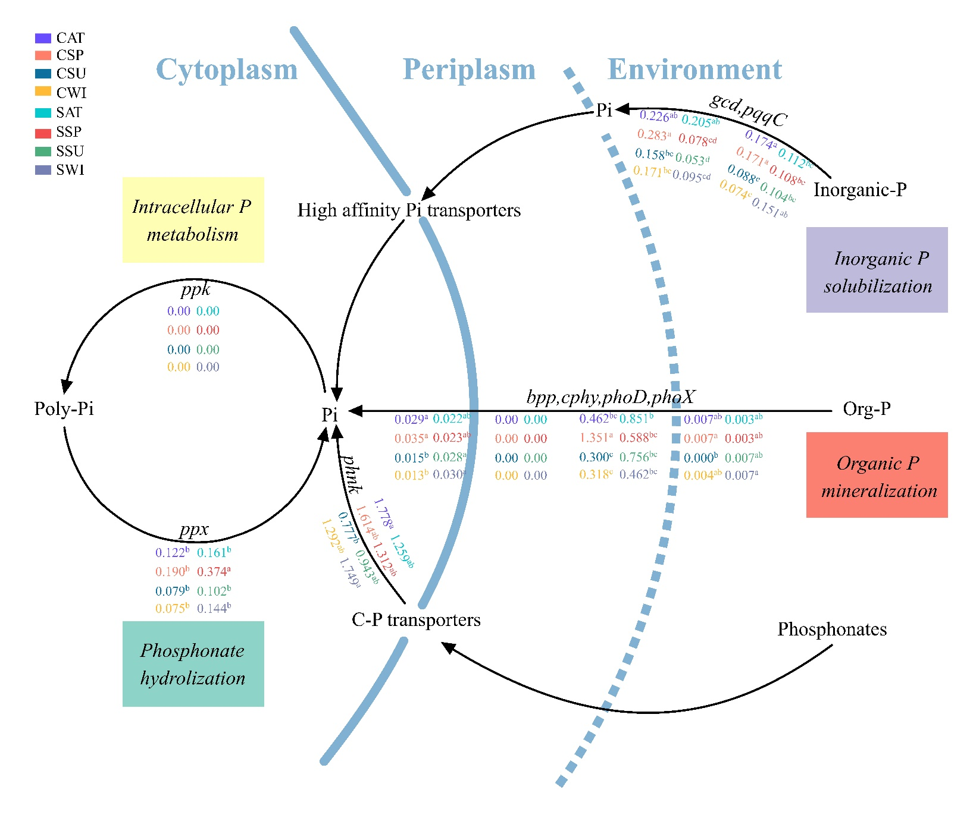
Supplementary Figure 20:
Microbe-driven phosphorus biogeochemical processes in different plantation types with four main seasonal variations. Different letters indicate the relative abundance of genes is statistically significant between two afforested plots with seasonal variations.

Abbreviations: C (Chinese pine tree plot), S (Chinese scholar tree plot), SP (spring), SU (summer), and AT (autumn), and WI (winter). P_{i} (inorganic orthophosphate).

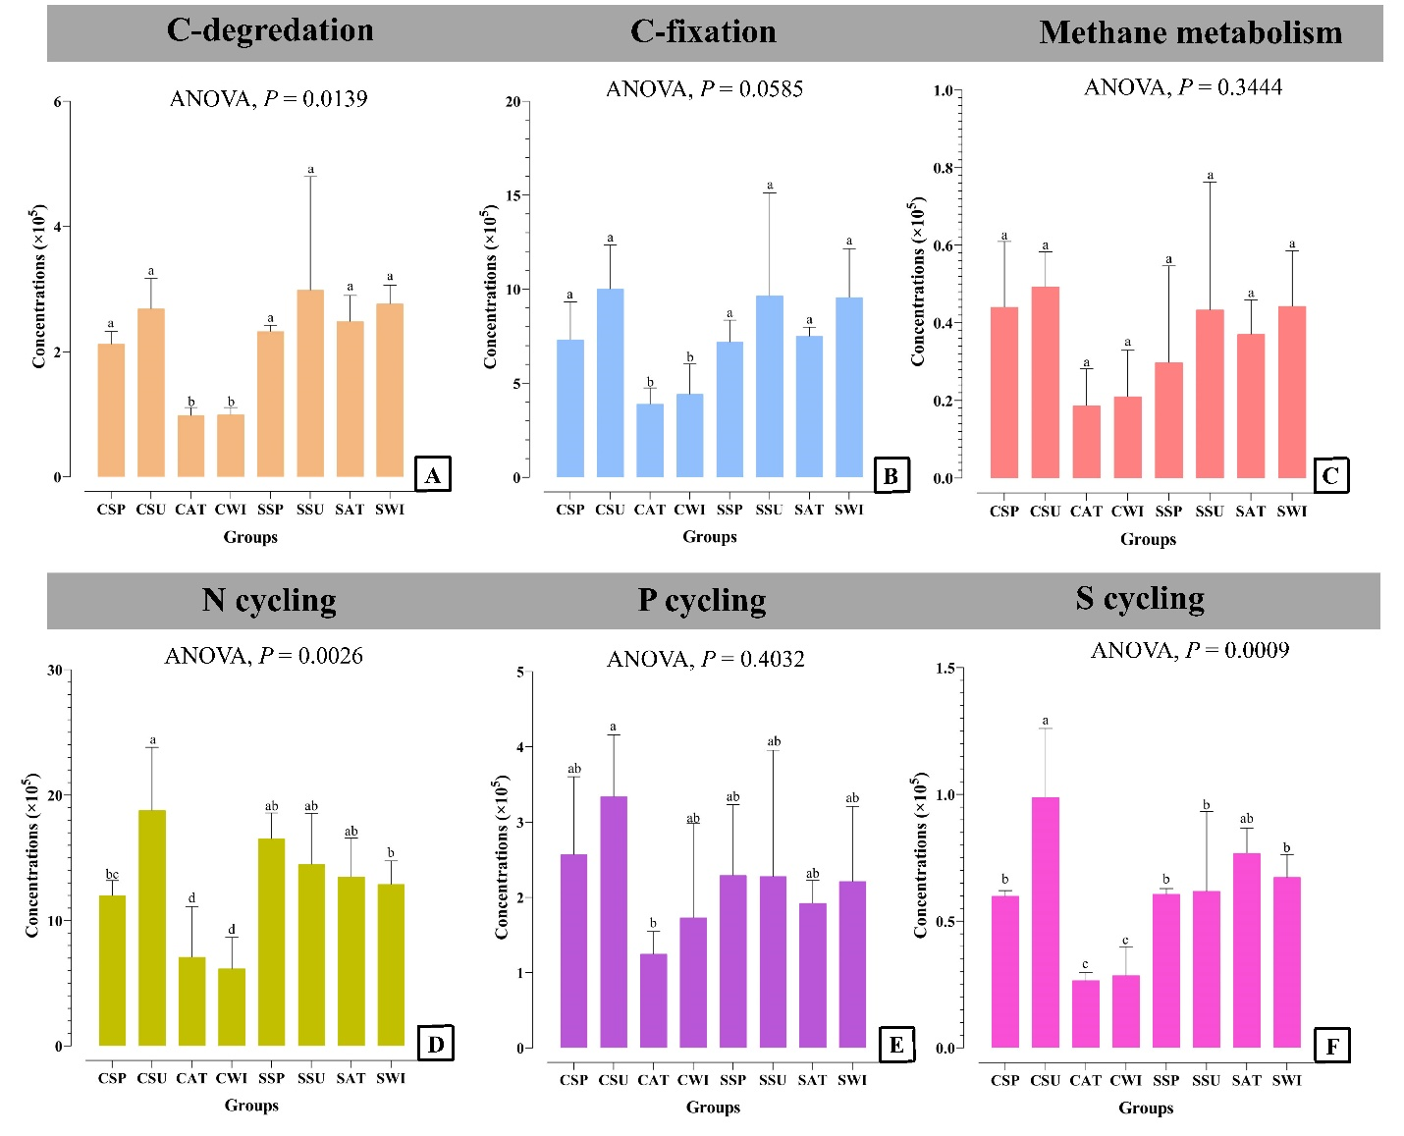
Supplementary Figure 21:
The abundance of CNPS cycling genes across different plantation types with four main seasonal variations. Different letters indicate significant differences between different plantation types seasonally at the 0.05 level (ANOVA, HSD-Tukey Kramer test).
Abbreviations: C (Chinese pine tree plot), S (Chinese Scholar tree plot), SP (spring), SU (summer), AT (autumn), and WI (winter).

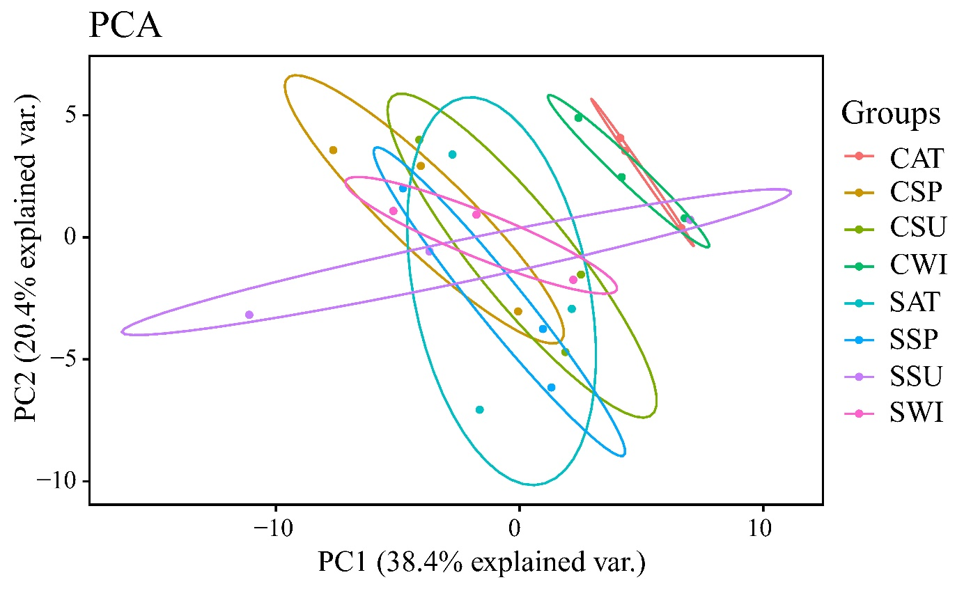
Supplementary Figure 22:
Principal Component Analysis (PCA) profile based on the Bray-Curtis distances showing the distinct but concentric patterns of CNPS cycling genes in different plantation types with seasonal variations.
Abbreviations: C (Chinese pine tree plot), S (Chinese Scholar tree plot), SP (spring), SU (summer), AT (autumn), and WI (winter).

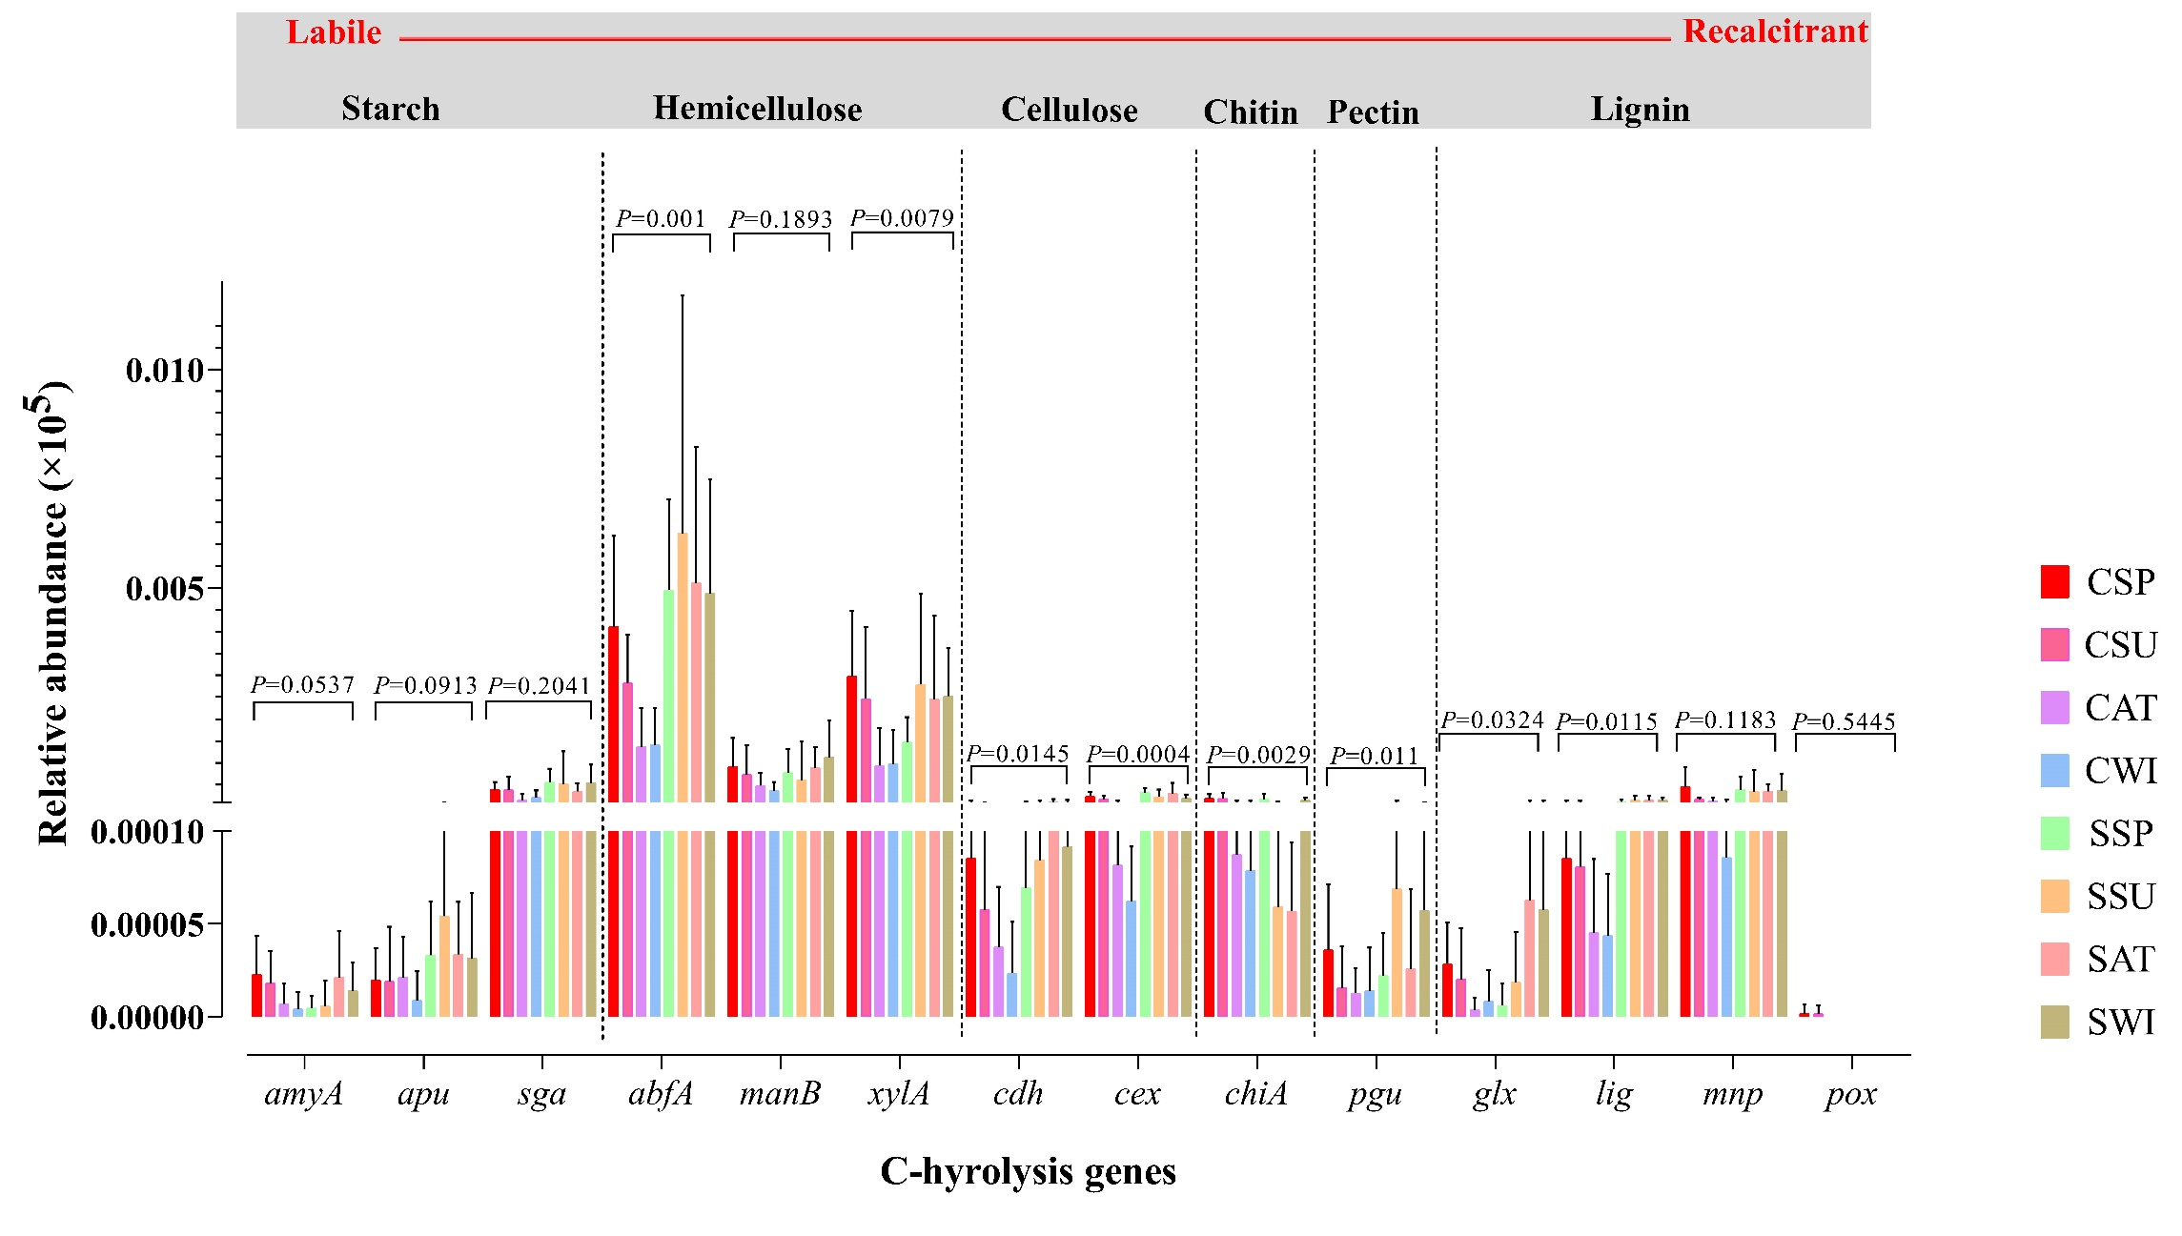
Supplementary Figure 23:
The abundance of key-stone C-hydrolysis genes. The potentials for starch degradation, amyA, and apu were significant, but the absolute abundance of sga was not significant in soils (P = 0.2041). The result showed that the abundance of C-hydrolysis genes involved in hemicellulose degradation, abfA (arabinofuranosidase), xylA (xylose isomerase), and manB (mannanase), was higher than other C-hydrolysis genes irrespective of plantation types and seasonal variations. The absolute abundance of those genes was involved in cellulose, pectin, and chitin were statistically differed between plantation types with seasonal variations. Among four genes related to lignin degradation, the absolute abundance of glx and lig was significantly different, whereas the abundance of mnp and pox was not statistically different in soils. We should mention that the abundance of the pox gene could detect just in Pinus Forest in spring and summer. Some vital genes previously reported (Zheng et al., 2018) did not detect in our study. These genes are comprised of amyx (starch degradation), naglu (cellulose), and exo-chi (chitin).

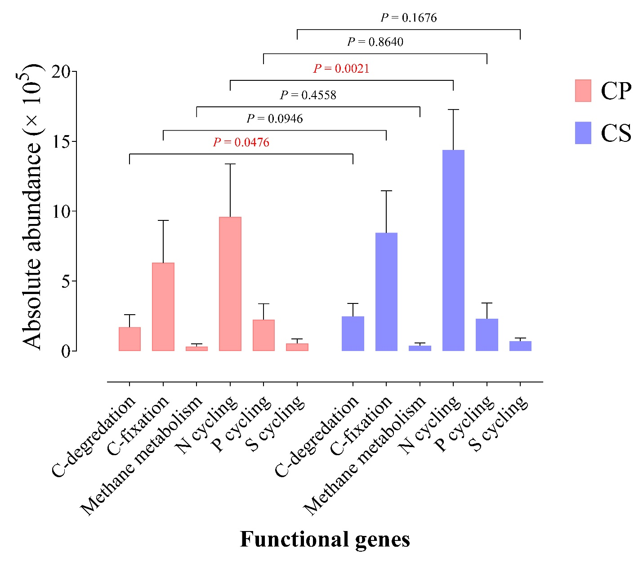
Supplementary Figure 24:
The abundance of CNPS cycling genes across two different plantation types (ANOVA, HSD-Tukey Kramer test).
Abbreviations: CP (Chinese pine tree plot), CS (Chinese Scholar tree plot)

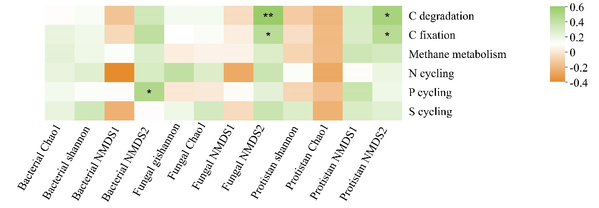

Supplementary Figure 25:
Spearman correlation heatmap between microbial diversity indices and CNPS cycle genes.

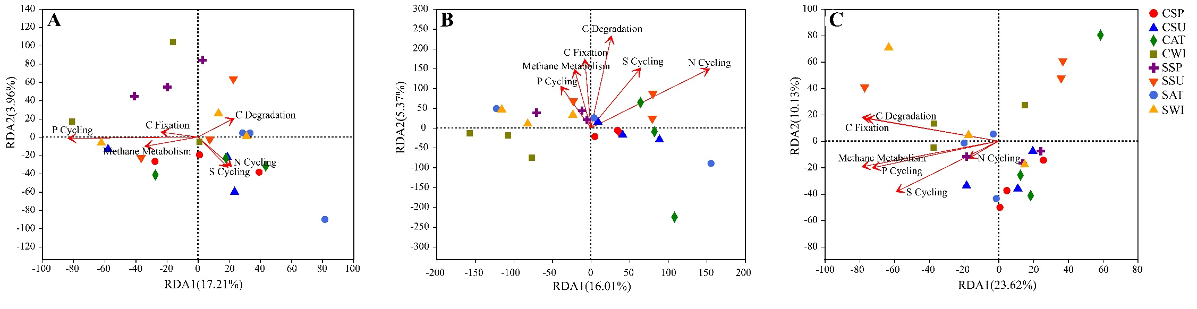
Supplementary Figure 26:
The link between CNSP cycling genes with bacterial (A), fungal (B), and protistan (C) community compositions. The RDA results showed that there was not any significant association between the abundance of CNSP cycling genes with bacterial composition in different plantations with seasonal variations [C-degradation (P = 0.835), C-fixation (P = 0.923), Methane metabolism (P = 0.774), N cycling (P = 0.87), P cycling (P = 0.247), and S cycling (P = 0.867)]. The fungal RDA plot showed that the abundance of functional genes involved in C-degradation and N cycling were significantly associated with fungal composition [C-degradation (P = 0.026), C-fixation (P = 0.163), Methane metabolism (P = 0.305), N cycling (P = 0.033), P cycling (P = 0.569), and S cycling (P = 0.156)]. The protistan RDA plot verified that the abundance of C-degradation, C-fixation and methane metabolism was statistically associated with the protistan composition in different plantation types seasonally [C-degradation (P = 0.04), C-fixation (P = 0.03), Methane metabolism (P = 0.043), N cycling (P = 0.853), P cycling (P = 0.054), and S cycling (P = 0.115)].

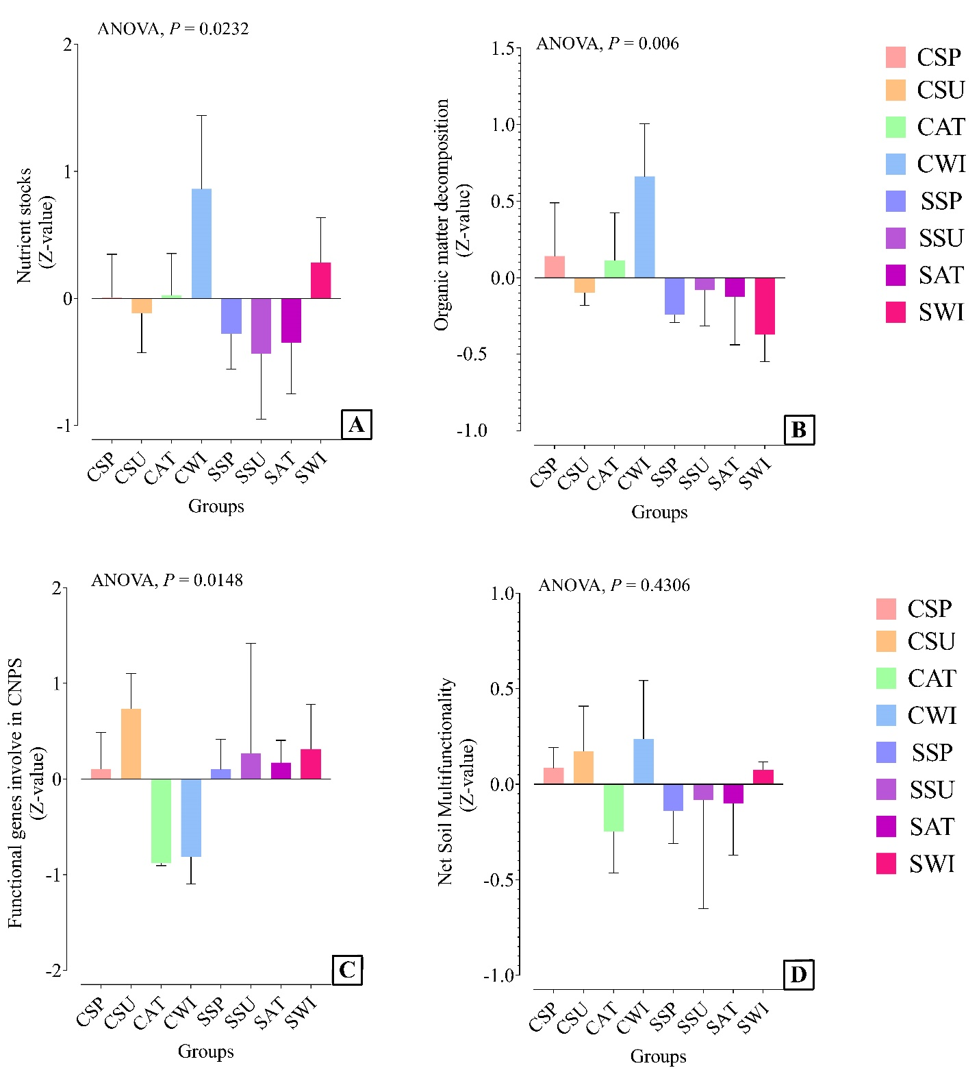

Supplementary Figure 27:
Average multifunctionality indices response to different plantation with seasonal variations. The narrow multifunctionality indices like nutrient stocks (A), organic matter decomposition (B), and functional genes involved in CNPS cycling (C) were significantly differed within different plantations seasonally, but net soil multifunctionality (D) did not show a significant difference within two plantation types with seasonal variations. This result indicates that the high level of nutrient cycling (nutrient stocks and organic matter decomposition) in winter for the Chinese pine plot compensated by decreases in measures of microbial functional genes involved in CNPS cycling in summer for this plot. Such tradeoffs among functional categories suggest that soils ordinarily may sustain a harmonious level of net soil multifunctionality.

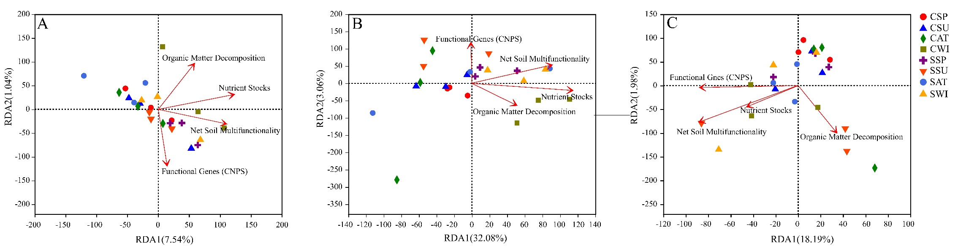
Supplementary Figure 28:
The correlation ship between multifunctionality indices and bacterial (A), fungal (B), and protistan (C) compositions. The bacterial RDA showed that ‘nutrient stocks’ and ‘organic matter decomposition’ indices were significantly correlated with bacterial composition [Nutrient stocks (P = 0.025), Organic matter decomposition (P = 0.015), Net soil multifunctionality (P = 0.202), Functional genes (CNPS) (P = 0.09)]. The fungal RDA plot demonstrated that ‘nutrient stocks’ index was statistically associated with fungal composition [Nutrient stocks (P = 0.006), Organic matter decomposition (P = 0.17), Functional genes (P = 0.051), and net soil multifunctionality (P = 0.053)]. The protistan RDA ordination plot showed that none of the multifunctionality indices were significantly associated with the protistan community [nutrient stocks (P = 0.481), Organic matter decomposition (P = 0.348), Functional genes (CNPS) (P = 0.077), and net soil multifunctionality (P = 0.079).

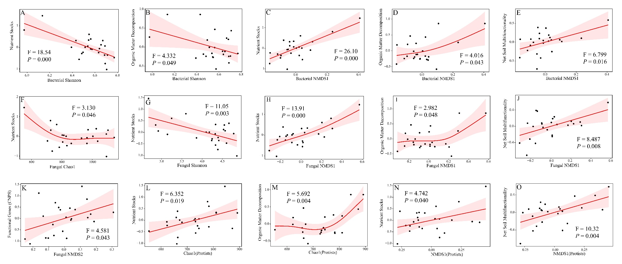

Supplementary Figure 29:
Microbial diversity (richness and Shannon diversity)-multifunctionality relationship using the GAM analysis. The results of GAM analysis showed that microbial richness and diversity indices were significantly associated with different functional groups. The results of the GAM analysis showed that the bacterial Shannon diversity was significantly associated with different functional categories like nutrient stocks and organic matter decomposition, and the bacterial β-diversity was statistically associated with nutrient stocks, organic matter decomposition, and net soil multifunctionality. Fungal richness was significantly associated with nutrient stocks function, and the fungal β-diversity was statistically linked with four functional groups. Protistan richness was congruent with nutrient stocks, organic matter decomposition, and their β-diversity was linked with nutrient stocks and net soil multifunctionality.

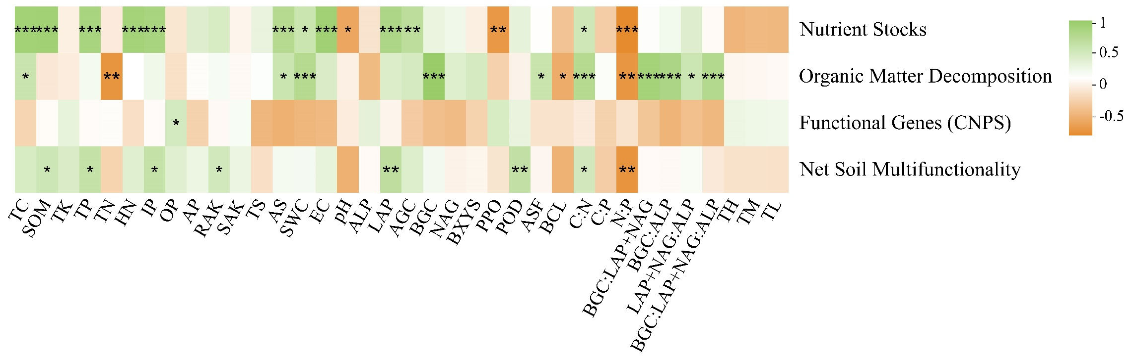
Supplementary Figure 30:
Heatmap of environmental driving factors derived multifunctionality indices. As a point of interest, two narrow functional categories, namely, nutrient stocks and organic matter decomposition, were associated with most environmental variables compared with the functional genes (CNPS) category and net soil multifunctionality. * indicates P-value < 0.05, ** indicates P-value < 0.01, and *** indicates P-value < 0.001

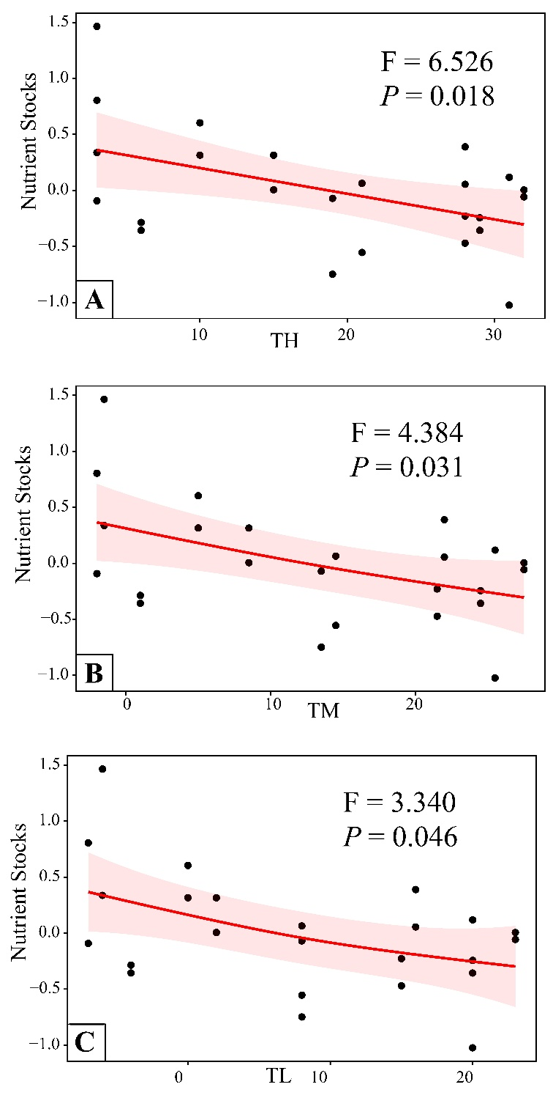

Supplementary Figure 31:
The association of multifunctionality categories with annual air temperature. Among all evaluated relationships, just the nutrient stocks category was significantly associated with the minimum, average, and maximum yearly air temperature.

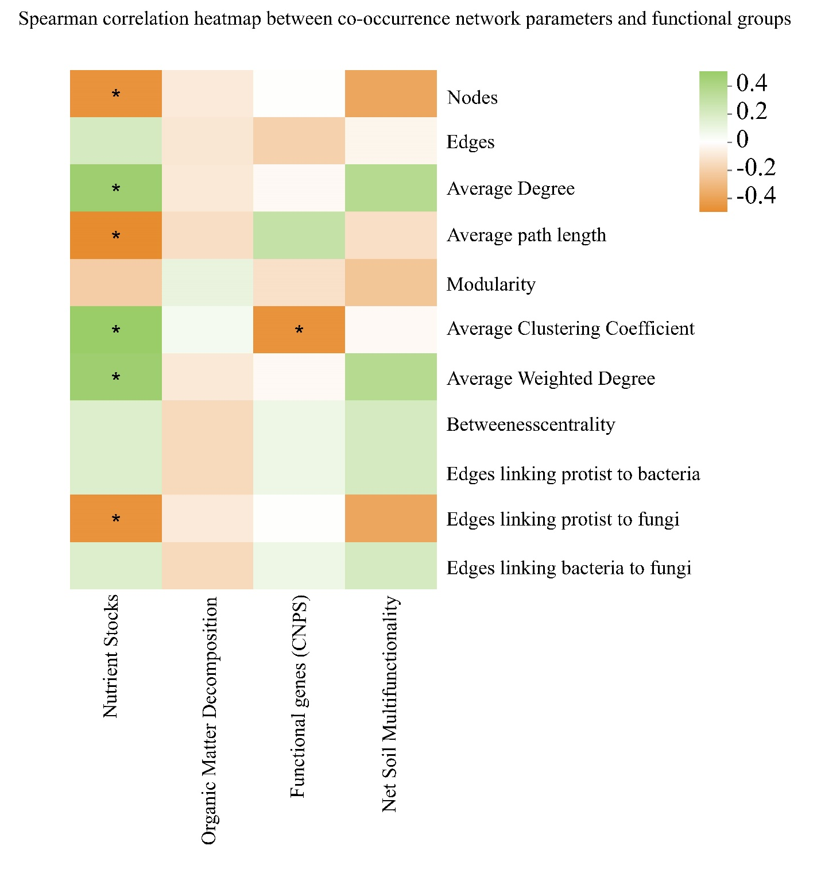
Supplementary Figure 32:
Linkage between co-occurrence network parameters and functional groups such as nutrient stocks, organic matter decomposition, functional genes (CNPS), and net soil multifunctionality. The nutrient stocks functional group is statistically associated with six network parameters, and the microbial functional genes (CNPS) category is just associated with the average clustering coefficient significantly. Green represents positive correlations, and orange represents negative correlations. * indicates P-value < 0.05.

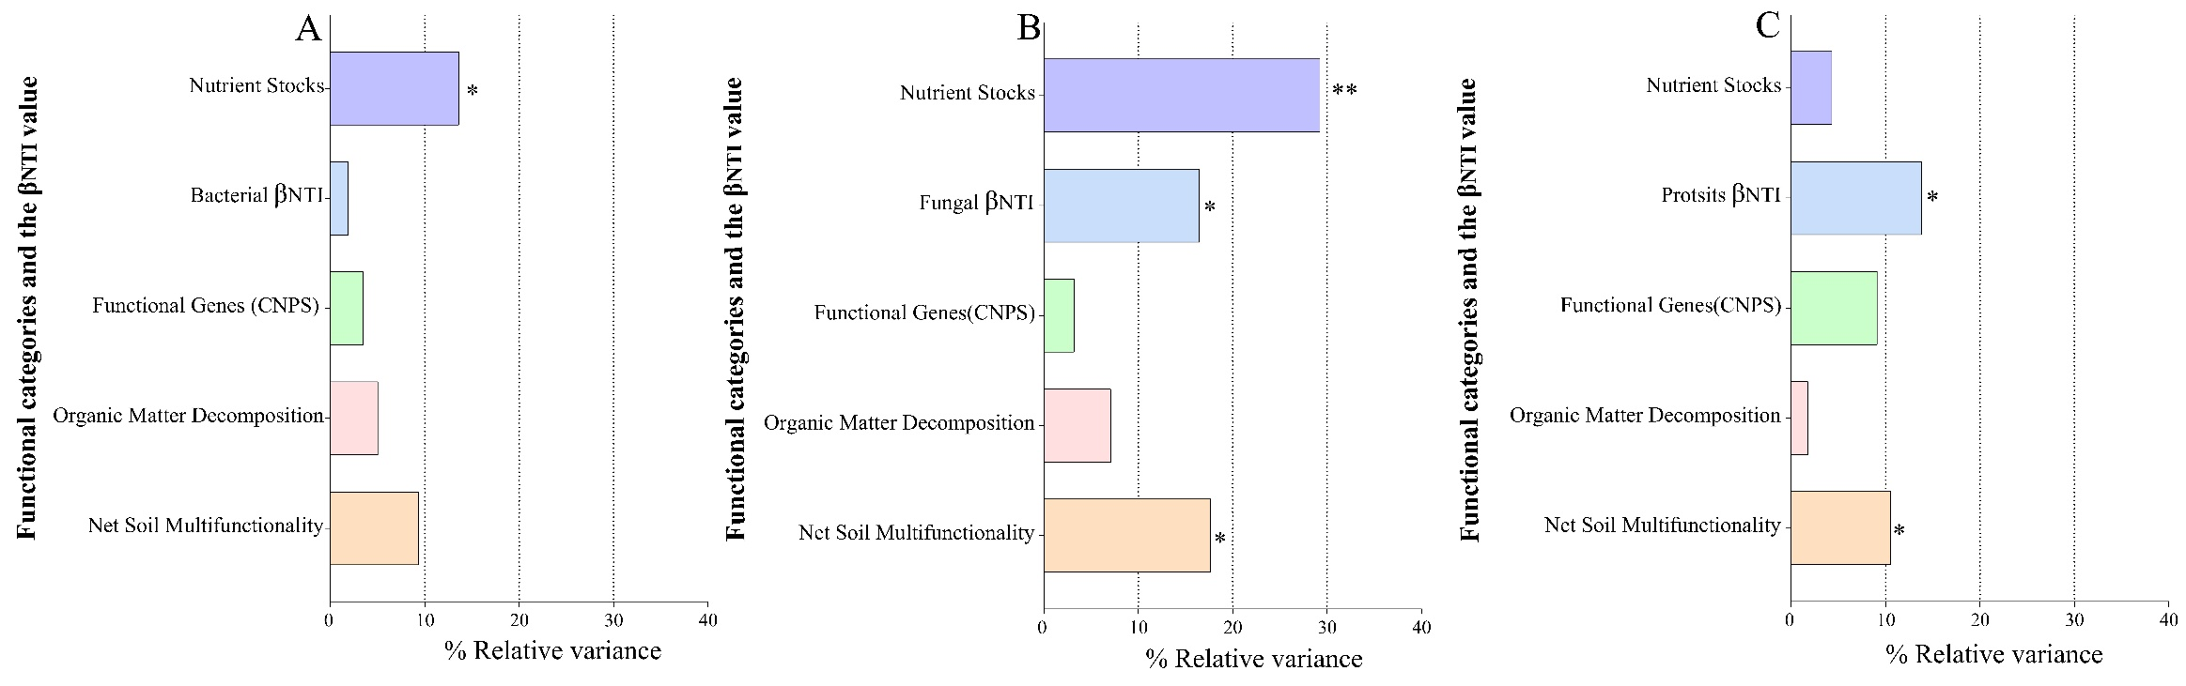
Supplementary Figure 33
PERMANOVA determined the contributions of different microbial multifunctionality categories and microbial βNTI values on the variation of microbial communities.

PERMANOVA analysis showed that nutrient stocks could explain 13.6% of the variation of the bacterial community significantly (P = 0.033). The fungal variation could be explained by nutrient stocks (29.24%, P = 0.003), net soil multifunctionality (17.66%, P = 0.027), and the βNTI value (16.45%, = 0.034) significantly, whereas net soil multifunctionality (10.55%, P = 0.046) and the βNTI value could explain the protistan variation (13.86%, P = 0.013).
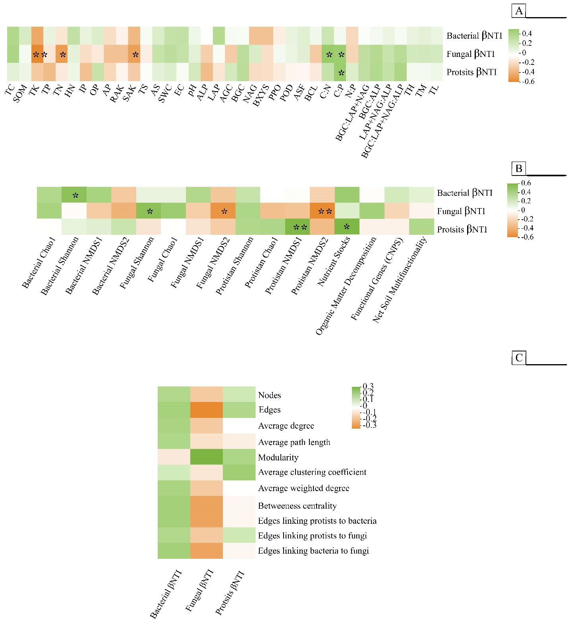
Supplementary Figure 34
The linkage between microbial βNTI values with environmental variables (A), microbial diversity indices (α- and β-diversities) (B), and co-occurrence network parameters (C). The bacterial βNTI value did not associate with environmental variables (A), whereas the protistan βNTI value was statistically linked with the C: P ratio. The fungal βNTI value was significantly congruent with several environmental variables like the C: P ratio, the C: N ratio, SAK, TN, and TK (). The βNTI value was significantly associated with the bacterial Shannon diversity (B). The fungal βNTI value was linked with the protistan NMDS2, the fungal NMDS2, and the fungal Shannon diversity. The protistan βNTI value was significantly correlated with nutrient stocks and the protistan NMDS1. None of the co-occurrence network parameters were associated with microbial βNTI values (C). Green represents positive correlations, and orange represents negative correlations. * indicates P-value < 0.05, and ** indicates P-value < 0.01.
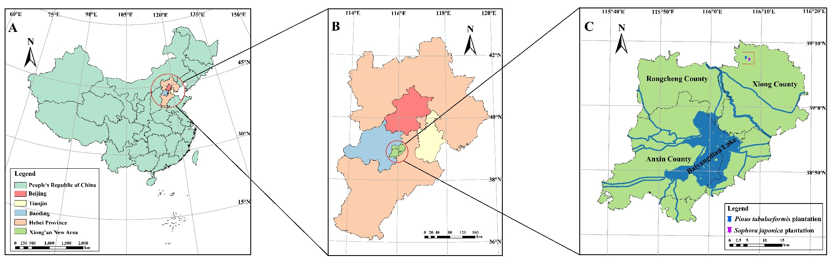
Supplementary Figure 35:
The map shows Beijing-Tianjin-Hebei, a regional city cluster called 'Jing-Jin-Ji' (A), the Xiong'an New Area (B) location, and the experimental plots. Geographical map with coordinates created by ArcGIS for Windows ver. 10.2 (Environmental Systems Research Institute [ESRI; www.esri.com; 2012], Redlands, USA).
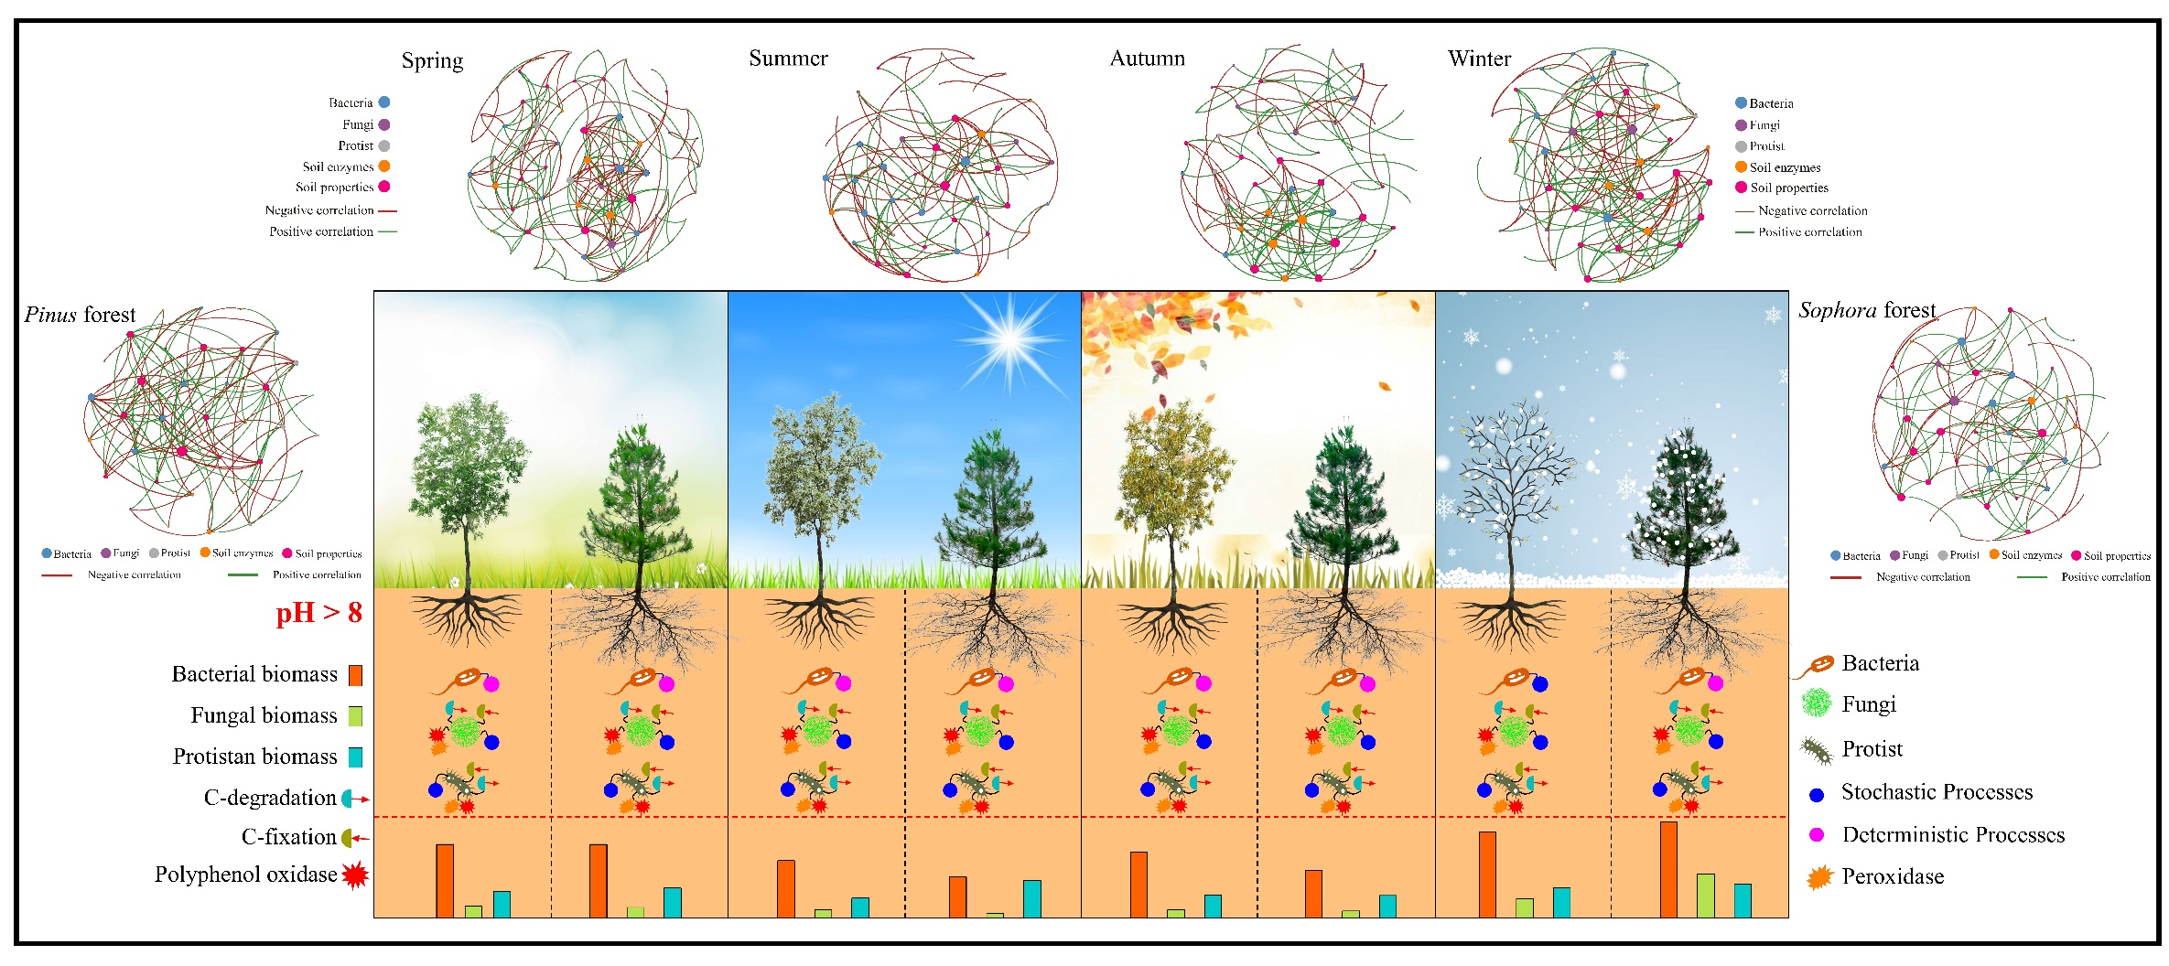

Supplementary Figure 36:
We summarized of the results as the bacterial communities were deterministically (variable selection and homogenous selection) structured, whereas the stochastic process of dispersal limitation was mainly responsible for the assembly of the fungal and protist communities. Also, we speculated that the composition of protist and fungal taxa might be influenced by the seasonal variations of bacterial c-related functional activities

References
Behie, S.W., Moreira, C.C., Sementchoukova, I., Barelli, L., Zelisko, P.M., and Bidochka, M.J. (2017). Carbon translocation from a plant to an insect-pathogenic endophytic fungus. Nature Communications 8 (1), 14245, DOI: https://doi.org/10.1038/ncomms14245.
Boerner, R.E.J., Brinkman, J.A., and Smith, A. (2005). Seasonal variations in enzyme activity and organic carbon in soil of a burned and unburned hardwood forest. Soil Biology and Biochemistry 37 (8), 1419-1426, DOI: https://doi.org/10.1016/j.soilbio.2004.12.012.
Criquet, S., Farnet, A.M., Tagger, S., and Le Petit, J. (2000). Annual variations of phenoloxidase activities in an evergreen oak litter: influence of certain biotic and abiotic factors. Soil Biology and Biochemistry 32 (11), 1505-1513, DOI: https://doi.org/10.1016/S0038-0717(00)00027-4.
Decker, K.L., Boerner, R.E., and Morris, S.J. (1999). Scale-dependent patterns of soil enzyme activity in a forested landscape. Canadian Journal of Forest Research 29 (2), 232-241, DOI: https://doi.org/10.1139/x98-192.
Finzi, A.C., Sinsabaugh, R.L., Long, T.M., and Osgood, M.P. (2006). Microbial community responses to atmospheric carbon dioxide enrichment in a warm-temperate forest. Ecosystems 9 (2), 215-226, DOI: https://doi.org/10.1007/s10021-005-0078-6.
Kellner, H., Luis, P., Schlitt, B., and Buscot, F. (2009). Temporal changes in diversity and expression patterns of fungal laccase genes within the organic horizon of a brown forest soil. Soil Biology and Biochemistry 41 (7), 1380-1389, DOI: https://doi.org/10.1016/j.soilbio.2009.03.012.
Nguyen, N.H., Song, Z., Bates, S.T., Branco, S., Tedersoo, L., Menke, J., Schilling, J.S., and Kennedy, P.G. (2016). FUNGuild: An open annotation tool for parsing fungal community datasets by ecological guild. Fungal Ecology 20, 241-248, DOI: https://doi.org/10.1016/j.funeco.2015.06.006.
Rimington, W.R., Pressel, S., Duckett, J.G., Field, K.J., and Bidartondo, M.I. (2019). Evolution and networks in ancient and widespread symbioses between Mucoromycotina and liverworts. Mycorrhiza 29 (6), 551-565, DOI: https://doi.org/10.1007/s00572-019-00918-x.
Sinsabaugh, R.L. (2010). Phenol oxidase, peroxidase and organic matter dynamics of soil. Soil Biology and Biochemistry 42 (3), 391-404, DOI: https://doi.org/10.1016/j.soilbio.2009.10.014.
Sinsabaugh, R.L., Gallo, M.E., Lauber, C., Waldrop, M.P., and Zak, D.R. (2005). Extracellular enzyme activities and Soil organic matter dynamics for northern hardwood forests receiving simulated nitrogen deposition. Biogeochemistry 75 (2), 201-215, DOI: https://doi.org/10.1007/s10533-004-7112-1.
Sinsabaugh, R.L., Saiya-Cork, K., Long, T., Osgood, M.P., Neher, D.A., Zak, D.R., and Norby, R.J. (2003). Soil microbial activity in a Liquidambar plantation unresponsive to CO2-driven increases in primary production. Applied Soil Ecology 24 (3), 263-271, DOI: https://doi.org/10.1016/S0929-1393(03)00002-7.
Toberman, H., Freeman, C., Evans, C., Fenner, N., and Artz, R.R.E. (2008). Summer drought decreases soil fungal diversity and associated phenol oxidase activity in upland Calluna heathland soil. FEMS Microbiology Ecology 66 (2), 426-436, DOI: https://doi.org/10.1111/j.1574-6941.2008.00560.x.
Weintraub, M.N., Scott-Denton, L.E., Schmidt, S.K., and Monson, R.K. (2007). The effects of tree rhizodeposition on soil exoenzyme activity, dissolved organic carbon, and nutrient availability in a subalpine forest ecosystem. Oecologia 154 (2), 327-338, DOI: https://doi.org/10.1007/s00442-007-0804-1.

