Supporting Information

Single-cell-guided apoptotic-mimetic mineralized nanovesicles deliver siPLIN2 to reprogram macrophage lipotoxicity and promote diabetic bone repair
Kai Wang ^{a,b,}*, Bin Gui^{a,}*,Ning Sheng^{c},Huimin Hu^{a,&},Liang Yan^{a,&}
ᵃ Department of Spine Surgery, Honghui Hospital, Xi'an Jiaotong University, Youyi East Road, Xi'an, Shaanxi 710054, China
b Xi'an Jiaotong University, No.28, Xianning West Road, Xi'an, Shaanxi 710049, China
c Department of Orthopedics, Guizhou Provincial People’s Hospital, Guiyang, China.
* First Authors: Wang Kai and Bin Gui contributed equally to this work.
&Corresponding authors:
Huimin Hu; E-mail: huhuiminxjtu@mail.xjtu.edu.cn
Liang Yan; E-mail: dryanliang5583@163.com

Contents
Figure S1. Integrated-atlas context for Cd36 expression and macrophage reclustering 2
Figure S2. Temporal redistribution of macrophage states during skeletal repair 3
Figure S3. State- and condition-resolved Plin2 expression 4
Figure S4. Cd36/Plin2 networks and stage-resolved programs 5
Figure S5. Condition-resolved macrophage regulon activity 6
Figure S6. Colloidal, loading, and vibrational characterization 7
Figure S7. High-resolution XPS spectra and protein-profile retention 8
Figure S8. Uptake of naked Cy5-siRNA by HG-conditioned macrophages 9
Figure S9. PLIN2 depletion and immunometabolic reprogramming 10
Figure S10. Complementary GSEA profiles 11
Table S1. Key materials, cell lines, reagents, and assay kits
Table S2. Antibodies used for immunoblotting, imaging, receptor blockade, and flow cytometry
Table S3. siRNA oligonucleotide sequences and modifications

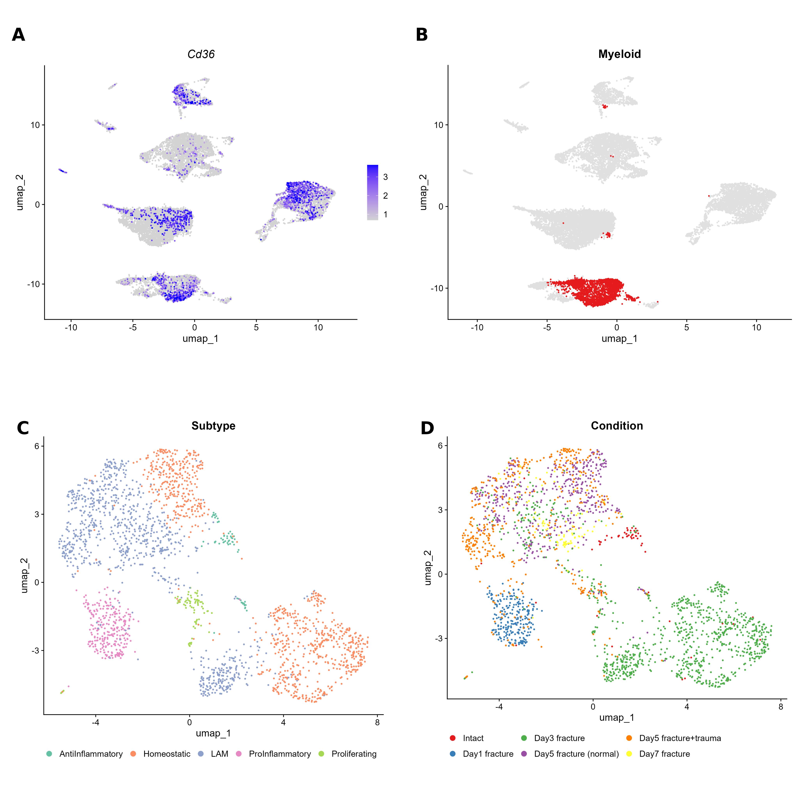
Figure S1. Integrated-atlas context for Cd36 expression and macrophage reclustering. (A) Cd36 expression across all cells in the integrated skeletal-repair atlas. (B) Myeloid cells highlighted in the full atlas (2259 of 19,475 cells; 11.6%). (C,D) Macrophage UMAPs colored by the five inferred states and by repair condition, respectively.

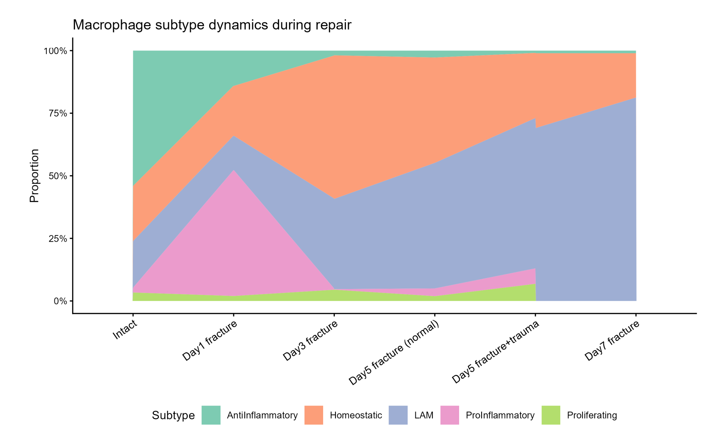
Figure S2. Temporal redistribution of macrophage states during skeletal repair. Stacked areas show the relative abundance of anti-inflammatory, homeostatic, lipid-associated macrophage (LAM), proinflammatory, and proliferating states in intact tissue and on days 1, 3, 5, and 7 after fracture, including separate day-5 normal-repair and trauma conditions.

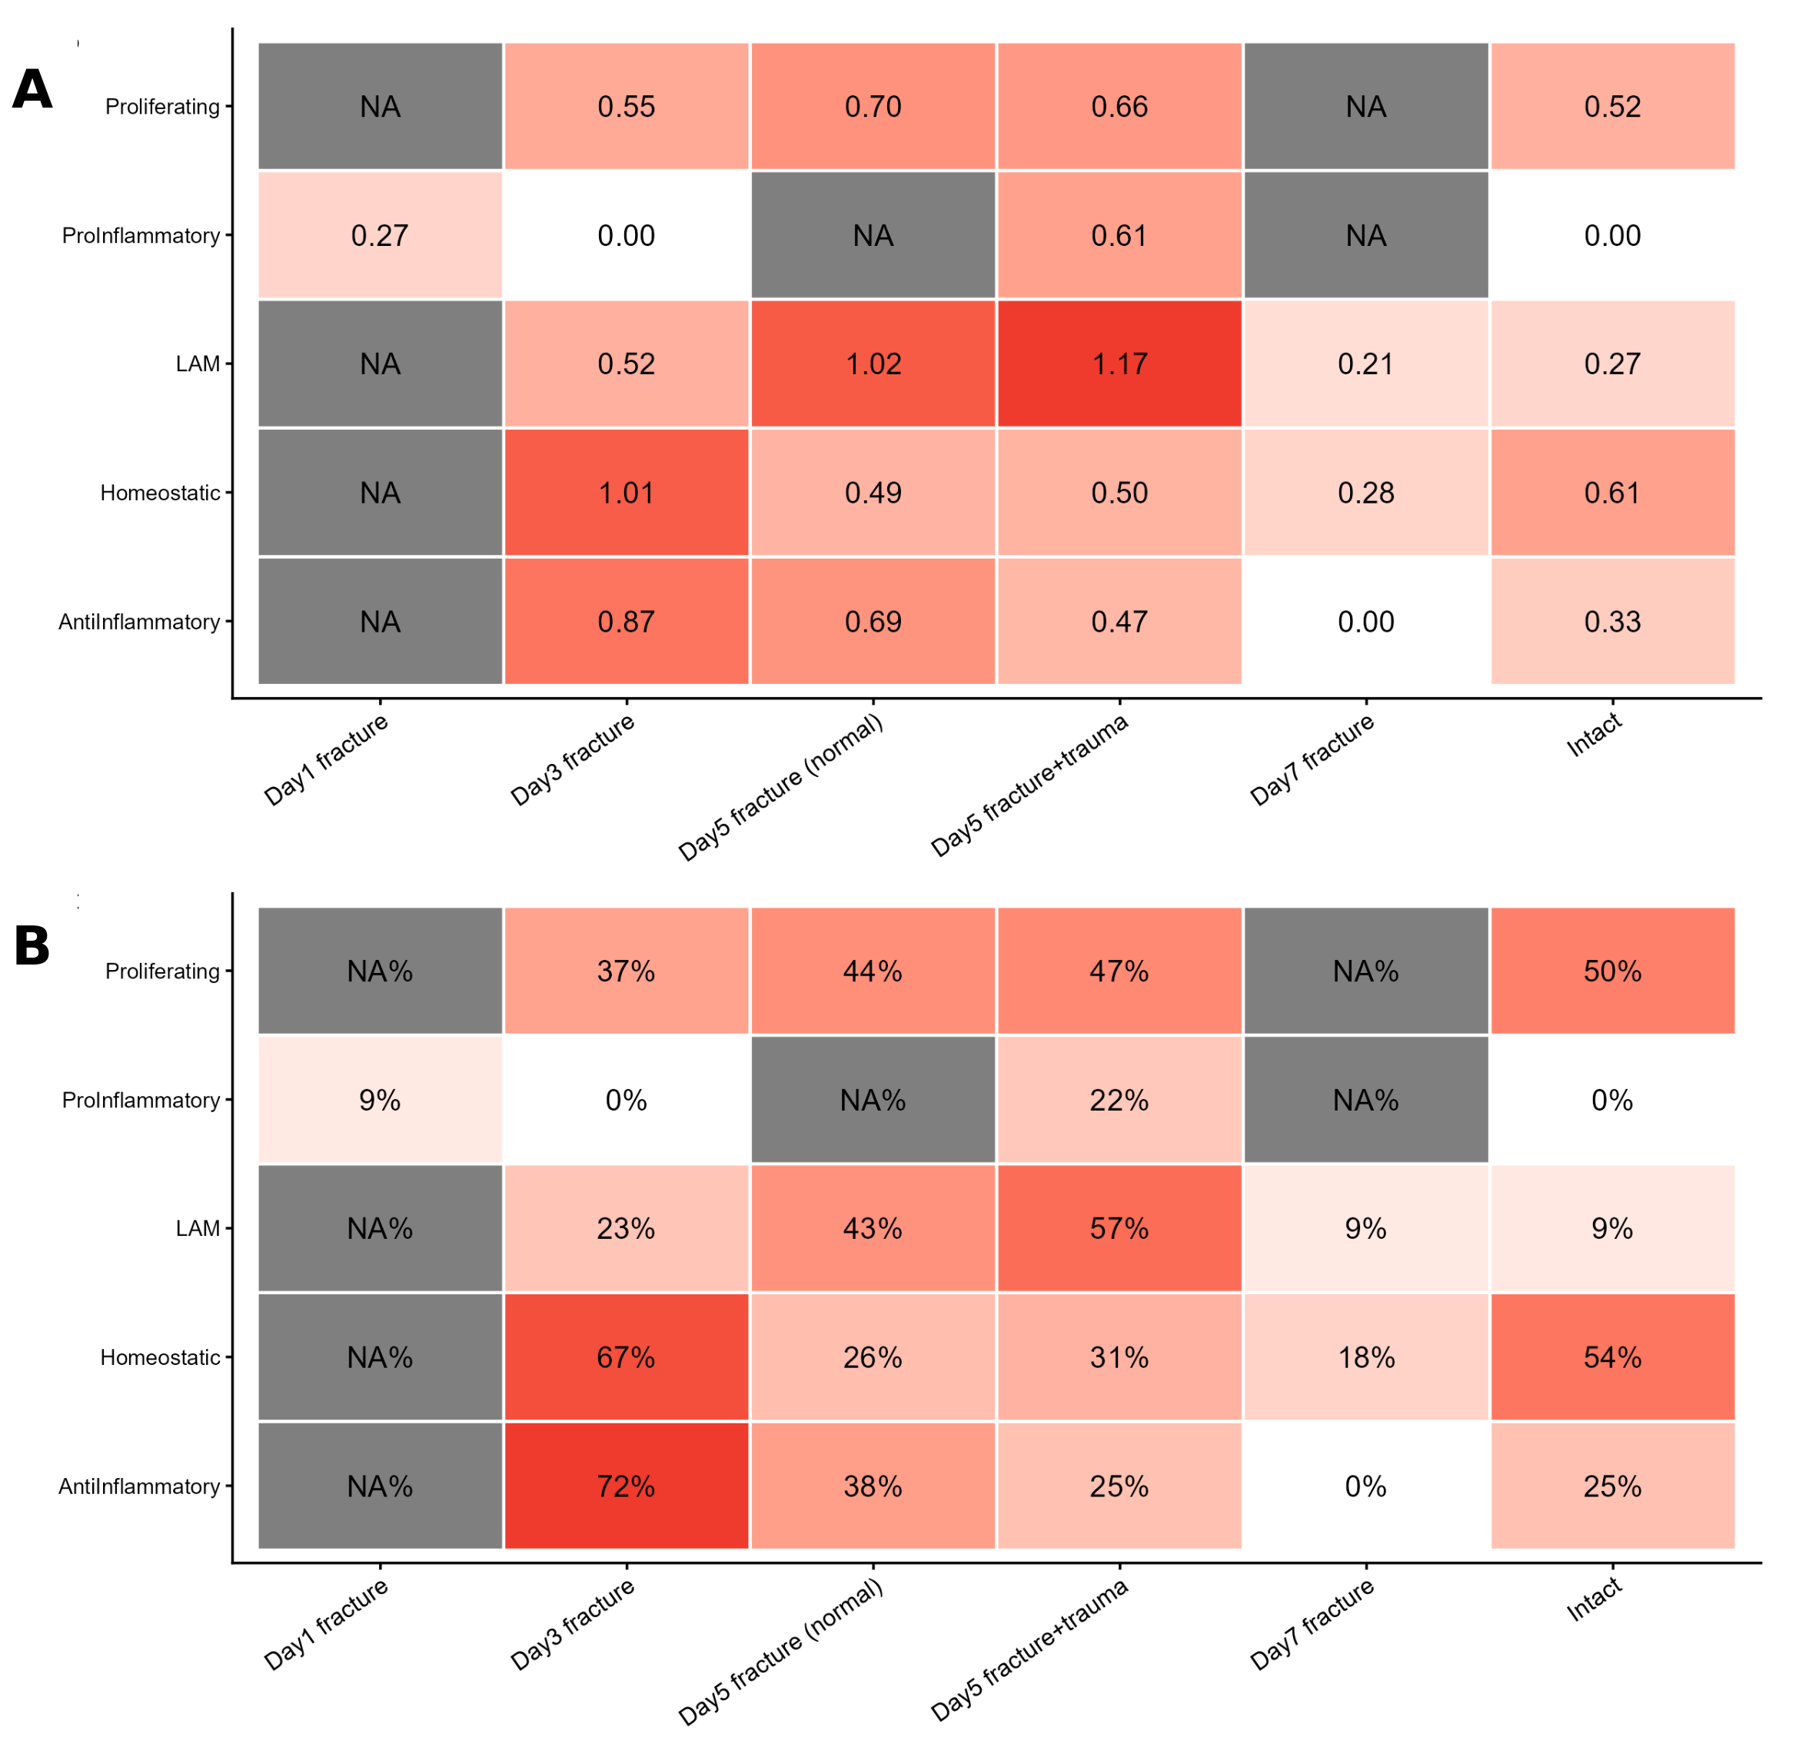
Figure S3. State- and condition-resolved Plin2 expression. (A) Mean Plin2 expression and (B) percentage of Plin2-positive macrophages across five macrophage states and six repair conditions. Gray cells indicate state–condition combinations that were not represented.

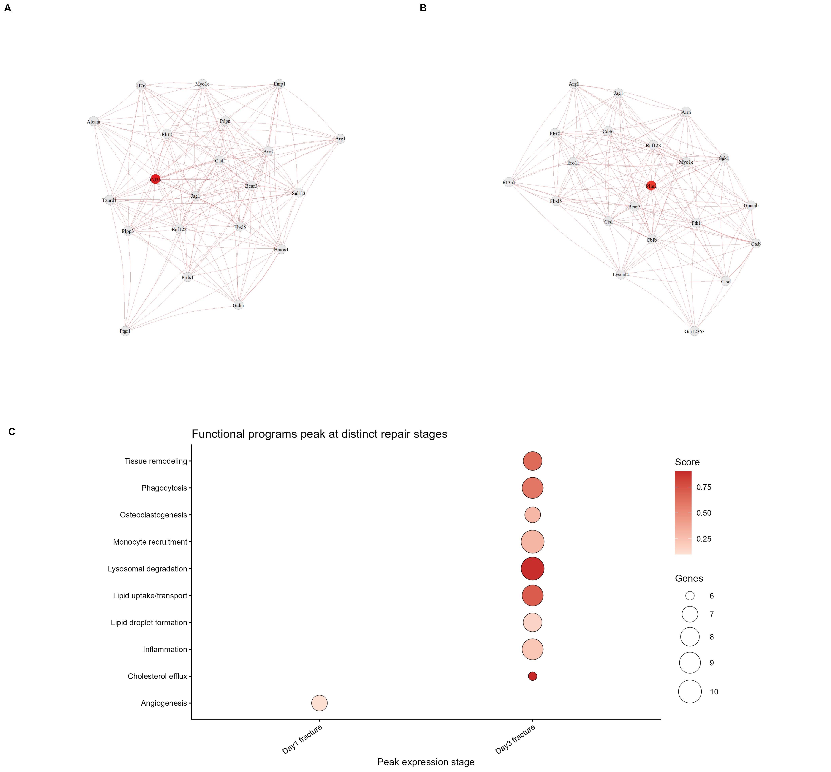
Figure S4. Cd36- and Plin2-centered gene networks and stage-resolved functional programs. (A,B) Correlation neighborhoods centered on Cd36 and Plin2, respectively. Labeled nodes identify the leading correlated genes, and edges denote retained correlations. (C) Repair condition at which each of 10 predefined functional programs reached its maximum mean score. Bubble color denotes program score, and bubble size denotes the number of genes in the program.

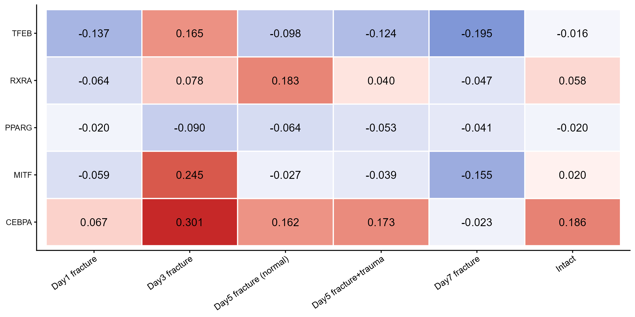
Figure S5. Condition-resolved macrophage regulon activity. Heatmap of inferred TFEB, RXRA, PPARG, MITF, and CEBPA regulon activity in intact tissue and five skeletal-repair conditions. Values are centered activity scores.

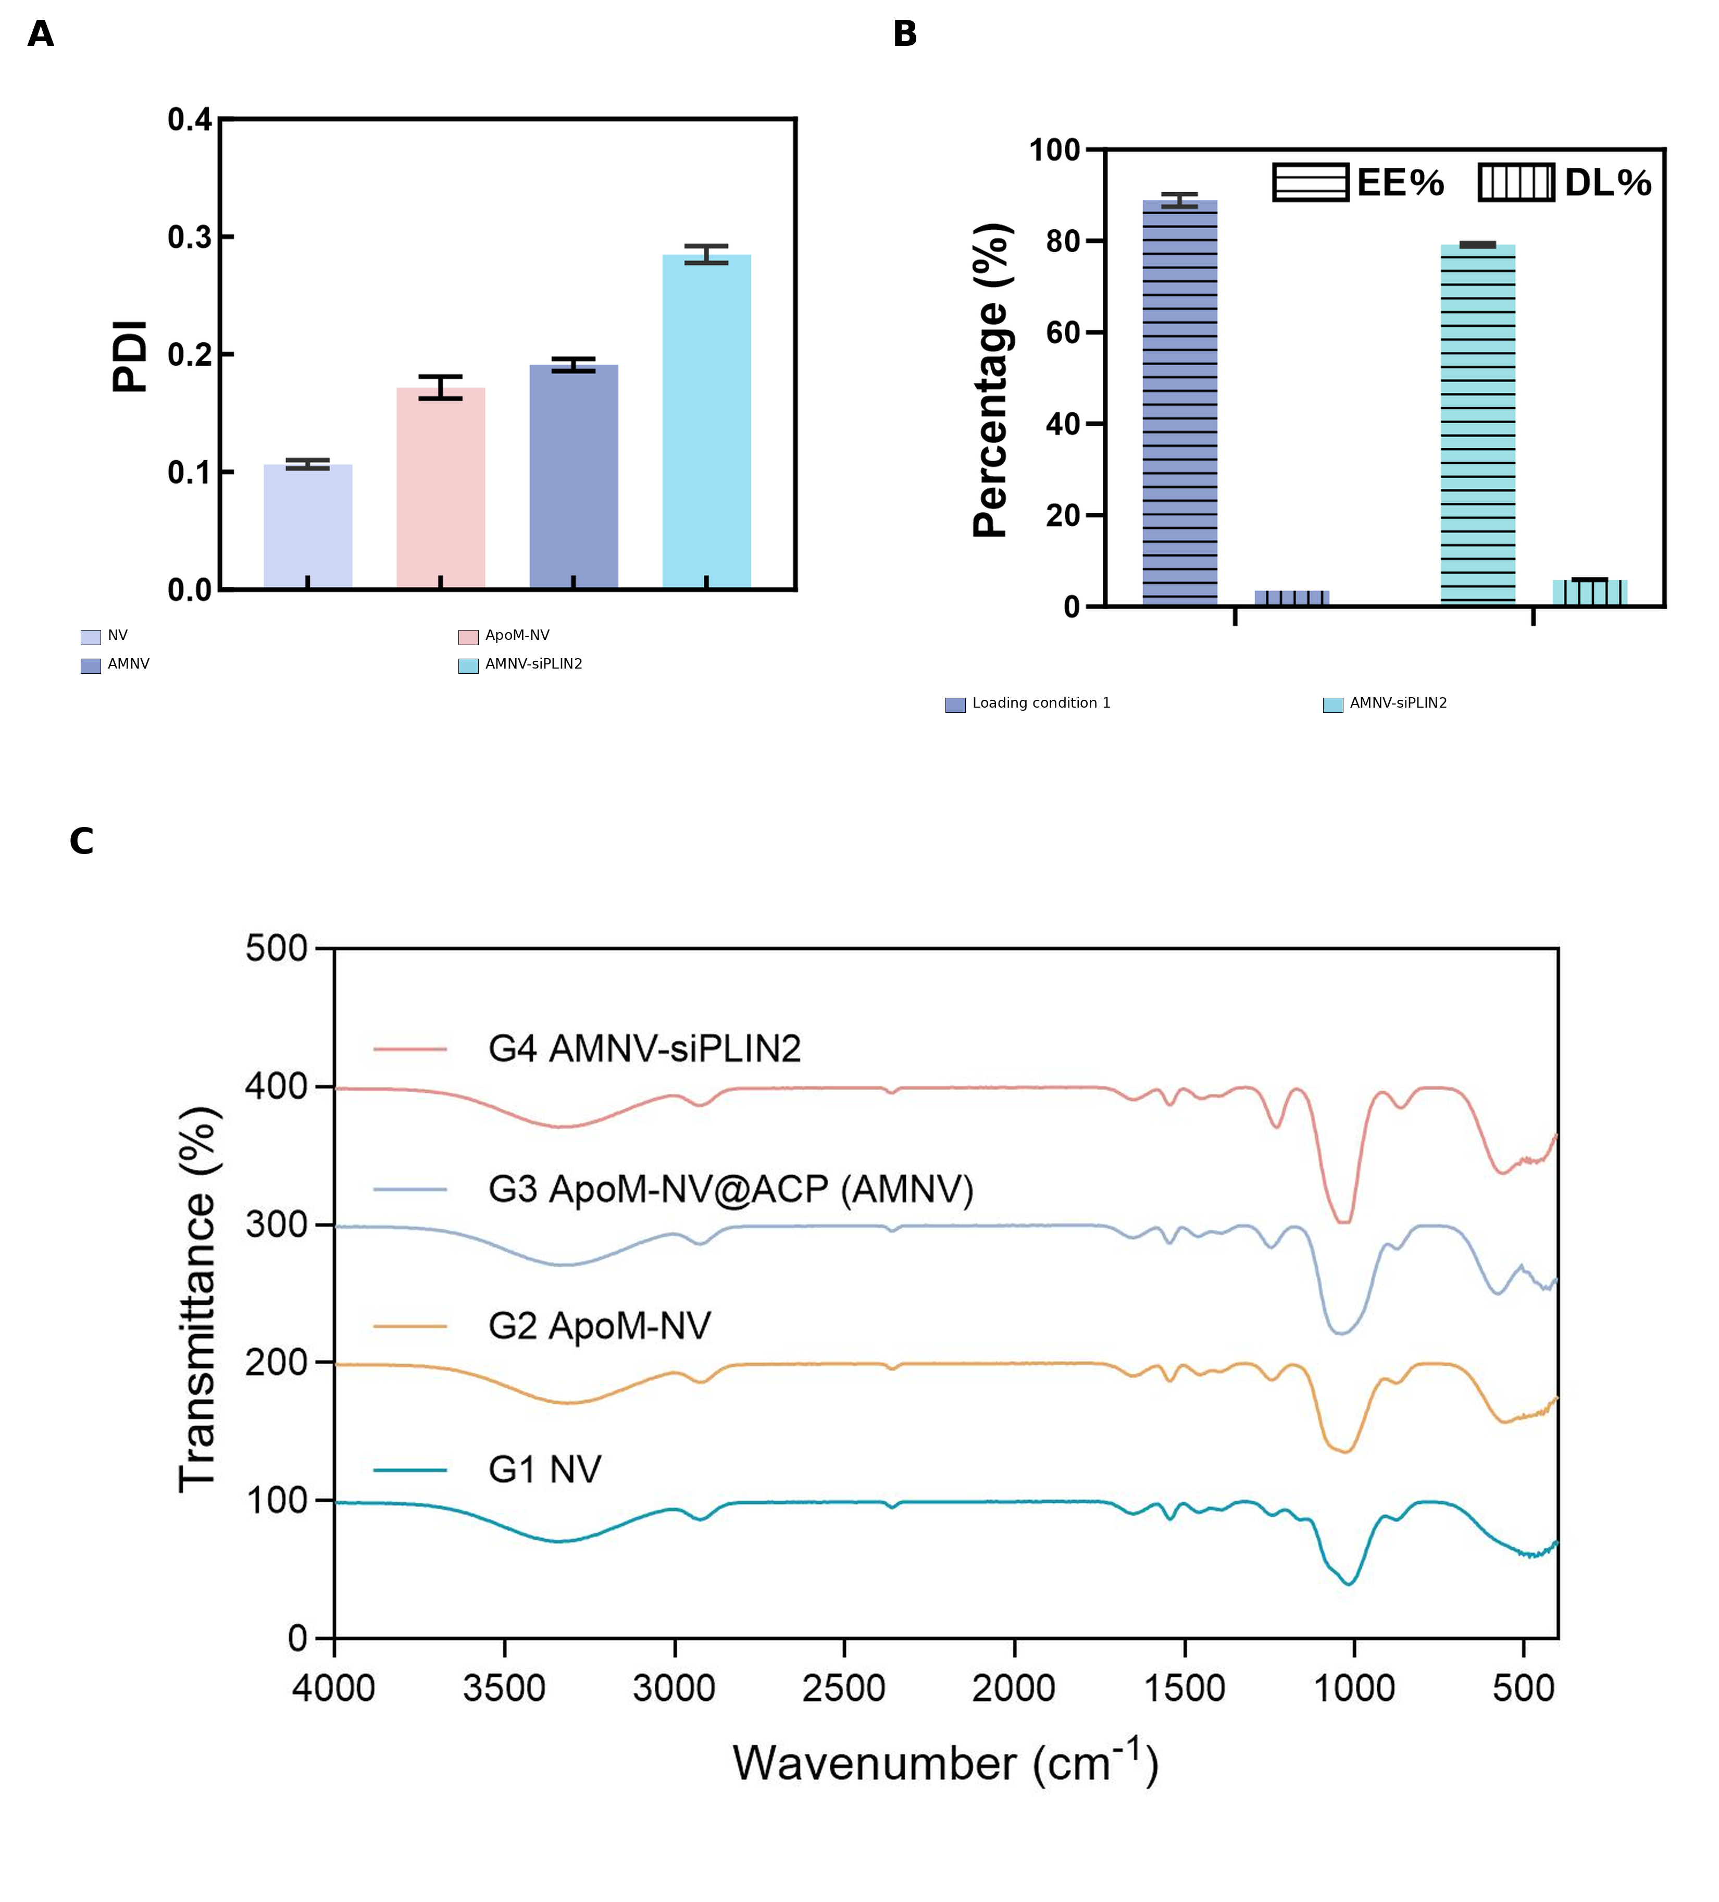
Figure S6. Additional colloidal, loading, and vibrational characterization of the stepwise vesicle formulations. (A) Polydispersity index (PDI) of NV, ApoM-NV, AMNV, and AMNV-siPLIN2. (B) Encapsulation efficiency (EE; horizontal hatching) and loading capacity (DL; vertical hatching) for the two siRNA-loading conditions; the final AMNV-siPLIN2 condition is shown in cyan. (C) FTIR spectra of NV (G1), ApoM-NV (G2), ApoM-NV@ACP/AMNV (G3), and AMNV-siPLIN2 (G4). Data in panels A and B are mean ± SD (n = 3 independent preparations).

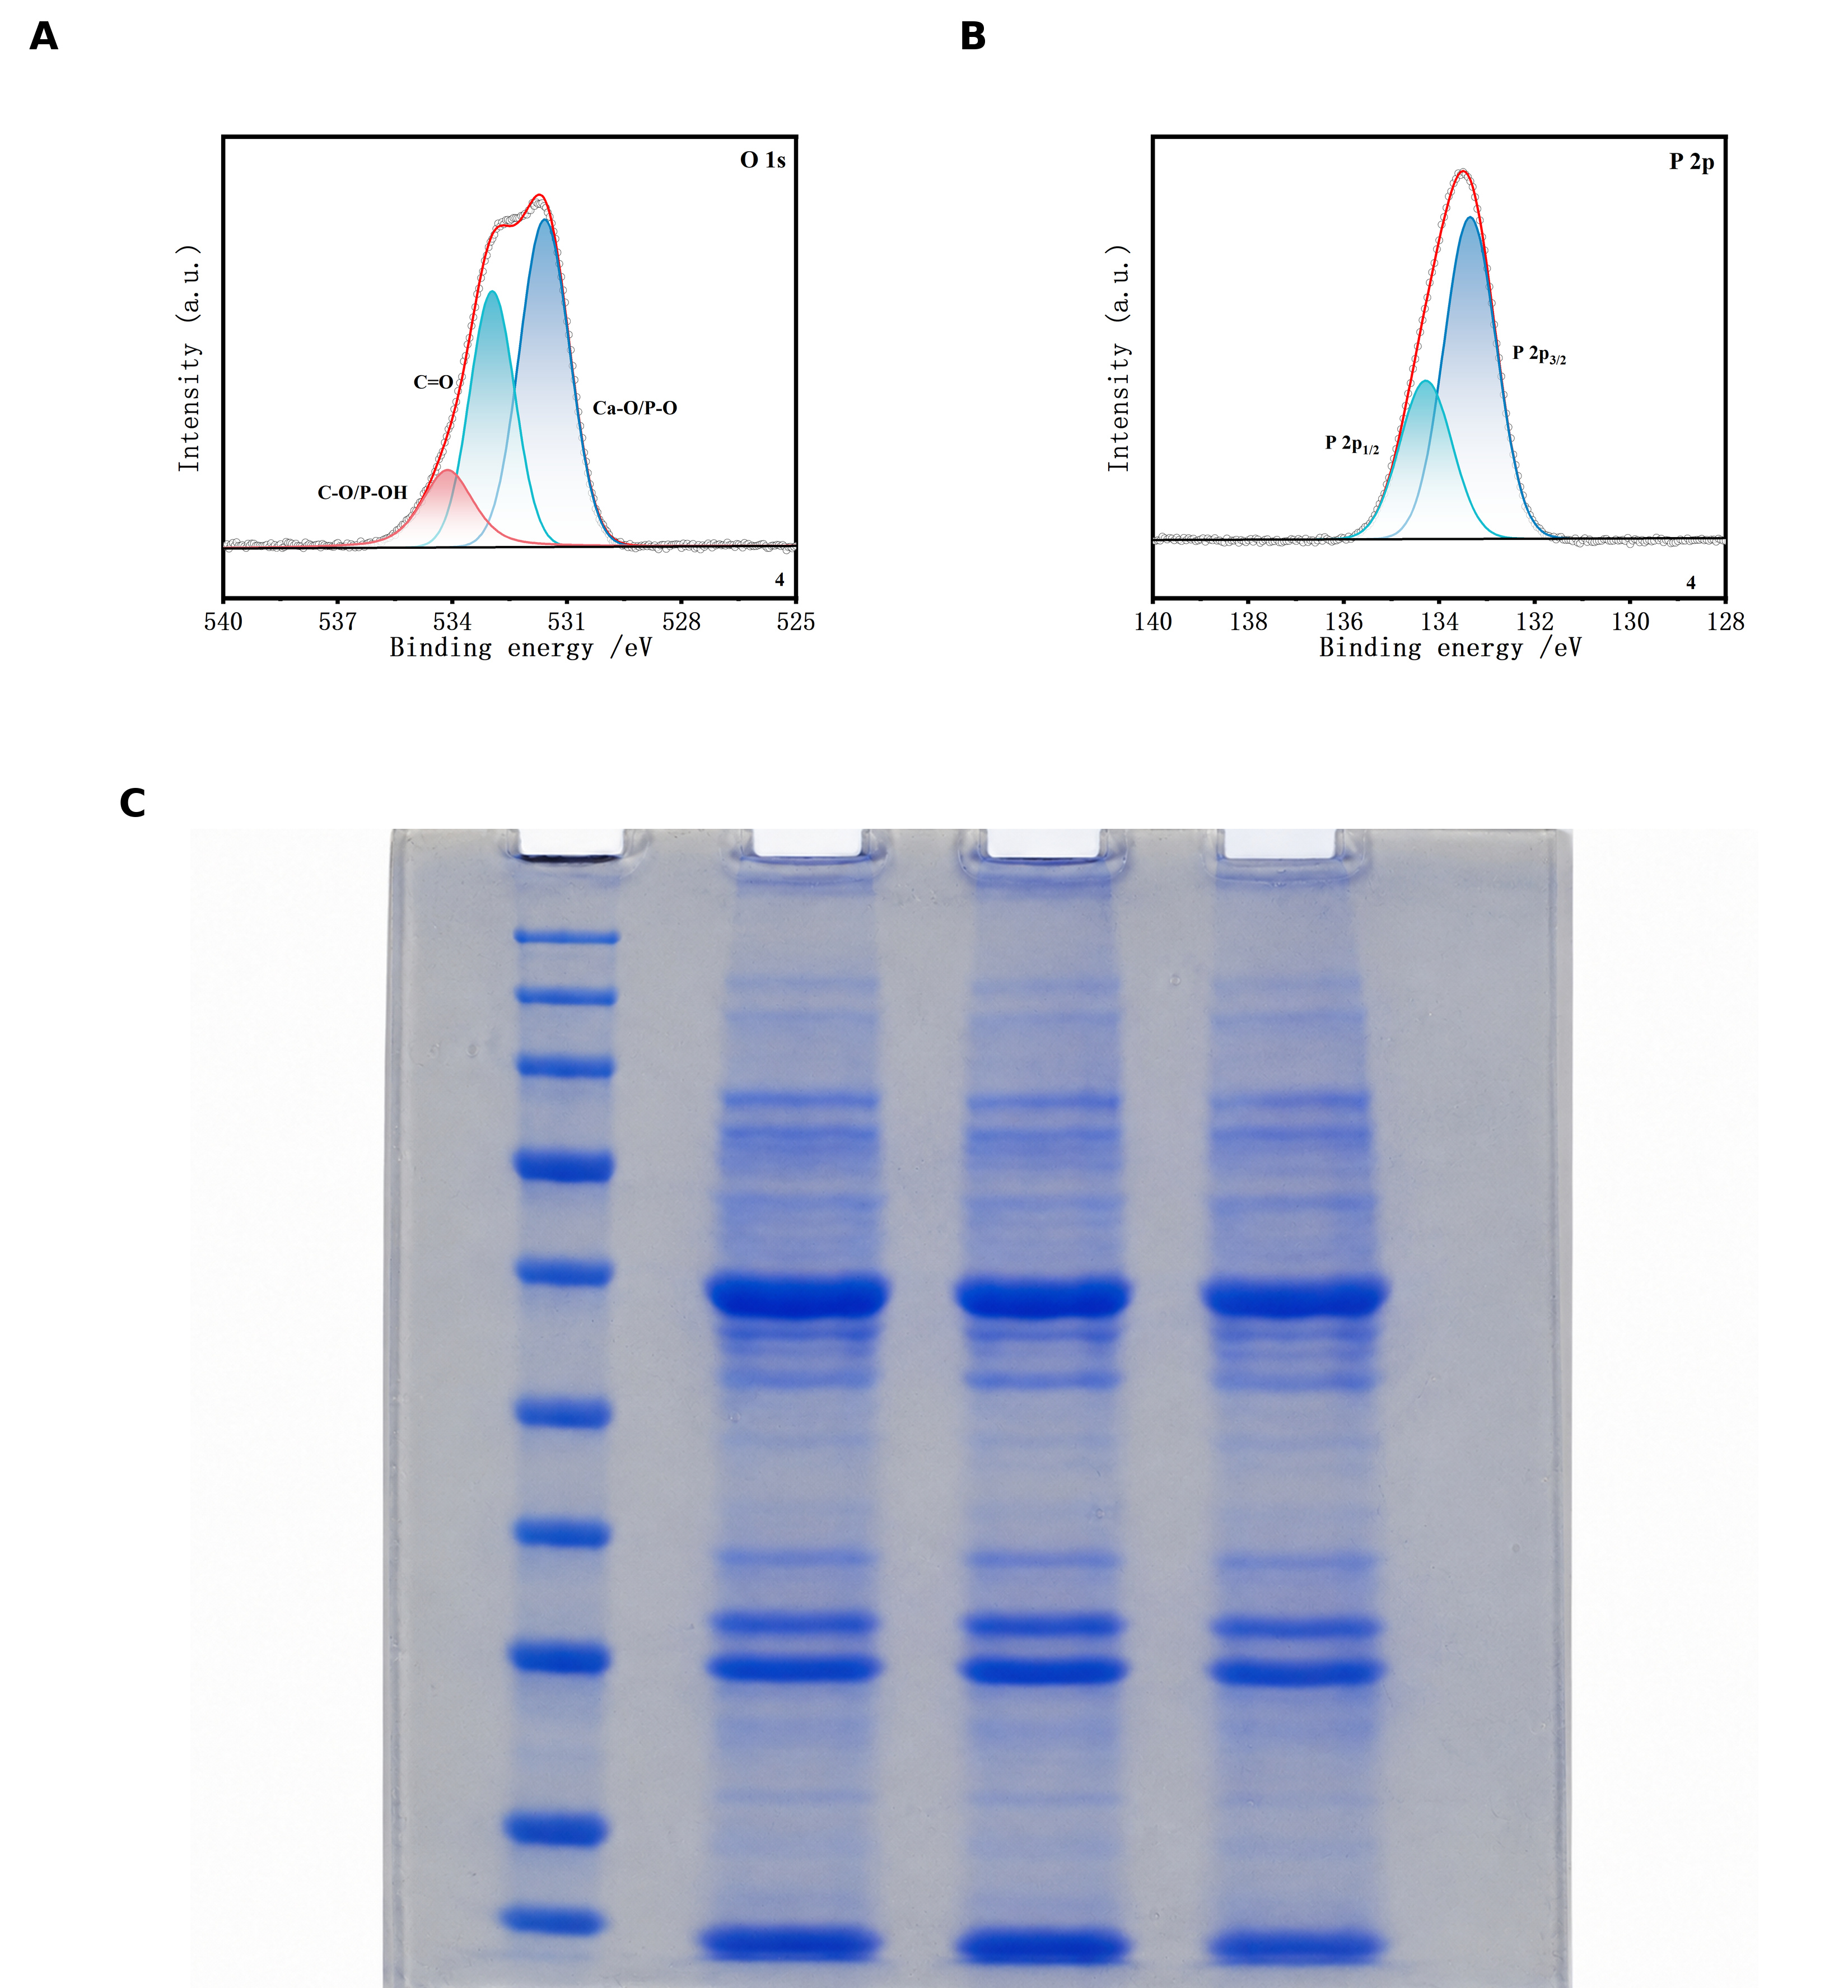
Figure S7. High-resolution XPS analysis and retention of the protein profile. (A) High-resolution O 1s spectrum of AMNV-siPLIN2 deconvoluted into C–O/P–OH (approximately 534.1 eV), C=O (approximately 532.9 eV), and Ca–O/P–O (approximately 531.6 eV) components. (B) High-resolution P 2p spectrum showing P 2p₁/₂ and P 2p₃/₂ components at approximately 134.3 and 133.4 eV, respectively. (C) Coomassie-stained SDS–PAGE of three vesicle-containing preparations. The marker lane is shown at left. Comparable multiband profiles across the three sample lanes indicate broad preservation of the vesicle-associated protein pattern during stepwise engineering.

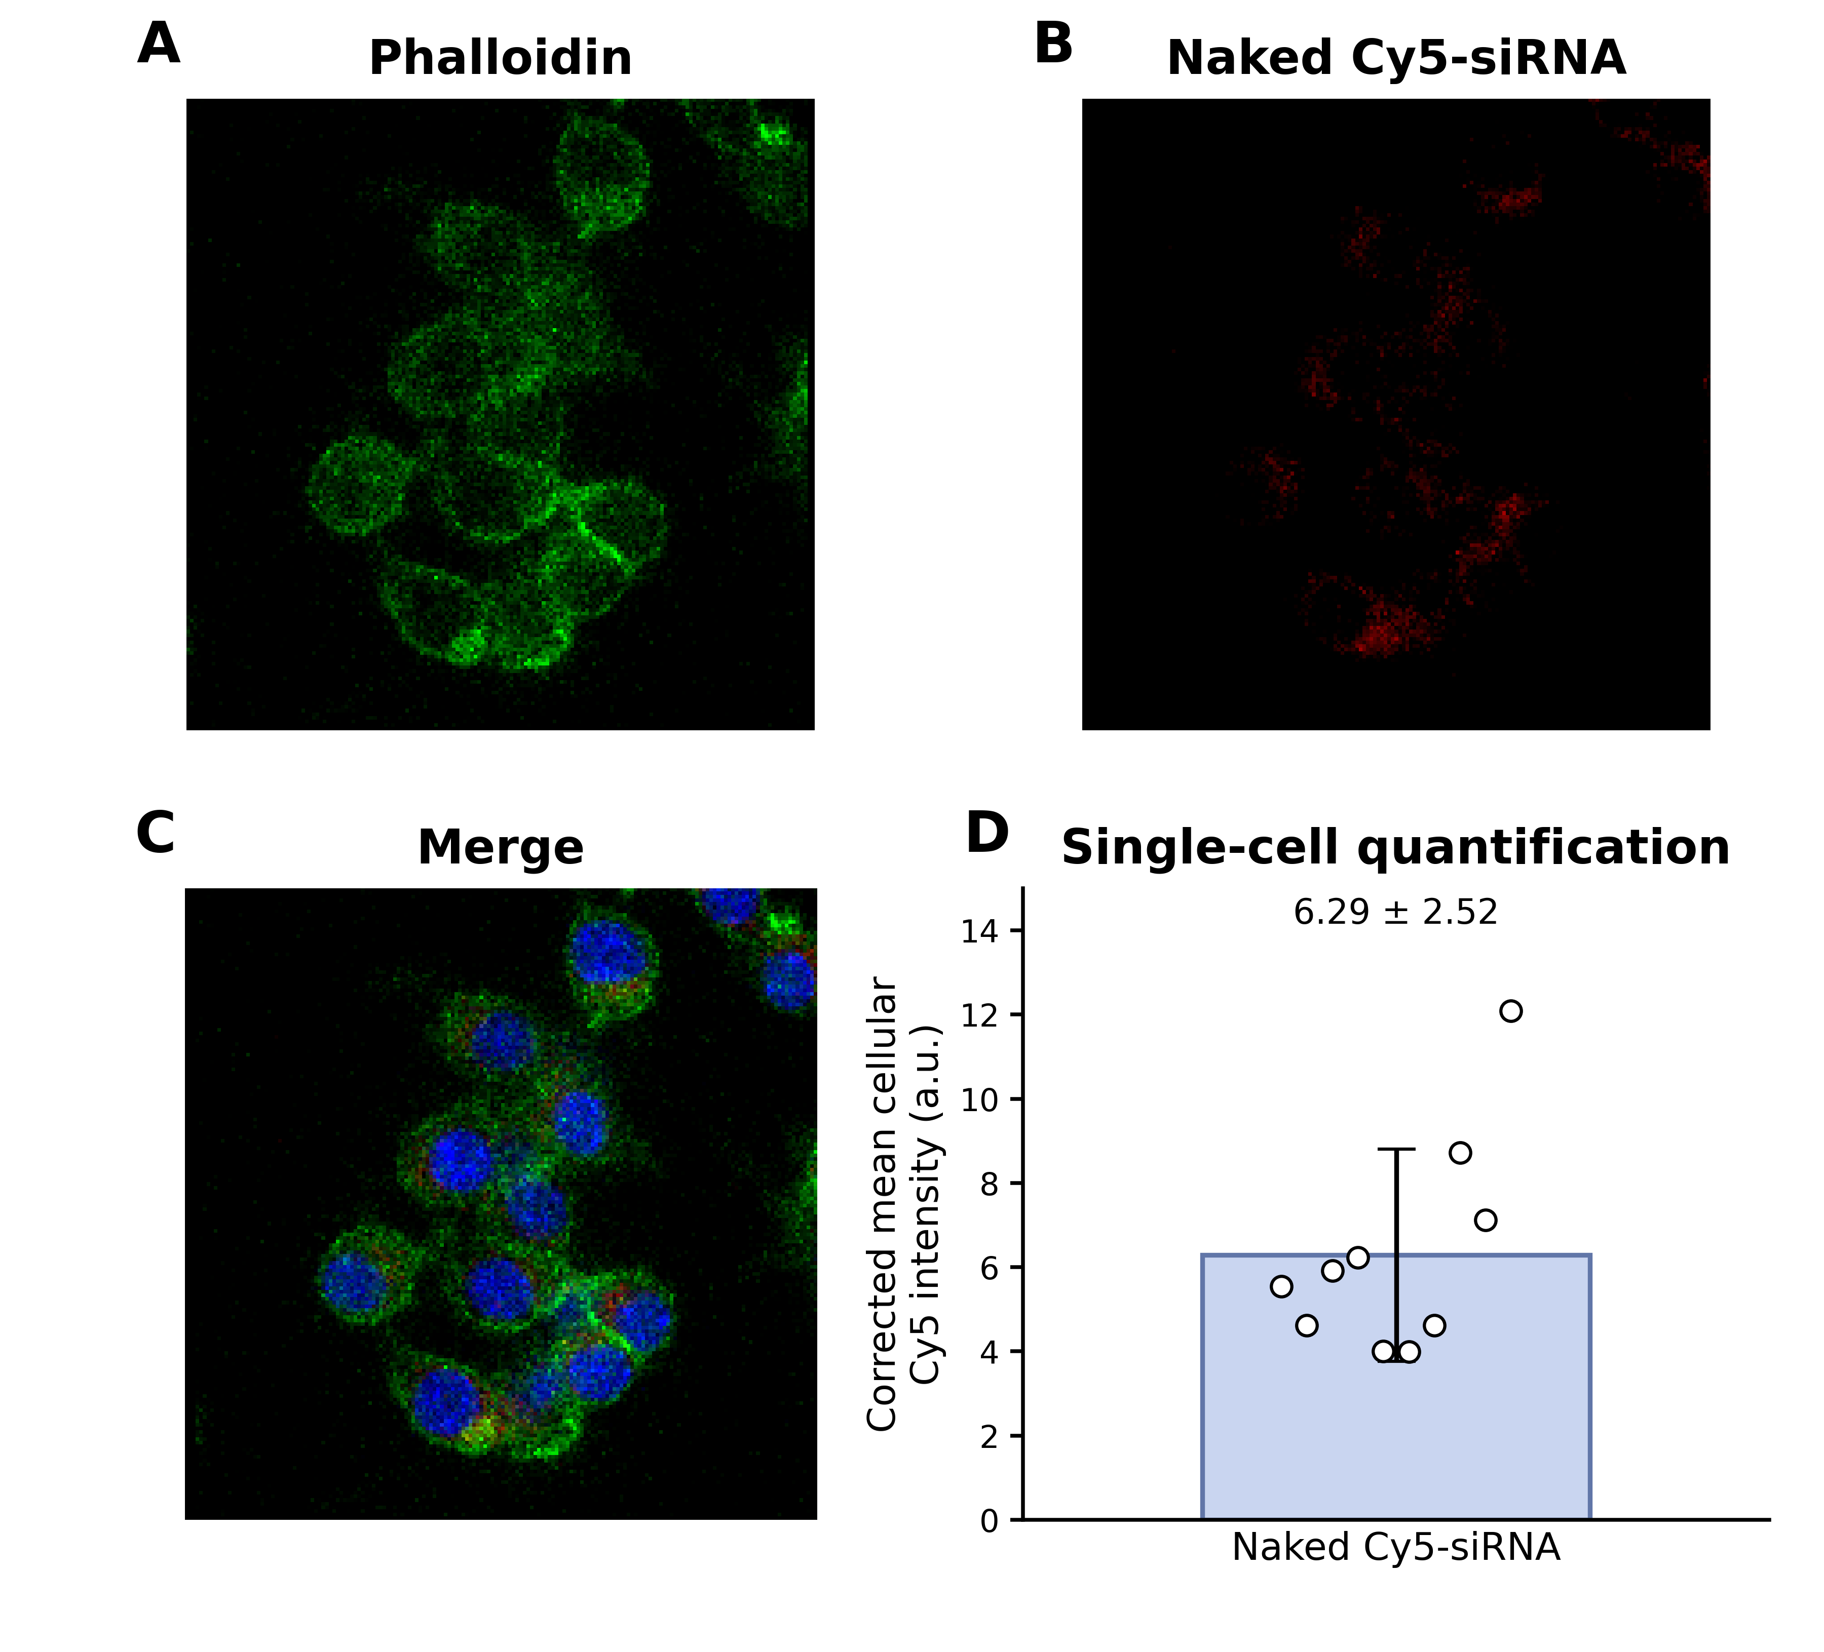
Figure S8. Limited uptake of naked Cy5-siRNA by HG-conditioned RAW264.7 macrophages. (A) Phalloidin, (B) naked Cy5-siRNA, (C) merged image with DAPI, and (D) background-corrected mean cellular Cy5 intensity. DAPI-positive nuclei were segmented; the edge-truncated nucleus and small fragments were excluded; and uniform cell-centered regions of interest were applied. Dots represent individual cells in one representative field (n = 10 cells); the bar and whiskers denote mean ± SD (6.29 ± 2.52 a.u.). This descriptive cell-level analysis does not represent 10 independent biological replicates.

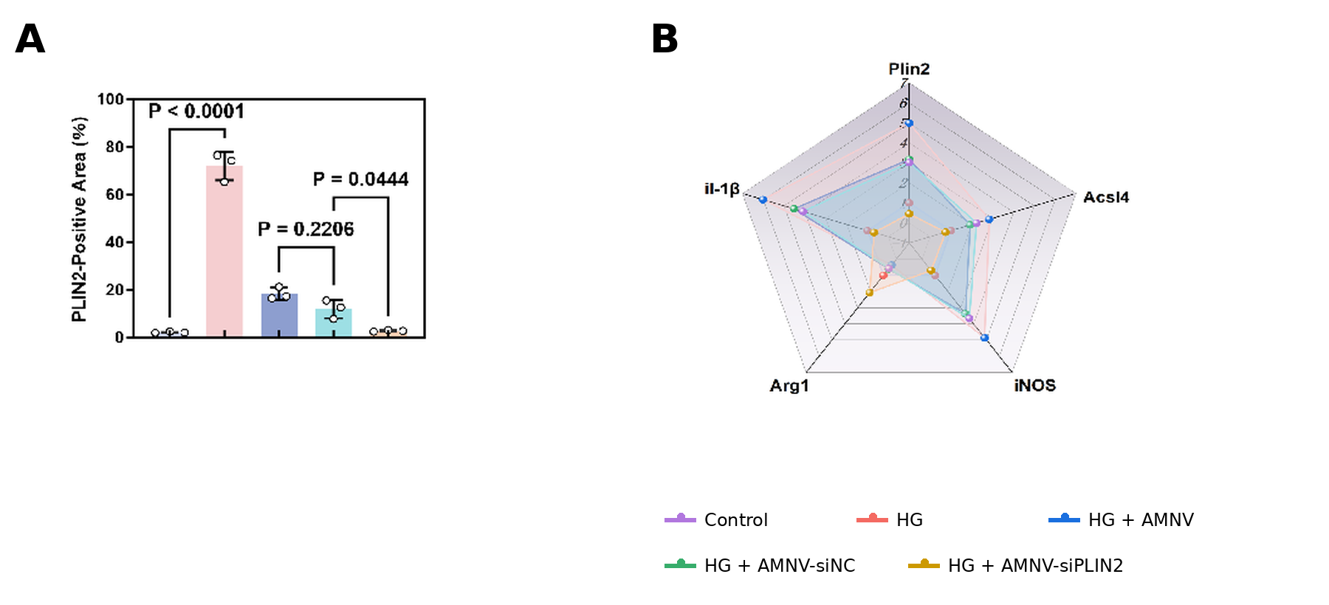
Figure S9. Orthogonal validation of PLIN2 depletion and downstream immunometabolic reprogramming. (A) PLIN2-positive area in Control, HG, HG + AMNV, HG + AMNV-siNC, and HG + AMNV-siPLIN2 macrophages. Data are mean ± SD (n = 3 independent cell preparations); exact P values are shown. (B) Radar plot of Plin2, Acsl4, Nos2, Arg1, and Il1b expression measured by quantitative PCR. Control expression was normalized to 1, and radial coordinates show group means from three independent cell preparations.

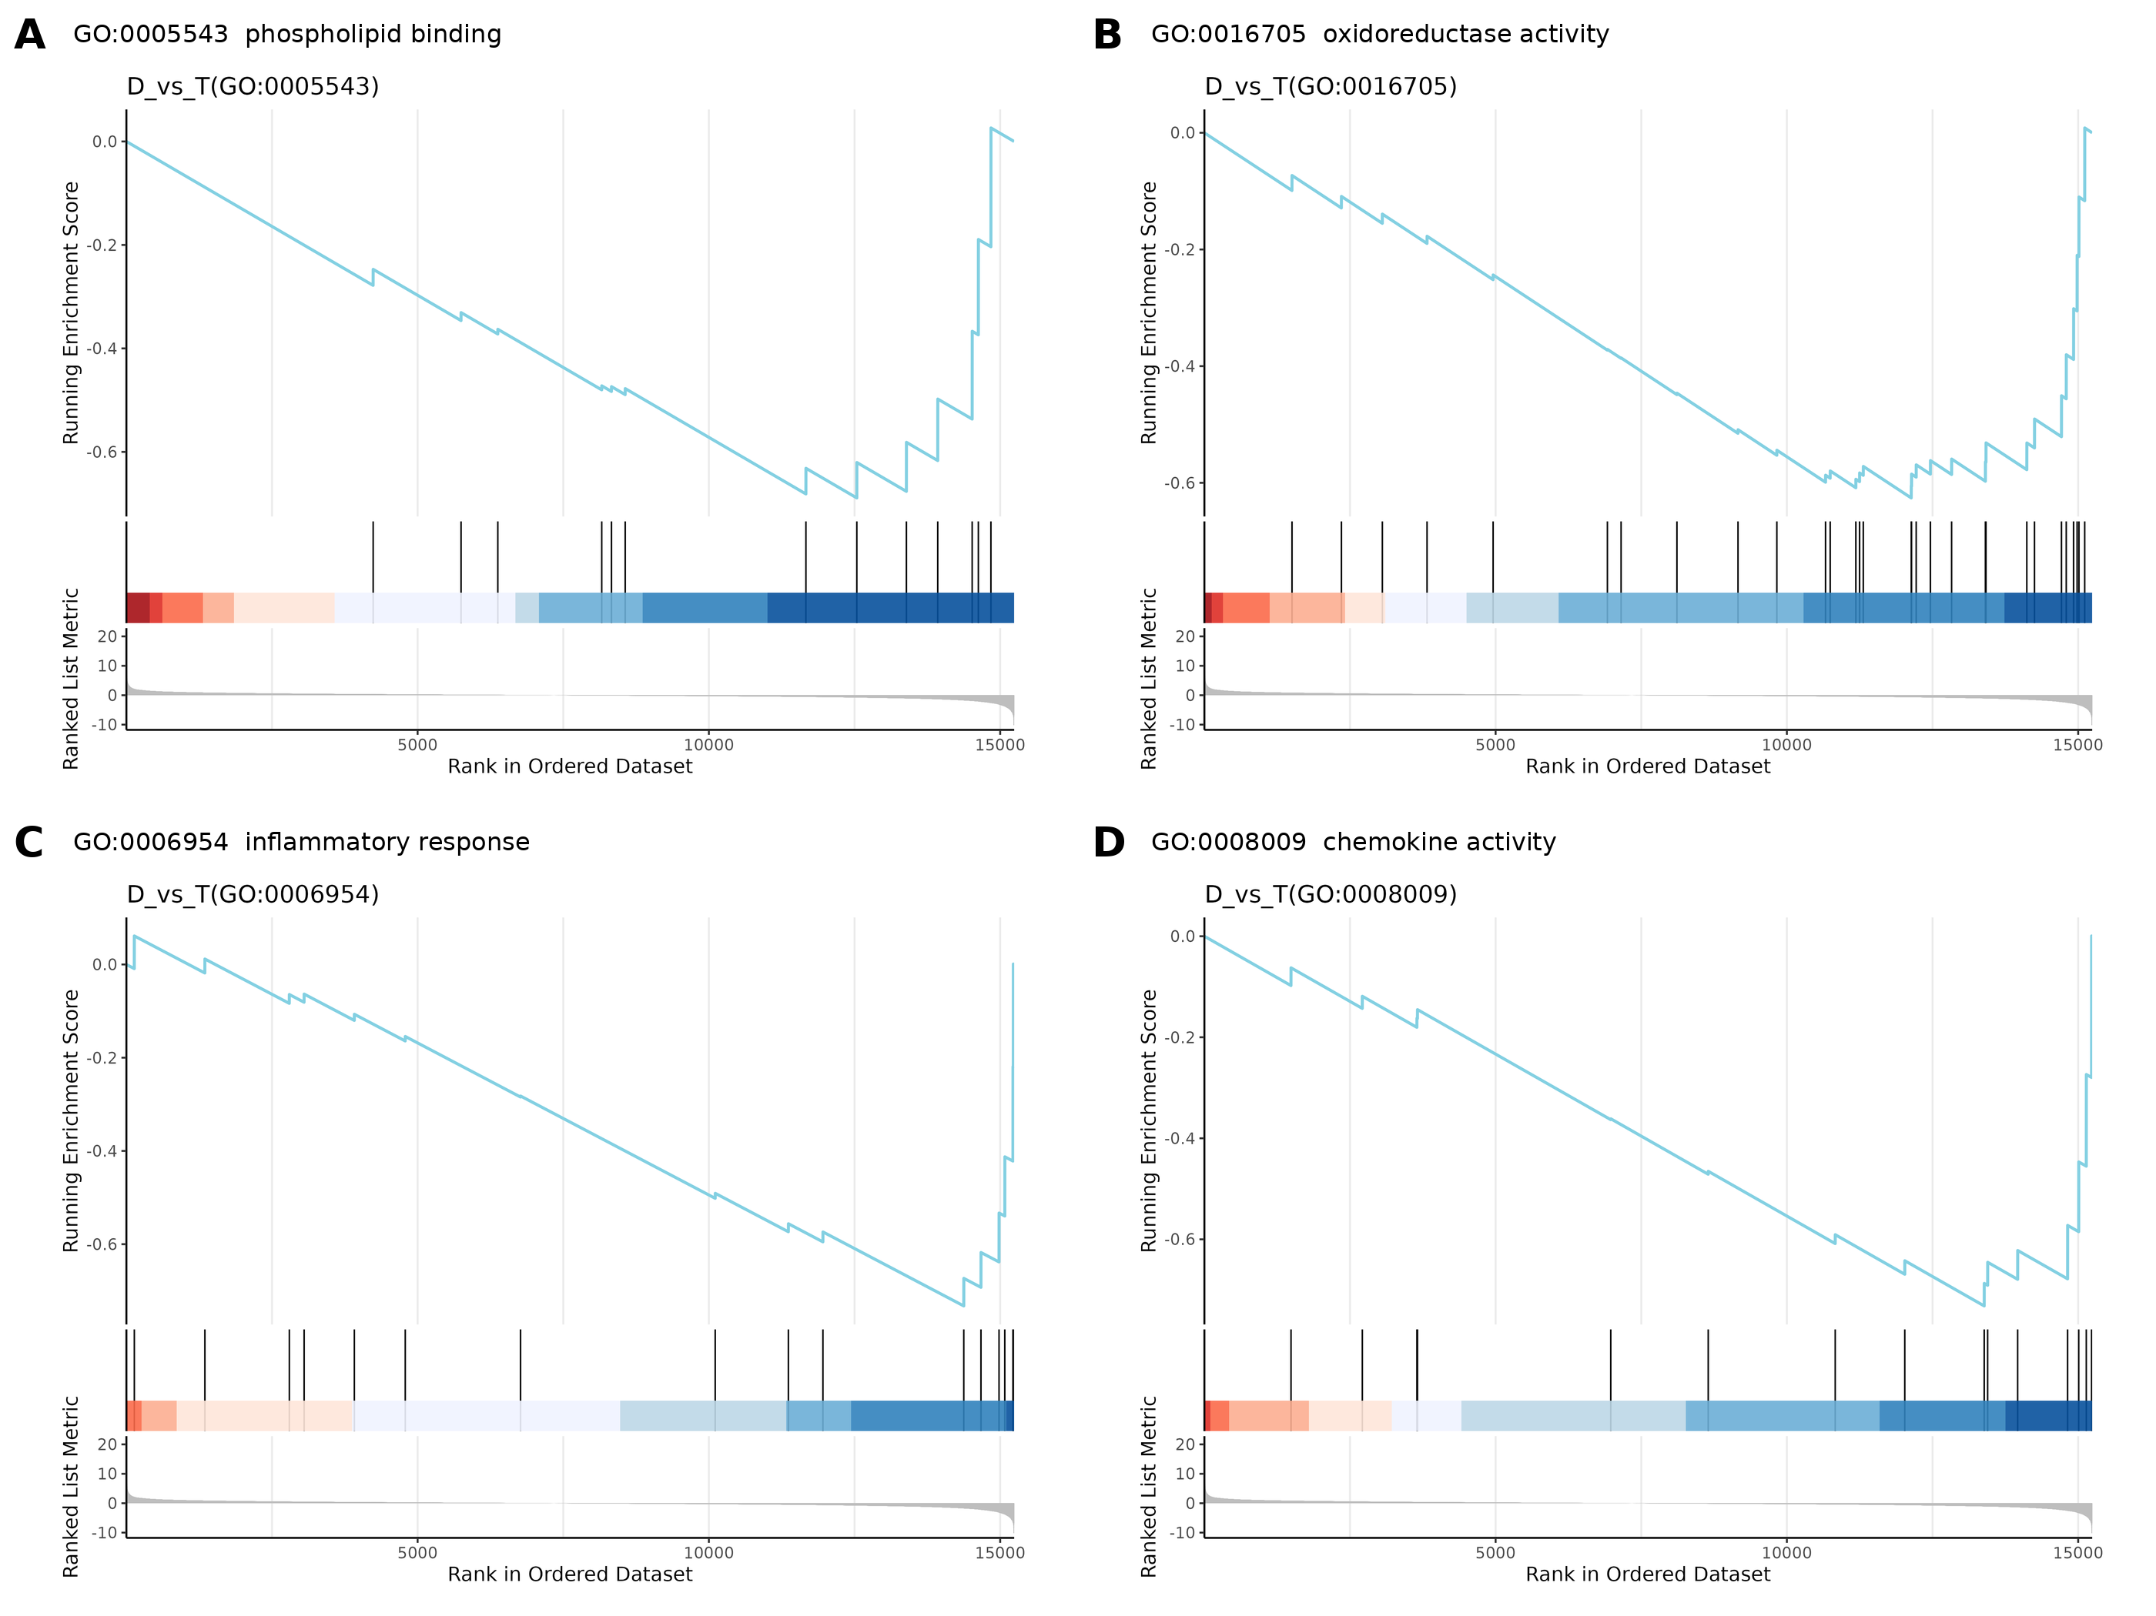
Figure S10. Complementary GSEA profiles linking lipid-interface remodeling to redox and inflammatory outputs. (A) Phospholipid binding (GO:0005543). (B) Oxidoreductase activity, acting on paired donors, with incorporation or reduction of molecular oxygen (GO:0016705). (C) Inflammatory response (GO:0006954). (D) Chemokine activity (GO:0008009). Genes were ranked for HG macrophages (D) versus HG + AMNV-siPLIN2 macrophages (T). These nonredundant terms extend the phospholipid-metabolism and TNF-receptor-binding profiles in Figure 7e by adding lipid-interface, redox, inflammatory, and chemokine context to the proposed PLIN2-centered mechanism.

Table S1. Key materials, cell lines, reagents, and assay kits.
Material or reagent | Supplier | Catalog no. | Principal use
RAW264.7 macrophages | ATCC | TIB-71 | HG macrophage experiments
PC12 cells | ATCC | CRL-1721 | Neuronal differentiation assays
C57BL/6 mouse BMSCs | Cyagen Biosciences | MUBMX-01001 | Osteogenic assays; passages 6–8
Low-glucose DMEM (5.5 mM glucose) | Gibco | 11885084 | RAW264.7 maintenance and control medium
Fetal bovine serum | Gibco | 10099141C | Cell-culture supplement
Penicillin–streptomycin | Gibco | 15140122 | Cell-culture supplement
Kaighn's modification of Ham's F-12 (F-12K) | ATCC | 30-2004 | PC12 maintenance
Heat-inactivated horse serum | Gibco | 26050088 | PC12 maintenance
Mouse BMSC complete medium | Cyagen Biosciences | MUXMX-90011 | BMSC expansion
Mouse BMSC osteogenic differentiation medium | Cyagen Biosciences | MUXMX-90021 | BMSC osteogenic induction
d-Glucose | Sigma-Aldrich | G7021 | Adjustment to 25 mM HG
DOPS | Avanti Polar Lipids | 840035P | Apoptotic-mimetic membrane
Calcium chloride | Sigma-Aldrich | C1016 | ACP mineralization
Disodium hydrogen phosphate | Sigma-Aldrich | S5136 | ACP mineralization
Annexin V-FITC apoptosis detection reagent | Beyotime | C1062S | Surface-accessible phosphatidylserine
Quant-iT RiboGreen RNA assay kit | Thermo Fisher Scientific | R11490 | siRNA EE, DL, and release
Cell Counting Kit-8 | Beyotime | C0038 | Metabolic activity
Calcein-AM/propidium iodide viability kit | Beyotime | C2015S | Live/dead imaging
DAPI | Beyotime | C1002 | Nuclear counterstaining
Actin-Tracker Green-488 phalloidin | Beyotime | C2201S | F-actin staining
LysoTracker Green DND-26 | Thermo Fisher Scientific | L7526 | Acidic-compartment tracking
BODIPY FL C16 | Thermo Fisher Scientific | D3821 | Fatty-acid uptake
BODIPY 493/503 | Thermo Fisher Scientific | D3922 | Neutral-lipid droplets
Nile Red | Sigma-Aldrich | 72485 | Bulk neutral-lipid staining
JC-1 mitochondrial membrane-potential kit | Beyotime | C2006 | Mitochondrial membrane potential
DCFH-DA ROS assay kit | Beyotime | S0033S | Intracellular ROS
RIPA lysis buffer (strong) | Beyotime | P0013B | Protein extraction
BCA protein assay kit | Beyotime | P0012 | Protein quantification
BeyoECL Plus | Beyotime | P0018S | Chemiluminescent immunoblot detection
Coomassie Brilliant Blue staining solution | Beyotime | P0017S | SDS–PAGE total-protein profiles
TRIzol reagent | Invitrogen | 15596026 | Total RNA isolation
HiScript III RT SuperMix for qPCR (+gDNA wiper) | Vazyme | R323-01 | Reverse transcription
ChamQ Universal SYBR qPCR Master Mix | Vazyme | Q711-02 | Quantitative PCR
BCIP/NBT ALP color-development kit | Beyotime | C3206 | Day-7 ALP staining
Alizarin Red S staining solution | Beyotime | C0148S | Day-21 mineralization
Mouse 2.5S nerve growth factor | Sigma-Aldrich | N0513 | PC12 differentiation; 100 ng mL⁻¹
Poly-l-lysine | Sigma-Aldrich | P4707 | PC12 plate coating
Collagenase type I | Sigma-Aldrich | C0130 | Defect-tissue dissociation
DNase I | Sigma-Aldrich | DN25 | Defect-tissue dissociation
3,3′-Diaminobenzidine substrate kit | Beyotime | P0203 | Immunohistochemistry
Citrate antigen-retrieval solution (50×) | Beyotime | P0081 | Immunohistochemical antigen retrieval
4% paraformaldehyde | Beyotime | P0099 | Cell and tissue fixation
Abbreviations: ACP, amorphous calcium phosphate; BMSC, bone-marrow mesenchymal stromal cell; DL, drug loading; EE, encapsulation efficiency; HG, high glucose.

Table S2. Antibodies used for immunoblotting, imaging, receptor blockade, and flow cytometry.
Target (host, clone) | Supplier | Catalog no. | Application | Working dilution or dose
CD36 (rabbit mAb, EPR22509-40) | Abcam | ab252922 | WB | 1:1000
PLIN2 (rabbit mAb, EPR3713) | Abcam | ab108323 | WB | 1:1000
PLIN2 (rabbit pAb) | Abcam | ab52356 | ICC/IF | 1:200
CD9 (rabbit mAb, EPR2949) | Abcam | ab92726 | WB | 1:1000
CD63 (rabbit mAb, EPR21151) | Abcam | ab217345 | WB | 1:1000
CD81 (rabbit mAb, EPR4244) | Abcam | ab109201 | WB | 1:1000
ACSL4 (rabbit mAb, EPR8640) | Abcam | ab155282 | WB | 1:1000
GPX4 (rabbit mAb, EPNCIR144) | Abcam | ab125066 | WB | 1:1000
NF-κB p65 (rabbit pAb) | Abcam | ab16502 | WB | 1:1000
NLRP3 (rabbit mAb, EPR23094-1) | Abcam | ab263899 | WB | 1:1000
Arg1 (rabbit mAb, EPR6671(B)) | Abcam | ab124917 | WB | 1:1000
iNOS (rabbit mAb, EPR16635) | Abcam | ab178945 | WB | 1:1000
β-Actin (mouse mAb) | Beyotime | AF0003 | WB | 1:5000
RUNX2 (rabbit mAb, EPR14334) | Abcam | ab192256 | ICC/IF | 1:200
Osteopontin/OPN (goat pAb) | Abcam | ab11503 | ICC/IF | 1:200
βIII-Tubulin/TUJ1–Alexa Fluor 594 (rabbit mAb, EP1569Y) | Abcam | ab201740 | ICC/IF | 1:200
Ki67 (rabbit mAb, SP6) | Abcam | ab16667 | WB | 1:1000
NF200/neurofilament heavy (rabbit pAb) | Abcam | ab8135 | WB | 1:1000
CD206 (rabbit pAb) | Abcam | ab64693 | IHC-P | 1:500
CD86 (rabbit mAb) | Beyotime | AG8128 | IHC-P | 1:200
Osteocalcin/OCN (rabbit pAb) | Abcam | ab93876 | IHC-P/IF | 1:100
CD31 (rat mAb, SZ31) | Dianova | DIA-310 | IHC-P/IF | 1:20
GAP43 (chicken pAb) | Abcam | ab134019 | IHC-P/IF | 1:500
CD36 (rat mAb, HM36; purified) | BioLegend | 102602 | Blockade | 10 μg mL⁻¹
CD86–PE (rat mAb, GL-1) | BioLegend | 105008 | Flow cytometry | 0.25 μg per 10⁶ cells
CD206–APC (rat mAb, C068C2) | BioLegend | 141708 | Flow cytometry | 0.25 μg per 10⁶ cells
CD11b–FITC (rat mAb, M1/70) | BioLegend | 101206 | Flow cytometry | 0.25 μg per 10⁶ cells
CD86–APC (rat mAb, GL-1) | BioLegend | 105012 | Flow cytometry | 0.25 μg per 10⁶ cells
Goat anti-rabbit IgG (H+L)–HRP | Beyotime | A0208 | WB/IHC | 1:1000
Goat anti-mouse IgG (H+L)–HRP | Beyotime | A0216 | WB/IHC | 1:1000
Donkey anti-rabbit IgG–Alexa Fluor 488 | Abcam | ab150073 | ICC/IF | 1:500
Donkey anti-rabbit IgG–Alexa Fluor 594 | Abcam | ab150064 | ICC/IF | 1:500
Donkey anti-goat IgG–Alexa Fluor 594 | Abcam | ab150132 | ICC/IF | 1:500
Goat anti-rabbit IgG–Alexa Fluor 405, preadsorbed | Abcam | ab175654 | IHC-P/IF | 1:500
Goat anti-rat IgG–Alexa Fluor 488 | Abcam | ab150157 | IHC-P/IF | 1:1000
Goat anti-chicken IgY–Alexa Fluor 594, preadsorbed | Abcam | ab150176 | IHC-P/IF | 1:500
Primary antibodies were incubated overnight at 4 °C unless stated otherwise. HRP- and fluorophore-conjugated secondary antibodies were incubated for 1 h at room temperature. Flow-cytometry antibody amounts are starting values and were titrated for the instrument and cell preparation.

Table S3. siRNA oligonucleotide sequences and modifications.
Oligonucleotide | Sequence (5′→3′) | Purpose or modification | Supplier
siPLIN2 sense | AACGUCUGUCUGGACCGAAUA | Mouse Plin2 targeting strand | GenePharma
siPLIN2 antisense | UAUUCGGUCCAGACAGACGUU | Complementary guide strand | GenePharma
siNC sense | UUCUCCGAACGUGUCACGUTT | Nontargeting negative control; 3′ dTdT overhang | GenePharma
siNC antisense | ACGUGACACGUUCGGAGAATT | Nontargeting negative control; 3′ dTdT overhang | GenePharma
Cy5–siNC sense | Cy5–UUCUCCGAACGUGUCACGUTT | Uptake and intracellular-trafficking tracer | GenePharma
Cy5–siNC antisense | ACGUGACACGUUCGGAGAATT | Complementary strand for Cy5–siNC | GenePharma
All oligonucleotides were HPLC-purified. The siPLIN2 duplex corresponds to a previously validated mouse Plin2-targeting sequence (RefSeq NM_007408.3): Senthivinayagam, S.; et al. Plin2 Inhibits Cellular Glucose Uptake through Interactions with SNAP23, a SNARE Complex Protein. PLoS One 2013, 8, e73696. https://doi.org/10.1371/journal.pone.0073696.
The Cy5-labeled nontargeting duplex was used for uptake and trafficking so that fluorescence tracking did not itself alter PLIN2 expression. U denotes uridine; T denotes the terminal deoxythymidine overhang.

