SUPPLEMENTARY MATERIALS

Enhanced eicosapentaenoic acid productivity in Microchloropsis salina through low-cost medium optimization and EMS-induced random mutagenesis
Hyeran Lee¹ and Bongsoo Lee^{1,*}

¹ Department of Microbial Biotechnology, Mokwon University, Daejeon 35349, Republic of Korea

*Corresponding author
Bongsoo Lee
Tel: +82-42-829-7555, Fax: +82-42-350-3910, E-mail: bongsoolee@mokwon.ac.kr

Supplementary Figures
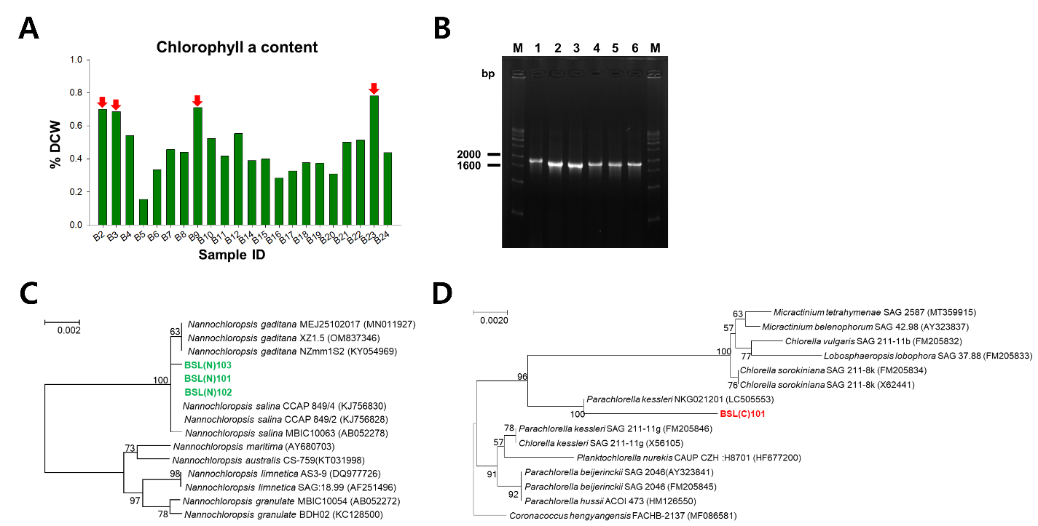
Supplementary Figure S1. Chlorophyll a screening, 18S rRNA gene amplification, and phylogenetic identification of selected marine microalgal isolates. (A) Chlorophyll a contents of marine microalgal isolates cultivated in f/2 medium. Values are expressed relative to dry cell weight and are presented as means ± SD of three independent biological cultures (n = 3). (B) PCR amplification of the 18S rRNA gene from selected isolates. The expected product size was approximately 1.8 kb. Lane M, 1-kb plus DNA ladder; lane 1, B2; lanes 2 and 3, B3; lanes 4 and 5, B9; lane 6, B23. (C) Phylogenetic placement of BSL(N)101, BSL(N)102, and BSL(N)103 within the Nannochloropsis/Microchloropsis lineage. (D) Phylogenetic placement of the Parachlorella-related isolate BSL(P)101. Bootstrap values are shown at the nodes, and scale bars indicate substitutions per site.

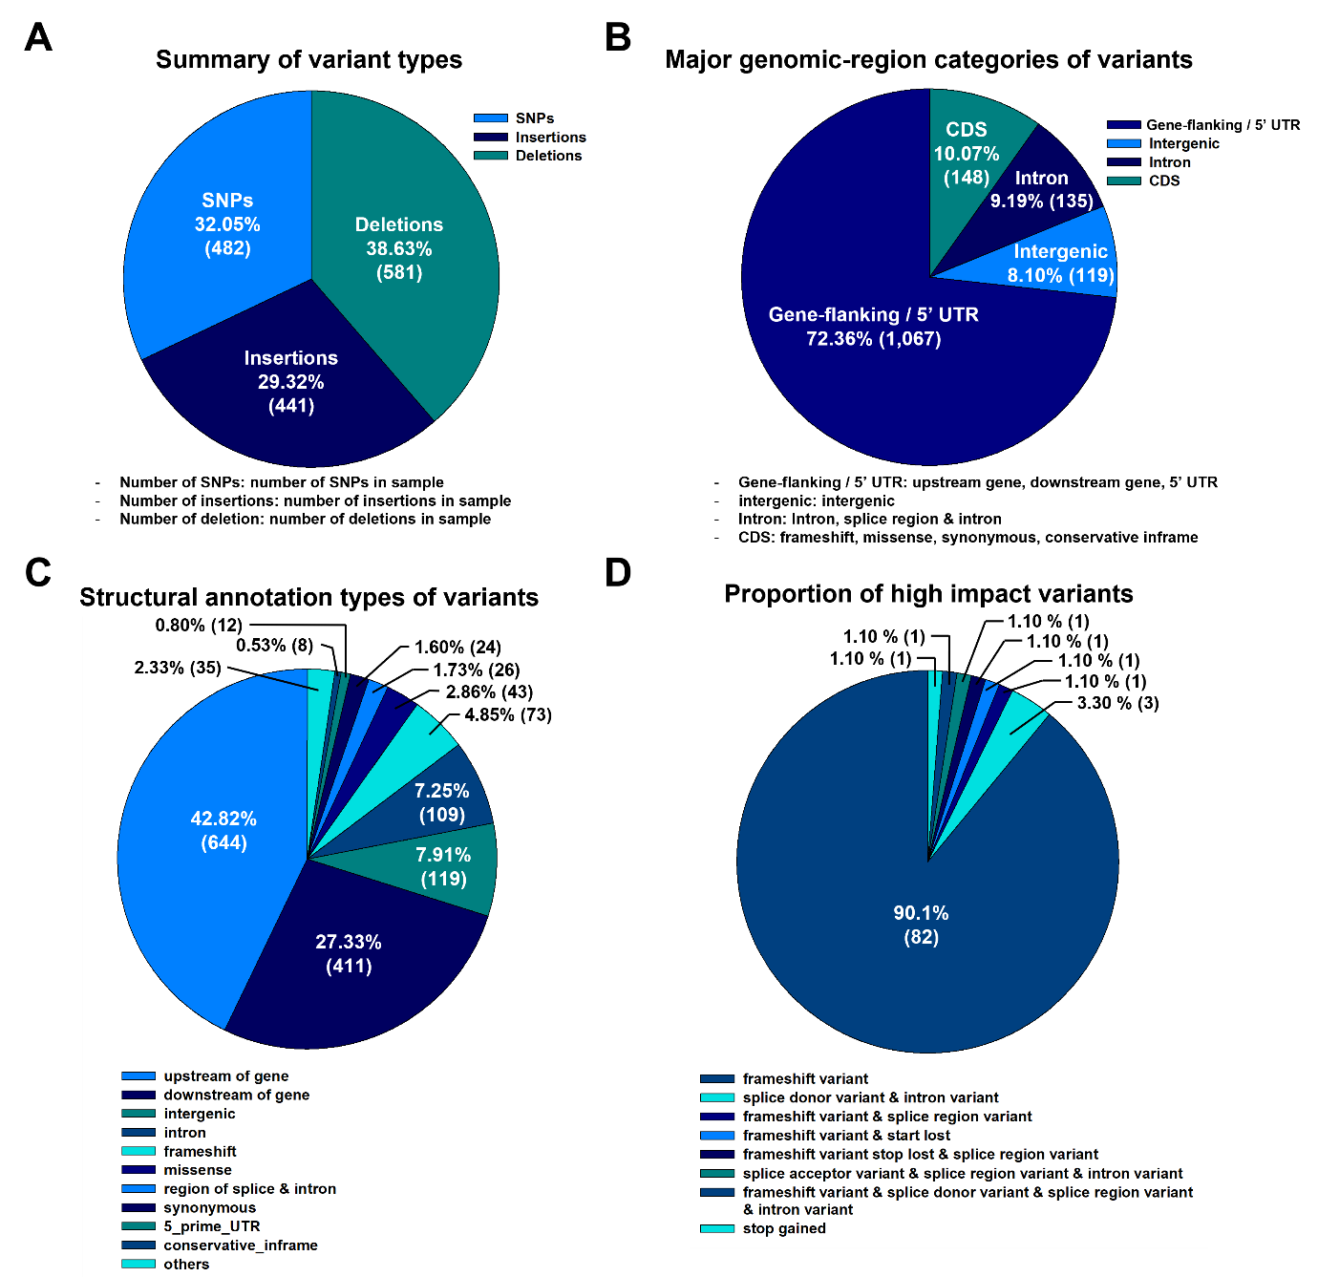
Supplementary Figure S2. Genome-wide variant landscape of BSL(N)103-1 revealed by whole-genome resequencing. Variants were identified relative to the published BSL(N)103 reference genome. (A) Distribution of 1,504 variants according to variant type, comprising SNPs, insertions, and deletions. (B) Distribution of 1,469 variants assigned to four major genomic-region categories. Thirty-five variants assigned to other annotation categories were excluded from this grouped representation, and percentages were calculated based on the 1,469 classified variants. Gene-flanking/5′ UTR includes upstream-of-gene, downstream-of-gene, and 5′ UTR annotations; Intron includes intron and splice-region/intron annotations; and CDS includes frameshift, missense, synonymous, and conservative in-frame annotations. (C) Detailed SnpEff annotation categories for all 1,504 variants. (D) Distribution of 91 predicted high-impact variants, among which frameshift variants accounted for 82 of 91 (90.1%). These annotations identify candidate variants but do not establish causal relationships with the enhanced phenotype.
Supplementary Table S1. Estimated nutrient-component cost of EPA production in f/2 and ES media on day 10.

Medium | Nutrient-component cost  (US$ t⁻¹)ª | EPA concentration  (mg L⁻¹) | Estimated nutrient cost  (US$ g⁻¹ EPA)^{b}
f/2 | 2.63 | 21.02 | 0.125
ES | 0.79 | 61.10 | 0.013
ª Commercial sea salt (17.5 g L⁻¹), which was common to both media, was excluded from the cost calculation; 1 metric ton of culture medium was approximated as 1,000 L. Costs in Korean won were converted to US dollars using an exchange rate of KRW 1,400 per US$1. ^{b} Calculated from the nutrient-component cost and the day-10 EPA concentration; cultivation, energy, harvesting, and downstream-processing costs were not included.
No. | gene | Biological Process (BP) | Molecular Function (MF) | Cellular Component (CC)
1 | GDCSP | glycine metabolic process  (GO:0006544) | glycine dehydrogenase  (decarboxylating) activity  (GO:0004375)  catalytic activity (GO:0003824)
glycine catabolic process
(GO:0006546)
 |  | obsolete oxidation-reduction process (GO:0055114)
2 | At3g21620_0 |  |  | membrane (GO:0016020)
3 | prs_0
4 | ANO10
5 | TIF3A1
6 | CHLH_1 | biosynthetic process (GO:0009058) | magnesium chelatase activity  (GO:0016851)
7 | POR | obsolete oxidation-reduction process  (GO:0055114) | FMN binding (GO:0010181)
8 | Mrto4 | ribosome biogenesis (GO:0042254)
ribosomal large subunit assembly
(GO:0000027)
9 | CIPK25 | protein phosphorylation (GO:0006468) | protein kinase activity (GO:0004672)
 |  |  | ATP binding (GO:0005524)
10 | GMPR | nucleotide metabolic process  (GO:0009117)  obsolete oxidation-reduction process  (GO:0055114) | oxidoreductase activity  (GO:0016491) | GMP reductase complex (GO:1902560)
 |  |  | catalytic activity (GO:0003824) | GMP reductase complex (GO:1902560)
 |  |  | GMP reductase activity  (GO:0003920) | GMP reductase complex (GO:1902560)
11 | crp-74 | translation (GO:0006412) | RNA binding (GO:0003723) | large ribosomal subunit (GO:0015934)
 |  | translation (GO:0006412) | structural constituent of ribosome (GO:0003735) | large ribosomal subunit (GO:0015934)
Supplementary Table S2. Gene Ontology annotations of genes carrying predicted high-impact variants in BSL(N)103-1.
continued.
No. | gene | Biological Process (BP) | Molecular Function (MF) | Cellular Component (CC)
12, 13 | atm1_1 | transmembrane transport  (GO:0055085) | ATP hydrolysis activity (GO:0016887) | membrane (GO:0016021)
 |  | transmembrane transport  (GO:0055085) | ATPase-coupled transmembrane transporter activity (GO:0042626) | membrane (GO:0016021)
 |  | transmembrane transport  (GO:0055085) | ATP binding (GO:0005524) | membrane (GO:0016021)
14 | HSPA1L
15 | pkbA_1 | protein phosphorylation  (GO:0006468) | protein kinase activity (GO:0004672)
 |  | protein phosphorylation  (GO:0006468) | ATP binding (GO:0005524)
 |  | protein phosphorylation  (GO:0006468) | protein serine/threonine kinase activity  (GO:0004674)
16, 17, 18 | aroC_2 | aromatic amino acid family  biosynthetic process (GO:0009073) | chorismite synthase activity  (GO:0004107)
19 | SPAPYUK71.03c_1 |  | lipid binding (GO:0008289)
20 | Rtf1 |  | DNA binding (GO:0003677)
21, 22 | cta3_3 |  | nucleotide binding (GO:0000166) | membrane (GO:0016021)
23 | Manba | carbohydrate metabolic process  (GO:0005975) | hydrolase activity, hydrolyzing O-glycosyl compounds (GO:0004553)
24 | csd_1 |  | catalytic activity (GO:0003824)
25 | EMB2247_1 | tRNA aminoacylation for protein  translation (GO:0006418)  tRNA aminoacylation for protein  translation (GO:0006418) | nucleotide binding (GO:0000166)
aminoacyl-tRNA editing activity
(GO:0002161)
 |  |  | ATP binding (GO:0005524)
26 | EMB2247_2 | tRNA aminoacylation for protein  translation (GO:0006418) | nucleotide binding (GO:0000166)
 |  | tRNA aminoacylation for protein  translation (GO:0006418) | ATP binding (GO:0005524)
 |  | tRNA aminoacylation for protein  translation (GO:0006418) | aminoacyl-tRNA ligase activity  (GO:0004812)

continued.
No. | gene | Biological Process (BP) | Molecular Function (MF) | Cellular Component (CC)
27 | ABCC2 | transmembrane transport  (GO:0055085) | ATPase-coupled transmembrane transporter activity (GO:0042626) | membrane (GO:0016021)
 |  |  | ATP binding (GO:0005524)
28 | SAC1_1
29, 30 | ELAC1_2 | obsolete tRNA 3'-trailer cleavage  (GO:0042779) | RNA endonuclease activity, producing 5'-phosphomonoesters (GO:0016891)
31 | FCF1 |  |  | small-subunit processome  (GO:0032040)
32 | xpr1 |  |  | membrane (GO:0016021)
33 | FCPA
34 | PGRL1A
35 | Swoo_3713
36 | HAC1_0
37 | GLSN | glutamate biosynthetic process  (GO:0006537)  obsolete oxidation-reduction process (GO:0055114) | oxidoreductase activity (GO:0016491)
 |  |  | glutamate synthase activity (GO:0015930)
 |  |  | catalytic activity (GO:0003824)
 |  |  | oxidoreductase activity, acting on the CH-NH2 group of donors (GO:0016638)
38 | PSTPIP1
39 | MJ0326_0 | transmembrane transport  (GO:0055085) | transmembrane transporter activity (GO:0022857) | membrane (GO:0016020)
40 | nadk2 | NADP biosynthetic process  (GO:0006741) | NAD+ kinase activity (GO:0003951)
41 | Tbc1d31 |  | protein binding (GO:0005515)

continued.
No. | gene | Biological Process (BP) | Molecular Function (MF) | Cellular Component (CC)
42 | grsT_1 | lipid biosynthetic process  (GO:0009058) | hydrolase activity, acting on ester bonds (GO:0016788)
43 | EIF2B3_0 | biosynthetic process  (GO:0009058) | nucleotidyltransferase activity  (GO:0016779)
44 | EIF2B3_1
45 | DDX21 |  | RNA binding (GO:0003723) | nucleus (GO:0005634)
 |  |  | ATP binding (GO:0005524)
 |  |  | nucleic acid binding (GO:0003676)
 |  |  | helicase activity (GO:0004386)
46 | spns2 | transmembrane transport  (GO:0055085) |  | membrane (GO:0016021)
47 | HACL |  | thiamine pyrophosphate binding  (GO:0030976)
 |  |  | catalytic activity (GO:0003824)
 |  |  | magnesium ion binding (GO:0000287)
48 | ATG8
BP, biological process; MF, molecular function; CC, cellular component. Blank cells indicate that no corresponding GO term was assigned. The listed genes represent candidate loci and do not establish causal relationships with the enhanced phenotype.

Supplementary Table S3. Annotation- and literature-based functional summary of genes carrying predicted high-impact variants in BSL(N)103-1.
 | contig | start | end | gene name | product | function
1 | contig4 | 1169684 | 1177413 | GDCSP | Glycine dehydrogenase  (decarboxylating), mitochondrial | glycine cleavage and glycine catabolism
2 | contig7 | 379694 | 383557 | At3g21620_0 | CSC1-like protein At3g21620 | putative stress-responsive cation transport
3 | contig15 | 469080 | 471078 | prs_0 | Ribose-phosphate pyrophosphokinase | phosphoribosyl pyrophosphate biosynthesis
4 | contig17 | 593721 | 597014 | ANO10 | Anoctamin-10 | putative membrane ion transport
5 | contig21 | 459071 | 463649 | TIF3A1 | Eukaryotic translation initiation  factor 3 subunit A | eukaryotic translation initiation and protein synthesis
6 | contig22 | 401563 | 407458 | CHLH_1 | Magnesium-chelatase subunit ChlH,  chloroplastic | magnesium chelation during chlorophyll biosynthesis
7 | contig23 | 403336 | 406188 | POR | NADPH—cytochrome P450 reductase | NADPH-dependent electron transfer to cytochrome P450 enzymes; redox metabolism
8 | contig25 | 44155 | 46241 | Mrto4 | mRNA turnover protein 4 | large-ribosomal-subunit maturation and ribosome biogenesis
9 | contig27 | 10523 | 12732 | CIPK25 | CBL-interacting  serine/threonine-protein kinase 25 | potassium homeostasis under low-oxygen stress (Tagliani et al. 2020)
10 | contig29 | 243504 | 247403 | GMPR | GMP reductase | conversion of GMP to IMP in purine metabolism
11 | contig29 | 248749 | 250664 | crp-74 | 60S ribosomal protein L10a | structural component of the large ribosomal subunit; translation
12 | contig32 | 124936 | 132110 | atm1_1 | Iron-sulfur clusters transporter atm1, mitochondrial | mitochondrial iron homeostasis (Kispal et al. 1997)
13 | contig32 | 124936 | 132110 | atm1_1 | Iron-sulfur clusters transporter atm1, mitochondrial | mitochondrial iron homeostasis (Kispal et al. 1997)
14 | contig32 | 183404 | 186412 | HSPA1L | Heat shock protein 1-like | protein folding and cellular stress response
15 | contig40 | 1 | 2987 | pkbA_1 | RAC family serine  /threonine-protein kinase | serine/threonine-protein-kinase signaling associated with growth and metabolism
16 | contig45 | 107793 | 111443 | aroC_2 | Chorismate synthase | chorismate formation and aromatic-amino-acid biosynthesis
17 | contig45 | 107944 | 111443 | aroC_2 | Chorismate synthase | chorismate formation and aromatic-amino-acid biosynthesis
18 | contig45 | 108111 | 111443 | aroC_2 | Chorismate synthase | chorismate formation and aromatic-amino-acid biosynthesis

Continued.
 | contig | start | end | gene name | product | function
19 | contig66 | 48 | 5912 | SPAPYUK71.03c_1 | Uncharacterized protein PYUK71.03c | -
20 | contig68 | 52533 | 57702 | Rtf1 | RNA polymerase-associated protein RTF1 | histone H2B ubiquitylation and transcription-associated chromatin regulation (Van Oss et al. 2016)
21 | contig73 | 11435 | 17441 | cta3_3 | Calcium-transporting ATPase 3 | calcium transport and cellular Ca2+ homeostasis
22 | contig73 | 11435 | 17441 | cta3_3 | Calcium-transporting ATPase 3 | calcium transport and cellular Ca2+ homeostasis
23 | contig75 | 22928 | 31043 | Manba | Beta-mannosidase | mannoside hydrolysis and carbohydrate metabolism
24 | contig79 | 51786 | 55408 | csd_1 | putative cysteine desulfurase | sulfur mobilization and iron-sulfur-cluster biogenesis
25 | contig83 | 118 | 2978 | EMB2247_1 | Valine—tRNA ligase,  chloroplastic/mitochondrial 2 | tRNA aminoacylation and protein biosynthesis
26 | contig83 | 3001 | 3790 | EMB2247_2 | Valine—tRNA ligase,  chloroplastic/mitochondrial 2 | tRNA aminoacylation and protein biosynthesis
27 | contig89 | 47385 | 51069 | ABCC2 | ABC transporter D family member 2,  chloroplastic | ATP-dependent transmembrane transport
28 | contig91 | 47017 | 47658 | SAC1_1 | Phosphoinositide phosphatase SAC1 | phosphoinositide homeostasis, intracellular signaling, and membrane trafficking
29 | contig93 | 5903 | 9553 | ELAC1_2 | Zinc phosphodiesterase ELAC protein 1 | tRNA 3'-end processing and RNA maturation
30 | contig93 | 6832 | 9553 | ELAC1_2 | Zinc phosphodiesterase ELAC protein 1 | tRNA 3'-end processing and RNA maturation
31 | contig99 | 37838 | 39163 | FCF1 | rRNA-processing protein FCF1 | rRNA processing and small-ribosomal-subunit biogenesis
32 | contig107 | 17539 | 26359 | xpr1 | SPX and EXS domain-containing protein 3 | inorganic-phosphate export and phosphate homeostasis (Giovannini et al. 2013)
33 | contig107 | 26643 | 27861 | FCPA | Fucoxanthin-chlorophyll a-c binding protein A, chloroplastic | light harvesting and excitation-energy transfer in fucoxanthin-chlorophyll antenna complexes (Pi et al. 2019)
34 | contig108 | 672 | 5564 | PGRL1A | PGR5-like protein 1A, chloroplastic | PGR5/PGRL1-dependent cyclic electron flow and photosynthetic redox balancing (DalCorso et al. 2008); disruption of this pathway has been associated with stress-dependent lipid accumulation in Chlamydomonas (Chouhan et al. 2022)
35 | contig114 | 3039 | 5426 | Swoo_3713 | UPF0250 protein Swoo_3713 | -

Continued.
 | contig | start | end | gene name | product | function
36 | contig118 | 375 | 2005 | HAC1_0 | Histone acetyltransferase HAC1 | histone acetylation and chromatin-associated transcriptional regulation
37 | contig120 | 262 | 5895 | GLSN | Glutamate synthase [NADH],  amyloplastic | glutamate biosynthesis and nitrogen assimilation
38 | contig121 | 8000 | 9897 | PSTPIP1 | Proline-serine-threonine  phosphatase-interacting protein 1 | putative phosphatase-associated signaling
39 | contig125 | 121 | 5764 | MJ0326_0 | Putative permease MJ0326 | putative transmembrane transport
40 | contig131 | 17938 | 22135 | nadk2 | NAD kinase 2, mitochondrial | mitochondrial NADP biosynthesis and redox homeostasis
41 | contig134 | 5134 | 6164 | Tbc1d31 | TBC1 domain family member 31 | putative Rab-GTPase-associated intracellular trafficking
42 | contig136 | 1492 | 3601 | grsT_1 | Gramicidin S biosynthesis protein GrsT | putative thioesterase or ester-bond hydrolase activity
43 | contig138 | 5384 | 7780 | EIF2B3_0 | Translation initiation factor eIF-2B subunit gamma | translation-initiation control
44 | contig138 | 8248 | 9570 | EIF2B3_1 | Translation initiation factor eIF-2B subunit gamma | translation-initiation control
45 | contig138 | 13304 | 21550 | DDX21 | Nucleolar RNA helicase 2 | rRNA processing and ribosome biogenesis
46 | contig148 | 16354 | 18573 | spns2 | Protein spinster 2 | sphingosine-1-phosphate transport (Kawahara et al. 2009)
47 | contig164 | 1708 | 5895 | HACL | 2-hydroxyacyl-CoA lyase | peroxisomal alpha-oxidation of 2-hydroxy and branched-chain fatty acids (Mezzar et al. 2017)
48 | contig172 | 1330 | 2320 | ATG8 | Autophagy-related protein 8 | stress-responsive autophagy in Chlamydomonas (Pérez-Pérez et al. 2010); autophagic flux contributes to TAG synthesis under nutrient stress (Couso et al. 2018)
Functions were assigned primarily from predicted product annotations; literature citations are provided where functional inference from homologous genes in other organisms was used. These annotations do not establish causal relationships with the enhanced biomass, lipid, or EPA phenotype. Repeated gene names indicate distinct predicted high-impact variant records affecting the same annotated gene.

Supplementary References
Chouhan N, Devadasu E, Yadav RM, Subramanyam R (2022) Autophagy induced accumulation of lipids in pgrl1 and pgr5 of Chlamydomonas reinhardtii under high light. Front Plant Sci 12:752634.
Couso I, Pérez-Pérez ME, Martínez-Force E, Kim HS, He Y, Umen JG, Crespo JL (2018) Autophagic flux is required for the synthesis of triacylglycerols and ribosomal protein turnover in Chlamydomonas. J Exp Bot 69:1355-1367.
DalCorso G, Pesaresi P, Masiero S, Aseeva E, Schünemann D, Finazzi G et al. (2008) A complex containing PGRL1 and PGR5 is involved in the switch between linear and cyclic electron flow in Arabidopsis. Cell 132:273-285.
Giovannini D, Touhami J, Charnet P, Sitbon M, Battini JL (2013) Inorganic phosphate export by the retrovirus receptor XPR1 in metazoans. Cell Rep 3:1866-1873.
Kawahara A, Nishi T, Hisano Y, Fukui H, Yamaguchi A, Mochizuki N (2009) The sphingolipid transporter Spns2 functions in migration of zebrafish myocardial precursors. Science 323:524-527.
Kispal G, Csere P, Guiard B, Lill R (1997) The ABC transporter Atm1p is required for mitochondrial iron homeostasis. FEBS Lett 418:346-350.
Mezzar S, De Schryver E, Asselberghs S, Meyhi E, Morvay PL, Baes M, Van Veldhoven PP (2017) Phytol-induced pathology in 2-hydroxyacyl-CoA lyase (HACL1) deficient mice: evidence for a second non-HACL1-related lyase. Biochim Biophys Acta Mol Cell Biol Lipids 1862:972-990.
Pérez-Pérez ME, Florencio FJ, Crespo JL (2010) Inhibition of target of rapamycin signaling and stress activate autophagy in Chlamydomonas reinhardtii. Plant Physiol 152:1874-1888.
Pi X, Zhao S, Wang W, Liu D, Xu C, Han G et al. (2019) The pigment-protein network of a diatom photosystem II-light-harvesting antenna supercomplex. Science 365:eaax4406.
Tagliani A, Tran AN, Novi G, Di Mambro R, Pesenti M, Sacchi GA et al. (2020) The calcineurin β-like interacting protein kinase CIPK25 regulates potassium homeostasis under low oxygen in Arabidopsis. J Exp Bot 71:2678-2689.
Van Oss SB, Shirra MK, Bataille AR, Wier AD, Yen K, Vinayachandran V et al. (2016) The histone modification domain of Paf1 complex subunit Rtf1 directly stimulates H2B ubiquitylation through an interaction with Rad6. Mol Cell 64:815-825.

