Table S1. Effects of the cocopeat and pumice mixtures on the physical properties of the growing medium
Treatment | Media mixture | MC (%) | AFP (%) | WHC (%) | D_{b} (g cm⁻³) | D_{p} (g cc⁻¹)
T1 | 100% cocopeat | 10.0ª | 30.5ª | 36.3^{b} | 0.06e | 0.06^{f}
T2 | 75:25 C/P | 3.7^{c} | 30.7ª | 31.7^{b} | 0.23de | 0.17^{ef}
T3 | 50:50 C/P | 9.4ª | 32.2ª | 17.0^{c} | 0.31^{cd} | 0.25de
T4 | 25:75 C/P | 7.0^{b} | 27.8ª | 15.3^{c} | 0.41^{cd} | 0.36^{cd}
T5 | 100% pumice | 9.7ª | 28.4ª | 13.6^{c} | 0.54^{bc} | 0.46^{abc}
T6 | 100% soil | 3.9^{c} | 12.3^{b} | 52.0ª | 0.84ª | 0.62ª
Means followed by the same letter within a column do not differ significantly using the standard errors. MC, moisture content; AFP, air-filled porosity; WHC, water holding capacity; Db, bulk density; Dp, particle density.

Table S2. Effects of cocopeat and pumice mixture on mini-tuber potassium, calcium, and nitrogen uptake at the early blooming stage of potato apical rooted cuttings
Treatment | Potassium (cmol kg¹) | Calcium (cmol kg⁻¹) | Nitrogen (g kg⁻¹)
100% cocopeat (T1) | 5.35ª | 0.23e | 1.50^{d}
75:25 C/P (T2) | 5.66ª | 0.91de | 2.12^{bc}
50:50 C/P (T3) | 5.37ª | 2.31^{ab} | 2.31^{ab}
25:75 C/P (T4) | 5.78ª | 2.58ª | 2.65ª
100% pumice (T5) | 5.34ª | 1.47^{cd} | 1.78^{cd}
100% soil (T6) | 4.75^{b} | 1.82^{bc} | 2.19^{b}
Means followed by the same letter within a column do not differ significantly.

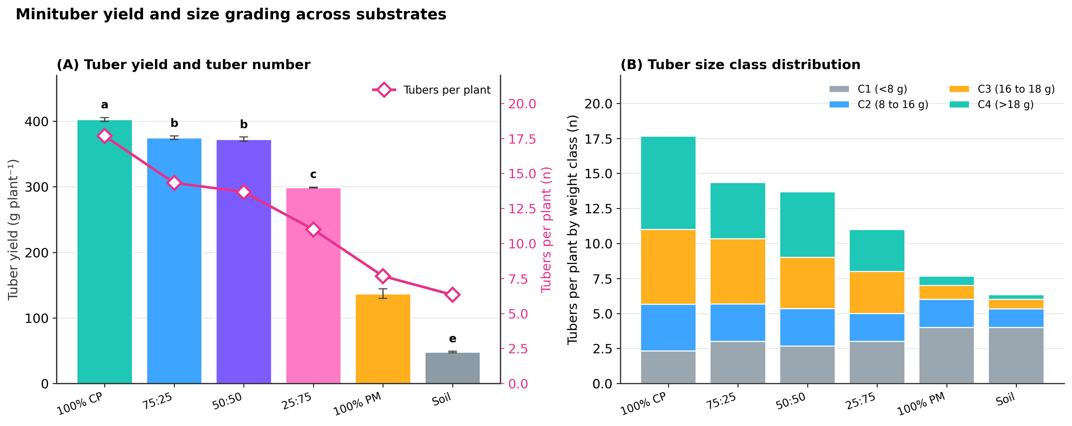
Figure S1. Effects of the cocopeat and pumice mixtures on potato yield and tuber production. (A) Total tuber yield per plant (bars) and number of tubers per plant (line); (B) distribution of tubers across the four size classes. Bars sharing a letter do not differ significantly.

