Supplementary Information
Residential gas combustion drives building-sector air pollution mortality in the U.S.
Manish Soni¹, Huy Tran¹, Mary D Willis², Kipruto Kirwa³, Brady Seals^{4a}, Jonathan J. Buonocore^{3a}, Saravanan Arunachalam^{1*a}

¹Institute for the Environment, The University of North Carolina at Chapel Hill, Chapel Hill, NC 27516, USA
²Department of Epidemiology, Boston University School of Public Health, Boston, MA 02118, USA
³Department of Environmental Health, Boston University School of Public Health, Boston, MA 02118, USA
⁴Electrification for Health, The Center for Human and Planetary Health, Stanford’s Woods Institute for the Environment, Stanford, CA 94305, USA
ªThese authors jointly supervised this work

*Corresponding Author:
Dr. Saravanan Arunachalam
Institute for the Environment
The University of North Carolina at Chapel Hill
Chapel Hill, North Carolina 27516, USA
Tel: 919-966-2126
Email: sarav@email.unc.edu

Table of Contents
Supplementary Tables
Supplementary Table 1. Summary of mean and 99th percentile concentrations for PM_{2.5}, NO₂, and O₃_8hr over CONUS land grid cells for annual and seasonal periods from all source contributions. Units are µg m⁻³ for PM_{2.5} and ppbv for NO₂ and O₃_8hr
Supplementary Table 2. U.S. State Abbreviations
Supplementary Table 3. Premature deaths for PM_{2.5}, NO₂ and O₃_8hr from building sector emissions due to different fuel and building type
Supplementary Table 4. State-wise premature deaths for PM_{2.5}, NO₂ and O₃_8hr from building sector emissions
Supplementary Table 5. Source Classification Codes (SCCs) and corresponding source descriptions from the 2021 Emissions Modeling Platform (EMP) associated with each building-sector group used in the CMAQ-DDM simulations
Supplementary Table 6. Emission totals in tons per month using 2021 Emission modeling platform for building sector
Supplementary Table 7. State-wise emissions in tons per year using 2021 Emission modeling platform for building sector
Supplementary Table 8. Concentration–response functions (CRFs) used to estimate health impacts associated with PM_{2.5}, NO₂, and O₃_8hr exposure, including health outcomes, populations at risk, exposure metrics, and central estimates with 95% confidence intervals
Supplementary Figures
Supplementary Figure 1. Spatial distribution of annual mean sensitivities over CONUS land for PM_{2.5}, O₃_8hr, and NO₂ from commercial and residential emissions (oil and coal). Units are µg m⁻³ for PM_{2.5} and ppbv for NO₂ and O₃_8hr
Supplementary Figure 2. Spatial distribution of monthly mean sensitivities over CONUS land for PM_{2.5}, O₃_8hr, and NO₂ from commercial and residential emissions gas for January and July 2021. Units are µg m⁻³ for PM_{2.5} and ppbv for NO₂ and O₃_8hr
Supplementary Figure 3. Spatial distribution of monthly mean sensitivities over CONUS land for PM_{2.5}, O₃_8hr, and NO₂ from commercial and residential emissions gas for April and October 2021. Units are µg m⁻³ for PM_{2.5} and ppbv for NO₂ and O₃_8hr
Supplementary Figure 4. Monthly mean sensitivities for January, April, July and October as per the pollutant precursor group over CONUS land for PM_{2.5}. Note: differing y-axes on each panel
Supplementary Figure 5. Monthly mean sensitivities for January, April, July and October as per the pollutant precursor group over CONUS land for O₃_8hr. Note: differing y-axes on each panel
Supplementary Figure 6. Monthly mean sensitivities for January, April, July and October as per the pollutant precursor group over CONUS land for NO₂. Note: differing y-axes on each panel
Supplementary Figure 7. Monthly mean sensitivities for January, April, July and October as per the pollutant precursor group over CONUS land for NO₂_NO_{x}
Supplementary Figure 8. Monthly mean sensitivities for January, April, July and October as per the pollutant precursor group over CONUS land for PM_{2.5}_NH₃
Supplementary Figure 9. Monthly mean sensitivities for January, April, July and October as per the pollutant precursor group over CONUS land for PM_{2.5}_NO_{x}
Supplementary Figure 10. Population-weighted annual mean sensitivities according to pollutant precursors of PM_{2.5} based upon group over CONUS domain. Pollutants refers to pollutant and precursor species. State abbreviations are described in Supplementary Table 2. Units are µg m⁻³ for PM_{2.5}. Note: Differing Y-axis scale in each plot
Supplementary Figure 11. Population-weighted annual mean sensitivities according to pollutant precursors of O₃_8hr and NO₂ based upon group over CONUS domain. Pollutants refers to pollutant and precursor species. State abbreviations are described in Supplementary Table 2. Units are ppbv for O₃_8hr and NO₂. Note: Differing Y-axis scale in each plot
Supplementary Figure 12. Chemically resolved PM_{2.5} sensitivities for January, April, July, and October across building-sector groups, highlighting the seasonal contributions of sulfate, nitrate, and ammonium-associated secondary inorganic aerosol components averaged over CONUS land
Supplementary Figure 13. Monthly mean Free Ammonia due to building sector emissions, estimated using a zero-out simulation for January, April, July, and October
Supplementary Figure 14. Annual mean Free Ammonia due to building-sector emissions, estimated using a zero-out simulation for January, April, July, and October
Supplementary Figure 15. Annual emissions of NOx, VOC, PM_{2.5}, SO₂, and NH₃ from building sectors across the United States. All values in tons/year
Supplementary References

Supplementary Table 1. Summary of mean and 99th percentile concentrations for PM_{2.5}, NO₂, and O₃_8hr over CONUS land grid cells for annual and seasonal periods from all source contributions. Units are µg m⁻³ for PM_{2.5} and ppbv for NO₂ and O₃_8hr
Period | PM_{2.5} Mean  (µg m⁻³) | PM_{2.5} 99th  (µg m⁻³) | NO₂ Mean  (ppbv) | NO₂ 99th  (ppbv) | O₃_8hr Mean  (ppbv) | O₃_8hr 99th  (ppbv)
Annual | 5.12 | 9.97 | 1.23 | 6.30 | 42.33 | 48.58
January | 4.34 | 10.82 | 1.45 | 8.15 | 38.22 | 45.71
April | 4.67 | 9.97 | 1.03 | 5.30 | 44.81 | 50.64
July | 7.62 | 17.17 | 1.13 | 5.47 | 45.28 | 55.04
October | 3.84 | 9.13 | 1.32 | 6.95 | 40.99 | 48.30

Supplementary Table 2. U.S. State Abbreviations
Abbreviation | State Name | Abbreviation | State Name | Abbreviation | State Name
AL | Alabama | AK | Alaska | AZ | Arizona
AR | Arkansas | CA | California | CO | Colorado
CT | Connecticut | DE | Delaware | FL | Florida
GA | Georgia | HI | Hawaii | ID | Idaho
IL | Illinois | IN | Indiana | IA | Iowa
KS | Kansas | KY | Kentucky | LA | Louisiana
ME | Maine | MD | Maryland | MA | Massachusetts
MI | Michigan | MN | Minnesota | MS | Mississippi
MO | Missouri | MT | Montana | NE | Nebraska
NV | Nevada | NH | New Hampshire | NJ | New Jersey
NM | New Mexico | NY | New York | NC | North Carolina
ND | North Dakota | OH | Ohio | OK | Oklahoma
OR | Oregon | PA | Pennsylvania | RI | Rhode Island
SC | South Carolina | SD | South Dakota | TN | Tennessee
TX | Texas | UT | Utah | VT | Vermont
VA | Virginia | WA | Washington | WV | West Virginia
WI | Wisconsin | WY | Wyoming

Supplementary Table 3. Premature deaths for PM_{2.5}, NO₂ and O₃_8hr from building sector emissions due to different fuel and building type
Building Type | Fuel Type | Total | PM_{2.5} | O₃_8hr | NO₂
Commercial | Oil | 1,200  (660, 1,700) | 190  (160, 220) | -31  (-16, -63) | 1,000  (520, 1,500)
Commercial | Gas | 3,100  (1,700, 4,600) | 270  (230, 320) | -110  (-55, -220) | 3,000  (1,500, 4,500)
Commercial | Coal | 16  (12, 20) | 12  (11, 15) | 0.0045  (0.0022, 0.0089) | 3.6  (1.8, 5.4)
Residential | Oil | 1,400  (860, 2,000) | 430  (370, 500) | -58  (-29, -120) | 1,100  (530, 1,600)
Residential | Gas | 7,900  (4,700, 11,000) | 2,200  (1,900, 2,600) | -810  (-400, -1,600) | 6,500  (3,200, 9,700)
Residential | Coal | 0.046  (0.034, 0.060) | 0.032  (0.027, 0.037) | 0.0032 (0.0016, 0.0065) | 0.011  (0.0056, 0.017)
Grand Total |  | 14,000  (7,900, 19,000) | 3,100  (2,700, 3,700) | -1,000  (-500, -2,000) | 12,000  (5,800, 17,000)

Supplementary Table 4. State-wise premature deaths for PM_{2.5}, NO₂ and O₃_8hr from building sector emissions
State | PM_{2.5} | O₃_8hr | NO₂ | Total | % Total | Rank
NY | 282 | -362 | 2479 | 2399 | 17.5% | 1
CA | 233 | -137 | 1381 | 1477 | 10.8% | 2
IL | 302 | -134 | 934 | 1102 | 8.1% | 3
PA | 272 | -66 | 804 | 1010 | 7.4% | 4
NJ | 81 | -81 | 827 | 828 | 6.0% | 5
MI | 260 | -55 | 532 | 737 | 5.4% | 6
OH | 298 | -36 | 396 | 658 | 4.8% | 7
MA | 136 | -34 | 454 | 557 | 4.1% | 8
TX | 84 | 6 | 448 | 538 | 3.9% | 9
MD | 87 | -17 | 303 | 372 | 2.7% | 10
IN | 137 | -15 | 177 | 299 | 2.2% | 11
WI | 108 | -22 | 183 | 268 | 2.0% | 12
VA | 77 | -2 | 185 | 260 | 1.9% | 13
CT | 53 | -10 | 205 | 248 | 1.8% | 14
MN | 57 | -27 | 196 | 225 | 1.6% | 15
MO | 74 | -9 | 149 | 213 | 1.6% | 16
NC | 70 | 12 | 118 | 201 | 1.5% | 17
GA | 45 | 8 | 143 | 196 | 1.4% | 18
CO | 7 | -19 | 200 | 187 | 1.4% | 19
WA | 15 | -27 | 197 | 185 | 1.3% | 20
NV | 1 | -6 | 119 | 114 | 0.8% | 21
TN | 42 | 6 | 58 | 107 | 0.8% | 22
KY | 50 | 1 | 53 | 103 | 0.8% | 23
OK | 30 | 1 | 70 | 101 | 0.7% | 24
IA | 52 | -4 | 53 | 101 | 0.7% | 25
AZ | -3 | 3 | 98 | 98 | 0.7% | 26
RI | 25 | -5 | 64 | 84 | 0.6% | 27
UT | 8 | -7 | 81 | 82 | 0.6% | 28
OR | 6 | -9 | 84 | 81 | 0.6% | 29
DC | 11 | -7 | 77 | 80 | 0.6% | 30
SC | 24 | 9 | 45 | 78 | 0.6% | 31
KS | 23 | -2 | 51 | 73 | 0.5% | 32
FL | 18 | 24 | 31 | 73 | 0.5% | 33
ME | 20 | 0 | 43 | 63 | 0.5% | 34
AL | 20 | 7 | 30 | 57 | 0.4% | 35
AR | 19 | 4 | 33 | 55 | 0.4% | 36
NH | 18 | 1 | 33 | 52 | 0.4% | 37
NE | 15 | -3 | 41 | 52 | 0.4% | 38
DE | 16 | -1 | 36 | 50 | 0.4% | 39
WV | 24 | 2 | 16 | 42 | 0.3% | 40
LA | 10 | 4 | 23 | 37 | 0.3% | 41
NM | 2 | 0 | 34 | 36 | 0.3% | 42
ID | 4 | -1 | 31 | 34 | 0.2% | 43
MS | 9 | 4 | 10 | 23 | 0.2% | 44
VT | 6 | 1 | 9 | 16 | 0.1% | 45
MT | 1 | 0 | 12 | 13 | 0.1% | 46
SD | 5 | 0 | 7 | 12 | 0.1% | 47
ND | 4 | -1 | 6 | 9 | 0.1% | 48
WY | 1 | 2 | 1 | 4 | 0.0% | 49

Supplementary Table 5. Source Classification Codes (SCCs) and corresponding source descriptions from the 2021 Emissions Modeling Platform (EMP) associated with each building-sector group used in the CMAQ-DDM simulations
SCC | DESCRIPTION | SourceType | BLDClass | DDM Group
10300403 | External Combustion Boilers;Commercial/Institutional;Residual Oil;< 10 Million BTU/hr ** | point | Fuel Comb - Comm/Institutional - Oil | commercial oil
10300503 | External Combustion Boilers;Commercial/Institutional;Distillate Oil;< 10 Million BTU/hr ** | point | Fuel Comb - Comm/Institutional - Oil | commercial oil
10300603 | External Combustion Boilers;Commercial/Institutional;Natural Gas;< 10 Million BTU/hr | point | Fuel Comb - Comm/Institutional - NatGas | commercial gas
10500202 | External Combustion;Space Heaters;Commercial/Institutional;Coal | point | Fuel Comb - Comm/Institutional - Coal | commercial coal
10500205 | External Combustion; Space Heaters; Commercial/Institutional; Distillate Oil | point | Fuel Comb - Comm/Institutional - Oil | commercial oil
10500206 | External Combustion;Space Heaters;Commercial/Institutional;Natural Gas | point | Fuel Comb - Comm/Institutional - NatGas | commercial gas
10500210 | External Combustion;water Heaters;Commercial/Institutional;Liquified Petroleum Gas (LPG) | point | Fuel Comb - Comm/Institutional - FosGas | commercial oil
10500213 | External Combustion;Space Heaters;Commercial/Institutional;Waste Oil: Air Atomized Burner | point | Fuel Comb - Comm/Institutional - Oil | commercial oil
10500214 | External Combustion;Space Heaters;Commercial/Institutional;Waste Oil: Vaporizing Burner | point | Fuel Comb - Comm/Institutional - Oil | commercial oil
2103001000 | Stationary Source Fuel Combustion;Commercial/Institutional;Anthracite Coal;Total: All Boiler Types | nonpoint | Fuel Comb - Comm/Institutional - Coal | commercial coal
2103002000 | Stationary Source Fuel Combustion;Commercial/Institutional;Bituminous/Subbituminous Coal;Total: All Boiler Types | nonpoint | Fuel Comb - Comm/Institutional - Coal | commercial coal
2103004000 | Stationary Source Fuel Combustion;Commercial/Institutional;Distillate Oil;Total: Boilers and IC Engines | nonpoint | Fuel Comb - Comm/Institutional - Oil | commercial oil
2103004001 | Stationary Source Fuel Combustion;Commercial/Institutional;Distillate Oil;Boilers | nonpoint | Fuel Comb - Comm/Institutional - Oil | commercial oil
2103004002 | Stationary Source Fuel Combustion;Commercial/Institutional;Distillate Oil;IC Engines | nonpoint | Fuel Comb - Comm/Institutional - Oil | commercial oil
2103005000 | Stationary Source Fuel Combustion;Commercial/Institutional;Residual Oil;Total: All Boiler Types | nonpoint | Fuel Comb - Comm/Institutional - Oil | commercial oil
2103006000 | Stationary Source Fuel Combustion;Commercial/Institutional;Natural Gas;Total: Boilers and IC Engines | nonpoint | Fuel Comb - Comm/Institutional - NatGas | commercial gas
2103007000 | Stationary Source Fuel Combustion;Commercial/Institutional;Liquified Petroleum Gas (LPG);Total: All Combustor Types | nonpoint | Fuel Comb - Comm/Institutional - FosGas | commercial oil
2103007005 | Stationary Source Fuel Combustion;Commercial/Institutional;Liquified Petroleum Gas (LPG); All Boiler Types | nonpoint | Fuel Comb - Comm/Institutional - FosGas | commercial oil
2103007010 | Stationary Source Fuel Combustion;Commercial/Institutional;Liquified Petroleum Gas (LPG); Asphalt Kettle Heaters | nonpoint | Fuel Comb - Comm/Institutional - FosGas | commercial oil
2103010000 | Stationary Source Fuel Combustion;Commercial/Institutional;Process gas;POTW Digester Gas-fired Boilers | nonpoint | Fuel Comb - Comm/Institutional - FosGas | commercial oil
2103011000 | Stationary Source Fuel Combustion;Commercial/Institutional;Kerosene;Total: All Combustor Types | nonpoint | Fuel Comb - Comm/Institutional - Oil | commercial oil
2103011005 | Stationary Source Fuel Combustion;Commercial/Institutional;Kerosene;All Boiler Types | nonpoint | Fuel Comb - Comm/Institutional - Oil | commercial oil
2103011010 | Stationary Source Fuel Combustion;Commercial/Institutional;Kerosene;Asphalt Kettle Heaters | nonpoint | Fuel Comb - Comm/Institutional - Oil | commercial oil
2104001000 | Stationary Source Fuel Combustion;Residential;Anthracite Coal;Total: All Combustor Types | nonpoint | Fuel Comb - Residential - Coal | residential coal
2104002000 | Stationary Source Fuel Combustion;Residential;Bituminous/Subbituminous Coal;Total: All Combustor Types | nonpoint | Fuel Comb - Residential - Coal | residential coal
2104004000 | Stationary Source Fuel Combustion;Residential;Distillate Oil;Total: All Combustor Types | nonpoint | Fuel Comb - Residential - Oil | residential oil
2104005000 | Stationary Source Fuel Combustion;Residential;Residual Oil;Total: All Combustor Types | nonpoint | Fuel Comb - Residential - Oil | residential oil
2104006000 | Stationary Source Fuel Combustion;Residential;Natural Gas;Total: All Combustor Types | nonpoint | Fuel Comb - Residential - NatGas | residential gas
2104006010 | Stationary Source Fuel Combustion;Residential;Natural Gas;Residential Furnaces | nonpoint | Fuel Comb - Residential - NatGas | residential gas
2104007000 | Stationary Source Fuel Combustion;Residential;Liquified Petroleum Gas (LPG);Total: All Combustor Types | nonpoint | Fuel Comb - Residential - FosGas | residential oil
2104011000 | Stationary Source Fuel Combustion;Residential;Kerosene;Total: All Heater Types | nonpoint | Fuel Comb - Residential - Oil | residential oil

Building-sector emissions were derived from the 2021 Emissions Modeling Platform and include contributions from commercial and residential combustion sources categorized into six groups based on fuel type and sector (Supplementary Table 5). These groups include oil, natural gas, coal, and other fossil fuels across commercial and residential applications.
For clarity, we refer to commercial and institutional sources collectively as “commercial.” We categorize emissions into six groups based on sector and primary fuel type: commercial oil, commercial gas, commercial coal, residential oil, residential gas, and residential coal.

Supplementary Table 6. Emission totals in tons per month using 2021 Emission modeling platform for building sector
Month | NO_{X} | PM_{2.5} | SO₂ | NH₃ | VOC
January | 71,784 | 1,624 | 927 | 9,081 | 4,068
April | 33,062 | 774 | 511 | 3,506 | 1,903
July | 9,356 | 256 | 233 | 291 | 570
October | 31,048 | 734 | 503 | 3,104 | 1,795

Supplementary Table 7. State-wise emissions in tons per year using 2021 Emission modeling platform for building sector
State | NH₃ | NO_{x} | PM_{2.5}-PRI | SO₂ | VOC | Rank
CA | 4642 | 33925 | 3102 | 981 | 3118 | 1
NY | 4796 | 41981 | 1181 | 910 | 2226 | 2
PA | 2498 | 24885 | 724 | 711 | 1306 | 3
TX | 2400 | 26481 | 564 | 321 | 1537 | 4
IL | 4009 | 29800 | 144 | 184 | 1665 | 5
MA | 1481 | 15113 | 670 | 149 | 827 | 6
MI | 3100 | 24466 | 162 | 158 | 1340 | 7
NJ | 167 | 18351 | 205 | 130 | 1017 | 8
OH | 2767 | 17695 | 146 | 115 | 980 | 9
VA | 875 | 9571 | 177 | 271 | 498 | 10
ME | 164 | 8569 | 623 | 355 | 483 | 11
CT | 682 | 8786 | 442 | 109 | 451 | 12
WI | 1428 | 13296 | 106 | 117 | 709 | 13
MN | 1347 | 13519 | 95 | 90 | 720 | 14
IN | 1364 | 11064 | 61 | 74 | 610 | 15
MD | 834 | 8170 | 162 | 77 | 437 | 16
MO | 1020 | 9102 | 51 | 395 | 490 | 17
WA | 902 | 8089 | 62 | 51 | 438 | 18
CO | 1377 | 7422 | 68 | 58 | 424 | 19
NC | 672 | 7020 | 74 | 90 | 371 | 20
IA | 664 | 7535 | 46 | 47 | 391 | 21
GA | 1206 | 7527 | 36 | 46 | 418 | 22
NH | 177 | 3966 | 246 | 225 | 172 | 23
NV | 491 | 3712 | 132 | 29 | 272 | 24
KS | 634 | 5359 | 35 | 32 | 293 | 25
OK | 620 | 5525 | 27 | 57 | 301 | 26
TN | 665 | 4149 | 39 | 31 | 228 | 27
UT | 676 | 4288 | 28 | 33 | 257 | 28
OR | 538 | 4037 | 45 | 27 | 222 | 29
VT | 52 | 2832 | 172 | 89 | 140 | 30
AR | 317 | 4442 | 20 | 27 | 242 | 31
NE | 381 | 3986 | 23 | 40 | 216 | 32
KY | 464 | 2950 | 33 | 19 | 161 | 33
RI | 225 | 2124 | 97 | 30 | 106 | 34
AZ | 386 | 3419 | 16 | 21 | 186 | 35
SC | 300 | 2975 | 20 | 42 | 159 | 36
ID | 316 | 2847 | 20 | 37 | 156 | 37
MT | 226 | 2778 | 15 | 16 | 143 | 38
NM | 367 | 2434 | 16 | 15 | 133 | 39
AL | 289 | 2328 | 14 | 44 | 123 | 40
ND | 128 | 1743 | 19 | 13 | 85 | 41
WV | 236 | 1468 | 20 | 9 | 79 | 42
DE | 119 | 1458 | 21 | 10 | 76 | 43
LA | 322 | 1776 | 9 | 11 | 99 | 44
SD | 138 | 1599 | 13 | 59 | 83 | 45
MS | 208 | 1482 | 6 | 9 | 76 | 46
FL | 175 | 1340 | 12 | 9 | 69 | 47
WY | 132 | 953 | 8 | 6 | 50 | 48

Supplementary Table 8. Concentration–response functions (CRFs) used to estimate health impacts associated with PM_{2.5}, NO₂, and O₃_8hr exposure, including health outcomes, populations at risk, exposure metrics, and central estimates with 95% confidence intervals
 |  | Concentration-Response Function
Health Outcome | Population at risk | Study | Pollutant | Metric | CRF central estimate (95% CI)
Mortality | Adults ≥ 25 years of age | Vodonos et al., 2018 | PM_{2.5} | Annual Average PM_{2.5} (µg/m³) | 1.29% (1.09 - 1.5%)  [note: slope at 10µg/m3]
Mortality | Adults ≥ 25 years of age | Turner et al., 2016 | O₃_8hr | Annual Average of the 8hr Maximum Daily Average (ppb) | 0.2% (0.1 - 0.4%)
Mortality | Adults ≥ 25 years of age | Faustini et al., 2014 | NO₂ | Annual Average (µg/m³) | 0.4% (0.2% - 0.6%)

Supplementary Figure 1. Spatial distribution of annual mean sensitivities over CONUS land for PM_{2.5}, O₃_8hr, and NO₂ from commercial and residential emissions (oil and coal). Units are µg m⁻³ for PM_{2.5} and ppbv for NO₂ and O₃_8hr
Supplementary Figure 2. Spatial distribution of monthly mean sensitivities over CONUS land for PM_{2.5}, O₃_8hr, and NO₂ from commercial and residential emissions gas for January and July 2021. Units are µg m⁻³ for PM_{2.5} and ppbv for NO₂ and O₃_8hr
Supplementary Figure 3. Spatial distribution of monthly mean sensitivities over CONUS land for PM_{2.5}, O₃_8hr, and NO₂ from commercial and residential emissions gas for April and October 2021. Units are µg m⁻³ for PM_{2.5} and ppbv for NO₂ and O₃_8hr
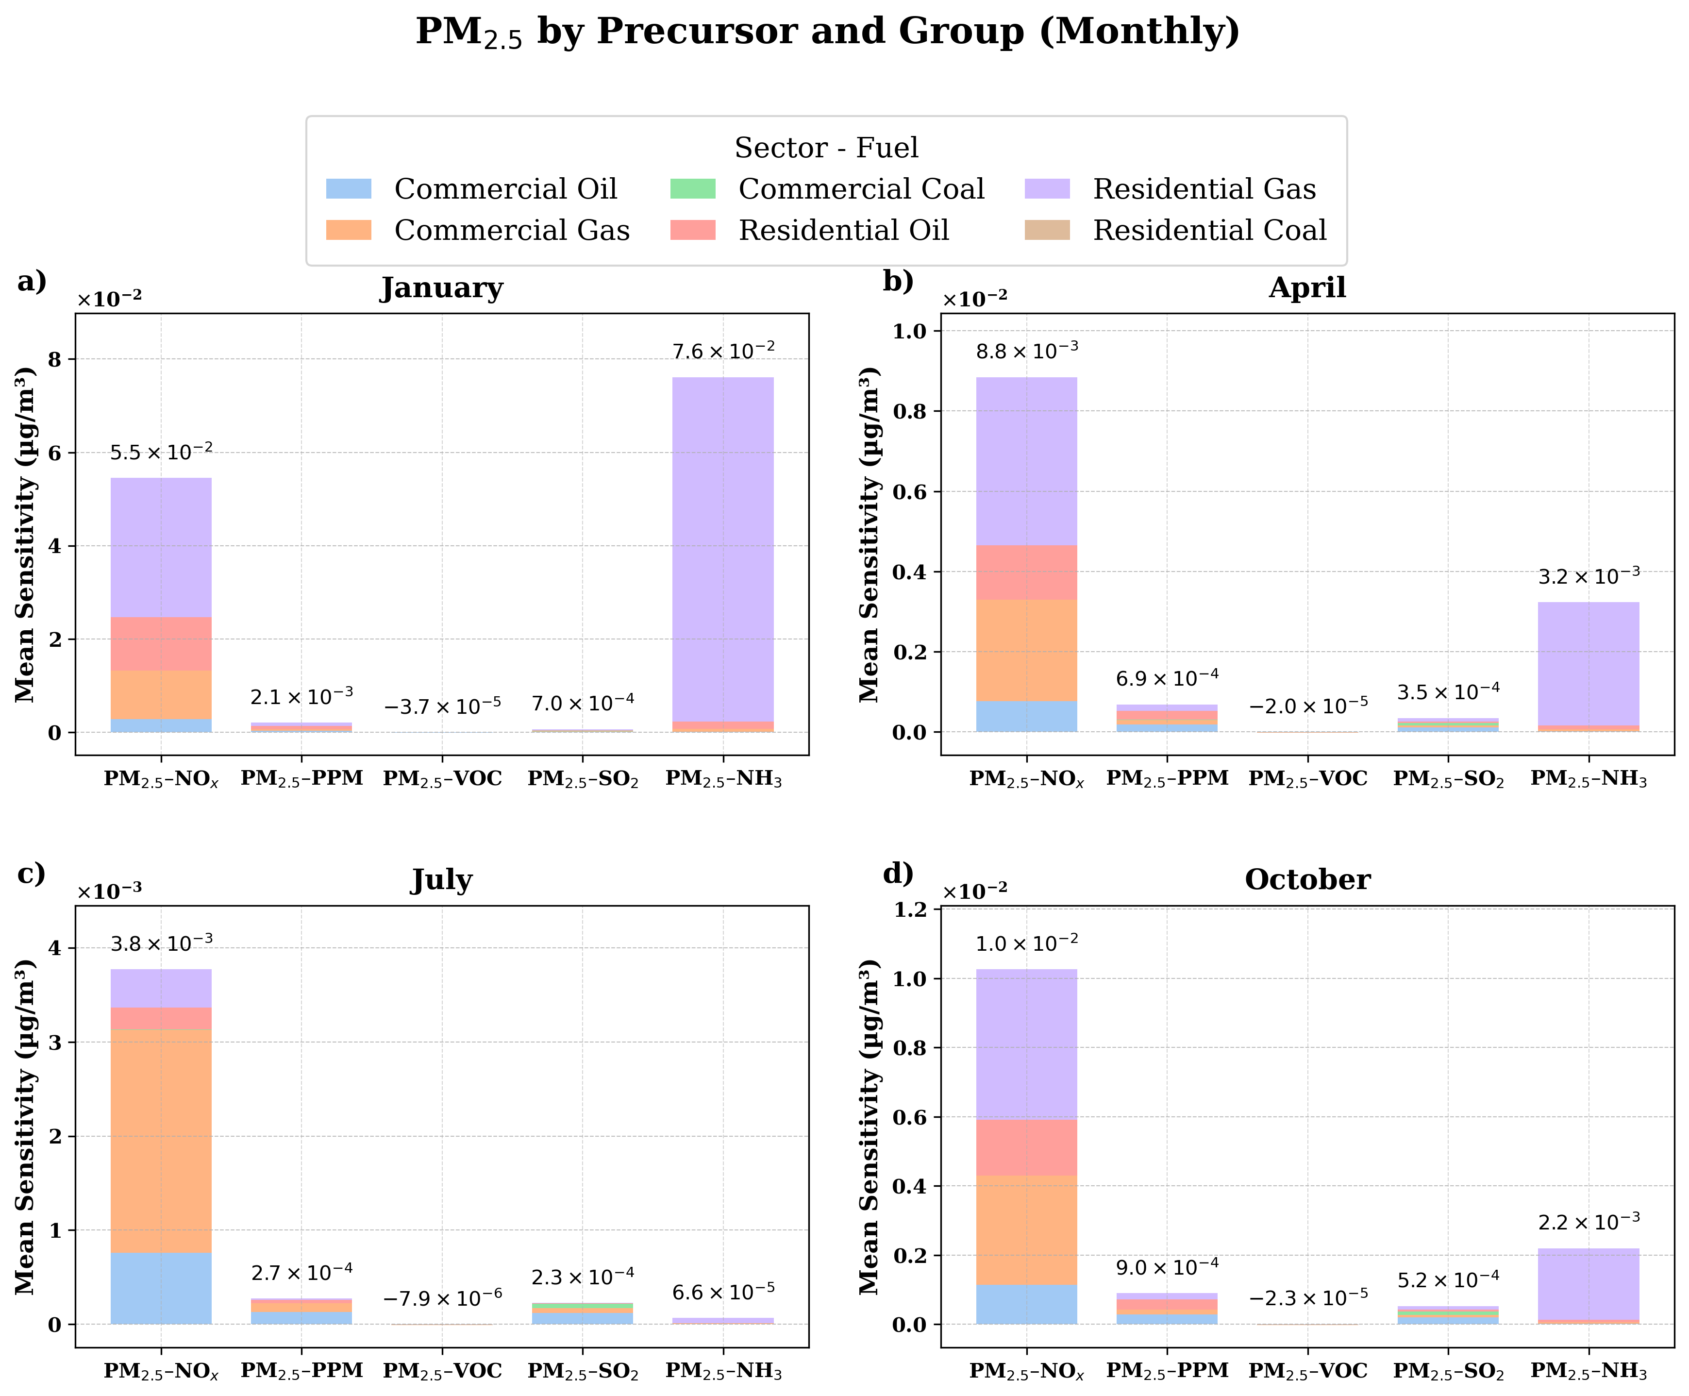
Supplementary Figure 4. Monthly mean sensitivities for January, April, July and October as per the pollutant precursor group over CONUS land for PM_{2.5}. Note: differing y-axes on each panel
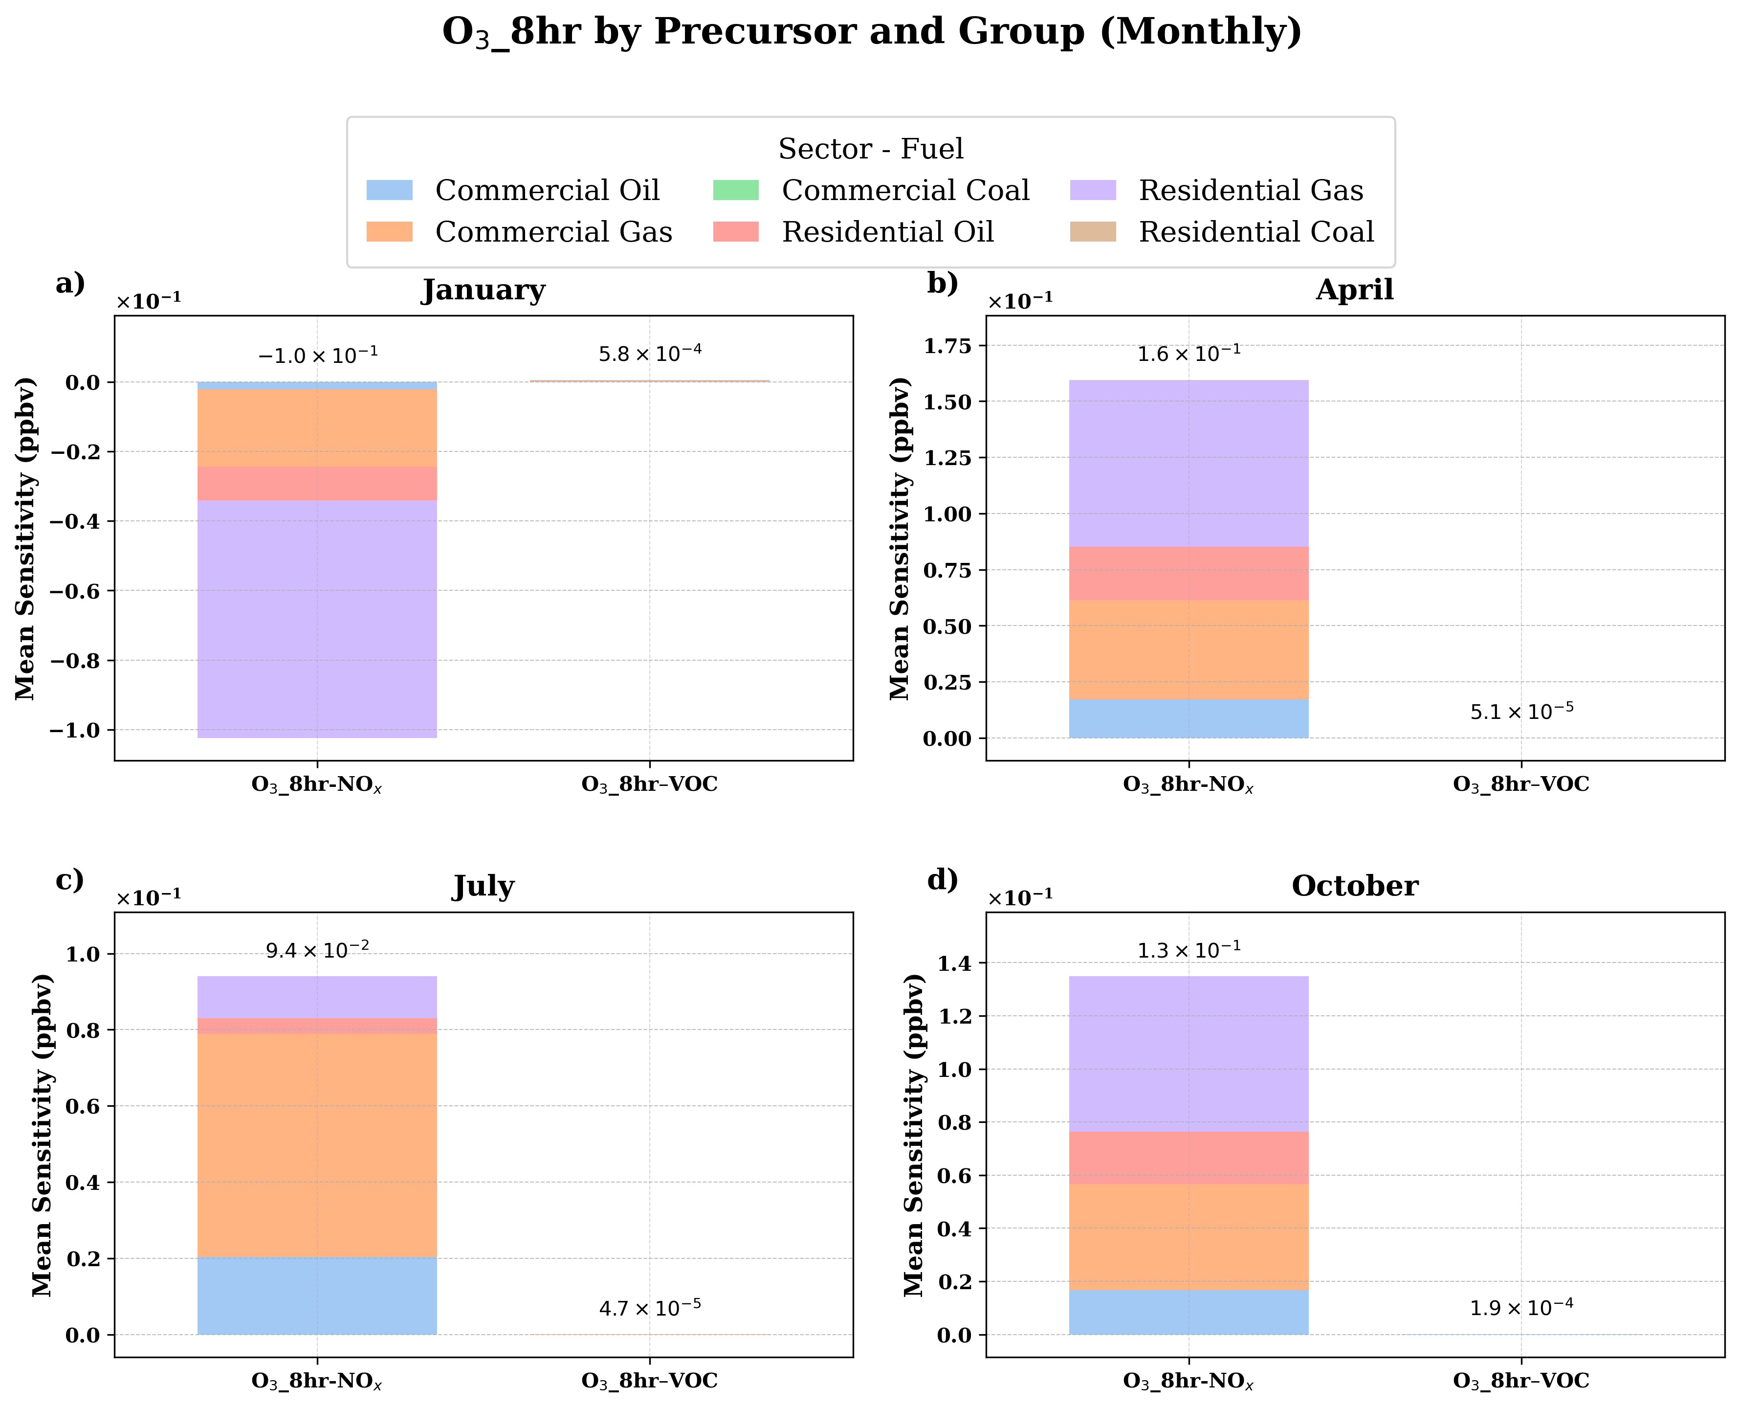
Supplementary Figure 5. Monthly mean sensitivities for January, April, July and October as per the pollutant precursor group over CONUS land for O₃_8hr. Note: differing y-axes on each panel
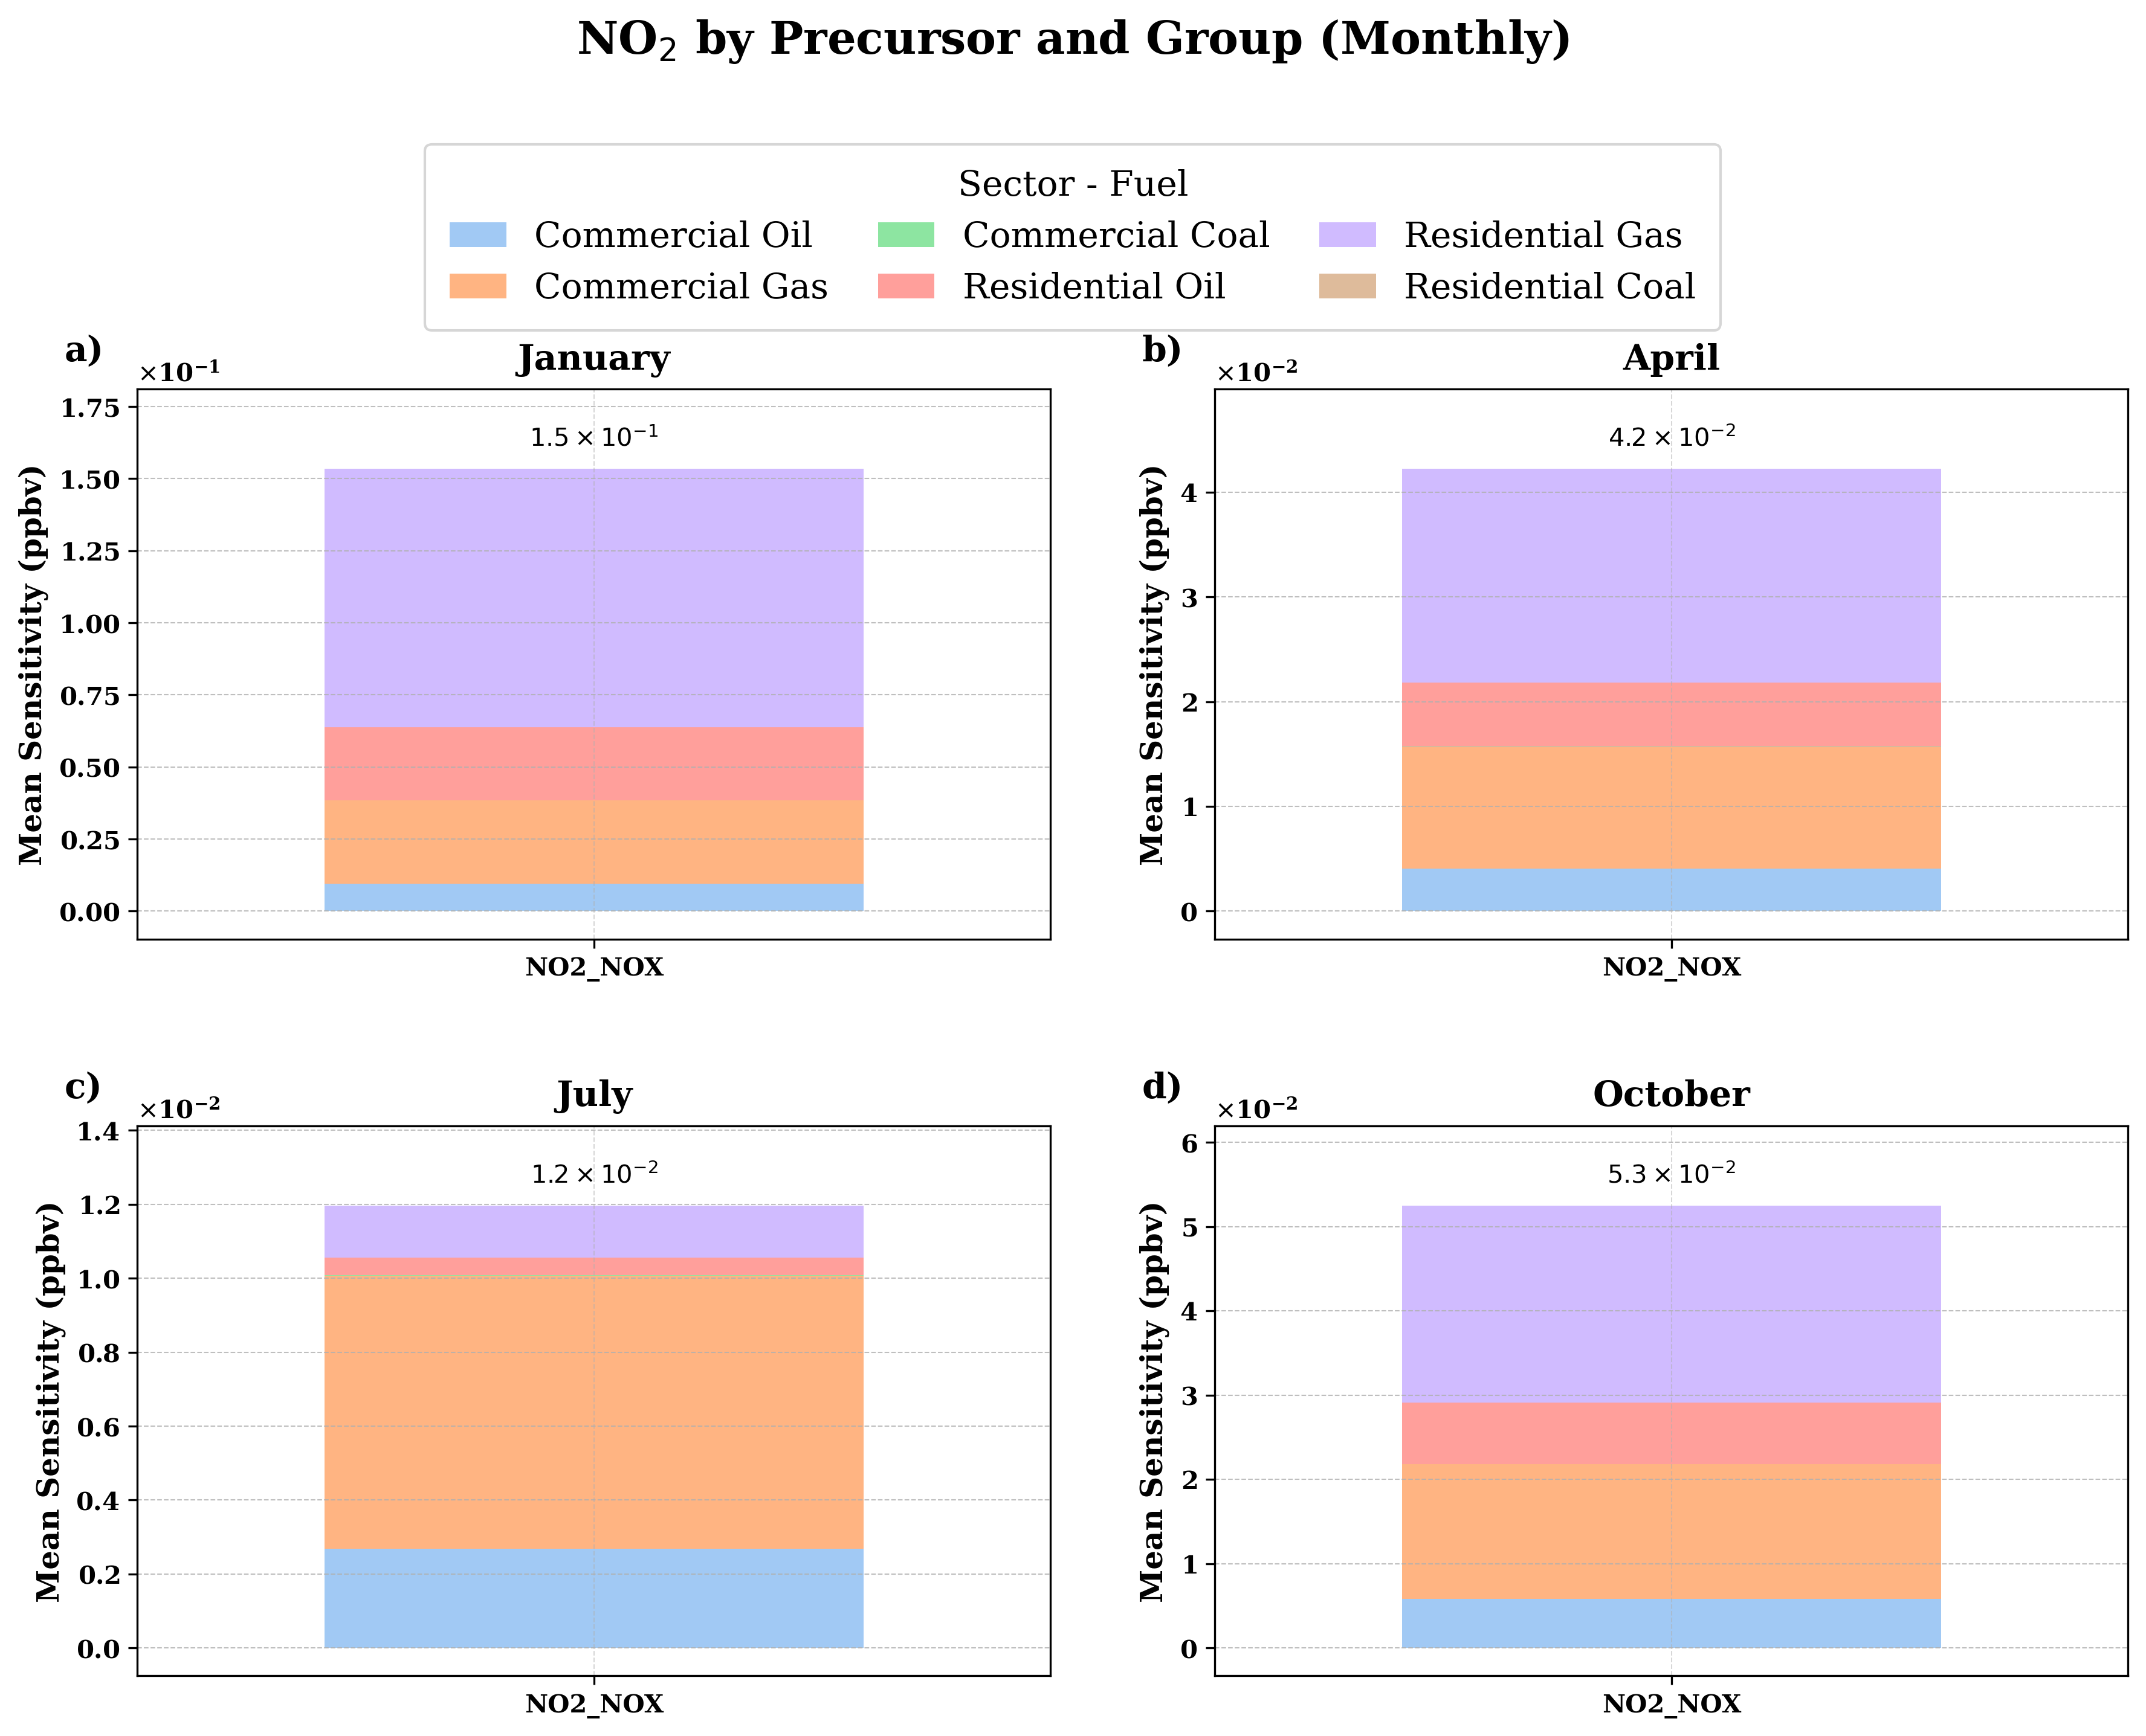
Supplementary Figure 6. Monthly mean sensitivities for January, April, July and October as per the pollutant precursor group over CONUS land for NO₂. Note: differing y-axes on each panel
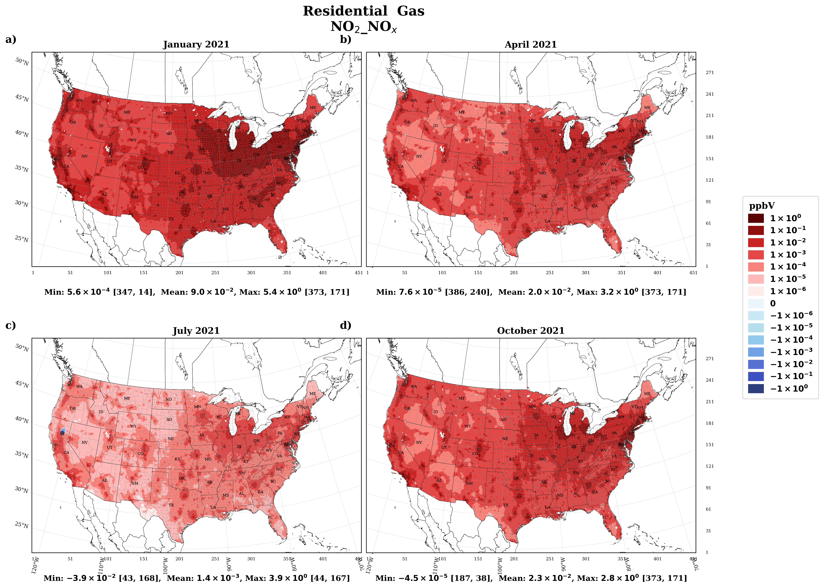
Supplementary Figure 7. Monthly mean sensitivities for January, April, July and October as per the pollutant precursor group over CONUS land for NO₂_NO_{x}

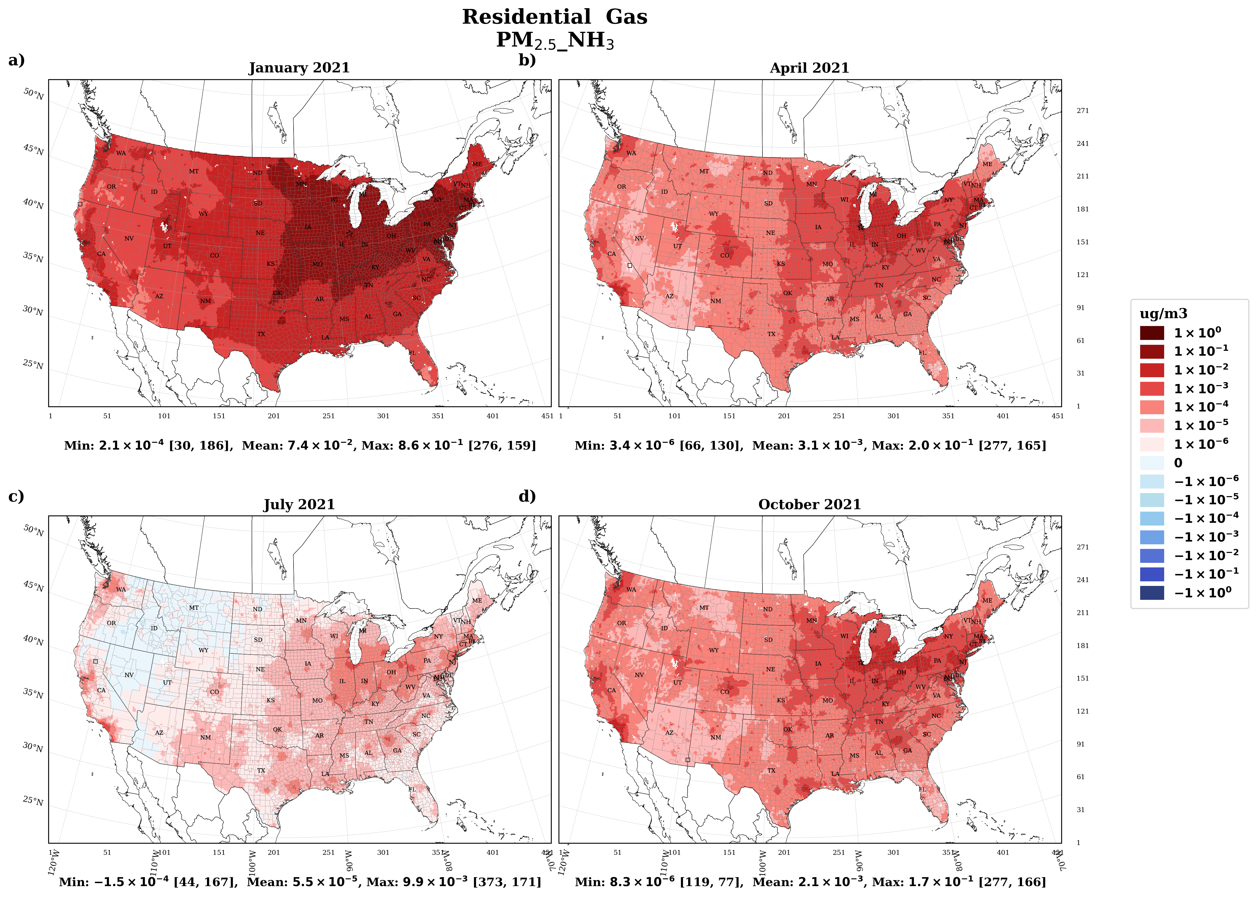
Supplementary Figure 8. Monthly mean sensitivities for January, April, July and October as per the pollutant precursor group over CONUS land for PM_{2.5}_NH₃
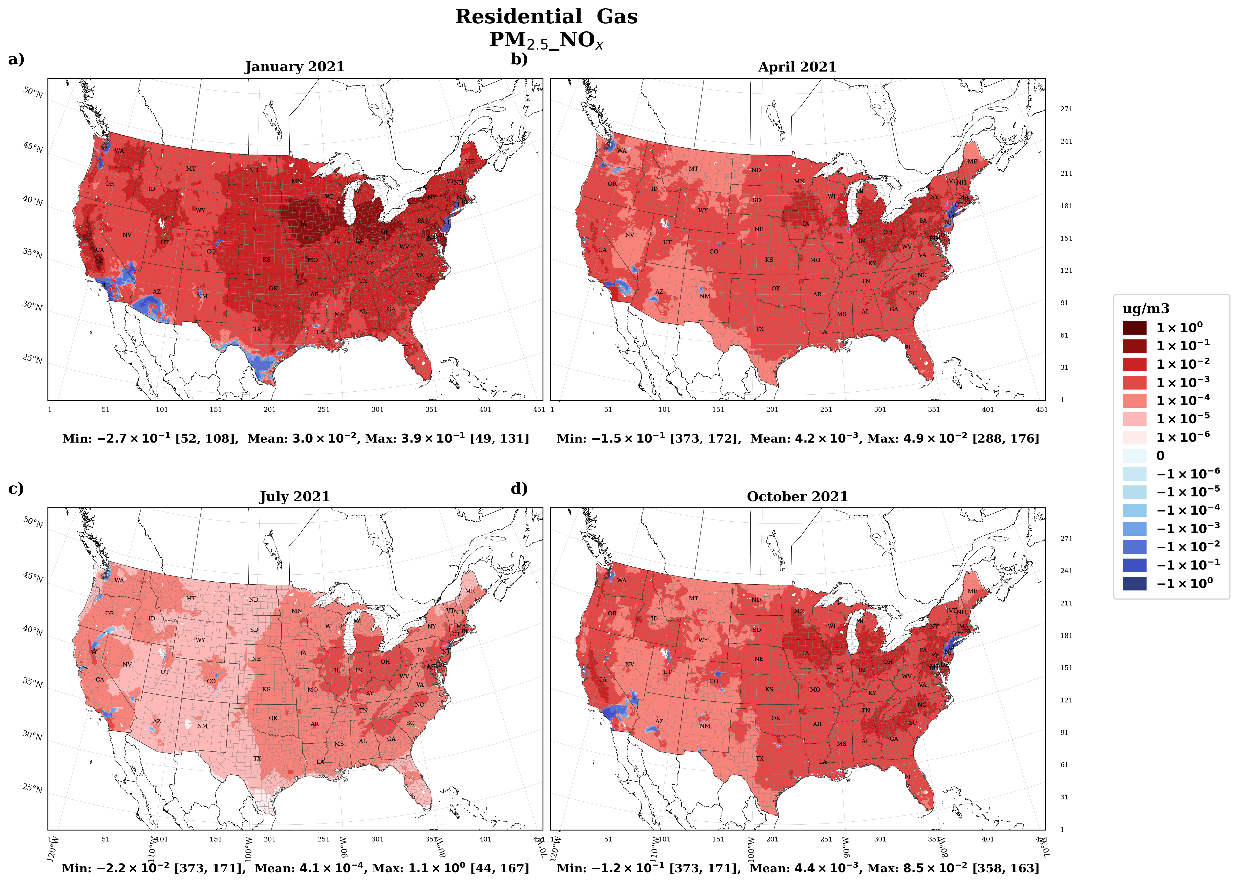
Supplementary Figure 9. Monthly mean sensitivities for January, April, July and October as per the pollutant precursor group over CONUS land for PM_{2.5}_NO_{x}

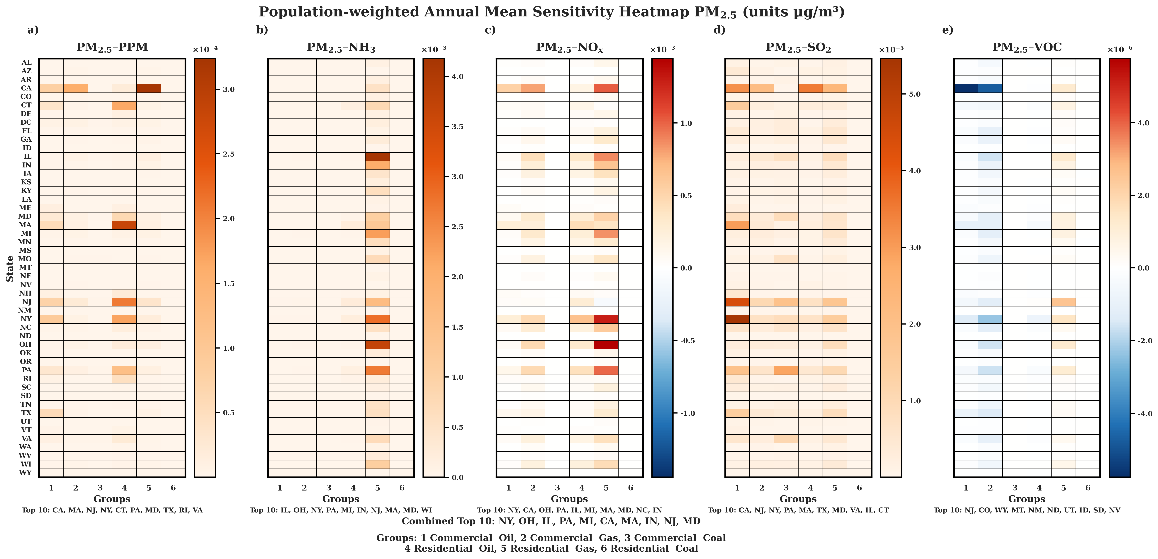
Supplementary Figure 10. Population-weighted annual mean sensitivities according to pollutant precursors of PM_{2.5} based upon group over CONUS domain. Pollutants refers to pollutant and precursor species. State abbreviations are described in Supplementary Table 2. Units are µg m⁻³ for PM_{2.5}. Note: Differing Y-axis scale in each plot
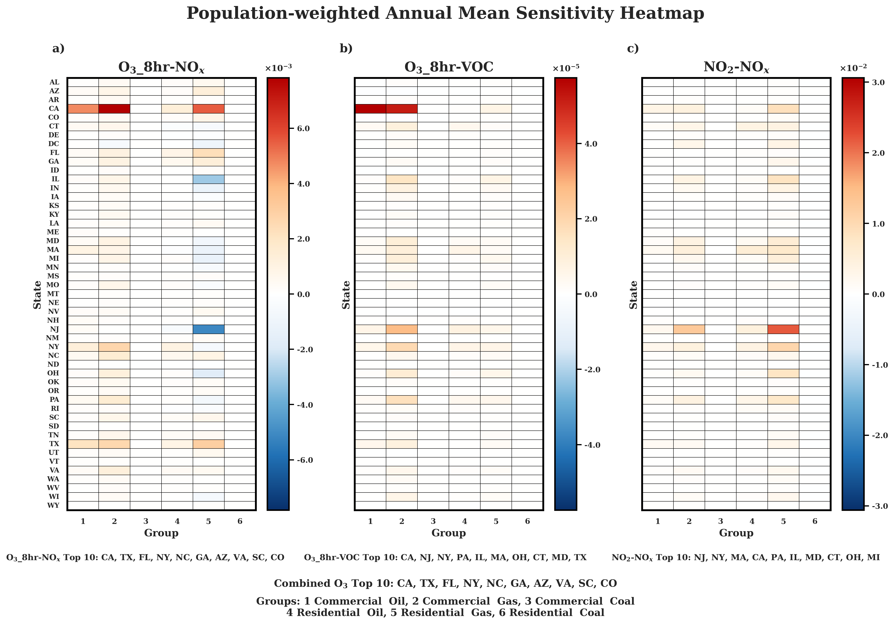
Supplementary Figure 11. Population-weighted annual mean sensitivities according to pollutant precursors of O₃_8hr and NO₂ based upon group over CONUS domain. Pollutants refers to pollutant and precursor species. State abbreviations are described in Supplementary Table 2. Units are ppbv for O₃_8hr and NO₂. Note: Differing Y-axis scale in each plot

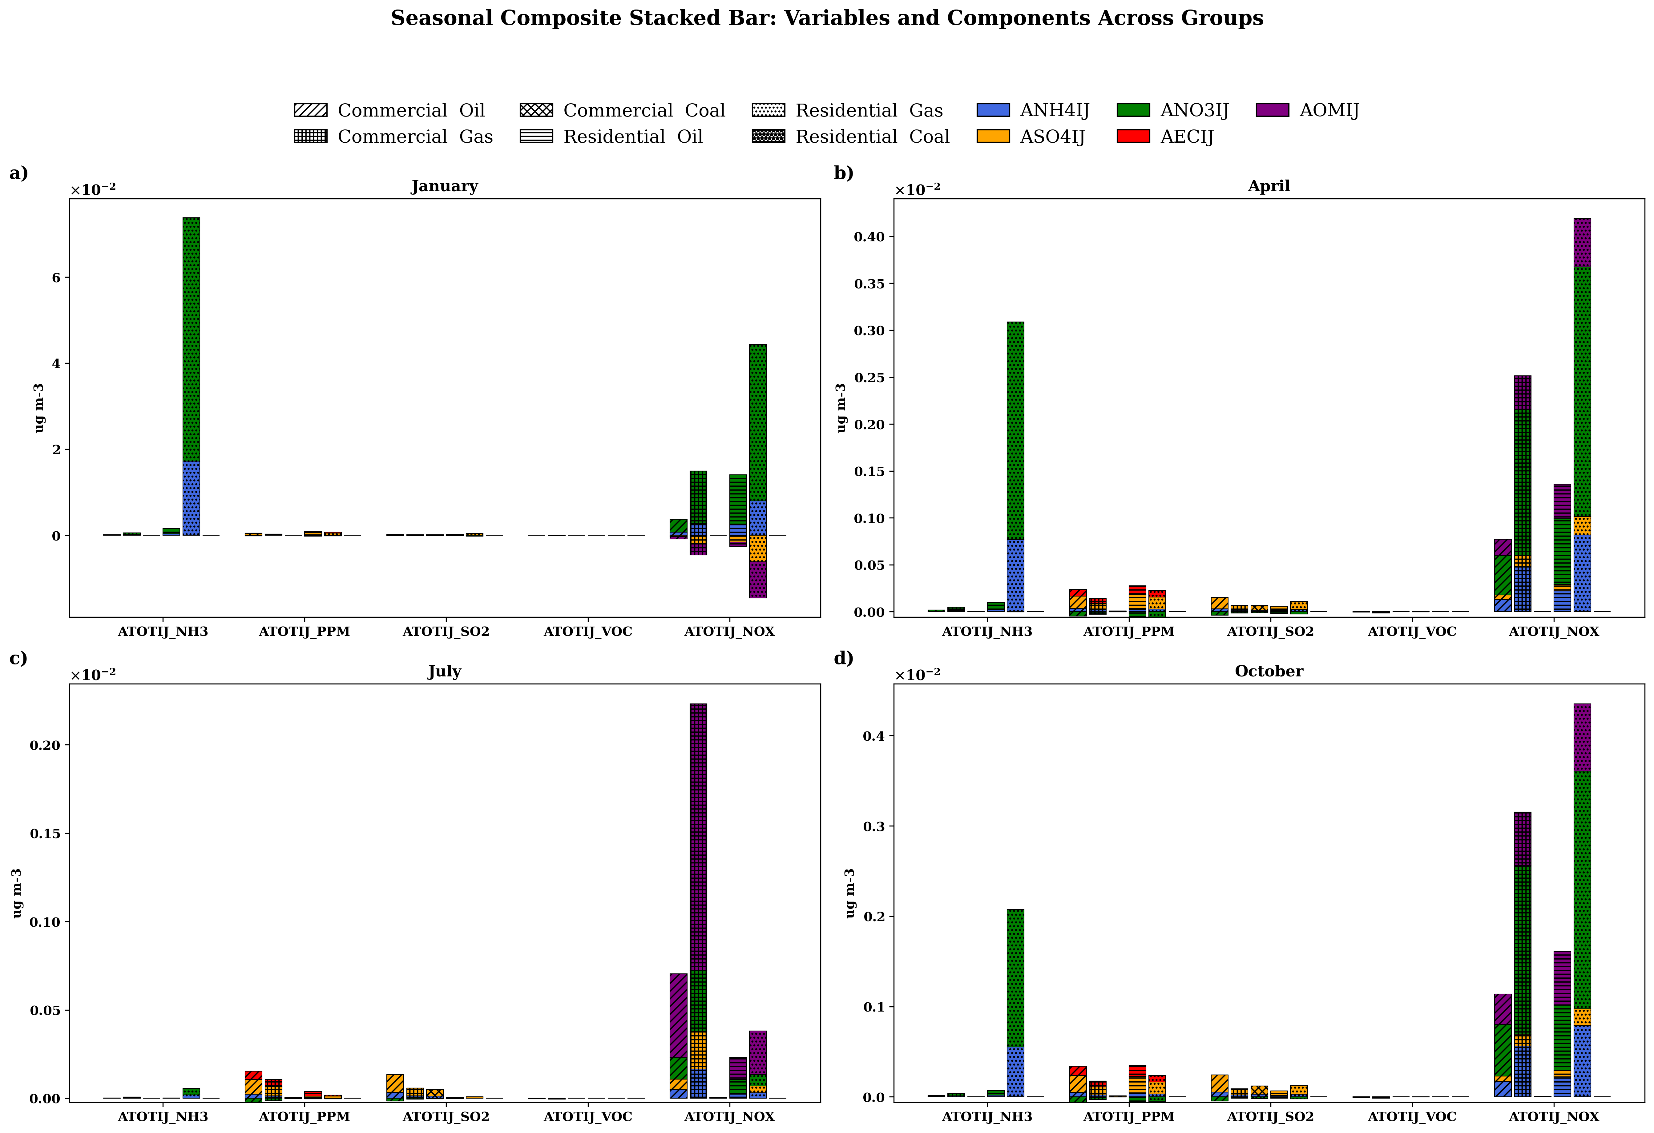Supplementary Figure 12. Chemically resolved PM_{2.5} sensitivities for January, April, July, and October across building-sector groups, highlighting the seasonal contributions of sulfate, nitrate, and ammonium-associated secondary inorganic aerosol components averaged over CONUS land
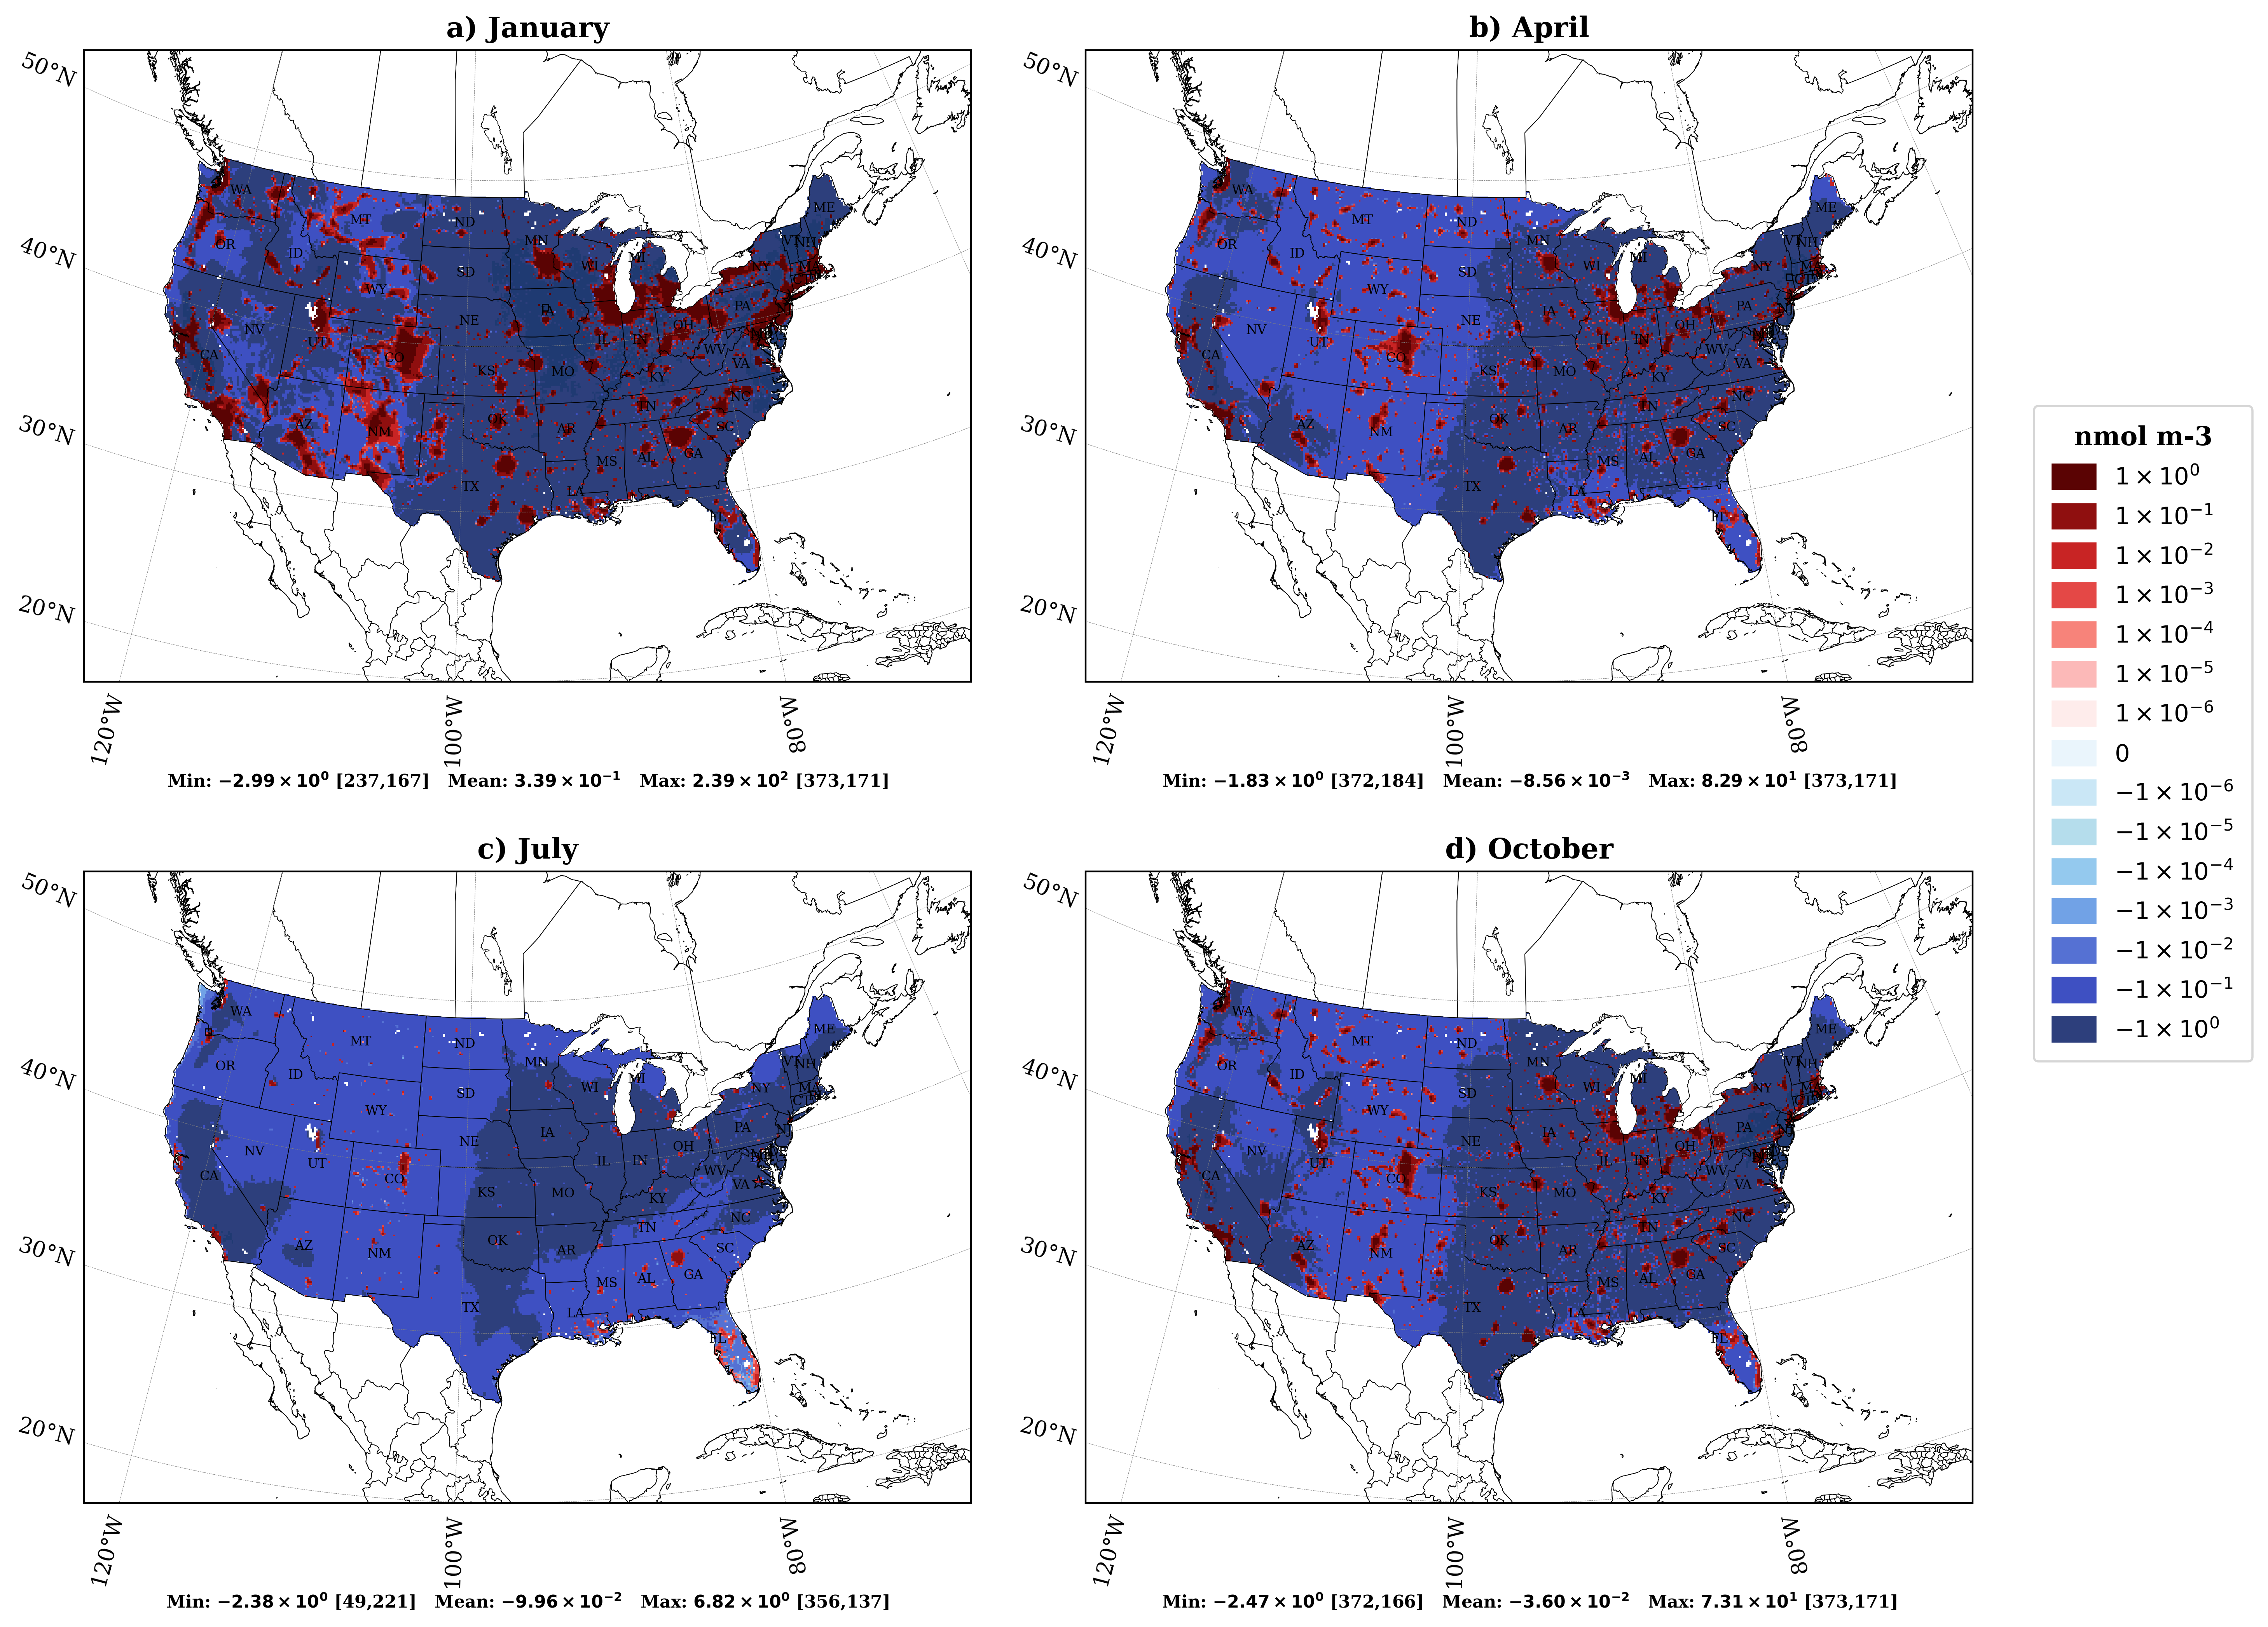
Supplementary Figure 13. Monthly mean Free Ammonia due to building sector emissions, estimated using a zero-out simulation for January, April, July, and October
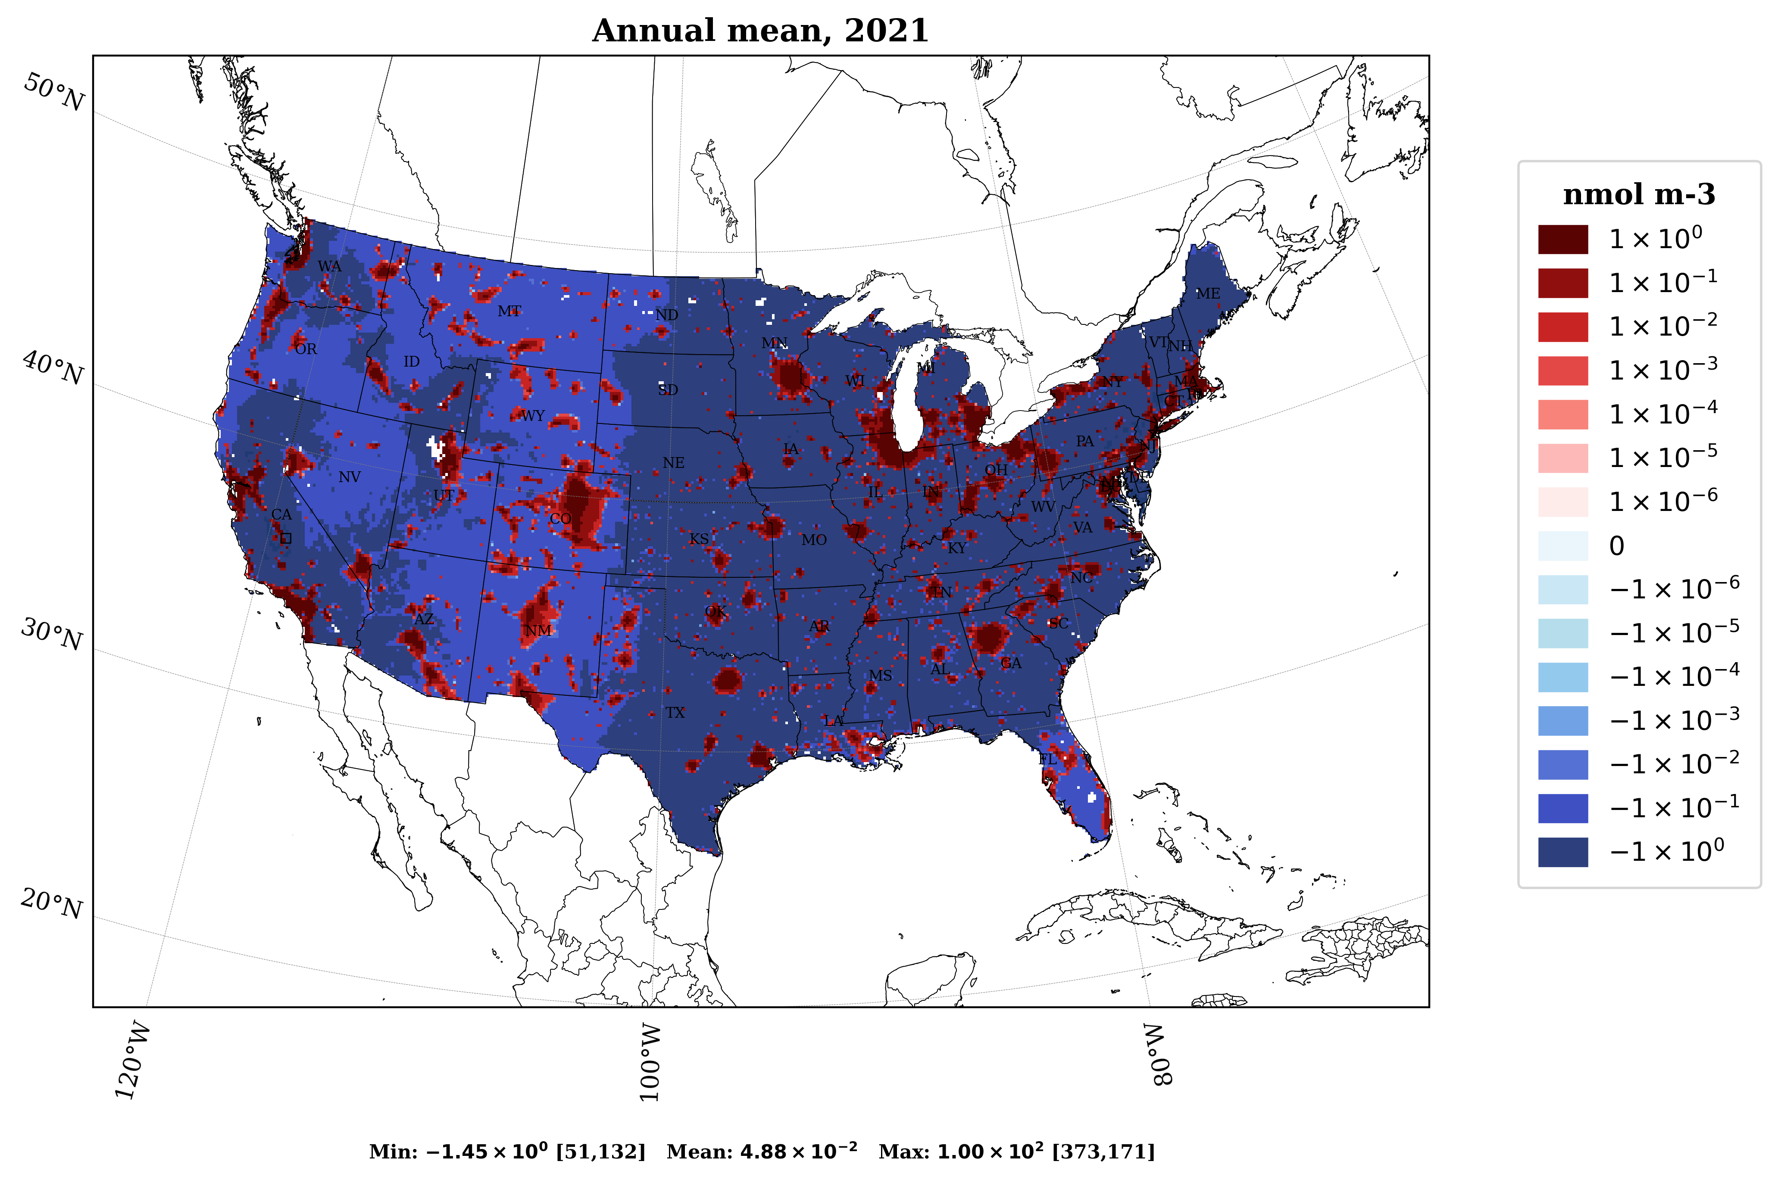
Supplementary Figure 14. Annual mean Free Ammonia due to building-sector emissions, estimated using a zero-out simulation for January, April, July, and October
As shown in Figure 3 and Supplementary Figure 4, PM_{2.5} exhibits the strongest sensitivity to NH₃ emissions, with NO_{x} emissions contributing the second-highest sensitivity, reflecting the coupled roles of SO₂, NO_{x}, and NH₃ in the formation of ammonium sulfate and ammonium nitrate. To further support this analysis, Supplementary Figure 12 presents the seasonally resolved, chemically decomposed (organic and inorganic) PM_{2.5} sensitivities, highlighting the dominance of secondary inorganic aerosol components across months. These results motivate examination of free ammonia (FA) as a diagnostic to interpret the chemical regime governing secondary inorganic aerosol formation.
To mechanistically interpret these sensitivities, we use the concept of free ammonia (FA), which provides a diagnostic of the ammonia–acid balance controlling secondary inorganic aerosol formation. Free ammonia (FA_{gas}) quantifies the balance between gaseous ammonia (NH₃) and nitric acid (HNO₃) in the atmosphere (Woody et al. 2011).
$${FA}_{gas}={[{NH}_{3}]}_{gas}- {[{HNO}_{3}]}_{gas}$$
All terms represent molar concentrations (e.g., mol m⁻³ or µmol m⁻³). Positive FA indicates an ammonia-rich regime, where excess NH₃ is available to neutralize nitric acid and promote ammonium nitrate (NH₄NO₃) formation. Negative FA indicates an ammonia-limited regime, where nitrate formation is constrained by NH₃ availability.
Importantly, FA is a system-level diagnostic that reflects the combined influence of all emission sources (anthropogenic, natural, and transported) and does not represent a source-specific quantity. To isolate the impact of building sector emissions on FA, we performed a sensitivity calculation by comparing a base simulation including all emissions with a simulation in which building emissions are removed (referred to as zero-out case). The difference between these simulations quantifies how building-sector emissions perturb the background FA field.
The monthly emissions totals (Supplementary Table 6) show that January has the highest precursor emissions among the selected months especially for NH₃ and NO_{x}. For example, January has 9,081 tons of NH₃ and 71,784 tons of NO_{x}, in comparison to April (3,506 tons NH₃; 33,062 tons NO_{x}), October (3,104 tons NH₃; 31,048 tons NO_{X}), and July (291 tons NH₃; 9,356 tons NO_{x}). A substantial fraction of this comes from natural gas combustion in residential buildings. In January, building sector emissions of NH₃ and NOₓ are at their highest, while temperatures are lowest and photochemical activity is weak. The elevated NH₃ emissions from residential gas combustion enhance ammonia availability, contributing to higher FA values and increased sensitivity of PM_{2.5} to NH₃ emissions from the building sector in January. Low temperatures thermodynamically favor the partitioning of ammonium nitrate to the particle phase, while weak photochemical activity reduces the oxidation of NO_{x} to HNO₃. These conditions do not create the ammonia-rich regime but instead enhance the persistence of excess NH₃ by limiting its conversion to acidic species and promoting efficient partitioning to particulate ammonium nitrate (Seinfeld and Pandis, 2016; Pinder et al., 2007). As a result, widespread positive FA values are observed, indicating sufficient NH₃ to neutralize available acidic species. This chemical environment explains the strong sensitivity of PM_{2.5} to NH₃ emissions, particularly through enhanced nitrate formation.
For sulfate formation, the behavior differs. Sulfate aerosol is typically ammonia-saturated due to contributions from multiple sources, leading to near-complete neutralization. In addition, SO₂ emissions from the building sector are relatively low, limiting their contribution to additional sulfate formation. In contrast, NOₓ emissions from the building sector contribute to nitrate formation through reactions with available NH₃ from both background and sector-specific sources.
As shown in Supplementary Figure 4, PM_{2.5} responds most strongly to NH₃ emission from building sector during January, with NO_{x} emissions exhibiting the second-highest sensitivity. When examining component wise ammonia sensitivity (Supplementary Figure 12) in January, nitrate aerosols exhibit higher sensitivity to ammonia emissions from the building sector, whereas ammonium aerosol components show comparatively lower sensitivity. This reflects an ammonia-rich regime, in which excess NH₃ drives efficient ammonium nitrate formation.
In this context, FA provides a mechanistic explanation for the observed sensitivity patterns. Positive FA values indicate excess NH₃ availability, supporting efficient nitrate formation and explaining the higher sensitivity of nitrate aerosols to ammonia emissions. Conversely, the low sensitivity of sulfate to ammonia is consistent with an already neutralized system, where additional NH₃ does not significantly enhance sulfate formation.
Supplementary Figure 13 shows the response of FA to building-sector emissions, estimated using a zero-out approach. In January, both the magnitude and spatial extent of FA enhancements are greatest, indicating a strong influence of building emissions on the ammonia–acid balance.
For April, the monthly emissions totals (Supplementary Table 6) also show that precursor emissions decrease substantially from January, with NH₃ and NO_{x} emissions accounting for only 40% and 45% of January levels, respectively. Also, the increased photochemical activity and moderate temperatures begin to shift the system toward transitional behavior. This results in reduced NH₃ availability relative to winter and a weakening of ammonia-rich conditions. The PM_{2.5} sensitivities become more balanced between NO_{x} and NH₃ emissions (Supplementary Figure 4) with other precursor emissions contributing very less.
For July, the monthly emissions totals (Supplementary Table 6) also show that NH₃ emissions are lowest, limiting ammonium nitrate formation. The FA for July also shows very few hotspots compared to January because FA represents the NH₃ remaining after sulfate neutralization. With stronger photochemical activity and higher temperatures in July, most nitrate remains in the gas phase and aerosol sulphate through the oxidation of SO₂ will contribute most to secondary inorganic PM_{2.5} (Pinder et al., 2007). However, despite the availability of NOₓ emissions, the scarcity of NH₃ emissions restricts the formation of ammonium nitrate. As shown in Supplementary Figure 3, PM_{2.5} is most sensitive to NO_{x} emissions in July, reflecting the relatively high NOₓ emissions during this month (Supplementary Table 6). Though NO_{x} emissions are at the lowest level in comparison to other months. The second highest sensitivity of PM_{2.5} came from SO₂ emissions showing the importance of SO₂ emissions during July (summer). FA concept is not as important in the summer months as most of the inorganic aerosol is sulfate (Pinder et al., 2007).
For October, the monthly emissions totals (Supplementary Table 6), NH₃ increases substantially relative to July (291 tpm to 3,104 tpm), and NO_{x} also increases from July to October (9,356 tpm to 31,048 tpm), though it remains slightly lower than April. The spatial pattern for FA is very similar to what was seen in April (Supplementary Figure 13). A moderate decrease in temperature from July to October, along with increased NH₃ and NO_{x} emissions relative to July, favors ammonium nitrate formation which can be seen in enhanced PM_{2.5} sensitivity in October. However, it should be noted that sensitivities vary across the precursors and emission groups (Supplementary Figure 4).
Overall, these seasonal differences indicate that wintertime PM_{2.5} formation is governed primarily by NH₃ availability, whereas summertime and transitional periods (April and October) exhibit greater sensitivity to NOₓ-driven nitrate chemistry (Supplementary Figure 2). These results align with previous studies (Ansari and Pandis, 1998; Pinder et al., 2008; Woody et al., 2011; Arter et al., 2021), and highlights how seasonal changes in ammonia levels, oxidants, and temperature together influence the formation of secondary inorganic aerosols. The annual FA pattern (Supplementary Figure 14) closely resembles that of January (Supplementary Figure 13), indicating that secondary inorganic aerosol formation is dominated by wintertime conditions. In particular, the enhanced contribution of ammonium nitrate during winter is evident in the FA results. Consistent with this, the seasonal sensitivity analysis of PM_{2.5} (Supplementary Figure 4) shows substantially stronger NH₃ sensitivity in winter (January) compared to other seasons, indicating NH₃-rich conditions. So, FA results provide a mechanistic link between enhanced wintertime ammonium nitrate formation and the elevated NH₃ sensitivity observed in PM_{2.5}.

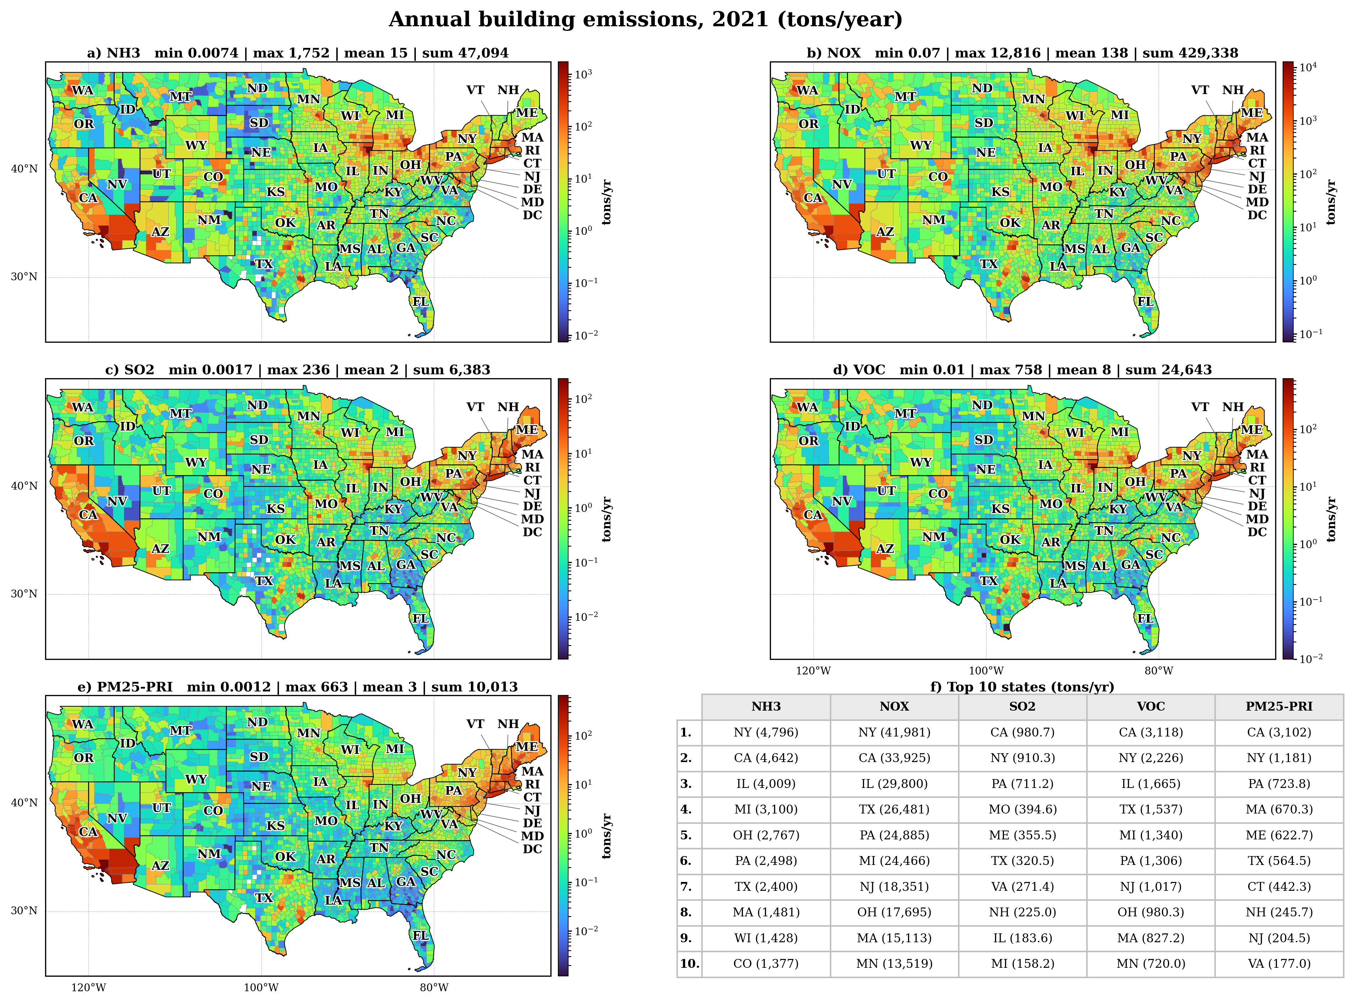
Supplementary Figure 15. Annual emissions of NOx, VOC, PM_{2.5}, SO₂, and NH₃ from building sectors across the United States. All values in tons/year

Supplementary References
Ansari, A. S., & Pandis, S. N. (1998). Response of inorganic PM to precursor concentrations. Environmental Science & Technology, 32(18), 2706–2714. https://doi.org/10.1021/es971130j
Arter, C. A., Buonocore, J., Chang, C., & Arunachalam, S. (2021). Mortality-based damages per ton due to the on-road mobile sector in the Northeastern and Mid-Atlantic U.S. by region, vehicle class and precursor. Environmental Research Letters, 16(6), 065008. https://doi.org/10.1088/1748-9326/abf60b
Guo, H., Sullivan, A. P., Campuzano-Jost, P., Schroder, J. C., Lopez-Hilfiker, F. D., Dibb, J. E., Jimenez, J. L., Thornton, J. A., Brown, S. S., Nenes, A., & Weber, R. J. (2016). Fine particle pH and the partitioning of nitric acid during winter in the northeastern United States. Journal of Geophysical Research: Atmospheres, 121(17), 10,355-10,376. https://doi.org/10.1002/2016JD025311
Pinder, Robert W, Adams, P. J., & Pandis, S. N. (2007). Ammonia emission controls as a cost-effective strategy for reducing atmospheric particulate matter in the Eastern United States. Environmental Science & Technology, 41(2), 380–386. https://doi.org/10.1021/es060379a
Pinder, R W, Gilliland, A. B., & Dennis, R. L. (2008). Environmental impact of atmospheric NH₃ emissions under present and future conditions in the eastern United States. Geophysical Research Letters, 35(12). https://doi.org/10.1029/2008GL033732
Seinfeld, J. H., & Pandis, S. N. (2016). Atmospheric Chemistry and Physics: From Air Pollution to Climate Change (3rd ed., p. 1152). Wiley.
Stelson, A., & Seinfeld, J. (2007). Relative humidity and temperature dependence of the ammonium nitrate dissociation constant. Atmospheric Environment, 41, 126–135. https://doi.org/10.1016/j.atmosenv.2007.10.063
Woody, M., Haeng Baek, B., Adelman, Z., Omary, M., Fat Lam, Y., Jason West, J., & Arunachalam, S. (2011). An assessment of Aviation’s contribution to current and future fine particulate matter in the United States. Atmospheric Environment, 45(20), 3424–3433. https://doi.org/10.1016/j.atmosenv.2011.03.041

