Supplementary file 1 for:
Hybridogenesis in Pelophylax hispanicus: mechanism of genome elimination and hemiclonal inheritance

Authors
Veronika Labajová^{1,2}, Dmitrij Dedukh³, Marie Doležálková-Kaštánková², Anna Dudzik⁴, Magdalena Chmielewska⁴ & Lukas Choleva^{1,2}

Affiliations
1 Department of Biology and Ecology, Faculty of Science, University of Ostrava, Ostrava, Czech Republic
2 Laboratory of Fish Genetics, Institute of Animal Physiology and Genetics, Czech Academy of Sciences, Libechov, Czech Republic
3 Laboratory of Non-Mendelian Evolution, Institute of Animal Physiology and Genetics, Czech Academy of Sciences, Libechov, Czech Republic
4 Amphibian Biology Group, Department of Evolutionary Biology and Conservation of Vertebrates, Faculty of Biological Sciences, University of Wrocław, Wrocław, Poland

Correspoding author: Lukas Choleva, lukas.choleva@osu.cz

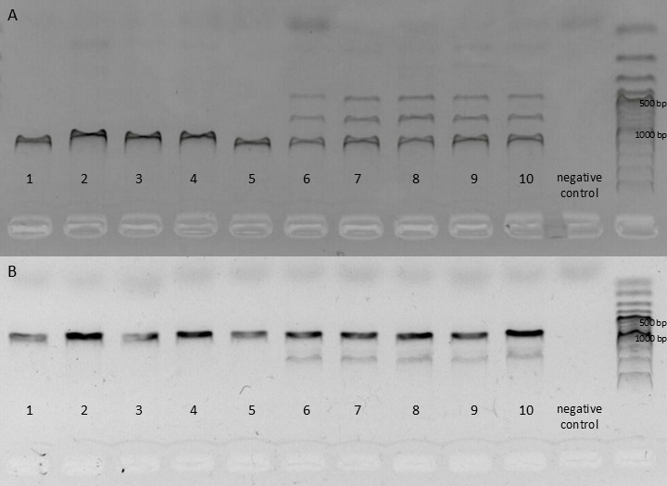
Fig. S1. Agarose gel electrophoresis of two diagnostic markers for discrimination between Pelophylax bergeri and P. hispanicus. (A) Restriction fragment pattern of RAG1 amplicons after digestion with EcoO109 on a 2% agarose gel (70 V, 2 h). Lanes 1–5 show P. bergeri samples with a single-band pattern; lanes 6–10 show P. hispanicus samples with the characteristic multi-band pattern. (B) Electrophoretic pattern of SAI-1 PCR products on a 0.8% agarose gel (90 V, 30 min). Lanes 1–5 show P. bergeri samples with a single fragment; lanes 6–10 show P. hispanicus samples with the characteristic two-band pattern. In both panels, the second-to-last lane contains the negative control and the last lane contains a 100 bp DNA ladder.

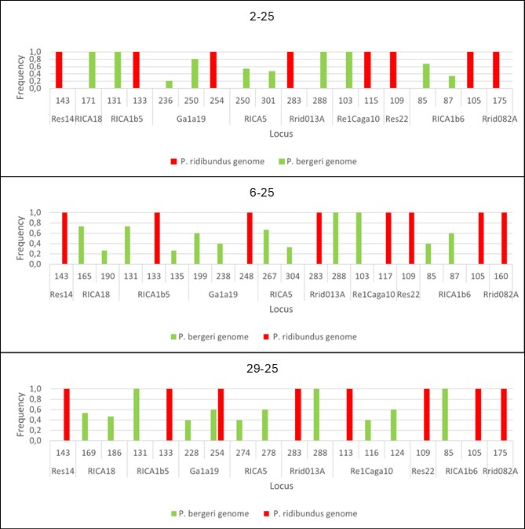
Fig. S2. Allele frequencies at diagnostic microsatellite loci in offspring from three backcross families. Frequencies of alleles assigned to the Pelophylax ridibundus-derived genome (red) and the P. bergeri genome (green) are shown for 15 juveniles from each family (2-25, 6-25, and 29-25). Numbers below the bars indicate allele sizes (bp), and bar height represents allele frequencies within each family. All offspring exhibited hybrid genotypes, and the observed allele distributions were consistent with hemiclonal transmission of the P. ridibundus-derived genome by the P. hispanicus parent.

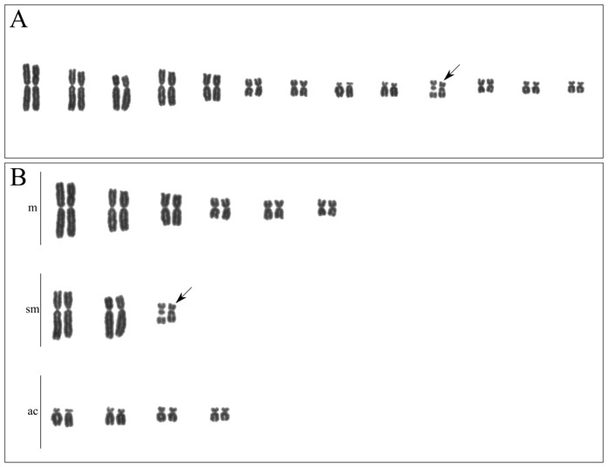
Fig. S3. Karyotype of Pelophylax bergeri. Chromosome spreads were stained with Giemsa. (A) The complete diploid chromosome complement of P. bergeri consists of 13 pairs of chromosomes. The pairs are arranged from the largest to smallest, resulting in two groups: five large and eight small. (B) Chromosome pairs are divided into classes according to the position of the centromere. Black arrows indicate the 10th chromosome pair with NOR; m, metacentric; sm, submetacentric; ac, acrocentric chromosomes.

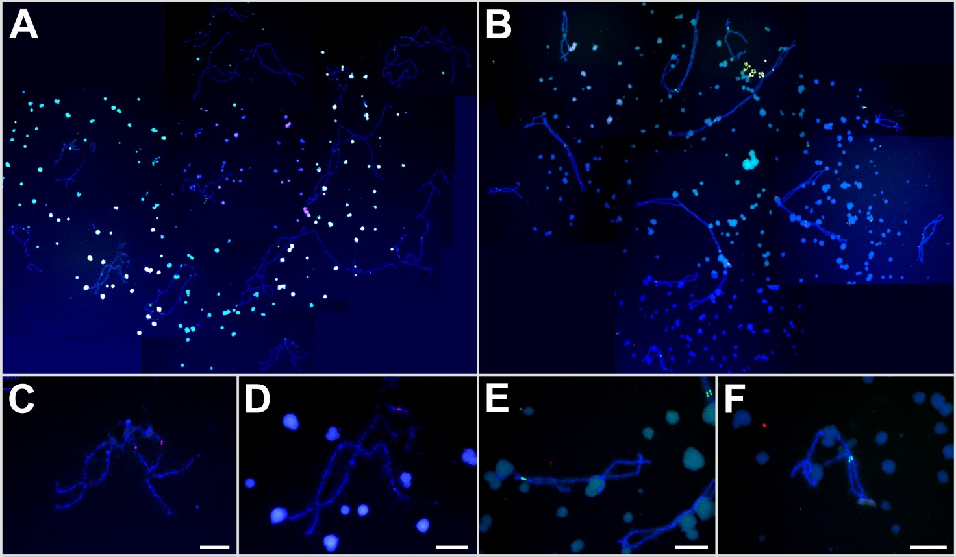
Fig. S4. Fluorescence in situ hybridization (FISH) analysis of lampbrush chromosomes from Pelophylax bergeri and P. hispanicus oocytes. Chromosomes were hybridized with the centromeric probes RrS1 (green) and PlesSat01-48 (red) and counterstained with DAPI (blue). (A) Complete lampbrush chromosome set of P. bergeri consisting of 13 bivalents, including five large and eight small bivalents. (B) Complete lampbrush chromosome set of P. hispanicus consisting of 13 normally paired bivalents. (C, D) Representative P. bergeri lampbrush bivalents showing weak RrS1 signals and strong PlesSat01-48 signals at the centromeric regions. (E, F) Representative P. hispanicus lampbrush bivalents showing strong RrS1 signals, whereas PlesSat01-48 signals were not detected. The absence of PlesSat01-48-positive chromosomes in P. hispanicus oocytes is consistent with the exclusive presence of the P. ridibundus-derived chromosome set at the lampbrush chromosome stage. Scale bars = 10 μm.

Table S1. Numbers of germ cells, micronuclei, and micronuclei with parental genome-specific FISH signals in tadpole gonads.
Sample ID | # of germ cells  (total) | # of micronuclei | # of micronuclei with PlesSat01-48 signals | # of micronuclei with RrS1-positive signals
2-25TAD1 | 184 | 71 | 1 | 2
2-25TAD3 | 241 | 80 | 5 | 8
2-25TAD4 | 319 | 70 | 7 | 14
2-25TAD5 | 229 | 16 | 2 | 6
6-25TAD5 | 769 | 239 | 42 | 37
6-25TAD6 | 375 | 206 | 33 | 19
6-25TAD7 | 561 | 265 | 24 | 41
6-25TAD9 | 520 | 295 | 44 | 62
29-25TAD1 | 172 | 21
29-25TAD3 | 472 | 11 | 2 | 5
29-25TAD7 | 616 | 76 | 11 | 28
29-25TAD6 | 439 | 47 | 6 | 14
29-25TAD8 | 543 | 55 | 16 | 18
29-25TAD9 | 324 | 27 | 5 | 8
29-25TAD10 | 699 | 83 | 11 | 31
29-23/25TAD1 | 506
29-23/25TAD6 | 166 | 5
29-23/25TAD7 | 468

