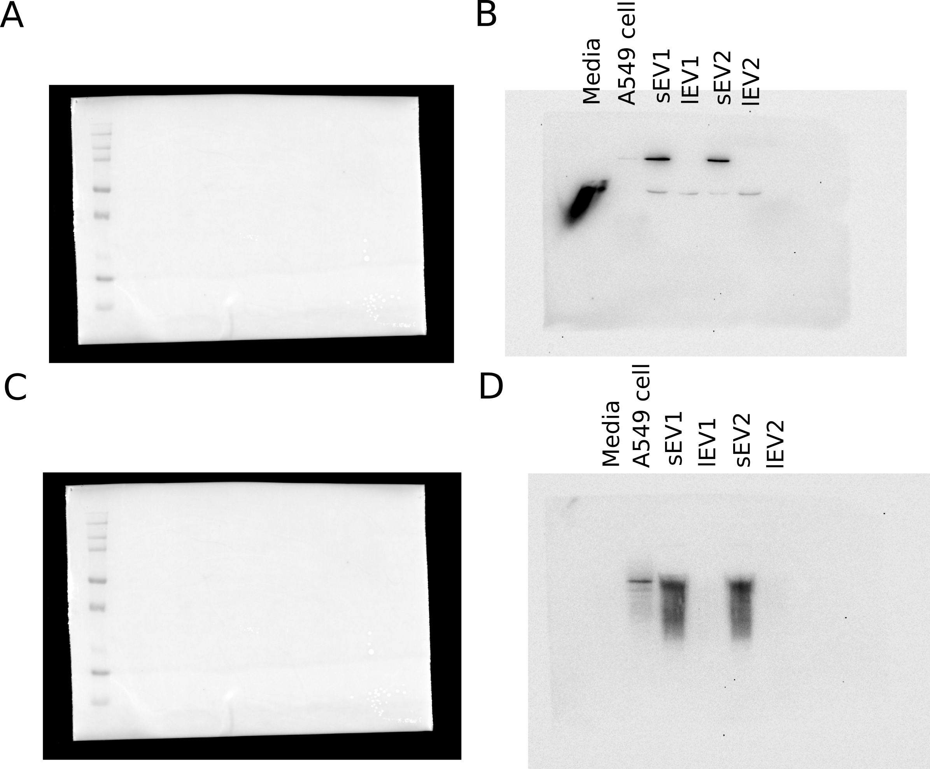
Supplementary File: Uncropped western blot images corresponding to Figure 7A. Full-length original membranes for Alix (top panels) and CD63 (bottom panels). For each target, the capture displaying the molecular weight marker is shown on the left, alongside the corresponding chemiluminescent capture on the right. The first four lanes correspond to the Media, A549 cell lysate, sEV, and lEV conditions, respectively, which were cropped to generate the representative images in main Figure 7A.

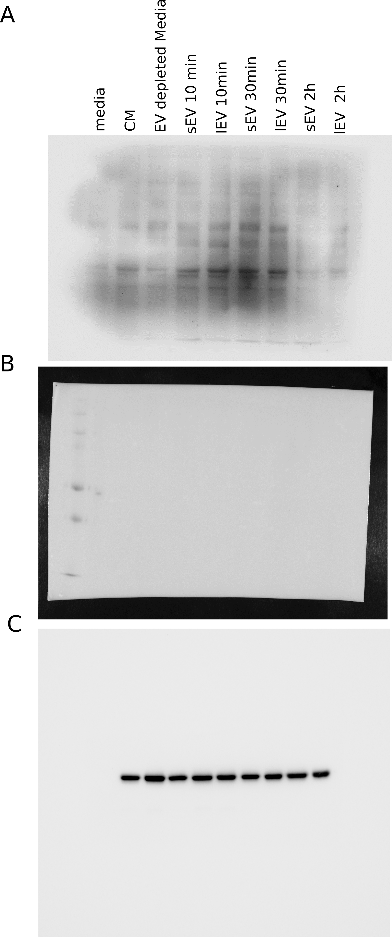

Supplementary File: Uncropped western blot images corresponding to Supplementary Figure S4. Full-length original membranes utilized for the phospho-tyrosine temporal analysis. The top panel displays the global chemiluminescent phospho-tyrosine signal across all experimental conditions. The middle panel shows the corresponding capture of the molecular weight marker. The bottom panel displays the chemiluminescent signal for the beta-actin loading control. The nine lanes correspond sequentially to the conditions shown in Supplementary Figure S4A: media, CM, EV depleted media, sEVs (10 min), lEVs (10 min), sEVs (30 min), lEVs (30 min), sEVs (2 hrs), and lEVs (2 hrs).

