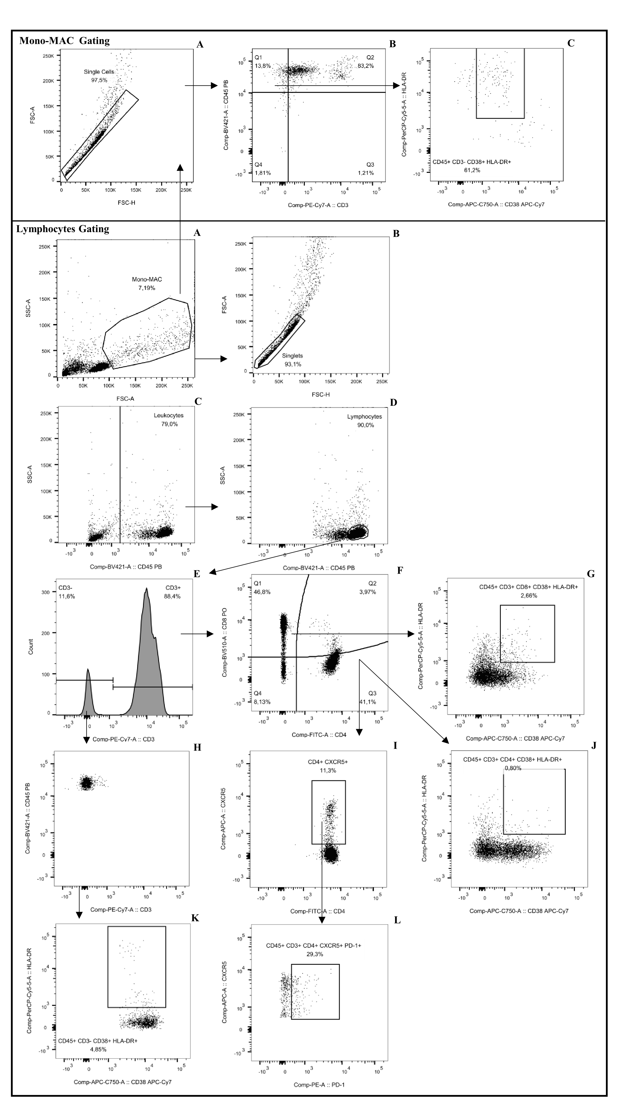
Fig. S1. Representative two-parameter density ﬂow cytometry plots of PBMCs, challenged with acellular pleural effusion transudate collected from a patient with cardiac failure, show gating strategy to deﬁne: Panel Mono-MAC gating (A); Mono-MAC Singlets using Forward Scatter Area and Height; (B); Mono-MAC CD45⁺ CD3⁻; (C) CD45⁺ CD3⁻ CD38⁺ HLA-DR⁺ activated cells. Panel Lymphocytes Gating (A) Isolated PBMCs, (B) Singlets using Forward Scatter Area and Height; (C) CD45⁺ singlets – leukocytes using Side Scatter Area and CD45-BV421; (D) CD45⁺ SSC low lymphocytes using Side Scatter Area and CD45-BV421, (E) CD45⁺ CD3⁺ T cells using CD45-BV421, CD3-PE-Cy7; (F) CD45⁺ CD3⁺ CD8⁺ T cells (cytotoxic) and CD45⁺ CD3⁺ CD4⁺ T cells (helper) using CD4-FITC and CD8-BV510; (G) CD45⁺ CD3⁺ CD8⁺ CD38⁺ HLA-DR⁺ activated T cells using CD38-APC-C750 /HLA-DR-PE; (H) Lymphocyte CD45⁺ CD3⁻ cells; (I) CD45⁺ CD3⁺ CD4⁺ CXCR5⁺ T cells using CXCR5-APC-A; (J) CD45⁺ CD3⁺ CD4⁺ CD38⁺ HLA-DR ⁺ activated T cells; (K) Lymphocyte CD45⁺ CD3⁻ CD38⁺ HLA-DR⁺ activated cells; (L) CD45⁺ CD3⁺ CD4⁺ CXCR5⁺ PD-1⁺ circulating follicular T helper cells (cTfh) using PD-1-PE-A.

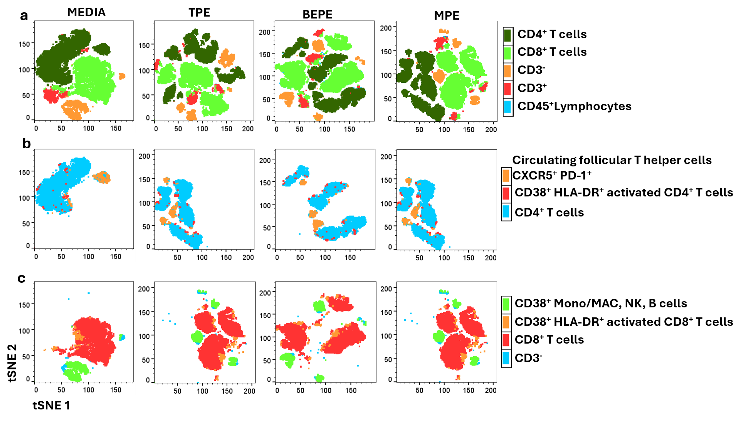
Fig. S2. t-SNE plots of healthy donor peripheral blood mononuclear cells challenged with acellular pleural effusion collected from patients with parapneumonic infection (BEPE), cardiac failure (TPE) and malignant lung adenocarcinoma (MPE). A) t-SNE plots were generated for CD45⁺ lymphocytes. The distribution of HD PBMCs subpopulations is represented for a) CD45-BV421, CD3-PE-Cy7, CD4-FITC and CD8-BV510. B) Subsets of CD4⁺ T cells as CXCR5-APC/HLA-DR-PE circulating T cells and activated CD4-FITC/CD38-APC-C750 cells and C) Subsets of CD8⁺ T cells and CD3⁻ cells (monocytes/MAC, NK and B cells) as CD38-APC-C750 /HLA-DR-PE activated cells and activated non -T cells such as monocytes, NKs and B cells.

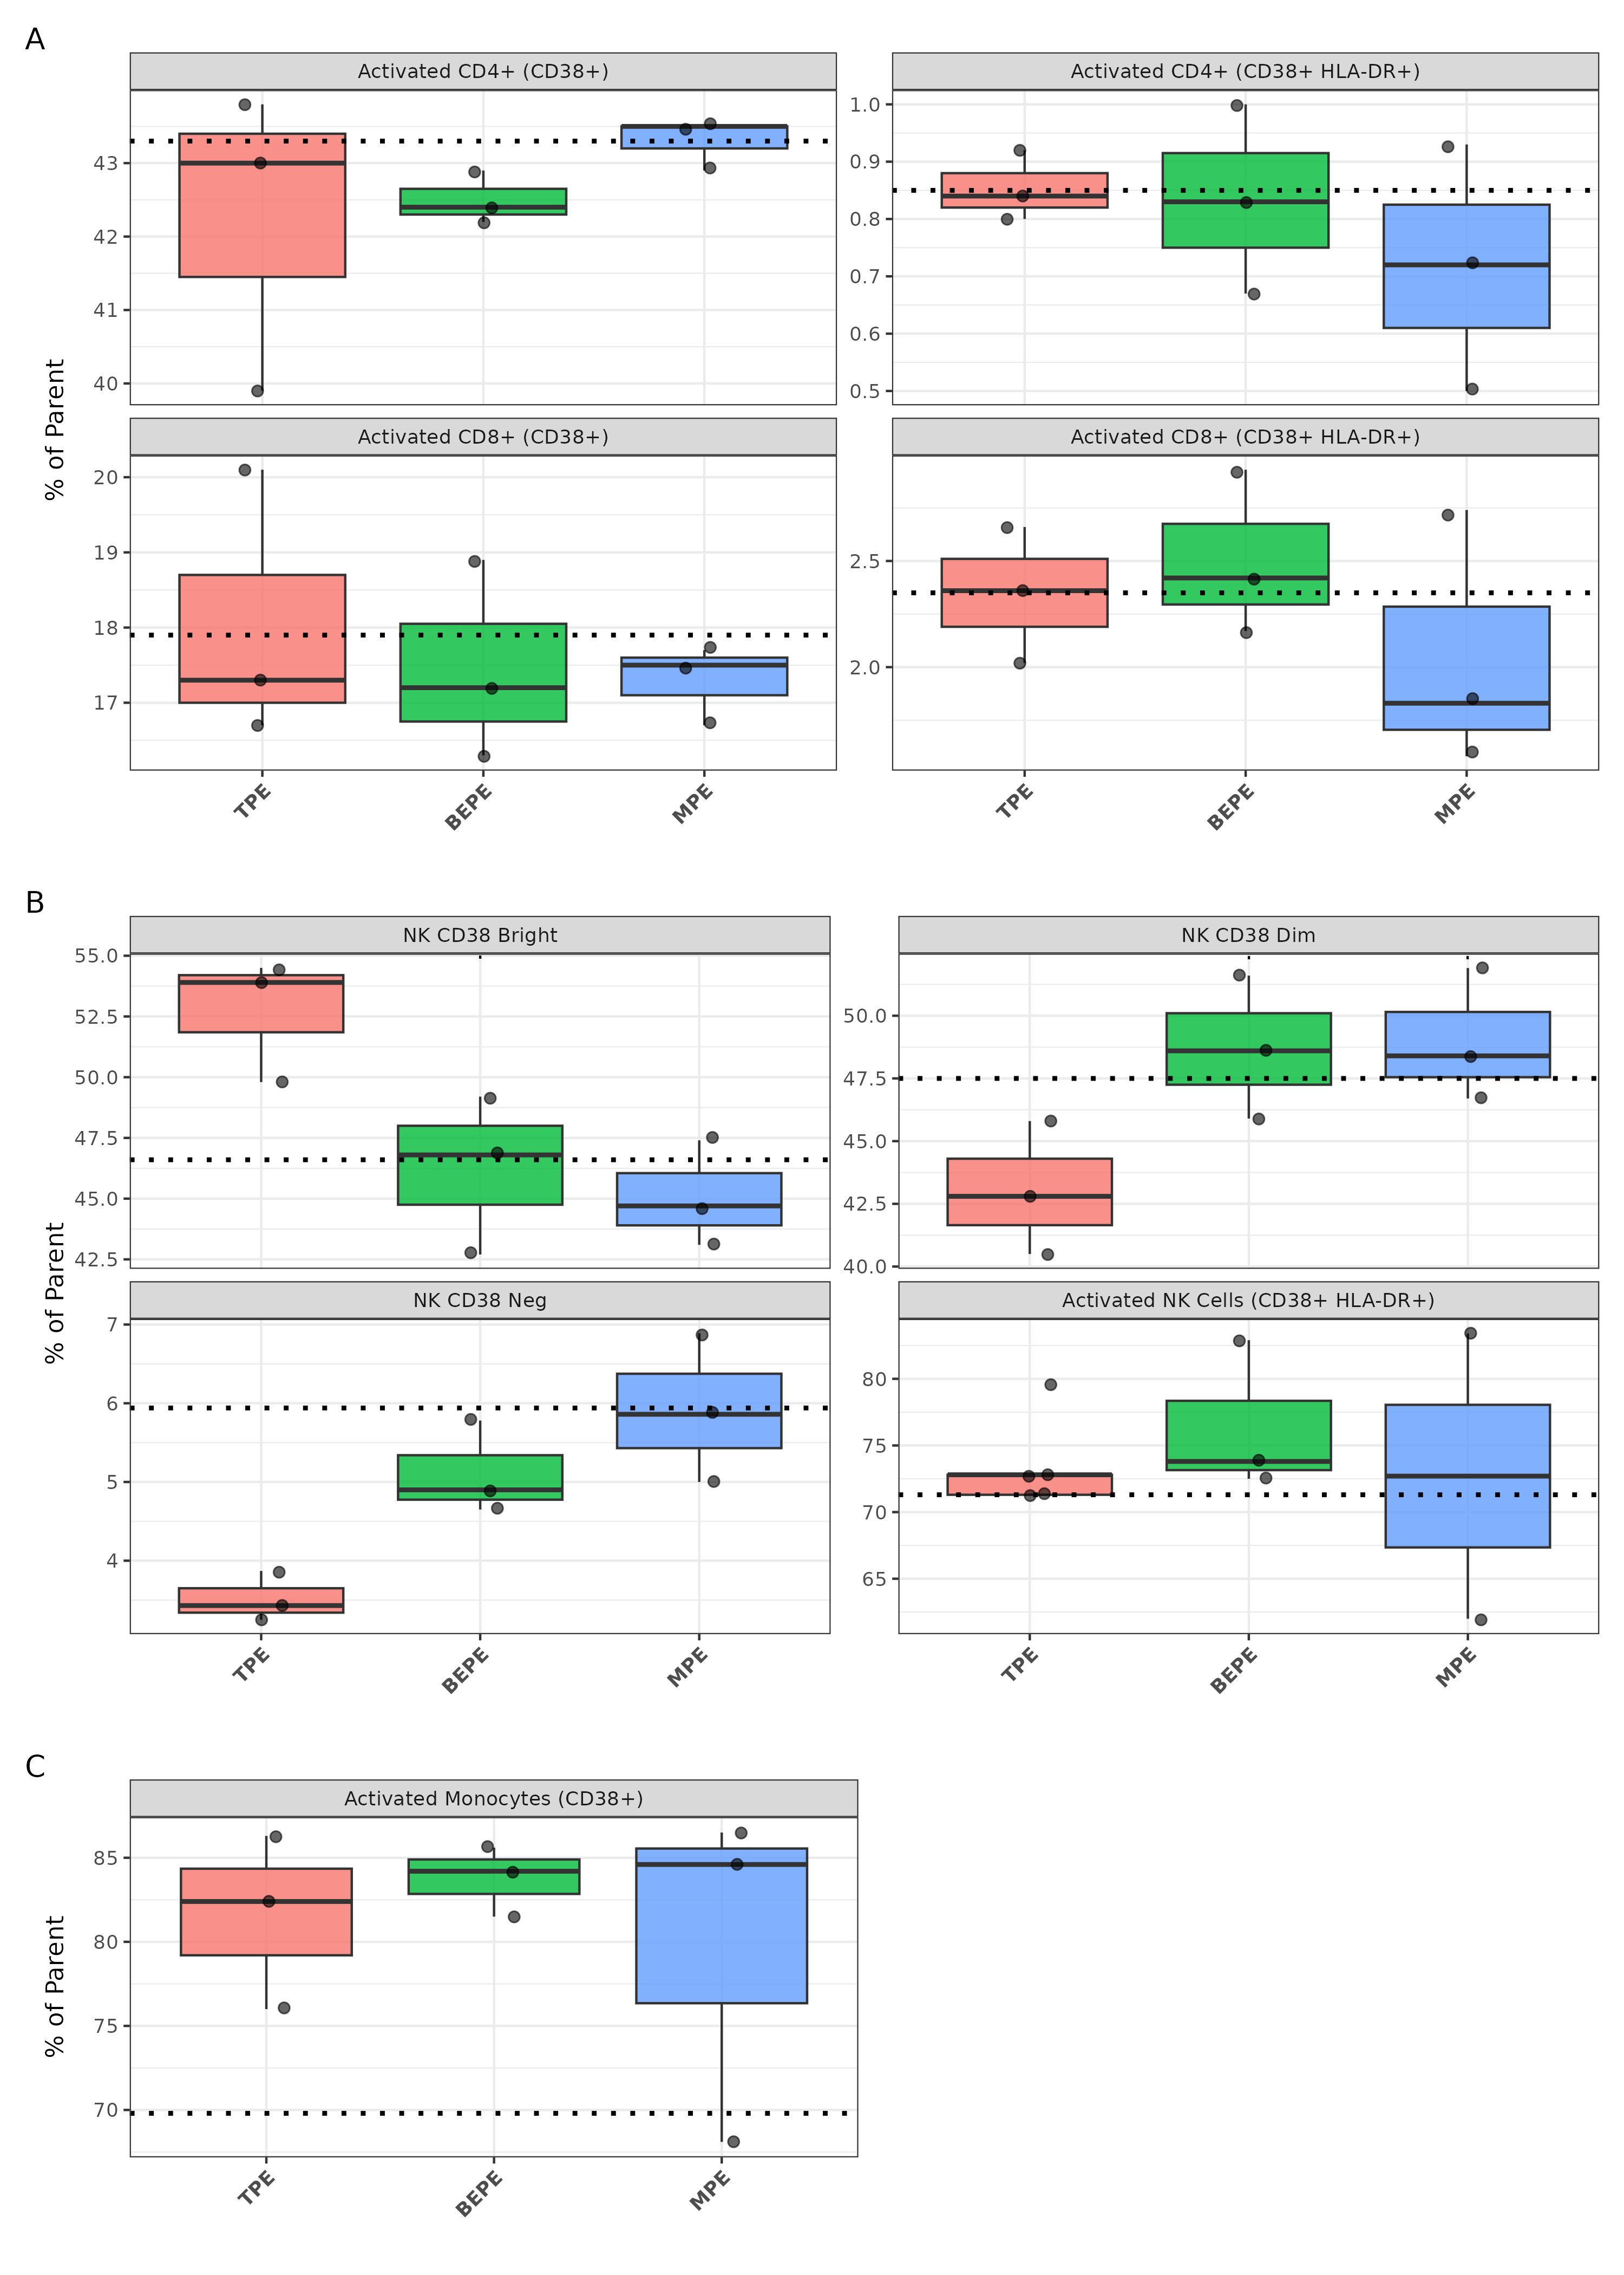
Fig. S3. Granular immunophenotyping of activation states and phenotypic shifts in peripheral immune subsets following pleural effusion exposure. Boxplots display the relative abundance of specific immune subpopulations in healthy donor PBMCs challenged for 24 hours with 50% TPE (transudative PE), BEPE (benign parapneumonic effusion), or MPE (malignant pleural effusion). (A) Frequencies of classically activated (CD38⁺ and CD38⁺ HLA-DR⁺) subsets within the parent CD4⁺ and CD8⁺ T-cell compartments. (B) Phenotypic shifts within the non-T cell compartment (CD3⁻ lymphocytes), illustrating the distribution of CD38 Bright, Dim, and Negative populations, alongside a highly activated (CD38⁺ HLA-DR⁺) subset. (C) Frequency of CD38⁺ activated cells within the surviving monocyte/macrophage (Mono-MAC) population. Individual dots represent biological replicates (n=3 per experimental condition). Boxes indicate the interquartile range with the median shown as the center line. The horizontal dashed black line represents the baseline value from the unchallenged media control (n=1).

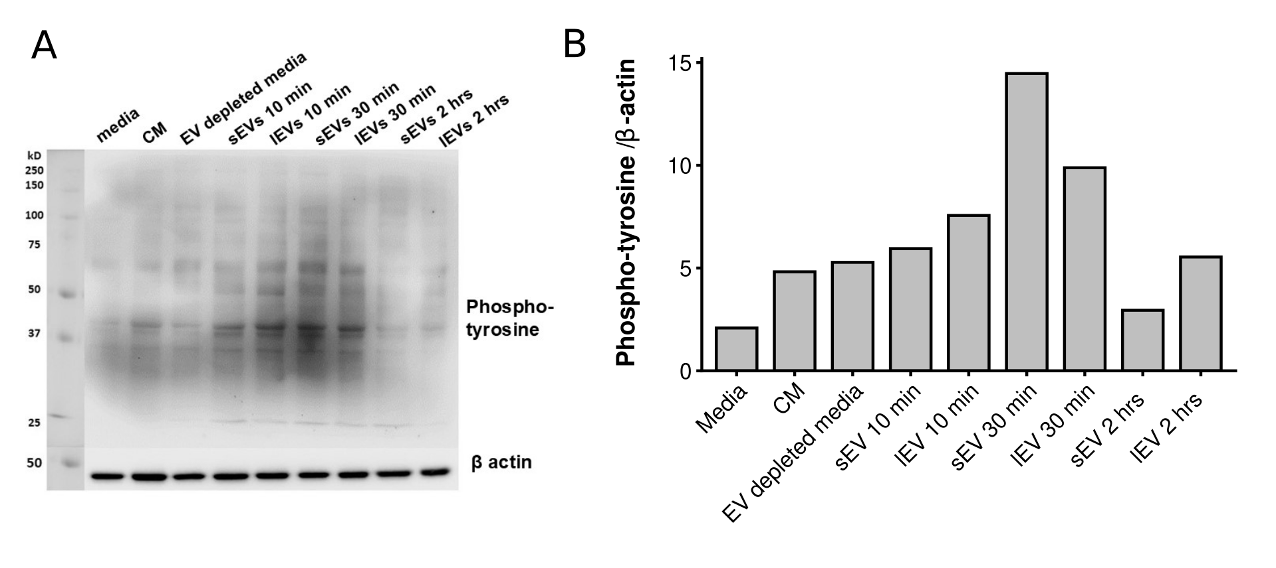

Fig. S4. Immunoblot analysis of PBMCs after treatment with TDEVs for phospho-tyrosine expression. (A)Western blot illustration for phospho-tyrosine and (B) quantification of the western blot bands after normalization with β-actin bands.

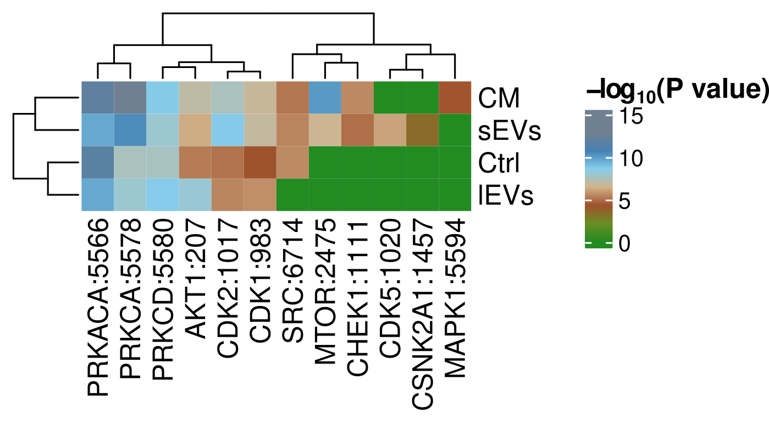

Fig. S5. Differential kinase enrichment mapping across fractions derived from lung cancer cell conditioned media. Heatmap displaying the hierarchical clustering of predicted kinase activity in PBMCs treated with specific components isolated from lung cancer cell conditioned media: EV-depleted conditioned media (CM), small extracellular vesicles (sEVs), control media (Ctrl), and large extracellular vesicles (lEVs). Identified phosphorylated substrates were empirically mapped to their corresponding upstream kinases, and an enrichment value was calculated for each kinase match. The multi-breakpoint color gradient reflects the statistical significance of this enrichment, plotted as the log₁₀(P value), ranging from non-significant (green, 0) to highly significant (grey/blue, up to 15). The clustering illustrates the distinct signaling topologies associated with the different fractions, highlighting the divergence between broad soluble-factor signaling cascades (e.g., the distinct enrichment of MAPK1 in CM) and highly targeted, vesicle-mediated signaling nodes (e.g., the unique co-enrichment of CDK5 and CSNK2A1 strictly within the sEV fraction).

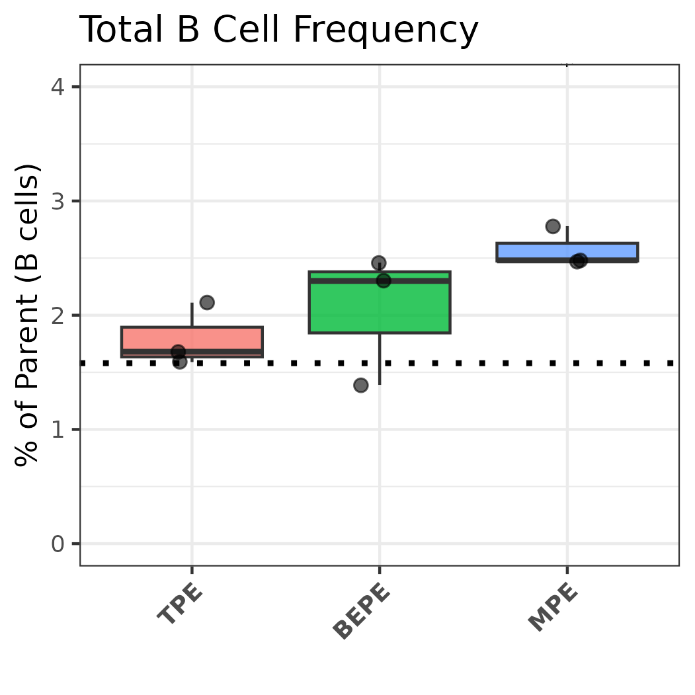

Fig. S6. B cell scarcity in the healthy donor peripheral mononuclear cell model. Boxplots illustrate the overall frequency of circulating B cells (CD45+ CD19+) in healthy donor PBMCs following 24-hour challenge with acellular pleural effusions. Across all conditions (TPE, BEPE, and MPE), the total B cell population remained highly scarce (< 4% of total events), validating that the non-T cell lymphocyte compartment (CD45+ CD3-) is predominantly represented by natural killer (NK) cells. Individual dots represent biological replicates (n=3 per experimental condition). The horizontal dashed black line represents the mean baseline frequency from the unchallenged media control.

