Supplementary Tables
Supplementary Table S1: Subgroup analysis: navigation-assisted versus conventional surgery within tumor-type, tumor-size, and surgery-status strata, for gross total resection (GTR) rate and estimated blood loss
Variable | Category | N (Nav vs No-Nav) | GTR Nav | GTR No-Nav | p | Blood loss Nav (mL) | Blood loss No-Nav (mL)
Tumor type | Functioning | 8 vs 5 | 5/8 (62%) | 3/5 (60%) | 1.000 | 250 (200–430) | 350 (250–420)
 | Non-functioning | 17 vs 20 | 2/17 (12%) | 1/20 (5%) | 0.584 | 300 (200–500) | 350 (200–640)
Tumor size | Macroadenoma (<30 mm) | 5 vs 5 | 4/5 (80%) | 3/5 (60%) | 1.000 | 250 (200–430) | 350 (250–420)
 | Large (30–39 mm) | 8 vs 7 | 3/8 (38%) | 1/7 (14%) | 0.569 | 275 (200–360) | 350 (200–600)
 | Giant (≥40 mm) | 12 vs 13 | 0/12 (0%) | 0/13 (0%) | 1.000 | 300 (200–500) | 350 (200–640)
Surgery status | Primary | 19 vs 21 | 6/19 (32%) | 4/21 (19%) | 0.473 | 250 (200–500) | 350 (200–640)
 | Recurrent | 6 vs 4 | 1/6 (17%) | 0/4 (0%) | 1.000 | 275 (200–360) | 325 (250–400)

Supplementary Table S2: Stratum-level randomization allocation across the 12 nominal strata defined by tumor size × functioning status × surgery status
Tumor size | Functioning status | Surgery status | Navigation, n | Conventional, n
Giant (≥40 mm) | Non-functioning | Primary | 8 | 10
Giant (≥40 mm) | Non-functioning | Recurrent | 4 | 3
Large (30–39 mm) | Functioning | Primary | 3 | 0
Large (30–39 mm) | Non-functioning | Primary | 3 | 6
Large (30–39 mm) | Non-functioning | Recurrent | 2 | 1
Macroadenoma (<30 mm) | Functioning | Primary | 5 | 5
Total |  |  | 25 | 25

Supplementary Figures captions
Supplementary Fig. S1: Extent of resection in the whole cohort (N = 50), stratified by tumor size. Stacked bars show the percentage of patients achieving gross total resection (GTR, 100%), near-total resection (NTR, ≥90%), subtotal resection (STR, 70–90%), or partial resection (Partial, <70%) within each tumor-size category, irrespective of navigation status. Corresponding sample sizes and the statistical association between tumor size and extent of resection are reported in Table 2
Supplementary Fig. S2: Resection completeness rate with versus without intraoperative neuronavigation, stratified by tumor type, tumor size, Knosp grade, and surgery status. Bars represent the percentage of patients achieving a radical resection (GTR + NTR) within each navigation arm and subgroup category. None of the between-arm differences reached statistical significance within any stratum; these are exploratory subgroup comparisons.

Supplementary Figures
Supplementary Figure S1
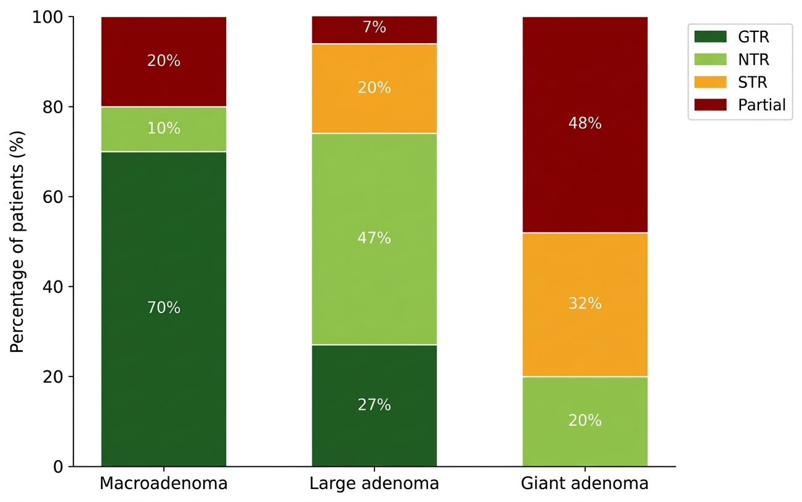
Supplementary Figure S2
