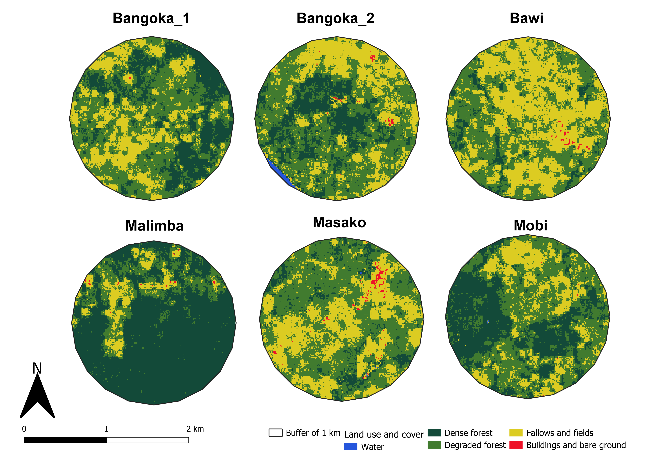
Figure S1. Spatial configuration of six 1-km maize landscapes near Kisangani, DRC, showing variation in forest cover and fragmentation used to assess Spodoptera frugiperda infestation patterns.

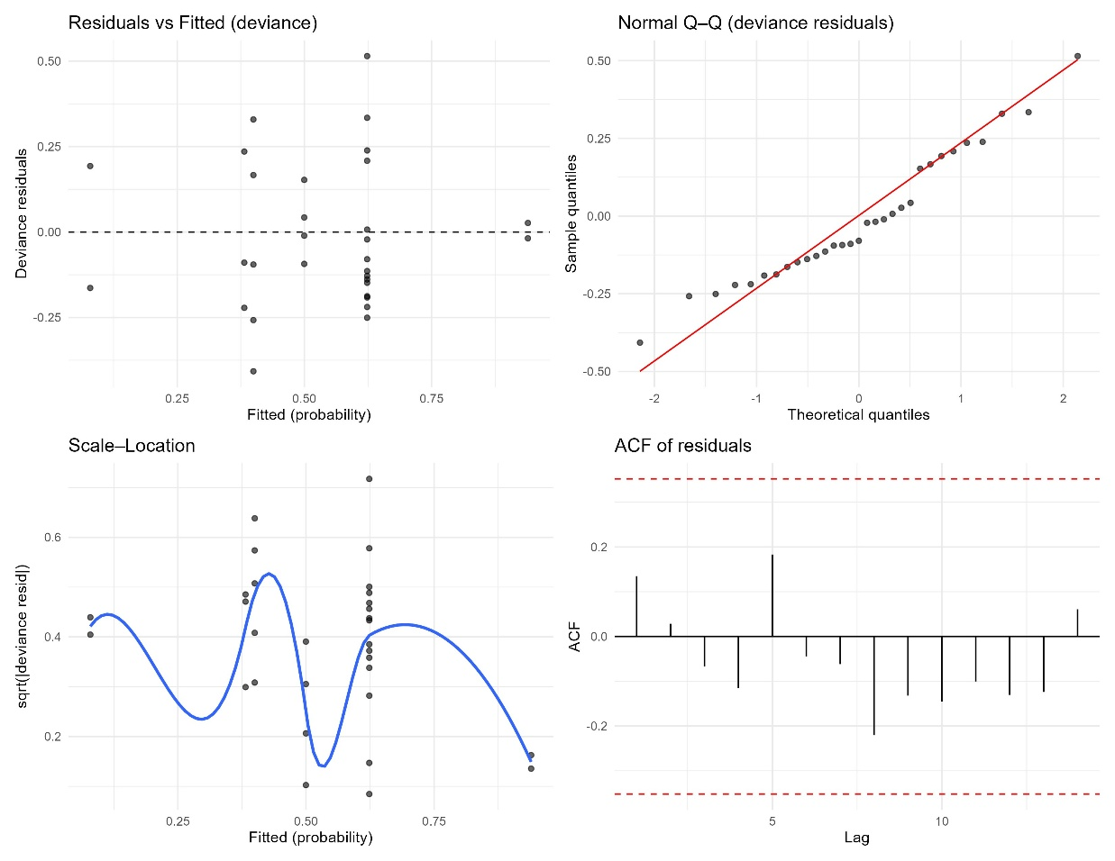
Figure S2. Diagnostic plots for the Generalized Additive Mixed Model (GAMM) predicting Spodoptera frugiperda infestation as a function of fractal dimension, contagion, edge density, and forest proportion.

Table S1. Results of the generalized additive mixed model testing the effects of landscape structure on maize infestation by Spodoptera frugiperda (binomial family, logit link).
Predictor (smooth term) | edf | Ref.df | F-value | p-value
s(FD) (Fractal dimension) | 1 | 1 | 5.127 | 0.032
s(FP) (Forest proportion) | 1.777 | 1.777 | 25.602 | < 0.001
s(ED) (Edge density) | 1 | 1 | 17.09 | < 0.001
s(CONTAG) (Contagion) | 1 | 1 | 11.978 | 0.002
Model details: Intercept = 0.071 (SE = 0.124, p = 0.572); Adjusted R² = 0.729; n = 31.
edf : estimated degree of freedom ; Rdf : reference degree of freedom

Table S2. Results of the distance-based redundancy analysis showing the significance of the global model and individual landscape predictors of maize infestation by FAW and stemborers.
Predictor | Df | Sum of squares | F-value | p-value
Edge density | 1 | 0.00017 | 0.010 | 0.970
Forest proportion | 1 | 0.06540 | 3.782 | 0.060
Fractal dimension | 1 | 0.60367 | 34.906 | 0.001
Contagion | 1 | 0.12139 | 7.019 | 0.017
Model | 4 | 0.79063 | 11.429 | 0.001
Residual | 26 | 0.44965

Table S3. Association of FAW and stemborers with landscape fractal dimension based on dbRDA scores. Positive scores indicate increasing association with greater landscape complexity, while negative scores reflect reduced affinity.
Species | dbRDA1 score | Association with fractal dimension
Spodoptera frugiperda (FAW) | 0.672 | Positive
Stemborers (B. fusca and S. calamistis) | -0.538 | Negative
Inertia partitioning (total = 1.2403; constrained = 0.7906 [63.8%]; Unconstrained = 0.4497 [36.2%])

