Supplementary Methodology
Radionuclide Analysis
Sediment activities of ⁷Be were measured using five Canberra low-energy germanium detectors (Canberra/Mirion Technologies, Meriden. CT, USA). Detection efficiency for each detector at the ⁷Be 477 KeV peak was interpolated using a calibration curve generated from IAEA reference materials RGU-1 and IAEA 135. Each sample was counted for 24h within one half-life of ⁷Be from the date of collection, and activities were decay-corrected to the date of sample collection.
To sample suspended sediment carried by the river and the oceanic plume, a series of polypropylene filters (2.25 cm outside diameter, hollow 2.5 cm internal diameter, 25 cm length, McMaster-Carr Supply Co., Atlanta, GA US) that were placed in a three-filter manifold in decreasing particle removal diameter of 100, 10, and 1 µm. Water was then pumped through by an electric high-capacity submersible pump. Before collecting, the filters were weighed while dry and clean. The pump was suspended about ~3 m below the water surface for the river samples collected in Baton Rouge and suspended at the surface of the water column by a buoy for the oceanic river-plume sample. Approximately 300-400 l of water was pumped through filters until flow ceased. The sediment-laden filters were then dried slowly over a 48-hr period and weighed again to determine the total mass of the sediment collected. Filters were then combusted individually in a furnace for 3 h at 425ºC. Ash from each filter was then weighed individually; all ash from each filtration event was then homogenized and placed into a container for ⁷Be analysis as described above
Detection limits for ⁷Be for each detector were determined from the calculated activity of 25 detector counts in 24 h (the count rate at which uncertainty exceeds measured activity for our detectors), after Sommerfield et al. 1999, which yields an average detection limit of 0.26 dpm g⁻¹. A typical sediment-surface activity of 4 dpm g⁻¹ decays to 0.26 dpm g⁻¹ in ~four half-lives. Any station with activity is below this limit and is displayed as ND (not detectable) on figures.
Sediment Load Calculations
$2024-25 Fines Load= -1.24e^{5}+\left(6.458e^{-1}\left(cfs\right)\right)+(-2.27e^{-7}*\left(cfs*cfs\right))$ SE 1
$2022-25 Fines Load= -1.516e^{5}+\left(8.125e^{-1}*\left(cfs\right)\right)+(-3.166e^{-7}\left(cfs*cfs\right))$ SE 2
Supplementary Table 1. Location, water depth, and ⁷Be data for stations located in the NE region.
Station Name | Latitude | Longitude | Water Depth (m) | Inventory (dpm cm^-2) | SDR (g cm^-2*day) | Surface Activity (dpm g^-1) | Mean Surface Grain Size (phi)
NB25_01BPC | 29.60 | -89.60 | 2.4 | 0 | 0 | 0 | 3.44
NB25_02PC | 29.55 | -89.60 | 2.8 | 0.54 | 012 | 0.24 | 4.14
NB25_03PC | 29.50 | -89.60 | 2.9 | 0 | 0 | 0 | 4.89
NB25_127PC | 29.59 | -89.30 | 4.1 | 3.11 | 071 | 1.46 | 4.95
NB25_128BPC | 29.55 | -89.30 | 4.6 | 0 | 0 | 0 | 4.51
NB25_129PC | 29.50 | -89.30 | 4.9 | 0 | 0 | 0 | 5.65
NB25_130PC | 29.45 | -89.30 | 5.6 | 0 | 0 | 0 | 6.66
NB25_43PC | 29.60 | -89.50 | 3.2 | 0 | 0 | 0 | 3.88
NB25_44PC | 29.55 | -89.50 | 3.3 | 0.25 | 006 | 0.10 | 5.16
NB25_45PC | 29.50 | -89.50 | 3.4 | 0 | 0 | 0 | 4.69
NB25_46PC | 29.45 | -89.50 | 2.7 | 0 | 0 | 0 | -
NB25_47PC | 29.43 | -89.47 | 1.9 | 0 | 0 | 0 | 4.89
NB25_85BPC | 29.60 | -89.40 | 4 | 0 | 0 | 0 | 5.18
NB25_86PC | 29.55 | -89.40 | 4.4 | 0 | 0 | 0 | 6.19
NB25_87PC | 29.50 | -89.40 | 4.3 | 0 | 0 | 0 | 6.64
NB25_88PC | 29.47 | -89.40 | 3.5 | 0 | 0 | 0 | 3.38
NB25_89BPC | 29.40 | -89.40 | 1.9 | 5.81 | 094 | 1.34 | 5.45
PS25_18-110MC | 29.43 | -89.28 | 7 | 5.92 | 0.0134 | 1.87 | 6.86
PS25_18-15MC | 29.40 | -89.20 | 7 | 6.41 | 0.0145 | 3.83 | 5.50
PS25_18-23MC | 29.40 | -89.10 | 7 | 0 | 0 | 0 | 2.28
PS25_18-25MC | 29.30 | -89.10 | 5.5 | 6.21 | 0.0141 | 1.18 | 7.36
PS25_18-29BMC | 29.45 | -89.00 | 12 | 2.04 | 046 | 0.46 | 7.49
PS25_18-35MC | 29.45 | -88.90 | 15.03 | 0 | 0 | 0 | 2.49
PS25_18-36MC | 29.35 | -88.90 | 24.28 | 0 | 0 | 0 | 3.58
PS25_18-95MC | 29.27 | -89.03 | 11.66 | 8.09 | 0.0183 | 4.39 | 3.93
PS25_18-97MC | 29.38 | -89.16 | 9.43 | 9.72 | 0.0220 | 5.48 | 6.47
PS25_18-98MC | 29.33 | -89.06 | 11.54 | 2.12 | 048 | 0.46 | 6.48
PS25_22-06MC | 29.56 | -89.21 | 5.5 | 2.68 | 061 | 1.28 | 5.09

Supplementary Table 2. Location, water depth, and ⁷Be data for stations located in the SE region.
Station Name | Latitude | Longitude | Water Depth (m) | Inventory (dpm cm^-2) | SDR (g cm^-2*day) | Surface Activity dpm g^-1 | Mean Surface Grain Size (phi)
PS25_18-107MC | 28.85 | -88.90 | 444.04 | 0.00 | 0.0000 | 0.00 | 6.93419
PS25_18-109MC | 29.05 | -88.70 | 203.18 | 1.10 | 0.0025 | 1.38 | 6.93222
PS25_18-18MC | 28.85 | -89.20 | 117 | 2.87 | 0.0065 | 0.34 | 5.30757
PS25_18-34MC | 28.85 | -89.00 | 250 | 0.00 | 0.0000 | 0.00 | 7.56789
PS25_18-42MC | 29.15 | -88.80 | 78.29 | 1.36 | 0.0031 | 1.27 | 6.16238
PS25_18-43MC | 29.05 | -88.80 | 161.77 | 0.00 | 0.0000 | 0.00 | 6.97234
PS25_18-45MC | 29.35 | -88.70 | 9.4 | 0.00 | 0.0000 | 0.00 | 7.1517
PS25_18-47MC | 29.25 | -88.60 | 70.73 | 0.00 | 0.0000 | 0.00 | 7.42794
PS25_18-48BMC | 29.15 | -88.60 | 105 | 0.00 | 0.0000 | 0.00 | 7.16187
PS25_18-53MC | 28.80 | -89.09 | 254.54 | 0.00 | 0.0000 | 0.00 | 6.90301
PS25_18-57MC | 29.23 | -88.94 | 31.58 | 2.05 | 0.0046 | 1.50 | 7.16163
PS25_18-59MC | 29.23 | -88.74 | 68.72 | 0.51 | 0.0012 | 0.33 | 6.44592
PS25_18-63BMC | 28.97 | -89.12 | 20.78 | 14.68 | 0.0333 | 6.40 | 6.50421
PS25_18-72DMC | 29.03 | -88.91 | 106.12 | 3.12 | 0.0071 | 2.71 | 3.10584
PS25_18-75MC | 28.93 | -88.95 | 166.2 | 1.43 | 0.0032 | 1.91 | 7.33758
PS25_18-77MC | 28.99 | -89.00 | 79.61 | 0.00 | 0.0000 | 0.00 | 7.90258
PS25_18-87MC | 28.88 | -89.14 | 95.06 | 0.00 | 0.0000 | 0.00 | 7.22487
PS25_18-88MC | 29.00 | -89.22 | -7.5 | 4.73 | 0.0107 | 1.23 | 6.37774
PS25_18-100BMC | 29.20 | -88.92 | 34.55 | 2.52 | 0.0057 | 1.20 | 3.33638
PS25_18-99MC | 29.15 | -88.92 | 44.01 | 6.14 | 0.0139 | 3.57 | 3.41936
PS25_18-44MC | 28.95 | -88.80 | 298.27 | 0.00 | 0.0000 | 0.00 | 6.60825
PS25_18-16MC | 29.00 | -89.20 | -5 | 5.54 | 0.0126 | 0.93 | 4.36503

Supplementary Table 3. Location, water depth, and ⁷Be data for stations located in the W region.
Station Name | Latitude | Longitude | Water Depth (m) | Inventory (dpm cm^-2) | SDR (g cm^-2*day) | Surface Activity dpm g^-1 | Mean Surface Grain Size (phi)
PS25_18-01MC | 29.10 | -89.60 | 29.26 | 0 | 0 | 0 | 3.85
PS25_18-03MC | 29.00 | -89.70 | 43.15 | 2.67 | 061 | 2.95 | 6.29
PS25_18-07MC | 28.80 | -89.50 | 78.27 | 1.61 | 037 | 2.52 | 5.89
PS25_18-101MC | 28.78 | -89.33 | 106.12 | 1.36 | 031 | 1.01 | 6.63
PS25_18-102BMC | 29.03 | -89.45 | 9.82 | 1.77 | 040 | 2.80 | 7.46
PS25_18-103MC | 28.95 | -89.53 | 46.48 | 0 | 0 | 0 | 5.48
PS25_18-104MC | 28.70 | -89.60 | 96.84 | 0 | 0 | 0 | 5.98
PS25_18-105MC | 28.70 | -89.32 | 138.04 | 0 | 0 | 0 | 6.05
PS25_18-108MC | 28.80 | -89.71 | 65.03 | 2.00 | 045 | 3.19 | 6.76
PS25_18-49MC | 28.86 | -89.53 | 53.11 | 0 | 0 | 0 | 9.62
PS25_18-62MC | 28.96 | -89.28 | -23 | 3.84 | 087 | 4.00 | 5.25
PS25_18-73MC | 28.95 | -89.33 | -14.8 | 1.16 | 026 | 0.59 | 5.71
PS25_18-84MC | 28.88 | -89.40 | -35 | 4.54 | 0.0103 | 4.79 | 2.80
PS25_18-89CGC | 28.94 | -89.29 | -38.5 | 5.27 | 0.0120 | 2.01 | 7.04
PS25_18-90AGC | 28.94 | -89.29 | -38.5 | 0 | 0 | 0 | 7.40
PS25_22-02MC | 28.99 | -89.28 | -9.7 | 4.96 | 0.0112 | 2.74 | 5.76
PS25_22-04MC | 29.04 | -89.49 | 11.58 | 1.12 | 025 | 0.33 | 4.16
PS25_18-05MC | 28.80 | -89.70 | 74.31 | 1.19 | 027 | 1.37 | 7.55

Supplementary Figure 1
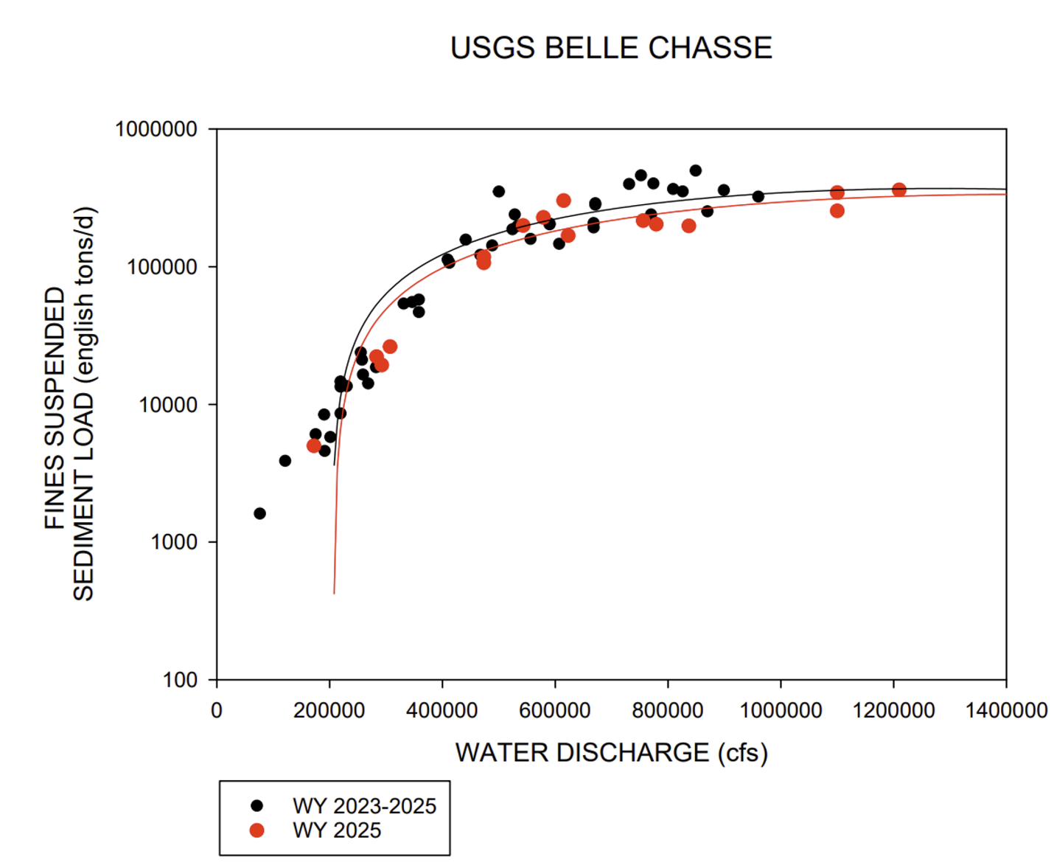
Supp. Fig. 1 Quadratic fit regressions used to calculated daily sediment load for the fines-only measurements for WY2025.

Supplementary Figure 2
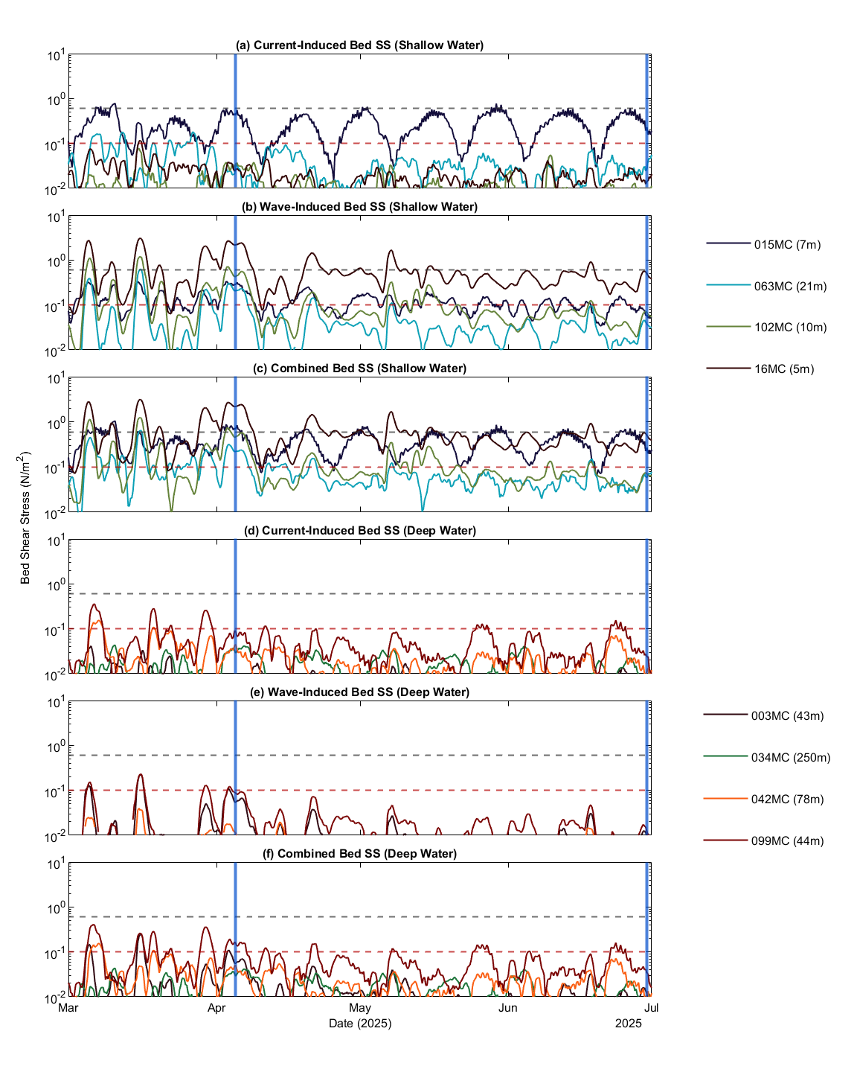
Supp. Fig. 2 a. Current-induced bed shear stress for stations located in shallow water (<40m) throughout the sampling period. b. Wave-induced bed shear stress for stations located in shallow water throughout the sampling period. c. Combined wave-current induced bed shear stress in shallow water stations. d. Current-induced bed shear stress for stations in deep water (>40m). e. Wave-induced bed shear stress in deep water stations. f. Combined wave-current induced bed shear stress in deep water stations. The red dashed line denotes 0.1 Pa and the grey dashed line denotes 0.6 Pa. The blue lines denote the time periods used to model the high and low-energy periods in Figure 4.
Supplementary Figure 3
Supp. Fig. 3 a. Satellite imagery of the plume at peak river discharge. b. Satellite imagery of the plume at lowest river discharge. C. Plume during high energy period determined from modelled bed shear stresses in SF 2. d. Imagery of the plume during period of low energy determined from modelled bed shear stresses in SF 2. Imagery sourced from the MODIS satellite imagery provided by the LSU Earth Scan Laboratory.

