Supplementary Materials for “Uncertainty Mindset Intervention Promotes Uncertainty-as-enabling Beliefs and Modulates Directed Exploration”

Data and code availability
All the data, code, and additional materials of this study are available at Open Science Framework and can be accessed via OSF.

Model Selection and Evaluation Procedure for Cognitive Flexibility Scores
Before proceeding with the final scoring and reasoning using the GPT-4o model, several large language models (LLMs) were systematically tested and compared. A sample of 118 ideas was evaluated using GPT-4o, while a smaller sample of 67 ideas was used for the remaining models to reduce computational time and cost. The following models were included in the comparison: GPT-4o, GPT-4o-mini, GPT-5-mini, GPT-5-mini (with seed), GPT-5-nano, and GPT-5-nano (with seed).

Although the underlying model behavior does not fundamentally change when a seed parameter is specified, the seeded versions were included in the trial because they allow reproducible randomness, which is useful for experimental consistency and validation. All models were evaluated using identical prompts to ensure comparability across conditions.

Each model was asked to assign scores to four dimensions: novelty, usefulness, feasibility, and elaboration and to provide a one-sentence rationale justifying each score. The overall creativity scores were calculated later by hand. The outputs were compiled into a master spreadsheet that enabled side-by-side comparison of model responses across ideas and evaluation dimensions.

Upon careful inspection of the model outputs, GPT-4o demonstrated the highest level of internal consistency. Conceptually similar ideas tended to receive the same or highly comparable ratings, indicating stable evaluation criteria. In contrast, GPT-5 models occasionally produced ratings that appeared inconsistent with the intended scoring framework. For example, the idea “art” was assigned a score of 3 on elaboration, despite limited descriptive detail, suggesting less reliable calibration of the scoring scale.

GPT-4o is optimized for natural language evaluation, human-like explanation, and nuanced judgment, which are central to the present task. In addition to producing clearer distinctions between scoring categories, GPT-4o demonstrated more appropriate use of the full ordinal scale, whereas smaller or more cost-efficient models sometimes exhibited inconsistent criteria or unstable decision boundaries. Furthermore, GPT-4o showed stronger performance in interpreting ambiguous or underspecified responses, a common characteristic of open-ended creativity tasks.

The GPT-5 models are primarily designed as reasoning-oriented systems, making them particularly well suited for structured tasks such as mathematical problem solving, logical reasoning, and formal analysis. However, the current study focuses on human judgment simulation, which requires qualitative evaluation, interpretive reasoning, and consistent application of subjective criteria. As a result, these reasoning-optimized models were not as well aligned with the demands of the task.

An additional practical consideration was that GPT-5 models do not allow adjustment of the temperature parameter, which limits the ability to conduct controlled experimentation on response variability. In contrast, GPT-4o supports such parameter tuning, enabling more flexible methodological testing when needed.

Although GPT-4o-mini produced results broadly similar to GPT-4o, its responses occasionally contained weaker repetition patterns and slightly less nuanced rationales. Considering overall consistency, interpretive reliability, and clarity of justification, GPT-4o was selected as the final model for evaluation in the study.

Ocsai Comparison with Novelty Scores
Ocsai https://openscoring.du.edu/scoringllm uses deep neural network-based LLMs on human evaluated Alternate Uses Task (AUT) responses (134). To test robustness of novelty evaluations of ideas generated by participants (5,266 ideas in total) in the current study using an automated evaluation framework blind to experimental conditions using GPT-4o, we additionally used Ocsai to evaluate individual ideas. We compared novelty scores and Ocsai-originality scores (weighted and unweighted), representing the identical construct.
- We applied z-score standardization for every column (since the ranges are different). Z-scoring does not change the distributions, it only changes the ranges.
- We calculated Pearson Correlation, Spearman Correlation and Intraclass Correlation Coefficient (ICC) for the score comparison.

Table S1
Comparison between two different scoring systems (novelty scores and ocsai originality) of the same concept.
Comparison | ICC(2,1) Single random raters | ICC(2,k) Average random raters | Pearson r  Correlation | Spearman ρ  Correlation
1) Novelty - Weighted originality | 0.77 | 0.87 | 0.77 | 0.79
2) Novelty - Unweighted originality | 0.76 | 0.86 | 0.76 | 0.77
3) Weighted - Unweighted originality | — | — | 0.98 | 0.98
Note. 1) Good agreement; averaging yields excellent reliability. Strong linear & rank correlation. 2) Good agreement; excellent reliability when averaged. Strong correlation, similar to above. 3) Perfect agreement; essentially duplicates. ICC (Intraclass Correlation Coefficient: Measures inter-rater reliability).

Detailed ICC calculation
Novelty vs Weighted originality. ICC1 (0.769): If each idea were rated by only one rater (chosen randomly), reliability is about 0.77. ICC2 (0.769): If raters are considered a random sample from a larger pool, the reliability generalizes to other raters and remains about 0.77. ICC3 (0.769): If you only care about these exact raters (fixed set), reliability is about 0.77. ICC1k (0.869): Averaging across your raters substantially increases reliability to about 0.87. ICC2k (0.869): Generalizable average reliability across any random raters is also about 0.87. ICC3k (0.869): If you only care about your specific raters, the average rating reliability is again about 0.87. Conclusion: For novelty vs weighted originality, single-rater reliability is strong (0.77), and aggregated reliability is excellent (0.87).
Novelty vs Unweighted originality. ICC1 (0.759): If each idea were rated by one random rater, reliability is about 0.76. ICC2 (0.759): Generalizable single-rater reliability across a random pool is also about 0.76. ICC3 (0.759): For your fixed set of raters, reliability remains 0.76. ICC1k (0.863): Averaging across raters boosts reliability to about 0.86. ICC2k (0.863): Generalizable average reliability across any random raters is again about 0.86. ICC3k (0.863): For your specific raters, average reliability is about 0.86. Conclusion: For novelty vs unweighted originality, single-rater reliability is slightly lower (0.76), and aggregated reliability is excellent (0.86).
Prompts coding methodology for reflection open-text responses
CATEGORIES = [
"Career/Jobs",
"Relationships",
"Health",
"Finances",
"Education/Academic",
"Legal/Bureaucracy",
"Moving/Relocation/Travel",
"Environment/Disaster",
"Public Health/COVID",
"Parenting/Family Responsibilities",
"Unclassified/Other",
]
CATEGORY_DEFS = """
Name\tDescription
Career/Jobs\tWork, employment status, layoffs, promotions, firm volatility, hiring/firing decisions.
Relationships\tRomantic, family, or friendship dynamics; intentions/commitments of others.
Health\tPersonal or loved one’s health status, diagnosis, treatment outcomes.
Finances\tPersonal money matters: debt, bills, investments, income stability.
Education/Academic\tAdmissions, grades, thesis, school policies.
Legal/Bureaucracy\tVisas, permits, court cases, insurance claims, institutional decisions.
Moving/Relocation/Travel\tRelocations, moving, trips.
Environment/Disaster\tNatural hazards (wildfire, flood), weather extremes, public-safety alerts.
Public Health/COVID\tPopulation-level disease threats (e.g., COVID-19), mandates, community risk.
Parenting/Family Responsibilities\tChildcare, elder care, custody, schooling for kids, unwanted pregnancy.
Unclassified/Other\tDoesn’t fit elsewhere or too broad/unclear to classify.
""".strip()
SYSTEM_PROMPT = (
"You are a careful, consistent first-coder of open-ended survey responses in a psychology study. "
"Your job is multi-label coding of the respondent's SITUATION paragraph into the provided categories. "
"Output ONLY a valid JSON object (no preface or extra text). "
"Rules:\n"
"• Assign 1 if the category is present; 0 otherwise. Multiple 1s are allowed.\n"
"• 'Unclassified/Other' is EXCLUSIVE: set it to 1 ONLY if ALL other categories are 0; otherwise set it to 0.\n"
"• Base your judgment solely on the text. Be conservative with inference; rely on explicit or strongly implied cues.\n"
"• Ignore the 'appraisal' portion unless it clarifies the situation’s domain.\n"
"• Keep 'notes' under 30 words.\n"
)
USER_TEMPLATE = """You will code the following survey response to the question:
"Now, we want you to reflect on your own life. Please think about a recent situation in which you experienced uncertainty and write a short paragraph where you (1) briefly describe this situation and (2) describe how you can appraise the uncertainty inherent in this situation based on what your learned in the video."
CATEGORIES (binary; 1=present, 0=absent). 'Unclassified/Other' must be 1 only if all others are 0:
{category_table}
TARGET RESPONSE (free text):
{response_text}
Return JSON with this shape:
{{
"response": str,
"codes": {{
"Career/Jobs": 0|1,
"Relationships": 0|1,
"Health": 0|1,
"Finances": 0|1,
"Education/Academic": 0|1,
"Legal/Bureaucracy": 0|1,
"Moving/Relocation/Travel": 0|1,
"Environment/Disaster": 0|1,
"Public Health/COVID": 0|1,
"Parenting/Family Responsibilities": 0|1,
"Unclassified/Other": 0|1
}},
"notes": str # <=30 words on why the chosen categories apply
}}
EXAMPLES (for style/format only):
EXAMPLE A (multi-label):
Text: "I moved states without a job lined up, applied everywhere, worried about paying bills, then landed a role."
Codes: Career/Jobs=1; Finances=1; Moving/Relocation/Travel=1; all others=0; Unclassified/Other=0
EXAMPLE B (single label):
Text: "My partner and I were unsure whether to stay together."
Codes: Relationships=1; all others=0; Unclassified/Other=0

EXAMPLE C (use 'Unclassified/Other'):
Text: "I just felt uncertain about life without a specific reason."
Codes: all specific categories=0; Unclassified/Other=1
"""

Supplemental Results
Fixed Effects Coefficients and Model Comparison

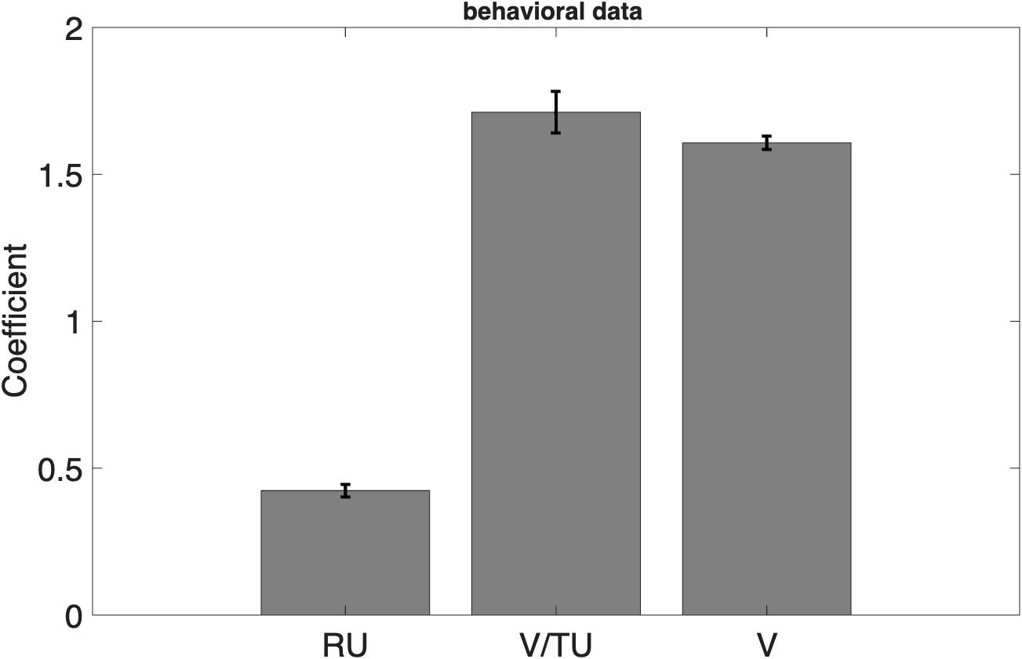
Fig. S1. Fixed Effects Coefficients of Different Exploration Strategies (N = 862).
Note. Bars represent 95% CI.

Table S2
Model Comparison
Model | Predictor | AIC | BIC | LL | Deviance
N = 862
Undirected exploration | V | 1.1848e+05 | 1.185e+05 | -59239 | 1.1848e+05
Directed exploration | V + RU | 1.0776e+05 | 1.0781e+05 | -53877 | 1.0775e+05
Random exploration | V/TU | 1.5413e+05 | 1.5415e+05 | -77063 | 1.5413e+05
Hybrid* | V + RU + V/TU | 1.0516e+05 | 1.0525e+05 | -52570 | 1.0514e+05
Note. AIC = Akaike Information Criterion; BIC = Bayesian Information Criterion; LL = Log likelihood. Lower model metrics suggest better model fit. * model with the best fit.

Cognitive Flexibility Predicting Exploration Strategies
Modelling the effects of cognitive flexibility dimensions on exploration strategies
This is analogous to equation (6), this time entering cognitive flexibility factors CogFlex. In Wilkinson notation modelled as: Choice ~ V + RU + V/TU + V:CogFlex + RU:CogFlex + V/TU:CogFlex + CogFlex + (V + RU+V/TU|SubjectID).

As shown in supplementary Table S3 and Fig. S3, categories used positively correlated with directed exploration (t(137,920) = 2.287, P = 0.022, β = 0.073, s.e.m. = 0.032). Moreover, elaboration positively correlated with random exploration t(137,920) = 2.002, P = 0.043, β = 0.164, s.e.m. = 0.081). Fluency negatively correlated with undirected exploration t(137,920) = -2.467, P = 0.014, β = -0.082, s.e.m. = 0.033).

Table S3
Interactions between Cognitive Flexibility Factors and Exploration Strategies
Cognitive Flexibility Factor | RU:Factor |  |  |  | V/TU:Factor |  |  | V:Factor
 | β(s.e.m.) |  | t | p | β(s.e.m.) | t | p | β(s.e.m.) | t | p
N = 862
Novelty | -0.007(0.029) | -0.234 |  | 0.815 | -0.140 (0.094) | -1.483 | 0.138 | 0.052(0.031) | 1.666 | 0.096
Usefulness | -0.014(0.026) | -0.526 |  | 0.599 | -0.061 (0.086) | -0.713 | 0.476 | -0.043(0.029) | -1.508 | 0.131
Elaboration | 0.024(0.025) | 0.952 |  | 0.341 | 0.164(0.081) | 2.022 | 0.043* | 0.023(0.027) | 0.859 | 0.390
Categories | 0.073(0.032) | 2.287 |  | 0.022* | 0.196(0.103) | 1.907 | 0.057 | 0.053(0.034) | 1.538 | 0.124
Fluency | -0.029(0.031) | -0.950 |  | 0.342 | -0.079(0.099) | -0.797 | 0.425 | -0.082(0.033) | -2.467 | 0.014*
Note. Cognitive flexibility factors were standardized before being added to the same model. A positive RU:Factor indicates increased directed exploration, a positive V/TU:Factor indicates increased random exploration, and a positive V:Factor indicates decreased undirected exploration. Additionally, age and gender were entered into the model. *P < 0.05

Table S4
Distribution of Thematic Categories in Open-Text Responses
Category | N | %
Career/Jobs | 241 | 57%
Education/Academic | 36 | 9%
Environment/Disaster | 5 | 1%
Finances | 79 | 19%
Health | 45 | 11%
Legal/Bureaucracy | 8 | 2%
Moving/Relocation/Travel | 78 | 19%
Parenting/FamilyResponsibilities | 25 | 6%
Public Health/COVID | 10 | 2%
Relationships | 91 | 22%
Unclassified/Other | 29 | 7%
Note. Percentages are based on the total number of responses (N = 421)

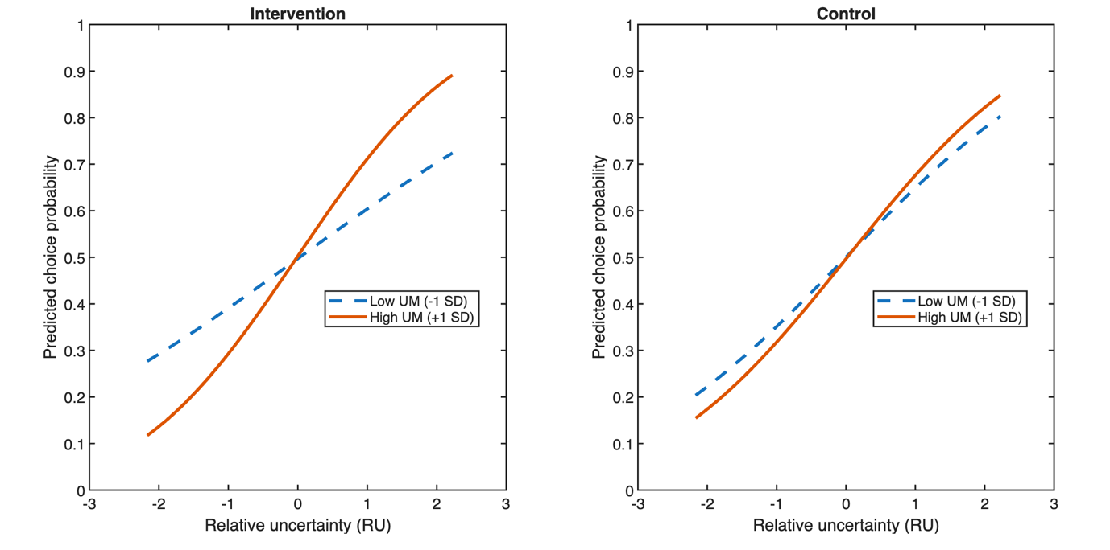
Fig. S2. Simple slopes of UM×RU in intervention group and control group, respectively (N = 862). UM levels binned into low (-1 SD; uncertainty-as-disabling) and high (+1 SD; uncertainty-as-enabling). Steeper slopes indicate a higher likelihood to choose the relatively more uncertain option (i.e., higher sensitivity to RU).

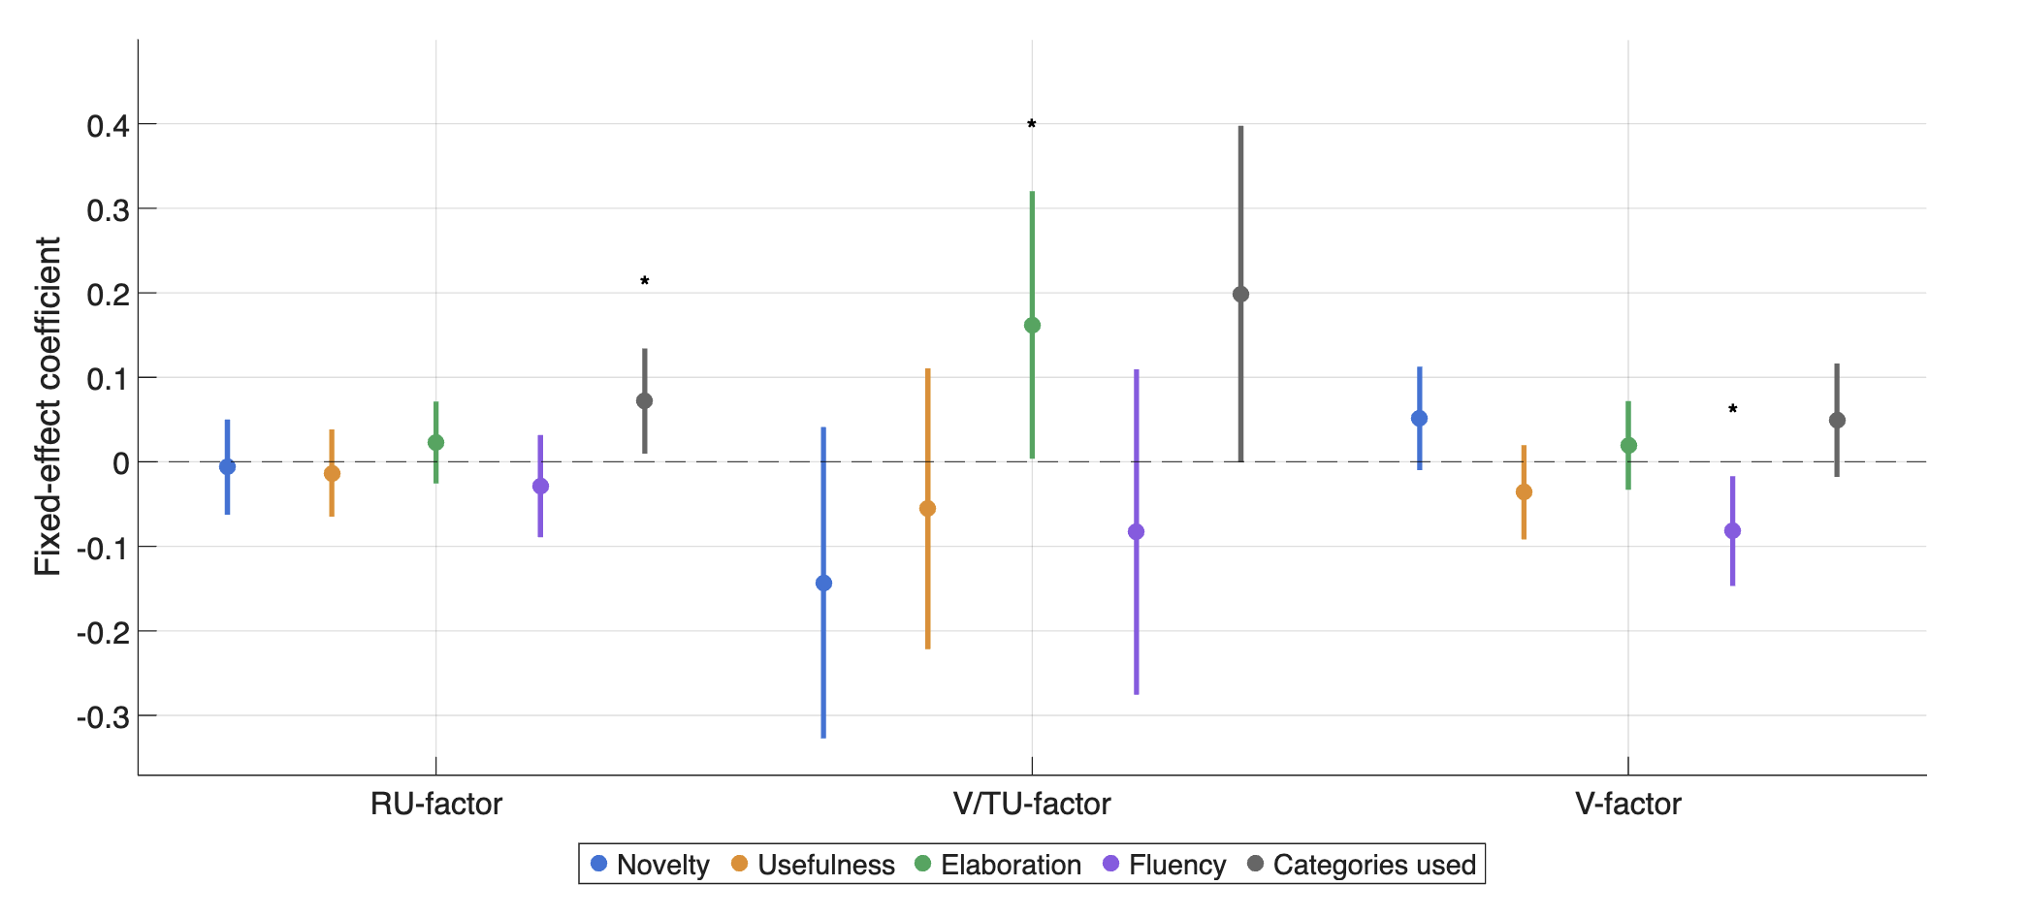
Fig. S3. Effects of cognitive flexibility factors on exploration strategies (N = 862). All factors were standardized. Dots show the fixed effect coefficients fit for each regressor using maximum likelihood estimation. Error bars indicate 95% confidence intervals. Age and gender were also included in the model. A positive coefficient for RU-factor and V/TU-factor signifies increased directed and random exploration, respectively. A positive coefficient for V-factor signifies reduced undirected exploration. Two-sided t-tests were conducted for significance assessment. Correction of family wise error rate was not applied. *P < 0.05, **P < 0.01, ***P < 0.001.

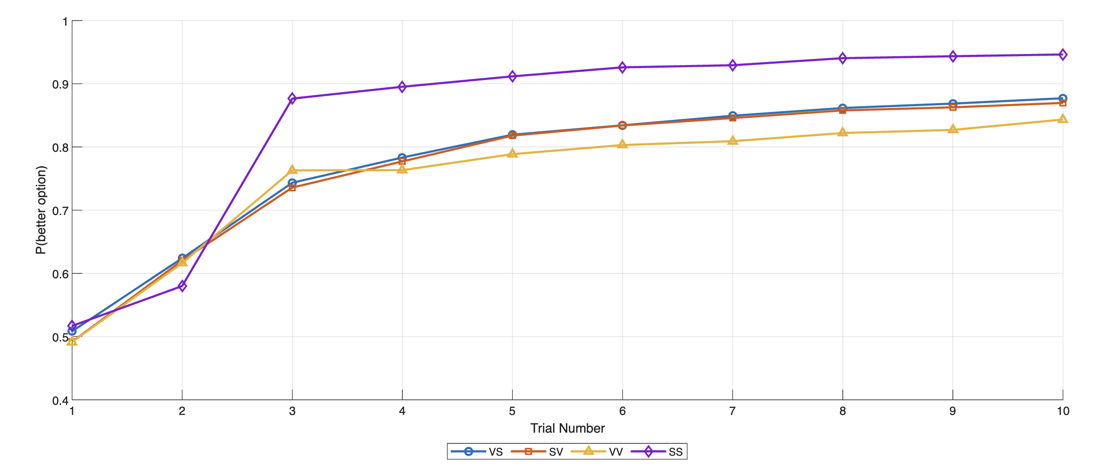
Fig. S4. Individuals’ performance across the different within-subjects conditions (N = 862). The better option reflects the option with the higher generative mean. Error bars show cross-subject SE.

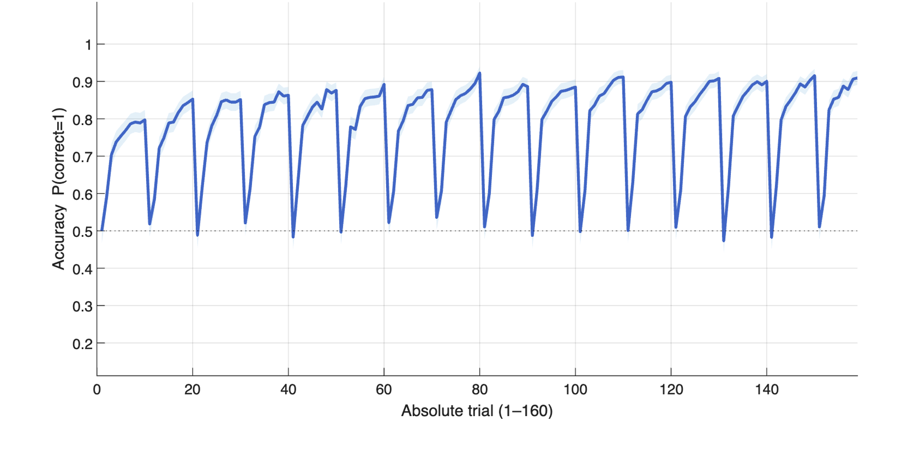
Fig. S5. Accuracy across all trials (N = 862). Mean ± within-subject 95% CI.

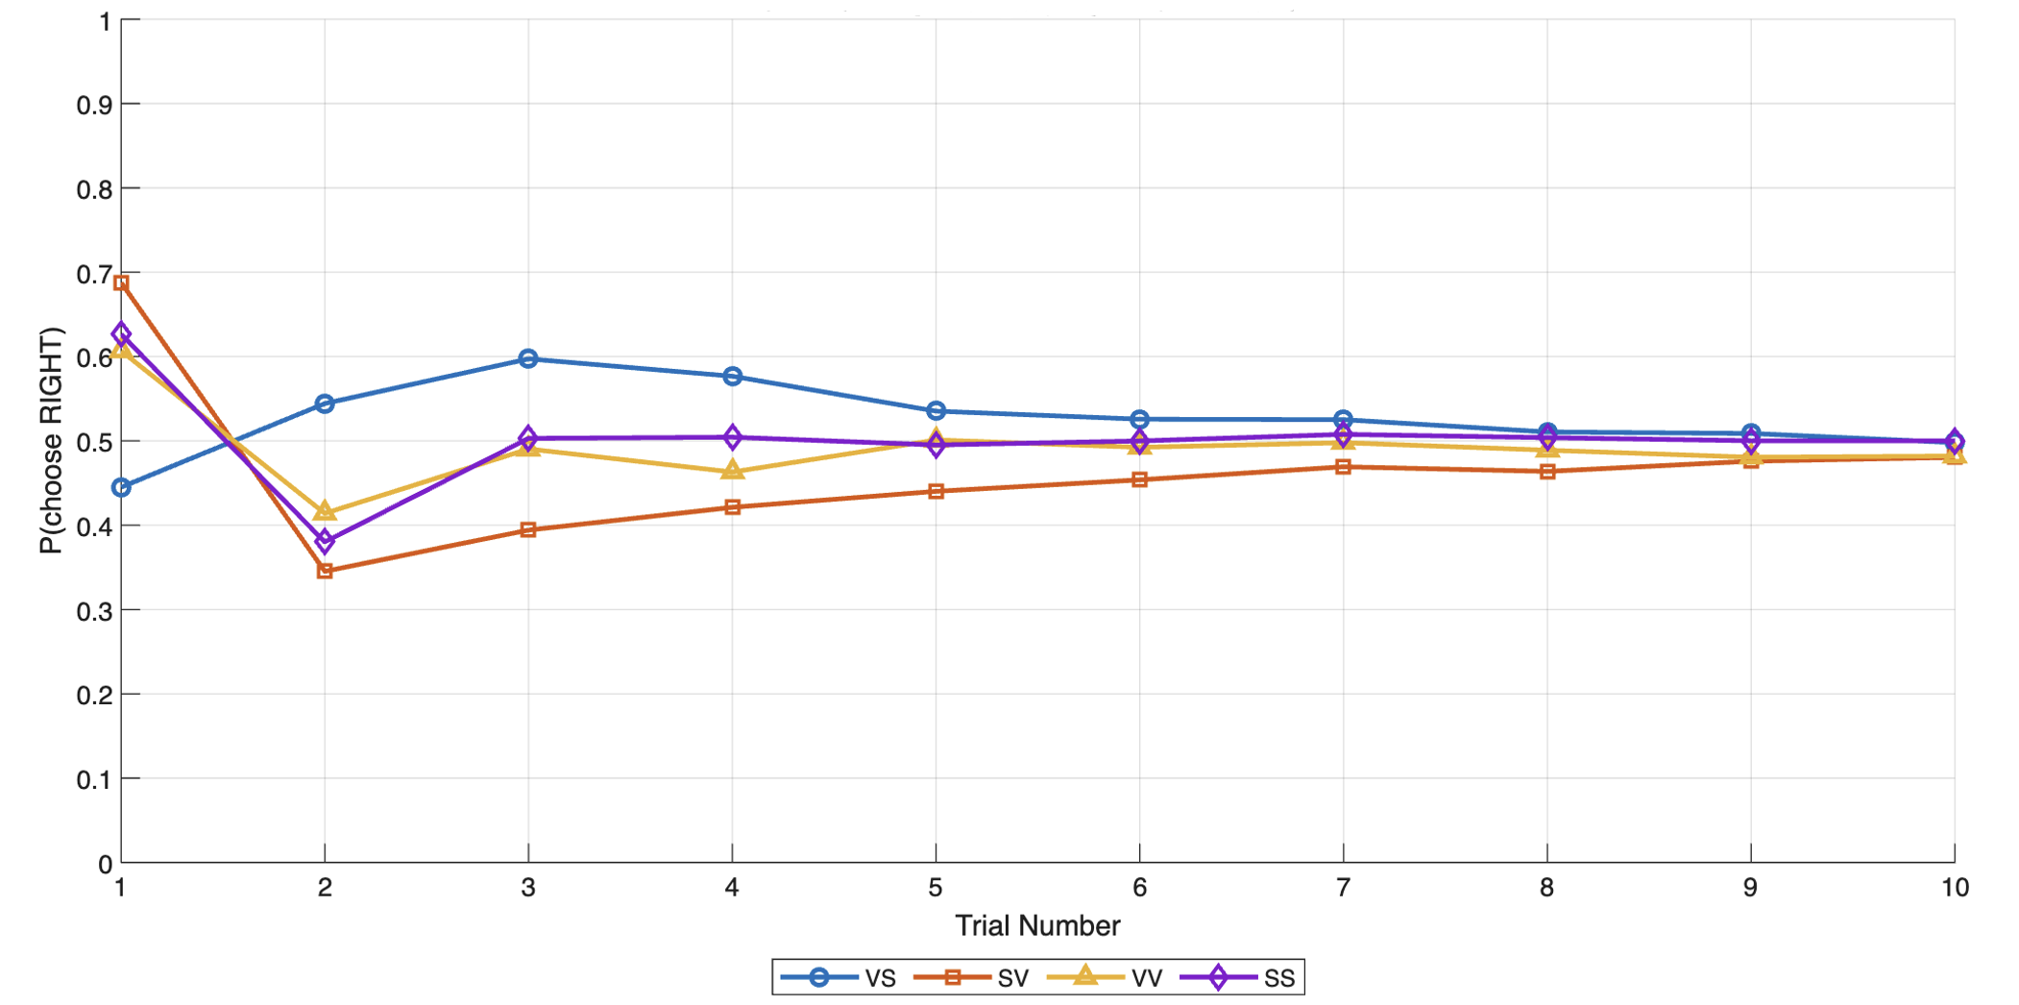
Fig. S6. Side bias (probability of choosing option on the right side) by trial and condition (N = 862).

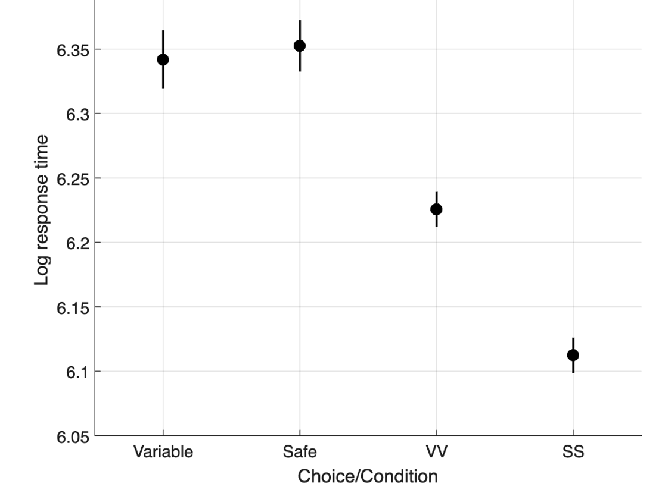
Fig. S7. Log response time (N = 862). Mean ± within-subject SE.

