Supplementary Material for: The Effects of Temperature on Preterm Births in Brazilian Regions and How Humidity Influence this Effects

This supplementary appendix presents the Brazilian study setting, regional distributions of daily mean temperature and relative humidity, candidate model specifications, model-performance indicators, and sensitivity analyses of the cumulative temperature–preterm birth associations.

Contents:

1. Study setting
2. Environmental exposure distributions
3. Candidate model specifications
4. Model performance and diagnostics
5. Root mean square error across candidate models and lag windows
6. Sensitivity analyses of cumulative temperature–preterm birth associations
6.1 North region
6.2 Northeast region
6.3 Midwest region
6.4 Southeast region
6.5 South region

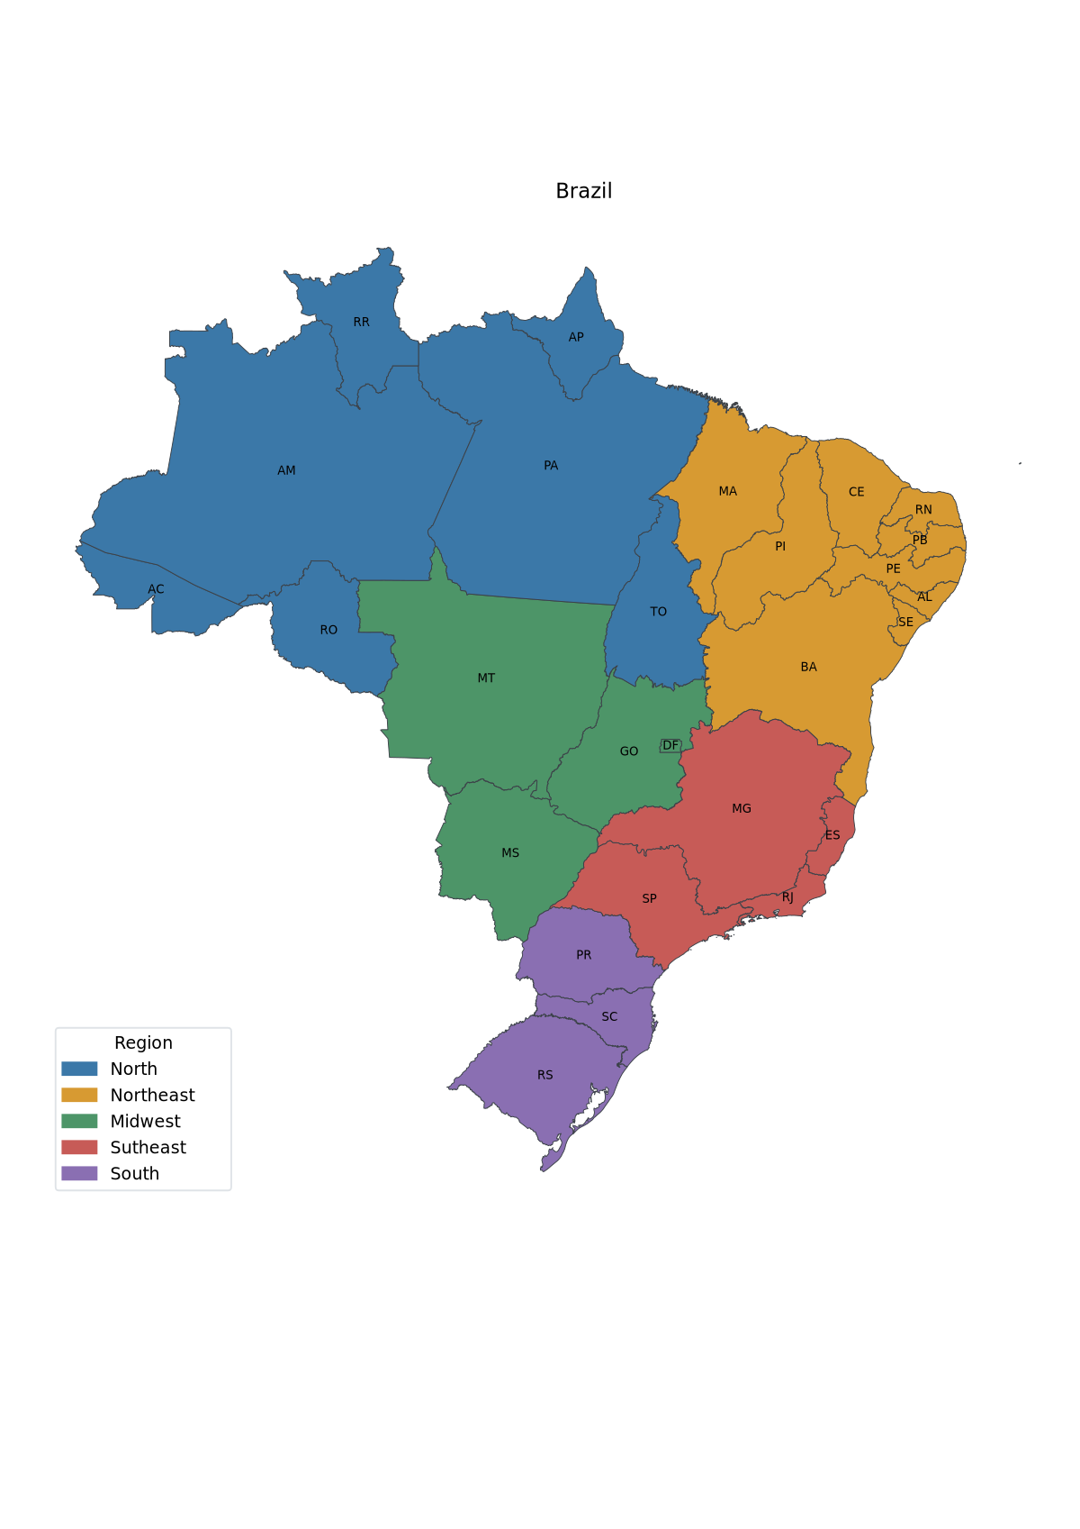
Figure S1. Study area and geographic regions of Brazil.

Note: The map shows the 26 Brazilian states and the Federal District (FU), grouped into the five official geographic regions: North, Northeast, Midwest, Southeast, and South. State boundaries and official abbreviations are displayed.

Figure S2-A. Distribution of daily mean temperature and relative humidity across Brazilian geographic regions.

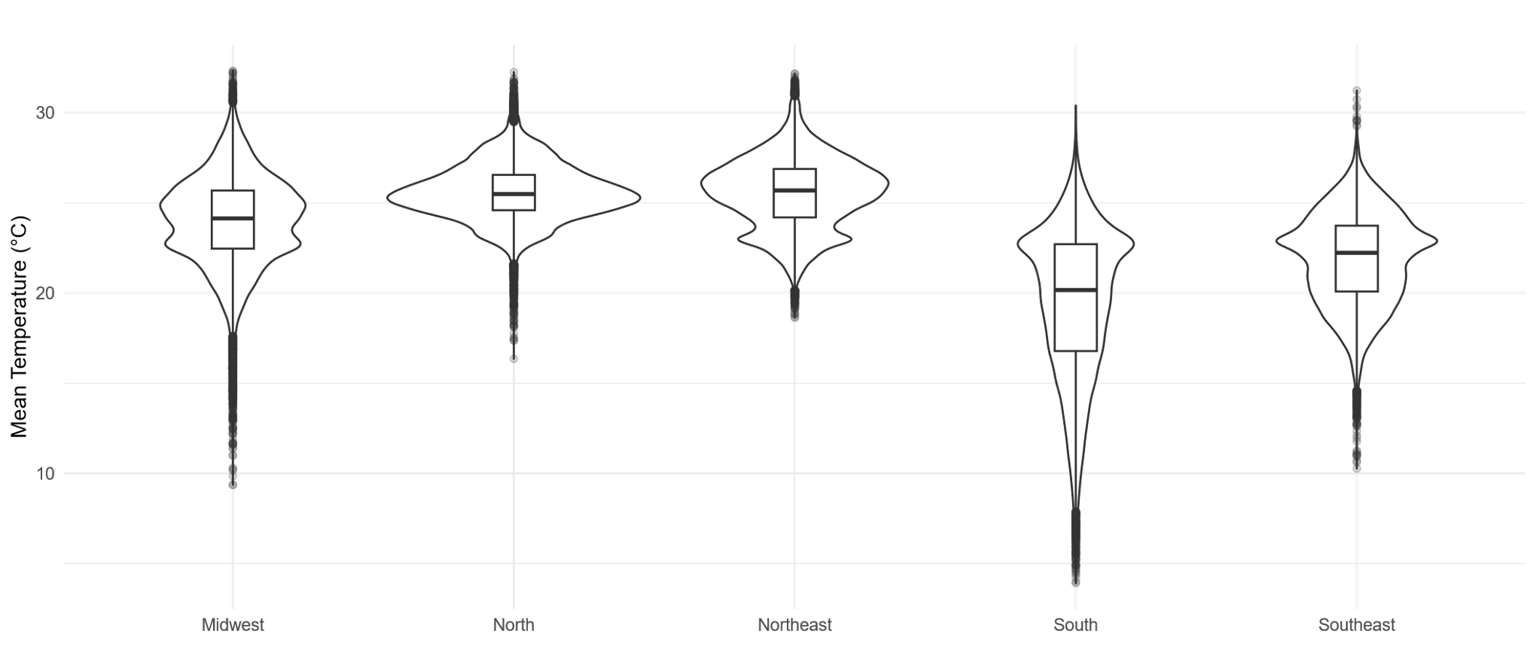

Note: Daily mean temperature in degrees Celsius. Violin plots represent the empirical distributions; internal boxplots show the median and interquartile range. Regions are displayed in the order used in the original plots.

Figure S2-B. Distribution of daily mean temperature and relative humidity across Brazilian geographic regions.

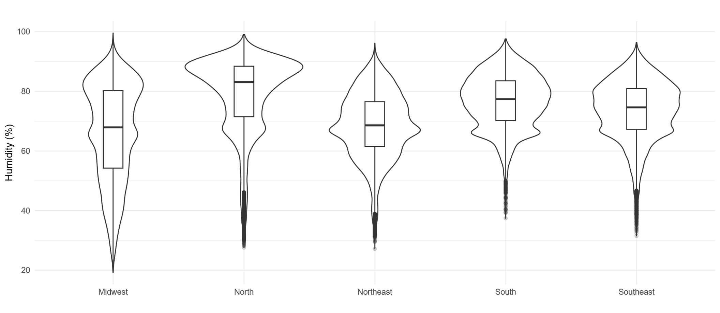

Note: Daily relative humidity in percent. Violin plots represent the empirical distributions; internal boxplots show the median and interquartile range. Regions are displayed in the order used in the original plots.

Table S1. Sequential candidate model specifications used in model development and sensitivity analyses.

Model | Adjustment set | Rationale
Model 0 | Y ~ cb_temp | Minimally adjusted model
Model 1 | Y ~ cb_temp + s(T4. k = 3) | Initial temporal adjustment
Model 2 | Y ~ cb_temp + s(T4. k = 30) | Flexible temporal adjustment
Model 3 | Y ~ cb_temp + s(T4. k = 30) + dow | Calendar adjustment
Model 4 | Y ~ cb_temp + s(T4. k = 30) + dow + s(hum. k= 5) | Environmental adjustment
Model 5 | Y ~ cb_temp + s(T4. k = 30) + dow + s(hum. k= 5) + S4 | Area adjustment
Model 5-I | Model 5 + ${UR.Ind}_{ft}$ | Continuous temperature humidity interaction;  UR.ind_{ft} corresponds to the regional P5, or P95

Note: Candidate models were fitted separately for each region and cumulative lag window. The adjustment set was expanded sequentially to evaluate the stability of the temperature–prematurity association.

Table S2. Performance indicators for adjusted models by Brazilian geographic region.

 |  | North |  |  | Northeast |  |  |  |  |  | Midwest |  |  |  |  |  | Southeast |  |  |  |  |  | South
 | Model | AIC | Deviance Explained | Dispersion φ | AIC |  | Deviance Explained |  | Dispersion φ |  | AIC |  | Deviance Explained |  | Dispersion φ |  | AIC |  | Deviance Explained |  | Dispersion φ |  | AIC |  | Deviance Explained |  | Dispersion φ
 | Model 0 | 269,665 | 0.01 | 1.00 | 403,302 | 0.01 |  | 0.94 |  | 171,063 |  | 0.01 |  | 0.97 |  | 220,739 |  | 0.02 |  | 1.01 |  | 145,586 |  | 0.01 |  | 0.99
 | Model 1 | 246,036 | 0.35 | 1.06 | 372,055 | 0.37 |  | 1.03 |  | 165,014 |  | 0.19 |  | 1.08 |  | 207,590 |  | 0.35 |  | 1.04 |  | 138,904 |  | 0.26 |  | 1.00
 | Model 2 | 236,628 | 0.47 | 1.06 | 357,635 | 0.50 |  | 1.09 |  | 162,335 |  | 0.25 |  | 1.08 |  | 201,054 |  | 0.48 |  | 1.03 |  | 136,619 |  | 0.33 |  | 1.00
 | Model 3 | 236,352 | 0.48 | 1.06 | 356,965 | 0.51 |  | 1.09 |  | 161,714 |  | 0.27 |  | 1.08 |  | 198,773 |  | 0.52 |  | 1.03 |  | 135,132 |  | 0.37 |  | 0.99
 | Model 4 | 236,311 | 0.48 | 1.06 | 356,655 | 0.51 |  | 1.09 |  | 161,636 |  | 0.27 |  | 1.08 |  | 198,451 |  | 0.53 |  | 1.03 |  | 135,044 |  | 0.38 |  | 0.99
Final Model | Model 5 | 233,989 | 0.50 | 1.02 | 353,963 | 0.53 |  | 1.06 |  | 157,981 |  | 0.35 |  | 1.05 |  | 194,684 |  | 0.58 |  | 1.01 |  | 132,298 |  | 0.45 |  | 0.99
Final Model | Model 5-I | 233,982 | 0.50 | 1.02 | 353,839 | 0.53 |  | 1.06 |  | 157,981 |  | 0.35 |  | 1.05 |  | 194,534 |  | 0.58 |  | 1.01 |  | 132,308 |  | 0.45 |  | 0.99

Note: The interaction model was alternatively centered at the region-specific 5th. and 95th percentiles of relative humidity to derive conditional exposure response curves. These parameterizations are algebraically equivalent and therefore have identical fitted values and model-performance statistics.

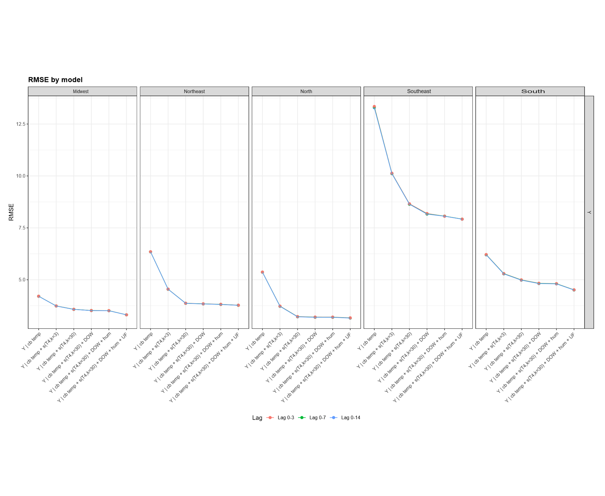
Figure S3. Root mean square error across candidate models and lag windows, by Brazilian geographic region.

Note: Please refer to table S1: M0 included only the temperature cross-basis; M1 added a temporal smooth with k = 3; M2 used k = 30; M3 additionally included day of the week; M4 included relative humidity; and M5 additionally adjusted for federative unit. Lower values indicate closer agreement between observed and fitted counts within each region. The lines by lag overlap, which is why we can only see the blue line for lags 0 to 14.
Figure S4. Sensitivity of the cumulative temperature–preterm birth association to model specification and lag window in the North region.
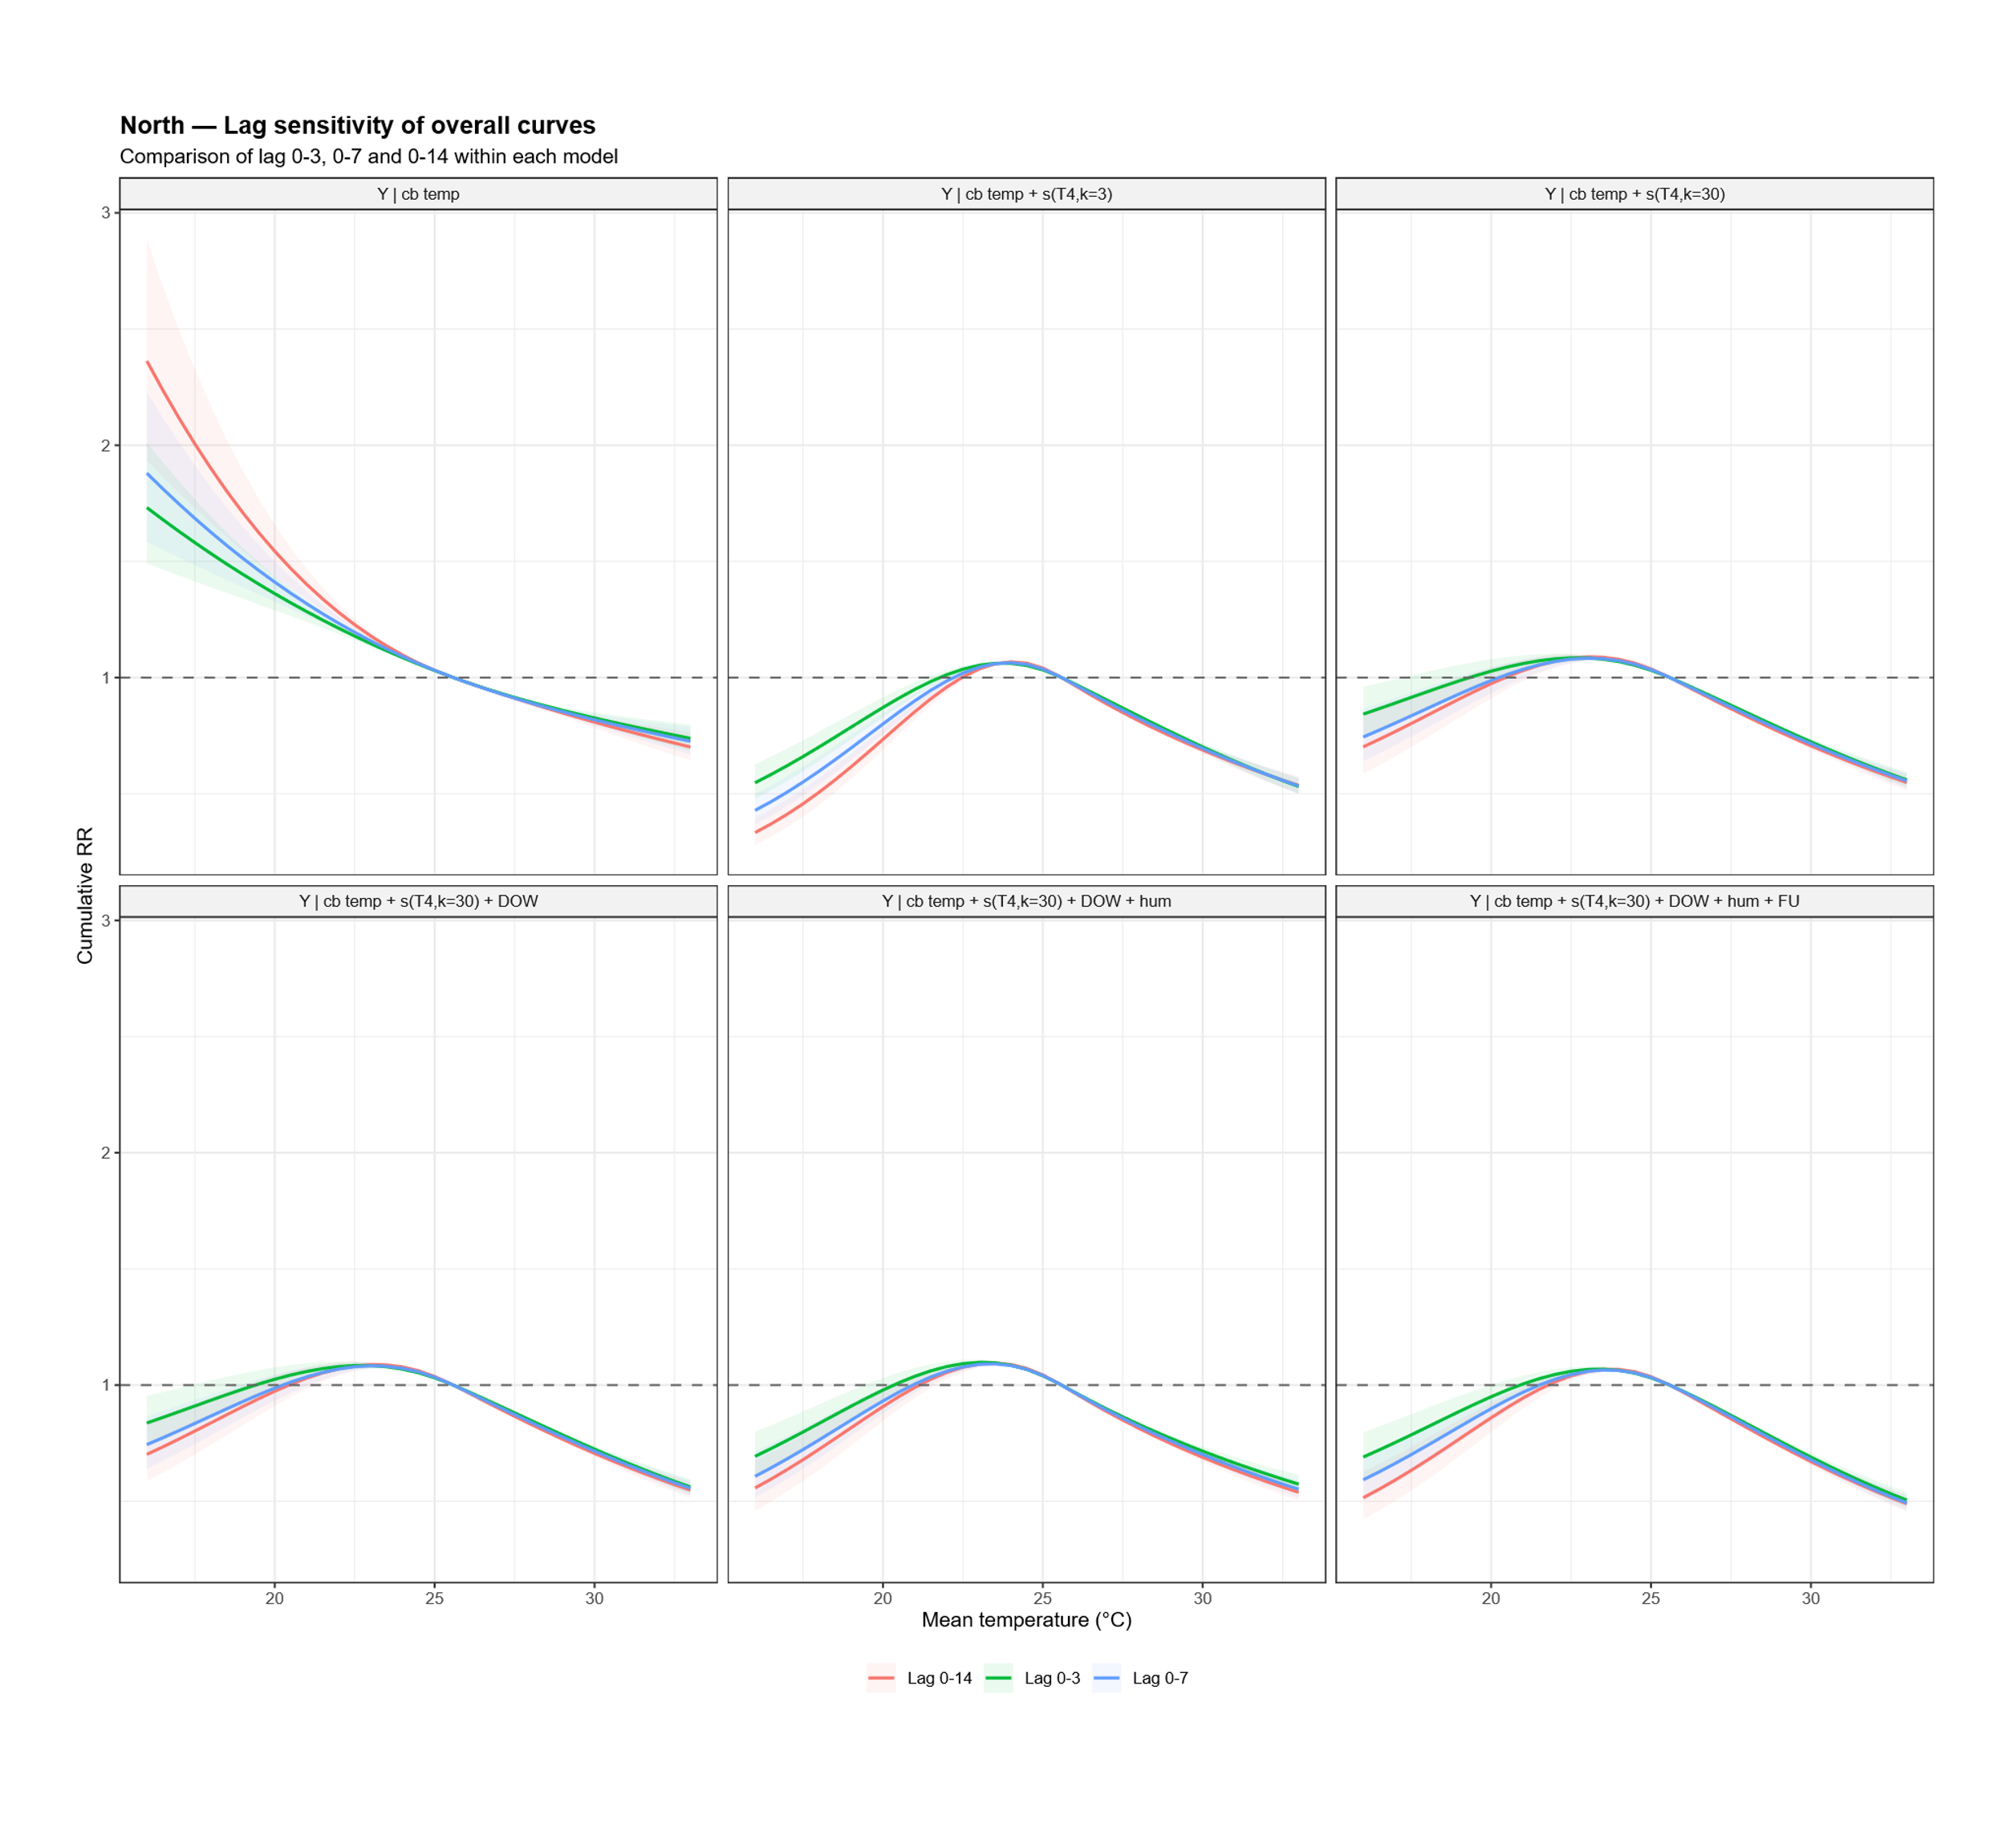

Note: Each panel represents one of the sequentially adjusted candidate models Model 0 – Model 5, as defined in Table S1. Curves show the overall cumulative relative risks for lag windows of 0 - 3, 0 - 7, and 0 - 14 days, centered at the region-specific mean temperature. Shaded areas represent 95% confidence intervals, and the horizontal dashed line indicates the null value of RR = 1.

Figure S5. Sensitivity of the cumulative temperature–preterm birth association to model specification and lag window in the Northeast region.
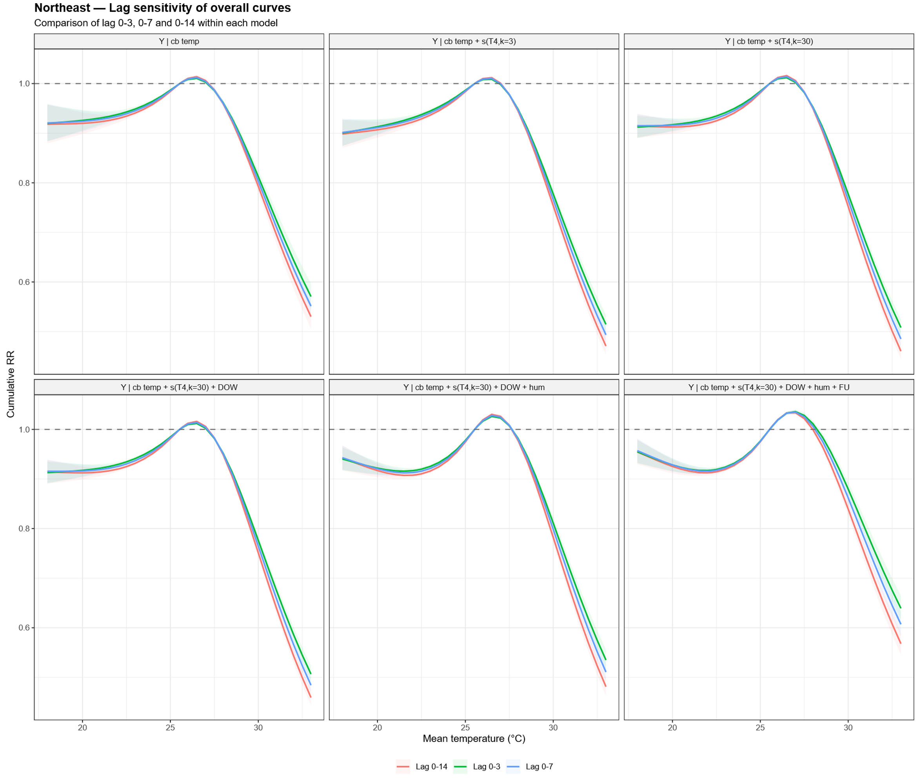

Note: Each panel represents one of the sequentially adjusted candidate models Model 0 – Model 5, as defined in Table S1. Curves show the overall cumulative relative risks for lag windows of 0 - 3, 0 - 7, and 0 - 14 days, centered at the region-specific mean temperature. Shaded areas represent 95% confidence intervals, and the horizontal dashed line indicates the null value of RR = 1.

Figure S6. Sensitivity of the cumulative temperature–preterm birth association to model specification and lag window in the Midwest region.
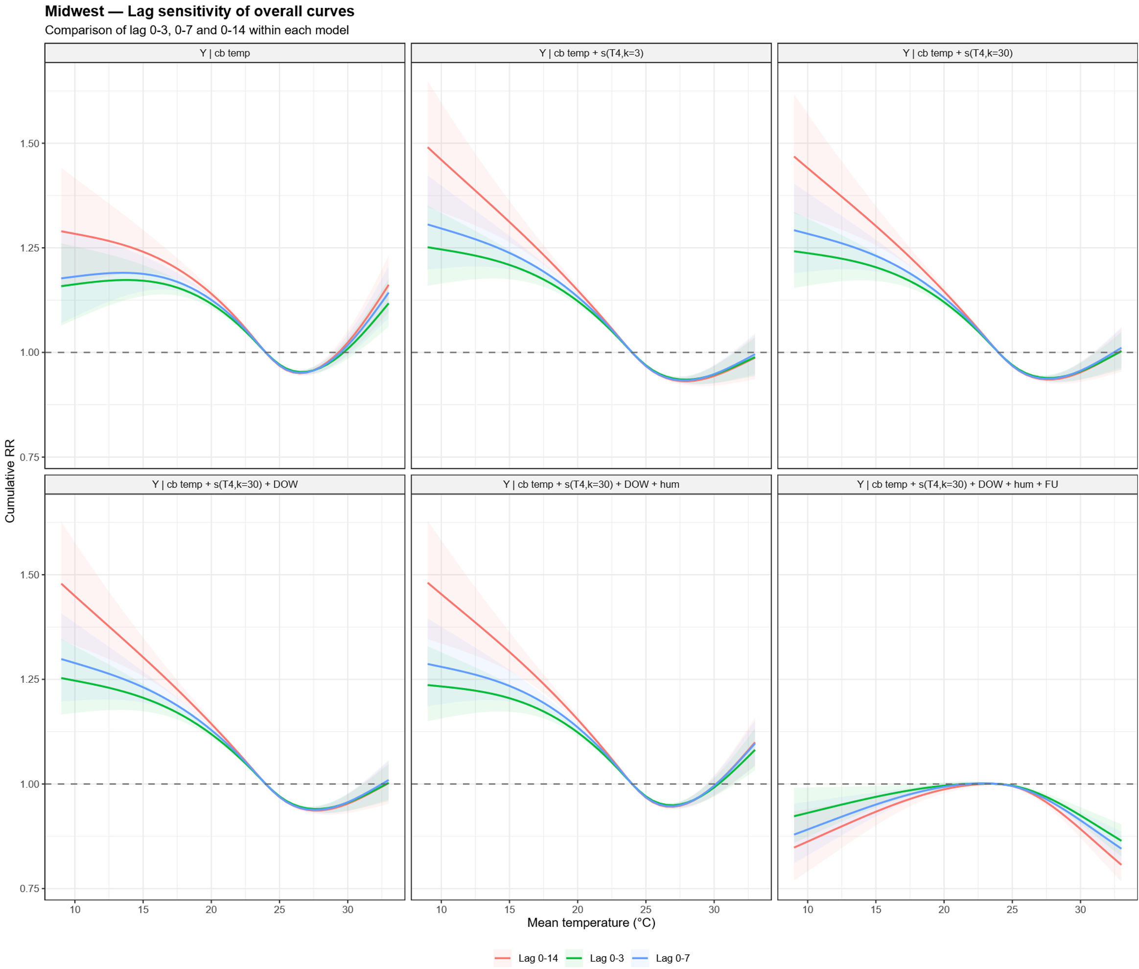

Note: Each panel represents one of the sequentially adjusted candidate models Model 0 – Model 5, as defined in Table S1. Curves show the overall cumulative relative risks for lag windows of 0 - 3, 0 - 7, and 0 - 14 days, centered at the region-specific mean temperature. Shaded areas represent 95% confidence intervals, and the horizontal dashed line indicates the null value of RR = 1.

Figure S7. Sensitivity of the cumulative temperature–preterm birth association to model specification and lag window in the Southeast region.
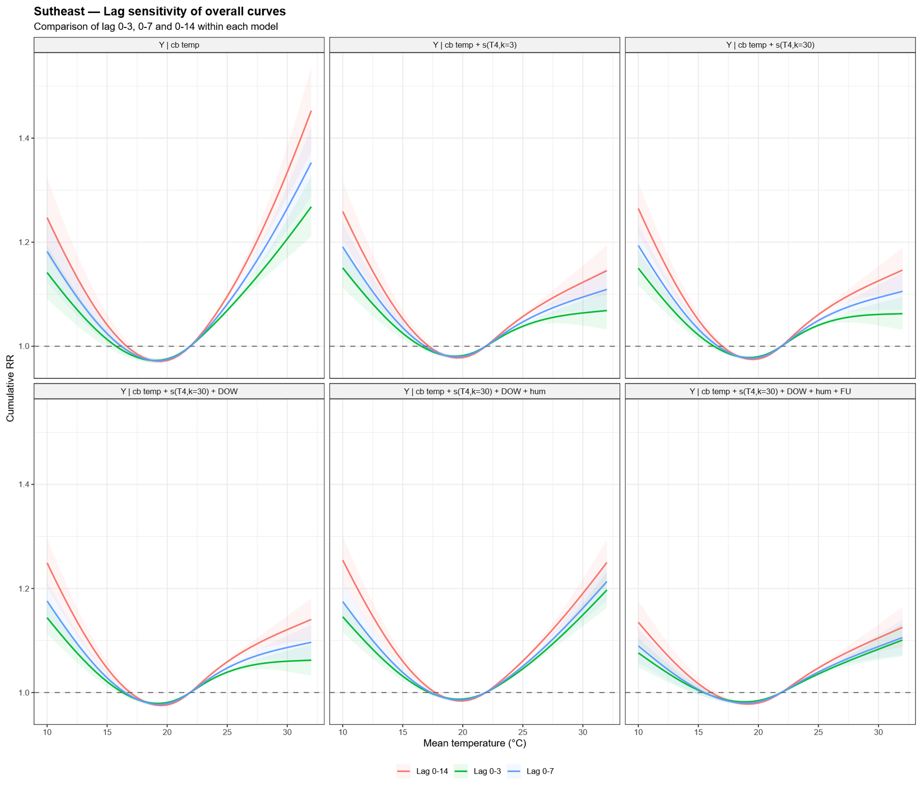

Note: Each panel represents one of the sequentially adjusted candidate models Model 0 – Model 5, as defined in Table S1. Curves show the overall cumulative relative risks for lag windows of 0 - 3, 0 - 7, and 0 - 14 days, centered at the region-specific mean temperature. Shaded areas represent 95% confidence intervals, and the horizontal dashed line indicates the null value of RR = 1.

Figure S8. Sensitivity of the cumulative temperature–preterm birth association to model specification and lag window in the South region.
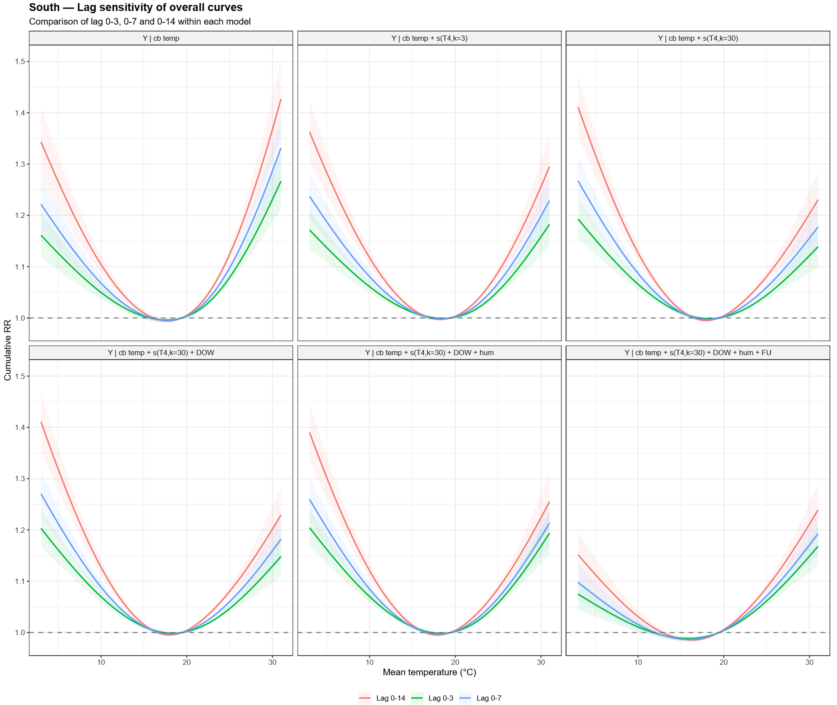

Note: Each panel represents one of the sequentially adjusted candidate models Model 0 – Model 5, as defined in Table S1. Curves show the overall cumulative relative risks for lag windows of 0 - 3, 0 - 7, and 0 - 14 days, centered at the region-specific mean temperature. Shaded areas represent 95% confidence intervals, and the horizontal dashed line indicates the null value of RR = 1.

