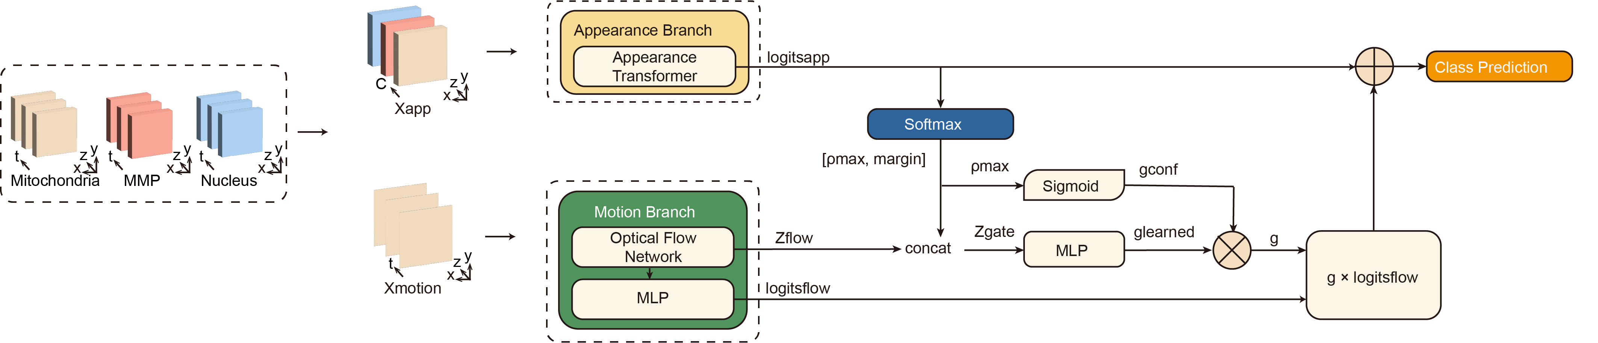
Supplementary Figure 1 | Architecture of the appearance–motion fusion model.
Three-channel single-cell z-stack images of mitochondria, mitochondrial membrane-potential-associated fluorescence, and nuclei were used to construct the appearance input (Xapp), whereas time-lapse image sequences were used to construct the motion input (Xmotion). The appearance branch generated appearance logits (logitsapp) from z-stack image features. The motion branch extracted optical-flow-based dynamic features (zflow) and generated motion-correction logits (logitsflow). The softmax output of the appearance branch provided the maximum class probability (pmax) and classification margin, which were combined with the motion descriptors to estimate a sample-level gate (g). The final prediction was obtained by combining appearance logits with gated motion-correction logits, which allowed motion features to contribute to appearance-based classification.
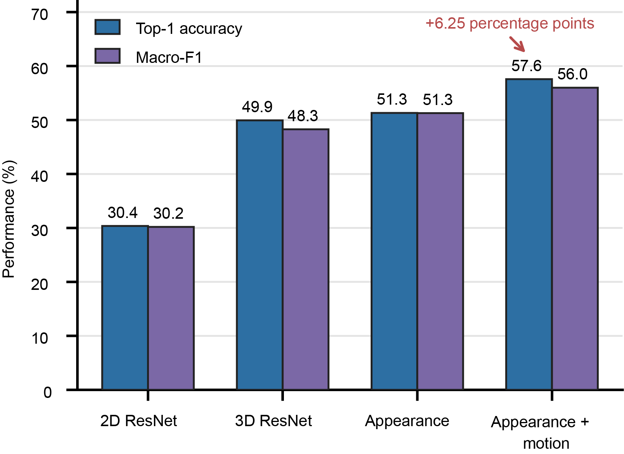
Supplementary Figure 2 | Benchmarking z-stack appearance modeling and motion-gated fusion for A549 phenotype classification.
Top-1 accuracy and macro-F1 scores for the 2D ResNet, 3D ResNet, z-stack appearance and appearance-plus-motion models. The z-stack appearance model improved performance compared with the 2D and 3D ResNet baselines. Incorporating motion-gated fusion further increased top-1 accuracy from 51.32% to 57.57% and macro-F1 from 51.27% to 55.99%, corresponding to gains of 6.25 and 4.72 percentage points, respectively. Values are shown as percentages.

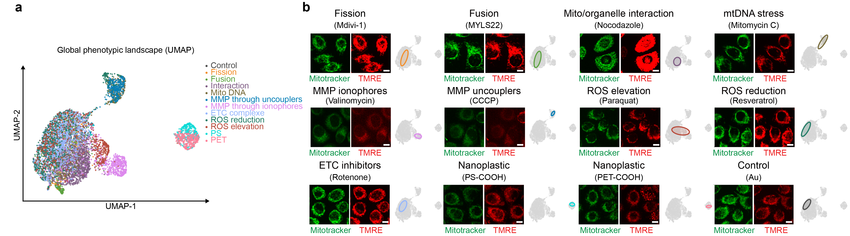
Supplementary Figure 3 | Image-based profiling distinguishes nanoplastic-associated phenotypes from reference mitochondrial perturbations in the A549 cell line.
(a) Embeddings from the A549 phenotype classifier. UMAP visualization of learned single-cell embeddings from the A549 phenotype classification model. Each point represents one cell, and colors indicate the corresponding treatment-associated phenotype group. The embedding shows the organization of nanoplastic-treated cells relative to reference mitochondrial perturbation classes in the learned feature space.
(b) Representative endpoint images of A549 cells acquired 360 min after the indicated treatments. MitoTracker and TMRE indicate mitochondrial morphology and membrane-potential-associated fluorescence, respectively. Images were individually contrast-adjusted for visualization. Scale bar, 10 μm.

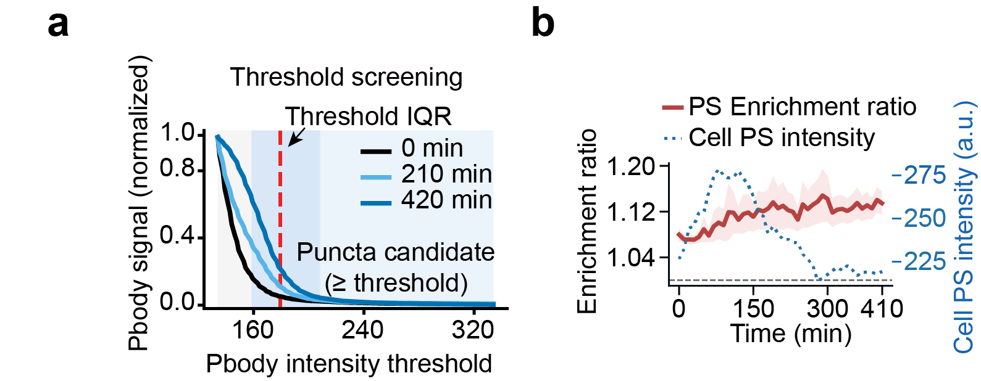
Supplementary Figure 4 | Detection-threshold selection and local PS enrichment at DDX6-positive puncta in NCM460 cells.
(a) Threshold screening for detection of DDX6–EGFP-positive P-body puncta across the time-lapse series. The shaded region indicates the selected threshold range.
(b) Time-resolved comparison of PS fluorescence near DDX6-positive puncta with whole-cell PS fluorescence in NCM460 cells. The enrichment ratio was calculated as the mean PS fluorescence within regions surrounding detected puncta divided by the mean PS fluorescence within the corresponding segmented cell mask. Lines show pooled-cell means and shaded regions indicate s.e.m.

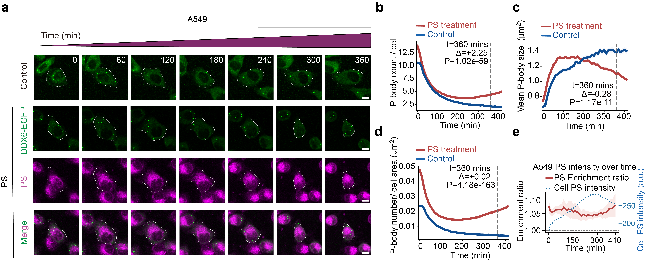
Supplementary Figure 5 | Live-cell analysis of DDX6-positive P-bodies and local PS fluorescence in A549 cells.
(a) Representative DDX6–EGFP live-cell time-lapse images of A549 cells exposed to Au nanoparticles or PS nanoplastics. For PS-treated cells, DDX6–EGFP, PS fluorescence and merged images are shown. Time indicates minutes after particle addition. Scale bar, 10 μm.
(b–e) Time-resolved DDX6-positive P-body punctum number per cell (b), mean punctum area per cell (c), punctum density (d) and local PS enrichment at DDX6-positive puncta relative to whole-cell PS fluorescence (e) in A549 cells. Punctum density was calculated as punctum number normalized to segmented cell area. Lines show pooled-cell means and shaded regions indicate s.e.m. At 360 min, Δ denotes the mean value in the PS-treated group minus that in the Au-treated group. n = 1,044 PS-treated cells and 760 Au-treated cells. P values for punctum number, mean area and density were calculated using two-sided Mann–Whitney U tests, with individual cells treated as the observational unit.
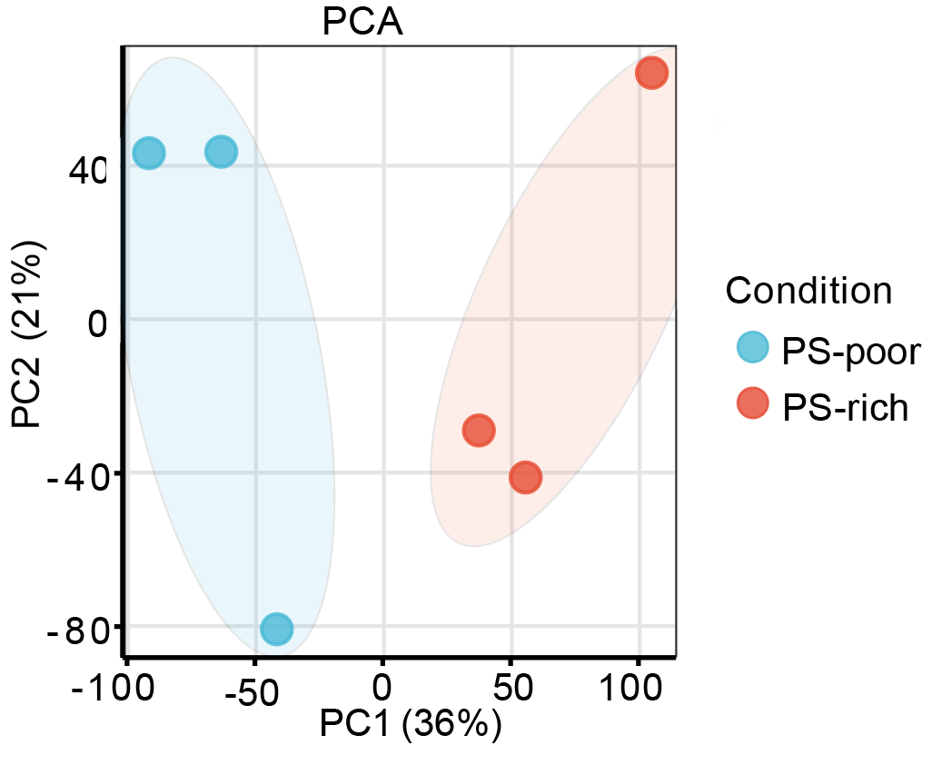
Supplementary Figure 6 | Principal-component analysis of local RNA-seq profiles from PS-poor and PS-rich regions.
Principal-component analysis of local RNA-seq profiles obtained from PS-poor and PS-rich cytoplasmic regions. Each point represents one RNA-seq sample, and shaded ellipses indicate group-level dispersion. n = 3 samples per regional group.

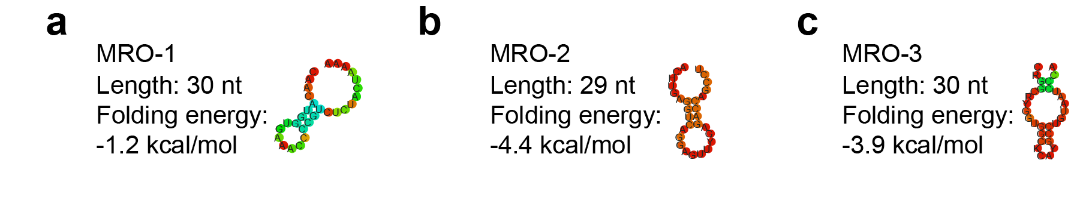
Supplementary Figure 7 | Predicted secondary structures of three motif-derived RNA oligonucleotides.
(a–c) RNAfold-predicted secondary structures of MRO-1 (a), MRO-2 (b) and MRO-3 (c), with the oligonucleotide name, sequence length and predicted minimum free energy indicated for each MRO.

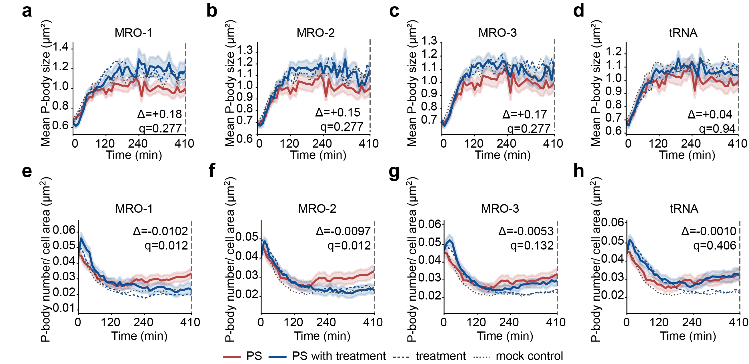

Supplementary Figure 8 | Effects of motif-derived RNA oligonucleotides and control RNA on PS-associated P-body morphology in NCM460 cells
(a–d) Time-resolved mean DDX6-positive P-body punctum area per cell in NCM460 cells treated with MRO-1 (a), MRO-2 (b), MRO-3 (c) or tRNA (d), with or without PS.
(e–h) Time-resolved DDX6-positive P-body punctum density in NCM460 cells treated with MRO-1 (e), MRO-2 (f), MRO-3 (g) or tRNA (h), with or without PS. Punctum density was calculated as punctum number normalized to segmented cell area.
For a–h, red, solid blue, dashed blue and dotted grey lines denote PS alone, PS plus RNA, RNA alone and mock control, respectively. Lines show pooled-cell means and shaded regions indicate s.e.m. At 410 min, PS-alone and PS-plus-RNA groups were compared using two-sided Mann–Whitney U tests with Benjamini–Hochberg adjustment across the four RNA conditions; exact q values are shown in the panels. Δ denotes the mean value in the PS-plus-RNA group minus that in the PS-alone group.
Cell numbers for PS alone, PS plus RNA, RNA alone, and mock control, respectively, were: MRO-1, 65, 48, 116 and 124; MRO-2, 65, 76, 151 and 124; MRO-3, 65, 85, 134 and 124; and tRNA, 65, 73, 138 and 124.
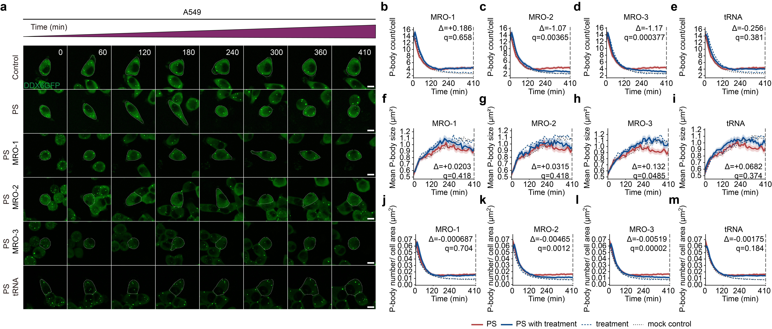
Supplementary Figure 9 | Effects of motif-derived RNA oligonucleotides and control RNA on PS-associated P-body morphology in A549 cells.
(a) Representative DDX6–EGFP time-lapse live-cell confocal images of A549 cells under mock control, PS-alone, and PS-plus-RNA conditions from 0 to 410 min. Dashed contours indicate segmented cell boundaries. Scale bar, 10 μm.
(b-e) Time-resolved DDX6-positive P-body punctum number per cell in A549 cells treated with MRO-1 (b), MRO-2 (c), MRO-3 (d) or tRNA (e), with or without PS.
(f–i) Time-resolved mean DDX6-positive P-body punctum area per cell in A549 cells treated with MRO-1 (f), MRO-2 (g), MRO-3 (h) or tRNA (i), with or without PS.
(j–m) Time-resolved DDX6-positive P-body punctum density in A549 cells treated with MRO-1 (j), MRO-2 (k), MRO-3 (l) or tRNA (m), with or without PS. Punctum density was calculated as punctum number normalized to segmented cell area.
For b–m, red, solid blue, dashed blue and dotted grey lines denote PS alone, PS plus RNA, RNA alone and mock control, respectively. Lines show pooled-cell means and shaded regions indicate s.e.m. At 410 min, PS-alone and PS-plus-RNA groups were compared using two-sided Mann–Whitney U tests with Benjamini–Hochberg adjustment across the four RNA conditions; exact q values are shown in the panels. Δ denotes the mean value in the PS-plus-RNA group minus that in the PS-alone group.
Cell numbers for PS alone, PS plus RNA, RNA alone, and mock control, respectively, were: MRO-1, 180, 167, 296 and 232; MRO-2, 180, 147, 312 and 232; MRO-3, 180, 199, 270 and 232; and tRNA, 180, 220, 270 and 232.

Supplementary Methods

Image-based phenotype classification model
The image-based phenotype classifier consisted of an appearance branch and a motion-integration branch. In the appearance branch, each z-slice from the multichannel single-cell image stack was processed using a shared two-dimensional multiscale encoder. Slice-level features were subsequently aggregated along the z-axis using an attention-pooling module to generate a 256-dimensional volumetric appearance embedding.
Mitochondrial motion was quantified from the mitochondrial channel using Farnebäck dense optical flow calculated between adjacent time-resolved z-projection images. The mean optical-flow magnitude within the segmented cell foreground was used to construct a single-cell mitochondrial motion profile. The appearance branch was trained first and subsequently frozen while the motion branch and fusion module were optimized. Appearance and motion predictions were integrated using a learned confidence-gated fusion strategy, in which the contribution of motion information was modulated according to the confidence and classification margin of the appearance prediction.
The appearance and fusion stages were trained for 100 and 30 epochs, respectively, using the Adam optimizer with a batch size of 32, weight decay of 1 × 10⁻³, an initial learning rate of 3 × 10⁻³ and a minimum learning rate of 1 × 10⁻⁶. Cross-entropy loss was applied with label smoothing of 0.1 and class weights estimated from the training set to reduce the effect of class imbalance. Mixed-precision training was used to improve computational efficiency.
Model performance was evaluated using top-1 accuracy, top-5 accuracy, macro-precision, macro-recall, and macro-F1 score. Learned feature embeddings were visualized using Uniform Manifold Approximation and Projection (UMAP) to examine phenotypic relationships among nanoplastic-treated cells and the reference perturbation groups.

