Supplementary material
Native image geometry and cross-partition patient overlap in a checksum-identified public liver ultrasound release: an audit of SMC-LUD
Yuan-Jie Jiang^{1,#}, Lei Gan^{2,#}, Jin Lan¹, Yi-Yi Liao¹, Xi Deng

Metadata identifier reconciliation
patient_id | diagnosis | status
Hem_45 | Hemangioma | Metadata record without image directory
Hem_63 | Hemangioma | Metadata record without image directory
Hem_68 | Hemangioma | Metadata record without image directory
Hem_69 | Hemangioma | Metadata record without image directory
Hem_75 | Hemangioma | Metadata record without image directory
Hem_246 | Hemangioma | Metadata record without image directory
Hem_379 | Hemangioma | Metadata record without image directory
Hem_504 | Hemangioma | Metadata record without image directory
Hem_583 | Hemangioma | Metadata record without image directory
Hem_87 | Hemangioma | Image directory without metadata record
Supplementary Table S1. Reconciliation of hemangioma patient identifiers between the released metadata table and image-bearing directories. Ten identifiers were not represented in both sources.

Prespecified model results
Partition | Seed | Patients | AUROC | AUPRC | Balanced accuracy | Best epoch
Released | 24 | 194 | 0.978 | 0.985 | 0.925 | 4
Released | 2026 | 194 | 0.989 | 0.993 | 0.947 | 8
Released | 3407 | 194 | 0.990 | 0.993 | 0.948 | 10
Patient-exclusive | 24 | 72 | 0.969 | 0.975 | 0.931 | 3
Patient-exclusive | 2026 | 72 | 0.957 | 0.957 | 0.919 | 7
Patient-exclusive | 3407 | 72 | 0.958 | 0.919 | 0.959 | 7
Supplementary Table S2. Patient-level performance for each prespecified initialization seed. Released and patient-exclusive partitions use different test cohorts; comparisons are descriptive and unpaired. AUROC, area under the receiver operating characteristic curve; AUPRC, area under the precision-recall curve.

Additional post hoc technical-harmonization sensitivity analysis
All images were decoded, converted to grayscale with three replicated channels, and resized directly to 224 × 224 pixels. The same patient-exclusive split, three initialization seeds, optimization, augmentation, and validation stopping rule were retained. This additional post hoc analysis was documented in protocol amendment 003.
Preprocessing | Seed | Patients | AUROC | AUPRC
Baseline | 24 | 72 | 0.969 | 0.975
Baseline | 2026 | 72 | 0.957 | 0.957
Baseline | 3407 | 72 | 0.958 | 0.919
Forced-square grayscale | 24 | 72 | 1.000 | 1.000
Forced-square grayscale | 2026 | 72 | 0.988 | 0.990
Forced-square grayscale | 3407 | 72 | 0.999 | 0.999
Supplementary Table S3. Patient-level discrimination before and after forced-square grayscale standardization on the identical 72-patient patient-exclusive test cohort. AUROC, area under the receiver operating characteristic curve; AUPRC, area under the precision-recall curve.
Interpretation: the harmonized three-seed ensemble AUROC was 1.000 (95% CI 1.000–1.000), compared with 0.966 (95% CI 0.909–1.000) for baseline preprocessing; paired difference 0.034 (95% CI 0.000–0.090). Forced-square resizing can preserve or introduce class-dependent technical cues and therefore does not establish lesion-specific learning.

Supplementary Figure S1

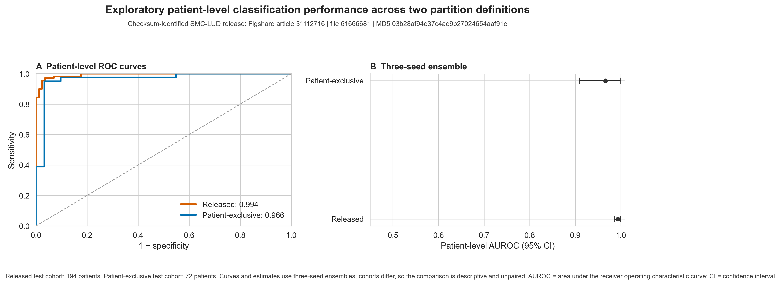

Supplementary Figure S1. Exploratory patient-level classification performance under the released and patient-exclusive partitions. Curves and point estimates summarize three-seed ensembles. Released and patient-exclusive partitions use different test cohorts; the comparison is descriptive and unpaired. AUROC, area under the receiver operating characteristic curve; CI, confidence interval.

