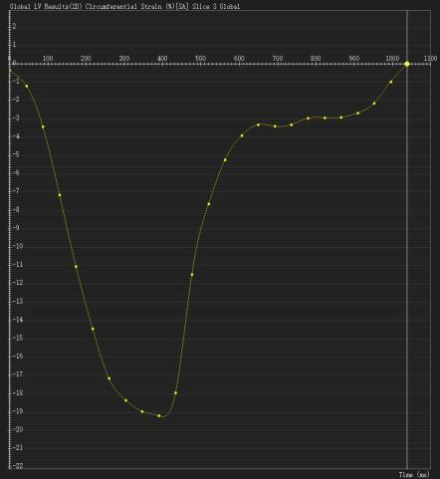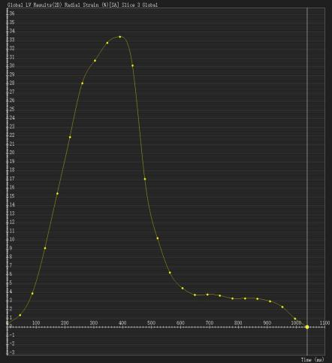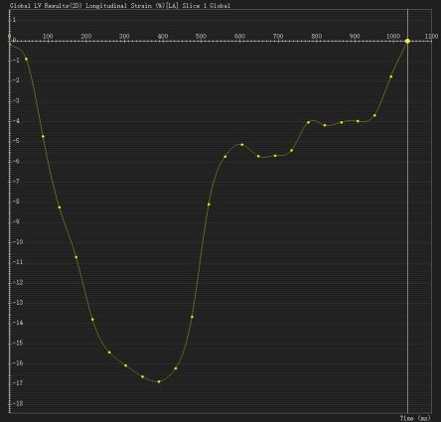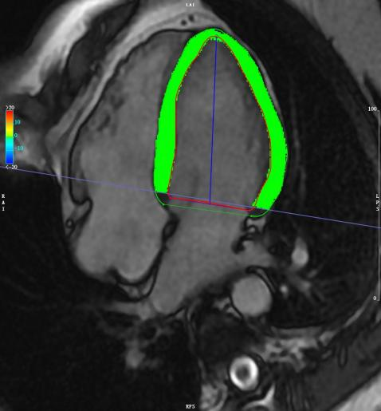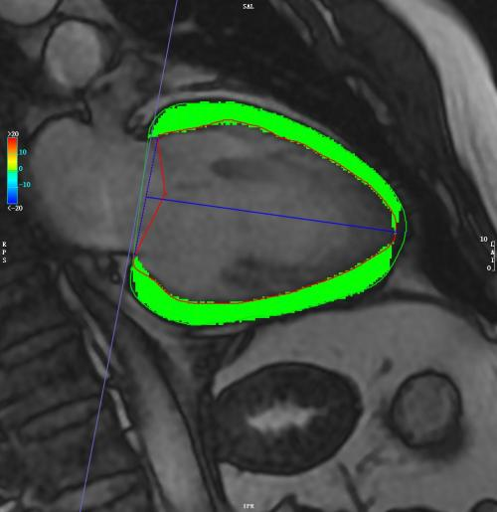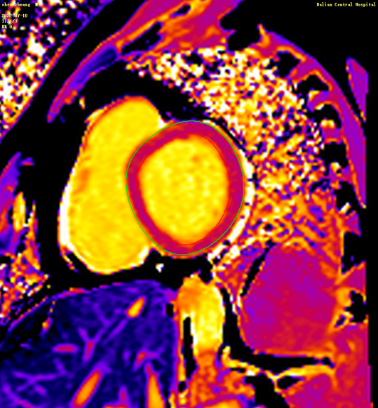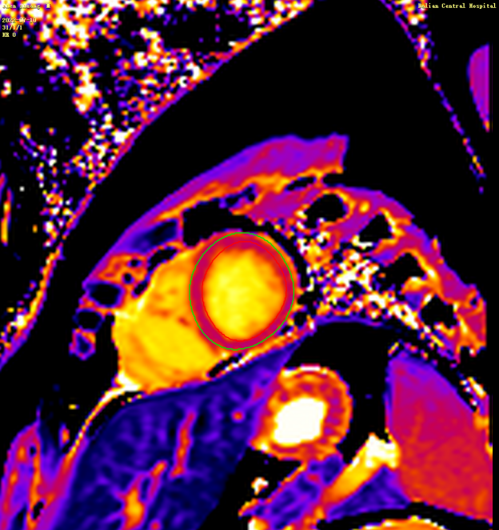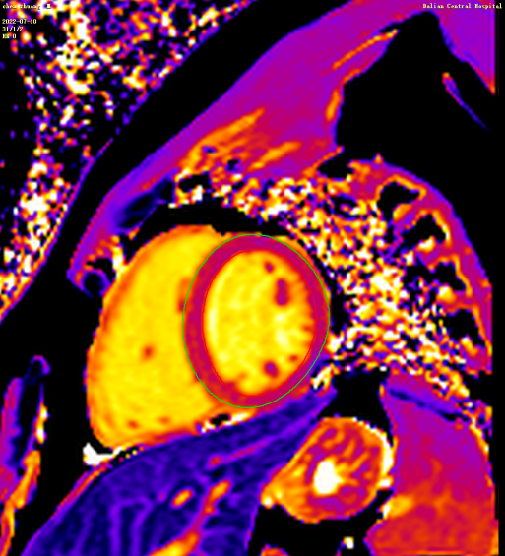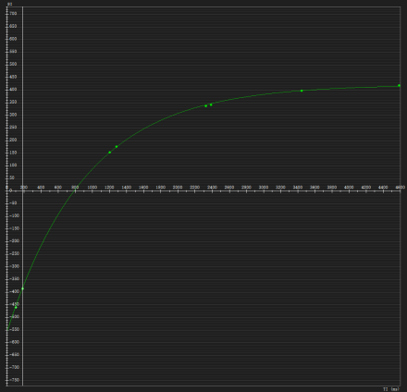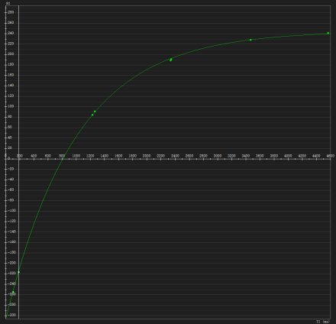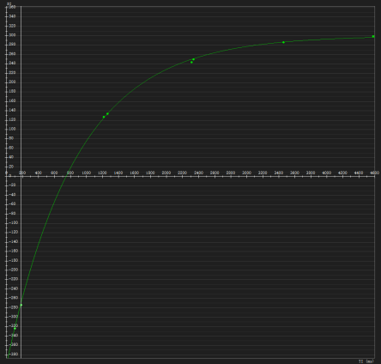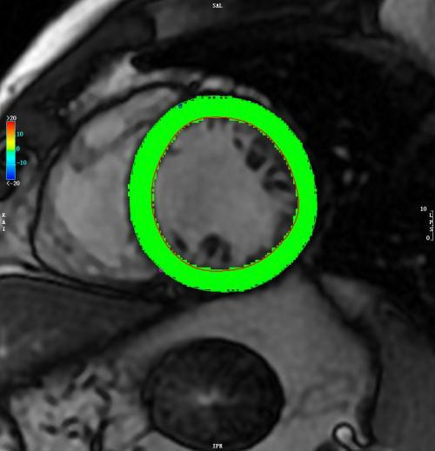
GPLS
GPRS
GPCS
Native T1=1246ms
Native T1=1172ms
Native T1=1228ms
a
bbbb
c
d
e
f
l
k
j
g
h
i
Figure S1. Schematic illustration of left ventricular measurements by cardiac MR cine feature tracking (a–f) and short-axis native T1 mapping (g–l).a. Short-axis view at end-diastole. b. Two-chamber view. c. Four-chamber view. d. Global circumferential strain curve.
e. Global longitudinal strain curve. f. Global radial strain curve. g. Basal segment. h. Mid-ventricular segment. i. Apical segment. j–l. Native T1 curves from the basal to apical segments.

Table S1 Correlations of hemodynamic parameters with cardiac function and structural parameters

Parameters | LVEF |  | CI |  | LVESVI |  | LVMI |  | LVMWT
Parameters | r | p-value | r | p-value | r | p-value | r | p-value | r | p-value
Delayed flow (%) | 0.345 | <0.001# | 0.035 | 0.674# | 0.237 | 0.004 | 0.002 | 0.978 | -0.071 | 0.397
Residual volume (%) | -0.442 | <0.001 | 0.048 | 0.567 | 0.536 | <0.001 | 0.531 | <0.001 | 0.229 | 0.006
Global KEi_{EDV} (μJ/mL) | 0.365 | <0.001# | 0.378 | <0.001# | -0.260 | 0.001 | -0.124 | 0.123 | -0.124 | 0.124
Average systolic KEi_{EDV} (μJ/mL) | 0.388 | <0.001 | 0.348 | <0.001 | -0.522 | <0.001 | -0.142 | 0.086 | -0.097 | 0.242
Average diastolic KEi_{EDV} (μJ/mL) | 0.191 | 0.017 | 0.403 | <0.001 | -0.168 | 0.036 | -0.118 | 0.141 | -0.132 | 0.100
Peak systolic KEi_{EDV} (μJ/mL) | 0.385 | <0.001 | 0.310 | <0.001 | -0.374 | <0.001 | -0.030 | 0.720 | -0.015 | 0.860
Peak E-wave KEi_{EDV} (μJ/mL) | 0.317 | <0.001 | 0.384 | <0.001 | -0.218 | 0.008 | -0.244 | 0.003 | -0.364 | <0.001
Peak A-wave KEi_{EDV} (μJ/mL) | 0.199 | 0.013 | 0.233 | 0.003 | -0.236 | 0.003 | -0.128 | 0.111 | -0.006 | 0.945
E/A | 0.262 | 0.001 | 0.239 | 0.003 | -0.102 | 0.219 | -0.229 | 0.005 | -0.412 | <0.001
Note: # indicates analyses performed using Pearson correlation; all other analyses were conducted using Spearman correlation. LVEF, left ventricular ejection fraction. CI, cardiac index. LVESVI, left ventricular end-systolic volume index. LVWMT, left ventricular maximum wall thickness. LVMI, left ventricular mass index.

Table S2 Intraobserver and interobserver LV blood flow components and KE parameters
Parameters | Intraobserver |  |  | Interobserver
Parameters | ICC | 95% CI |  | ICC | 95% CI
Direct flow (%) | 0.983 | 0.956-0.993 |  | 0.971 | 0.865-0.991
Retained infow (%) | 0.965 | 0.910-0.986 |  | 0.876 | 0.686-0.951
Delayed ejection fow (%) | 0.984 | 0.960-0.994 |  | 0.880 | 0.759-0.912
Residual volume (%) | 0.938 | 0.839-0.976 |  | 0.913 | 0.774-0.966
Global KEi_{EDV}(μJ/mL) | 0.998 | 0.990-0.999 |  | 0.992 | 0.980-0.997
Average systolic KEi_{EDV}(μJ/mL) | 0.988 | 0.970-0.995 |  | 0.981 | 0.952-0.992
Average diastolic KEi_{EDV}(μJ/mL) | 0.990 | 0.975-0.996 |  | 0.980 | 0.948-0.992
Peak systolic KEi_{EDV}(μJ/mL) | 0.999 | 0.997-0.999 |  | 0.998 | 0.995-0.999
Peak E-wave KEi_{EDV}(μJ/mL) | 0.999 | 0.996-0.999 |  | 0.999 | 0.996-0.999
Peak A-wave KEi_{EDV}(μJ/mL) | 0.999 | 0.998-0.999 |  | 0.969 | 0.923-0.988
E/A | 0.999 | 0.998-0.999 |  | 0.978 | 0.940-0.991
LVGPLS | 0.976 | 0.938-0.990 |  | 0.953 | 0.880-0.981
LVGPCS | 0.981 | 0.952-0.993 |  | 0.984 | 0.960-0.994
LVGPRS | 0.979 | 0.946-0.992 |  | 0.980 | 0.951-0.992
LV_{d}GLSR | 0.890 | 0.722-0.956 |  | 0.914 | 0.783-0.966
LV_{s}GLSR | 0.845 | 0.557-0.899 |  | 0.840 | 0.597-0.937
LV_{d}GCSR | 0.831 | 0.574-0.933 |  | 0.829 | 0.569-0.932
LV_{s}GCSR | 0.908 | 0.768-0.964 |  | 0.896 | 0.686-0.919
LV_{d}GRSR | 0.900 | 0.746-0.960 |  | 0.962 | 0.904-0.985
LV_{s}GRSR | 0.853 | 0.629-0.942 |  | 0.877 | 0.689-0.951
Note: ICC, intraclass correlation coefficient. CI, confidence interval.

