Additional file 1 — Supplementary material

Manuscript: Silent calibration drift in a frozen clinical prediction model: a decade-long audit and an operational monitoring framework.

Table S5. Data quality by era
Table S5. Data quality by era. Predicted postoperative FEV1 (ppoFEV1) was recorded as exactly 0 in 100 patients and above 150% predicted in 3; the observed distribution contains no values between 0 and 18.5% predicted, identifying 0 as a sentinel for an unmeasured value. ppoFEV1 is a derived quantity: FEV1 × (1 − resected segments / 19) reproduces the recorded value with r = 0.981 and a mean absolute error of 0.5 percentage points. It was therefore recomputed rather than imputed in the 90 affected records whose FEV1 was itself valid (first row). A further 16 records carried implausible values of other predictors. In total 24 of 1561 records (1.5%) had a value set to missing and imputed with frozen development-era medians. The calibration drift was reproduced under complete-case analysis (n = 1537; intercept −0.58 in 2016–17 and −0.35 in 2018–21) and under multiple imputation (−0.53 and −0.32; 20 imputed datasets generated by iterative imputation drawing from the posterior; within each dataset the development model was refitted on the 2011–15 era and evaluated on the later eras, and the per-era calibration intercepts were combined by Rubin’s rules).
Variable | 2011–15 | 2016–17 | 2018–21
ppoFEV1 recomputed from FEV1 × (1 − segments/19) | 56 | 17 | 17
FEV1 ≤0 or >200% predicted → missing | 1.7% | 0.5% | 0.5%
ppoFEV1 still missing (FEV1 invalid) | 1.8% | 0.5% | 0.3%
BMI, albumin, age, sex, ASA, pN2 → missing | 0.4% | 1.3% | 0.6%
Any value set to missing and imputed | 2.0% | 1.6% | 1.1%

Contents: Tables S1–S5; Figure S1; note on the supplementary code. The completed TRIPOD+AI checklist is provided separately as Additional file 2.

Table S1. Full case-mix and outcome characteristics across eras
Table S1. Patient, tumour, and operative characteristics by era. Continuous variables: mean ± SD. Binary variables: n (%). P values from one-way ANOVA (continuous) or χ² test (binary).
Characteristic | 2011–15 | 2016–17 | 2018–21 | P
Age, years | 63.1 ± 10.4 | 64.5 ± 9.5 | 65.1 ± 9.3 | 0.003
ASA class | 1.8 ± 0.7 | 2.4 ± 0.6 | 2.5 ± 0.6 | 0.000
FEV1, % pred | 83.8 ± 20.4 | 82.3 ± 21.2 | 85.3 ± 18.8 | 0.058
ppoFEV1, % pred | 63.8 ± 17.9 | 63.7 ± 19.2 | 65.6 ± 16.6 | 0.131
BMI, kg/m² | 25.6 ± 4.7 | 26.2 ± 4.9 | 26.3 ± 5.0 | 0.037
Albumin, g/L | 39.6 ± 5.1 | 40.0 ± 4.5 | 39.9 ± 3.1 | 0.366
Procedure, min | 161.2 ± 55.2 | 160.7 ± 55.7 | 169.5 ± 57.1 | 0.013
Anaesthesia, min | 222.1 ± 60.7 | 224.7 ± 62.0 | 232.2 ± 64.1 | 0.016
Male sex | 396 (73.2) | 278 (73.4) | 430 (67.1) | 0.031
Minimally invasive access | 186 (34.4) | 244 (64.4) | 472 (73.6) | 0.000
Lobectomy | 433 (80.0) | 295 (77.8) | 507 (79.1) | 0.721
Segmentectomy | 23 (4.3) | 39 (10.3) | 57 (8.9) | 0.001
Bilobectomy | 20 (3.7) | 14 (3.7) | 23 (3.6) | 0.994
Pneumonectomy | 66 (12.2) | 39 (10.3) | 64 (10.0) | 0.440
Active smoking | 470 (86.9) | 348 (91.8) | 555 (86.6) | 0.029
Diabetes | 87 (16.1) | 48 (12.7) | 124 (19.3) | 0.020
Hypertension | 199 (36.8) | 174 (45.9) | 302 (47.1) | 0.001
COPD | 166 (30.7) | 136 (35.9) | 177 (27.6) | 0.022
Coronary artery disease | 76 (14.0) | 50 (13.2) | 95 (14.8) | 0.768
Cardiac arrhythmia | 49 (9.1) | 36 (9.5) | 54 (8.4) | 0.834
Heart failure | 18 (3.3) | 14 (3.7) | 13 (2.0) | 0.229
Renal failure | 20 (3.7) | 17 (4.5) | 27 (4.2) | 0.824
pN1 | 69 (12.8) | 47 (12.4) | 60 (9.4) | 0.134
pN2 | 57 (10.5) | 51 (13.5) | 65 (10.1) | 0.234
Postoperative pneumonia | 148 (27.4) | 67 (17.7) | 124 (19.3) | 0.000
ASA, American Society of Anesthesiologists; FEV1, forced expiratory volume in 1 s; ppoFEV1, predicted postoperative FEV1; BMI, body-mass index; COPD, chronic obstructive pulmonary disease.

Table S2. Covariate-shift metrics (development vs later eras)
Table S2. Magnitude of distributional shift for each predictor between the development era (2011–15) and the pooled later eras (2016–21). |SMD|, absolute standardized mean difference; PSI, population stability index (PSI<0.1 negligible, 0.1–0.25 moderate, >0.25 major shift). Ranked by |SMD|.
Variable | |SMD| | PSI | Shift
ASA class | 0.97 | 1.142 | major
Minimally invasive access | 0.77 | 0.538 | major
Segmentectomy | 0.21 | 0.044 | negligible
Hypertension | 0.20 | 0.040 | negligible
Age, years | 0.18 | 0.067 | negligible
BMI, kg/m² | 0.14 | 0.109 | moderate
Male sex | 0.08 | 0.007 | negligible
Albumin, g/L | 0.07 | 0.201 | moderate
pN1 | 0.07 | 0.005 | negligible
Pneumonectomy | 0.07 | 0.004 | negligible
ppoFEV1, % pred | 0.06 | 0.017 | negligible
Active smoking | 0.05 | 0.003 | negligible
Renal failure | 0.03 | 0.001 | negligible
pN2 | 0.03 | 0.001 | negligible
Diabetes | 0.02 | 0.000 | negligible
FEV1, % pred | 0.02 | 0.016 | negligible
Cardiac arrhythmia | 0.01 | 0.000 | negligible
Coronary artery disease | 0.00 | 0.000 | negligible
COPD | 0.00 | 0.000 | negligible
The strongest drift affects ASA class and minimally invasive access, mirroring the structural change in thoracic surgical practice over the study period.

Table S3. Development-era prediction model (2-year mortality)
Table S3. Multivariable logistic regression for 2-year mortality, fitted on the development era (2011–15, 111 events). β, log-odds coefficient; OR, odds ratio; CI, confidence interval. All continuous predictors are entered on their natural scale and all binary predictors are coded 0/1 (reference = absence of the characteristic; open access for surgical approach; and lobectomy or bilobectomy — that is, non-pneumonectomy, non-segmentectomy resection — for resection extent), so an individual risk is reconstructed as logit(p) = β0 + Σ βk·xk with the coefficients below. This provides the full model specification required by TRIPOD item 21.
Predictor | β coefficient | OR | 95% CI | P
Intercept | −0.9699 | — | — | 0.556
Age (per year) | 0.0067 | 1.01 | 0.98–1.03 | 0.629
Male sex | 1.4332 | 4.19 | 1.87–9.41 | 0.001
Diabetes | 0.5464 | 1.73 | 0.91–3.27 | 0.094
Hypertension | −0.2899 | 0.75 | 0.43–1.30 | 0.306
Coronary artery disease | −0.2925 | 0.75 | 0.36–1.56 | 0.439
Cardiac arrhythmia | 0.1029 | 1.11 | 0.49–2.53 | 0.807
COPD | 0.3628 | 1.44 | 0.86–2.41 | 0.170
Renal failure | −0.0798 | 0.92 | 0.28–3.03 | 0.895
ASA class (per level) | 0.5147 | 1.67 | 1.14–2.46 | 0.009
FEV1 (per % predicted) | 0.0307 | 1.03 | 1.01–1.06 | 0.011
ppoFEV1 (per % predicted) | −0.0395 | 0.96 | 0.93–0.99 | 0.014
Active smoking | 1.2858 | 3.62 | 0.79–16.61 | 0.098
BMI (per kg/m²) | −0.1212 | 0.89 | 0.83–0.94 | 0.000
Albumin (per g/L) | −0.0349 | 0.97 | 0.92–1.01 | 0.128
Minimally invasive access | −0.4829 | 0.62 | 0.34–1.12 | 0.113
Pneumonectomy | −0.0303 | 0.97 | 0.38–2.46 | 0.949
Segmentectomy | 0.1852 | 1.20 | 0.31–4.74 | 0.791
pN1 | 0.5831 | 1.79 | 0.91–3.52 | 0.091
pN2 | 0.7060 | 2.03 | 0.94–4.35 | 0.070
Continuous predictors entered per unit as indicated; the model is reported to document specification, not as a deployable score.

Figure S1. Era-specific calibration curves
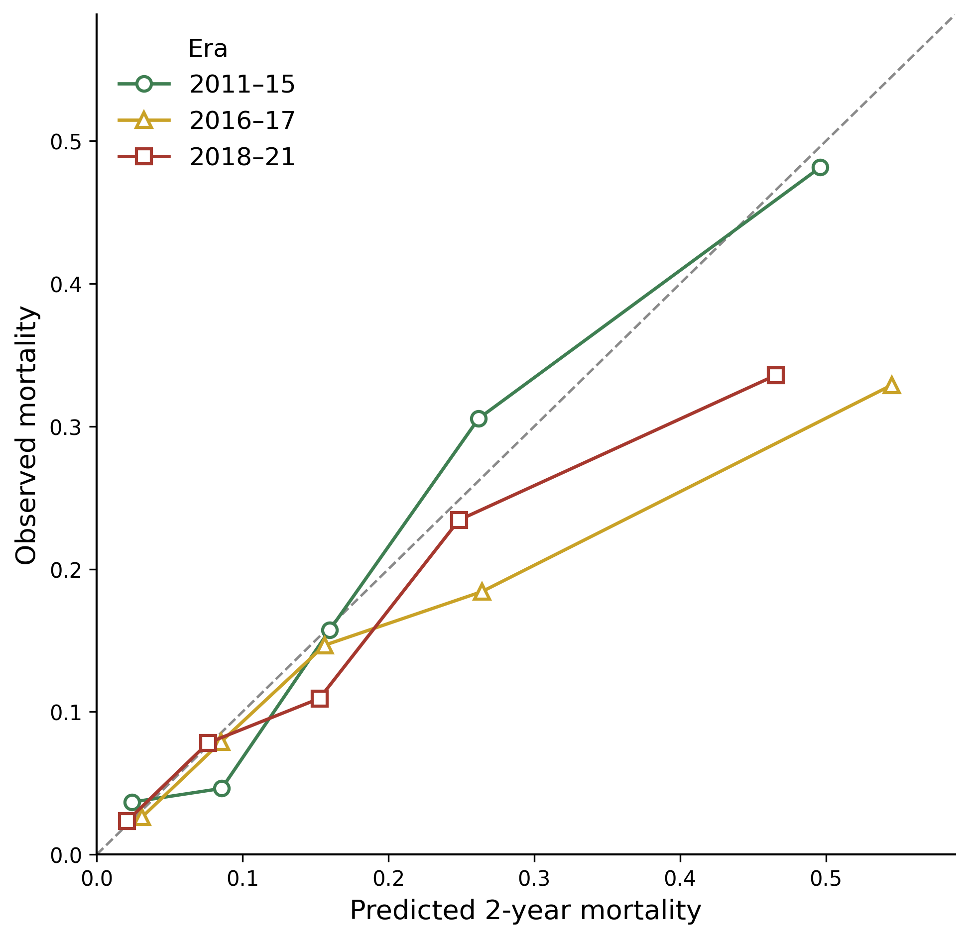
Figure S1. Calibration curves for 2-year mortality in each era, using the model frozen on 2011–15. Points are quintiles of predicted risk (x = mean predicted risk, y = observed proportion of deaths); curves are drawn between observed quintiles and are not extrapolated. The development-era curve follows the diagonal, whereas both validation-era curves fall below it, indicating over-prediction of risk. The departure is not monotonic across eras: miscalibration is greater in 2016–17 than in 2018–21.
Alt text: Calibration plot with three curves by quintile of predicted risk. The 2011–15 curve lies along the diagonal of perfect calibration; the 2016–17 and 2018–21 curves fall below the diagonal, showing the frozen model over-predicts mortality in later eras.

Table S4. Sensitivity analysis: penalized (ridge) regression
Table S4. Temporal validation repeated with L2-penalized (ridge) logistic regression (penalty tuned by internal cross-validation), compared with the unpenalized development model. The discrimination-stable / calibration-drift pattern is unchanged, indicating that the calibration-in-the-large drift is not an overfitting artifact. Penalization does move the validation calibration slopes upward (0.69→0.76 and 0.74→0.82), consistent with the slope below 1 being a development-overfitting phenomenon rather than temporal drift.
Era | AUC (unpen.) | AUC (ridge) | Intercept (unpen.) | Intercept (ridge)
2011–15 | 0.81 | 0.80 | +0.00 | −0.00
2016–17 | 0.74 | 0.72 | −0.54 | −0.47
2018–21 | 0.75 | 0.73 | −0.31 | −0.31
Ridge penalty selected by 5-fold cross-validation on the development era. Penalization leaves discrimination and the calibration-in-the-large drift unchanged, but moves the validation calibration slopes upward (unpenalized 0.69 and 0.74; ridge 0.76 and 0.82), consistent with the slope below 1 being a development-overfitting phenomenon rather than temporal drift.

Supplementary Code
A standalone, documented Python module (model_monitoring.py) implementing the monitoring loop of Figure 3 and Table 4 is provided: case-mix shift detection (standardized mean difference, population stability index), calibration metrics (intercept, slope, ICI, observed-to-expected), bootstrap intercept confidence intervals, intercept and logistic recalibration, and a single-call monitor_window() trigger. Running the module executes a fully synthetic demonstration that reproduces the qualitative findings (stable discrimination, drifting calibration, restored by recalibration) without any patient-level data. The complete, runnable analysis pipeline is deposited in a versioned public repository archived with a DOI (Zenodo; https://doi.org/10.5281/zenodo.21459490), together with a synthetic dataset mirroring the real data structure. Calibration metrics use the integrated calibration index computed from an isotonic calibration curve; recalibration performance is estimated by five-fold cross-fitting; random seeds and package versions are recorded in the repository.

TRIPOD+AI checklist
A completed TRIPOD+AI reporting checklist, mapping each item to the relevant section and page of the main manuscript, is provided as a separate file at submission.

