Supplementary Material
Does CSF testing add value after an indeterminate plasma p-tau217 result?
Bernardi E, Arranz J, Rubio-Guerra S, et al., for the Alzheimer's Disease Neuroimaging Initiative

Figure S1. Flowchart of sample composition
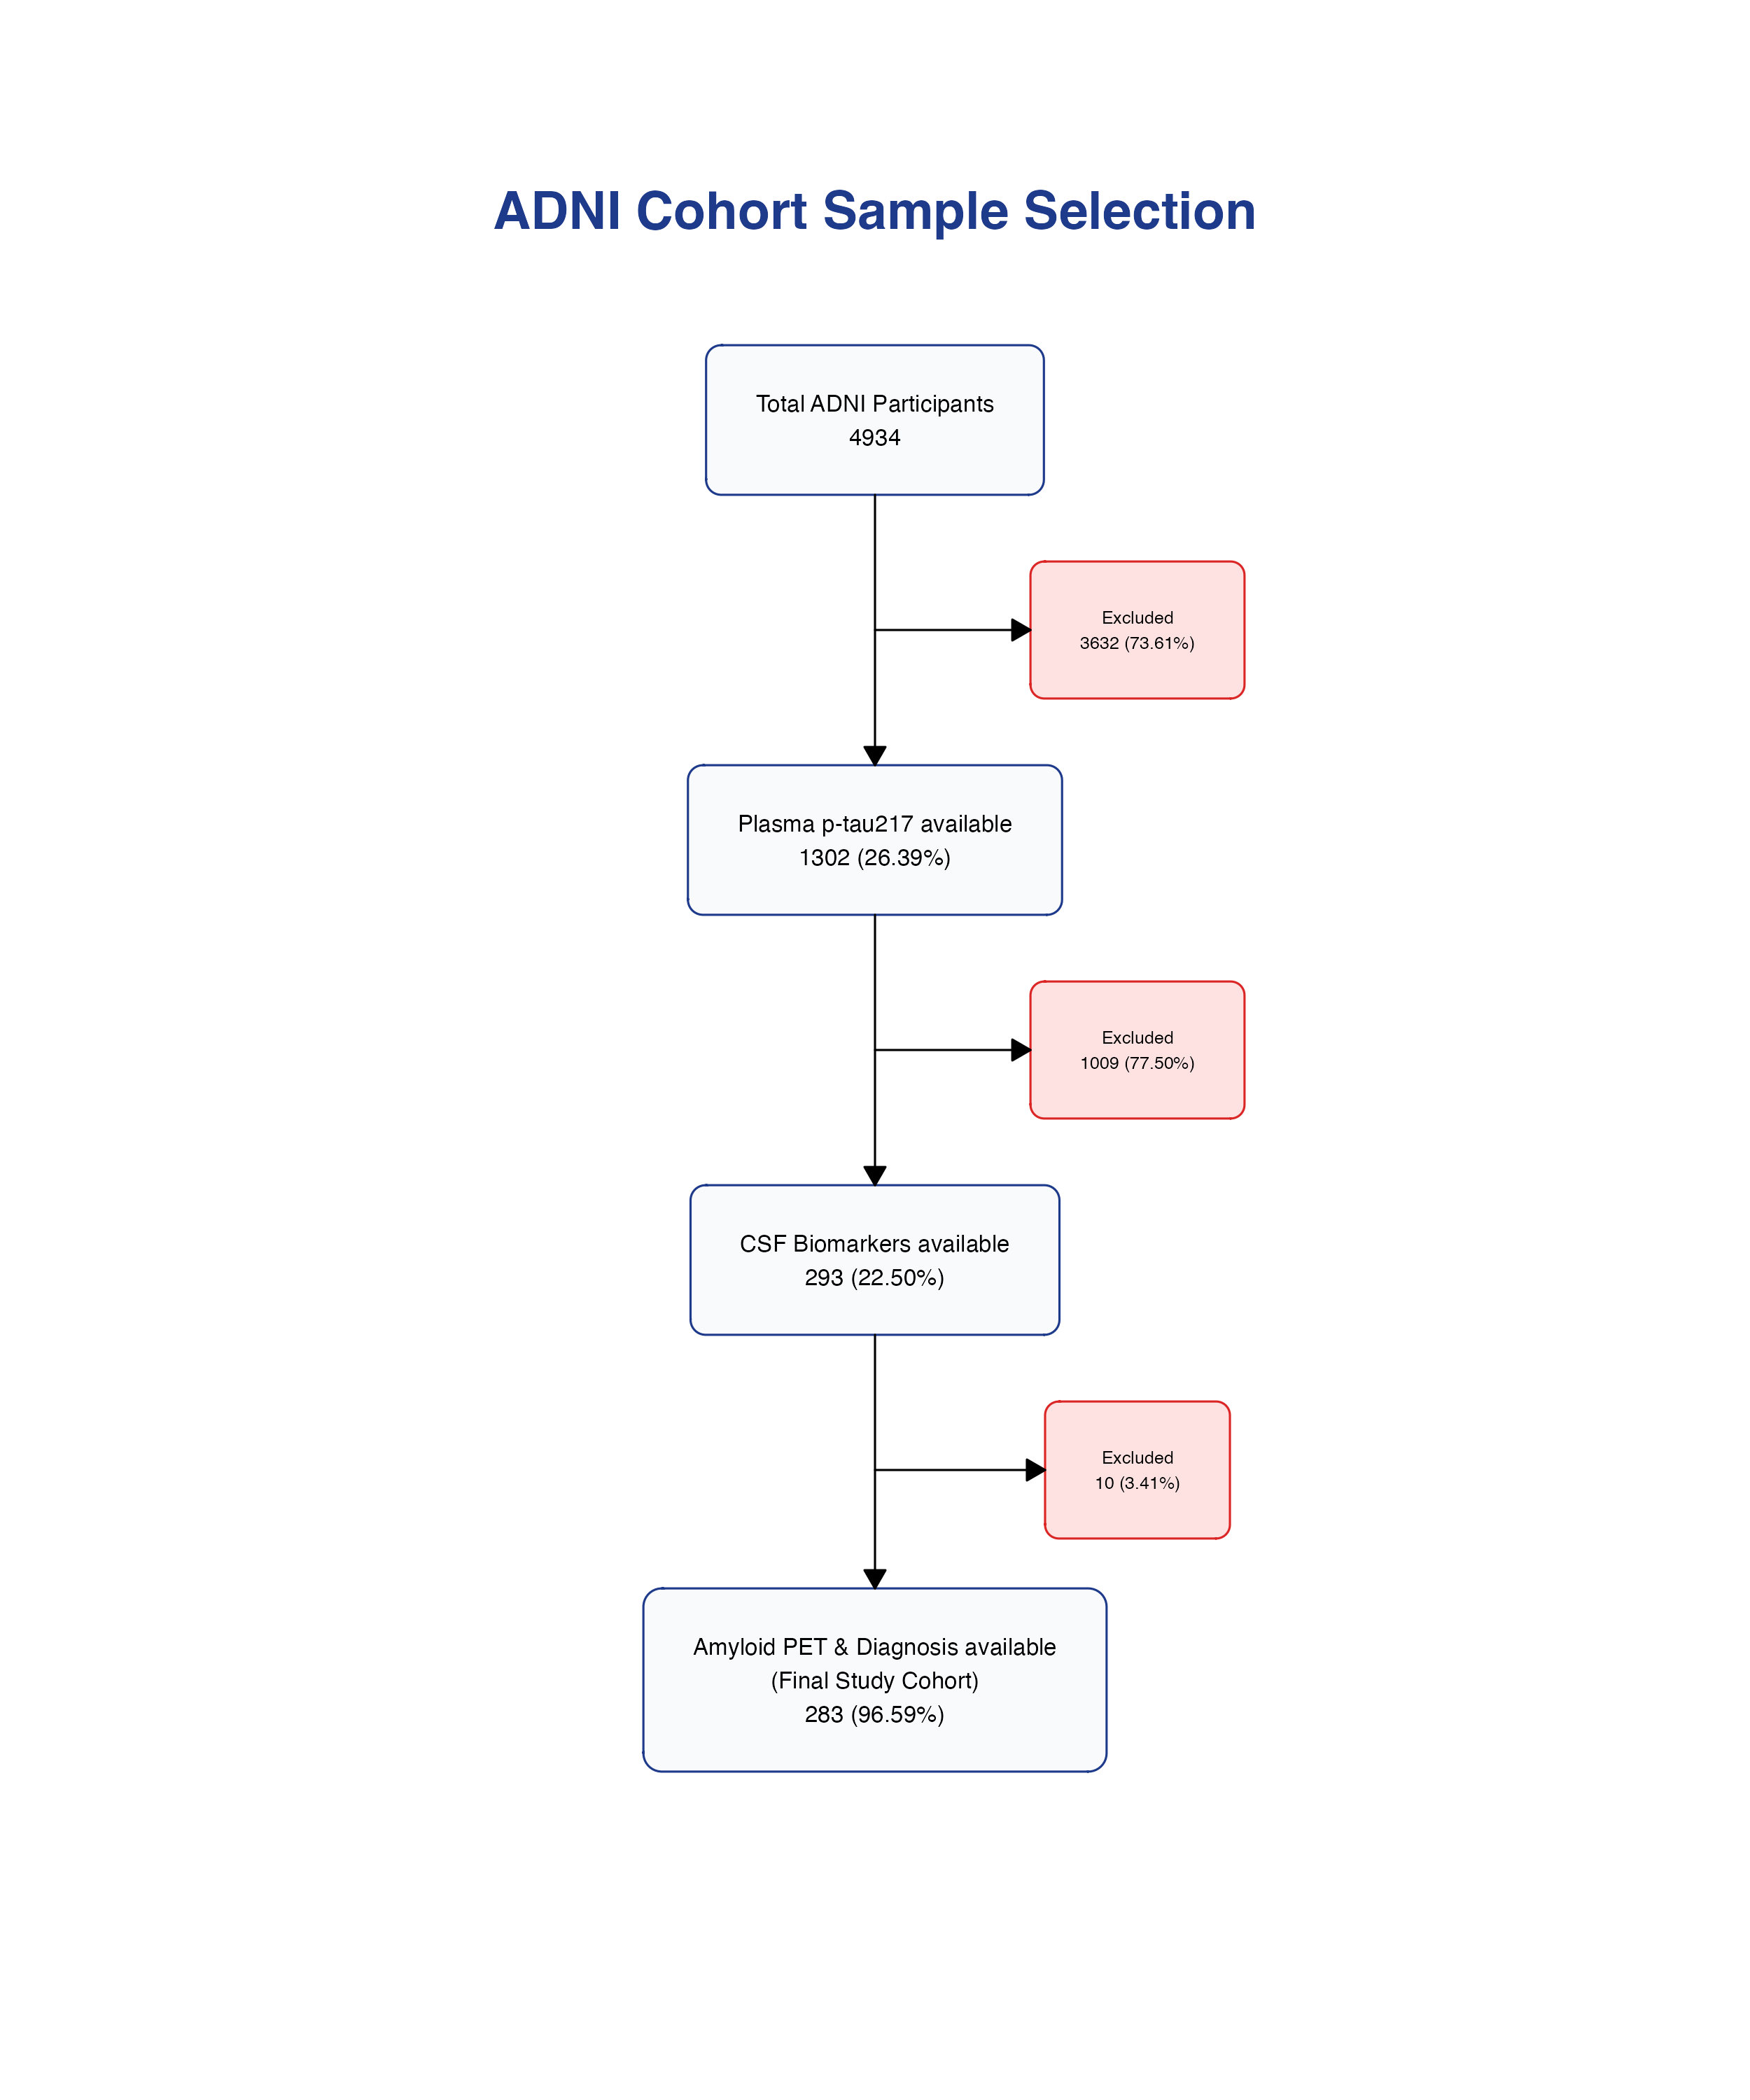
Figure S1. Inclusion required the concurrent availability of plasma p-tau217, both core cerebrospinal fluid (CSF) biomarker ratios (p-tau181/Aβ42 and Aβ42/40), amyloid PET and a clinical diagnosis at the same study visit. Of 4,934 ADNI participants with demographic data, 1,302 (26.4%) had a plasma p-tau217 measurement, 293 of those (22.5%) also had both CSF ratios at the same visit, and 283 of those (96.6%) also had amyloid PET and a recorded diagnosis, forming the study cohort; 265 of them (94%) additionally had tau PET. The percentage shown in each box is the proportion of participants retained relative to the preceding box, not to the initial sample.
Abbreviations: ADNI, Alzheimer's Disease Neuroimaging Initiative; CSF, cerebrospinal fluid; PET, positron emission tomography; p-tau217, phosphorylated tau at threonine 217.
Table S1. Paired comparison of ROC performance between plasma p-tau217 and core CSF biomarkers
Panel A. Amyloid PET
 | PET threshold | Total N | Positive | Plasma AUC | CSF AUC | ΔAUC  [95% CI] | Raw p | FDR q
Symptomatic
CSF Aβ42/40 | Centiloid 18 | 135 | 79 | 0.95 | 0.98 | -0.03  [-0.06 to 0.00] | 0.07 | 0.32
CSF p-tau181/Aβ42 | Centiloid 18 | 135 | 79 | 0.95 | 0.98 | -0.03  [-0.06 to -0.01] | 0.02 | 0.26
CSF Aβ42/40 | Centiloid 37 | 135 | 67 | 0.96 | 0.94 | 0.02  [-0.02 to 0.06] | 0.29 | 0.70
CSF p-tau181/Aβ42 | Centiloid 37 | 135 | 67 | 0.96 | 0.95 | 0.01  [-0.03 to 0.04] | 0.77 | 0.92
CSF Aβ42/40 | Centiloid 45 | 135 | 65 | 0.95 | 0.94 | 0.01  [-0.03 to 0.06] | 0.56 | 0.80
CSF p-tau181/Aβ42 | Centiloid 45 | 135 | 65 | 0.95 | 0.95 | 0.00  [-0.03 to 0.04] | 0.97 | 0.97
CU
CSF Aβ42/40 | Centiloid 18 | 148 | 42 | 0.89 | 0.89 | -0.01  [-0.08 to 0.07] | 0.90 | 0.97
CSF p-tau181/Aβ42 | Centiloid 18 | 148 | 42 | 0.89 | 0.92 | -0.03  [-0.10 to 0.05] | 0.48 | 0.80
CSF Aβ42/40 | Centiloid 37 | 148 | 29 | 0.93 | 0.96 | -0.04  [-0.08 to 0.01] | 0.11 | 0.33
CSF p-tau181/Aβ42 | Centiloid 37 | 148 | 29 | 0.93 | 0.97 | -0.04  [-0.09 to 0.01] | 0.08 | 0.32
CSF Aβ42/40 | Centiloid 45 | 148 | 24 | 0.95 | 0.96 | -0.01  [-0.05 to 0.03] | 0.60 | 0.80
CSF p-tau181/Aβ42 | Centiloid 45 | 148 | 24 | 0.95 | 0.96 | -0.01  [-0.05 to 0.02] | 0.51 | 0.80
ΔAUC > 0 indicates plasma outperforms CSF. Significance evaluated after false discovery rate correction: *** q < 0.001, ** q < 0.01, * q < 0.05.

Panel B. Tau PET
 | Braak stage | Total N | Positive | Plasma AUC | CSF AUC | ΔAUC  [95% CI] | Raw p | FDR q
Symptomatic
CSF Aβ42/40 | Braak I-II | 86 | 21 | 0.88 | 0.87 | 0.01  [-0.06 to 0.08] | 0.78 | 0.87
CSF p-tau181/Aβ42 | Braak I-II | 86 | 21 | 0.88 | 0.87 | 0.00  [-0.07 to 0.07] | 0.93 | 0.93
CSF Aβ42/40 | Braak I-VI | 125 | 60 | 0.93 | 0.90 | 0.03  [-0.02 to 0.08] | 0.25 | 0.81
CSF p-tau181/Aβ42 | Braak I-VI | 125 | 60 | 0.93 | 0.91 | 0.02  [-0.03 to 0.06] | 0.43 | 0.81
CSF Aβ42/40 | Braak III-IV | 75 | 10 | 0.89 | 0.93 | -0.04  [-0.15 to 0.07] | 0.52 | 0.81
CSF p-tau181/Aβ42 | Braak III-IV | 75 | 10 | 0.89 | 0.92 | -0.03  [-0.13 to 0.07] | 0.57 | 0.81
CSF Aβ42/40 | Braak V-VI | 94 | 29 | 0.98 | 0.92 | 0.07  [0.01 to 0.12] | 0.02 | 0.14
CSF p-tau181/Aβ42 | Braak V-VI | 94 | 29 | 0.98 | 0.94 | 0.04  [0.00 to 0.08] | 0.03 | 0.14
CU
CSF Aβ42/40 | Braak I-VI | 140 | 15 | 0.87 | 0.85 | 0.03  [-0.06 to 0.11] | 0.54 | 0.81
CSF p-tau181/Aβ42 | Braak I-VI | 140 | 15 | 0.87 | 0.88 | -0.01  [-0.08 to 0.06] | 0.78 | 0.87
ΔAUC > 0 indicates plasma outperforms CSF. Significance evaluated after false discovery rate correction: *** q < 0.001, ** q < 0.01, * q < 0.05.

Table S1. Paired DeLong comparisons of the area under the ROC curve between plasma p-tau217 and each CSF ratio. ΔAUC is calculated as plasma AUC minus CSF AUC, so positive values favour plasma. Raw p-values and Benjamini-Hochberg false discovery rate q-values are given. In cognitively unimpaired participants only Braak I-VI could be modelled, because too few participants had isolated higher-stage tau pathology. Because these are tests of the null hypothesis of equal AUCs, a non-significant result indicates that no difference was detected and does not establish equivalence; the confidence intervals should be inspected to judge which differences remain compatible with the data.
Abbreviations: Aβ, amyloid beta; AUC, area under the receiver operating characteristic curve; CI, confidence interval; CSF, cerebrospinal fluid; FDR, false discovery rate; ROC, receiver operating characteristic.
Figure S2. Classification patterns at each threshold
Panel A. Youden threshold
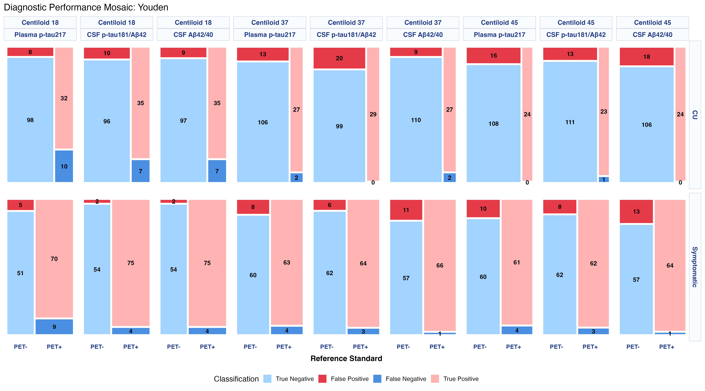
Panel B. Threshold constrained to 95% sensitivity
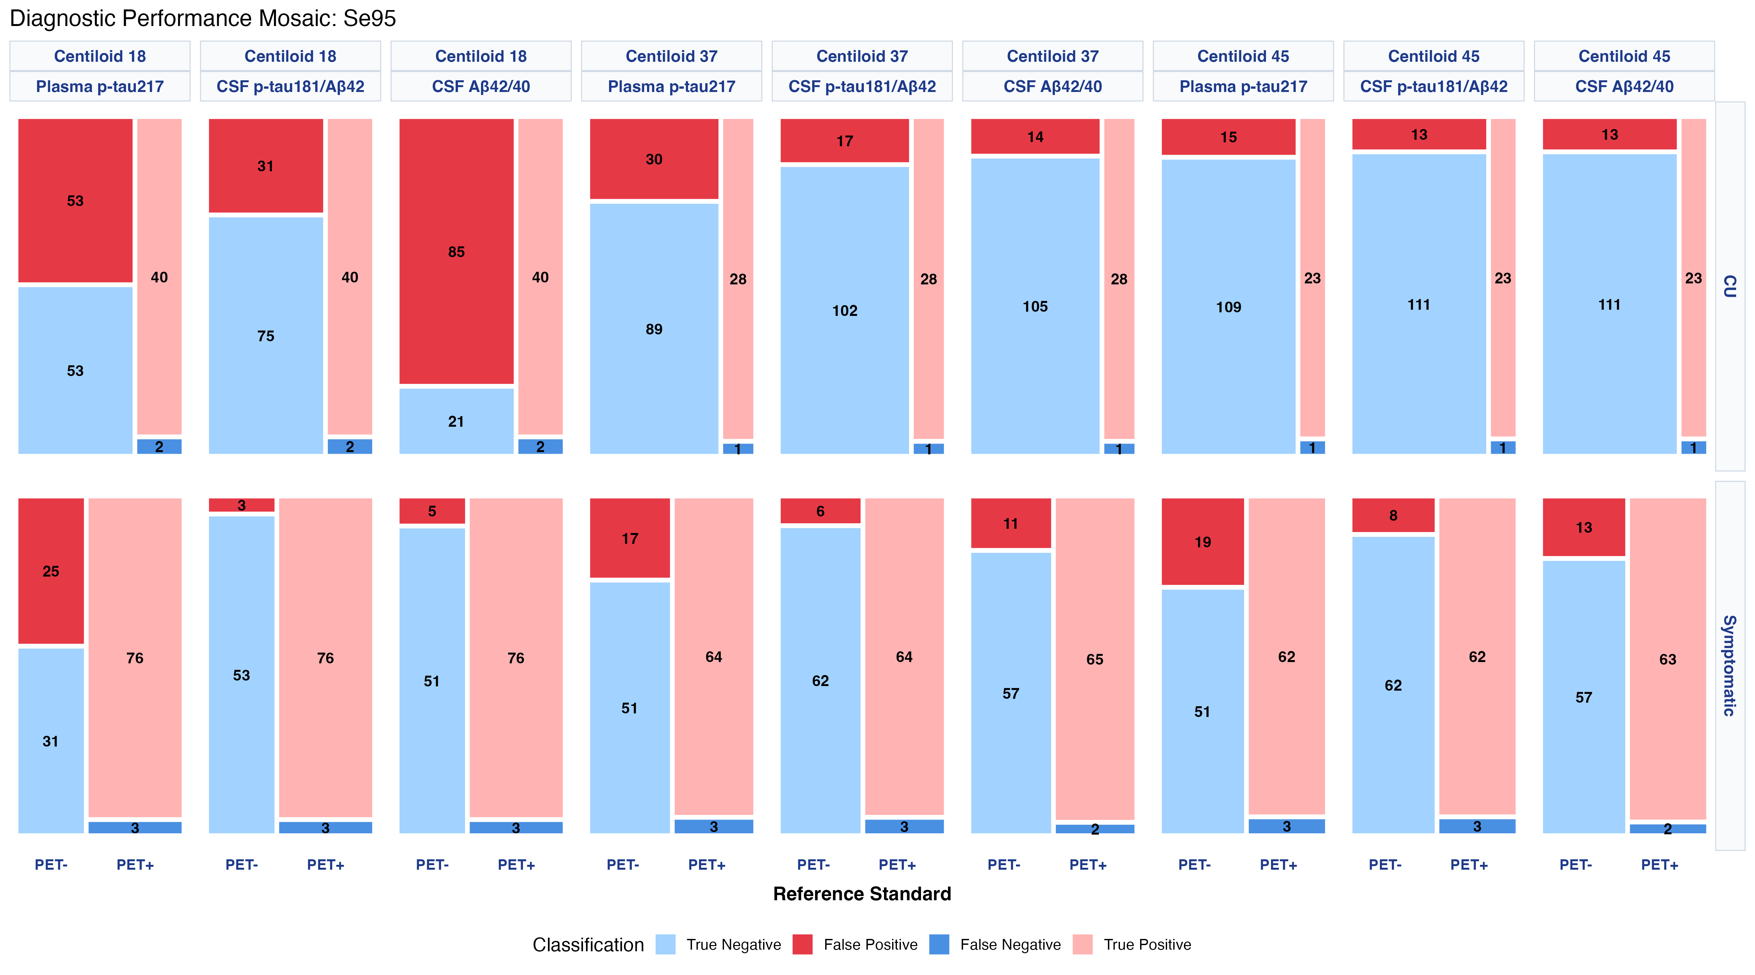
Panel C. Threshold constrained to 95% specificity
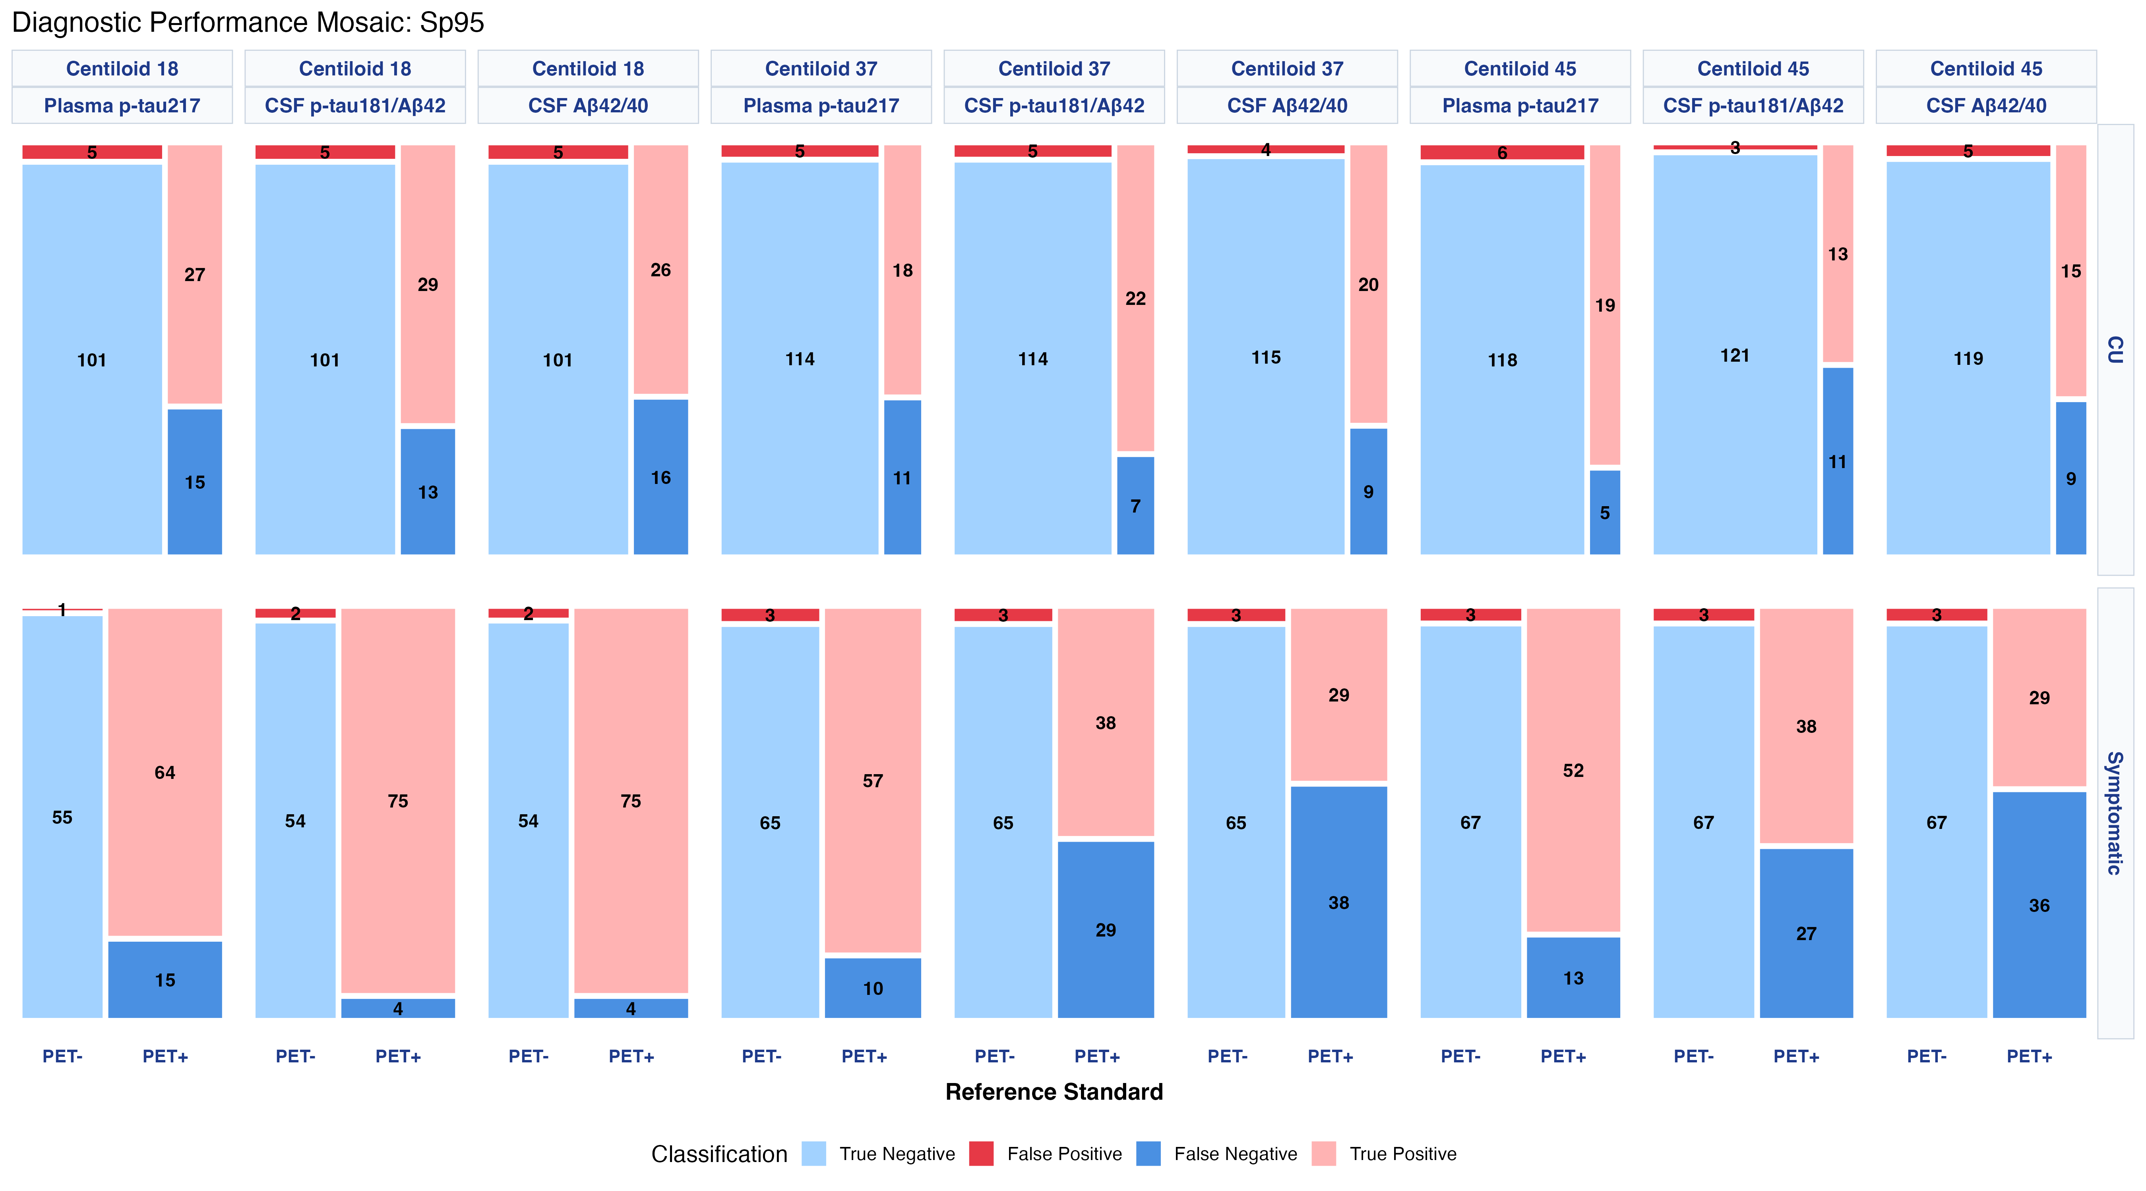
Figure S2. Mosaic plots of the contingency tables relating each fluid biomarker classification to amyloid PET positivity at Centiloid 18, 37 and 45, stratified by clinical status. Cell areas are proportional to the number of participants.
Abbreviations: CSF, cerebrospinal fluid; PET, positron emission tomography; p-tau217, phosphorylated tau at threonine 217.
Table S2. Plasma p-tau217 thresholds across amyloid PET targets
Panel A. Cognitively unimpaired participants
 | Early amyloid  (CL ≥ 18) | Intermediate  (CL ≥ 37) | Advanced  (CL ≥ 45)
Optimal (Youden)  Maximum accuracy | 0.17  [0.12 – 0.19] | 0.17  [0.17 – 0.20] | 0.17  [0.17 – 0.25]
High sensitivity (Se95)  Rule-out | 0.10  [0.07 – 0.13] | 0.13  [0.09 – 0.19] | 0.18  [0.17 – 0.25]
High specificity (Sp95)  Rule-in | 0.20  [0.17 – 0.46] | 0.26  [0.18 – 0.90] | 0.25  [0.20 – 0.63]

Panel B. Symptomatic participants
 | Early amyloid  (CL ≥ 18) | Intermediate  (CL ≥ 37) | Advanced  (CL ≥ 45)
Optimal (Youden)  Maximum accuracy | 0.18  [0.18 – 0.32] | 0.20  [0.20 – 0.33] | 0.20  [0.20 – 0.35]
High sensitivity (Se95)  Rule-out | 0.11  [0.10 – 0.16] | 0.16  [0.14 – 0.28] | 0.16  [0.14 – 0.28]
High specificity (Sp95)  Rule-in | 0.27  [0.18 – 0.32] | 0.32  [0.23 – 0.37] | 0.35  [0.27 – 0.61]

Table S2. Plasma p-tau217 thresholds (pg/mL) with bootstrap 95% confidence intervals (1000 resamples), derived within this sample at three amyloid PET targets. The Youden threshold was comparatively stable (0.17 pg/mL at every target in cognitively unimpaired participants; 0.18-0.20 pg/mL in symptomatic participants), whereas the boundaries of the indeterminate zone moved with the target burden: the rule-out threshold (95% sensitivity) rose from 0.10 to 0.18 pg/mL in cognitively unimpaired participants and from 0.11 to 0.16 pg/mL in symptomatic participants, and the rule-in threshold (95% specificity) rose from 0.20 to 0.25 pg/mL (peak 0.26 pg/mL at CL 37) and from 0.27 to 0.35 pg/mL, respectively. All thresholds were derived and applied within the same sample and are optimistically biased; they are reported to compare biomarkers under a common framework and not as clinical decision limits.
Abbreviations: CL, Centiloid; Se95, threshold constrained to 95% sensitivity; Sp95, threshold constrained to 95% specificity.
Figure S3. Reclassification flows within the plasma indeterminate zone (amyloid PET)
Panel A. CSF p-tau181/Aβ42
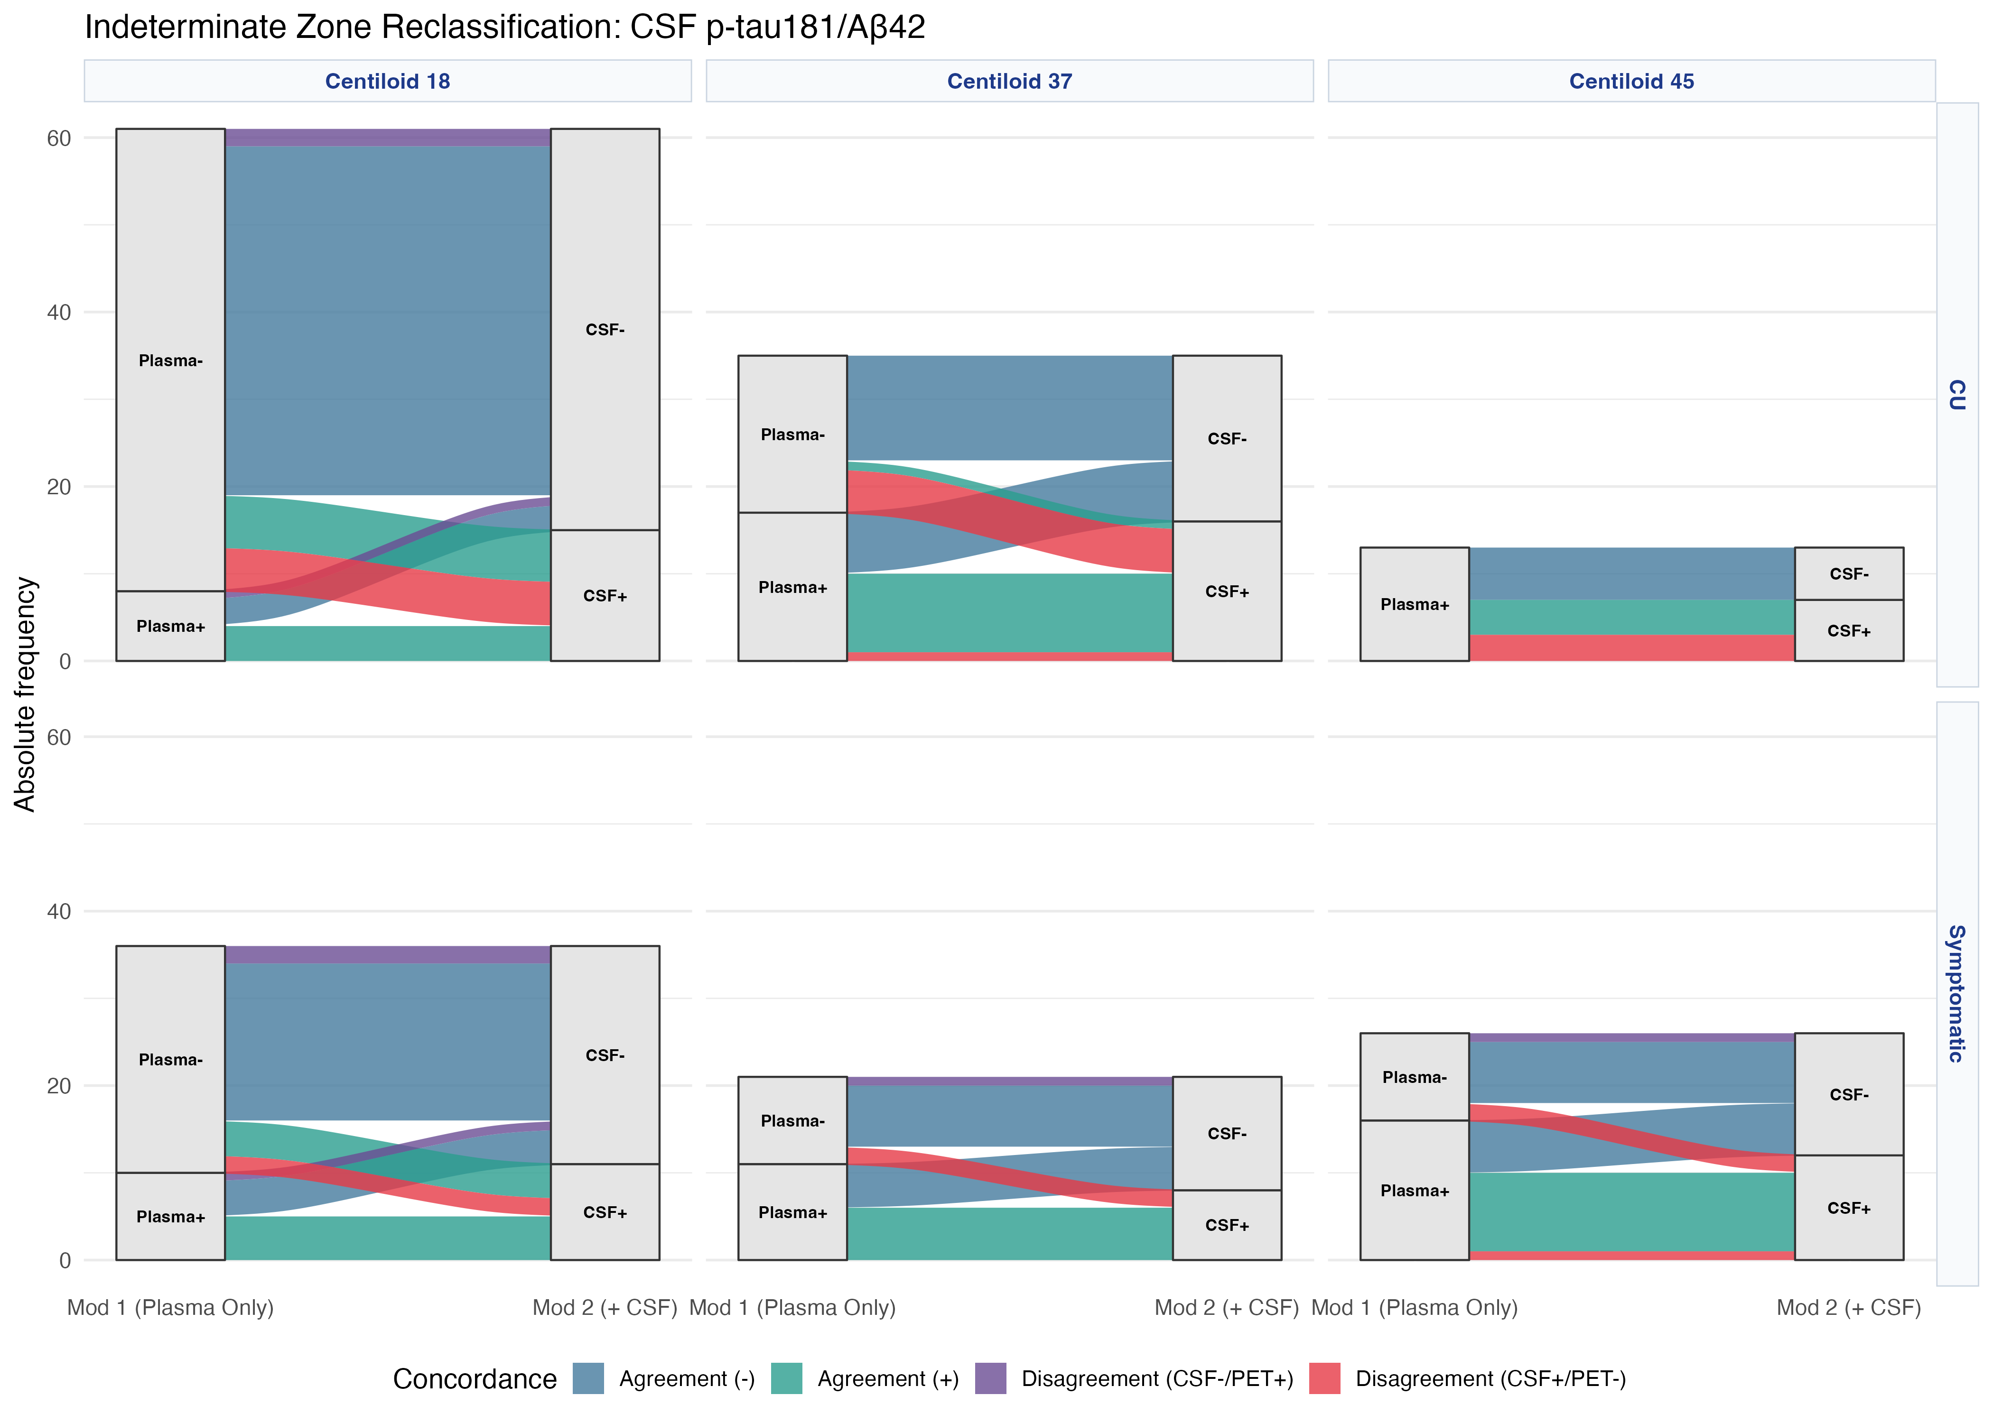
Panel B. CSF Aβ42/40
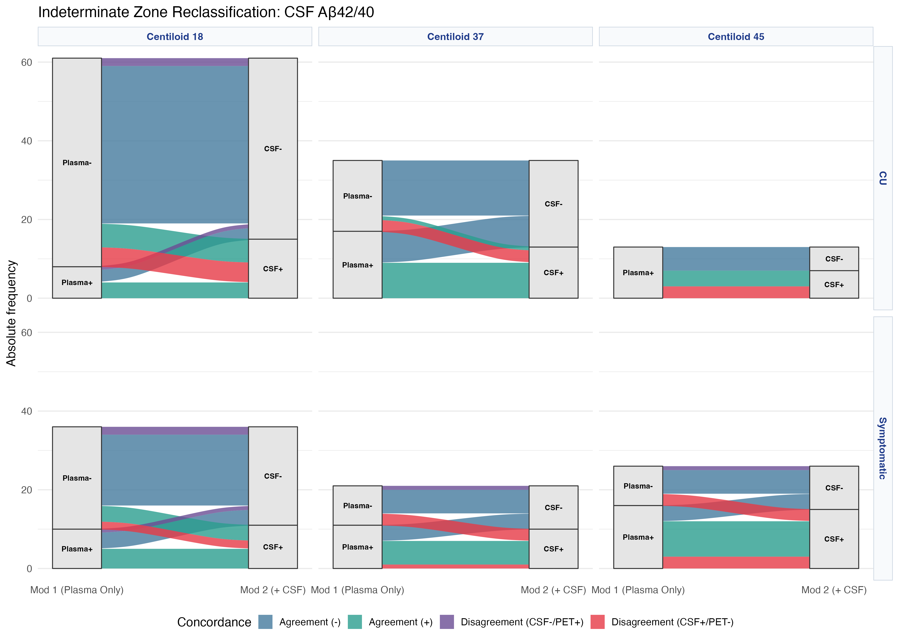
Figure S3. Alluvial plots showing the trajectories of participants with an indeterminate plasma p-tau217 result when a second step based on CSF is added, stratified by clinical status and evaluated against amyloid PET thresholds of 18, 37 and 45 Centiloids. Column height represents the number of participants in the indeterminate zone at each threshold and ribbon width is proportional to the number of participants following each trajectory. Colour denotes concordance with the amyloid PET reference standard after the second step, with red bands marking trajectories in which CSF testing produced a classification that conflicted with PET.
Figure S4. Reclassification flows within the plasma indeterminate zone (tau PET)
Panel A. CSF p-tau181/Aβ42
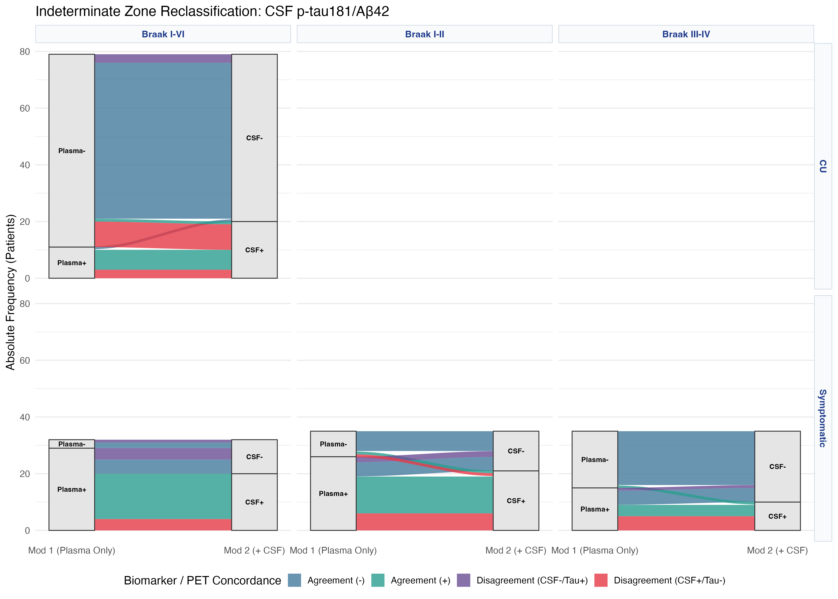
Panel B. CSF Aβ42/40
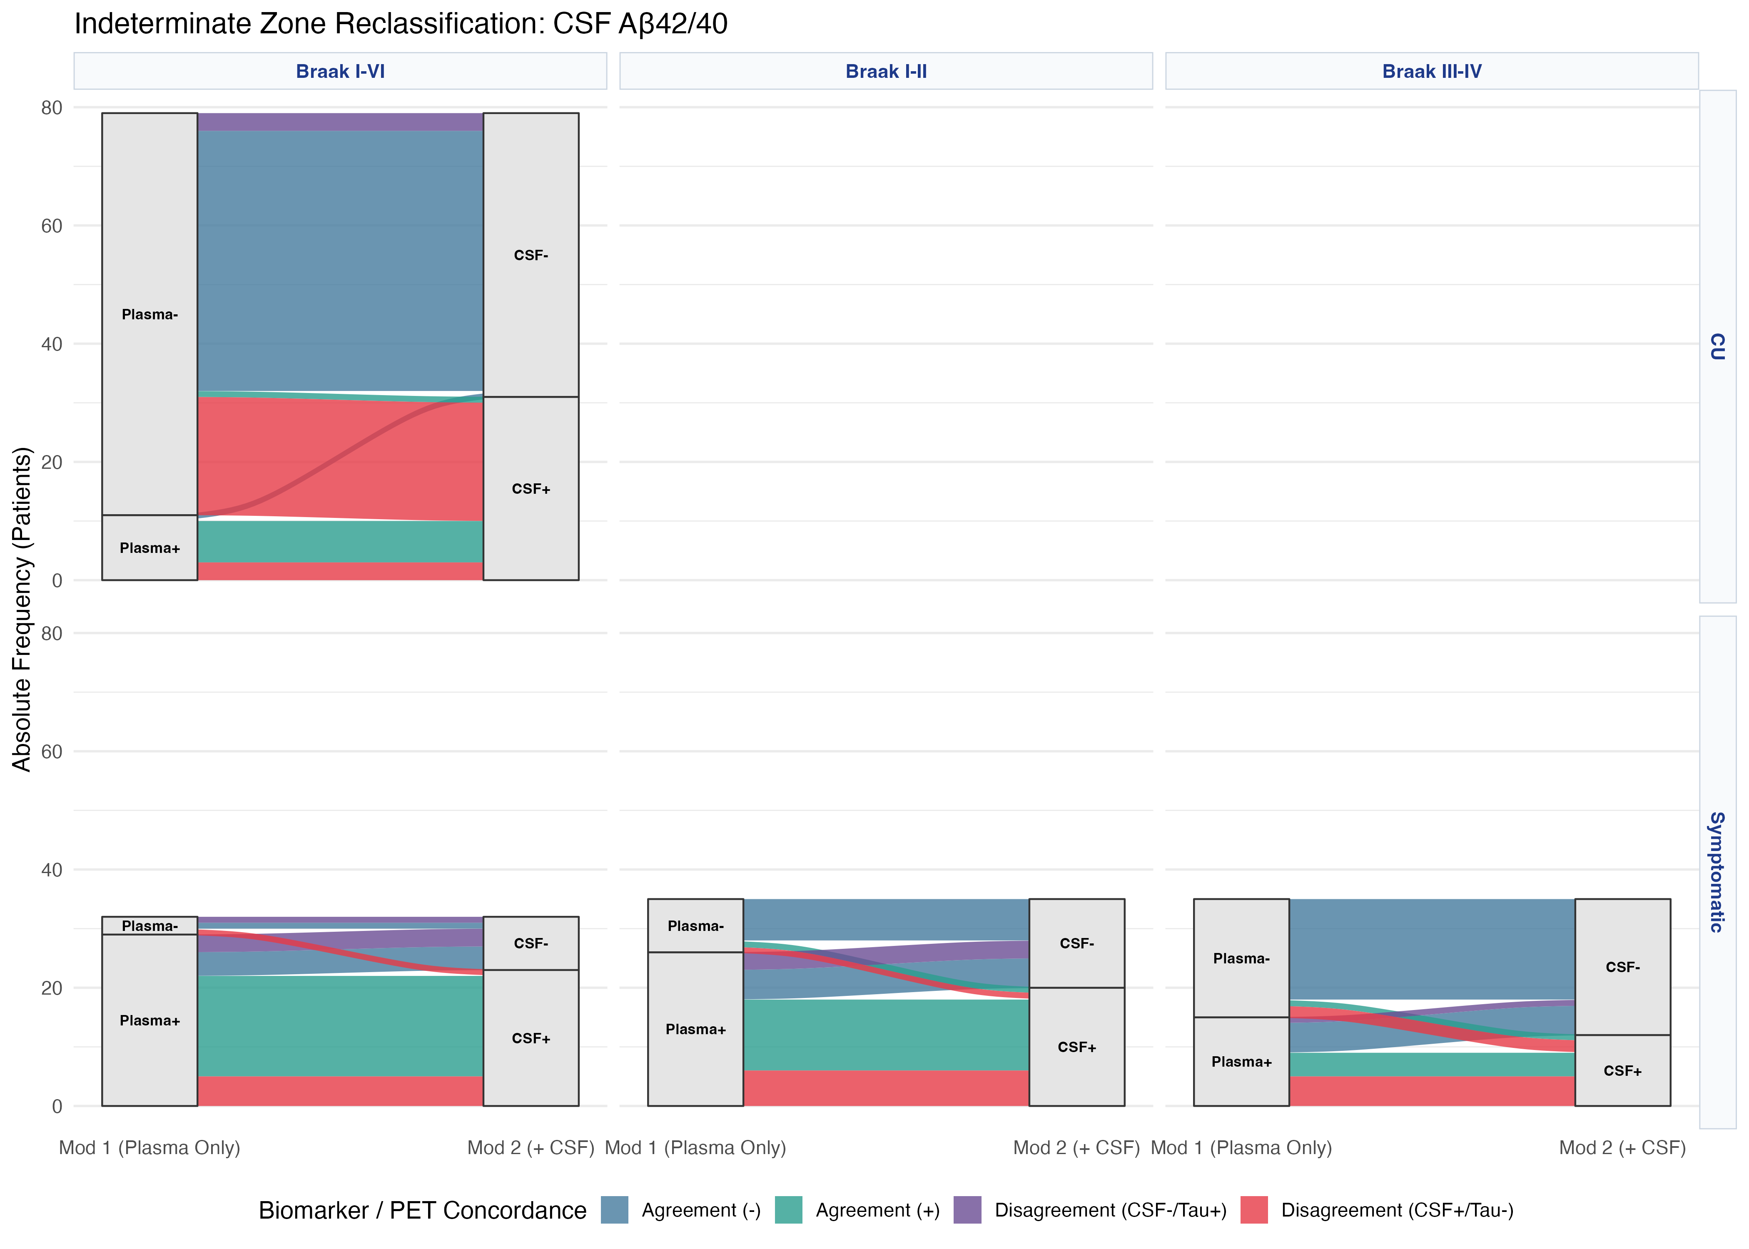
Figure S4. Alluvial plots for tau PET, following the same logic and colour coding as Figure S3. Positivity is defined by Braak stage rather than on the Centiloid scale because of the regional distribution of the tau radioligand signal. No symptomatic participant fell within the plasma indeterminate zone at Braak V-VI.
Table S3. Plasma p-tau217 thresholds across tau PET stages
Panel A. Cognitively unimpaired participants
 | Braak I-VI | Braak I-II | Braak III-IV | Braak V-VI
Optimal (Youden)  Maximum accuracy | 0.26  [0.12 – 0.32] | Insufficient N | Insufficient N | Insufficient N
High sensitivity (Se95)  Rule-out | 0.10  [0.10 – 0.19] | Insufficient N | Insufficient N | Insufficient N
High specificity (Sp95)  Rule-in | 0.44  [0.12 – 0.90] | Insufficient N | Insufficient N | Insufficient N

Panel B. Symptomatic participants
 | Braak I-VI | Braak I-II | Braak III-IV | Braak V-VI
Optimal (Youden)  Maximum accuracy | 0.17  [0.16 – 0.28] | 0.16  [0.14 – 0.24] | 0.18  [0.11 – 0.33] | 0.47  [0.27 – 0.54]
High sensitivity (Se95)  Rule-out | 0.16  [0.11 – 0.19] | 0.14  [0.14 – 0.18] | 0.11  [0.11 – 0.33] | 0.47  [0.27 – 0.54]
High specificity (Sp95)  Rule-in | 0.47  [0.24 – 0.81] | 0.47  [0.14 – 0.80] | 0.59  [0.13 – 0.92] | 0.47  [0.27 – 0.81]

Table S3. Plasma p-tau217 thresholds (pg/mL) with bootstrap 95% confidence intervals across tau PET Braak stages. In symptomatic participants, Youden thresholds rose as the target tau burden advanced, from 0.16 pg/mL (95% CI 0.14-0.24) at Braak I-II to 0.47 pg/mL (0.27-0.54) at Braak V-VI, whereas the 95%-sensitivity and 95%-specificity thresholds were more variable. In cognitively unimpaired participants only the Braak I-VI stratum could be modelled (Youden threshold 0.26 pg/mL, 95% CI 0.12-0.32), because too few participants showed isolated higher-stage tau pathology.
Abbreviations: CI, confidence interval; PET, positron emission tomography; p-tau217, phosphorylated tau at threonine 217.

