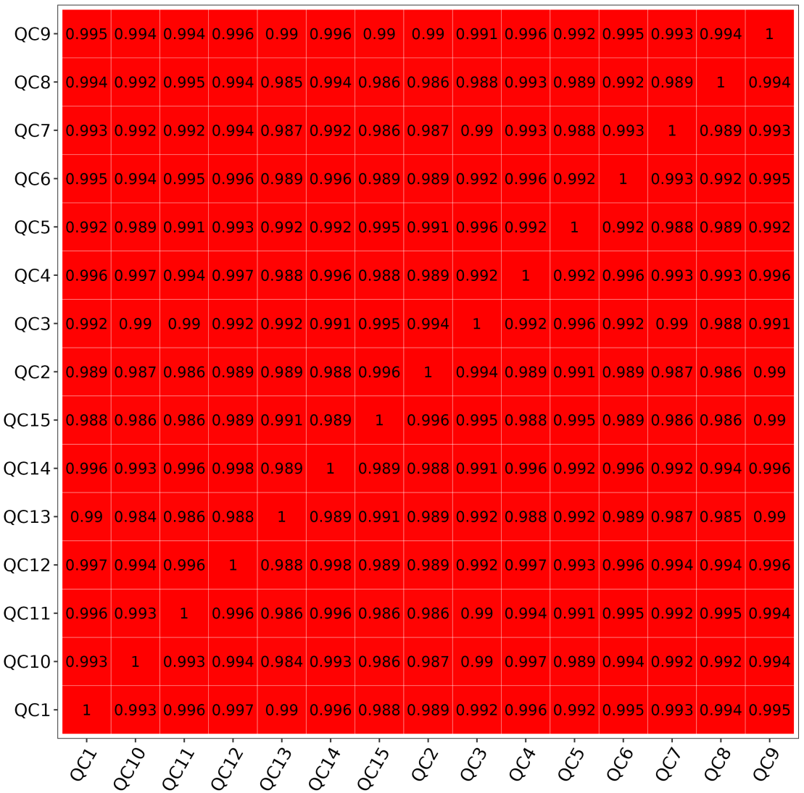
Suppl. Fig. 1 Pearson correlation heatmap of quality control samples

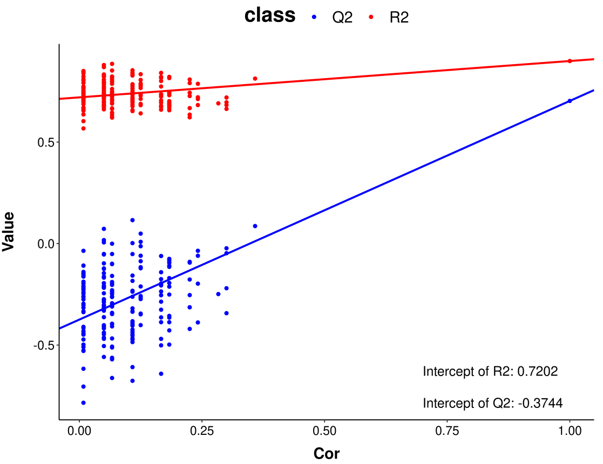
Suppl. Fig. 2 Permutation test of the PLS-DA model (PsA vs HC)
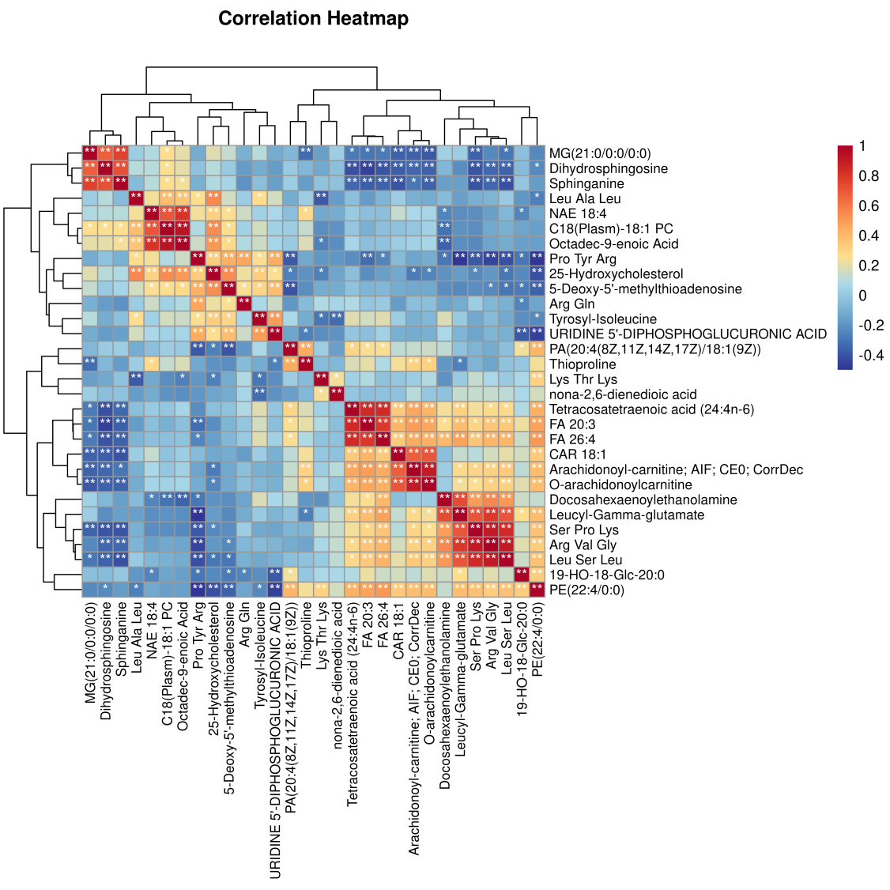
Suppl. Fig. 3 Correlation heatmap (PsA vs HC)

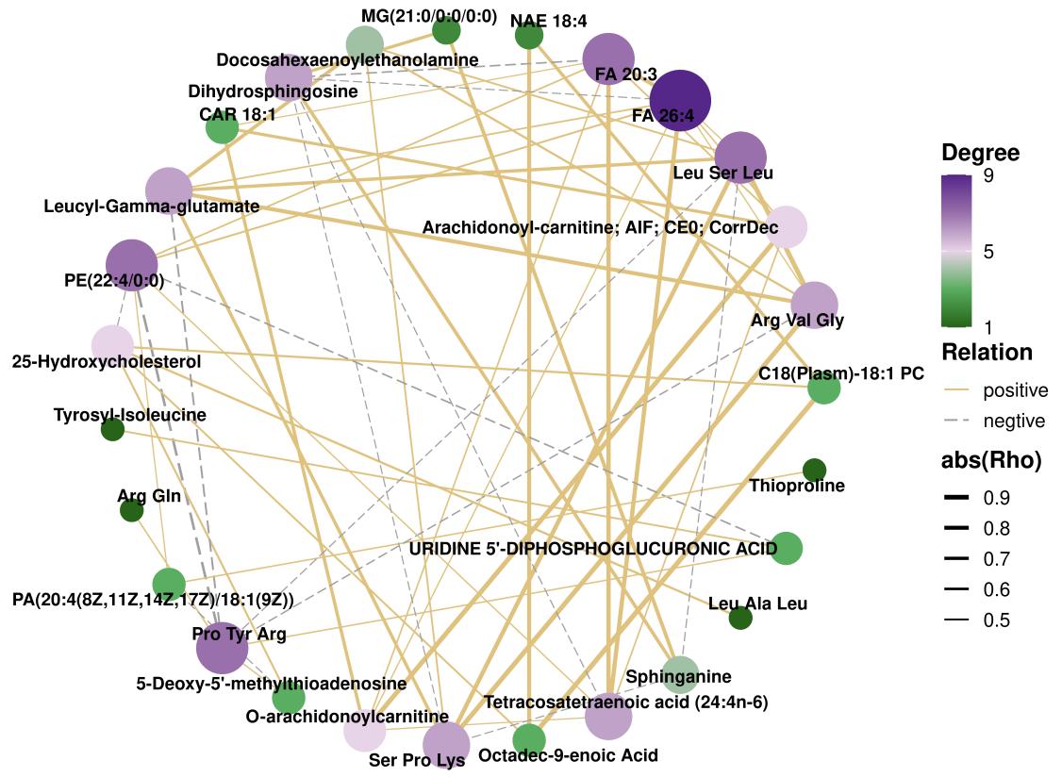
Suppl. Fig. 4 Correlation network (PsA vs HC)
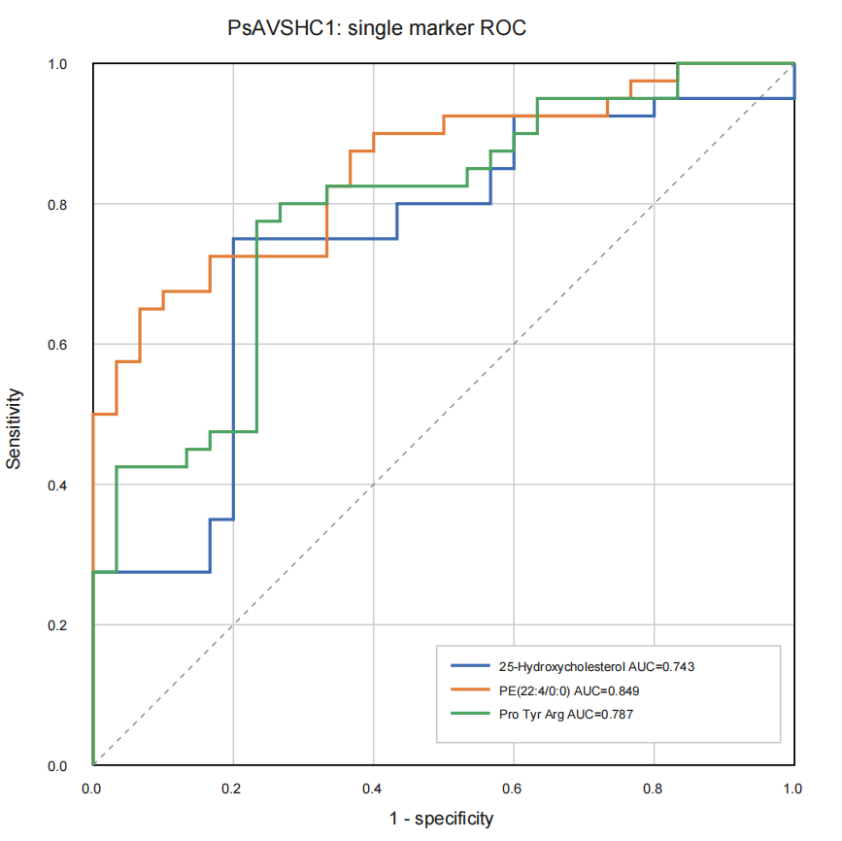
Suppl. Fig. 5 ROC curves of individual diagnostic markers (PsA vs HC)

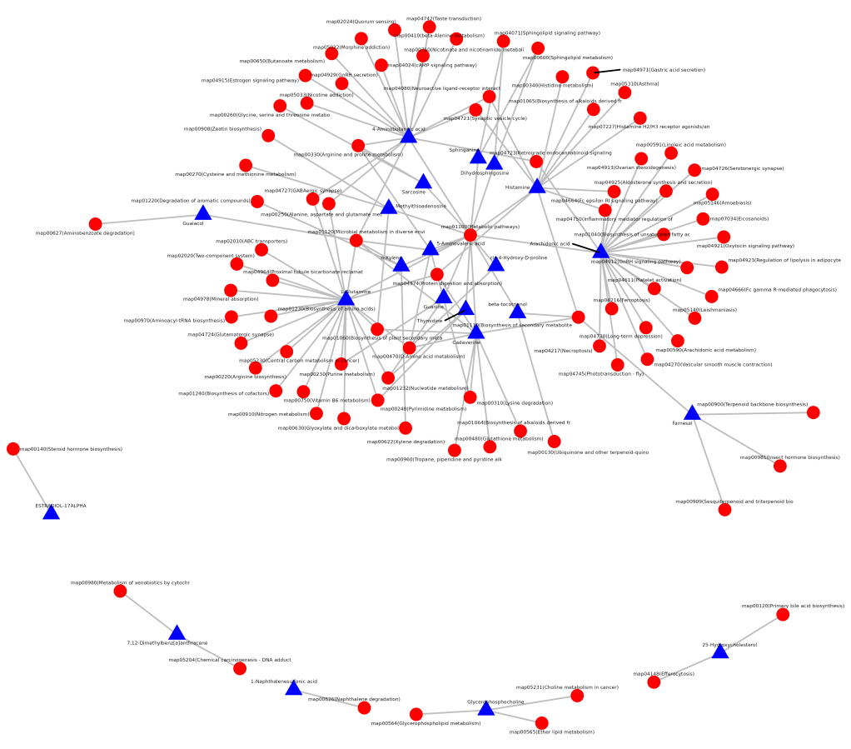
Suppl. Fig. 6 Differential metabolite-pathway association network (PsA vs HC)
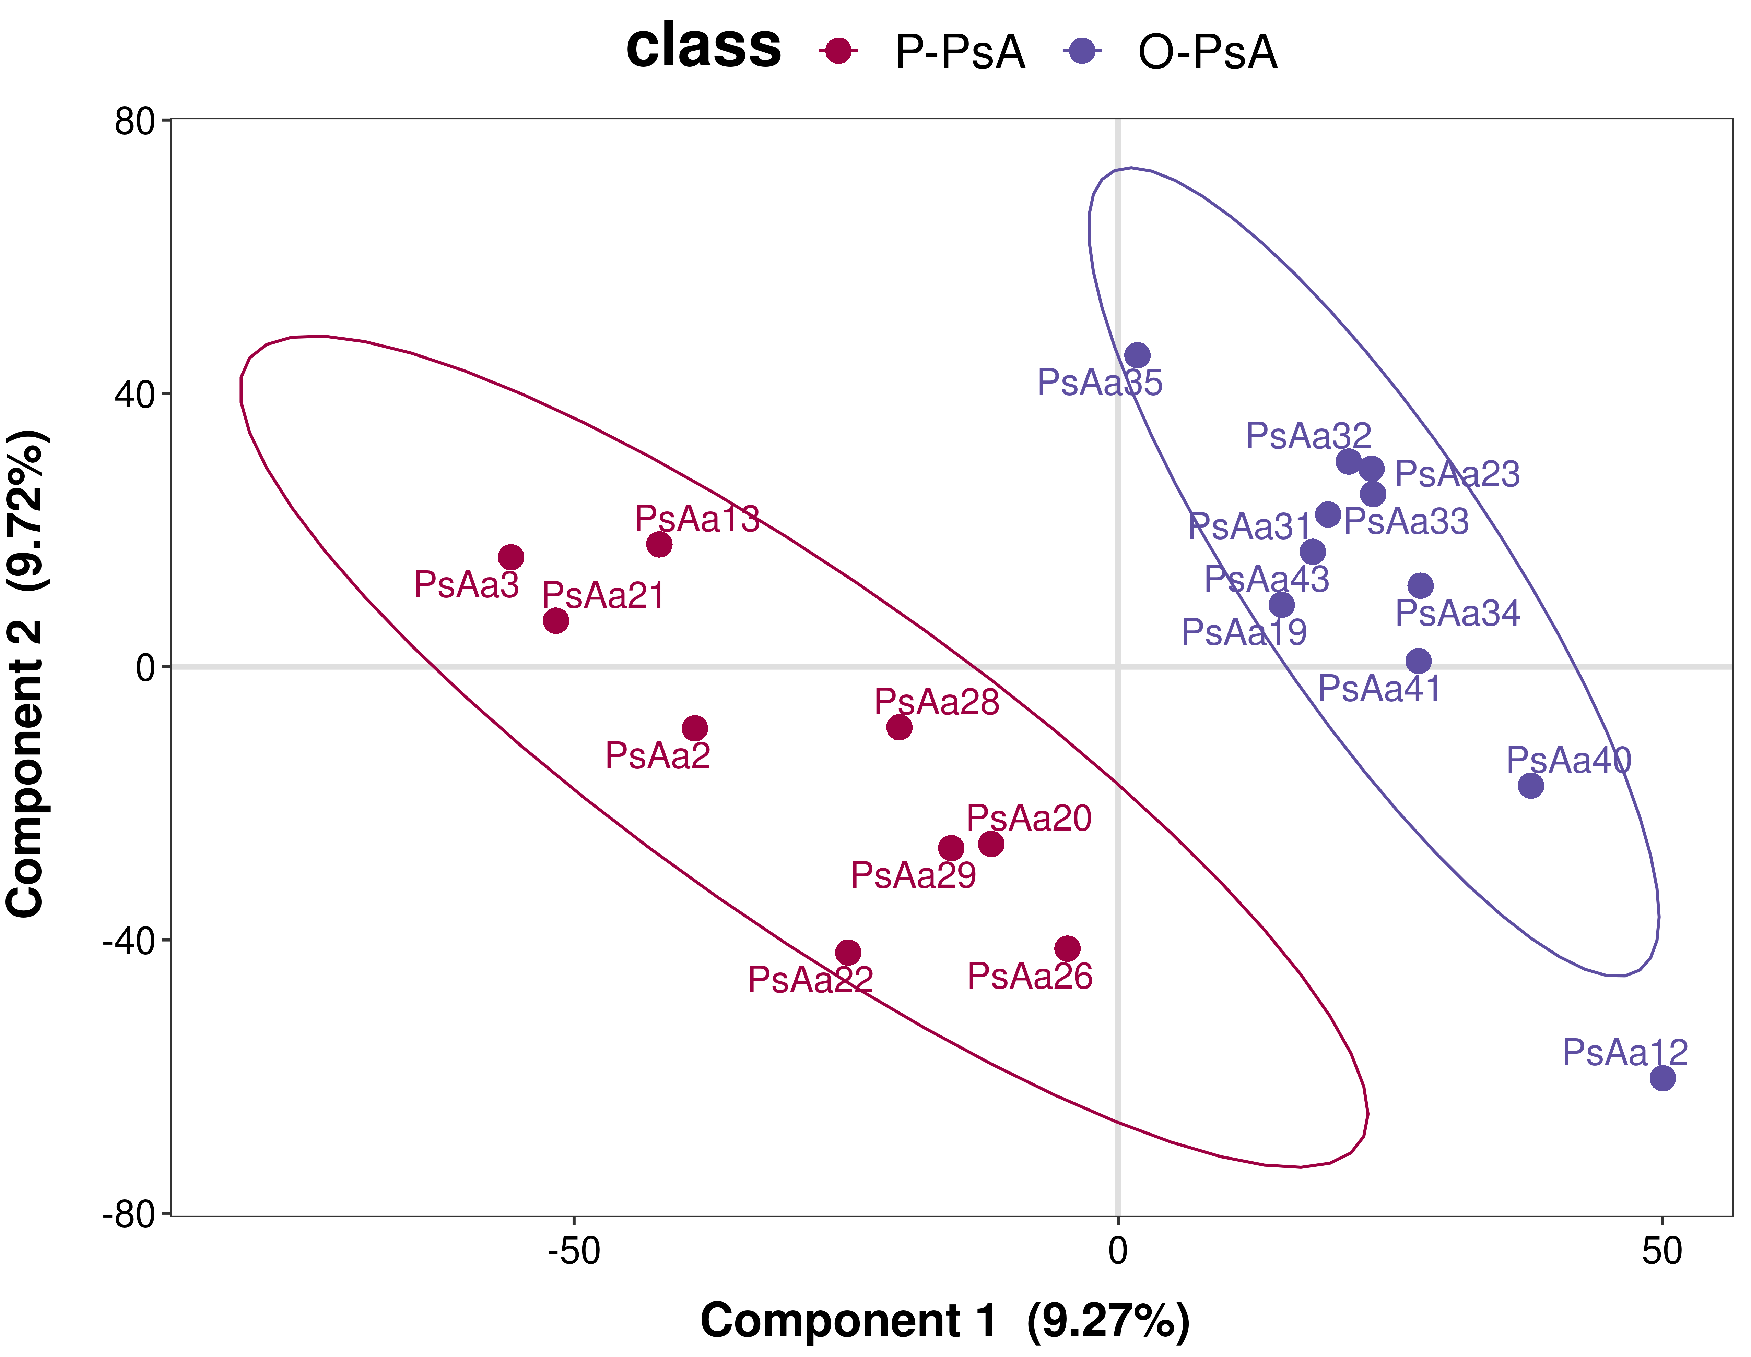
Suppl. Fig. 7 PLS-DA score plot (P-PsA vs O-PsA)

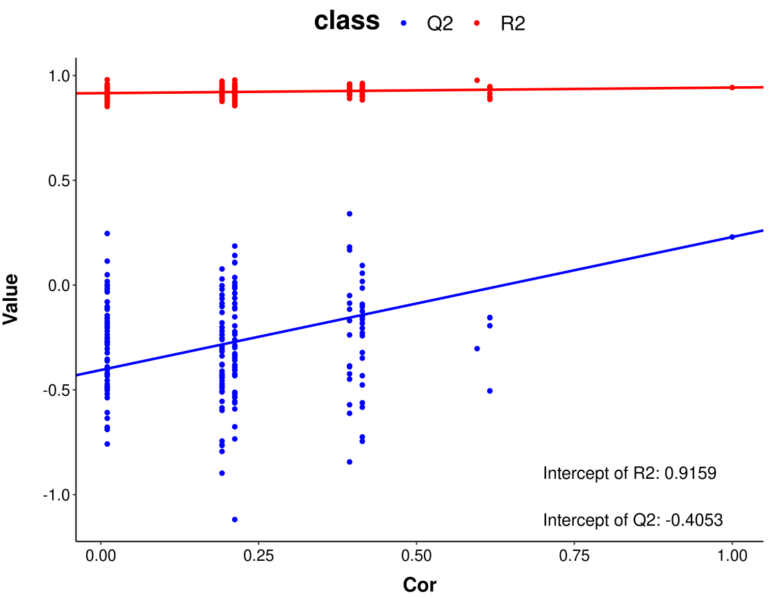
Suppl. Fig. 8 Permutation test of the PLS-DA model (P-PsA vs O-PsA)
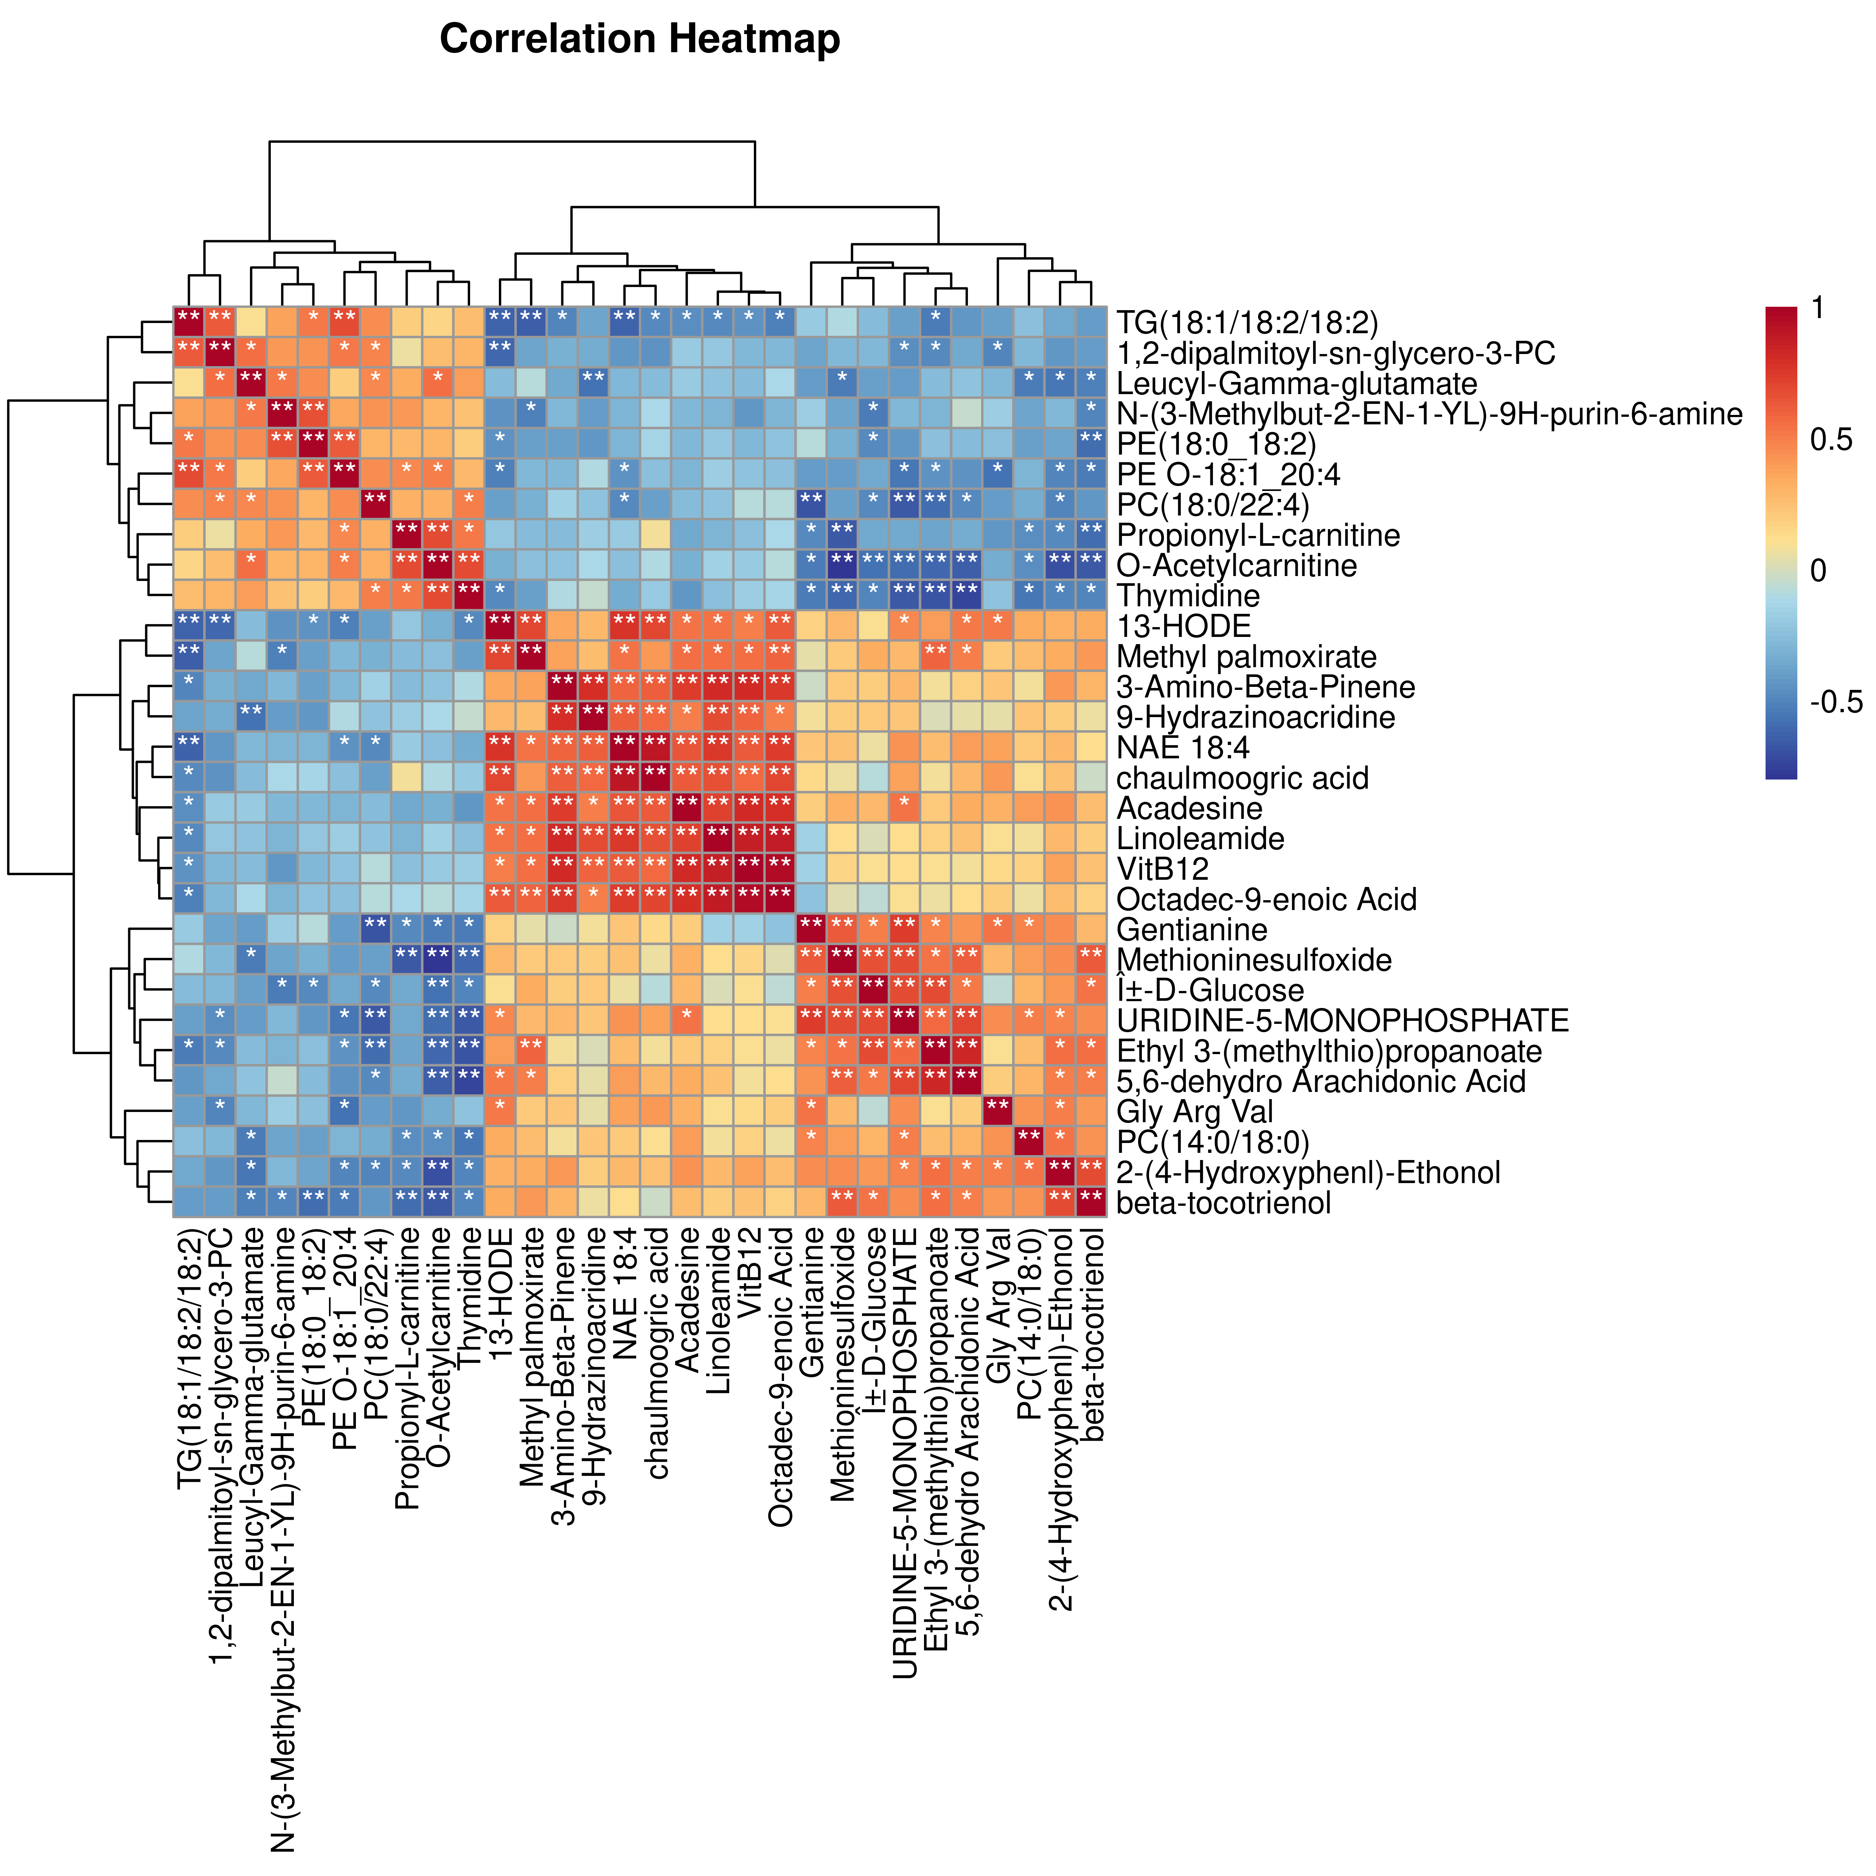
Suppl. Fig. 9 Correlation heatmap (P-PsA vs O-PsA)

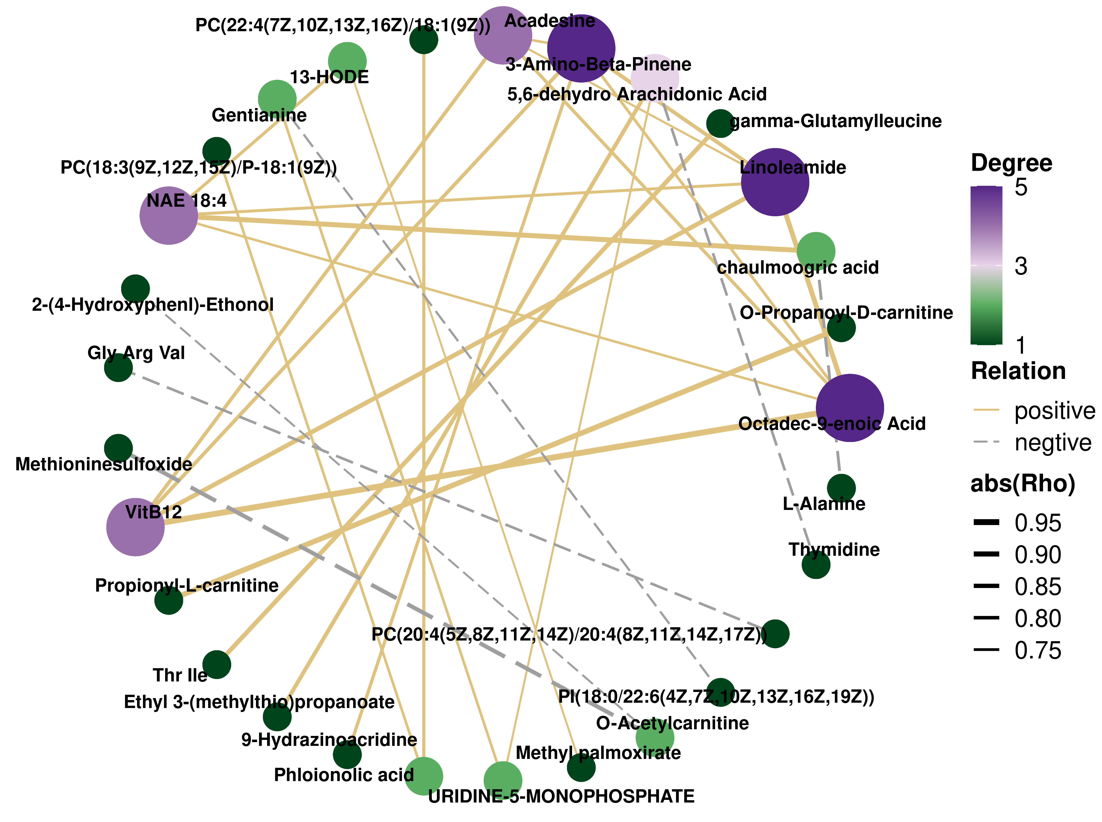
Suppl. Fig. 10 Correlation network (P-PsA vs O-PsA)
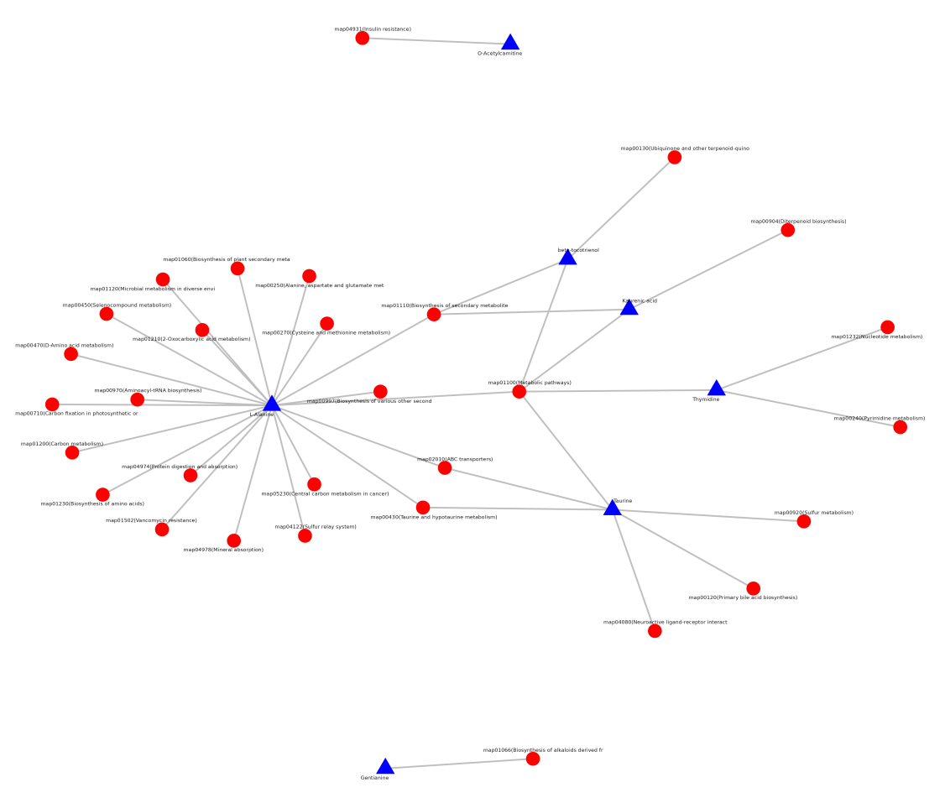
Suppl. Fig. 11 Differential metabolite-pathway association network (P-PsA vs O-PsA)

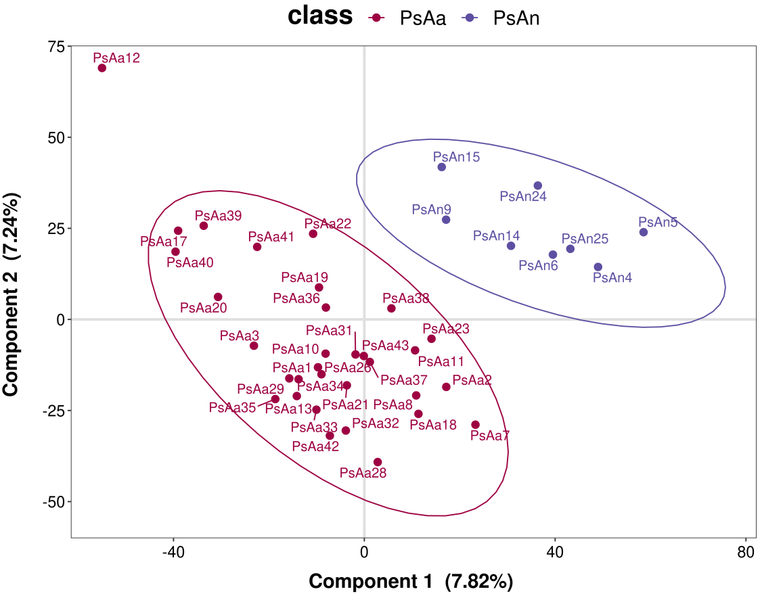
Suppl. Fig. 12 PLS-DA score plot (PsAa vs PsAn)
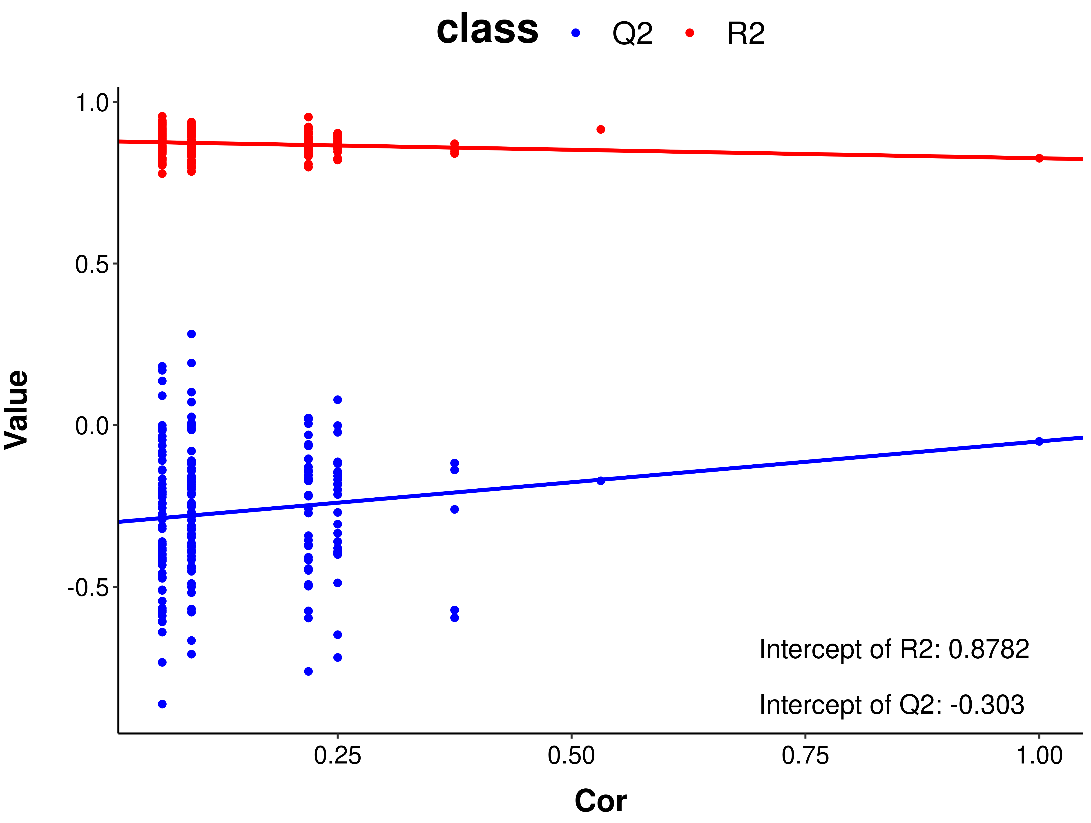
Suppl. Fig. 13 Permutation test of the PLS-DA model (PsAa vs PsAn)

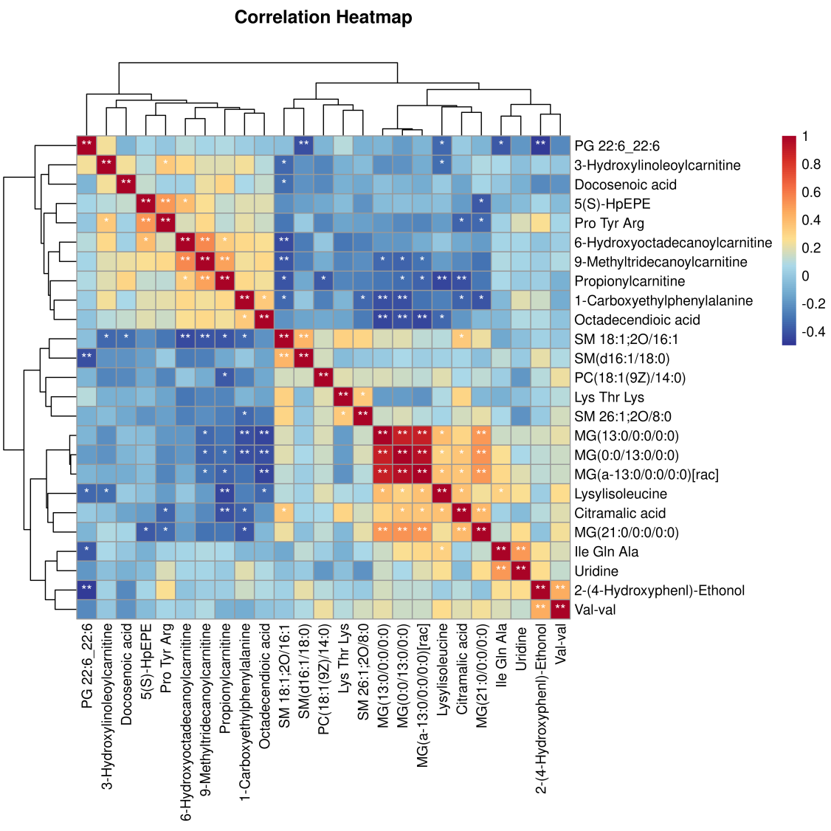
Suppl. Fig. 14 Correlation heatmap (PsAa vs PsAn)
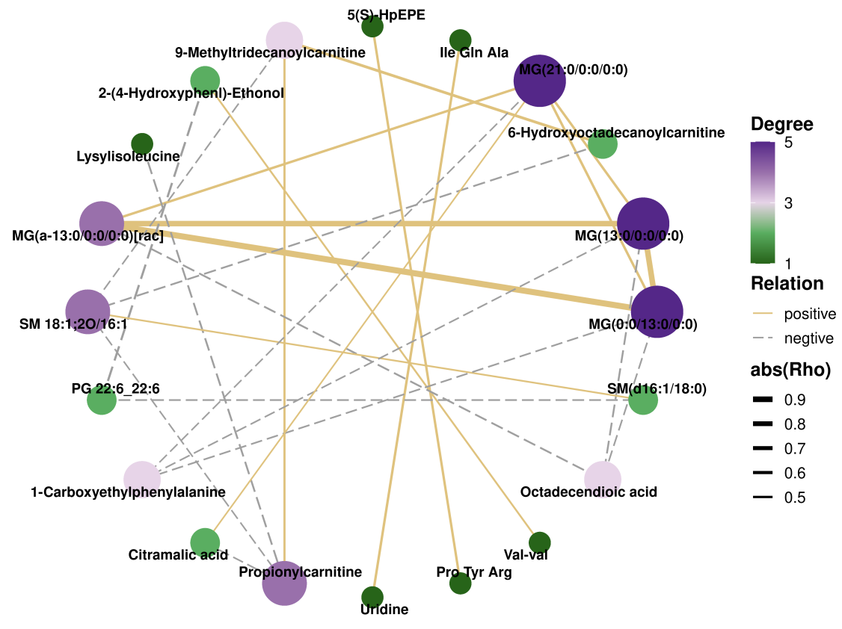
Suppl. Fig. 15 Correlation network (PsAa vs PsAn)

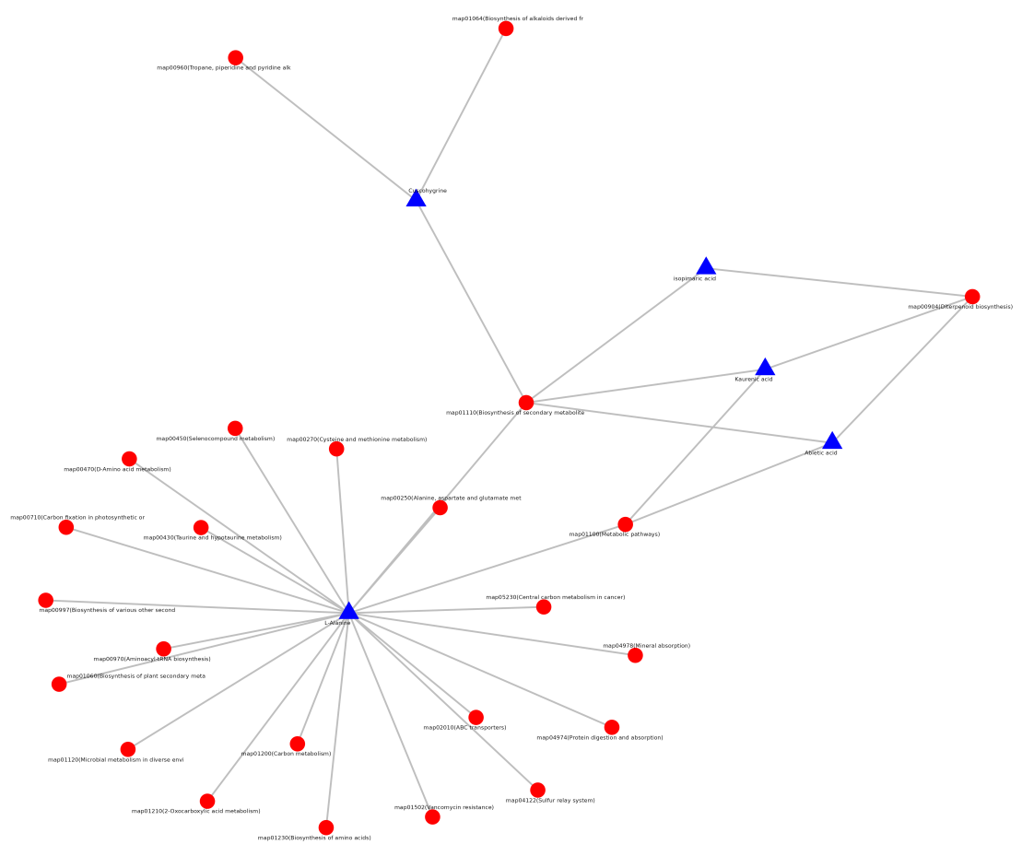
Suppl. Fig. 16 Differential metabolite-pathway association network (PsAa vs PsAn)
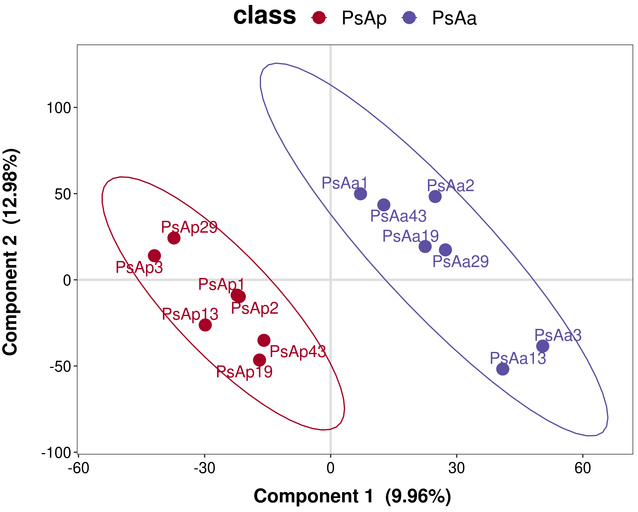
Suppl. Fig. 17 PLS-DA score plot (PsAp vs PsAa)

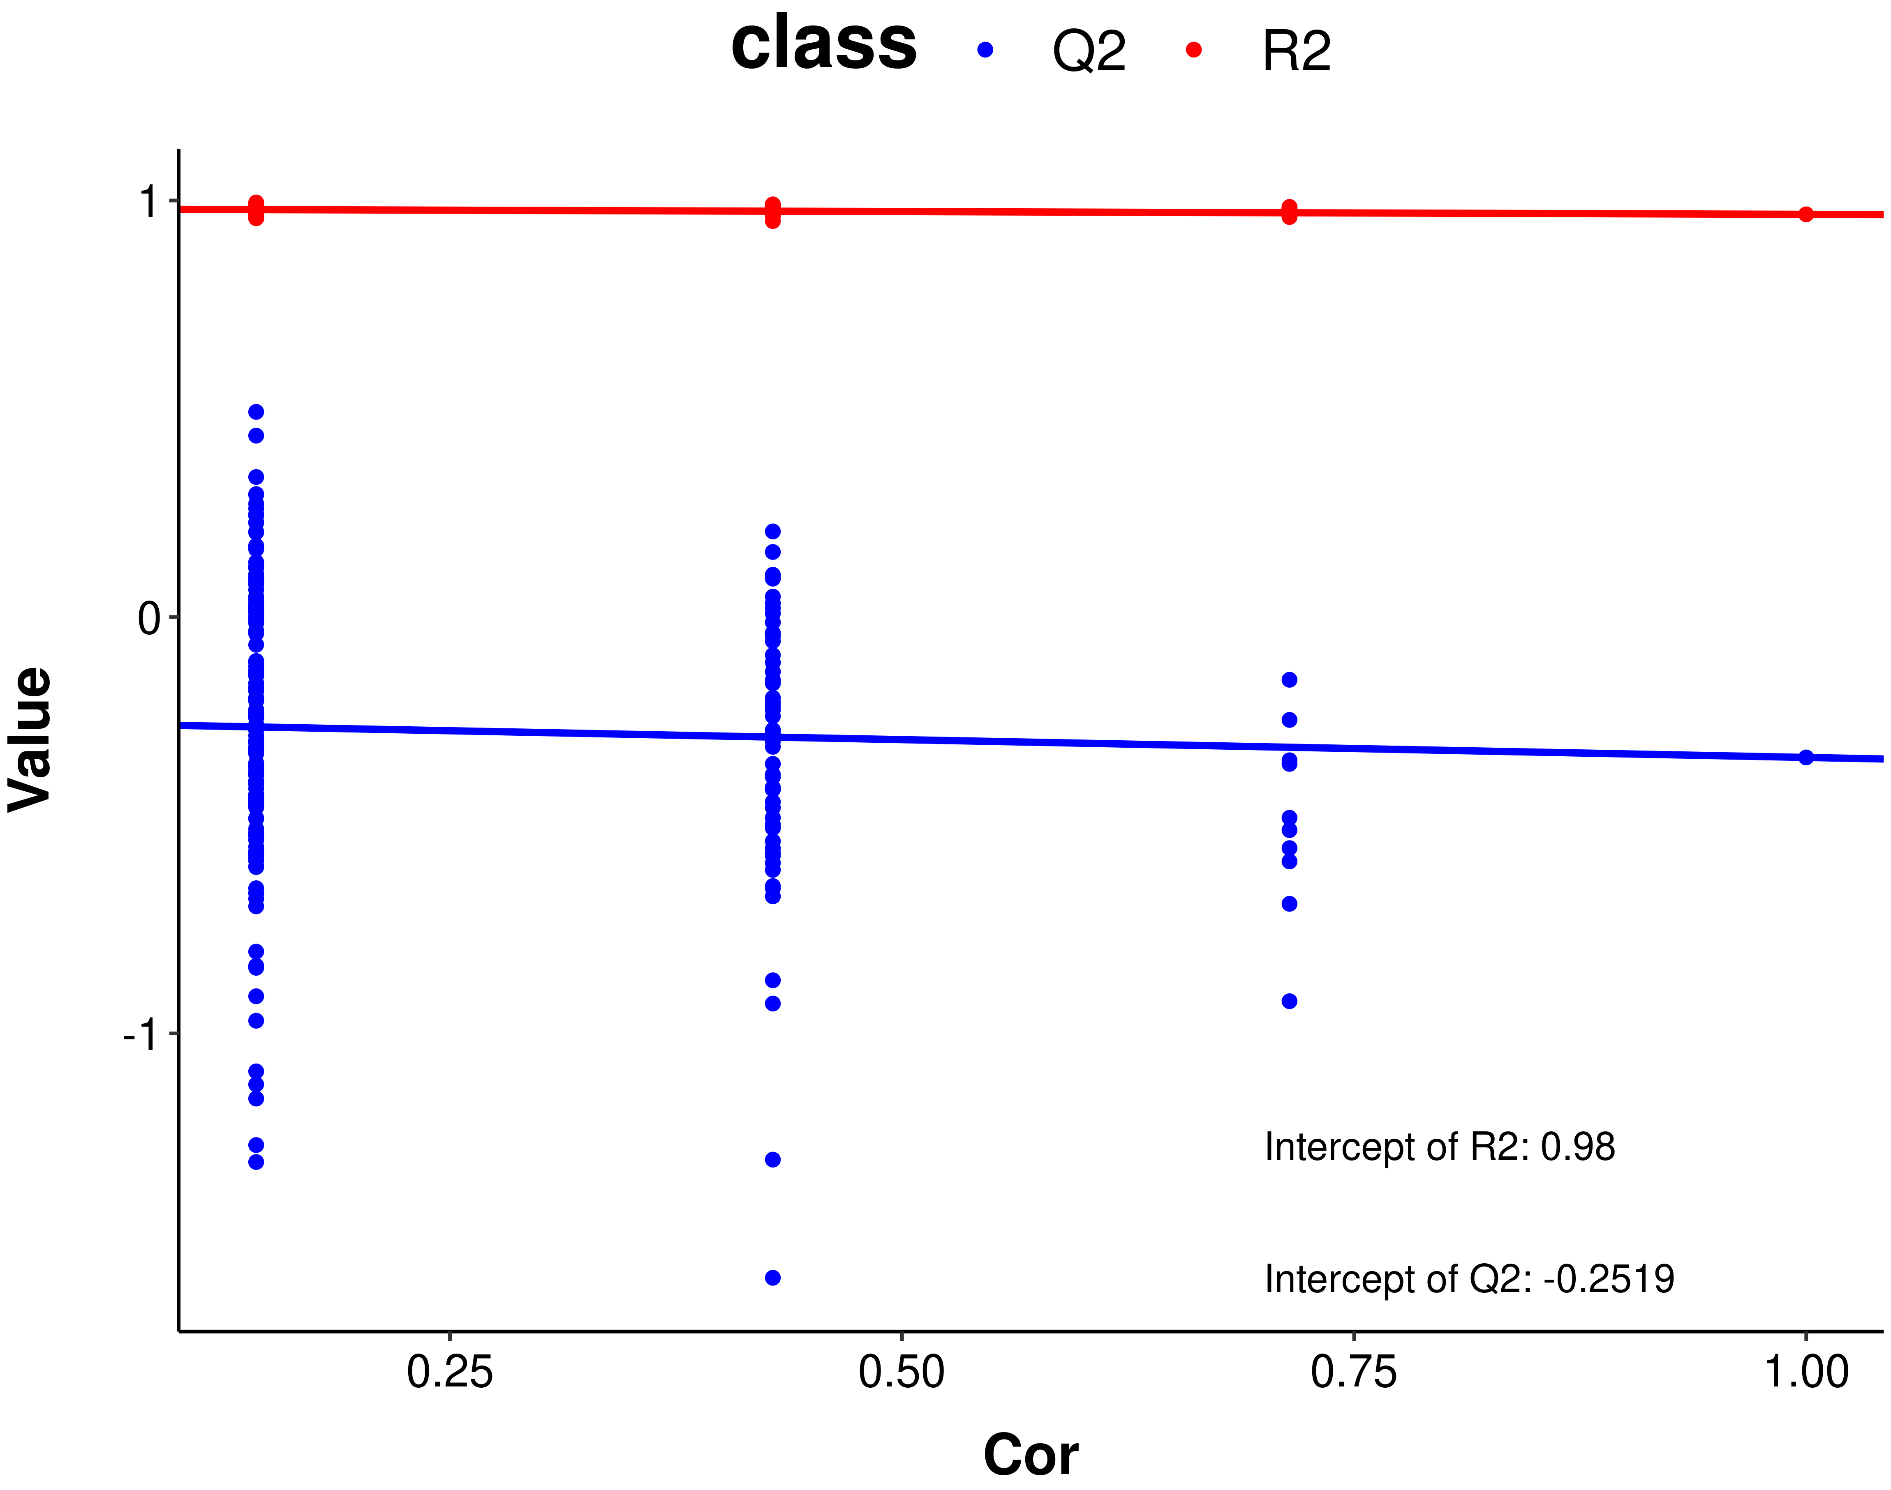
Suppl. Fig. 18 Permutation test of the PLS-DA model (PsAp vs PsAa)
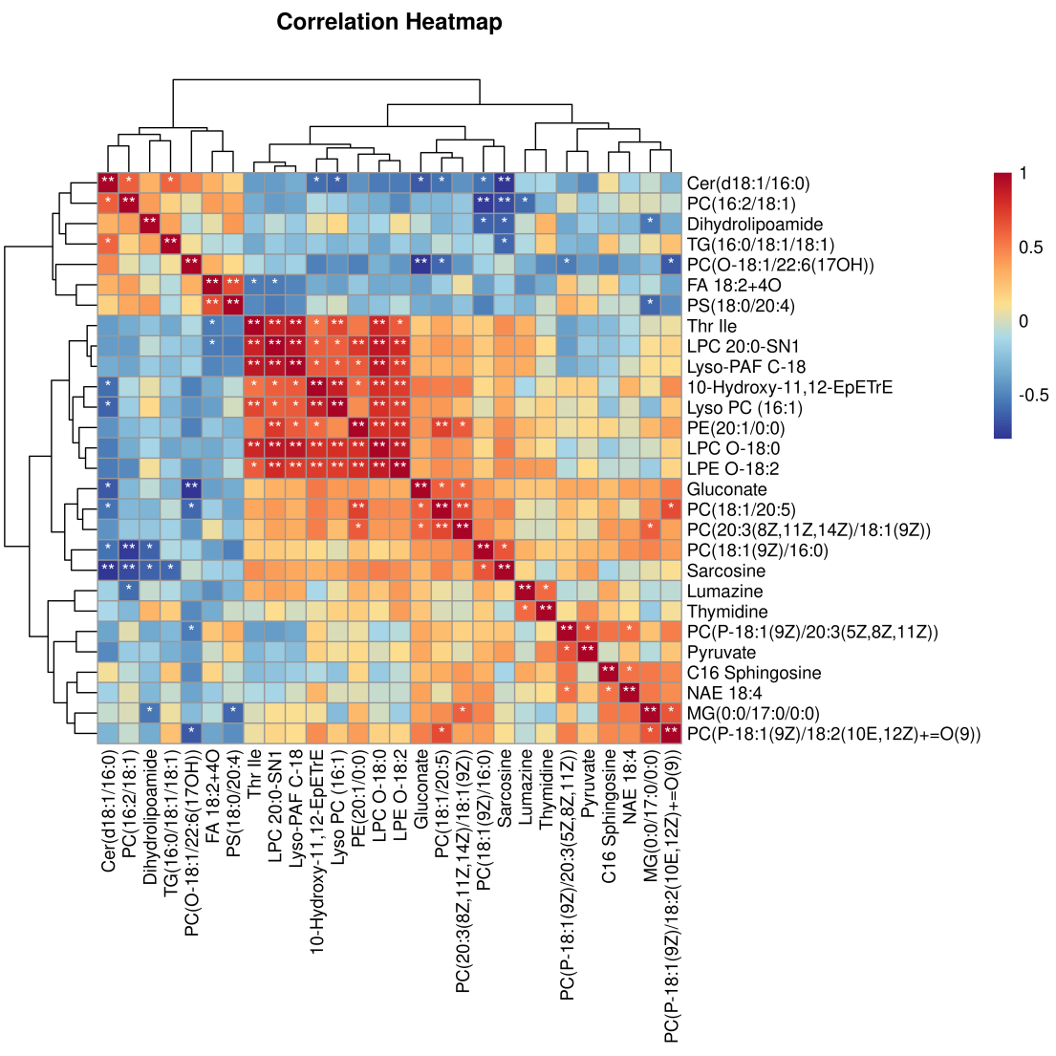
Suppl. Fig. 19 Correlation heatmap (PsAp vs PsAa)

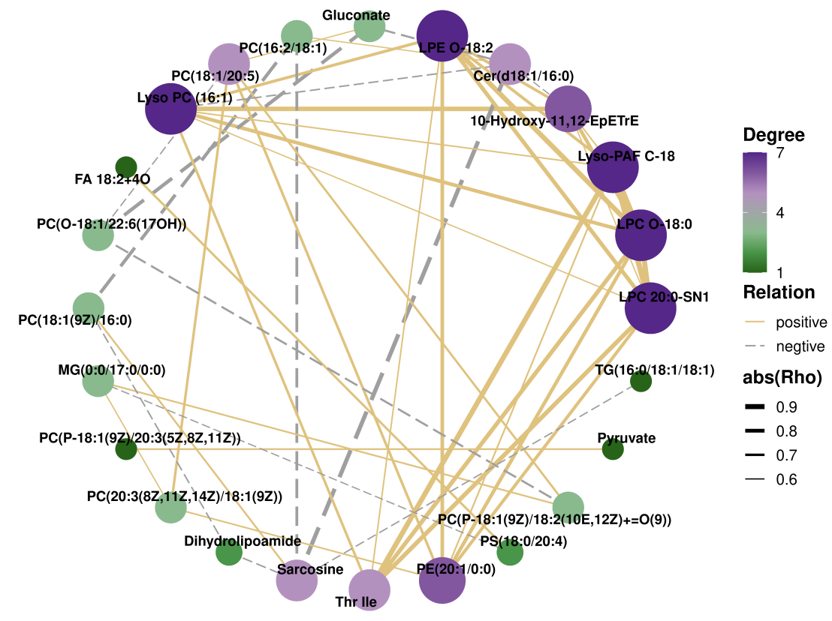
Suppl. Fig. 20 Correlation network (PsAp vs PsAa)
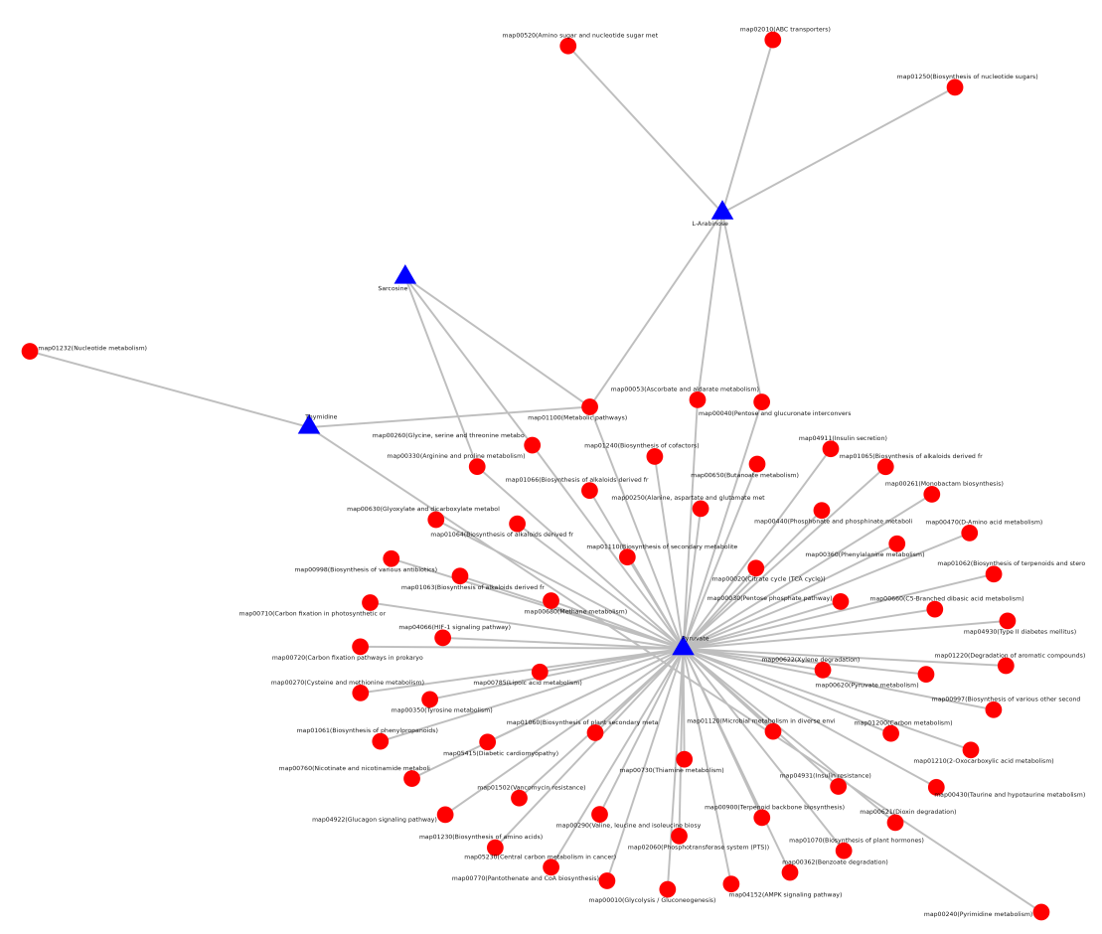
Suppl. Fig. 21 Differential metabolite-pathway association network (PsAp vs PsAa)

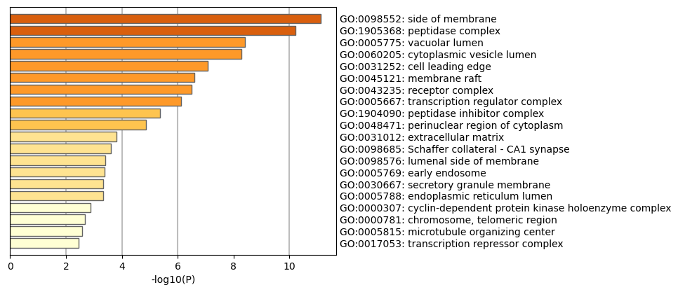
Suppl. Fig. 22 GO cellular component enrichment analysis

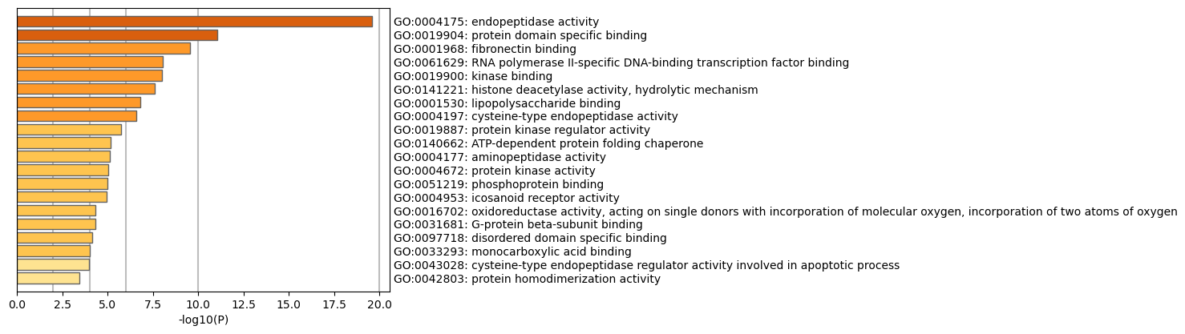
Suppl. Fig. 23 GO molecular function enrichment analysis

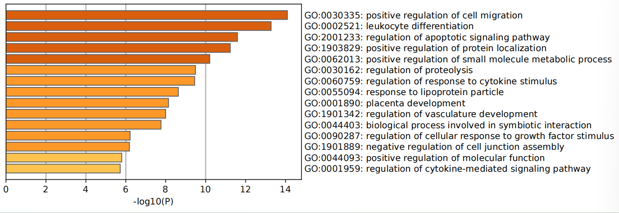
Suppl. Fig. 24 GO biological process enrichment of core hub genes

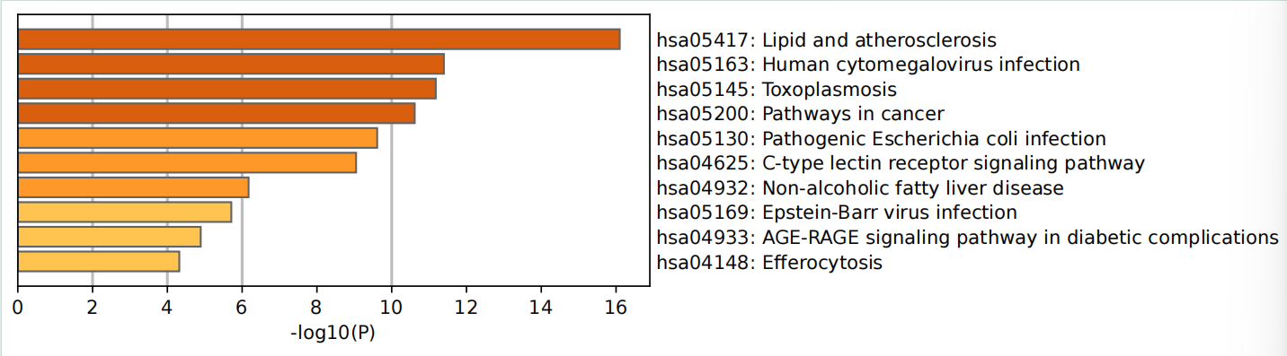
Suppl. Fig. 25 KEGG pathway enrichment of core hub genes

