Supplementary Appendix 5

Structured Cognitive-Based Intervention Framework and Adaptive Progression Model

I. Conceptual Definition of the Structured Intervention Framework
The “structured” nature of the intervention referred to the integration of a standardized session architecture, protocolized task sequencing, individualized entry-level assignment, adaptive progression rules, and supervised delivery within a common cognitive-based intervention framework. Each session followed a predefined five-component structure consisting of attentional preparation, event- and prospective-memory activities, multidomain cognitive exercises, ADL/IADL-oriented functional cognition tasks, and structured relaxation. Detailed descriptions of individual exercises are provided in Supplementary Appendix 1.
The intervention adopted a semi-standardized adaptive approach in which participants progressed through four hierarchical difficulty levels according to baseline cognitive performance and predefined progression criteria. This framework was designed to maintain intervention consistency while allowing individualized adjustment of task complexity, pacing, and cognitive demands.
The program additionally employed a multidomain cognitive-based structure by integrating exercises targeting attention, memory, executive function, language, visuospatial processing, abstraction, and functional cognition within the same intervention framework. This approach was intended to promote simultaneous engagement of multiple cognitive processes and support transfer to cognitively demanding everyday activities.

II. Standardized Session Structure

Five-Component Session Architecture
Each intervention session followed a predefined five-component structure designed to provide standardized cognitive engagement while maintaining functional and ecological relevance.
- Attentional preparation consisted of guided breathing and relaxation activities intended to facilitate attentional readiness and reduce external distraction prior to cognitive training.
- Event- and prospective-memory activities focused on reinforcement of episodic retrieval, prospective memory, and compensatory memory strategies applicable to daily task management.
- Multidomain cognitive exercises comprised structured tasks targeting multiple cognitive domains, including attention, memory, executive function, language, abstraction, and visuospatial processing.
- ADL/IADL-oriented functional cognition tasks emphasized sequencing, planning, and organization of cognitively demanding everyday activities to support functional independence.
- Structured relaxation was implemented at the end of each session to reduce cognitive fatigue and facilitate transition out of cognitively demanding activities.
Detailed descriptions of individual exercises are provided in Supplementary Appendix 1.

Session Timing and Delivery
The intervention was delivered over a 12-week period with one supervised session per week. Each session lasted approximately 90 minutes and was conducted in a hospital-based setting by trained healthcare personnel following a standardized intervention protocol.
To support maintenance of learned cognitive strategies and sustained engagement after completion of the core intervention phase, participants additionally attended a structured booster session at week 20. The booster session followed the same standardized session architecture and adaptive framework as the primary intervention program.

III. Hierarchical Adaptive Progression Framework

Four-Level Progression Structure
The intervention adopted a hierarchical adaptive framework consisting of four semi-standardized progression levels (Levels A–D). Each level was designed to progressively increase cognitive integration, task complexity, multitasking demands, and functional relevance while maintaining compatibility with individual cognitive performance.
Level A focused on foundational cognitive engagement using relatively simple and supportive tasks intended to facilitate familiarization with the intervention structure, promote confidence, and minimize cognitive overload.
Level B introduced greater cognitive demands through integration of attention, memory, and executive-processing tasks requiring increased information maintenance and sequential processing.
Level C emphasized multidomain cognitive integration through more complex and multitasking-oriented activities involving simultaneous processing across multiple cognitive domains.
Level D represented the highest progression level and incorporated cognitively demanding tasks involving abstraction, flexible reasoning, complex cognitive integration, and increased functional problem-solving demands relevant to real-world situations.

Cognitive and Functional Characteristics Across Levels
The hierarchical progression framework was designed to gradually increase cognitive and functional demands across levels while maintaining individualized adaptability.
Lower levels emphasized foundational cognitive engagement through structured and supportive activities targeting attentional control, basic memory processing, and familiarization with intervention procedures. Intermediate levels progressively incorporated multidomain integration by combining simultaneous demands on memory, attention, executive function, language, and visuospatial processing within the same task structure.
Higher progression levels introduced greater multitasking demands requiring concurrent information processing, flexible task switching, and increased working-memory load. These levels additionally emphasized abstraction and cognitive flexibility through rule-based reasoning, semantic association, and complex problem-solving activities.
The highest levels incorporated increased ecological complexity by integrating cognitively demanding tasks with functional and everyday-life contexts intended to support transfer of cognitive strategies to real-world activities and daily functioning.

IV. Individualized Entry-Level Assignment
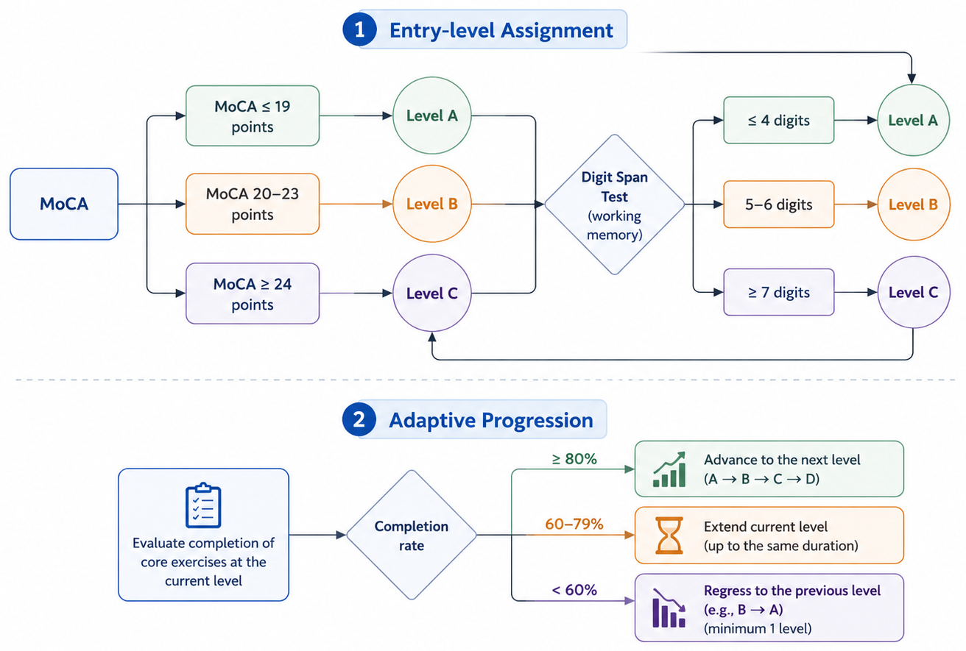
Figure 1 Entry-level assignment and progression algorithm (Figure created by the authors).

Baseline Cognitive Stratification
Initial entry-level assignment was determined using baseline cognitive performance assessed by the Montreal Cognitive Assessment (MoCA) and the Digit Span Test. The MoCA was used to provide a general estimate of global cognitive status and overall level of cognitive impairment, whereas the Digit Span Test was used to further assess working-memory capacity and short-term information maintenance.
These measures were jointly used to support individualized allocation to an appropriate starting level within the adaptive progression framework, with the aim of minimizing cognitive overload while maintaining sufficient cognitive challenge and engagement.

Entry-Level Allocation Principles
Participants were assigned to individualized starting levels within the four-level adaptive framework according to baseline cognitive performance. This approach was intended to balance cognitive challenge with task feasibility while maintaining engagement throughout the intervention period.
The allocation strategy was additionally designed to reduce the risk of cognitive overload in participants with lower baseline performance and minimize floor effects associated with excessively difficult tasks. Conversely, participants with relatively preserved baseline cognitive function were assigned to higher entry levels to maintain adequate cognitive stimulation and prevent under-engagement.
Entry-level assignment therefore allowed adaptation of task complexity, pacing, and multidomain cognitive demands according to individual cognitive capacity at baseline.

V. Adaptive Progression Rules

Advancement Criteria
Participants progressed to the subsequent difficulty level when they achieved a completion rate of ≥80% for the multidomain cognitive exercises assigned within the predefined training period. This criterion was intended to ensure sufficient mastery of the current cognitive demands before escalation to higher levels.

Extension Criteria
When participants achieved a completion rate between 60% and 79%, the current difficulty level could be extended for an additional period not exceeding the originally allocated duration of that level. This approach was intended to provide additional training exposure while maintaining progression flexibility.

Regression Criteria
Participants with a completion rate of <60% were reassigned to the immediately preceding difficulty level. This strategy was implemented to reduce excessive cognitive burden and maintain compatibility between task demands and individual cognitive capacity.

Flexible Duration Across Levels
The duration of each progression level was individualized according to the participant’s initial entry level and progression rate within the fixed 12-week intervention framework. This adaptive pacing approach allowed participants with different baseline cognitive capacities to complete the intervention while maintaining standardized overall program duration.

VI. Protocolized Task Sequencing
Exercises were distributed across progression levels according to predefined cognitive and functional demands within the standardized intervention framework. Lower levels primarily emphasized foundational cognitive engagement and relatively simple single-domain activities, whereas higher levels incorporated increasingly complex multidomain and functionally oriented tasks.
Task sequencing was designed to progressively increase cognitive complexity through greater working-memory load, attentional demands, abstraction, rule processing, and simultaneous information integration. Higher progression levels additionally incorporated greater multidomain integration by combining memory, executive function, language, visuospatial processing, and attentional control within the same task structure.
Functional demands also progressively increased across levels through greater incorporation of ecologically relevant activities, task sequencing requirements, prospective-memory components, and cognitively demanding ADL/IADL-related scenarios intended to support transfer to real-world functioning.
Exercise-specific details are presented in Supplementary Appendix 1.

VII. Structured Booster Session
A structured booster session was conducted at week 20 following completion of the primary 12-week intervention phase. The booster session was designed to reinforce previously learned cognitive strategies, promote continued application of cognitive and compensatory techniques, and support maintenance of long-term engagement with cognitively stimulating activities.
The booster session followed the same standardized session architecture and adaptive framework as the primary intervention program, with emphasis on sustained cognitive participation and reinforcement of functionally relevant cognitive activities.

